

COURSE: PROGRAMMING TECHNIQUE I (SECJ)

ASSIGNMENT II

MODULE / SECTION | SECJ 1013 / 08
ASSIGNMENT TYPE | GROUP 10
TITLE OF ASSIGNMENT | Hotel Management
CASE STUDY | Case Study 11
PREPARED FOR | Dr. Adila Firdaus Binti Arbain
PREPARED BY (Group 10) | - Brendan Dylan Gampa anak Joseph Dusit@Dusit
PREPARED BY (Group 10) | - Siew Yu Xuan
PREPARED BY (Group 10) | - Theresa Lau Xin Yi
DUE DATE | 31/12/2020

Comparing the previous pseudocode with our coding.
Pseudocode | C++ Programming
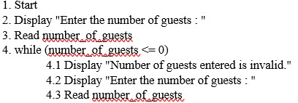 | 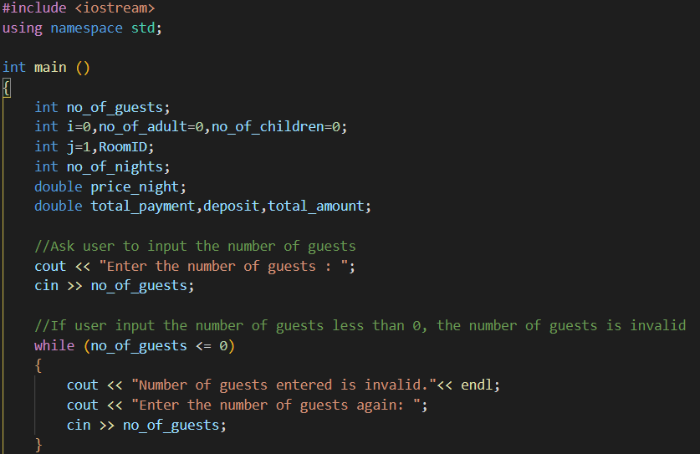
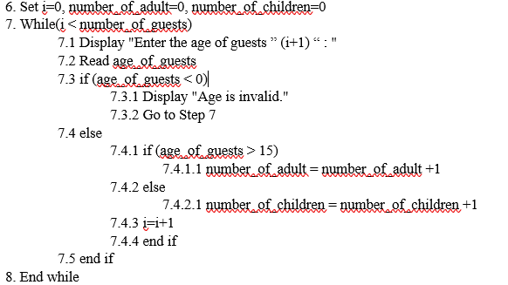 | 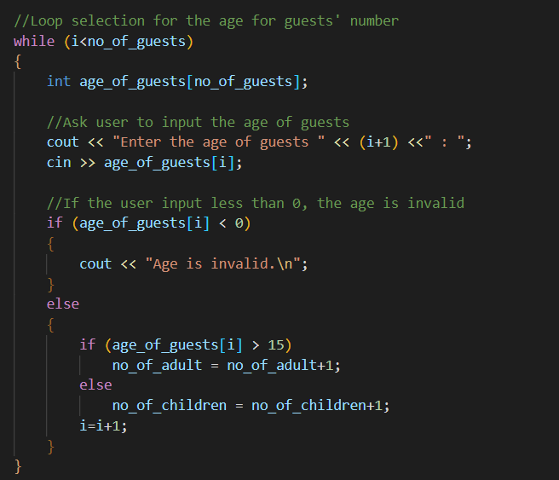

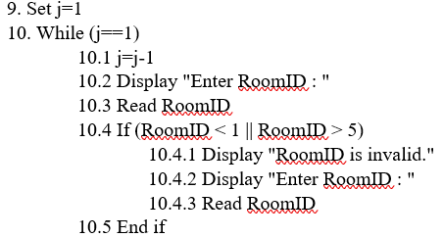 | 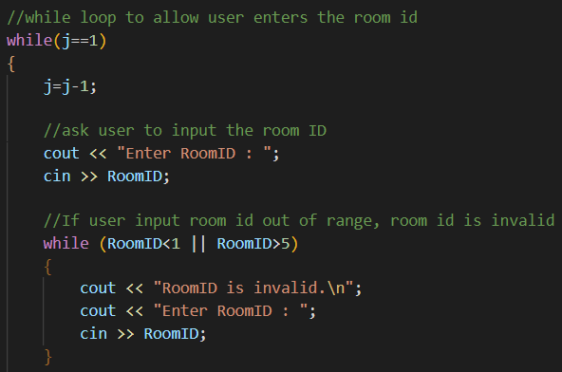
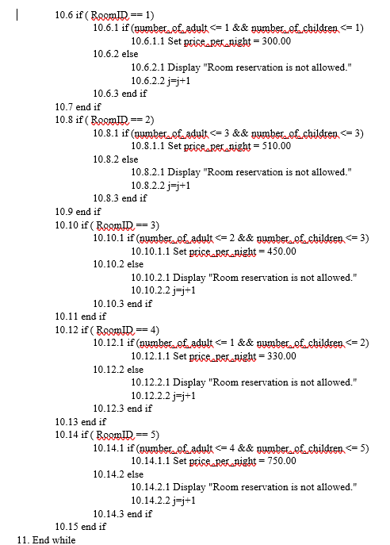 | 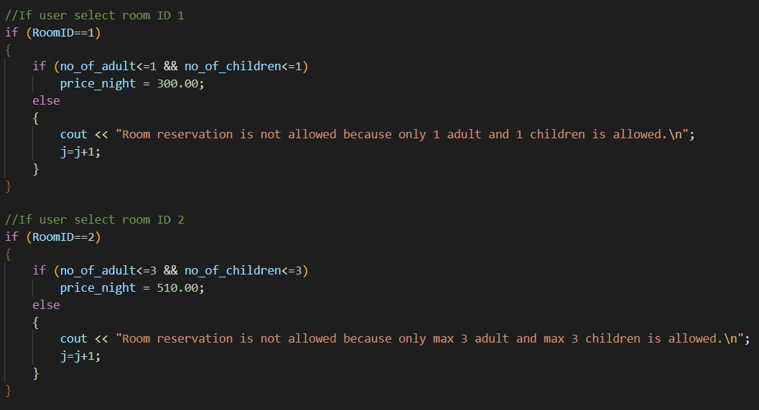  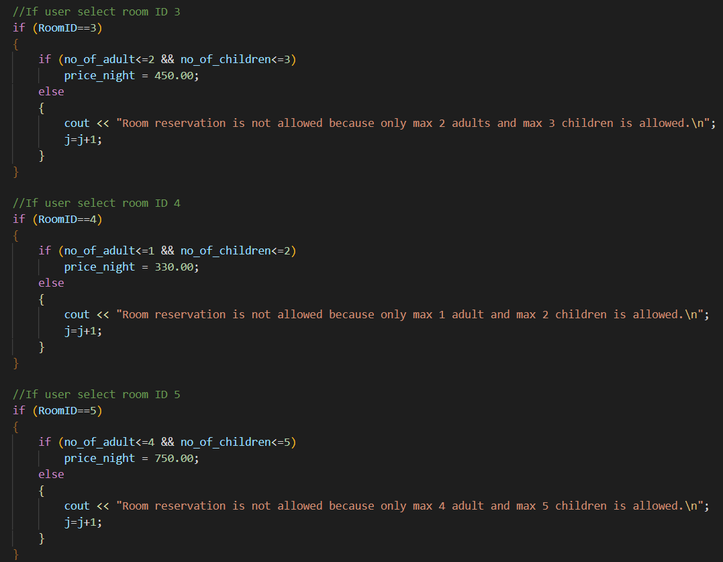

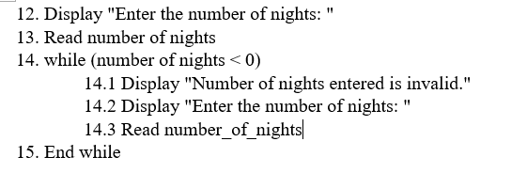 | 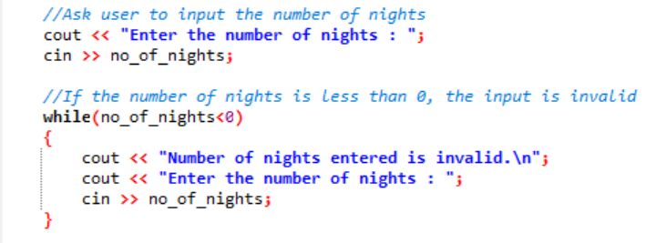
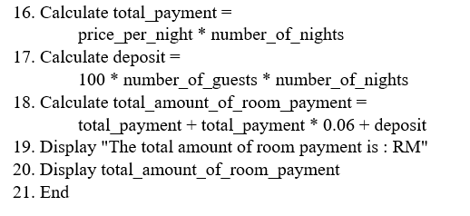 | 