

TECHNOLOGY & INFORMATION SYSTEMS

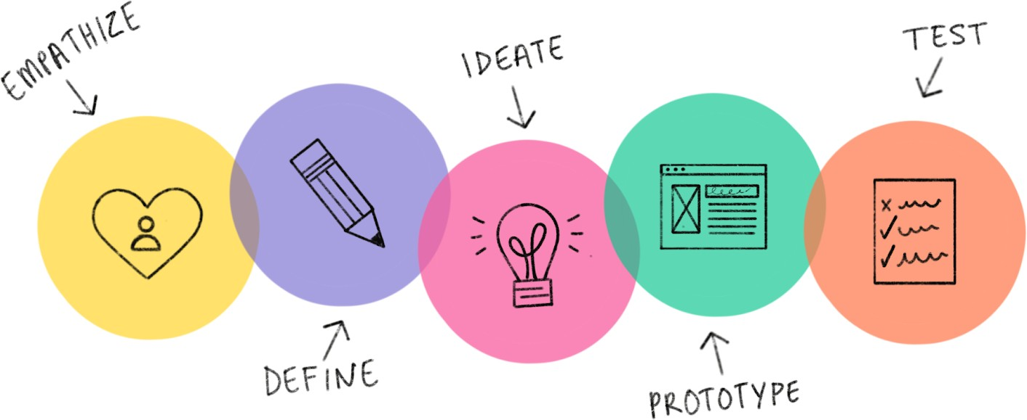

TOPIC: DESIGN THINKING LECTURER: DR. ARYATI BINTI BAKRI
DATE OF SUBMISSION: 15 NOVEMBER 2019 GROUP MEMBER:
NAME | MATRIC NUMBER
LOW JUNYI | A20EC0071
MUHAMMAD IMRAN HAKIMI BIN MOHD SHUKRI | A20EC0213
MADINA SURAYA BINTI ZHARIN | A20EC0203
NUR SYAMALIA FAIQAH BINTI MOHD KAMAL | A20EC0118
SAKINAH AL’IZZAH BINTI MOHD ASRI | A20EC0142

TABLE OF CONTENTS
TABLE OF CONTENTS 1
INTRODUCTION 2
DETAILED STEPS AND DESCRIPTION 4
DESIGN THINKING EVIDENCE 8
REFLECTION 16
TASK OF EACH MEMBER 18
CONCLUSION 20
REFERENCE

INTRODUCTION

What is design thinking? Design thinking can be defined as a prominent process or approach to come out with innovative and creative solutions in our daily life in solving problems. Along with the development of science and technology in this sophisticated and modern era, design thinking is essential and useful to be learned by new generations especially for students as they will lead the country in the future. This highly innovative process was subsequently advanced by experts from a number of disciplines, including architecture and engineering, to meet human needs in the modern era as they identify the way to solve problems for the consumers of their goods and services through design thinking. Furthermore, the value of design thinking is far exceeding as it is not only creating the solutions for the problems in building products, but can be used in any critical situations in daily life. Hence, there are five steps in design thinking which are Empathize, Define, Ideate, Prototype and Test.

Firstly, Empathy is the main key to a process of human-centered design, such as design thinking, as it enables you to put aside your own world assumptions and gain real insight into users and their needs. Secondly, Define is analysing the findings and synthesizing them to identify the key issues from the gathered data or information, which is known as a problem statement. The third step is Ideate. This step allows people to be creative and generate a range of ideas as much as possible before the evaluation phase. For example, brainstorming with group members. Next, Prototype is the process of experimenting the products in physical form whether it will be useful for the user or not. Lastly, the final step is Test which means getting results from the prototype after refine it into a better product. In this report, we will use the method of design thinking in generating new solutions regarding our topic which is system unit. For most electronic devices that we use, we typically have one thing in common: a system unit. System unit is a main part of a computer's components that contain a motherboard, CPU, RAM and etc. The computer chassis, cabinet, or just case are other names for the

system unit since it is shaped like a box-like case containing a computer's electronic components. Furthermore, to distinguish between the computer and peripheral equipment, such as the display, keyboard, and mouse, the word 'system unit' is commonly used. Although laptops often have integrated displays, they are not referred to as system units, as the term applies only to desktop computers.

DETAILED STEPS AND DESCRIPTIONS

DATE | ACTIVITIES
25 OCTOBER 2020 | - Briefing by Dr Aryati about the assignment.  - We were assigned as a group and instructed on the topic given with the criteria we needed to achieve in order to complete the tasks given.
29 OCTOBER 2020 | - Meeting up with the members to discuss more on the topic given.  - Exchanging ideas to draw a draft on the questions that  will be asked to the lectures and technicians regarding the topic.
1 NOVEMBER 2020 | - Checking and asking for advice on the draft of questions with Dr Aryati to know whether the questions are valid and suitable.  - Meeting with the members to renew the draft before the interview.
3 NOVEMBER 2020 | - Interviewing the CICT lecturers and technicians using online platforms such as webex and Google Meet.  - Taking notes from the interview.  - Recording of each session was given in the group.  - Checking the outcomes on the interviews recording.
6 NOVEMBER 2020 | - We identified all the problems and found the solutions that we got from the interview recordings.  - We discussed, designed and recorded the prototype of our project.  - We distributed each task to the members.

14 NOVEMBER 2020 | - We tested the prototype by using Google Forms to get feedback from the users.  - We finalised our prototype.  - We started editing our video.
15 NOVEMBER 2020 | - We completed the editing of our report, slides and videos.  - We wrote the reflection on the topic.  - We uploaded the videos on Youtube.  - We submitted our assignment.

Table 1: Detailed Steps and Descriptions In Design Thinking

DETAIL DESCRIPTION (PROBLEMS, SOLUTIONS AND TEAM WORKING)

The system unit is the house for most of the electronic components to make up a computer system. There are a lot of components in the system unit such as motherboard, Central Processing Unit (CPU), Random Access Memory (RAM), Graphic Processing Unit (GPU), internal storage, cables, cooling system, DVD ROM, power supply unit, Read Only Memory (ROM), ports and many more.

Based on the interview with the CICT staff, we had identified a few problems. The problems are mainly about the components at the system unit which are cooling system, internal storage and ports.

Components / Details / Problems | Solutions
Cooling system | Adding case fans
Cooling system is required to remove the waste heat produced by the computer components to maintain the suitable temperature. | Adding case fans will be a big help. Since performance-enhancing memory and graphic cards generate a lot of heat, case fans can help increase airflow to your components by attaching to the front
The hot running system unit could spoil the system unit as the system needs to run all the time. The heat could easily be felt as most of the system units are commonly made from steel or aluminium. | and back of your system. Many of our ballistics customers opt to install two case fans: one to move cool air into the PC and another to move warm air out of the PC. If you decide to add case fans, make sure that the intake and exhaust levels match.  Water cooling kit
 | For gaming systems with high-end CPUs and
overclocked components, often the fastest fans can't keep up with the increased temperatures. To solve this problem, many gamers opt for water cooling kits as a way to cool the CPU. In the water-cooling kit, a pump cycles cold water down to the CPU in self-contained
tubes, then pumps the water out of the system where it
 | can be cooled before returning to the CPU for additional cooling.

Components / Details / Problems | Solutions
Internal storage  Internal storage is the hardware that holds the data inside the computer. The data or information will remain inside it although the computer has no power. There are two types of internal storage which are Hard Disk Drive (HDD) and Solid-State Disk (SSD).  No matter how big the storage is, people need more than that to store or backup data. Moreover, if the storage is full, people are lazy to choose which data is necessary or not. | Wireless External SSD  Benefits of SSD are:  - Less energy consumption  - Faster  - Compact  - Reliable  The wireless SSD could be connected to the system unit by using Bluetooth. The benefits of our wireless SSD are:  - Easy to carry  - Reduce the usage of ports on laptops.The battery can be exploited as a power bank to charge USB devices like phones.  - It has multipurpose functions as it can keep photos, videos or any files from phone and tablet
Ports  Ports are the point where external devices can be connected to the computer. Ports in laptops or any small devices have limited amounts of ports compared to the computer system unit. The types of ports which commonly being used in laptops are USB and HDMI. | Laptop with projector  We planned to invent a laptop which also contained a mini or Pico projector in it. This projector includes a brightness controller and on/off button. The user could also turn the projector on/off through the operating system itself. Therefore, this could reduce the usage of ports on laptops.

Table 2: Detail Description (Problems and Solutions)

After we defined all the problems, we decided to do an online meeting via Google Meet to brainstorm the idea to solve the problems regarding the system unit. Based on the problems, we found some solutions which are enhancing the cooling system in the system unit, provide an alternative to store data other than the internal storage which sometimes is not enough for the user and lastly, we planned to reduce the usage of ports by adding a mini projector to the laptop. The solutions that we planned are based on the interview sessions with the staff from the CICT unit. While brainstorming, we also use some tips that were given by the expert so that we could easily reach an agreement for our prototype.
Although there are constraints to meet face-to-face, we took the challenge by using all the online platforms to make sure this assignment could be done completely before the due date. During the online meeting, we also took some time to distribute the works equally which are making the report, making a video regarding the design thinking and also the chapter presentation video. Other than doing an online meeting, we also use another platform which is Whatsapp for discussions.

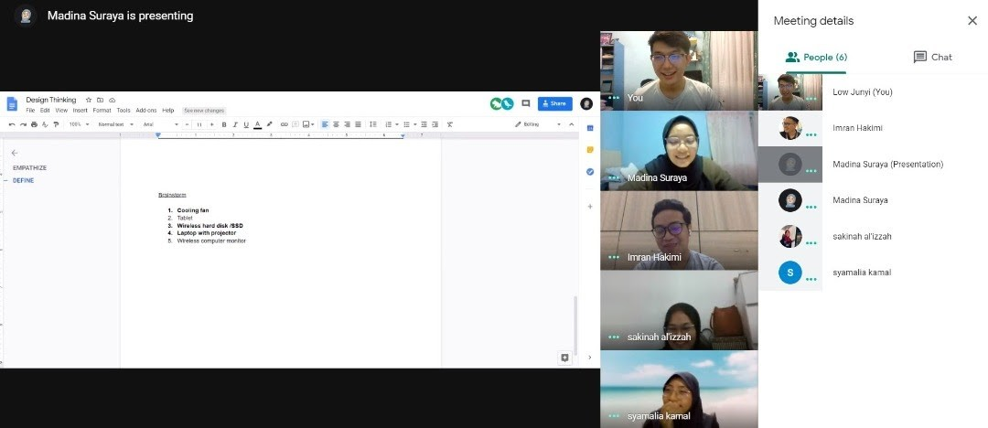

DESIGN THINKING EVIDENCE

Design thinking is a process that can help people to solve the problems in a creative way which could bring great and quality outcomes. There are 5 steps in design thinking which are empathize, define, ideate, prototype and the last one is test. These steps have helped us a lot to complete this assignment.

STEP 1: EMPATHIZE

To complete this step, we need to interview the experts or staff from the CICT unit. The interview sessions were conducted via GoogleMeet.

1) Time/Date: 3.30 p.m. / 3 Nov 2020

Name: Mr. Mohd Zahari Bin Zainal Abidin

Work Field: Network Admin

Experience : 17 years working in UTM

2) Time/Date: 9.00 p.m. / 3 Nov 2020

Name: PM Dr Murtadha Bin Mohamad

Work Field: Information Systems

Questions and Answers:

- What is your opinion about the devices last time than current devices?

Last time, phones were big and wired so it was difficult to bring it anywhere. After that, it
became smaller and wireless but only had some basic function such as call and messages.
Next, technology changed after the presence of the internet. It changed from small to
slightly bigger again as it has more functions.

- What is your opinion on how to overcome a hot running system unit?

The hot running system unit can make the system unit spoil easily. The system needs to
be run all the time. So, to maintain it, all the servers in the data system must be redundant
and must be clustered. If one of the servers is down, the others could still run the system.
However, the heat produced by the system unit could still be felt and sometimes people
are scared if there are any problems regarding the wiring in the system unit, power supply
or anything else.

- What do you think about memory in any device?

Storage will never be enough although the device has a higher specification. There is no
limit to human usage. An individual needs to know what are the necessary apps and data
that you really want your phone to handle and cope with. The difficulty is that humans
can’t easily decide which one is important and less important but at the same time want
everything in an unlimited condition.

- What is your opinion or improvement of our future computer or laptop in terms of design and function?

To design a device, we need to learn about human computer interaction. For example, we
need to know why laptops have a touch mouse which is placed at the center of the laptop.
So, to design something, we need to know the purpose and in terms of human needs. The
problems that some people and I are facing is that it is difficult to do the presentation or
watch a movie with a big screen without a projector. The projector is heavy and difficult
to bring anywhere. If we want to use the projector, we also need to bring along our
computer or laptop. Thus, it requires more energy and work that can make people easily
tired.

STEP 2: DEFINE

In this phase, we need to identify the problems based on the interview so that we could find an idea to ease the user.

Problems from empathy step:

- The heat produced by the system unit after a long period of time which concerns the users. They are scared if something happens in it such as any damage to the components or the power supply. Here, we get the idea to increase the efficiency of the cooling system in the system unit.

- The storage in any device is still not enough for everyone as there are many important data or information that need to be kept safely. People also did not have much time to choose which information is necessary or not as they might want to save it for future use. Although there are many external devices that could keep the information, it usually used wire such as USB to connect to the device. Thus, ports are needed. Here, we get an idea to make an external storage device to store the information without using the ports.

- Projector is very helpful for people to do presentations on a large screen. However, the projector itselfs are heavy and require ports to connect it. Sometimes, thinner laptops did not have enough ports for external devices. Thus, it requires much work such as to bring the heavy projectors and a big laptop with enough ports at one time. Here, we get the idea to invent friendly user projectors.

STEP 3: IDEATE

In this phase, we do an online meeting via GoogleMeet to brainstorm some ideas to bring satisfaction for the user regarding the system unit. During the meeting, we list down some of the best solutions for the problems and based on the list, we only choose some of it that we think could bring better results with a high quality for our prototype.

Brainstorm process:
- Cooling fan
- Tablet
- Wireless hard disk /SSD
- Laptop with projector
- Wireless computer monitor

Based on the information that we had gathered from the previous task, we had come with five ideas. We narrowed down the detail of ideas and characteristics on some features of our incoming prototype. Firstly, smaller in size and portable. This is because bigger size electronic

devices make it hard to move around and cause discomfort as it will certainly be heavy. It will hinder the user to bring it to anywhere else. Secondly, we want the product to be heat efficient as it will cause data redundancy and result in a server down. Hence, a cooling system is convenient in reducing the heat produced by the system unit. Next, we need a bigger capacity storage to store all the files, pictures and videos in the device. It is an important feature as the users usually work with a lot of things and require large spaces to keep information preserved for their work. Lastly, multitasking in doing presentations. Large screen is a common characteristic needed for audiences to see the slides or any information virtually, however, the projector itself requires cable to connect it to the laptop, tablet or computer. Thus, we had come to the conclusion that a cooling fan, wireless hard disk or SSD and laptop with a projector will become the incoming prototypes of our project.

STEP 4 (PROTOTYPE)
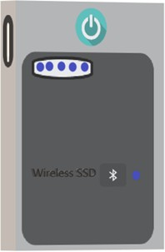
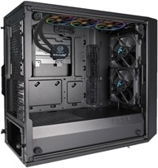

Figure 1: Wireless External SSD Figure 2: CPU Cooling System

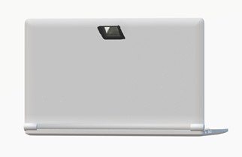
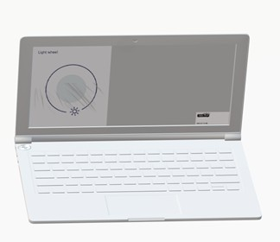

Figure 3: Laptop with Projector

In this step, we came up with three prototypes out of five from the proposed solution was used to test ideas. By using the application 3D paint, we created the prototype shown in Figure 1, Figure 2, and Figure 3. The reason we do prototyping is to make a comparison with the last time devices and recognize the flaws to resolve the problems. Generally, through prototyping, we can understand the human needs that are essential for the product.

Step 5: Test

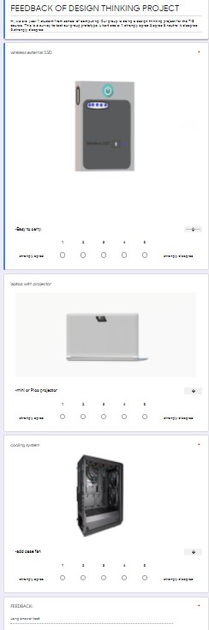

Figure 4 : Google Forms Testing of Prototypes

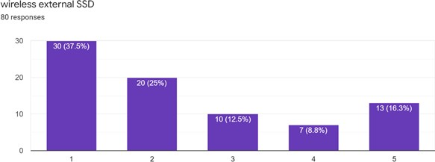

Figure 5 : Wireless External SSD Feedback from Responses

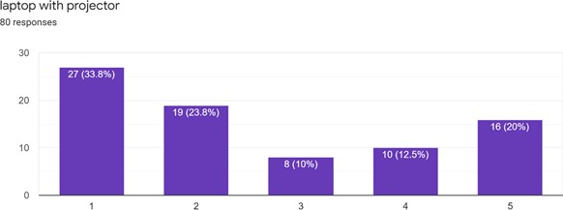

Figure 6 : Laptop with projector Feedback from Responses

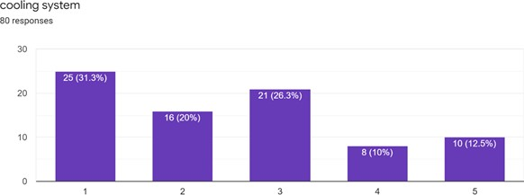

Figure 7: Cooling System Feedback from Responses

In this phase, we test the prototype by spreading the google form (Figure 4). Three prototypes were tested using a scale from 1 (strongly agree) to 5 (strongly disagree) and asked user recommendations to improve our prototype. From 80 responses, three prototypes highest feedback on a strongly agreed scale( Figure 5, Figure 6, and Figure 7) , but some of our responses did not agree with the design. Thus, we receive positive feedback and improvement for a better prototype.

REFLECTION

- LOW JUNYI
For my goal on my data engineering course, I’m not hoping to get a good result but I have to score a great result as there are many computer science students outside the UTM. I also need to join and learn more computing languages and soft skills so that I can be special and different with other computer science students as this course is very competitive. I also want to do more exercise and do more research in my data engineering course which allows me to have a great fundamental to start at the beginning.

Design thinking has impacted me a lot on my goal regarding my data engineering program. Design thinking has taught me about empathy, define, ideate, prototype and test which are very useful for future me to design a brand new own product in the future. These five phases are very important as they need to be going through to achieve to get our final product. Design thinking also has taught me teamwork as my teammates and I work together because we have the same goals that ace our design thinking assignment well. Design thinking also has made our relationship closer to each other. Teamwork is very important in the computer system industry. This design thinking assignment had also let me have a chance to do the research well with my team and all of us had brainstormed

together to think of getting the best prototype and the best idea. Thus, my knowledge and research capability had increased throughout this design thinking assignment.

I had a lot more that needed to be improved such as time management and skill. As I’m not skillful in video editing, I faced a lot of problems from this part. I had to improve my communication skill as well to let my teammates understand my message for them. I should work harder and harder to achieve a better result in the assignment in the future. Last but not least, I should learn and do more research in my industry for a better understanding of whole computer science. All this improvement will give me a great boost in my industry in the future.

- MUHAMMAD IMRAN HAKIMI BIN MOHD SHUKRI

When it comes to technology, I couldn’t say no to it. Since I was in primary school, I used to see how technologies are evolving especially the use of smartphones. At that particular period, many people went from a very basic phone with basic functionalities into a very much complex smartphone, with complexity in terms of functionality. From that, I’ve become more eager and keen on how technology is going to be developed into. Today’s technology is more than enough in getting everyday’s job done.

Design thinking is going to bring me much closer to technology. Not only that, I’ve also got some idea about the process of making them and designing them. I’ve learned that while pouring our ideas into a jar when inventing something, we might also need to think, how is it good for users or consumers, and how is it bad for them. This way, we could make any cons in our product as minimal as possible. Of course, no products are actually perfect. Take smartphones for instance, there are users who demand a small sized phone for easier reachability but there will also be a drawback. Which is of course, the battery capacity cannot be as big as a large phone since there’s not enough space to fit the bigger battery component.

I also love how by learning design thinking has given me such proper steps and processes

while inventing a product or technology. These manners surely would make any creation or invention more solid and well-built. This assignment has given me a little bit of a picture on how I am going towards the future, where there’s a lot to be invented. Also I’ve got to know that to create something, it should be based on what humans, at that particular time frame, really need. Otherwise, it would be pointless.

Before diving and digging deeper in this industry, I would like to get better in brainstorming ideas, analyzing and identifying problems, and also to be brave to speak up for my ideas as long as it benefits users and the environment. Next, I should do more lookups and research to make sure that I know what I am actually looking for in this industry of dream, at least for me. Finally, I really need to improve myself when designing or prototyping a product especially in drawing. I am very sure that with all those improvements, I could turn myself into a very successful person mainly in this industry.

- MADINA SURAYA BINTI ZHARIN

Since the world is now focusing on the Industrial Revolution 4.0, I am looking forward to getting a job that could cope with it very well. Since middle school, I really like to work with numbers and data. Therefore, pursuing my degree in data engineering
has given me a glimpse of my future. I really hope that I could work with big data at a big company and become a successful data engineer.

This design thinking assignment teaches me a lot on how to solve a problem in a creative way with a proper procedure. Other than that, it also helps me to improve my soft skills especially communication skills since the COVID-19 restricts us to meet
face-to-face. Although at first it is hard for me to communicate with the group members since we never meet before, but soon after that, I could handle it as we need to complete the assignments within the time given. Therefore, this challenge gives me a wider view towards more challenging things that could happen after I get my dream job.

Lastly, to make sure that I can get my dream job, I need to work really hard so that I could increase my knowledge and also improve my soft skills. Therefore, exploring things more could benefit me for my future.

- NUR SYAMALIA FAIQAH BINTI MOHD KAMAL

My goal for this course is to be good enough to process and absorb all the knowledge that will be learned. I realised that nowadays people who master information technology skills are more sought after, especially in businesses and industrial. Thus, data engineering course has become my choice as big data is used in almost every company for collecting many information. I believe this course and program will bring a great opportunity for me to learn and adapt it into my life. I also hope this program will make me into a more confident and high self esteem person.

Design thinking changes my way of thinking in many aspects. It enhances me to be more efficient in managing tasks and sharpen my soft skills. Besides, it helps me to open my mind and think outside of the box on solving the problems. Design thinking certainly will become a good weapon for me in job employment as companies seek for those who are mature in solving, analysing and handling projects brilliantly especially in crisis.

Before entering the industry, I am determined to work harder and efficiently in fulfilling my purpose as a student because it is one step before entering the working environment. So, I will practise to sharpen and refine my design thinking skill, soft skill and technical skill not only for gaining potential in the industry, but for lifelong learning.

- SAKINAH AL’IZZAH BINTI MOHD ASRI

I believe that in life, everyone has a dream that they are striving to achieve. I have a lot of it that I would like to reach out in my life. One of them is to pursue my study related to technology. I choose data engineering as my bachelor's program because data helps us make a better decision. From this course, I might be able to gain technical and soft skills. Both skills are required to further my career as a data scientist. Thus, technology and

information courses give a good chance for me to apply both skills through design thinking.

The impact of design thinking is I discover that we need to design based on human needs and essentials. Therefore, the output will come up great and full-filled the demand. Besides that, I have gained so much knowledge like, make a 3D paint prototype, system unit, and receive feedback from people. Hence, it increased my interest in this program because I can study more about technology.

To fit in the industry, I am going to improve my technical and soft skills, especially in communication, software usage, and critical thinking. Finally, I need to explore the technology to create a connection with the industry.

TASK OF EACH MEMBER

PICTURE | TASK
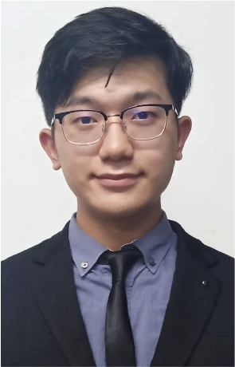 | LOW JUNYI  - Slide editor  - Video editor  - Reflection  - Presenter

 | MUHAMMAD IMRAN HAKIMI BIN MOHD SHUKRI  - Video editor  - Reflection  - Presenter
 | MADINA SURAYA BINTI ZHARIN  - Report editor (Detail description (Problems, Solutions and Team working) and design thinking evidence)  - Reflection  - Presenter
 | NUR SYAMALIA FAIQAH BINTI MOHD KAMAL  - Report editor (Introduction, detailed steps and description, and design thinking evidence)  - Reflection  - Presenter
 | SAKINAH AL’IZZAH BINTI MOHD ASRI  - Report editor (design thinking evidence)  - Prototype  - Reflection  - Presenter

CONCLUSION

In a nutshell, we had experienced and learned how to do design thinking from scratch. All the five steps which are empathy, define, ideate, prototype and test will be implemented in daily activities as it can develop critical thinking skills. Furthermore, we have learned about the system unit which is the most basic feature in starting the computer. We hope that in the future our prototype that has been invented will be developed and become sophisticated to be used by others. Not only that, we hope we can solve a lot of technology problems nowadays and increase the pace of technology growth by applying the concepts of design thinking. Hence, creating chances and improving ourselves to pave the way to become a leader for the technologies advancement and innovation. Our university’s life will become a stepping stone for our bright future and we will never forget and appreciate the guidance from the lectures.

REFERENCE

- Kamau, P. (2010, December 02). Overview of Computer System Unit Parts - TurboFuture Technology. Retrieved November 08, 2020, from https://turbofuture.com/computers/Pcs-system-unit
- System Unit. (n.d.). Retrieved November 08, 2020, from http://computerit4u.weebly.com/system-unit.html
- What is Design Thinking? (n.d.). Retrieved November 08, 2020, from https://www.interaction-design.org/literature/topics/design-thinking

