The Importance and Trending of
IT Project Management

Muhammad Amiruddin¹, Amir Firdaus¹, Tie Sing Hao¹, Nur Hannan¹,
¹ SECJ-Software Engineering, School of Computing, UTM
Skudai, Johor, Malaysia.

Abstract— In this paper, we will concisely state the major points that we gained from the Industrial Talk organized by Technology and Information Systems (SECP1513), School of Computing, UTM which is the importance and trending of IT project management and some relevant IT careers. In this paper, we also conclude some the action or plan that necessary for us to improve our potential in this current industry
Keywords-component; importance, trend, IT project management.

Introduction

The Industrial Talk was organized by Technology and Information Systems (SECP1513), School of Computing, UTM on the 1st of December 2020 from 10:00 A.M until 11.30 A.M. The talk was conducted by Dr Goh Eg Su, Senior Lecturer of School of Computing,UTM and presented by the caliber speaker Mr Mohd Khairul Reeza Ruslan, Head of Project Management Office Commerce Dot Com Sdn Bhd. The talk was held via Cisco Webex application.

Importance of Project Management

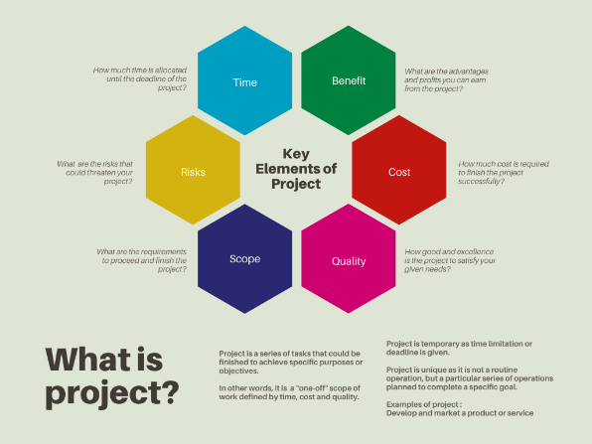

Project management is the application of knowledge, skills, tools and techniques to project activities to meet the project requirements, quality and objectives [1]. According to the Project Management Institute (PMI), organizations that undervalue project management report an average of 50% more of their projects failing outright [2]. The following are the importance of project management to ensure the project stays on track all the way to success [2].

Clear focus and objectives
The main goals and objectives of the project need to be clarified before the project is initiated by breaking up and distributing tasks equally among the team, identifying the potential risk factors to ensure there’s a proper plan for executing on strategic goals.

Realistic project planning
A realistic and not overstated project planning is essential by outlining a project plan that balances those priorities within the constraints of time and budget to ensure proper and achievable expectations are set, like what can be delivered, by when and how much can be cost.

Strategic alignment
Aligning projects with business strategy can be achieved by reviewing or supervising the planning and execution of a project establishes what is being delivered and is right.

Quality control
Project management is dominant to make sure the quality being delivered consistently hit the mark. The failure of project quality can be occurred mostly when the team is working under pressure. Therefore, sufficient time and resources should be allocated for the project.

Reduced costs
Project cost can be reduced using project management by improving efficiency, mitigating risks, and optimizing resources. Also, the productivity of the project can be increased within shorter time.

IT Project Management Trends
Over the years, IT project management is changing in the following aspects due to evolving technologies.
- Gig Economy
A company had to hire freelance workers for a project to minimize the management cost because the workers are needed as long as the project is available. Most of the gig workers are independent workers and temporarily hold their positions for some projects. Hence, gig economy is the prevalence in current industries.
- Big Data
Collecting and analyzing data are vital to understand the customers’ needs for future insights. An accurate decision is made from various data. Wrong decision due to insufficient or inaccurate data can cost the loss of millions of money in a project.
- Change Management
A company had to ensure a project is flexible throughout the years. When they implement an IT system, they have to assure that the users are ready to use it on the launch day, or else it will be a long-term useless system.
- Tools and Solutions
For the purpose of reducing cost and completing a project on time, tools are needed to assist the team in project planning and communication. The current communication tool, particularly online communication is not something new for most people, but everyone has just started to get use into it.
- Automation and Artificial Intelligence (AI)
The major advantage of AI is that it helps to quickly and efficiently assign resources in real-time. From table I, AI can help managers to match people with the projects that suits them. However, AI would not replace the project managers as the system lacks in some aspects.
TABLE I. HUMAN VS. MACHINE PROJECT MANAGEMENT [4]
 | Traditional Project Manager | Robot Project Manager
Staff Evaluation | Long project planning cycles involving budgeting and recruiting | Automated skill matching , and team making
Work Assignment | Planning tools, long term meetings, strategic business alignment | Automated availability detection
Performance Monitoring | Qualitative and quantitative data | Automated monitoring
Sanction Underperformers | Performance management plans and dismissal | Errors and automated warnings
Personal Issues, and Workplace Nuance | Issue identification, work with team member and HR on resolving issues | Errors and automated warnings
- Emotional Intelligence (EQ)
EQ will increase the project quality value. If project managers were unable to control their emotions, they would fail to lead the team. When emotions take over one’s mind, the person cannot view the situation realistically, hence affecting the output of the project.

RELEVANT CAREERS IN IT
Due to the incoming Industrial Revolution 4.0, there has been a spike in job opportunities for IT related jobs. The most notable career is a computer programmer. These programmers are the building blocks for the revolution as they are the ones who code and build new software. The software they build will be used to create new technology for a better future.

Next is web developers. Web developers focuses on designing appearance of a website, its navigation system and the content organization. Web developers are gems for companies bidding to go online as they need websites to further promote their products online. Thus, it creates a huge demand for web developers in the market.

REFLECTIONS
  - Reflection 1. (My goal is to understand better how technology is being successfully created along with the future demands that we will face in this industry.)
  - Reflection 2. (The talk imparted knowledge that soft skills are essential in project management to produce the best product. Improvements that will be made is on maturity and communication skills)
  - Reflection 3. (My action to improve our potential in the industry is preparing myself with a complete knowledge of business strategic planning so that I can cope with future IR demands)
  - Reflection 4. ( I need to prepare my self with good project management skills)

Acknowledgment
We would like to thank our lecturer, Dr Zuraini Binti Ali Shah for presenting us this assignment. We took it as an opportunity to dive in to the career world of IT and learned a plethora of new things, such as trends in IT project management and also the importance of relevant IT careers.

References

- What is Project Management. (n.d.). Retrieved from PMI: https://www.pmi.org/about/learn-about-pmi/what-is-project-management
- Why Is Project Management Important? (n.d.). Retrieved from Lucidchart Blog: https://www.lucidchart.com/blog/why-is-project-management-importantI
- https://utm.webex.com/recordingservice/sites/utm/recording/1f7c1229a78448648c63a11cd72bd8ba/playback
- https://blog.capterra.com/i-project-manager-the-rise-of-artificial-intelligence-in-the-workplace/

