
SEM 1 20202021 : SECTION 08

Technology and Information System

CHAPTER 8: NETWORK AND COMMUNICATION

Group Number : 07

Students Information : SECP1513 Section 08

Name : 1.MUHAMMAD AMIRUDDIN BIN ZULKIFLI(A20EC0208)
2.AMIR FIRDAUS BIN ROSMAN (A20EC0180)
3.TIE SING HAO (A20EC0168)
4.NUR HANNAN BINTI JAMALUDIN (A20EC0222)

Lecturer : DR ZURAINI BINTI ALI SHAH

INTRODUCTION

In today’s world, we constantly find ourselves on the internet for various reasons. This includes meeting with other people, looking up the meaning of words, searching for entertainment and also for work purposes. The importance of the internet has increased rapidly due to the current global pandemic which has prevented people around the globe to meet physically. Hence, they turned their heads to a virtual solution, by doing it online. It is a great option and a reliable one, however there is a flaw to it, it needs a strong internet connection, which would bring us to our groups problem.

PROBLEM

To accommodate the ever increasing need of virtual meetings and online learning, one must have a strong internet connection to ensure a smooth sailing during the activities. This is not the case for a majority of people. Sadly, there is a huge chunk of people who live without a strong internet connection, which in this new norm would prove to be a big burden for them. It limits a lot of things such as work and school. There is an array of causes that contributed to these problems such as lack of access points, geographical obstacles and also lack of providers. This problem is slowly turning out to be a big burden as it would inhibit a lot of things such as work and classes, thus impacting a lot of people in the process.

SOLUTION

After a few brainstorming sessions, our team has come up with a solution called Ytender. It is a prototype that carries our vision to help enhance internet connections to cope with the new norm. We focused to make our prototype suitable for interior uses in small places such as between rooms in houses for starters. In the future, we would continue to improve it for a bigger scope.

EMPATHY

To find ideas for the problems, we had utilized the current pandemic situation and online distance learning in search for problems. We have looked at the possible problems caused by this new norm by asking people and found out that a lot of them have encountered some sort of problems with shaky and unstable internet connections. One of our main method is by online interview through video conferencing as seen below,

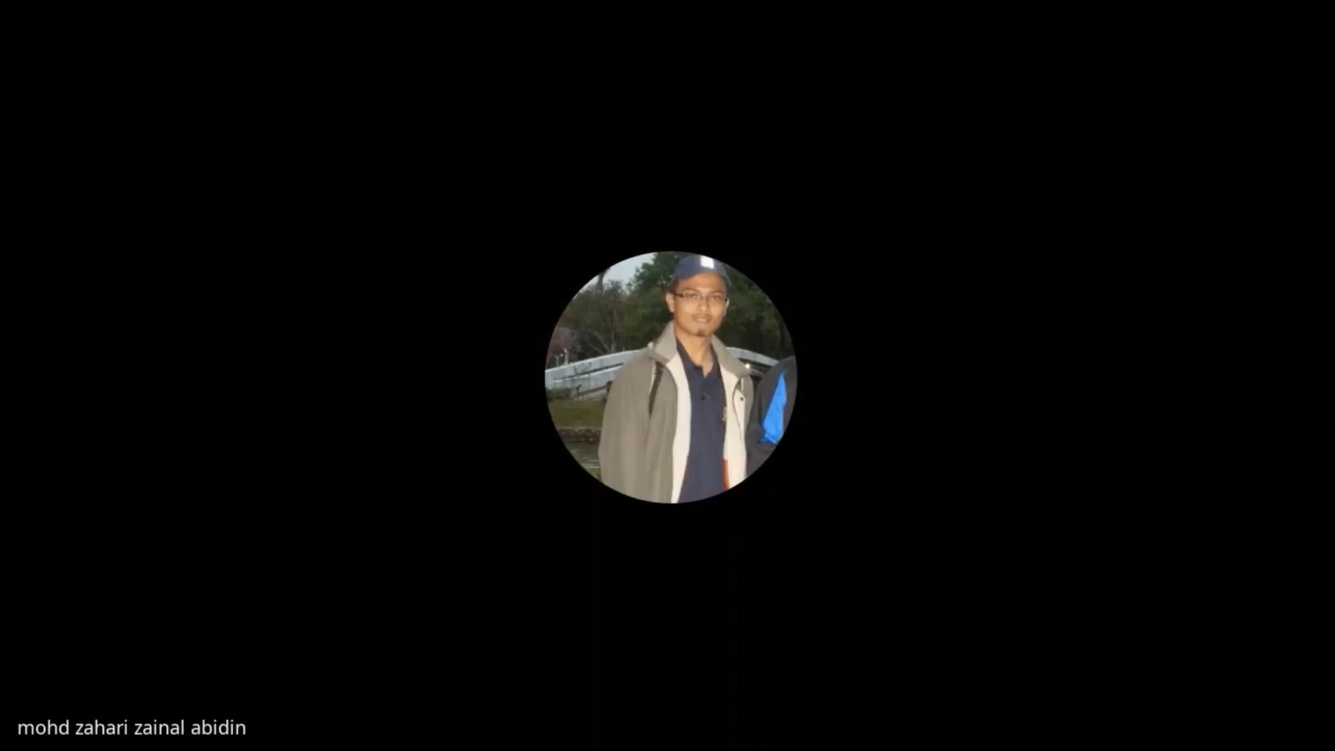

As you could see in the photo, we had an interview with a staff from Universiti Teknologi Malaysia (UTM). He had touched on a plethora of problems, but what stood up the most are the internet connection problems that really intrigued us. As stated in the problem section, unstable and weak internet connection is like an inhibitor, it would inhibit us from carrying on our online distance learning smoothly since some students might miss out on certain parts of the lecture.
Another method we did is by conducting a survey on the UTM students. From the survey, we had observed that 69% of students have experienced some sort of internet problem such as unstable internet connections that has disrupted the lecture for them. We could conclude that this is a problem that has affected a lot of students and staff here. Thus, we could say that this is slowly becoming a very concerning problem.

DEFINE

To define our problem,we have to look at the causes of the problems and also define the scope of the problem. Our problem is unstable internet connections which have a lot of potential causes to explore. For example, there are too many obstacles in its way and also access points which are far apart from each other. These factors have caused a weak internet connection due to disruption in sending the signals which prevents or slows down the process of data transfer between access points thus our goal is to overcome such hurdles.

For the scope of our problem, since we’re focusing our solution for students and lecturers, we have defined our scope for interior use such as houses and offices. As stated in solution, we would consider making more improvements in the future to accommodate a bigger scope.

IDEATE

To solve this problem, we had an online video conferencing through Google Meet to discuss. We had to brainstorm a lot before coming up with our solution. The following is a picture from the video conference,

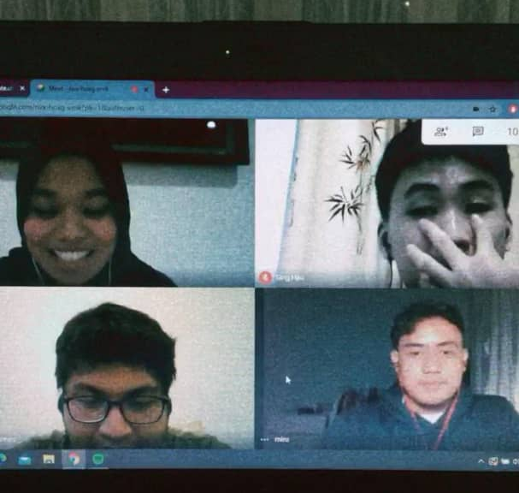

In the meeting, we discussed the materials needed for the prototype, steps to make the prototype and also on how to test the prototype. Then, we divided our works accordingly before starting to work on it.

PROTOTYPE

For the prototype, we’re short on supplies, thus we decided to make use of the things we have around us. For the mechanism of the prototype, the prototype will receive a signal from the main router. The amplifier in the prototype would be used to amplify the signals by increasing the frequency of signals so that the signals would still be sufficient enough when it reaches an access point. Then, the signals would be transmitted to the access points or devices through the transmitter. The cycle continues until someone turns the prototype off or someone removes it.

After spending a lot of time on the prototype, we finished it and documented it for display. The prototype is as below,

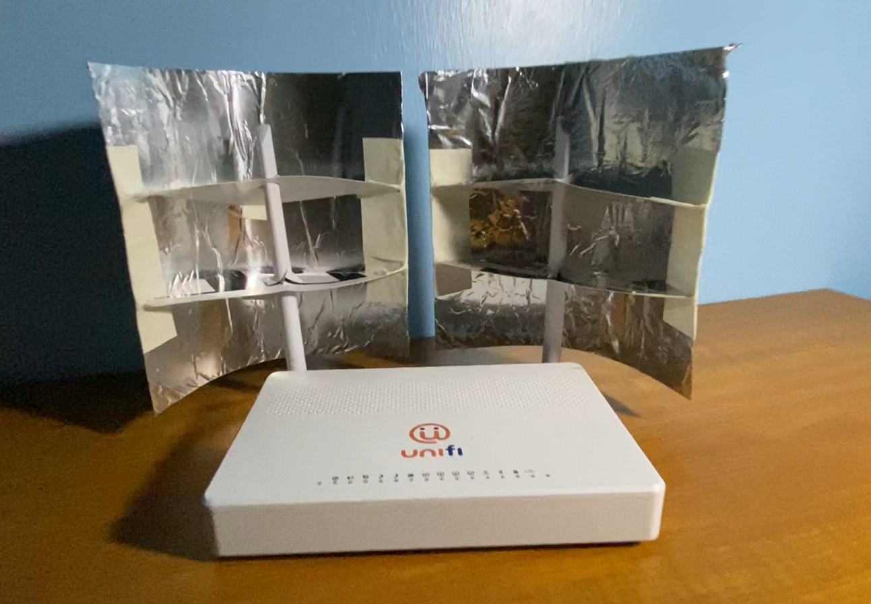

TESTING

We tested this Ytender on a 5 GHz frequency Unifi router using the Wifi Analyzer app for Android. We recorded the signal strength in decibel-milliwatts (dBm) and the distance at which the signal dropped below -80 dBm and became unusable from outside the house. The extenders were pointed out a window where in the testing direction.

Without Ytender | With Ytender
Standing about 10 feet away in the same room, we recorded -36 dBm.  The signal dropped below -80 dBm at a distance of approximately 120 feet | Ytender boosted signal strength to  -30 dBm.  The wifi range rose to 150 feet,  30 feet more than no extender at all.

REFLECTION

Muhammad Amiruddin Bin Zulkifli (Leader)

As a leader of this group, I would gladly emphasize that our goal is to help students and lecturers to combat problems related to internet connections. We have envisioned a scenario where students and lecturers are able to conduct an online class smoothly without any disruptions, hence helping the students out academically.
For these few weeks I realized that communication is the key for everything. I’m glad that all of my team members are easy to communicate with and they are always being considerate and prioritized assignment tasks in the first place. For the subsequent future, I hope that I can act and respond faster so that I would not drag the team because of my lack of prompt acts.

Nur Hannan Binti Jamaludin

As of the design thinking concept, the empathy part really helped us in searching for a problem. On top of that, we had the opportunity to make use of video conference apps such as Cisco webex app for the interview. The app was very convenient, easy to use and had high quality video. We would always consider it for future uses. Another concept that really helped us in this project is the define part. It made us define the problem thoroughly and created a visual picture of the problem, hence we could make a prototype that would answer all of the problems.

Amir Firdaus Bin Rosman

For future improvements, we had emphasized that we planned on making it for a bigger scope. For that, we would need to strengthen the amplifier so that it could amplify the signal to be bigger since the signal would have to travel a greater distance. Then we would put our focus on the transmitters too, since a weak transmitter would be a loophole in the prototype.

Tie Sing Hao

We have divided our work equally among our group mates. For example, our leader Amiruddin was chosen to create and edit the video for the prototype as he has the best editing skills among us. I was selected as the presenter of our group as I had the best soft skills out of the 4. I got help from Hannan who wrote the script for my presentation. Lastly, Amir wrote this 4-page report with help from the other 3. Our members' dedication towards this project has helped us achieve our goal.

TASK ASSIGNMENT

Muhammad Amiruddin Bin Zulkifli (Leader)
- Editing Design Thinking Video and Chapter Presentation Video
- Making slides animation for chapter presentation
- Create the prototype
- Handle meeting

Nur Hannan binti Jamaludin
- Prepared some points in the chapter presentation
- Interview UTM’s network administrator
- Create the mind map

Amir Firdaus Bin Rosman

- Prepared the group report
- Analysed the criterias in report
- Created the scripts for Chapter Presentation Video

Tie Sing Hao
- Presented the design thinking project
- Created slides for the chapter presentation

VIDEO LINKS:
Design Thinking: https://youtu.be/gdVJ0NNQHZU
Chapter Presentation: https://youtu.be/-rjgaxbceAo

