

SEM 1 20202021 : SECTION 08

Technology and Information System

Course Chapter Assignment
(Presentation)

Chapter 8

NETWORK AND COMMUNICATION

Group Num# : 07

Students Information : SECP1513 Section 08

Name : 1.MUHAMMAD AMIRUDDIN BIN ZULKIFLI(A20EC0208)
2.AMIR FIRDAUS BIN ROSMAN (A20EC0180)
3.TIE SING HAO (A20EC0168)
4.NUR HANNAN BINTI JAMALUDIN (A20EC0222)

Lecturer : DR ZURAINI BINTI ALI SHAH

Mind map
Summarize your group chapter
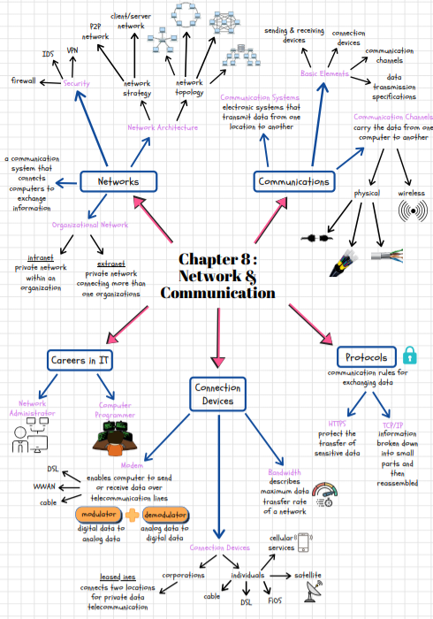

Video presentation URL

https://youtu.be/-rjgaxbceAo

