
SEM 1 20202021 : SECTION 08

Technology and Information System

ASSIGNMENT 3: STEP BY STEP PC ASSEMBLY

Group Number : 07
Students Information : SECP1513 Section 08
Name : 1.MUHAMMAD AMIRUDDIN BIN ZULKIFLI(A20EC0208)
2.AMIR FIRDAUS BIN ROSMAN (A20EC0180)
3.TIE SING HAO (A20EC0168)
4.NUR HANNAN BINTI JAMALUDIN (A20EC0222)
Lecturer : DR ZURAINI BINTI ALI SHAH

Part A
- Screwdrivers
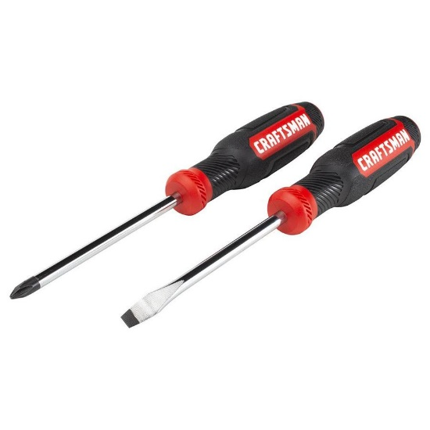
The screwdrivers have two types which are Philips screwdrivers for Philips-head screws and flat screwdrivers for flat-head screws. The screwdrivers are used to tighten the screws on the components. They are important to make sure the components are held securely in place.

- Needle-nose plier
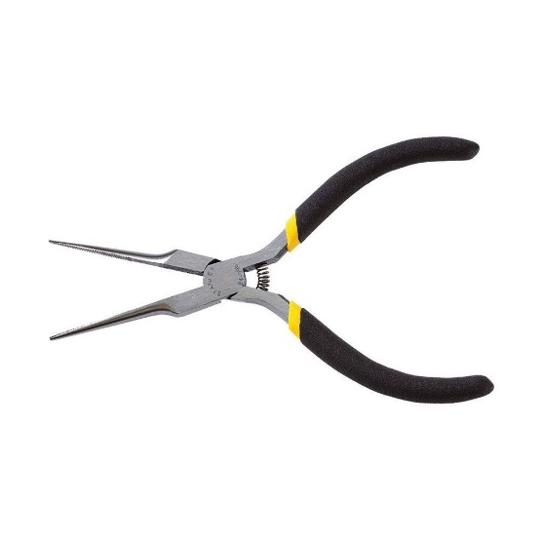
Plier is used for loosening up bolts that are too tight, picking up small screws that may have dropped within the hard-to-reach places and removing motherboard standoffs. It is an important tool because it provides better grip and is designed to fit into the tightest and most cramped spaces, which cannot be reached otherwise.

- Anti-static wrist strap
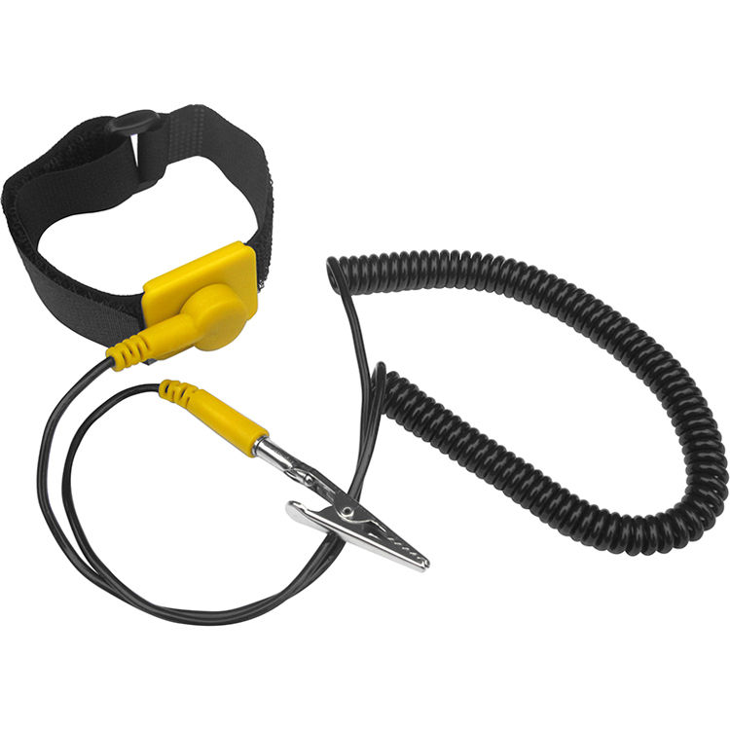
Anti-static wrist strap is worn on the wrist which connects to an electric socket. If any electrical charge builds up between the user and the hardware components, the charge will be safely dissipated through to the socket. The importance is to avoid a spark that can potentially cause damage to the PC parts.

- Zip ties
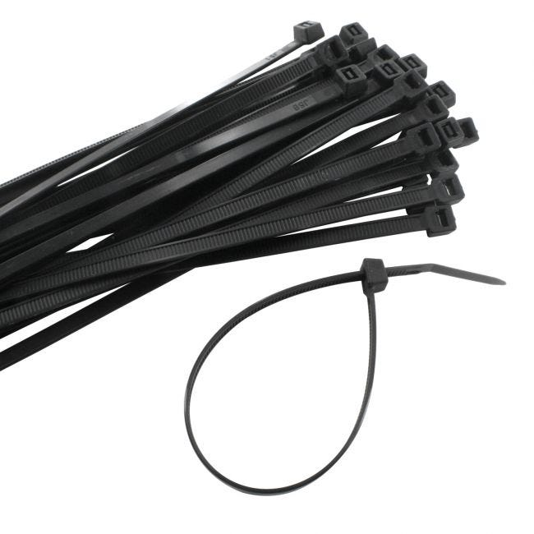
The zip ties are used to tie up any loose cables lying around in the case. They are important not only to make the finished build looks neat, but also to provide better airflow within the case.

- Headlamp
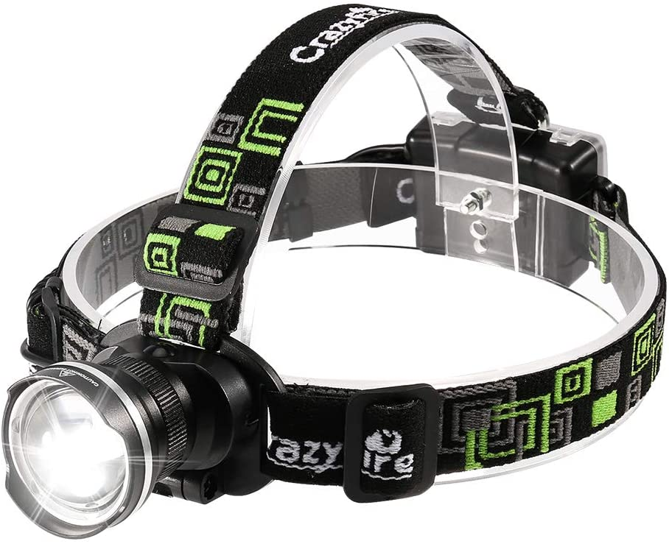
Extra light might be needed in PC assemble as some components or the PC case may block the existing light. With the headlamp, we can see clearly what we are working on. Thus, the importance of the headlamp rather than other flashlights is that it frees up both of our hands to allow us to handle the components properly.

PARTB
1.0
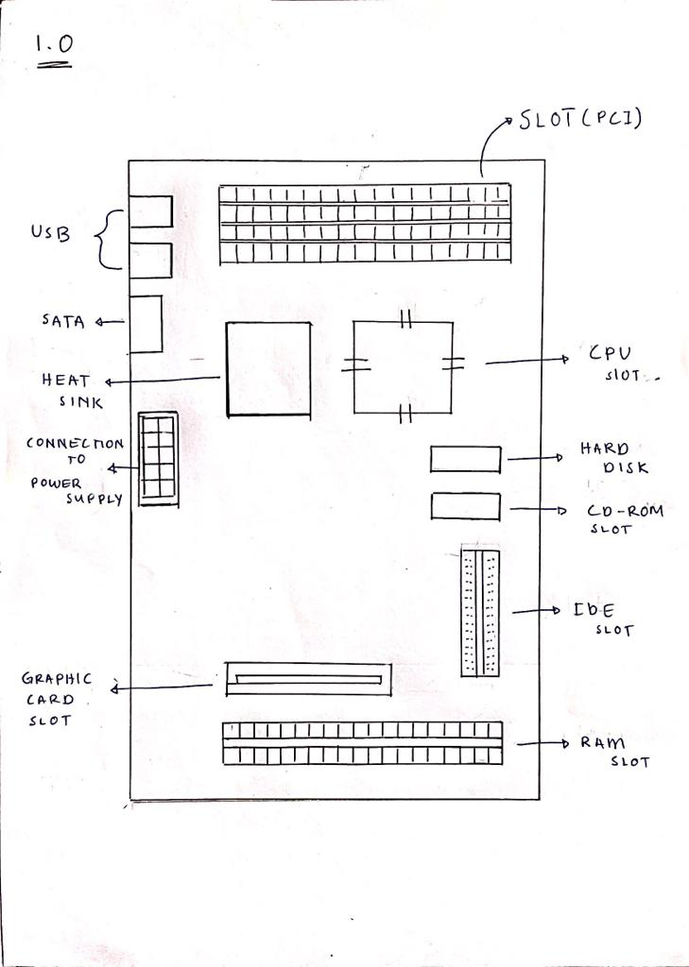

2.0
1. CPU/PROCESSOR

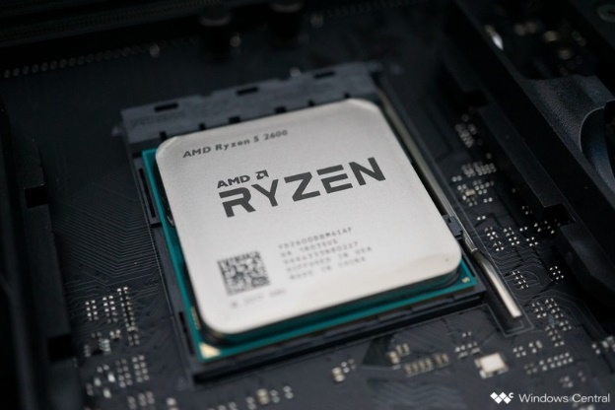

-Logic circuitry that responds do and processes the basic instructions that drive a computer.
-Used to fetch , decode and execute and write back.
CPU perform basic arithmetic , logic, controlling and input/output operation specified by instruction in the program.
Example: AMD RYZEN 9 5950X

2. GRAPHIC CARD

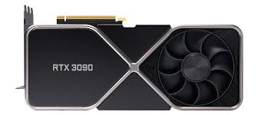

- Responsible for rendering an image to your monitor. It does this by converting data into a signal that your monitor can understand.
-The better your Graphic Card, the better and smoother an image can be produced.
Example: Nvidia GeForce RTX3090

3. HEAT SINK
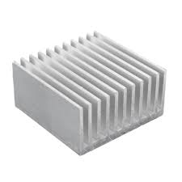

- A component that increase the heat flow away from a device.
Example: Jetson Nano

4. CD-ROM

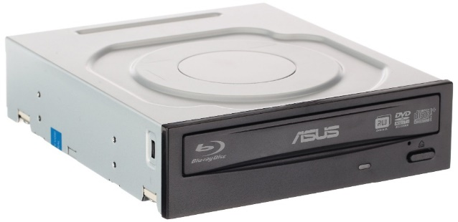

- Optical disk that contains audio or software data whose a memory read-only.
EXAMPLE: CDRom Drive

5. USB CABLE
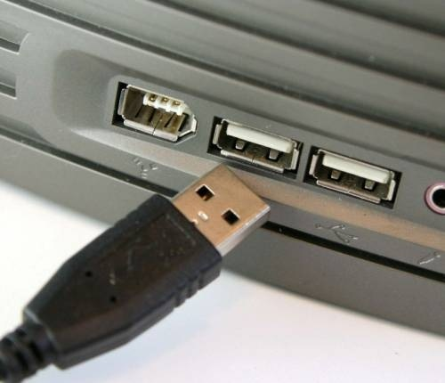

-Used to connect computers to peripheral devices.
Example: USB 2.0 Micro Type B Jack

6. RAM
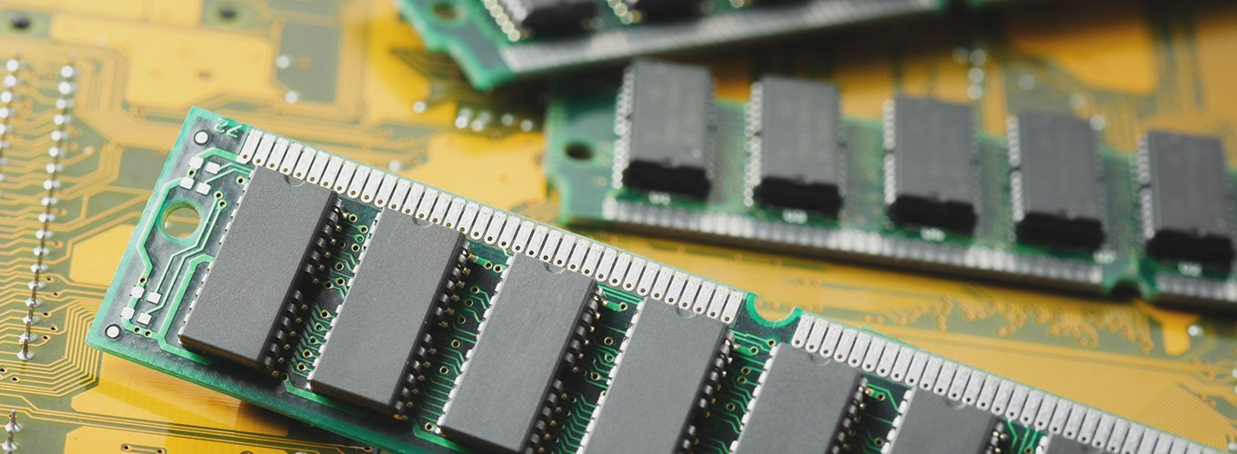
-RAM allows you to access multiple programs at once with speed and efficiency.
-RAM is your computer’s short-term memory. In contrast, a computer’s hard disk or SDD is its long-term memory, where things are stored more or less permanently.
Example: Corsair Vengeance RGB Pro LED 16GB 3,200MH

7. SATA Cables
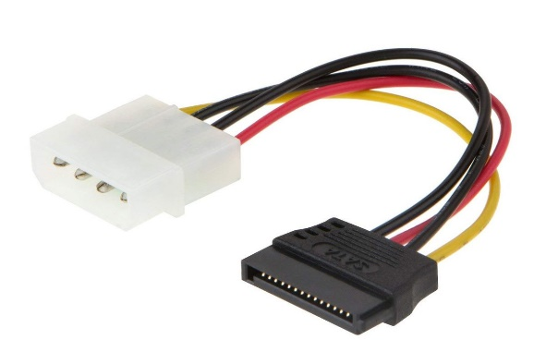
- Used to connect devices in computer cable assembles such as storage devices like Hard drives , Optical drives and Solid State memory drives.
Example: Star Tech 300mm SATA Cable

8. POWER SUPPLY
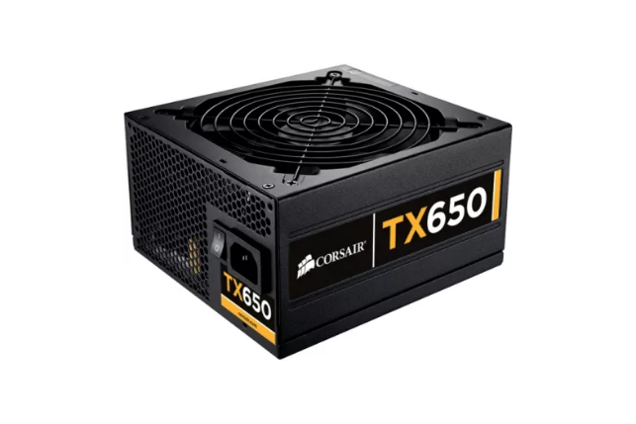
-Used to:
- Change Voltage
- Convert power
- Regulate power
Example: Cooler Master MasterWatt 750W

9. HARD DISK
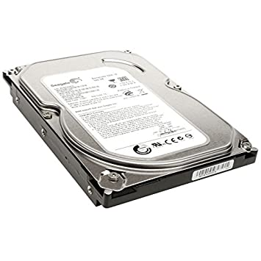
- Stores and provides relatively quick access to large amounts of data on an electromagnetically charged surface or set surface.
Examples: Seagate FireCuda (2TB)

10. IDE CABLE
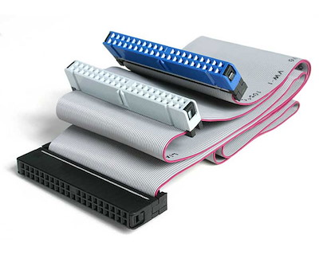
- Integrated Drive Electronic (IDE) is a standard type of connection for storage devices in a computers.
- Used to connect some hard drives and optical drives to each other and to the motherboard.
Example: 34-pin and 40-pin IDE cable

11. SLOT
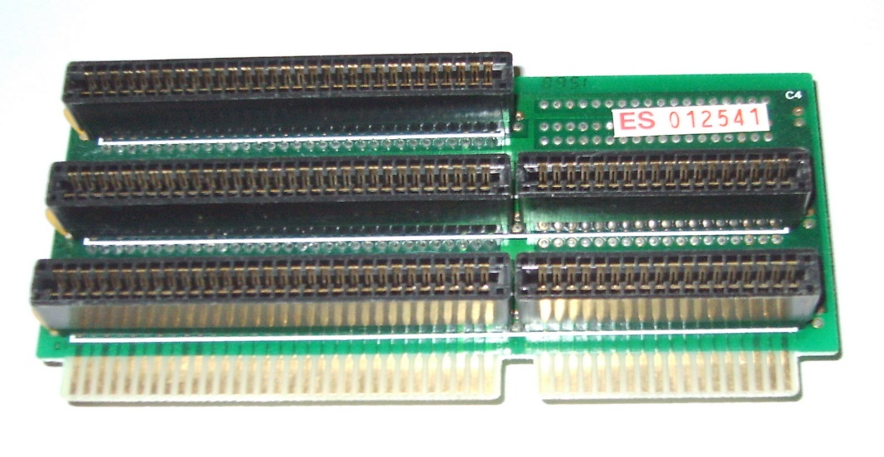
-Used to add adapters to the motherboard. It also used for a components replacement.
Example: -
- RAM Slot
- They often come packaged with multiple strips located in RAM slots on the motherboard that are easily removable and replaceable.
- PCI Slot
- PCI slots are used for a variety of devices: modems, network cards, television tuners, radio tuners, video cards and sound cards, among others. Most computers today have several of these cards already built in. For computers that do not, these expansion devices provide additional functionality to a computer, making it possible for essential functions in a business such as wireless Internet connectivity.
- CPU slot
- The CPU slot (also known as a CPU socket) is where the processor is stored on a computer's motherboard

PART C

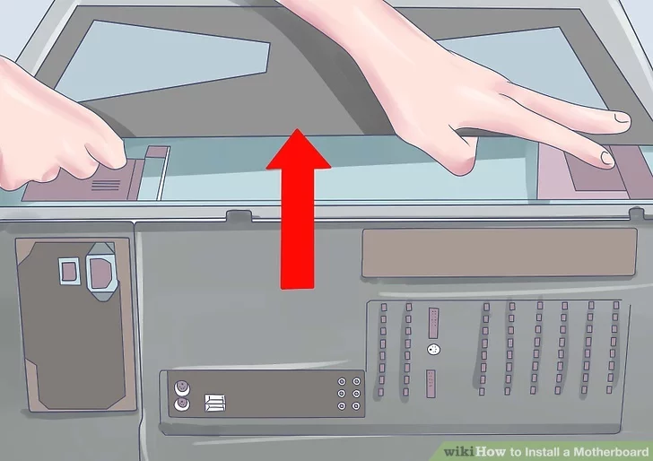
Step 1: Remove Side Panels on Case

To start, simply remove the side panels from the case using thumb screws.

- Keep any screws which were supplied with the case separate and take note of the different types. Most cases will come with a few different packets of screws and they may have different sizes or threads, so make sure to match them up with the correct mounting locations as best as possible.

- If in doubt, refer to the documentation which came with your computer case.

Step 2: Mount Motherboard
Before mounting the motherboard, make sure all the nuts in place fits with the new board. This is to avoid any complications further on. Put an extra emphasis on it to make sure it will not interfere with the solder points on the board.
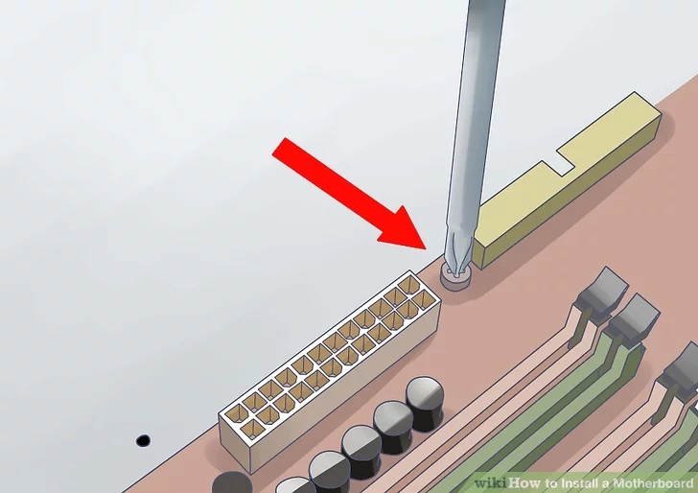

After that, place the motherboard in its place and screw the screws to hold the motherboard in place. If your motherboard tray does not come out of the case, you may need to gently force the motherboard against the I/O panel on the back of the case to fit it. Start securing the motherboard with screws.

- Don’t overtighten the screws. Make sure it is firm but not too tight. Do not use an electric screwdriver.
- Holes that don’t have metal on them will need cardboard washers between the screw and the motherboard. It is best to avoid using non-metallic holes at all.
Step 3: Mount Processor (CPU) and Install CPU cooler

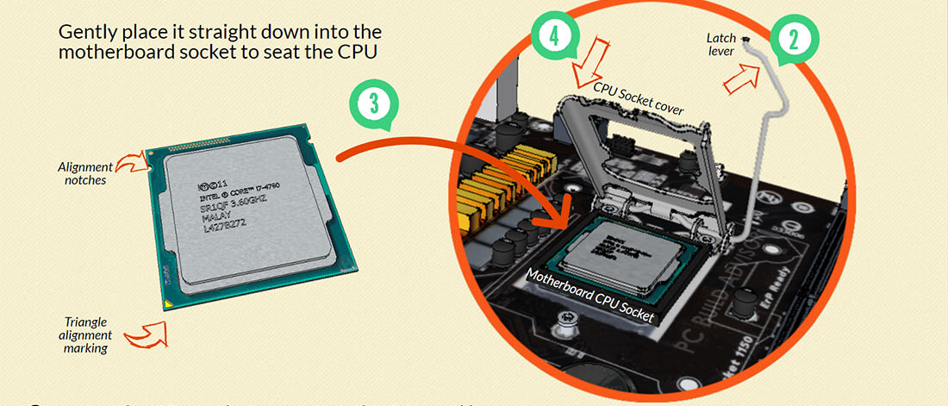
Before installing the new processor, make sure to ground yourself to discharge any static forces on you that may burn the processor.

- Locate the CPU socket holder on the motherboard
- Lift up the latch lever to release and hinge open the CPU socket cover.
- Holding the CPU by its sides, line up any alignment notches or the triangle marked on the corner of the CPU to the triangle marked on the motherboard. Gently place it straight down into the motherboard socket to seat the CPU
- Lower the CPU socket cover over the CPU and lower the latch lever closed again to secure the CPU socket holder closed
Don’t apply force to seat the CPU. Avoid touching or pressing down on the back of the CPU with your fingers, as any residue from your hands can destroy the heat transfer surface for the cooler which will be mounted next. Another important thing to note is to remove any plastic packaging around the CPU socket cover before installing your CPU and cooler.

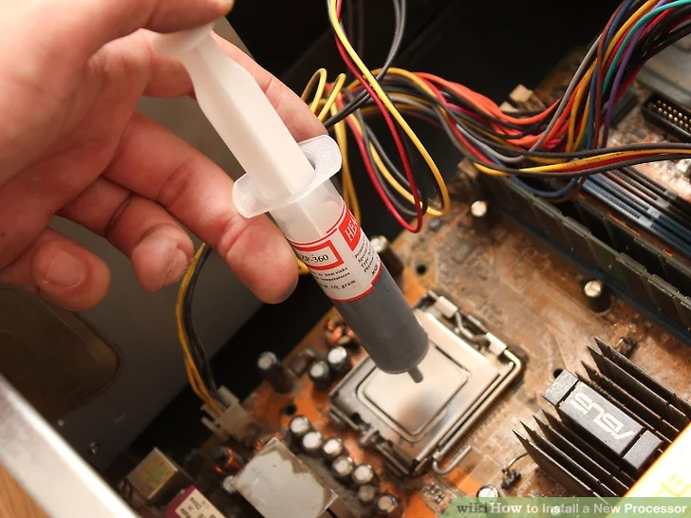

Before installing the CPU cooler, you'll want to apply a thin layer of thermal paste to the top of the CPU. This helps conduct heat from the processor to the CPU cooler by removing any imperfections on the contact surfaces.

Make sure the CPU cooler is installed directly to the back of the CPU metal housing instead of installation at where the plastic packaging on the CPU socket cover. Don’t make this expensive mistake, as this will cause overheating and damage to your CPU.
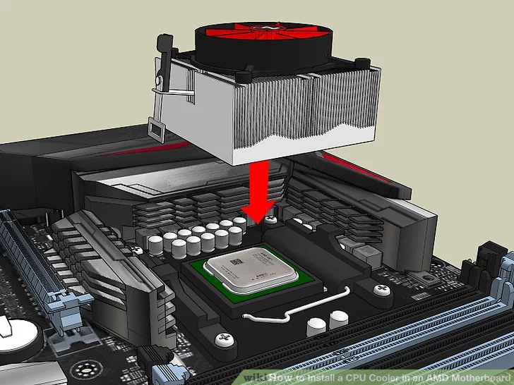

Seat CPU heatsink/cooler and fix in position

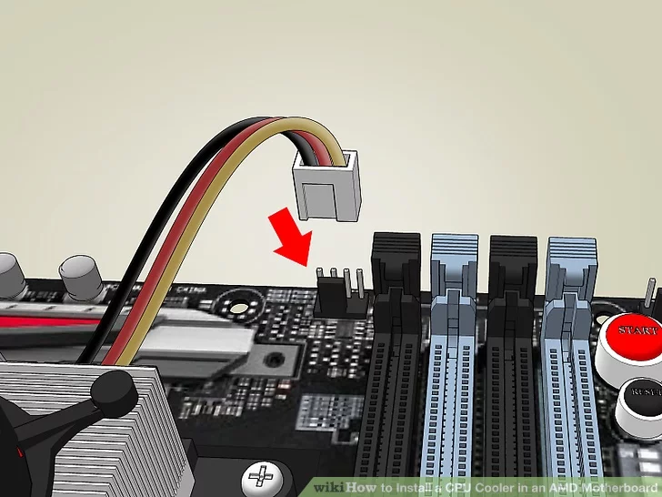

Plug the power cable attached to the cooler fan into the motherboard connector.

Step 4: Install Power Supply
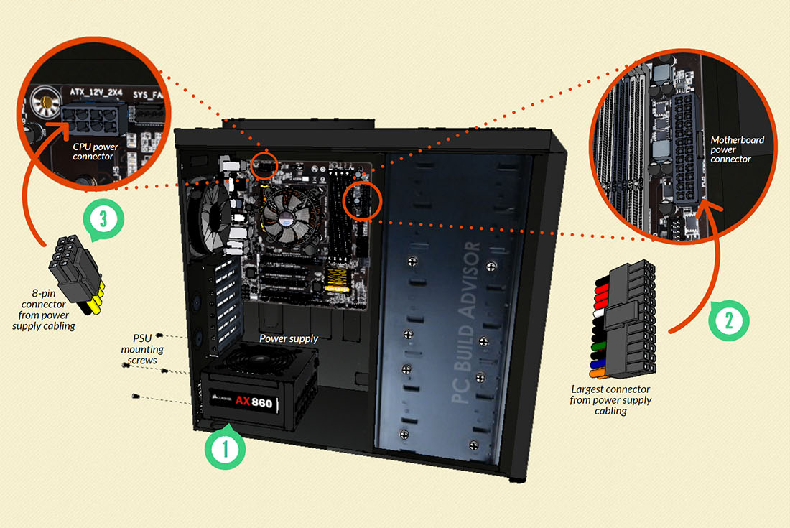

- Mount the power supply and fasten with screws to the case mounting points
- Plug the largest cabling connector from the power supply cabling into the motherboard power connector.
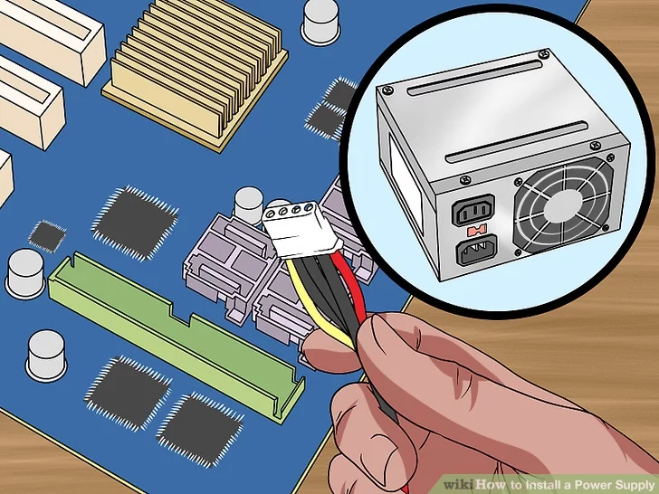
- Plug the 8-pin cabling connector from the power supply cabling into the CPU power connector
Most power supplies will have a whole bunch of cabling and connectors coming out of the rear. Others may have sockets for cables to be plugged in. We find it easiest to connect the power cabling for each hardware component to the power supply as you assemble the PC (rather than waiting until all the parts are assembled and plugging in all power cables at once); we do it this way so that you won’t accidentally forget to connect power to any device.

Step 5: Mount Memory
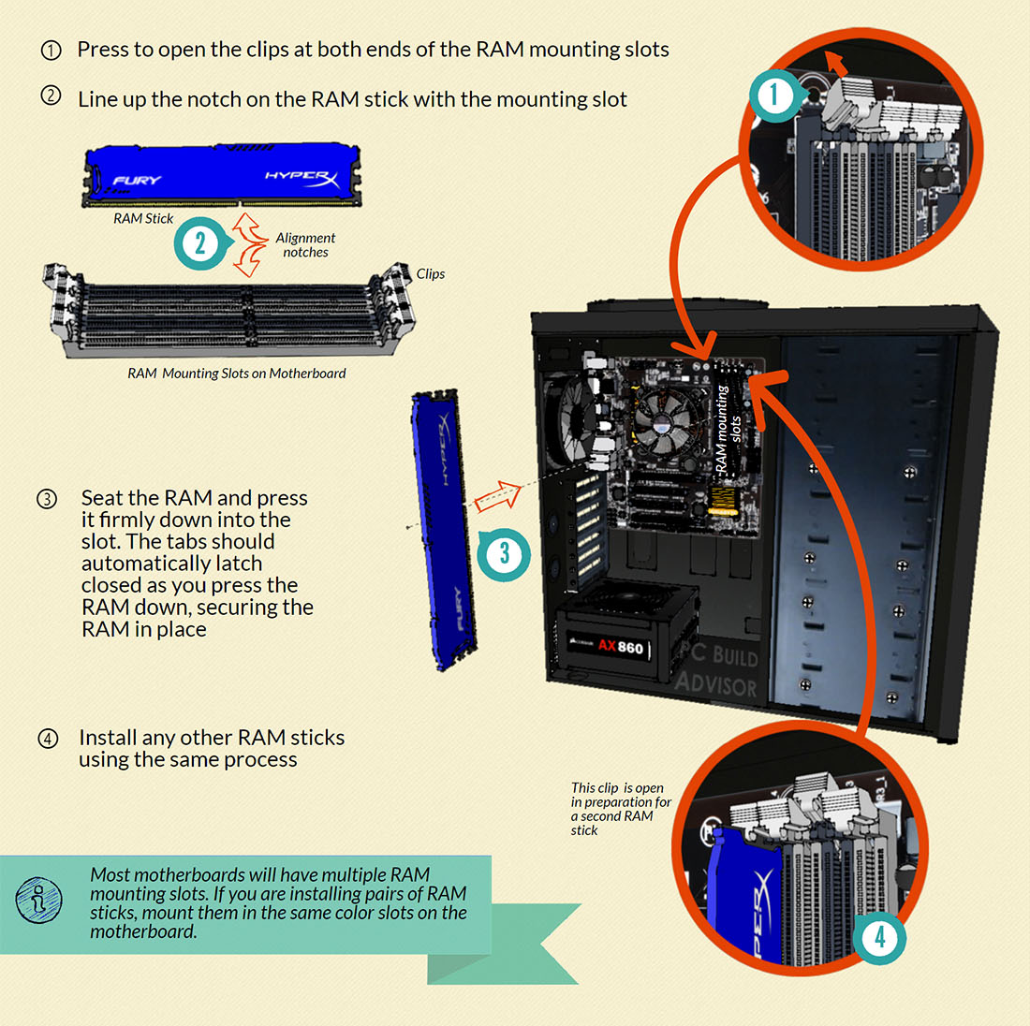

1. Press to open the clips at both ends of the RAM mounting slots

2. Line up the notch on the RAM stick with the mounting slot

3. Seat the RAM and press it firmly down into the slot. The tabs should automatically latch
closed as you press the RAM down, securing the RAM in place
4. Install any other RAM sticks using the same process

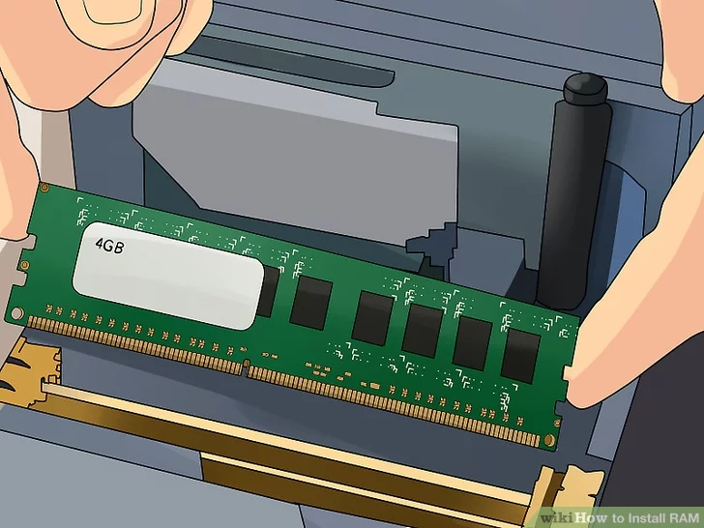

When pressing the RAM into the motherboard mounting slots, you’ll often have to use a fair amount of force to ensure it is seated properly. Be careful not to flex the motherboard too much when doing this – it can help to support the edge of the board if necessary with your spare hand to avoid bending the motherboard too much as you press down on the back of the RAM stick.

Step 6: Install Graphics Card

If you have decided to use the on-board graphics of your motherboard instead of installing a dedicated graphics card, you can skip this section.
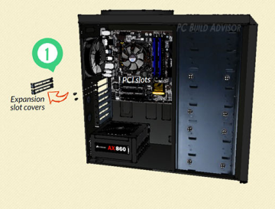

1. Remove the expansion slot covers from the rear of your case where the graphics card will sit

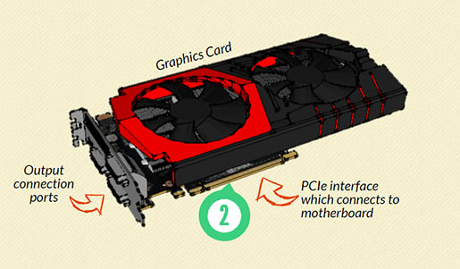
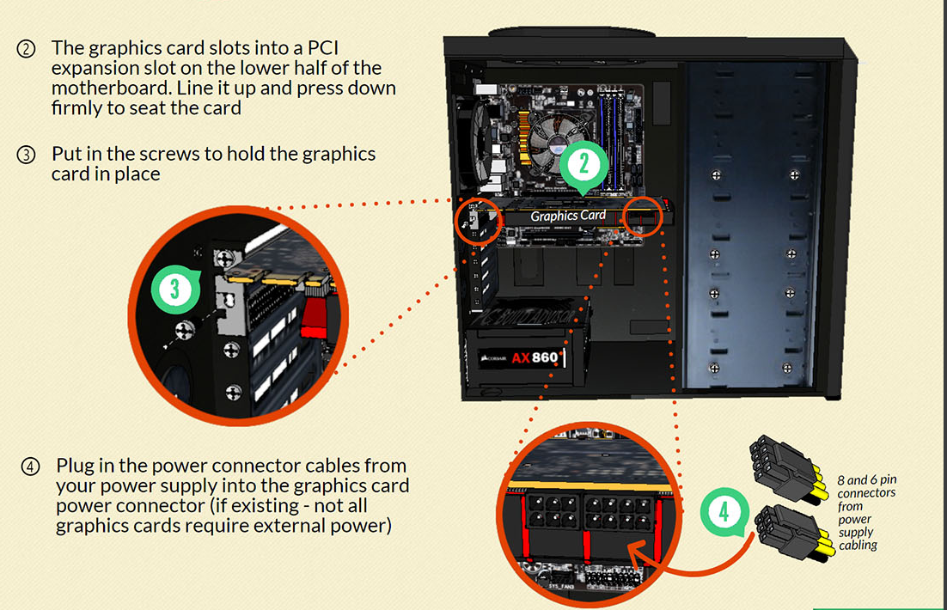

2. The graphics card slots into a PCI expansion slot on the lower half of the motherboard. Line it up and press down firmly to seat the card.

3. Put in the screws to hold the graphics card in place

4.Plug in the power connector cables from your power supply into the graphics card power connector (if existing – not all graphics cards required external power)

When you plug in your display monitor, always use the output ports of the graphics card first (if you have one installed) and not the output ports of the motherboard itself. This ensures you are actually using your graphics card.

Step 7: Mount Storage Devices
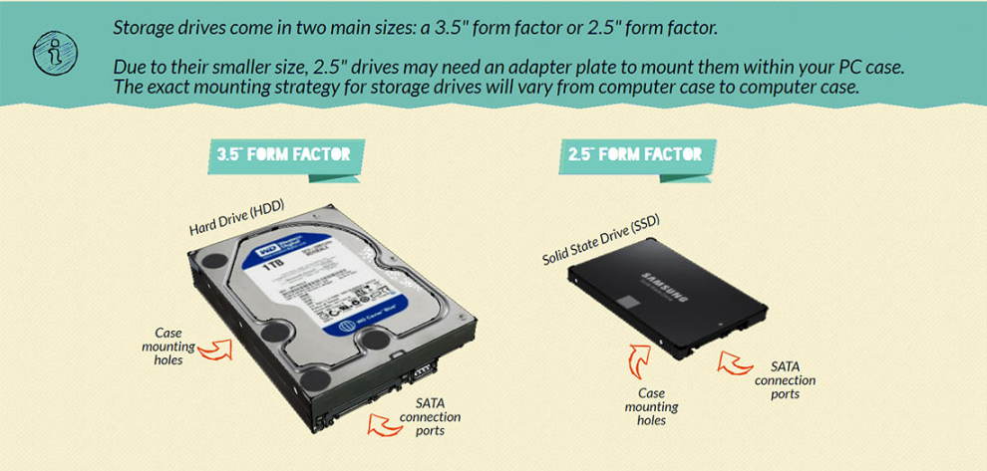

Sometimes, you may need to refer to the manual for your case in order to fit drives into the drive bays.
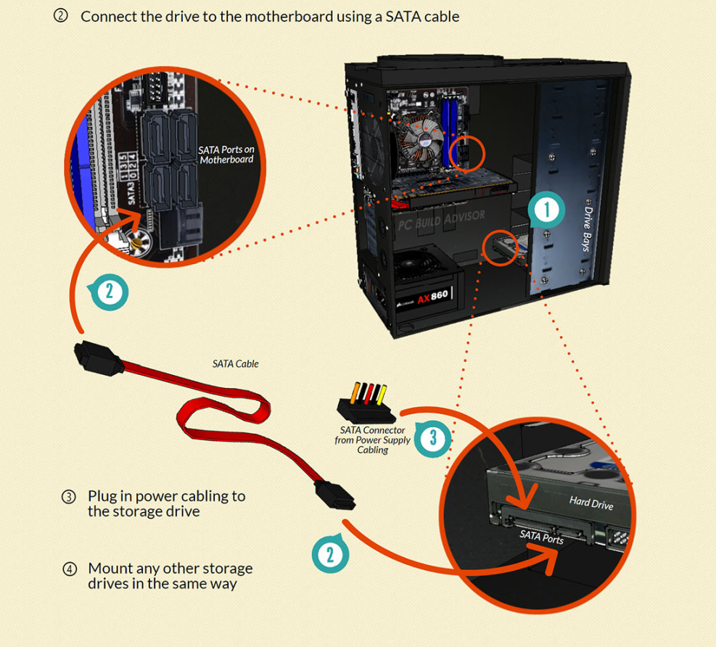

Connect a SATA cable / IDE cable to the hard disk and the other end to the SATA port / IDE port on the motherboard. Then, connect the hard disk to the power supply.

Step 8: Mount Optical Drive
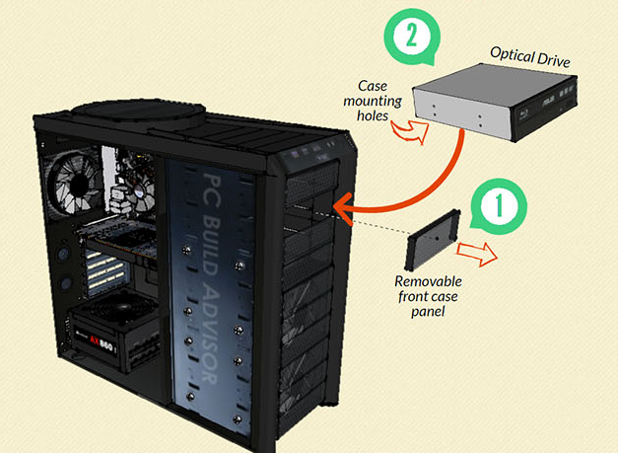

Remove any front panels from the computer case where the optical drive will sit. Mount optical drive in the case by fixing with screws through the case frame into the case mounting holes located on the optical drive.

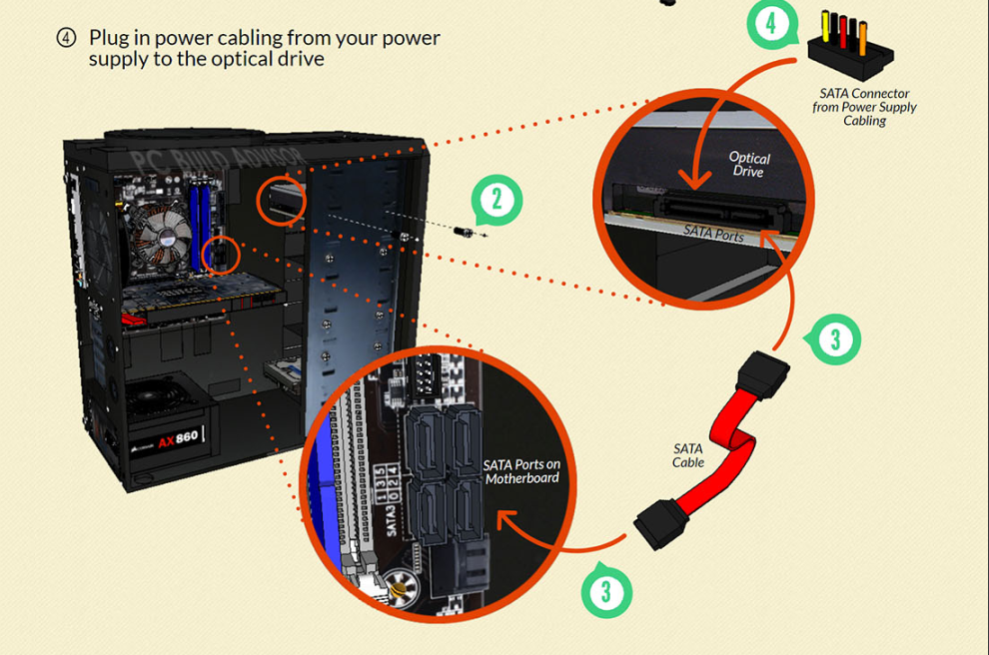

Then, like the hard disk, connect the CD-ROM with a SATA cable / IDE cable on one end and the other end to the SATA port / IDE port on the motherboard.Then, connect the CD-ROM to the power supply.

Just like external storage drives that we connected in Step 7, optical drives also require two connections: power and data. Again, the data connection cable is a SATA cable which connects the optical drive to the motherboard. The power connection cable supplies power to the drive, and plugs into the drive from the power supply

Step 9: Connect case fans and front panel connectors

Some computer cases come with case fans already installed/mounted within the case. However, we will still need to plug the power cables of these fans into a header port located on your motherboard. This supplies the fan with power which is required for it to operate.

In other cases, we will need to mount our own case fan, or we may even choose to run our computer without any case fans at all.

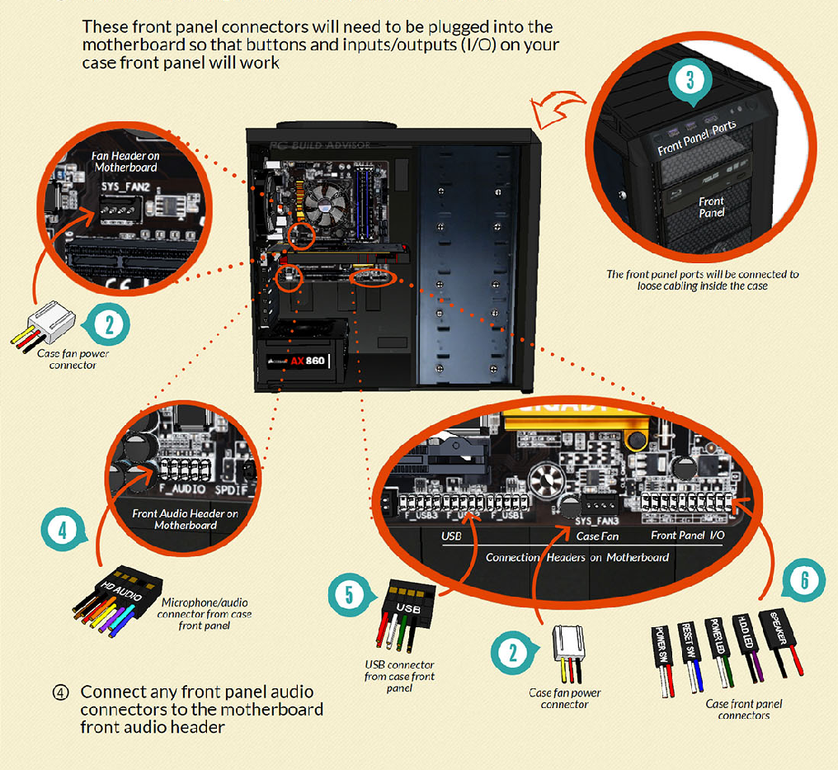
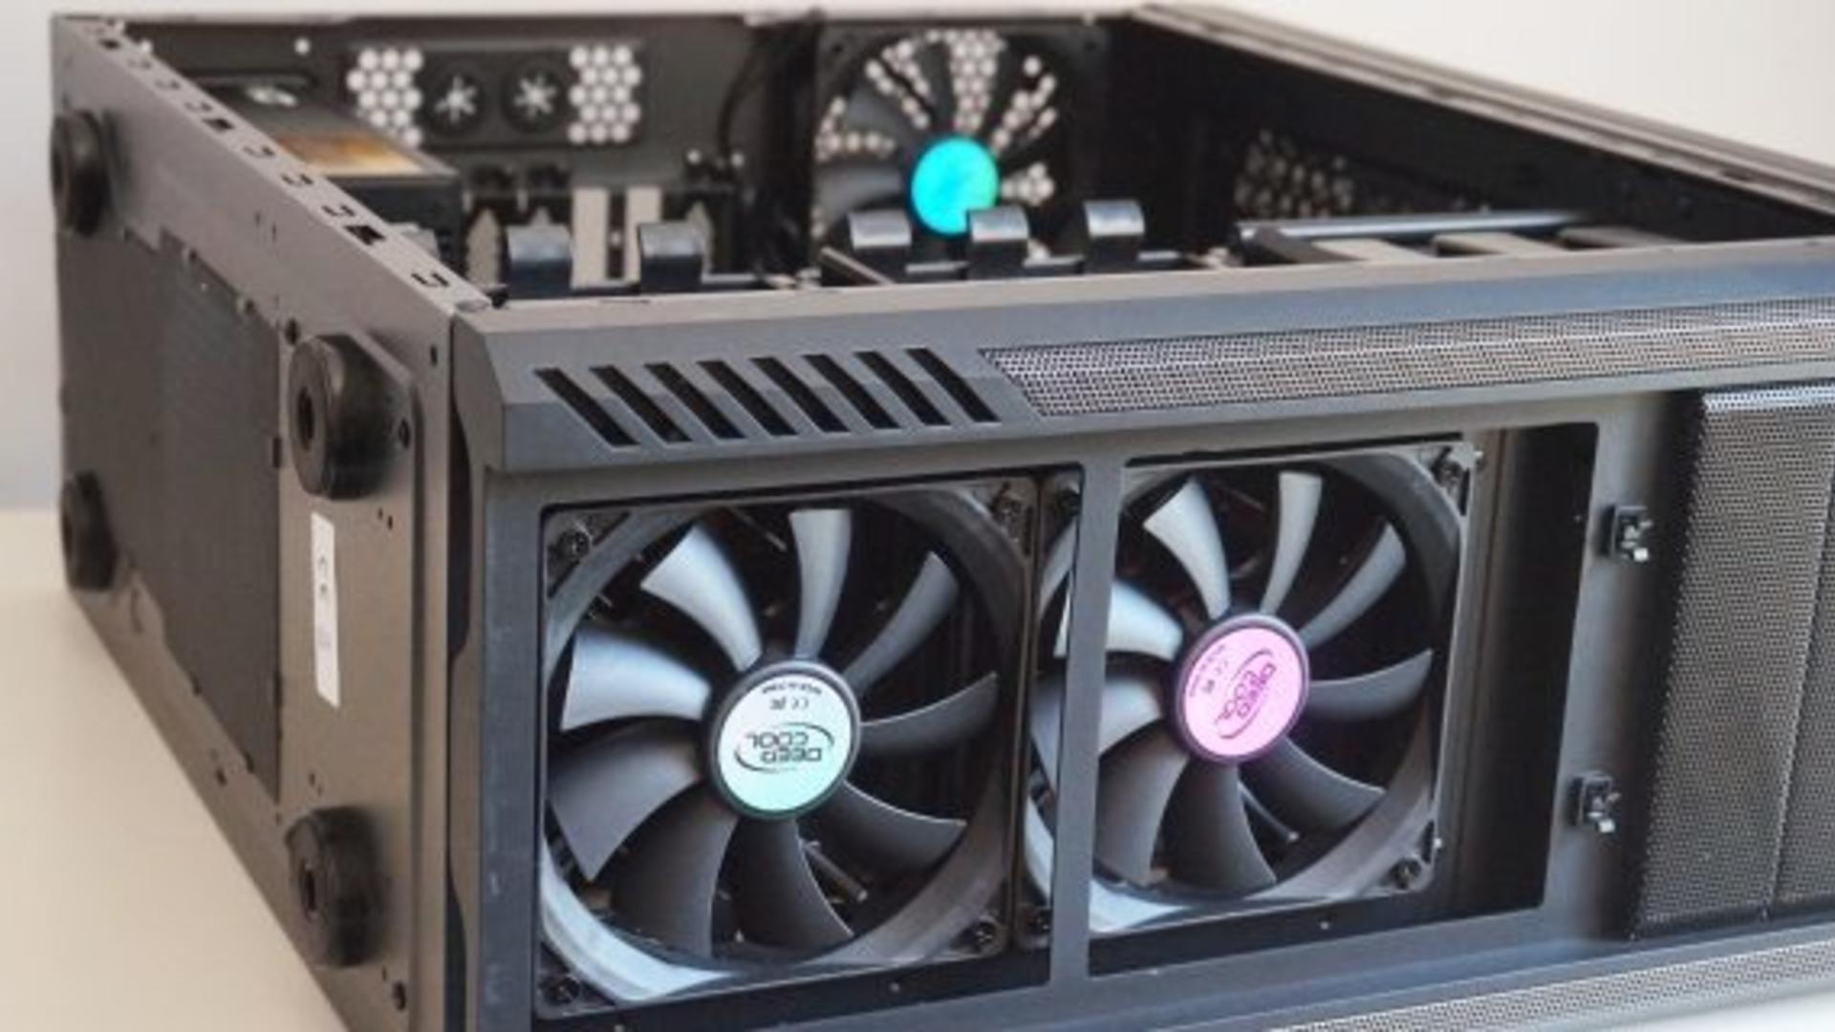

1. Mount any case fans within your case as required using the supplied screws or clips

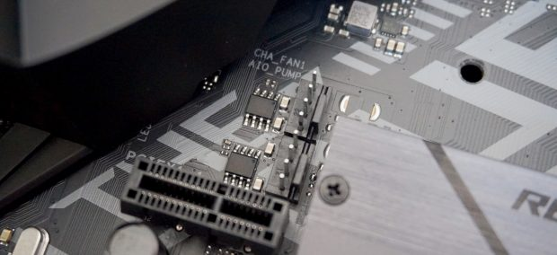

2. Connect any case fan power connectors to the multiple fan headers located at various places on the motherboard.

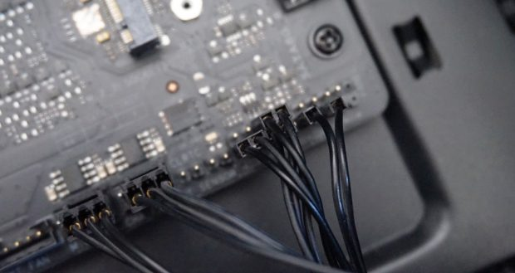
3. Identify the cabling from the front panel ports of your PC. These front panel connectors will need to be plugged into the motherboard so that buttons and inputs/outputs (I/O) on your case front panel will work.
4. Connect any front panel audio connectors to the the motherboard front audio header
5.Connect any front panel USB connectors or USB cables to the motherboard USB headers
6.Connect the front panel case connectors to the motherboard front panel I/O headers
Different computer cases may have slightly different I/O connections, but generally both the connectors and motherboard headers are labelled, so use these to your advantage when working out where to plug each cabling connector! If in doubt, refer to the documentation which came with your motherboard, which should tell you exactly where to connect these items.

Step 10: Close Case and Connect Peripherals
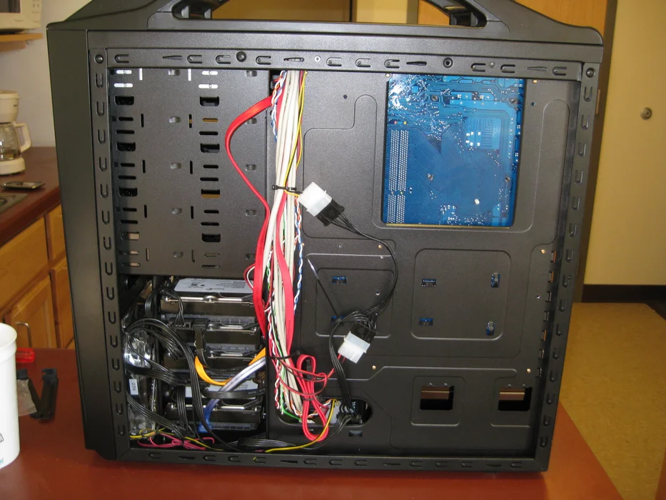

Before closing up the case completely, ‘cable management’ can be done, which means tucking away, rerouting, or removing and securing any loose slack from cables which would otherwise be hanging around loose in your case. Cables are recommended to be tied neatly to secure the cables away from the moving parts such as fans.

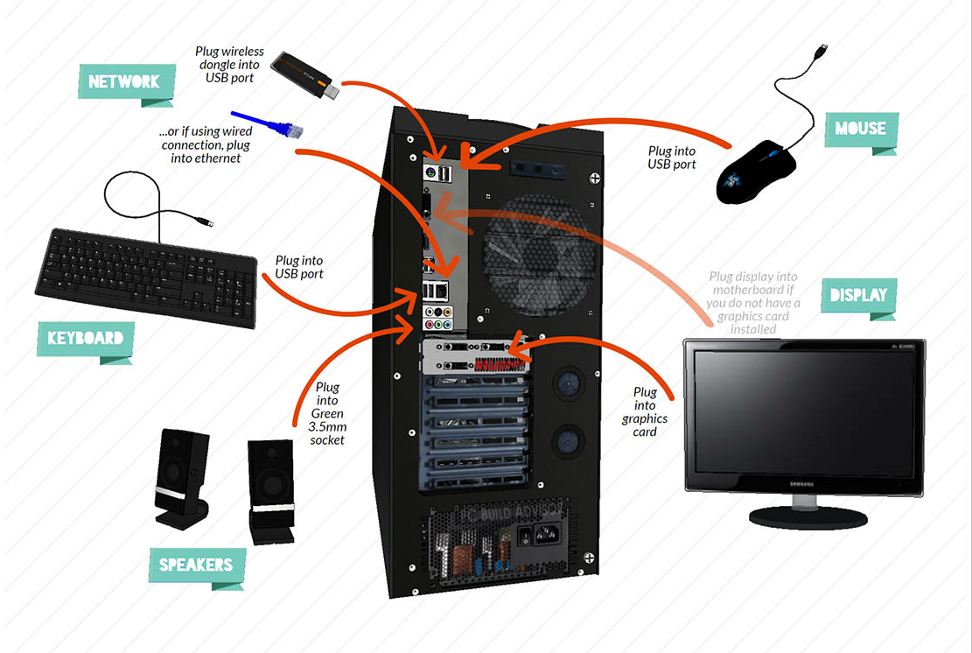
After that, place the side cover back on and secure the side panel with case screws using tools. The peripheral devices including mouse, monitor, keyboard, speakers etc now can be connected. Make sure everything you want to use with your computer (like keyboard, mouse, speakers etc) is plugged in to the right spot.

Plug into USB ports:
- Keyboard
- Mouse
- Wireless network dongle
- Printers
- Webcams

Plug into 2.5mm sockets:
- Speakers
- Microphone
- Line-in/line-out devices

Plug into ethernet ports:
- Internet connection
- Local area network (LAN) cables

Plug into display ports:
- Monitor / screens
- Be sure to plug into the correct display ports: always plug into the graphics card display output (if you have one installed) instead of the motherboard display ports.
- If you don’t have a dedicated graphics card, then plug into the motherboard’s display output ports.

