Alumni Sharing Session
  - Inspiring Work experience & Covid19 Pandemic Challenge
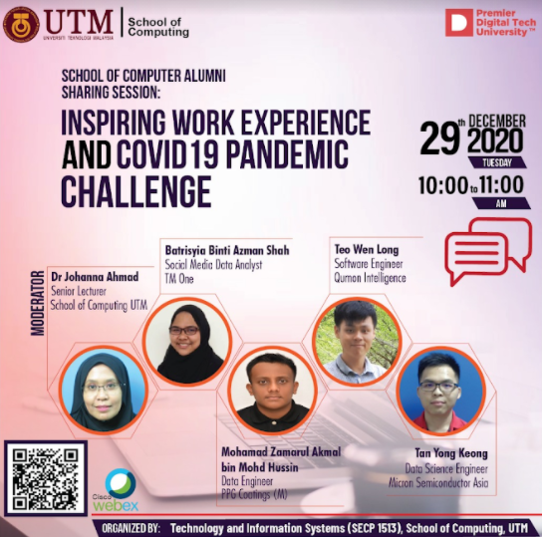
General View Of This Sharing Session.  On 29th December 2020, an online Alumni Sharing Session was held by Technology and Information Systems (SECP 1513), School of Computing, UTM. With the title of “Inspiring Work Experience & Covid19 Pandemic Challenge”, this session which leads by our lively moderator, Dr. Johanna Ahmad | filled with a lot of helpful and applicable work experience by the UTM Alumni. The successful alumni which got invited were Mohamad Zamarul Akmal bin Mohd Hussin, Batrisyia Binti Azman Shah, Teo Wen Long and Tan Yong Keong. They shared their personal thought about how was it a career life compared to university life. From this sharing session, we as undergraduate students gained so many tips on | how to be successful in an interview and how important campus participation for hiring criteria. Since we are currently facing the Covid-19 pandemic globally, it is important to stay motivated on our daily basis. The alumni give so much exposure to how they managed to survive these pandemic challenges and how to stay positive in any kind of situation.
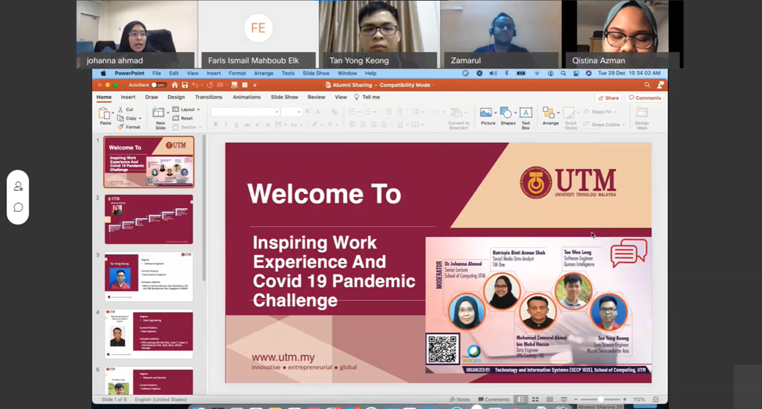 | Purpose of the talk  The purpose of the talk by graduate students is mainly to share informative tips and their work experiences to help the undergraduates especially the first-year undergraduate students to prepare for their careers.
WHAT HAPPENED IN THE PROGRAM?  At the beginning of the session, Moderator Dr. Johanna Ahmad welcomed the speakers and they began to introduce their background to the audience. As the alumni of UTM, the speakers shared their effort to secure a job as fresh graduates. Most of them agreed that being proactive during the internship is the key to gain trust from the employer thus being absorbed in the company after graduating.  Apart from that, the audience was given some tips and advice on studies as well as work experience. Rather than focusing only on achieving high CGPA, the speakers encouraged the students to enhance soft skills and nurture self-confidence to cope with the working life. At the end of the program, there was a Q&A session between the speakers and participants. | 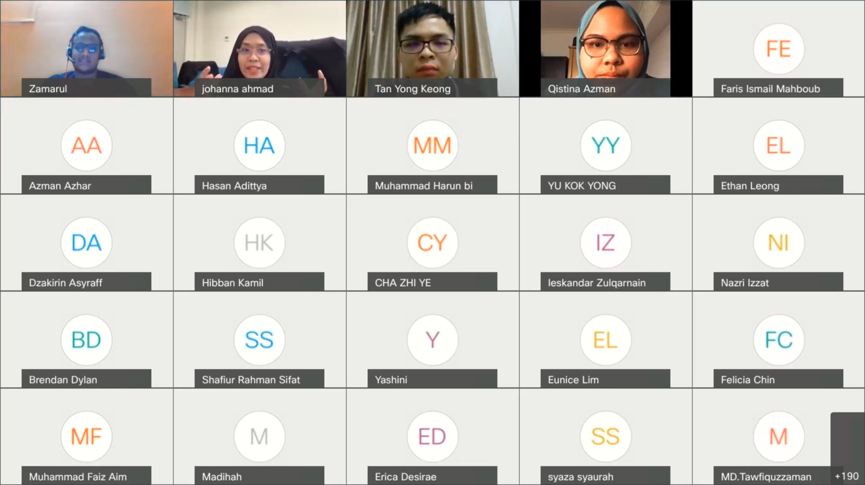

SUMMAry
To put it in simple words, we have been blessed with this activity as it has opened up our eyes to a lot of things. They have given a lot of insight into how career life is different from university life. All the hustle and bustle they went through during the early stages of their career pathway was nothing less than eventful and memorable, had thought them a lot and made good stories to be shared with aspiring students such as ourselves. The alumni themselves were invested in telling their experiences with their tones and expression, which drew the attention of the people who were present. Our ears perked up every time the story took a twist. This coupled with a friendly and lively moderator who oversaw the session with flying colors was nothing short of amazing, to say the least. Another important aspect that we refused to look down upon was the flexibility of the alumni as they tried to give advice that was molded specifically for the pandemic. In these tough times, the situation is severely different from the past, but they have managed to advise and motivated us to push through it.

Group reflection
The talk truly delivered useful information to the undergraduate students. The talk was interesting and engrossing at the same time too as the speakers as well as also our senior shared their experiences in their university life and working life. Unfortunately, due to the covid-19 pandemic, the talk can only be conducted online and because of this, closer interactions between audience and speakers are limited.
After the talk, we took time to reflect on ourselves. We thought of our strengths and weaknesses, the assets and skills we have to power through our career days and also the liabilities that lie within us, that could possibly hinder ourselves in the future.

individual reflection
Firstly, the most obvious thing I discovered from the talk was about how is our future career exactly look like. I got to know more about what will we face or experience during our job career, which is a valuable knowledge for me.
Secondly. I gained motivation from the speakers that is we should always keep ourselves proactive and be willing to learn other technical skills and soft skills which may handy to us in our future career.
Lastly, I feel grateful that this kind of talk is being organised as I had earned benefits from this. I wish a talk like this can be conducted again in the future.

Team members

