Semester I 2020/2021

Subject : Technology and Information Systems (SECP1513)
Section : 8
Assignment : Step by step PC Assembly

GROUP NAME / NUMBER : GROUP 8
1 |  | Name :  Amir hanis bin Azman  Matric Number :  A20EC0181  Phone Number :  011-37073948  E-mail :  amirhanis@graduate.utm.my
2 |  | Name :  Siew Yu Xuan  Matric Number :  A20EC0146  Phone Number :  011-16668991  E-mail :  siewxuan@graduate.utm.my
3 |  | Name :  Muhammad Faiz Aiman bin Fakhrurrazi  Matric Number :  A20EC0209  Phone Number :  012-3829170  E-mail :  Faizaiman2261@gmail.com
PART A
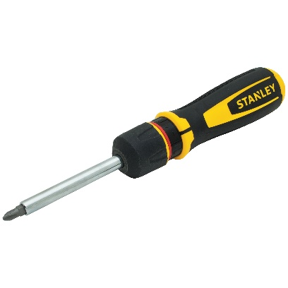
- Screwdrivers
The screwdriver is used to tighten screw in small part. The importance of screwdriver is to make sure all computer component is in fix position in cases.

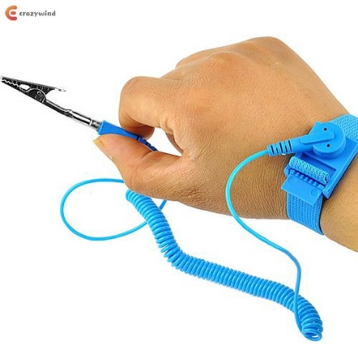
- Anti-static wrist wrap

Anti-static wrist strap is used to safely ground a person working on very sensitive electronic equipment. The importance is to prevent the build-up of electricity near sensitive electronics.

- Flashlight
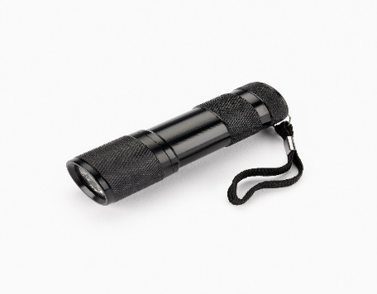
Flashlight is used to provide light at small part in the computer cases. The importance of this tool is to give better vision at small part area.

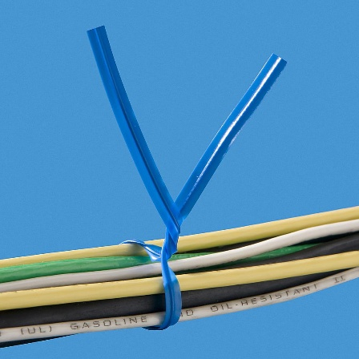
- Twist ties
Twist ties is used to tie wires. The importance is to keep wires in clean and tidy.

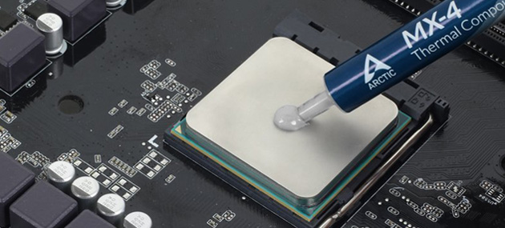
- Thermal paste
Thermal is used to fill the air gap between CPU and CPU cooler. The importance is to give more efficient transfer of heat.

PART B
1.0
Diagram 1.0

2.0
- Graphic card
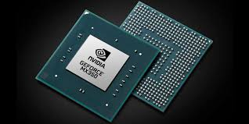
Functions : Used to produces the image you see on a PC
Example of models : AMD Radeon VII, Nvidia Quadro RTX 4000

- USB cable
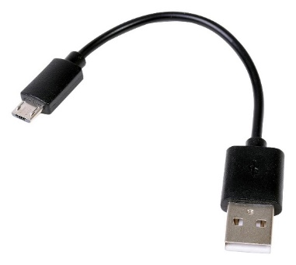
Functions : Used to connect peripheral devices like mobile phones, cameras, camcorders and printers directly to computer
Example of models : USB-A, Micro-USB

- IDE cable
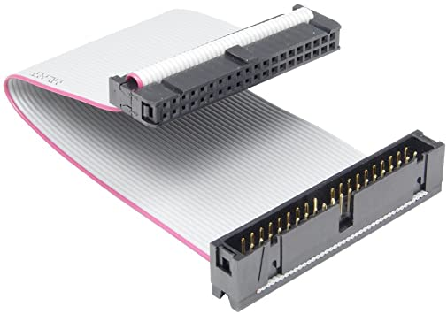
Functions : used to connect a motherboard to storage devices such as hard drives
Example of models : 34-pin cable, 40-pin cable

- CPU / Processor
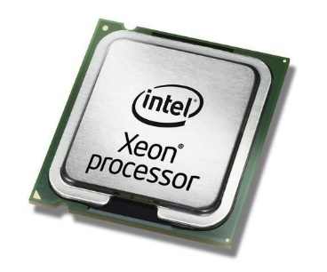
Functions : To execute instructions that make up a computer program
Example of models : 3xx – Celeron D, E1xxx – Celeron Dual-Core

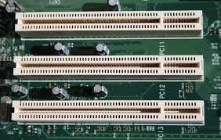
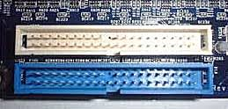
- Slots (IDE, PCI)

Functions :
IDE- used to connect a motherboard to storage devices such as hard drives
PCI- used to insert or install Add-on cards, such as LAN cards, sound cards and Capture cards
Example of models : 32 bit PCI with 5V signal voltage, 64 bit PCI with 3.3V signal voltage

- Power Supply
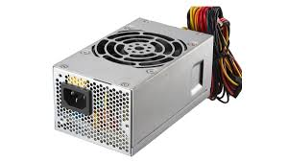
Functions : converts main AC to low voltage regulated DC power for the internal components of a computer
Example of models : Model 5150, ROG Thor 850W Platinum

- Heat sink
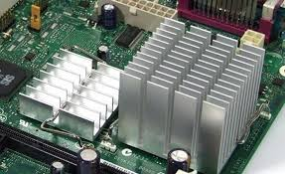
Functions : increases the heat flow away from a hot device
Example of models : Passive Heat Sink, Pumped Liquid Heat Sink

- RAM
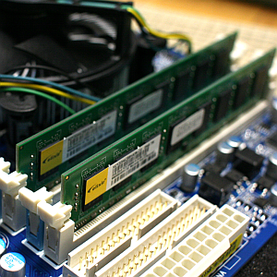
Functions : allows data items to be written or read in same time irrespective of the physical location of the data inside the memory
Example of models :DRAM, SRAM

- Hard disk ( jumper setting, either master / slave)
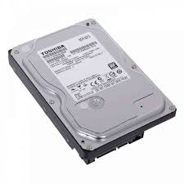
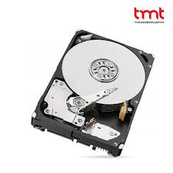
Functions : stores and retrieves digital data using magnetic storage and one or more rigid rapidly rotating platters coated with magnetic material
Example of models : Seagate Exos X, WD Black

- CD ROM
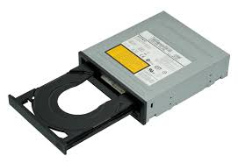
Functions : CD that can be read by a computer with an optical drive
Example of models : ISO/IEC 10149

- SATA cable
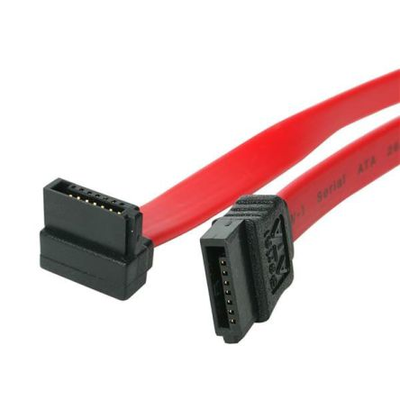
Functions : used to connect a mass storage device to a host bus adapter such as motherboard
Example of models : Micro SATA, SATA Bridge

PART C
STEP 1 – Installing Processor / CPU
- Locate the CPU socket. It looks like a large square and has metal lever.
- Open the CPU socker by lifting the lever.
- Look at the socket for small mark or icon in the bottom left corner. This indicates which way to install CPU.
- Precaution: Ground yourself by touching the metal part of your case or another metal object. Avoid touching the bottom and top of CPU.
- Lock the CPU socket by lowering the lever. Clip it back into the hook.

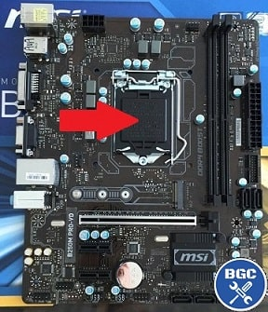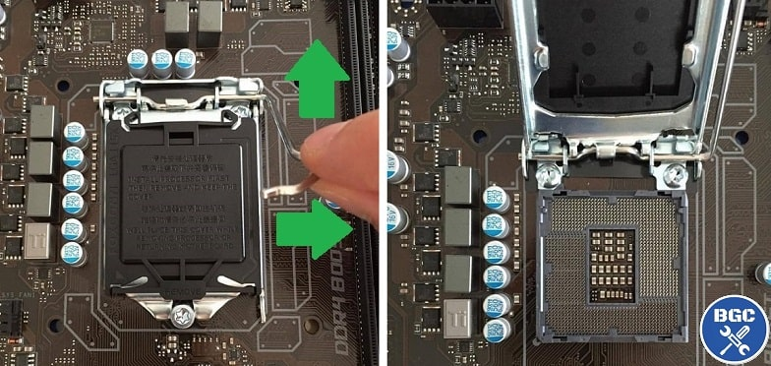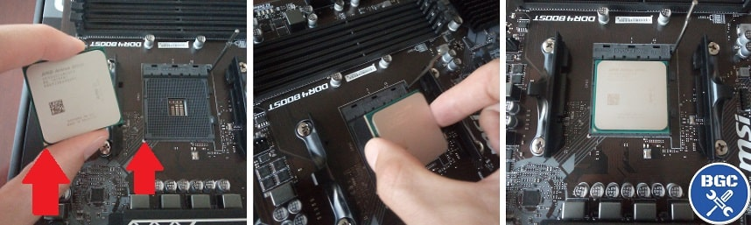
STEP 2 – Installing Heat Sink
- Precaution: Ground yourself first.
- Lower heat sink onto the top of CPU by lining up the four corners with the four holes.
- Push down on each of four corners until hear a clicking sound for each to lock heat sink

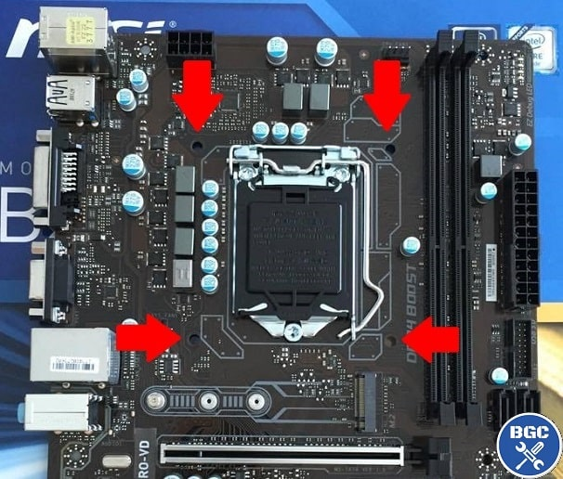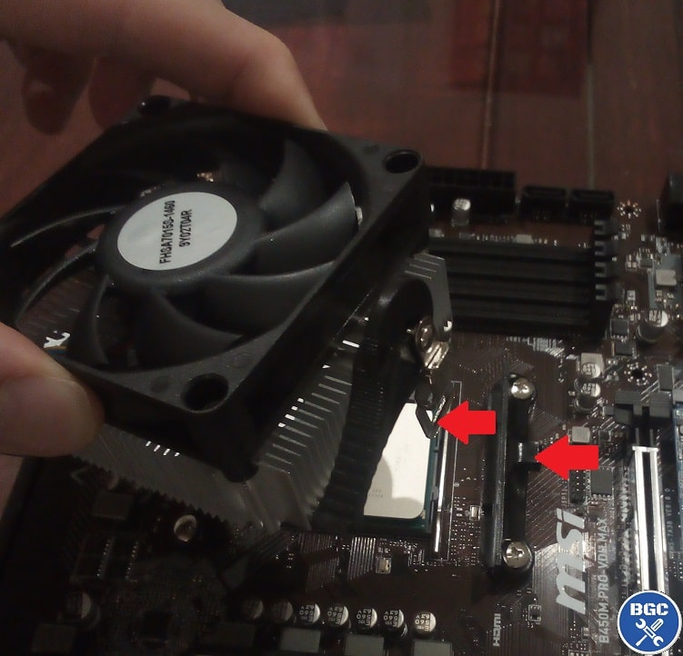

STEP 3 – Install RAM
- Locate the correct slot for RAM. It should be on the first slot.
- Insert the RAM by matching up the bottom connectors on the RAM to the cutouts on the slot.
- Lock the slot

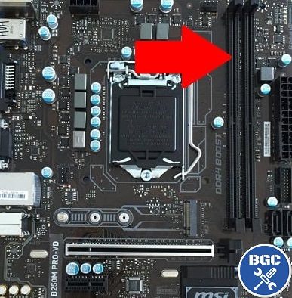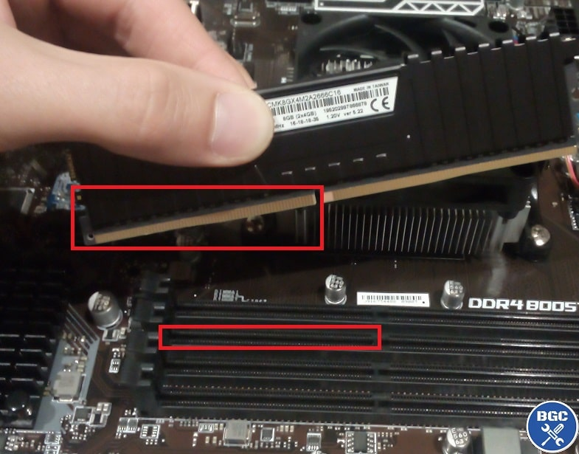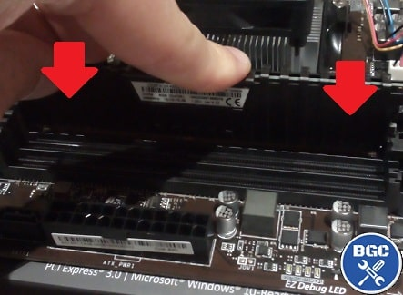
STEP 4 – Install Graphic Card
- Find the best slot.
- Remove case expansion bracket by unscrewing them.
- Unlock the retention clip and remove the cover.
- Precaution: Ground yourself.
- Insert the graphic card by aligning it to the back of the case in proper position. Then, insert the bottom of the card into the socket.
- Secure it with gentle press down until it’s firmly in place.

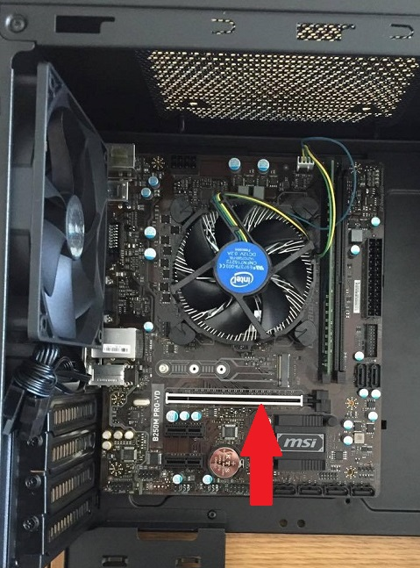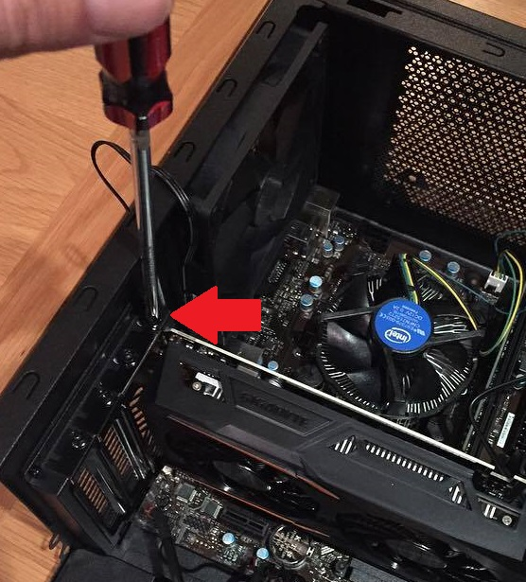

STEP 5 – Install Hard Disk
- Locate 3.5” drive bay.
- Insert the drive into place.
- Screw holes on the sides.

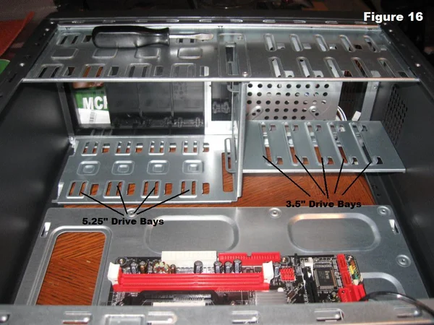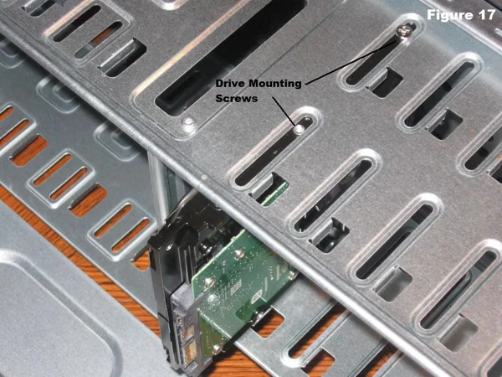
STEP 6 – Install CD ROM
- SATA cable are needed.
- Locate spare 5.25” drive bay.
- Remove the driver bay cover.
- Insert CD ROM into drive bay by slotting it in from the front of the case.
- Line up holes on the side and screw CD ROM into place.
- Connect CD ROM to motherboard with SATA data cable
- Connect CD ROM to power supply with SATA power cable

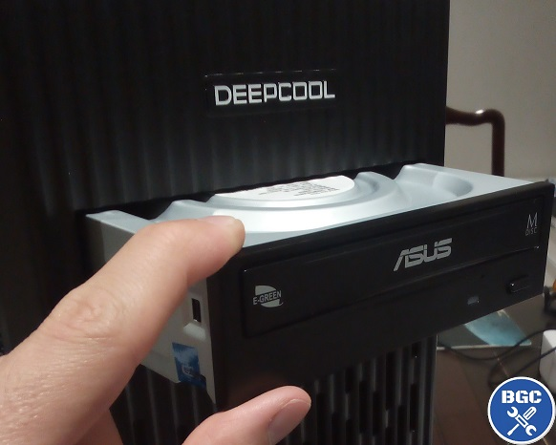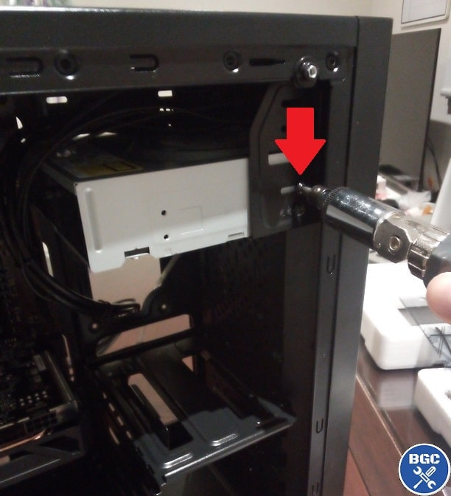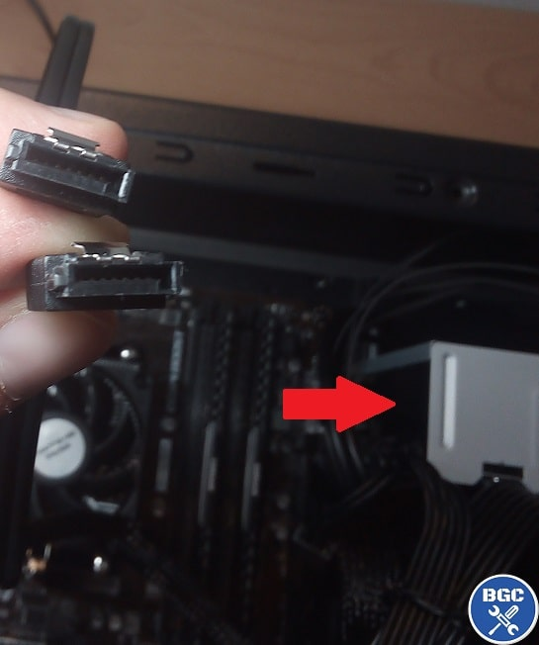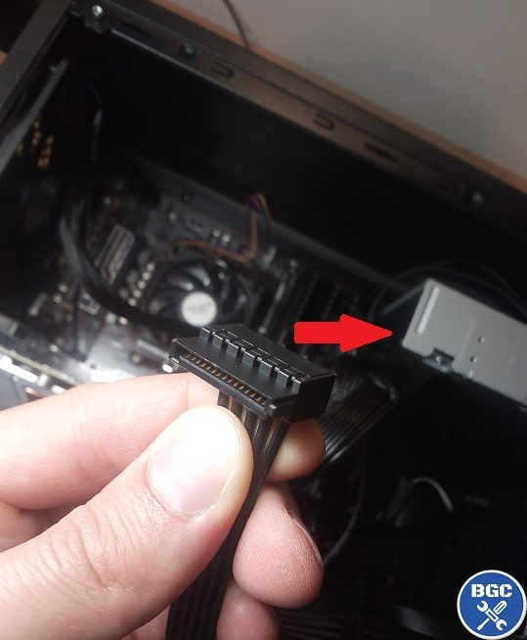
STEP 7 – Connect Front Panel Cables (USB Ports, Power Switch)
- Locate front panel headers on motherboard.
- Connect front panel cables to motherboard headers.

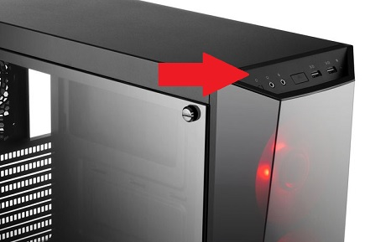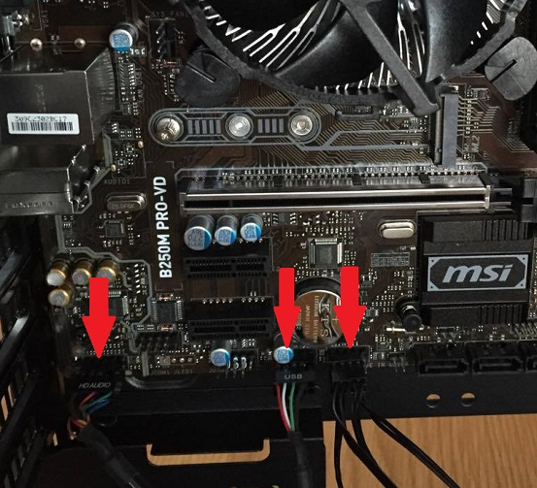

STEP 8 – Install Power Supply
- Decide which way to install power supply.
- Insert power supply in bottom of case.
- Precaution: ground yourself before handling power supply.
- Secure power supply to case by screwing holes on the back of the case.

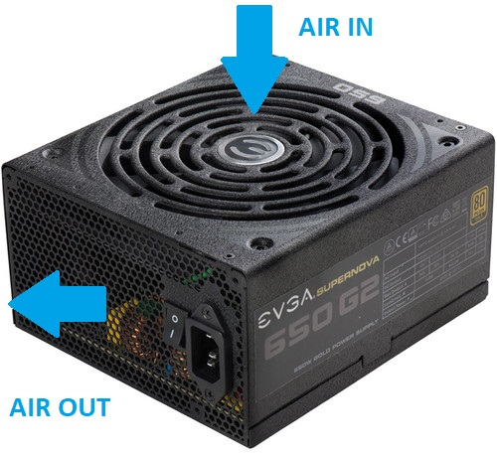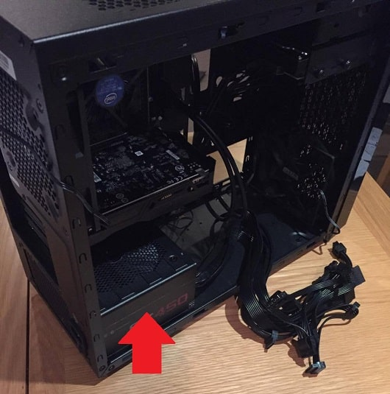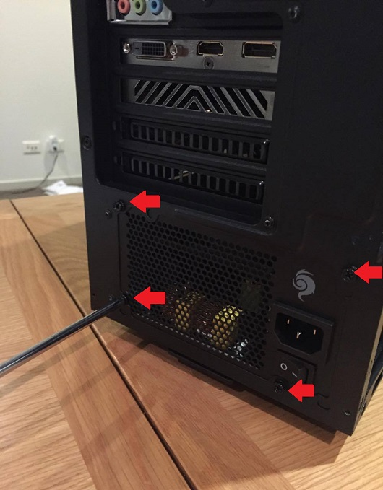
STEP 9 – Closing the Case and Connecting the Peripherals
- Place the side cover back on and secure the side panels with case screws.
- Connect peripheral devices which include keyboard, mouse, wireless network dongle, printer and webcams with your CPU by plugging into USB port.
- Then, connect speakers and microphone into 2.5 mm sockets.
- Finally connect the CPU with monitor by plugging into display ports

