

SEM 1 20202021 : SECTION 08

Technology and Information System

Course Chapter Assignment
(Presentation)

Chapter 9

PRIVACY, SECURITY AND ETHICS

Group Num# : GROUP 8

Students Information : SECP1513 SECTION 08

Name : AMIR HANIS BIN AZMAN MUHAMMAD
SIEW YU XUAN
FAIZ AIMAN BIN FAKHRURRAZI

Lecturer : DR. ZURAINI BINTI ALI SHAH

Mind map
Summarize your group chapter
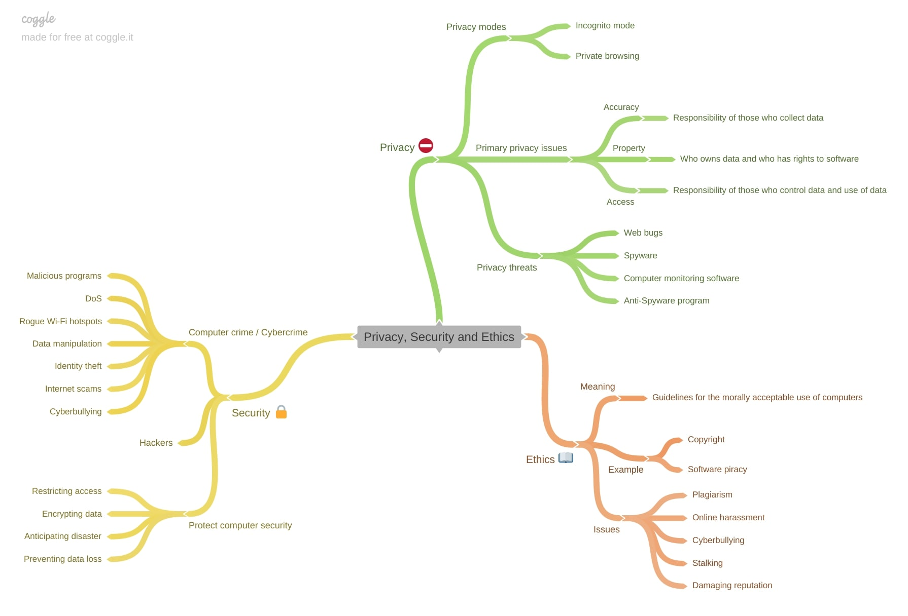
Video presentation URL
Please make in youtube

https://www.youtube.com/watch?v=5Rl0Am6X20E

