CLOUD COMPUTING FUNDAMENTALS
Hong Pei Geok, Maizatul Afrina Safiah Binti Saiful Azwan, Muhammad Dinie Hazim Bin Azali, Nurfarrahin Binti Che Alias, Singthai Srisoi
School of Computing,
81310 Skudai，Johor Malaysia
1 Introduction
Cloud computing is the on-demand computing service that delivered through the use of Internet. It including data storage, servers, databases, networking, and software [1]. With cloud computing, people can access data at any time and any place with devices that have Internet access. Nowadays, there are many Cloud Computing Service Providers such as Amazon EC2, Google Cloud Platform, and Microsoft Azure. In order to suite the requirements of users, these providers also updated their services like expand storage and provide service with low cost. We can know that cloud computing is one of the most convenience and useful service especially for people who worked in industrial.
2 Comparative Evaluation
2.1 Service model (IaaS, PaaS, SaaS)
SaaS Software as a Service, also known as cloud application, services, represents the most utilized option for businesses in the cloud market. SaaS utilizes the internet to deliver applications, which are managed by a third-party vendor, to its users. Most SaaS applications run directly through your web browser, which means they do not require any downloads or installations on the client side. For example, Google Workspace, Dropbox, Salesforce, Cisco WebEx, Concur, GoToMeeting [2].
Platform as a Service (PaaS) provide cloud components to certain software while being used mainly for applications. PaaS delivers a framework for developers that they can build upon and use to create customized applications. All servers, storage, and networking can be managed by the enterprise or a third-party provider while the developers can maintain management of the applications. For example, AWS Elastic Beanstalk, Windows Azure, Heroku, Force.com, Google App Engine, Apache Stratos, OpenShift [2].
Cloud infrastructure services, known as Infrastructure as a Service (IaaS), are made of highly scalable and automated compute resources. IaaS is fully self-service for accessing and monitoring computers, networking, storage, and other services. IaaS allows businesses to purchase resources on-demand and as-needed instead of having to buy hardware outright. For example, DigitalOcean, Linode, Rackspace, Amazon Web Services (AWS), Cisco Metapod, Microsoft Azure, Google Compute Engine (GCE) [2].
2.2 Virtual Machine (VM) instance types offered (such as micro, small, medium, large etc.)
A virtual machine (VM) is a virtual environment that functions as a virtual computer system with its own CPU, memory, network interface, and storage, created on a physical hardware system. It allows you to share a system with many virtual environments.
Each machine type family includes different machine types. Each family is curated for specific workload types. The following primary machine types are offered on Compute Engine:
- General-purpose machine types offer the best price-performance ratio for a variety of workloads.
- Memory-optimized machine types are ideal for memory-intensive workloads because they offer more memory per core than other machine types, with up to 12 TB of memory.
- Compute-optimized machine types offer the highest performance per core on Compute Engine and are optimized for compute-intensive workloads. Compute-optimized machine types offer Intel Scalable Processors (Cascade Lake) and up to 3.8 GHz sustained all-core turbo.
- Accelerator-optimized machine types are ideal for massively parallelized CUDA compute workloads, such as machine learning (ML) and high-performance computing (HPC).
- Shared-core machine types are available in the E2 and N1 families. These machine types timeshare a physical core. This can be a cost-effective method for running small, non-resource intensive applications.
2.3 Storage
There are three types of cloud data storage: object storage, file storage, and block storage. Each offers their own advantages and have their own use cases:
Object Storage - Applications developed in the cloud often take advantage of object storage's vast scalability and metadata characteristics. Object storage solutions like Amazon Simple Storage Service (S3) are ideal for building modern applications from scratch that require scale and flexibility and can also be used to import existing data stores for analytics, backup, or archive [3].
File Storage - Some applications need to access shared files and require a file system. This type of storage is often supported with a Network Attached Storage (NAS) server. File storage solutions like Amazon Elastic File System (EFS) are ideal for use cases like large content repositories, development environments, media stores, or user home directories [3].
Block Storage - Other enterprise applications like databases or ERP systems often require dedicated, low latency storage for each host. This is analogous to direct-attached storage (DAS) or a Storage Area Network (SAN). Block-based cloud storage solutions like Amazon Elastic Block Store (EBS) are provisioned with each virtual server and offer the ultra-low latency required for high performance workloads [3].
2.4 OS environment offered
Azure is the product of Microsoft and mainly referred to as Microsoft Azure. It is also a cloud computing service platform. It was created by Microsoft and initially released in the year 2010. It supports the Linux and Microsoft Windows operating systems. It is used for building, deploying and testing and managing the applications. In Azure, the computer power or machine can be selected and this machine mainly refers to VHD that is called as Virtual Hard Disk. It can be configured by them or the user and maybe the third party. Strength of Azure such as total support for Microsoft legacy apps, easy one-click migrations in many cases, conversion of on-prem licenses to the cloud, good support for mixed Linux and Windows environments, better hybrid cloud offering and better support for disaster recovery. [4]
Google Cloud Platform is a public cloud infrastructure, as well as Google Workspace which is the enterprise versions of Android and Chrome OS. Google Cloud is a cloud computing platform and released in the year 2008. It was written in Java, C++, Python including Ruby. Google cloud is categorized into different platforms like google app engine, google compute engine, google cloud datastore, google cloud storage, Google big query and google cloud SQL. Strength of google cloud platform such as top kubernetes support, better devops support, heavy involvement in AI, simpler licensing, faster private network for low latency and better load balancing globally. [4]
2.5 Security
There are three primary areas to be considered regarding security: device, connection and cloud security. For authentication and authorization, Microsoft Azure provides Active Directory Premium to manage access and identity of users. Other than that, the Azure Hub Identity Registry provides secure storage of device identities and each security key to ensure that all connections have to be initiated by the device to the Hub but not vice versa. Microsoft Azure also provides Transport Layer Security (TLS) with X.509 certificate. It can help to encrypting the communication between web applications and servers and encrypt other communications such as email, messaging, and voice over IP (VoIP). [5]
For Google Cloud Platform, it provides Cloud Identity and Access Management (IAM) and Cloud Identity-Aware Proxy to allows to control, authenticate and authorize the Cloud IoT Core API access. It also refer to the ability to manage user identities and their access to IT resources from the cloud. Google infrastructure provides a variety of storage services and a central key management service. The storage services can use keys from central key management service to encrypt data before it is written to physical storage. It also implements addition layer of protection to prevent malicious disk firmware. Figure 1 shows several data security challenges and the major data security challenges in the cloud. [6]
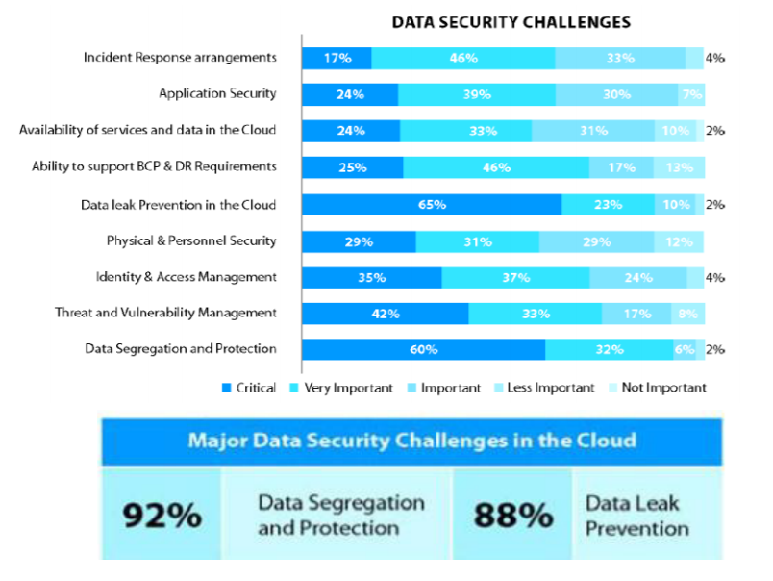
Figure 1: Data Security Challenges
2.6 Performance and scability
Based on the experiment done by Malawski, he used Benmarks to compare the performance of both cloud computing service provider. He found that Microsoft Azure has much wider distribution, and the average execution times are relatively slower. This can be attributed to different hardware, but also to the underlying operating system (Windows) and virtualization. [7]
Google cloud functions execution time have multimodal distributions with higher dispersion. For example, for the 256 MB function, the execution time is most often around 27 s, but there is another peak around 20 s, coinciding with the faster 512 MB function. Similarly, the distribution for the slowest 128 MB function has multiple peaks, overlapping with faster functions and reaching even the performance of the fastest 2048 MB function. This suggests that GCF does not enforce strictly the performance limits, and opportunistically invokes smaller functions using the faster resources. Figure 2 shows the results of the integer benchmarks using Mersenne Twister random generator. [7]
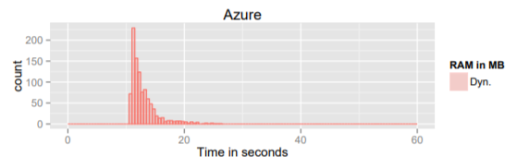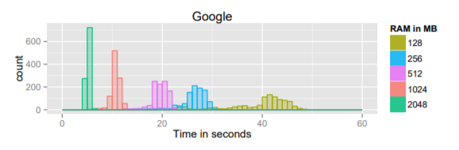
Figure 2: Histogram of integer-based Mersenne Twister random number generator benchmark execution time versus cloud function size
The next aspect measured in order to determine the performance of cloud service providers is network latency. Endpoints exposed by cloud providers are secured with HTTPS protocol. The average results were consistent with typical Benchmarking Heterogeneous Cloud Functions 9 network latency for Google Cloud Functions – 150 ms. However, for Azure the latency measured that way was 439 ms which is significantly larger than the network ping time. Figure 3 shows the result of the network latency for Microsoft Azure and Google Cloud Platform. [7]
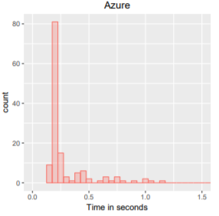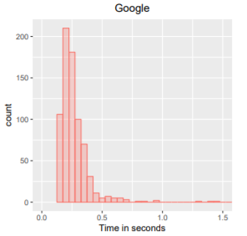
Figure 3: Distribution of network latency for cloud function provider
2.7 Pricing model
Pricing model is the most important thing for providers as they can control it to encourage the use of their services. Pricing also is a very important thing for the company and in terms of economy because it will involve clients and provider profits. Every provider has their own pricing models for the cloud services offered for clients. Providers have their own target which is to make huge profits but the client’s target is to have the best service at a low price. Thus, an optimal pricing methodology is required to satisfy both parties.
There are two pricing models for Microsoft Azure, namely pay-per-use and subscription. For Google Cloud Platform, the pricing models available on their service are subscription and hybrid pricing. Pay-per-use pricing, clients only have to pay for what they use in the function of time or quantity taken. This is a bit unfair to the clients because they may have to pay more for the services they use. Next, subscription pricing needs its clients to pay repeatedly or monthly to access the services provided. This kind of pricing model sometimes can charge the clients more or less depending on the provider. Lastly, hybrid pricing is the combination of pay-per-use and subscription. The price to be paid by the clients is not fixed as it depends on the job queue wait times. This model is said to be fair to clients. [8]

2.8 Auto-Scaling/Elasticity
Auto-scaling is a hugely important feature for software providers, identifying an auto-scaling policy that can assure no breach of performance is an extremely difficult task, and will invite failure unless significant precautions are taken. Auto-scaling enables resources to be purchased and published on demand. In addition, in order to properly configure a rule-based auto-scaling policy, there must be an in-depth amount of knowledge and a high level of expertise, which is not necessarily true in practise.
Microsoft Azure has recently increased their auto-scaling rules offered to clients by allowing a wide range of metrics. [9] Microsoft Azure has its own name for services that run auto-scaling operation which is Azure Autoscale. At the same time, Google Cloud Platform also has the same thing which is Managed Instance Groups. This service provides automatic healing and built-in load balancing for clients who use their cloud.
2.9 Monitoring tools/Service provided
Cloud monitoring is a process of checking, analysing and controlling the operating workload in a cloud-based IT facility. [10] A few cloud services have the self-belief and provide clients with tools to monitor the availability of services. Monitoring services could be managed by providers or by a third party.
Microsoft Azure has provided many first party Azure monitoring tools with a specific purpose such as Microsoft Azure Monitor to collect and analyze performance metrics, Azure Advisor to scan resource configurations, Azure Automation to automate cloud management tasks and many more. There also other organizations that made cloud monitoring tools that work with Azure such as AppDynamics, Datadog, LogicMonitor and Serverless360. Google Cloud Platform monitoring, it use Stackdriver but we can also use third party monitoring tools.
3 Opinions
In our opinion, Microsoft Azure gives a lot of benefits to all the users especially users who are in the field of business. First of all, security. Microsoft Azure takes a big step to ensure the security of their user and this can easily identify any suspicious activity within the technology. Secondly, privacy. This technology will not easily share the users data or information to others unless it is authorized by the owner. Other than that, availability and the scalability are high. Microsoft Azure provides higher availability and scalability compared to other cloud service providers and last but not least is the cost. Cost of this technology is more worth it other than cloud service providers it is because the cost of maintenance, infrastructure and others can be reduced. Although there are many advantages but there are still some disadvantages that the users need to know. One of the disadvantages is the need of experts. Azure need expertise to make sure that everything works efficiently. This is because this is one of the mistakes that always happen to other administrators. [11]
For Google Cloud Platform, this platform is one of the fastest, simplest and also cheapest. However, there are some advantages and disadvantages. As we all know, the storage for Google Cloud Platform is so fast with unlimited bandwidth and also highly consistent listings. Other than that, the security and access are easy. So, this shows the control and the flexibility that are available to all users which means that the user can decide either to use or not the platform and they can easily delete their data from Google Cloud. The disadvantages of this platform are the lack of managed services and also limited and outdated versions.
4 Conclusion
As a conclusion, cloud computing is one of the technologies that has been created and give a big impact not only to our county but also to the whole world. It also one of the fastest growing part of IT. This really helps people all around the world with massive benefits to users of all sizes. Cloud computing also is a service provider that are simpler to acquire and can scale either up or down. Among all of the clouds, public clouds work the best for some but not for all however for private clouds, this cloud provide many benefits for all internal applications. Moreover, for your information, public clouds and private clouds can be used in combination. Private clouds known as an internal or enterprise cloud meanwhile public cloud is a standard cloud computing model that are use to make resources and the only way to differentiate between public cloud and private cloud is that users are not responsible for any management of a public cloud. [12]

References
- Steve.R. “What is cloud computing? Everything you need to know about the cloud explained”, December 2018, [online]. Available : https://www.zdnet.com/article/what-is-cloud-computing-everything-you-need-to-know-about-the-cloud/
- Stephen.W. SaaS vs PaaS vs IaaS: What’s The Difference & How To Choose, June 2019, [online]. Available : https://www.bmc.com/blogs/saas-vs-paas-vs-iaas-whats-the-difference-and-how-to-choose/
- MacAskill.D. Benefits of Cloud Storage, November 2018, [online]. Available : https://aws.amazon.com/what-is-cloud-storage/?nc1=h_ls
- C. Preimesberger, At a High Level: Microsoft Azure vs. Google Cloud Platform, eWEEK, September 2019, [online]. Available : https://www.eweek.com/cloud/microsoft-azure-vs-google-cloud-platform
- Pierleoni, P., Concetti, R., Belli, A., & Palma, L. (2019). Amazon, google and microsoft solutions for iot: Architectures and a performance comparison. IEEE Access, 8, 5455-5470
- Rao, R. V., & Selvamani, K. (2015). Data security challenges and its solutions in cloud computing. Procedia Computer Science, 48, 204-209.
- Malawski, M., Figiela, K., Gajek, A., & Zima, A. (2017, August). Benchmarking heterogeneous cloud functions. In European Conference on Parallel Processing. Springer, Cham. pp. 415-426.
- Mazrekaj, A., Shabani, I. and Sejdiu, B., 2016. Pricing schemes in cloud computing: an overview. International Journal of Advanced Computer Science and Applications, 7(2), pp.80-86.
- Evangelidis, A., Parker, D. and Bahsoon, R., 2018. Performance modelling and verification of cloud-based auto-scaling policies. Future Generation Computer Systems, 87, pp.629-638.
- Ciuffoletti, A., 2016. Application level interface for a cloud monitoring service. Computer Standards & Interfaces, 46, pp.15-22.
- Key Advantages of Microsoft's Azure Cloud. (n.d.). Retrieved January 16, 2021, from https://www.dyntek.com/blog/4-key-advantages-of-microsofts-azure-cloud#:~:text=Azure%20offers%20a%20pay%2Das,management%20of%20your%20IT%20environment.
- Private vs. Public Cloud: What's the Difference? (2014, June 05). Retrieved January 16, 2021, from https://www.expedient.com/knowledgebase/blog/2014-06-05-private-vs-public-cloud-whats-difference/

