Semester I 2020/2021

Subject: Technology and Information Systems (SECP1513)

Section: 02

Assignment: Step by step PC Assembly

GROUP NAME / NUMBER: 03

Table of Contents

PART A – TOOLS NEEDED 3
1.0 Screwdrivers 3
2.0 Needle-nose Pliers 3
3.0 Anti-static Wrist Strap 4
4.0 Zip or Twist Ties 4
5.0 Light Source 5
6.0 Extra Screws 5
7.0 Thermal Paste 6
PART B – Sketch of a motherboard layout 7
1.0 A Sketch of Motherboard Layout 7
2.0 Function of importance components on motherboard 7
2.1 Graphic Card 7
2.2 CPU / Processor 8
2.3 Heat Sink 8
2.4 CD ROM 9
2.5 USB Cable 9
2.6 Slots 10
2.7 RAM 10
2.9 IDE Cable 11
2.10 Power Supply 11
2.11 Hard Disk 12
PART C – Step by Step PC Assembly 13

PART A – TOOLS NEEDED

Screwdrivers

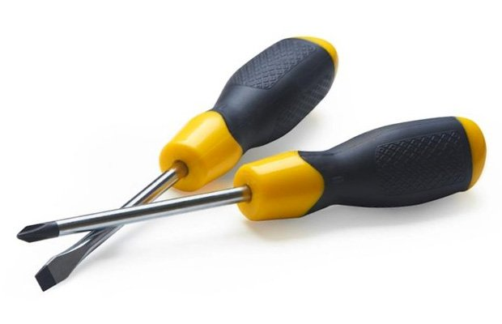
There are two types of screwdrivers which are flat-head screwdriver and phillips-head screwdriver. Flat-head screwdriver is used tighten or loosen slotted screws while phillips-head screwdriver is used to tighten or loosen cross-headed screws. These screwdrivers are important because it can give extra leverage and prying things apart if we use flat-head screwdrivers and for phillips-head screwdrivers with a big bit, it can help us from stripping the head.

Needle-nose Pliers

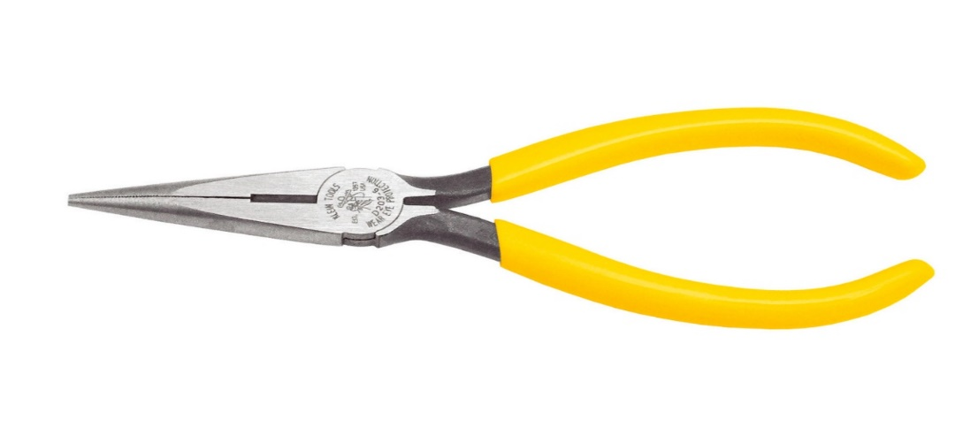
Needle-nose pliers which sometimes known as pointy-nose pliers is used to hold and cut wires. It also can bend small wires and electrical wiring. This is important because this pliers are good to reach into small areas that cannot be reached where regular pliers are unhandy. This tool can grip a lot of wires and pick up small screws with a strong grip. Besides that, this pliers also can be used to cut of the wire’s excess.

Anti-static Wrist Strap
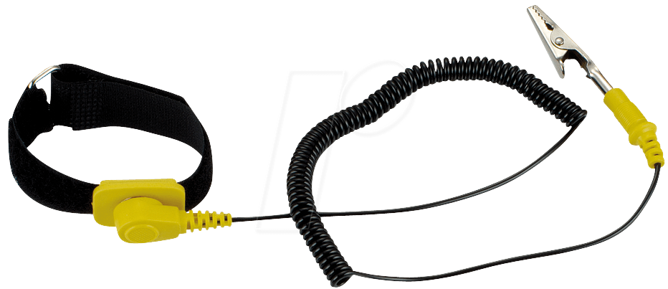
Anti-static wrist strap is one of the safety gear that can prevent the build-up of static electricity near sensitive electronics or cause safety issues. The wrist strap has a highly conductive threads on it and it can become a ground conductor in order to discharge static electricity safely. This anti-static wrist strap is important to protect items like circuit boards whether during construction, testing or other projects.

Zip or Twist Ties

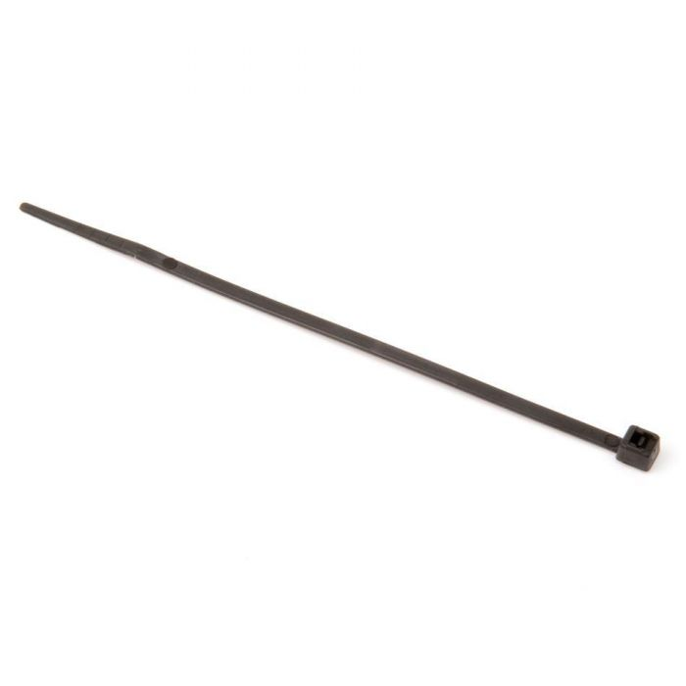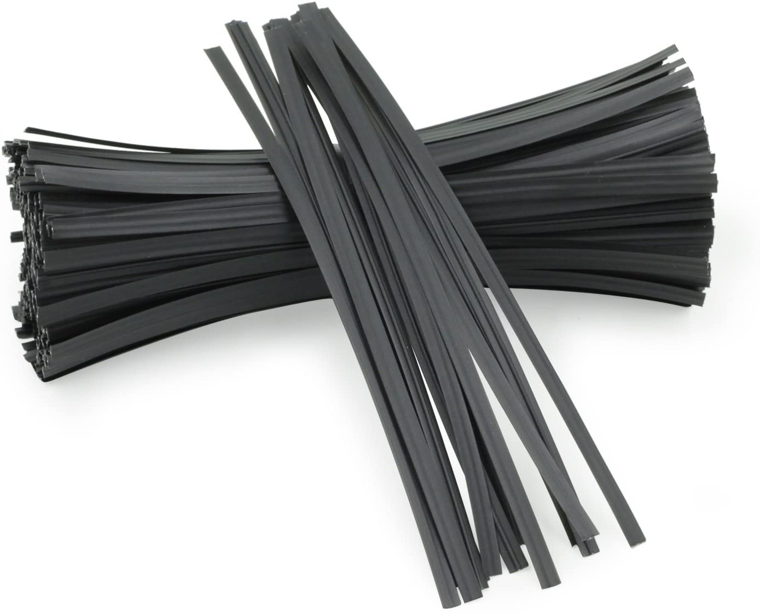
Zip or twist ties is necessary to holding items together such as electrical cables or wires. This is important because it can keep the cables organized and can prevent any damage. Besides that, it also is necessary to reduce the accumulation of dust and better airflow. Nevertheless, please do not tight the cables too tight because it can damage the cables.

Light Source

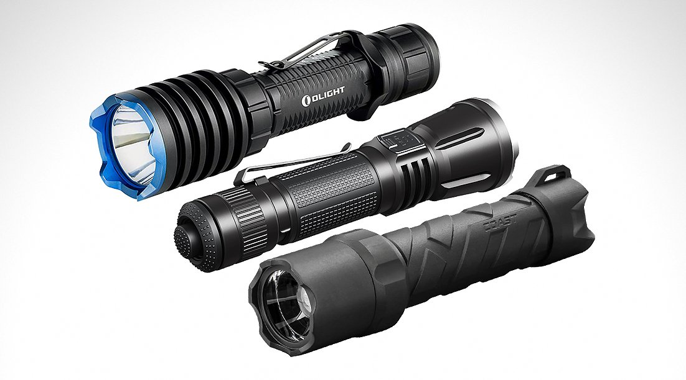
These light sources such as flashlights and lamps are used to provide directed light and to avoid visual glare. The importance of light sources is we can easily see any small parts such as screws, wires and others because we know that these small parts can easily lost from our sight moreover when we work at the dark places.

Extra Screws

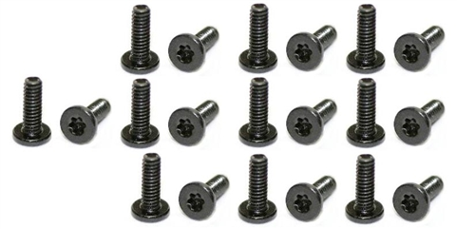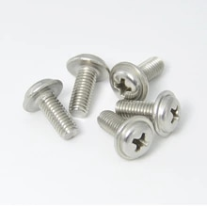
Screws are used to hold things together tightly and efficiently. This is important because they used to keep side panels in place, attached graphic cards to the back of the case and it also can held together any pieces of internal case. So, these extras can be use when we lost our previous screws.

Thermal Paste

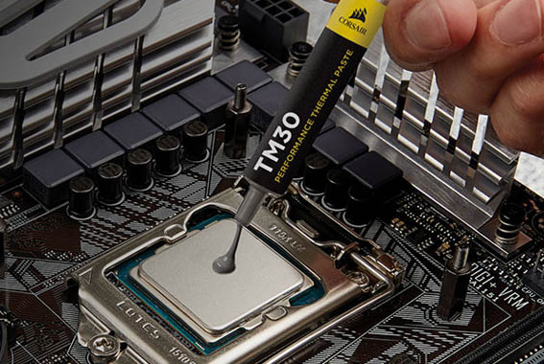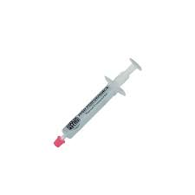
Thermal paste is a substance with silvery-gray that we can apply to a processor before installing a cooling solution. It can transfer heat from the Integrated Heat Spreader (IHS) of the processor to the base plate of the Central Processing Unit (CPU) cooler that is designed to dissipate the heat. The importance of thermal paste is it can fills in those gap ais and allows the heat to transfer more efficiently.

PART B – Sketch of a motherboard layout

1.0 A Sketch of Motherboard Layout
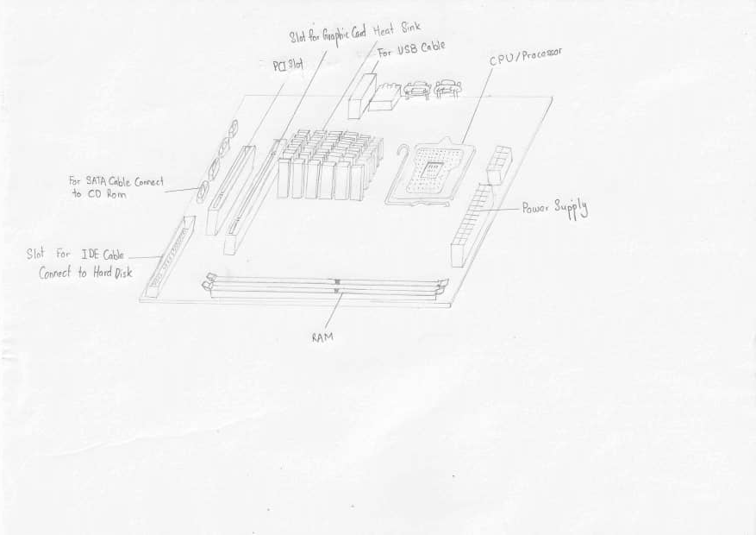

2.0 Function of importance components on motherboard

2.1 Graphic Card
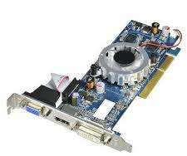
The graphic card is used to optimize quality of graphics in order to display at a high rate of speed. Some of the examples of graphic card are AMD Ryzen Threadripper Graphics Card Video, PowerColor Devil Graphics Card Video and GeForce GTX 1080 Ti Graphics Card Video.

2.2 CPU / Processor
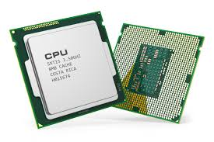
CPU is Central Processing Unit which is used to control all the operations of computer. It is similar as the brain of computer. For instances, Intel Core i5, Intel Core i7, AMD Ryzen and AMD Athlon.

2.3 Heat Sink
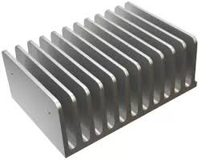
The main function of heat sink is preventing devices from getting over hot by carring heat way from devices through large surface area. Example of models of heat sink are BGA, SFP and XFP heat sink.

2.4 CD ROM
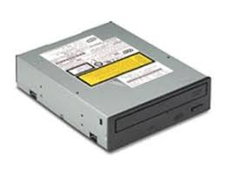
CD ROM or Compact Disc Read Only Memory is importance for stores data from computer such as text, graphic and audio.

2.5 USB Cable
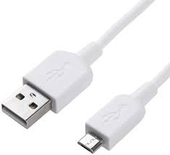
The function of USB cable is connecting external devices such as printer, mice and keyboard to PC. Example of type of USB cable are USB Type-A, USB Type-C and Micro-USB.

2.6 Slots
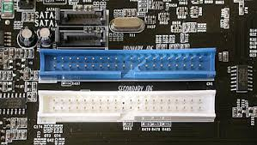
Slots can provide connection point for specialized cards or circuit boards and also provide expansion capabilities for the computer in order to increase the performances of computer. Some of the example of expansion slots are AGP (Video card), AMR (Modem, Sound card) and PCI (Network card, SCSI, sound card, video card).

2.7 RAM
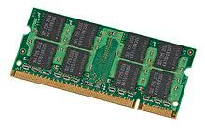
The function of RAM or random access memory is providing a place to store data on a short-term basis. Two main types of RAM are Static RAM and Dynamic RAM.
2.8 SATA Cable
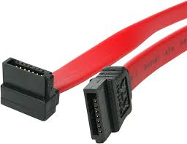
SATA cable or Serial Advanced Technology Attachment used to connect external secondary storage for high speed connection.

2.9 IDE Cable
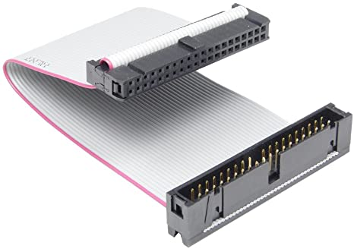
IDE cable (Integrated Drive Electronics Cable) can use to connect storage devices in computer. Generally, there are two common types of IDE cable which are 34-pin cable used for floppy drives and the 40-pin cable for hard drives and optical drives.

2.10 Power Supply
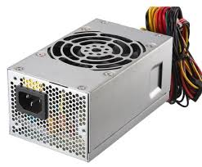
Power supply is used to supply electric power to devices and also convert electric current into correct voltage that required by computer. Some of the example of power supply are EVGA SN 1600 T2, Seasonic FOCUS 750 and Corsair AX1600i.

2.11 Hard Disk
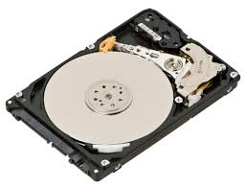
Generally, users can set the hard disk jumper to Master or Slave. Hard disk can store digital data by using magnetic storage. Example models of hard disk are Seagate BarraCuda, Toshiba X300 and WD VelociRaptor.

PART C – Step by Step PC Assembly

Step 1 – Install Processor (CPU)
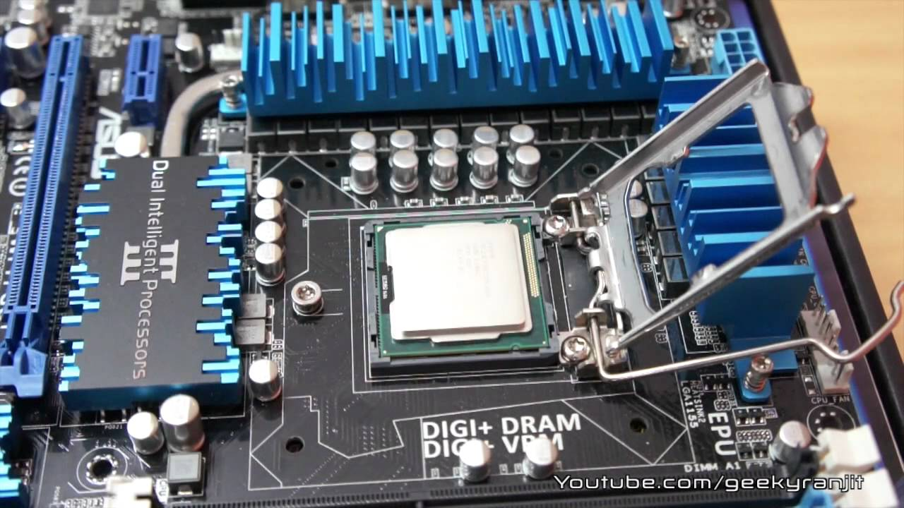
Place the holder of the CPU socket on the motherboard. Lift up the latch lever and open the CPU socket cover. Keeping the CPU on its sides, align any alignment dots or triangle on the corner of the CPU to the triangle indicated on the motherboard to ensure proper orientation. Gently put it straight down into the motherboard socket to carry the CPU. Lower the CPU socket cover over the CPU and lower the latch lever closed again to protect the closed CPU socket holder.

Step 2 – Install CPU Cooler/ Heatsink
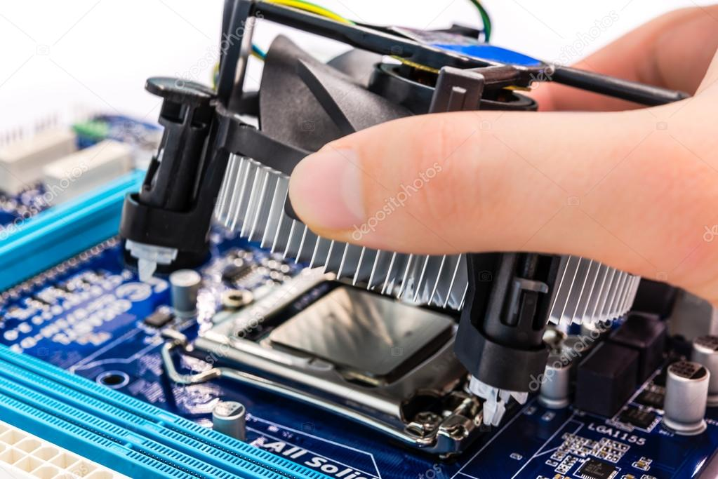
If possible, spread thermal paste to the back of the CPU. Seat the heatsink/cooler of the CPU and set it in place. Make sure the heatsink/cooler of the CPU has been clipped tightly. Attach the power cable to the cooler fan to the motherboard connector.

Step 3 – Install Memory (RAM)
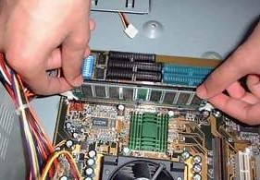
Press to open the clips at both ends of the RAM mounting slot. Line up the notch of the RAM stick with the mounting slot. Sit down the RAM and press it tightly into the slot. The tabs should automatically close when you press the RAM down and lock the RAM in place. Install any other RAM sticks that use the same method.

Step 4 – Install Power Supply
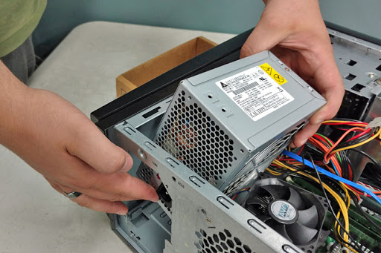
Attach the power supply and tighten the screws to the mounting points of the frame. Make sure all of the screws are tightened.

Step 5 – Install Motherboard in the Case
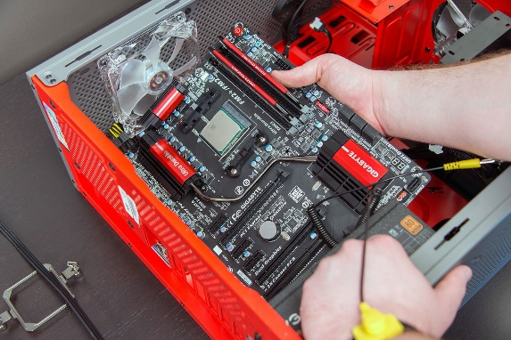
First, find the standoffs and install the standoffs as the standoffs is the place to put the motherboard. Then, place motherboard on the standoffs where the holes and the standoffs should line up. If the motherboard does not come out of the case, gently force the motherboard to fit in the panel. Secure the board with screws.
Precautions;
- Don’t overtight the screws and do not use an electric screwdriver
- Avoid using non-metallic holes

Step 6 – Adding a Graphic Card
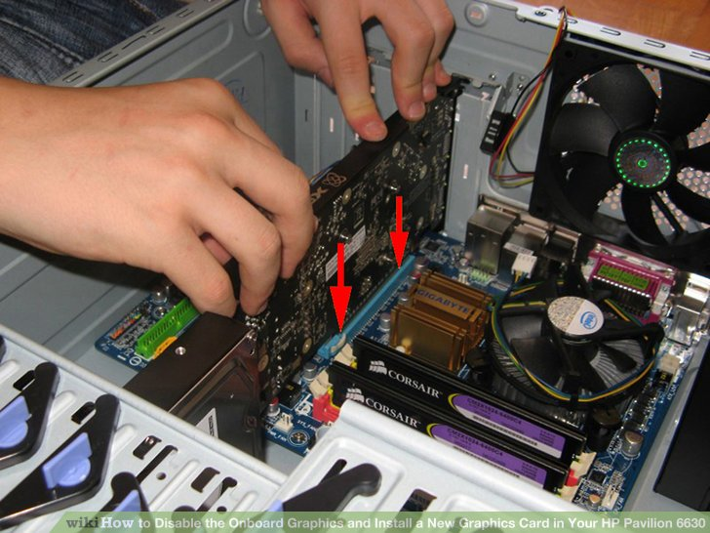
Remove the card gently from its bag, making sure that the card does not touch any electric component. Insert it straight into the empty PCI-e slot and apply even pressure to the top until it is placed correctly. Then, use case screws to secure the graphics card to the chassis.

Precautions:
- Make sure no cables or any other components are in the way before completely seating the card.

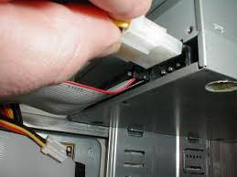
Step 7 - Install CD ROM

First, Insert the CD-ROM drive inside the drive bay slowly to make sure it will not get stuck. Then, fasten the CD-ROM drive with the locking mechanism and connect the SATA power cable to the CD-ROM drive. Connect the other end of the SATA power cable to the power supply and then Connect the SATA data cable to the CD-ROM drive. Lastly, connect the other end of the SATA data cable to the motherboard.

Step 8 - Install Hard Drive 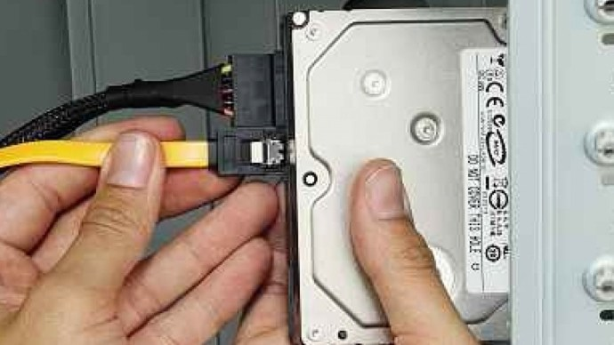
First, fit the hard disk into the bay. Then, plug in the SATA power cable. Be extremely careful when plugging it in, because any downward pressure can break the clip surrounding the power connector. Then, connect the SATA cable into the rear of the hard disk. Lastly, plug in the SATA cable into the motherboard.

Step 9 - Install SATA Cable
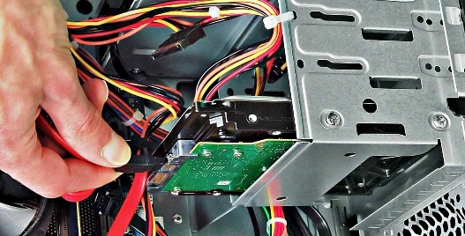

Connect the IDE cable, SATA cable and install the power supply. Connect the SATA power to a storage drive. Make the wire neat by tied it. This will help it in saving the space and hardware cooling.

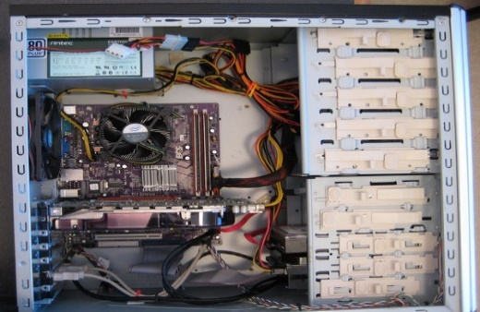
Step 10 - Install Switch Wire and USB

Connect the switch wire and USB onto the motherboard correctly. Note that every device that has been installed needs power. The power supply connectors are shown. The motherboard has two power connections, and there are two connectors specifically for SATA devices. The other connectors will run fans and other non-SATA devices. Data cables connect drives and front panel devices to the motherboard.

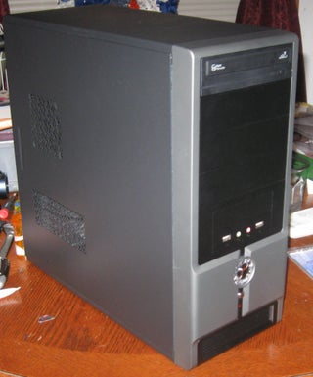
Step 11 – Closing The Case and Connecting The Peripherals

Install the side panels and make sure all the screws are tight enough to hold the side panels. This give a good protection from physical damage to the hardware inside. The computer is now ready for the software installation.
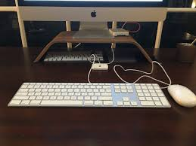

Connect the keyboard, mouse, wireless network dongle and webcams with CPU by plugging into USB port.
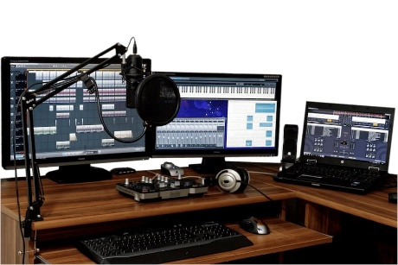

Then connect speakers and microphone into 2.5mm socket.

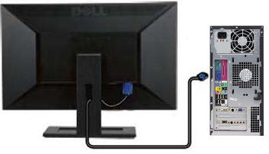

Finally connect the CPU with monitor by plugging into display ports.

