

REPORT DESIGN THINKING

SUBJECT:
SECP1513-02 TECHNOLOGY AND INFORMATION SYSTEM

TOPIC:
THE INTERNET, THE WEB AND ELECTRONIC COMMERCE

LECTURER’S NAME:
DR ARYATI BAKRI

GROUP MEMBERS:
NAME | MATRIC NO.
Hong Pei Geok | A20EC0044
Maizatul Afrina Safiah Binti Saiful Azwan | A20EC0204
Muhammad Dinie Hazim Bin Azali | A20EC0084
Nurfarrahin Binti Che Alias | A20EC0121
Singthai Srisoi | A20EC0147
Table of Contents

1.0 INTRODUCTION 5
2.0 DETAILED STEPS 6
3.0 DETAILED DESCRIPTION (PROBLEM, SOLUTION, TEAM WORK) 9
4.0 DESIGN THINKING ASSESSMENT 10
5.0 DESIGN THINKING EVIDENCE 11
6.0 REFLECTION 15
6.1 Hong Pei Geok 15
6.2 Maizatul Afrina Safiah Binti Saiful Azwan 16
6.3 Muhammad Dinie Hazim Bin Azali 17
6.4 Nurfarrahin Binti Che Alias 18
6.5 Singthai Srisoi 19
7.0 CONCLUSION 20
8.0 REFERENCES 21
9.0 TASK FOR EACH MEMBER 22

List of Tables

Table 5.1 Questions and answer for interview 12

List of Figures

Figure 2.1 Interview session 6
Figure 2.2 Discussion with group members 7
Figure 2.3 Problems and solutions 7
Figure 2.4 Process of making prototype 8

Figure 5.1 Group discussion session 12
Figure 5.2 Solutions for the problems faced 13
Figure 5.3 Our prototype 13

1.0 INTRODUCTION

Design Thinking is an iterative process to understanding problems that faced by people and find out solutions to overcome these problems. It is widely used in all field such as education and business to develop thinking skill. Design thinking consists of 5 phases which are Empathy, Define, Ideate, Prototype and Testing.
For this project, we will discuss about the Internet, the web and electronic commerce. Internet is the large global network connecting smaller networks all over the world. It can be used for communication, searching, entertainment, education and shopping. Most of our applications needed internet to work. As we know, the requirement of people toward the speed of Internet keep increasing. This situation encourages the development of Internet from 1G to 5G.
Next, web defined as multimedia interface to the resources available on the Internet and it consists of billion of webpages. We always obtained information from websites through Internet. It also developed from web 1.0 to web 3.0 which is widely used nowadays. However, some of them may consist inaccurate or inappropriate information which will misleading people especially kids. From the definition of Internet and web, we can know that these two are difference things although they always worked together.
Another term that we will discuss in this project is electronic commerce with short form e-commerce. Both web and e-commerce require internet to proceed. E-commerce is a business model that lets people buy and sell things over the internet. It does not need face to face interaction, all buying process will be run virtually. For example, Shopee, Lazada and Amazon. Thus, it is very convenient for people who have transportation problem but it also can cause the problems like scam.
In this project, we will focus our discussion on internet which including problems that faced by most of the users and try to find out solutions to overcome these problems. Before that, we have to study what is Internet, web and electronic commerce first in order to let our project carry on successful.

2.0 DETAILED STEPS

In design thinking process we have gone through five steps which are Empathy, Define, Ideate, Prototype and Testing. For the first step which is Empathy we have to view user and their behaviour (observe). Thus, we decided to make an interview with Mohd Zahari bin Zainal Abidin who is the admin of network in UTM on $3^{rd}$ of November through google meet. We have asked some questions to he during this interview session in order to more understanding what problems faced by users when using internet. We have also recorded the interview in the form of video and audio. Figure 1.0 shows the interview session with Mohd Zahari bin Zainal Abidin.
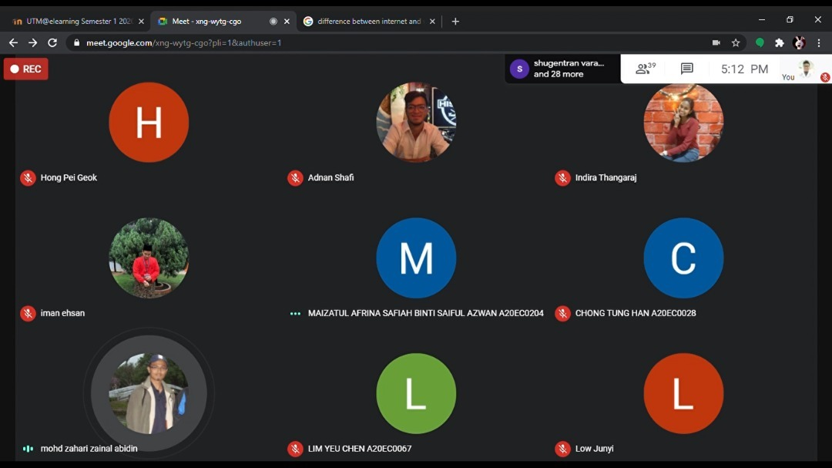
Figure 2.1 Interview session

After that, we moved to the next step which is Define step. We gathered all the information that we collected during interview and discussed it in our Whatsapp group and through google meet. Through discussion, we have figured out several problems that faced by users when using internet and found that the range of people that using internet are large. Every people have their own problems when using Internet. Thus, we decided to narrow our scope and focus our project on Internet problems that faced by kids. Figure 2.0 illustrates our group discussion through Google Meet.
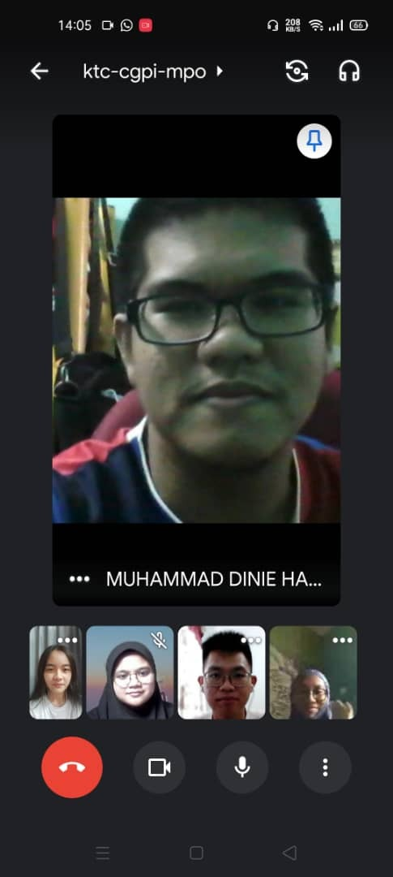
Figure 2.2 Discussion with group members
After we listed out all the problems that faced by kids, we started our third step, Ideate step. We have one session called brainstorming session, everyone of us started thinking as many solutions as possible to overcome those problems and we tried to find out the best solution through vote. In order to get the ideas to solve the problems, we have discussed the topic, problems and solutions together and shared our opinion. We have also searched information from different resources like book, Internet and newspaper. Figure 3.0 shows the problems and also solutions that listed by our group members.
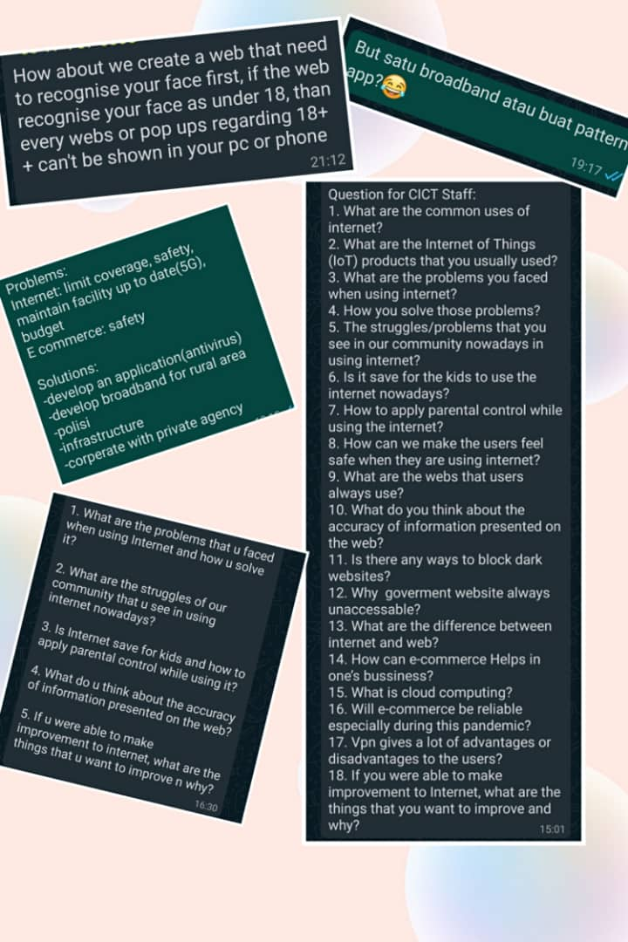
Figure 2.3 Problems and solutions

Next, in the prototype step, we decided to create a rough prototype of application that will automatic recognize users faces to determine their ages before they can enter certain web. This can ensure kids do not take the opportunity or accidentally enter certain unhealthy web through internet. This application can use in both mobile and laptop and it can use 3D face recognization. So, it requires real face and cannot use picture to log in. Figure 4.0 demonstrates our procedure of making rough prototype.
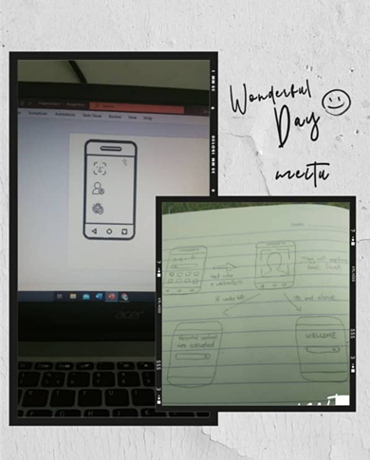
Figure 2.4 Process of making prototype

Lastly, we have tested our prototype to determine whether it can be function well or not and try to find out new solution to improve our prototype.

3.0 DETAILED DESCRIPTION (PROBLEM, SOLUTION, TEAM WORK)

The concerns we've found in the interview process are that there is a lack of safety for the users when browsing the web. Nowadays all users no matter what aged they can browse a lot of things through the internet. So, we as a group make a decision that we have to take a step to prevent this from happening and keep on worsening in our community.
All the members brainstorm together to figure out the best ways and solutions to solve these problems after all the problems are identified. Then the solutions are filtered and concluded. Since our primary emphasis is on users, we wanted to make it acceptable for the preference and circumstance of the users. The solution we have proposed is to build an app that can recognise the users’ age to restrict users from enter the prohibited site. For users that age 18 and above can access any website like usual while for users that aged under 18, they can only access certain websites to prevent them from any bad activity.
Arguments and difference of opinion are inevitable in our debate, but we are lucky that all of our participants are willing to consider the opinions of each other and eventually come to a consensus that everybody is happy with. Then the tasks are assigned to members of the community where someone is in charge of video editing, report writing, prototype producing. To enhance performance, all members assist each other in their duties and a harmonious environment is created.

4.0 DESIGN THINKING ASSESSMENT

The first phase that we have to face is empathize. This phase actually a skill that enables us to understand the same feelings that others feel and share them. Through empathize, we are able to put ourselves in the shoes of other people and interact with how they can feel about their challenges, problems and circumstances. So, in this phase our group decide to find and interview someone who is an expert and skilled in network as well as experience in facing problems in this field. Fortunately, we found UTMDigital staff who specialized in network, Mr. Mohd Zahari bin Zainal Abidin. Then, we conducted an interview with him and jotted down all his opinion and experience that he shared with us. We also asked a few questions regarding our topic. With all of the information that we gathered, we understood what problem and circumstances that faced by users.
The next phase is define. In this step, we start to examine all the data that we have about network and internet. Then, at the same time, we found that there are lots of advantages and disadvantages. We mainly highlighted the disadvantages for users especially aged 18 and below. We believe that these disadvantages are the problem that we faced nowadays.
Now we move to the next phase which is ideate. In this phase we brainstormed ideas and solutions for the problems we analyzed during the previous phase which was define. All members in the group shared their own ideas which leads to the production of the main idea
Lastly, prototype phase. We developed the idea using computer software as our prototype as we are facing pandemic COVID-19 right now so we were only able to do our tasks online via Google Meeting and Webex Meeting. We ensure that in the process of making prototype, the produced item is compatible with the main purpose which is solving the problem that user faced.

5.0 DESIGN THINKING EVIDENCE
a. The sample work by students working to solve the design challenge
Based on our discussion and investigation, we found that many kids were exposed to unhealthy web when they were using internet. Thus, this situation needed to be correct since kids are the people that needed for our country development. Therefore, we decided to develop an application that can recognise users faces and determine their ages.
b. Record for each phase
During the Empathy phase, we have prepared some questions to ask Mohd Zahari bin Zainal Abidin who is the amin of network in UTM. He has 17 years of working experiences in UTM.
Table below shows the questions that we asked during interview and also answers.
No | Questions | Answers
1 | What are the problems that you faced when using internet and how you solved it? | No problem for me but because UTM area is too big so there were many students cannot used Internet or too slow but I have told they can make complaint to Digital centre and I will check it and try to solve it.
2 | Is Internet save for kids and how to apply parental control while using it? | We have software in our laptop or pc so we can manage by our own. The software can prevent the kids or students access dark web or any other dangerous web. Parents can also monitor how long their kids using gadgets by using phone or pc.
3 | If you were able to make improvement to internet, what are the things that you want to improve and why? | We need to upgrade ICT and prepare facilities to convert from 4G to 5G and also need to secure our network because some students connect to UTM wifi but they do not install antivirus in their laptop so this will harm our system.
Table 5.1 Questions and answer for interview

In the Define phase, we have discussed the problems from our interview session. We know some of the Internet problems that faced by users including coverage and safety. These were the common problems that faced by users not only adult but also kids. Figure 5.0 shows our discussion about responses from interview session.
Figure 5.1 Group discussion session

In phase three which is the ideate phase, we have brainstormed and got ideas as many as possible. After that, we have voted to the idea that we thought it is most functional and effective. The result came out was we decided to make an application that can recognize users faces and determined whether their ages qualified to enter certain websites. Figure 6.0 illustrates our idea for solutions to overcome problems.
Figure 5.2 Solutions for the problems faced

In the prototype phase, we made a handphone and application of scan face to test whether users age is below 18 or not before get into certain web by using computer software. Therefore, we can visualize this application and recognize and problems of the application for improvement. Figure 7.0 is our final prototype.
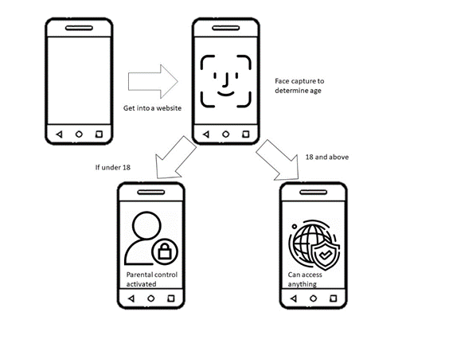
Figure 5.3 Our prototype

c. This is the YouTube link to the video we make for this project and video footage of our interview with the respondents :
https://youtu.be/oH9vLz4-W04

6.0 REFLECTION

6.1 Hong Pei Geok
My dream with regard to my course which is computer science is become a professional data engineering. This is because a data engineering can help other solve their problems in computing no matter in software or hardware. I think this career will be the most demand career in future as the world is always change and become an era full with advance technology.
This design thinking project is the first project that I do related to my program of study which is Bachelor of Computer Science (Data Engineering). Due to our project title is about Internet, web and electronic commerce, I have learnt many new things that I never think about before this. This project helped me more understanding how to solve problems and enhanced my critical thinking skill. I think these skills are important for us to be success in our future.
I believe that everyone of us have targets or purposes that we wanted to be achieve during these four years of study. For me, I want to improve my soft skills which are leadership and communication skills during the life in University. Thus, the first step is I needed to be brave and get involved in every discussion during the project. As we know, soft skills are the main requirement for company during recruitment. So, I will try my best to improve myself in both knowledge and soft skills.

6.2 Maizatul Afrina Safiah Binti Saiful Azwan
My goal towards this program is to be a successful data engineer. I hope that I can contribute a lot to my faculty and my campus.
This design thinking makes me realized to achieve our goal we have to study hard and always hands-on with our work. Not just reading it but we have to do it. Moreover, design thinking shows that in every project that we do we have to plan it one by one which is empathized, define, ideate, prototype, and testing. It shows that every decision that I make I have to plan and test it when everything is done.
I think the first improvement that I will make is to improve my critical thinking skills. Without critical thinking skills, I cannot have a great idea when doing my project. I will take more action in doing exercise and discipline myself to have those skills needed. This skill can also be apply in my future when I work.

6.3 Muhammad Dinie Hazim Bin Azali
My goal for this course is of course I want to learn something new about technology that I never know. This design thinking give impact on me because many I can learn from it such as editing video, interview someone and writing a report. The improvement that I need to do to my potential in the industry is my soft skills because I think I still lack of soft skills especially talking to someone.

6.4 Nurfarrahin Binti Che Alias
Throughout this project, I have learnt the difficulties of carrying out assignments online instead of face-to-face. However, my group and I can handle the situations well. Besides, I have learnt the importance of teamwork especially when working on a project and the amount of pressure that we need to handle as a team. Furthermore, this project has broaden my knowledge and widen my perspectives in technology compared to before. Considering soft skills are most needed when I want to get a job after I graduated, I also learnt to speak up my thoughts in giving suggestions and overcome my fear to communicate with people. Therefore, I think this project has given me so much benefits that I can apply in the future.

6.5 Singthai Srisoi
What I expect to get from this program is to get knowledge of technology in different dimension. I would like to know what the technology meant to a teacher, a student, or any other position in the society. With this program, I can do more research by interview or form internet. Other than that, I learnt some skill to cooperate with my teammate and communicate skill. For now, I realize I am lacking experience in communication. So, I will try to be more active in class or in a group assignment.

7.0 CONCLUSION

In conclusion, this design thinking project had taught us many useful things like how to find out problems and overcome it with our own ideas. The five phases in Design Thinking were Empathize, Define, Ideate, Prototype and Test which can help us in problem solving. During the Empathize phase, we need to know what problems were faced by users so we have an interview session. This can help us improve our communication skill because we have asked some questions to interviewer. After we understood the problems, we moved to Define phase in which we need to gather all the information and problem together. Next, we started to brainstorm ideas and listed all the solutions that we have think in order to find out the best solution. Finally, we can use our creativity to build a prototype and tested it again and again in order to make it perfect. Throughout these phases in design thinking, we have gained a lot of experiences and knowledges which we cannot obtain it from book. We also have been given opportunities to improve our soft skills like leadership, communication skills and creativity. We are so glad as we can involved in this meaningful and amazing project.

8.0 REFERENCES
1. Dam, R., & Siang, T. (n.d.). 5 Stages in the Design Thinking Process. Retrieved November 13, 2020, from https://www.interaction-design.org/literature/article/5-stages-in-the-design-thinking-process
2. Dam, R., & Siang, T. (n.d.). What is Design Thinking and Why Is It So Popular? Retrieved November 13, 2020, from https://www.interaction-design.org/literature/article/what-is-design-thinking-and-why-is-it-so-popular
3. Stevens, E. (2019, July 09). The Key Principles And Steps Of The Design Thinking Process. Retrieved November 13, 2020, from https://careerfoundry.com/en/blog/ux-design/design-thinking-process/
4. Stevens, E. (2019, July 09). The Key Principles And Steps Of The Design Thinking Process. Retrieved November 13, 2020, from https://careerfoundry.com/en/blog/ux-design/design-thinking-process/

9.0 TASK FOR EACH MEMBER



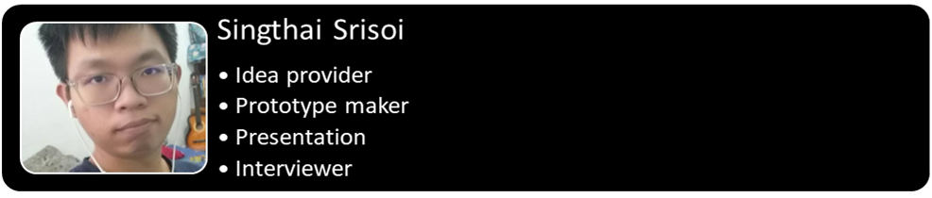
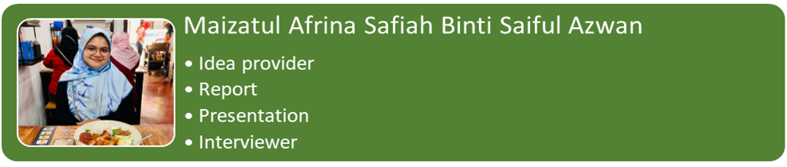

Link of video presentation on Chapter 2: The Internet, The Web and Electronic Commerce
https://youtu.be/2wnZbLley0U

