School of Computer Alumni Sharing Session

December 29, 2020 - A sharing session from the alumni of UTM Computer Science students was conducted via the Webex meeting platform. The topic is ‘Inspiring Work Experience & COVID19 Pandemic Challenge’. Three alumni have joined this talk. These alumni were chosen as they managed to get a secure job in a short time. Tan Yong Keong was the first alumni to share their work experience. He was a student of Software Engineering, graduating from UTM in 2019. His current position is Data Science Engineer at Micron Semiconductor Asia Operations Pte Ltd in Singapore. The next alumni are Qistina Batrisyia Binti Azman Shah. She is a Data Engineering student who graduated from UTM in 2020. Now, she is a Social Media Data Analyst, working at TM One for almost a year, including her internship. Next, the third alumni are Mohamad Zamarul Akmal Bin Mohd Hussin. He is also a fresh graduate student with a degree in Data Engineering and is now a Data Engineer working at PPG Coatings (M) Sdn. Bhd. In addition, Dr. Johanna Ahmad, moderator of this talk, shared her experience as a Software Engineer and Data Administrator for about 11 years before becoming a senior lecturer at UTM.

One of the purposes of this talk was to give a true picture of the world of work to year 1 students. Immediately, they can find out how to get a job, undergoing an interview session, and can make initial preparations starting from now. Next, students will be given guidance and tips on managing time and stress so that they will always be self-motivated to perform every task or activity. This talk is also capable of making students aware of the importance of participating in co-curricular activities and competitions. Students can therefore broaden their points of view, add experience, and hone communication skills.

First, Dr. Johanna Ahmad introduced three alumni members. After that, Yong Keong explained the journey of his success. “I participated in a lot of competitions and gained some professional skills. I did an internship in ViTrox and received the Chancellor Award from UTM. It is important to have a soft skill because more companies will prioritize it”, said Yong Keong. After that, the moderator asked how Zamarul and Qistina got his job as a fresh graduate. Both have been absorbed as permanent staff as their internship is in their company. Her current project is a social media project that gathers all social media data and transforms it into a dashboard for client and management. “To increase the possibility of getting hired, we need to excel in python programming and, most importantly, be effective and proactive,” said Qistina. Zamarul told us that we should learn more new technical skills outside the university, because it will make us different from others and more reliable. Next, the moderator asks the alumni on how to improve the programming subject. Yong Keong explains that we need to practice more as practice made perfect. Following on how to increase our confidence, “I joined a lot of competition that required me to present, which increased my confidence”, said Yong Keong. While for Zamarul, he always volunteers to present the assignment and programming code to the client. Next, Dr Johanna asks the alumni which they prefer compared with study life and career life. “I prefer to study life as now I just have free time during lunch hour and weekend”, said Zamarul. The next question is how to motivate ourselves in our university life. For Zamarul, he always told himself that he is a lucky person to have this chance to perform well and he should achieve the best result in his task. The question is deeply to how they motivate themselves in university life. For Zamarul, he always told himself that he is a lucky person to have this chance to perform well and he should achieve the best result in his task. Lastly, Q&A session with the alumni. Finally, it is the end of the sharing session, and Dr. Johanna wishes us all the best after receiving this wonderful talk.

There are a lot of things we have learned from the Alumni Sharing session, to attract companies to employ us, being proactive is one of the most important. We cannot deny that academic results are what are eligible for employment, but there is also a great need to be hungry to get hired. Being proactive means when there are tasks given, an employee must try to learn how to do the tasks, instead of waiting for someone to teach. Next, we need to learn new technical skills by taking extra courses online. Besides, joining these courses may provide us with certificates that can be attached on our resume. Not only that, but soft skills also play a key role in employment. When we are working, everything needs communication. It is important to voice out our own opinions and ideas so that we can understand the purpose of the project and work as a team. We need to practice frequently to improve on what we are doing. In general, learning and reading concepts will not help all the time. Being practical will give us experience that will be useful in our workflows.

Reflecting on the talk, “There are a lot of inspiring tips that I get, especially on how to secure a job. One of the tips is developing soft skills like communication skills. The most important thing the company is looking at is the soft skills, not only the examination pointer. Therefore, I need to work hard while in UTM to be ready for my industrial training. Next, the talk emphasizes the current condition which is the COVID-19 pandemic. Honestly, I think that it will provide more points if there are also some alumni who have been in the industry for so long as they have more experience.” said Madina.

“This talk is giving motivation and exposure for year 1 students including me about how university’s life and working environment looks like. It is a wise action for students to gain information to start preparing for the future. However, this talk is too short and many of the alumni shared the same experiences. I hope there will be another opportunity to gain this experience from other alumni with different backgrounds. I had learned many positive inputs from this talk inspiring me to sharpen my skills and widen my knowledge. Thus, I will work smart and enhance my soft skills for a better future.” said Syamalia.

“This talk gave me a lot of motivation and inspired me a lot. The alumni introduced some sources such as code camp, edx and Linkin learning which can increase our skills as programming language is a practice make perfect subjects and shared the tips on how to get hired. I think we as first year students want to know which company is the best company to work with to give us a direction in the future. The motivation that I got is from Zamarul, who mentioned that not everyone has the chance like me to study at UTM. This statement is very true, and I should work harder in the future.” said Junyi.

“I learned a lot from the talk, mainly on how to improve our soft skills in communication and programming skills. From there, I get the motivation to make myself better and of course, it is for the future of my work. Although skills are more important in industry, obtaining the First Class Honours cgpa is an achievement to compete with people out there. The talk would have an impact on a new student to learn more about this course. Even though I do not think the talk touches more deeply on how the industry's life, but it is a valuable sharing.” said sakinah.

“The talk has taught me that life after studying is not easy. Jobs are now very limited, and the increment of unemployment happens for a reason. We need to compete with many people out there. The seniors have shared their experiences and few tips on how to get employed. Being proactive and having good communication skills will always help. Not only that, listening and attending the talk really makes me more eager to improve my technical and soft skills because I know that the future will be more and more difficult especially for fresh graduates.” said Imran.
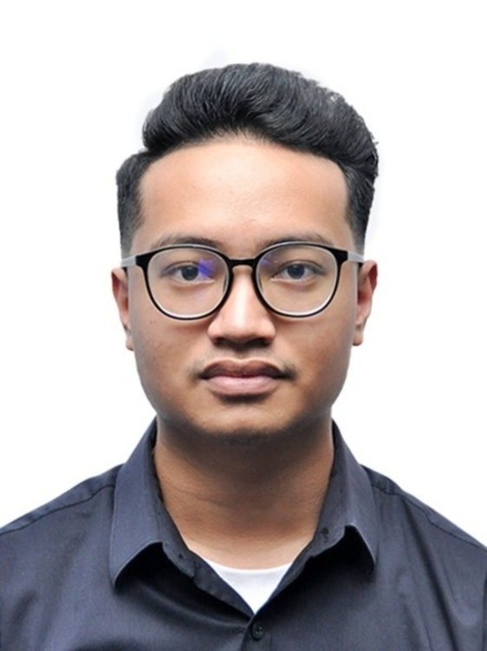
Muhammad Imran Hakimi

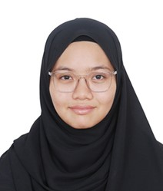
Low Junyi Madina Suraya
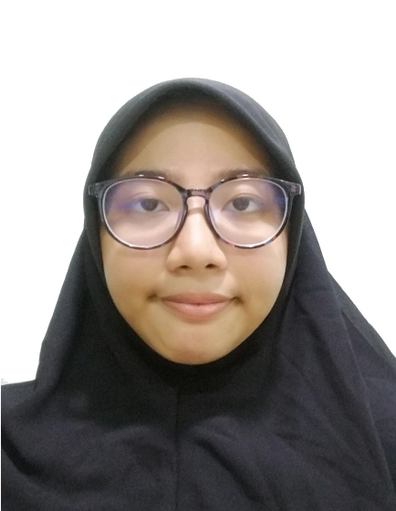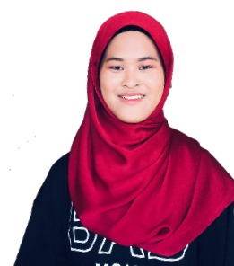
Nur Syamalia Sakinah Al’izzah
Faiqah

