Cloud Computing Fundamentals-
Literature Review on Cloud Computing Service Providers
$${Lee Cai Xuan}^{1}, {Chong Kai Zhe}^{1}, {Nayli Nabihah binti Jasni}^{1}, {Afif Hazmie Arsyad bin Agus}^{1}$$
$$1_{ Sultan Ibrahim Chancellery Building, Jalan Iman, 81310 Skudai, Johor}$$
{Lee Cai Xuan, Chong Kai Zhe, Nayli Nabihah binti Jasni, Afif Hazmie Arsyad bin Agus}

1 Introduction
In 1961, John McCarthy introduced the idea of ‘computation being delivered as a public utility’. Over the next five decades, various technology innovation enabled today’s cloud computing. Cloud computing provides modern alternative to the traditional on-premises data center. It provides an online portal for users to easily manage compute, storage, network and application resources. There are private cloud and hybrid cloud. In private cloud, we create a cloud environment in our own data center and provide self-service access to compute resources in our organizations. While, a hybrid cloud integrates public and private clouds. It allows us to host workloads in the most appropriate locations. There are some examples of computing clouds such as Microsoft Azure and Google Cloud Platform.

Microsoft Azure
Microsoft Azure is Microsoft cloud computing platform that provides a wide variety of service without purchasing or provisioning our hardware. It enables rapid development and provides resources that accomplish tasks that may not feasible in an on-premises environment. Microsoft unveiled Window Azure in early October 2008. Later in 2014, Microsoft changed its name from Window Azure to Microsoft Azure. Microsoft deployed Azure data-centers in many regions across the globe including China and Singapore. Therefore, using Azure makes it easy for enterprises of any size to gain the ability to deploy their service close to customers.

Google Cloud Platform
Google Cloud Platform is built on the same world-class infrastructure that Google designed, assembled and uses for corporate products like Google search. It provides series of modular cloud services including computing, data storage, data analytic and machine learning. In April 2008, Google offered a platform for developing and hosting web applications in Google-managed data centers. Google Cloud Platform is a part of Google Cloud that enterprises version of Android and Chrome OS and application programming interfaces (APIs) for machine learning.

2 Comparative Evaluation of Microsoft Azure and Google Cloud Platform

2.1 Service Model (IaaS, PaaS, SaaS)
Infrastructure as Service (IaaS) enables to create virtual machines that run on vendor’s infrastructure. Azure provides the ability to set up virtual networks, load balancers and storage. Azure IaaS offers Azure Virtual Machines that enables ‘lift and shift’ model for migration. We can configure a virtual machine similar to the infrastructure currently running out services in our data centers and migrate our software to new virtual machine. There are many applications can be migrated in this manner. In Google Cloud Platform, Compute Engine provides as IaaS. This is because the system of Compute Engine can provide a robust computing infrastructure.
In Platform as Service (PaaS), Microsoft Azure provides Azure Websites and Azure Cloud Services. Developers do not have to create virtual machines and only need to us Remote Desktop to log into each other and install the applications. In Google Cloud Platform, App Engine provides a service as PaaS. With App Engine, Google can handle most of the management of the resources of us.
In Software as Service (SaaS), Microsoft Azure provides Microsoft One Drive, Dropbox and Wordpress. Office 365 is prototypical model of a SaaS offering. Subscribers can pay monthly to get Exchange as Service, Storage as Service and the rest of the Microsoft Office Suite. On the other side, Google Cloud Platform has SaaS built-in to build better product and grow the business through the internet. With Google Kubernetes Engine, we can easily deploy our products across global cloud network.

2.2 Virtual Machine (VM) instance types offered
Type of VM | Microsoft Azure | Google Cloud Platform
General-purpose | -Suitable for small to medium database and low to medium traffic web server | - Suitable for medium-large database  -Web serving and App serving
Memory-optimize | -Suitable for relational database server  -Suitable for medium to large Caches | -Suitable for large-in-memory database  -Used for genomics analysis and in-memory analytic
Compute-optimize | -Suitable for network appliances and batch processes | -Suitable for gaming and single-threaded applications

2.3 Storage
In term of storage, both of the clouds offer 5 tier of storage services. This comparison will only show the benefits and features for both cloud services. For the first services which is object storage. Microsoft Azure object storage is called Azure Blob Storage while for Google Cloud it is called Google Cloud Storage. Azure Blob Storage provides REST API, Powershell and CLI access. Meanwhile Google Cloud Storage optimizes price and performance using Object Lifecycle Management. Moving on to the next storage services which is persistent disk storage. For HHD or SSD, Azure managed Disks offer Ultra disk SSD with up to 2GB per second, 1.6m IOPS while Google persistent disk offer the cheapest price and performance for both HHD and SSD. The third services are file storage. Azure Files provides access to files via standard SMB protocol while Google Cloud Filestore offer NAS access and integrates with GKE (Google Kubernetes Engine). The fourth services which is Cold Storage. Azure Long-Term Storage offer hot, cool and archive access tiers while Google Nearline & Coldline offer cold storage with sub-second response times. For the last storage services which is Data transfer. Azure Import/Export Service offers a data transfer command tool and an option for shipping physical drives. For Google Storage Transfer Service, it offers API and console access and let user schedule data transfer tasks. In general, Microsoft Azure is a fully developed set of storage services and offers many features. Azure services can be hard to learn if the users do not have background in Microsoft technology. Meanwhile Google storage services offers less features than Azure but the price is also less than Azure and easy to use. The better storage services will be Google Cloud Storage.

2.4 OS environment offered
In computer software, an operating environment or integrated applications environment is the environment in which users run an applications software. An operating environment is usually not a full operating system, but in is a form of middleware that rests between the OS and the application. On all main operating systems, such as Windows, Mac OS and Linux, both Azure and Google Cloud are compatible. Regardless of their preference of operating system, the two services are offered to almost everyone, which can be called a user-friendly service. While certain applications, such as Microsoft Azure SDK Installer for Mac OS and the latest version of Nod, must be installed for Mac and Linux users.

2.5 Security
Security is the most important thing needed for every company because they will hold a lot their users’ data and information. Both Microsoft and Google are renowned for providing the highest levels of cloud security. At a high level, they deliver security in three ways. The first way is Security of cloud platform which is delivering security capabilities that are built into the infrastructure of the cloud platform, providing protection by default. Next is security in cloud platform which deliver security products and services within the platform that can be configured to protect your applications and data. For the last way is Security anywhere which is expanding security capabilities beyond the cloud platform to protect your assets regardless of location. To say it in easier way, Azure compliance is the highest of any cloud provider, meeting 90+ compliance standard across region while Google compliance meeting 45 compliance standard. Next, Azure and Google cloud support encryption as default using 256-bit AES. Microsoft refers to Azure services as Key Vault while Google refers its services as Cloud Key Management Service. For firewall, Azure offers additional firewall as service product including Azure Firewall, Azure Web Application Firewall and Azure Firewall Manager. To conclude, Microsoft Azure cloud offers more features compared to Google Cloud which means Azure has the better security.

2.6 Performance, Scalability & Autoscaling

Next aspect is based on performance and scalability. Both performance and scalability are an important aspect in cloud computing in terms of optimization and growth of it. Performance in cloud computing is important when it comes to maximize the data transfer in an instant. Scalability is one of the essential parts in the scope of performance. Scalability in cloud computing focused on the potential to increase and decrease needed resources according to demand required. Microsoft Azure and Google Cloud Platform prepared different variety characteristics to provide the best performance for different purpose of the users. Microsoft Azure includes a characteristic that supports auto-scaling for certain users according to their needs. In Microsoft Azure, the process of auto-scaling is much easier than the traditional way as the server is not involved in this process and does not require the users to check the metrics one by one. However, this feature is only provided for certain type of subscriber only. Google Cloud Platform also provide the users with an auto-scaling configuration. Almost same as Microsoft Azure, Google Cloud Platform give the users choices on various input. Users allow to set the minimum and maximum limits of scaling behavior and produce a ‘multiple scaling policies’ for different unique scenes. Both clouds gave out different features to suit their users need but maintain the main purpose of auto-scaling which to provide the automatic scale of computing resources used by the app.

2.7 Pricing Model

There are two types of pricing model which are fixed and dynamic pricing models. Both two of them are significantly different from each other as it provides the users different features as well. Fixed pricing model is named as it is because it has a stable maintaining price a long period of time. Dynamic pricing model also known as Real-time pricing is calculated based on the features used by the users for their own demand and move along the time it being used. Microsoft Azure and Google Cloud Platform offer both type of pricing models but in different rates. Each cloud services pricing can be varied based on the locations and zones for example, Google Cloud Platform monthly charged for network usage is $0.12/GB for every 0-1TB and this price is the same all around the world except Australia and Asia. Microsoft Azure provides four different zones for their users such as Zone 1, Zone 2, Zone 3 and DE Zone. These zones have specific pricing rates and different from each other because of the bandwidth offered. Azure datacenters are place in which data is moving in and out. Most inbounds data are free to be sent to the datacenter but the process of moving it out require users to pay for it. To perform this, users need to pay according to the price set for each different zone provided. For each type of feature, both cloud services offer different prices for each of it. So, it is hard to say which one of it is to decide which one is more worth it. To get the most worthwhile price, users should specifically know what type of cloud services they mostly need to use and compare the price rates between the services.

2.8 Monitoring tools/services
2.8.1 Microsoft Azure
Azure Application Services Diagram
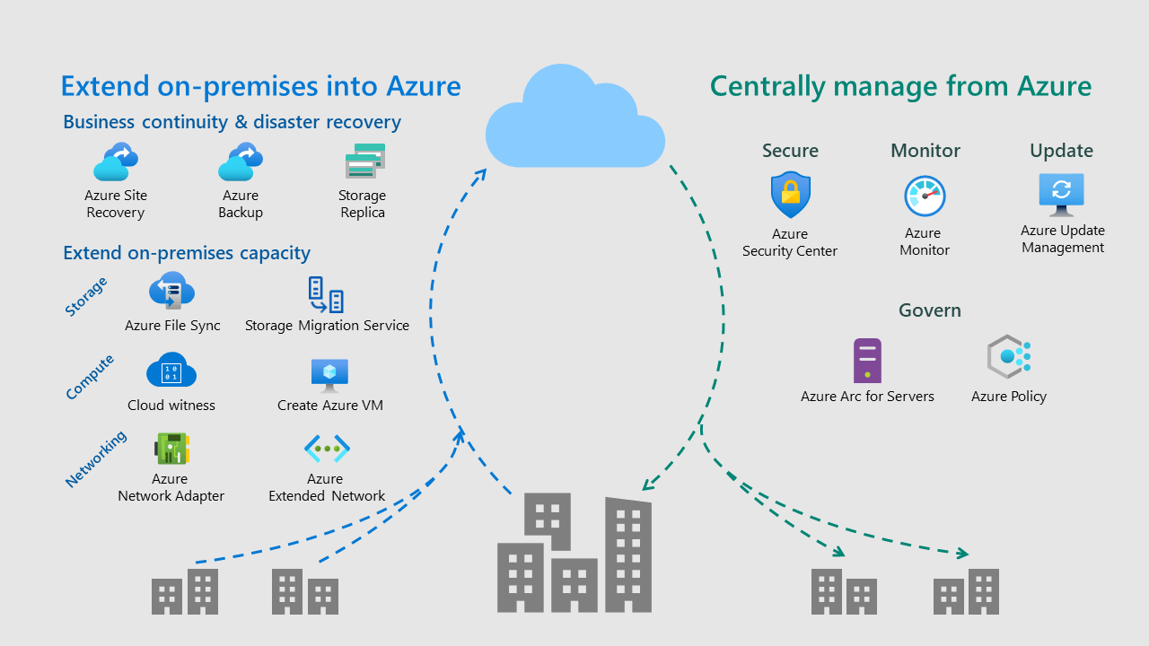

2.8.2 Google Cloud Platform
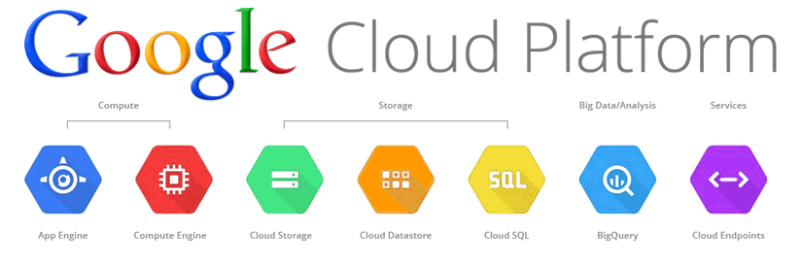
3 Comparison between Microsoft Azure and Google Cloud Platorm

 | Microsoft Azure | Google Cloud Platform
Object Storage | Provides REST, API, Powershell and CLI access | Optimizes price towards the performance using Object Lifecycle Management
Persistent Disk Storage | Offers Ultra Disk SSD | Offers cheapest price/performance for HDD or SSD
Data Transfer | Offers a data transfer command line tool and an option for shipping physical drives | offers API and console access and lets you schedule data transfer tasks
Function as a Service | Offers an end-to-end experience from coding to deployment and monitoring | emphasizes simplicity
Billing and Pricing | Price per month: $ 627  Price per hour: $0.166 | Price per month : $ 421  Price per hour: $0.150
After knowing both Microsoft Azure and Google Cloud Platform with the varieties that showed in the table, we will choose Google Cloud Platform as our choice. The reasons of us choosing Google Cloud Platform is because Google Cloud Platform is cheaper in term of cost, as we see in the table, Google only costs $ 421 monthly and Azure has cost $ 627 monthly, the difference between the price is $206 which is a lot for us as a student’s perspective. Not only that Google Cloud Platform are more into simplified for the service, which will help us easier to know how to use it.

4 Conclusion

Microsoft has larger user base and are located in more regions than Google Cloud Platform but we could not deny that Google Cloud Platform also has some advantages that will affect people choices. In future Cloud Computing will be trend, as cloud computing allows people access to any resources as long as there is Internet and cloud computing will update and have constant maintenance to ensure it works in the optimum ways. Not only that cloud computing also has the best security systems.

5 Reference
- Collier, M. and Shahan, R., 2015. Microsoft Azure Essentials-Fundamentals of
Azure. Microsoft Press.
- Gonzalez, J.U. and Krishnan, S.P.T., 2015. Building your next big thing with
Google cloud platform: A guide for developers and enterprise architects.
Apress.
- Duan, Q., 2017. Cloud service performance evaluation: status, challenges, and
opportunities–a survey from the system modeling perspective. Digital
Communications and Networks, 3(2), pp.101-111.
- Ahmad, A.A.S. and Andras, P., 2019. Scalability analysis comparisons of
cloud-based software services. Journal of Cloud Computing, 8(1), pp.1-17.

