Alumni Sharing Session – Inspiring Work Experience and Covid-19 Pandemic Challenge
December 29, 2020-Technology & Information System, School of Computing has held a program called Alumni Sharing Sessions to students who take the subject Technology & Information System (SECP1513) under University Technology Malaysia. This program was carried out via Webex and hosted by Dr. Johanna Ahmad. The program was attended by 4 alumni. The first alumni is Mr. Tan Yong Keong who was graduated from Software Engineering and currently working as Data Science Engineer. Next, Mrs. Qistina Batrisyia Binti Azman Shah who studied in Data Engineering and now she works as Social Media Data Analyst in TM One. The next alumni is Mr. Mohamad Zamarul Akmal Bin Mohd Hussin who was also graduated from Data Engineering and currently working as Data Engineer.
The purpose of this talk is to invite past year graduated students which all of them had successfully got their job after graduation. The talk was mostly attended by first year students who take the Technology and Information System course. The main purpose of this sharing sessions was for students to learn on how to get employed by higher chance and how to successfully graduate from university. The talk also enabled all the students who attended to learn from the speakers journey during their degree time until they get their job.
The sharing session is started with Dr. Johanna Ahmad introducing all the alumni. Then, it continued with the first question which is how they manage to secure their job. “I love to participate in many competitions and it helps me to gain more skills that are required for interview and internship” answered Mr. Tan. Then, Mr. Zamarul mentioned that his supervisor had gave his attention to him when he was able to come up with many great ideas in his career. This helps him to get a permanent job.
After that, Mr. Tan shared about how he managed to learn new language in programming. “We do not have to memorize all the function of the code but we need to understand the concept of the language. So, it will be easier for us to apply the code in different situation” said Mr. Tan. Next, all the alumni shared their tips on how to have a higher chance to get hired such as learn technical skills, join programs to gain experience and be proactive.
The next question is asked by Dr. Johanna Ahmad about how to improve programming skills. Mr. Tan advised all the juniors to always do programming exercise and try to think that programming is a way to create something new which could help many people Then, all the alumni shared about the way to gain their confidence. Mr. Tan and Ms. Qistina both agreed that confidence can be trained. Besides, Mr. Zamarul said that he always volunteer to expose and present his project in front of others to develop his confidence.
They also shared their opinions about the differences between study life and career life. Mr. Zamarul said he enjoyed study life because he has a lot of free time. He also emphasized that responsibility is very important to finish the task in his work. He said that if someone made a big mistake in the company, it can affect his future career. During QnA session, there are student asked about the importance of CPGA to get a job. All the alumni agreed that in order to get a job, students must get at least 3.0 points for their CGPA.
At last, all the alumni advised that all the juniors should take chances to learn and develop more skills. The sharing session is then ended with blessing words like “good luck”, “stay safe” and “don’t stressed out” from all the alumni.
Alumni Sharing Experience Talk is centered to the happening of their pasts on how they managed to be a successful employee in their respective companies. All three speakers share their knowledge on working situations, some tips on how to be a great employee and briefly about the projects they worked on. The speakers also talked about their unique ways on how they secure their job even if they were only fresh graduates at that moment. Some of them were absorbed by their internship company and the other managed to get his from based on the interview he went for the company he chose. They also highlight actions that we as students can practice to improve ourselves. Overall, from this talk session, we can use their experience as a guideline for us in the future if we encounter similar situations and we can practically try to do it too.
“From this talk, I get to know some of the situation that I need to be prepared as an employee. This talk also gives me some clues on what strength should I focus on for my future. I think the weakness of this session is the fact that it is held online, it may be hard for me to focus on what they talked about because of distractions around me. All of the speakers experiences opened my eyes on how important it is to continue practice what we have learned because it can be useful for me in unexpected times” said Nayli Nabihah binti Jasni about her reflection.
“I realize that as a student, we have so many potential but we need to stay motivated to learn more. We must always be proactive to ask question. So that, we can learn from our mistakes and get more inspiration. We must value the time in university to develop more skills and learn the knowledge that are not taught in the class. Besides, I realize that we must start to prepare ourselves in order to get a good job after we graduate” said Lee Cai Xuan.
“ The strength of the talk is that they really showed me that a great academic is not a determinant for the future career. There are other more skills and general knowledge that is needed in order to get a job. The weakness for this sharing session is the session was held online because of the pandemic. Overall, this sharing session has motivated me to be an enthusiastic in seeking knowledge and participating in upcoming activities. It taught me that just do what I love and never give up on it” said Afif Hazmie Arsyad bin Angus.
“From this talk, I realized that in order to get a better job, I have to be more brave to attend more activities and try the best to perform. Listening to the experience of the speakers, I know that having good results, good communication and able to think out of the box are the qualities to bring us to bright future. This talk has makes me to overthink about myself, so that I know what I had and what is lacking off” said Chong Kai Zhe.

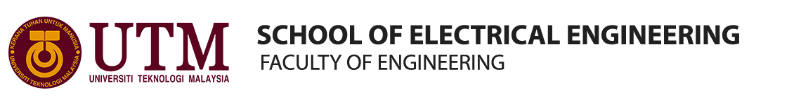
Technology and Information Systems (SECP1513)
Group: Group 5
1 | 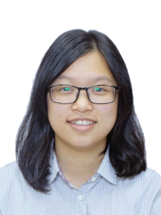 | Name: Lee Cai Xuan  Matric Number: A20EC0062  Phone Number: 0175893741  E-mail: leexuan@graduate.utm.my
2 | 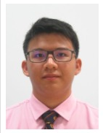 | Name: Chong Kai Zhe  Matric Number: A20EC0186  Phone Number: 0174551376  E-mail: k.zhe29@gmail.com
3 | 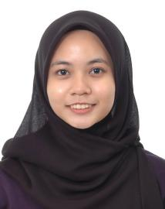 | Name: Nayli Nabihah binti Jasni  Matric Number: A20EC0105  Phone Number: 0192463571  E-mail: naylinabihah@graduate.utm.my
4 | 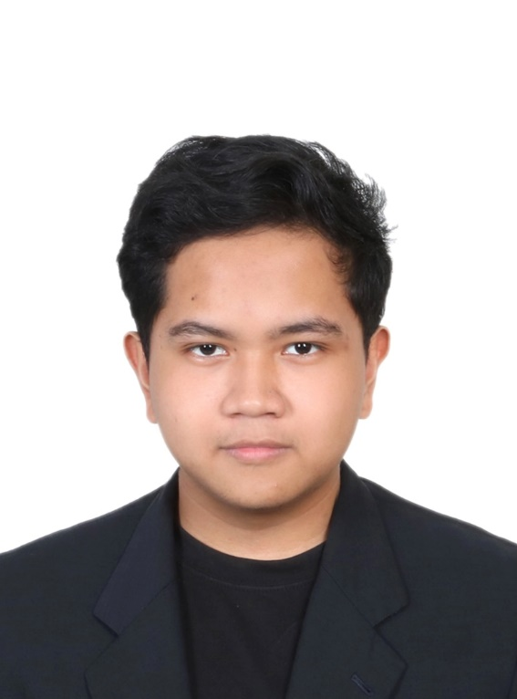 | Name: Afif Hazmie Arsyad bin Agus  Matric Number: A20EC0176  Phone Number: 0197910545  E-mail: afifhazmie2@gmail.com

