
REPORT:
DESIGN THINKING

SUBJECT:
TECHONOLOGY AND INFORMATION SYSTEMS (SECP1513-02)

GROUP/TOPIC:
GROUP 5: INPUT AND OUTPUT

LECTURER:
DR ARYATI BAKRI

NAME | MATRIC NUMBER
Lee Cai Xuan | A20EC0062
Chong Kai Zhe | A20EC0186
Nayli Nabihah binti Jasni | A20EC0105
Afif Hazmie Arsyad bin Agus | A20EC0176

Content

Introduction 4
Empathy 5
The Interview 6
Define 7
Ideate 8
Prototype 10
Testing 15
Reflection 16
Reference 18
Video Link 19

List of Figures

Figure 1 : Empathy map 5
Figure 2 : Microphone 11
Figure 3 : Sketch of prototype 11
Figure 4 : 3D model prototype 12
Figure 5 : Foldable headset 12
Figure 6 : Step 1 13
Figure 7 : Step 2 13
Figure 8 : Step 3 14
Figure 9 : Step 4 14

Introduction

Input and output may sound familiar to anyone around the world. Input and output brings different meanings in different categories such as, if in economics, input is defined as ingress of a production process and output carries the meaning of egress of any production process. However, the common thing that any human being can relate input and output with is technology. Nowadays, everyone knows how to use computers, tablets and also smart phones regardless how old you are or what your gender. People work with input and output everyday throughout their working and leisure time. So, basically input is data that is obtained by a computer and output is the data sent out by a computer. Input devices use is to digitalize raw data in order to be received by the system unit. In example, input devices are mice, keyboard, touch pad and also microphone. Meanwhile, output devices are sort of a platform used by system units to send the processed data and the examples of output devices are printers, projectors and also speakers. Hence, input and output are the essential devices in order for computers or digital technologies to be operated smoothly.

We are generating a design thinking report based on input and output. Design thinking is actually a process in which we try to deeply acknowledge the difficulties that users encounter, then, try to look into a smaller scope to identify the main problem, and find other possible solutions from the problem identified based on what we have learned. Each of these processes have its own significant usability. Design thinking projects are one of the ways for students or professionals to make use of to improvise anything.

Design thinking includes five different phases as listed below:

- Empathise - understand the users situation
- Define - in this phase, problem should be derived as the difficulties is identified
- Ideate - seek for the ideas based on problem occurred
- Prototype - sketch and clearly know how the product can help users
- Testing - final phase to see if the prototype brings positive outcome

Empathy
The primary phase of Design Thinking is empathize. Empathy and understanding moves parallel with each other. On the other word, we can say empathy is the ability to understand matters. Empathy is really important in human relationships as empathy is the key of communication between human beings. In the Design Thinking process, the ability of designers to make use of empathy of target users can bring positive outcomes. Target users will be satisfied as designers are on the same page as they are. A designer should be able to master the skill of empathy in order to solve the problems encountered by target users.

There are a few guidelines to use when we conduct the empathy phase. One of the guidelines is by using the empathy map. Empathy maps help designers to see clearly what kind of information they should get from target users.

A method that can be carried by a designer to perform this stage is by doing interviews. Interviews can be conducted between the designer and target via virtual or reality.

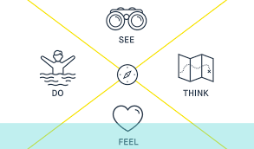
Figure 1: Empathy map

Based on the empathy map above, we go through the process:
- See through and listen towards every details target user said
- Put themselves in the shoes of target users so that designers can fully immersed in users feelings
- Captivate target users way of thinking to understand them better
- Understand target users situation so that the solution is suitable with what they does

The Interview
Our project mainly focuses on input and output. Then, we reduced it into a smaller scope which are input and output devices. We perform an interview with Mr. Mohd Farid Bin Sarji virtually via an application called Cisco Webex. Due to current circumstances, which affects the whole world, we had to interview him virtually and with another group of people but we still managed to ask him about issues he faced while working with input and output devices.

Interviewee Profile
Name: Muhd Farid Bin Sarji
Position: Information Technology Officer

During the interview session, we get to ask him about his experiences with input and output and also the difficulties he faced. From the questions that we asked, it can be deduced that Mr. Farid believed that during the global pandemic nowadays, communication is one of the big problems he had faced. Currently, in Malaysia, most states are still under the Movement Control Order (MCO) and this has affected many parties which requires them to work-from-home. Other than that, he also voices out his opinion on how to adapt with this situation.

Current situation has caused any physical meeting to be prohibited and any meeting must be done virtually. He focused on the problem of the communication between different parties during virtual meetings because this is what he had to go through. His main concern was how the receiver would interact with him because there were times that we cannot hear their voice clearly during virtual meetings.

After that, we seek for some clues according to this matter and we found that some platforms of virtual meetings like Google Meet have a button to turn on caption. However, the accuracy of this setting is still low and cannot change into any other language.

Define
- Microphone has low sensitivity of voice recognition
During online meeting, user cannot hear clearly what others are
talking

- User prefers wired device more than wireless device
Wired device has a better connection compared to wireless device and
it does not depend on battery and does not need to be recharged

- Accuracy of caption
Accuracy of caption is low because the voice detection is not accurate
in certain condition

- No translation for the caption
In our prototype, we have to add on a new output which is the
translation for the caption into different language, so user can
understand more clearly during online meeting

Ideate
After the first two steps of empathizing and defining, we know that the requirements of our user needed. We need to bring up the process of Design thinking about what we should do about our design of prototype and how to have our project done successfully. You can define a problem, keeping in mind all considerations, and you can also empathize with your subjects and their feelings, but those are futile if you cannot come up with the appropriate ideas to solve those issues. This makes the ideate phase very critical to the entire design thinking process.

After considering all the possible outcomes, our team brought up all together and consistently sharing our opinions and experience according to the problems that we had collected in Empathize step. Since we could not meet each other physically due to the Pandemic of Covid-19, so we meet up each other online by using Google Meet. Some of our teammates are facing Internet issues, so we also created a Whatsapp group. The goal was just to be able to come up with as many ideas as possible and look forward for the upcoming problems that we are going to face to improve as much as we could.

First and for all, how might we choose a perfect microphone? After the interview with technician and lecturer about this topic, the conclusions that we got are wired microphone is better than wireless microphone in term of transmission of the protocol of the microphone to the computer, so the quality of the voice recorded would be better when wired microphone is used.

In order to come up with a good design idea, we carry out a brainstorm process online using Pinup. After several discussion, we decide that the headset should be portable and comfortable. In term of portable, we will make sure that the headset is foldable and the microphone should be able to adjust. To be comfortable, we make sure that the ear bud of the headset is made of cushion.

Lastly, how we solve the problem of people complain about could not hear clearly during the voice call or online meeting. To solve the problem, we would completely redesign and come up with a new platform that replaces all the existing features of Google Meet. The new interface would be more helpful than older since we will add on a new feature like translating the subtitles during the online meeting or voice call into different language. Eventually, we would be able to understand what the other is talking even if we could not listen to them clearly.

Prototype
Prototype is the first version of the product that we are going to make where it will justify all possibilities. We brainstorm based one all the information we got from the interview and add our own idea to make it even better. So, we have come up with a device that can help to translate every language which they speak through microphone and display subtitles on the screen. The input of our prototype is the audio recorded into the microphone and the output is the translation of caption on the screen.

Firstly, we want to make this device different from the other available devices on the market. We are designing a headset with microphone that can detect any language and it can be translated into the language of our choice. So that, we can get an accurate caption and translation of the caption on the screen during online meeting. Having translation of the caption on the screen can help the users understand better in an online conversation.

Moving on to the next point, we also have discussed the shape and build quality for the microphone. The main quality is that we want to make it affordable and long lasting so that people don’t have to buy it often.

For the shape, we want the device to make the user comfortable for a long-term use and does not interfere with its ongoing activities. So that, thin and light devices are the best design.

One small feature on the device is that it is wired device. We chose the device to be wired because wired device is easier to use for anyone. The device will not be turned off in the sudden because it does not depend on battery and has a wire that supplied constant power to the device. There will be people say that wired device can be messy sometimes. We will also provide a non-removable strap on wire itself so that it can be used to tie up the wire whenever needed.

- The microphone
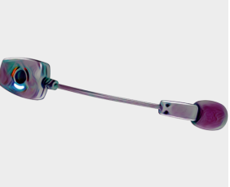
Retrieved from https://www.google.com/search?q=attachable+microphone&rlz=1C1CHBF_enMY916MY916&sxsrf=ALeKk02_YqJwjvujpzyVoNrpXXpV45mHoA:1605344993462&source=lnms&tbm=isch&sa=X&ved=2ahUKEwjK286Q2IHtAhVkmeYKHRIUCr4Q_AUoAXoECBgQAw&biw=1366&bih=695#imgrc=G6nV0jlgCJ7-hM

Figure 2: Microphone

- The full prototype

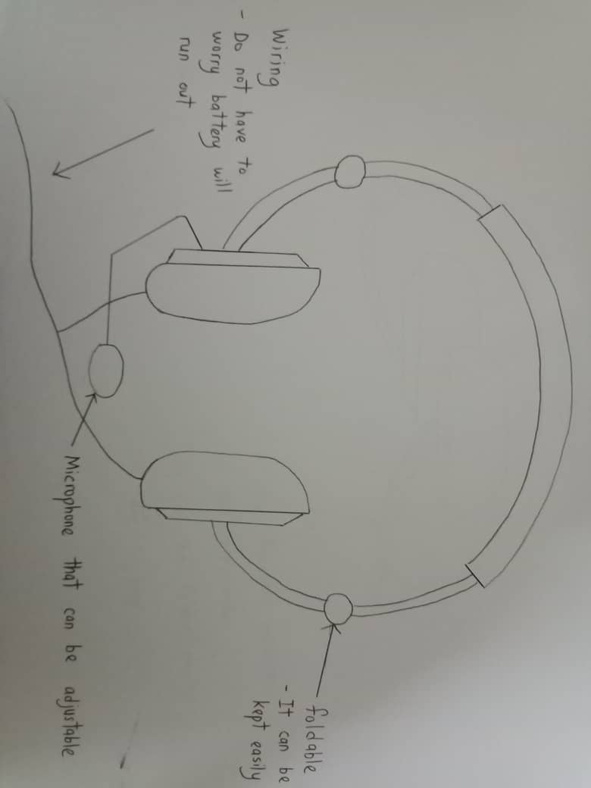
Figure 3: Sketch of prototype

Characteristics:
- Wired
- Connected to microphone
- Foldable

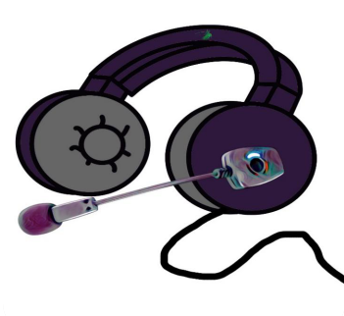
Figure 4: 3D model prototype

- Foldable

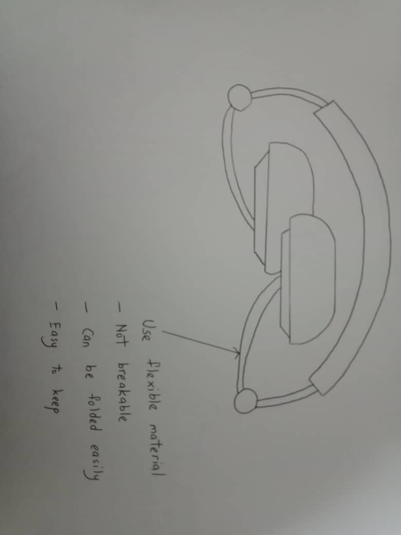
Figure 5: Foldable headset

The headset prototype is foldable in order for user to keep it easily.

- How it should work

  - 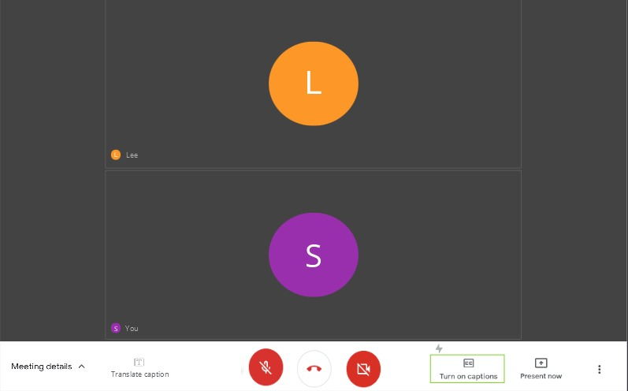
Figure 6: Step 1

The user can turn on caption on the screen.

  - 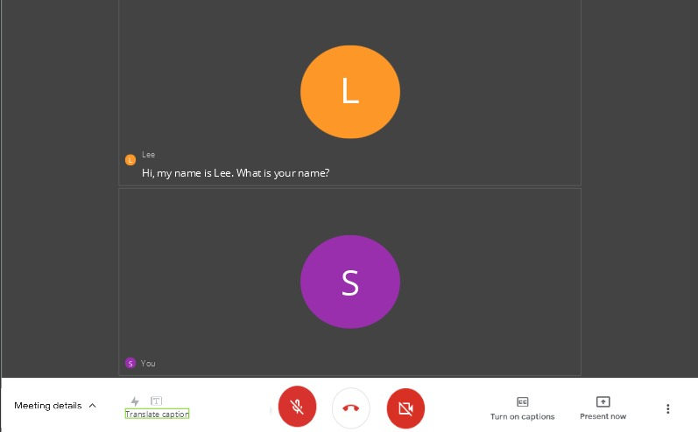
Figure 7: Step 2

When they want to translate the caption into other languages, the
users can click on the ‘translate caption’ button.
  - 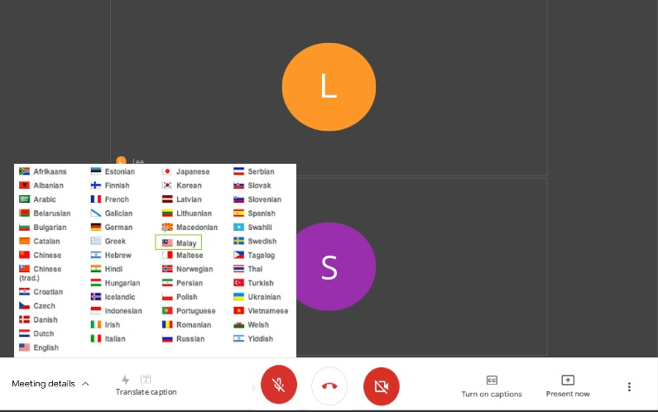
Figure 8: Step 3

After clicking the ‘translate caption’ button, the users can choose the language they want from the box.

  - 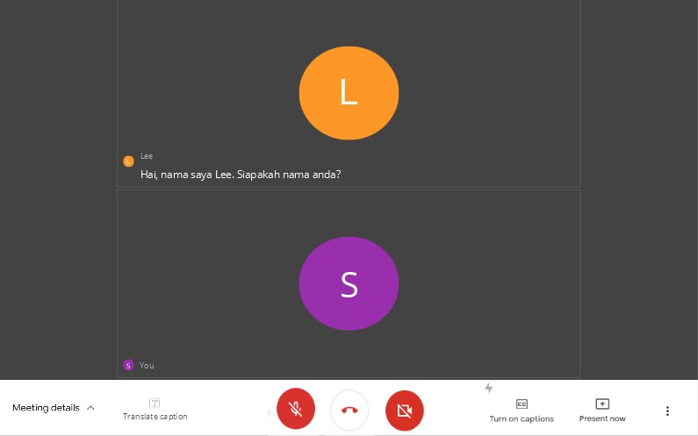
Figure 9: Step 4

The caption will be translated into the language the users choose to
translate.

Testing

For testing, each of our group members, we went to see our own family members because now there are incidents that do not allow us to leave the house.
We showed our prototype respectively and explain to them how it is going to work. Some of them show a good respond towards the device and some of them are not.
The good respond is:
- Do not have to charge the device because it is wired and easy to keep
- Sometimes others’ pronunciations are hard to understand which
the device will be required to help them understand.
- It can help international students to focus more and understand better
during online learning.

Reflection
By Lee Cai Xuan
Throughout this design thinking project, I learn that communication skills are very important to work with others and build up teamwork spirit in a group especially during this global pandemic. In a group, I learn how to be respectable to accept others’ opinions. Next, I learn that I should be brave to share my opinions. For me, design thinking is really an effective way to understand what the user’s needs and problems and I realize that I need to be more creative and improve my critical thinking skills in order to become a good engineer after I graduate. This is because a good engineering is not just good at programming but is also good at defining user’s needs to innovate something better that can help improving their lives. I’m so grateful that this project helps me to learn every steps of design thinking and let me know what my limits and what I should improve.

By Chong Kai Zhe
After finishing the design thinking project, I had learned and realised different skillsets and knowledge to be success in the project. I realised that to had a good project of a certain product, we need to have some communication skill to ask other people during interview and curiosity about why does the other people says that certain features on the product will be cool and nice. Not only that, working with a team I had to pay attention all time towards what my teammates wanted and make sure our progress will not slow down because of individual mistake. As for the design thinking project, we need to be more creative too to solve the problems that people facing. We had to think out of the box as for an engineer. Lastly, we need to always stick to what our client needs and do not simply add on some other features that our clients requested unless we had enough of facts or proof to show our clients that with that extra features, the product will be much better.

By Nayli Nabihah Binti Jasni

This course has opened my eyes to see beyond the eyesight. It teaches me to learn and know more about technologies. From what I have learned, I know that I can practically use it in my daily life for a better understanding. Design thinking projects have challenged my mind to be more creative and innovative just as the purpose of this thinking skill. Design thinking is a skill that is essential for students and workers since it tests our brain limit in order to find the most possible solution. It also guided us with some simple steps in order to achieve the desired outcome and it is an effective way of cognitive thinking. Next, communication skills are extremely needed by any individual. However, by applying design thinking, designers' communication skills will be on a higher level than the ordinary individual. This is because designers interpret the problem in another way around that considers the users need more. Therefore, I should master the design thinking skill to be better for my present and future.

By Afif Hazmie Arsyad bin Agus
This design thinking process is a good example for my future life and career. Firstly, this is because I have to do the interview in order to get the problems that we as a group will solve symbolizes like the outside world where we create new things is to solve the problems that users face every day. People don’t just make new things without knowing the reason of it. Newly marketed products always have other advantages than the existing product even if it only gives small effect especially in terms of technology. There are always a good in all things. Secondly during the process of making this whole design thinking, I have gain new knowledge on certain things. I learnt how to edit the videos, how to make a good video and the ways to do our work without copying other people's work which is why we do some research.
Thirdly, I have learnt that teamwork makes the dream work quoted by John C. Maxwell. My groupmates are very responsible with the works given to them. They do not complain or do work insincerely. They keep giving new ideas which some of them is better than my idea. To conclude, I have learnt a lot during the design thinking process. I hope I can maintain the momentum like this for future works or assignment.

Reference
Razzouk, R. and Shute, V., 2012. What is design thinking and why is it important?. Review of educational research, 82(3), (pp.330-348).

Park, J.M., Samsung Electronics Co Ltd, 2012. Audio signal output method and apparatus for short-range communication enabled headset. U.S. Patent 8,265,293.

Burnett, G.C., Petit, N.J., Asseily, A.M. and Einaudi, A.E., AliphCom LLC, 2013. Microphone and voice activity detection (VAD) configurations for use with communication systems. U.S. Patent 8,467,543.

Friis Dam, Teo. (2020, July). What Is Design Thinking and Why Is It So Popular?, from https://www.interaction-design.org/literature/article/what-is-design-thinking-and-why-is-it-so-popular

Priyanka J. (2020, August 1). How Empathy Works In Design Thinking, from
https://uxdesign.cc/how-empathy-works-in-design-thinking-d05f19a9c667

Video Link

Video Design Thinking
https://youtu.be/Cip59q3kwrw

Video Chapter Presentation
https://youtu.be/qEq3u5-gk2w

