

Subject : Technology and Information Systems (SECP1513)
Section : 2
Assignment : Step by step PC Assembly

GROUP NAME/NUMBER: Group 5

1 |  | Name: Lee Cai Xuan  Matric Number: A20EC0062  Phone Number: 0175893741  E-mail: leexuan@graduate.utm.my
2 | 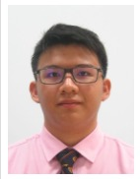 | Name: Chong Kai Zhe  Matric Number: A20EC0186  Phone Number: 0174551376  E-mail: k.zhe@gmail.com
3 |  | Name: Nayli Nabihah binti Jasni  Matric Number: A20EC0105  Phone Number: 0192463571  E-mail: naylinabihah@graduate.utm.my
4 |  | Name: Afif Hazmie Arsyad bin Agus  Matric Number: A20EC0176  Phone Number: 0197910545  E-mail: afifhazmie@gmail.com

CONTENT

PART A 4
PART B – Sketch of a mother board layout 7
PART C - “Step by Step PC Assembly” 13
REFERENCE 17

List of Figures
Figure 1 : Screwdrivers 4
Figure 2 : Anti-Static Wrist Strap 4
Figure 3 : Cable or Twist Ties 5
Figure 4 : Flashlight 5
Figure 5 : Needle-Nose Pliers 6
Figure 6 : Sketch of Motherboard 7
Figure 7 : Graphic Card 9
Figure 8 : CPU/Processor 9
Figure 9 : Heat Sink 9
Figure 10 : CD ROM 10
Figure 11 : USB Cable 10
Figure 12 : Slots (IDE, PCI) 10
Figure 13 : RAM 11
Figure 14 : Sata Cable 11
Figure 15 : IDE Cable 11
Figure 16 : Power Supply 11
Figure 17 : Hard disk (jumper setting either master or slaves) 12
Figure 18 : Install processor 13
Figure 19 : Thermal paste 13
Figure 20 : Install heat sink 14
Figure 21 : Install RAM 14
Figure 22 : Install power supply 14
Figure 23 : Install graphic card 15
Figure 24 : Install hard disk drive and CD ROM 15
Figure 25 : IDE cable and Sata cable 16
Figure 26 : Cover cabinet 16

PART A

List at least FOUR tools needed to assemble a PC. For each tool, Provide picture(s), explanations of its functions and its importance.
Figure 1: Screwdrivers
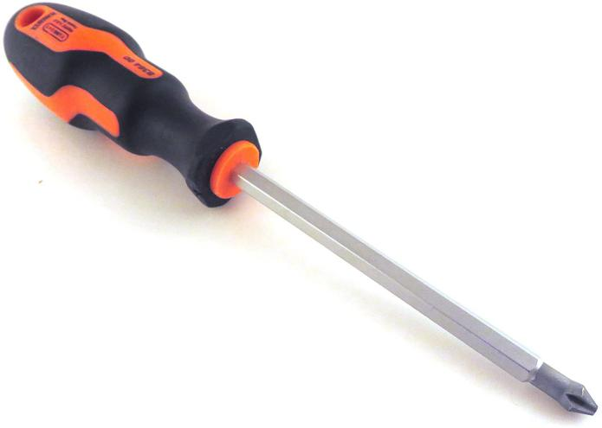
https://www.amazon.com/Narex-Universal-Phillips-Drive-Screwdriver/dp/B00VDH1VX4

The screwdrivers are used to tighten the screws on the components to hold them securely in place.

Figure 2: Anti-Static Wrist Strap
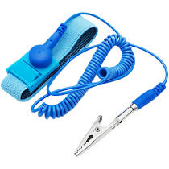
https://shopee.com.my/%E3%80%90Supersales-%E3%80%91Anti-Static-Wrist-Strap-Grounding-Wrist-Strap-Band-Prevents-Static-Forming-i.91791313.6652196999?gclid=Cj0KCQiAzZL-BRDnARIsAPCJs73OJIDEZCMnc5MTysq2g92B9SfibSCATVSOz6JHxoVfK7ycBeuop5waAgqmEALw_wcB
The anti-static wrist strap is a bracelet-type device that wear on the wrist which connects to an electric charge builds up between the user and the hardware components, the charge is safety dissipated through to the socket. This is to avoid a spark and potentially causing damage to the components.

Figure 3: Cable or Twist Ties
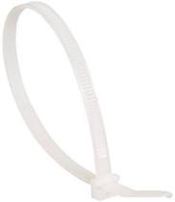
https://my.rs-online.com/web/p/cable-ties/7048683/?cm_mmc=MY-PLA-DS3A-_-google-_-PLA_MY_EN_Cables_And_Wires-_-Cable_Accessories_And_Ties_And_Tools%7CCable_Ties-_-7048683&matchtype=&pla-391854541420&gclid=Cj0KCQiAzZL-BRDnARIsAPCJs71hCMlw3sQppFUHFdfdJceaIwNjS0gDQNr6xBLN1njN6wPjhkcYI7UaAg3PEALw_wcB&gclsrc=aw.ds
Cable ties and twist ties are used to zip any loose cables lying around in the CPU case, the use of cable ties and twist ties will only make the finished build look neater, but promotes better airflow within the case.

Figure 4: Flashlight
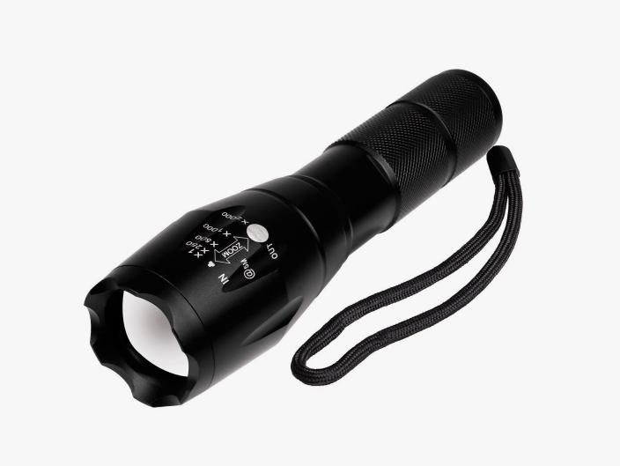
https://www.amazon.com/Flashlights-LED-Tactical-Flashlight-S1000/dp/B07X5TTTJT
Flash light will provide extra light source to see exactly what had done when working within the case. Flashlight is important when the PC case is covered and barely could see when we are fixing component, flashlight will provide light source so we are able to fix the components cautiously.

Figure 5: Needle-Nose Pliers
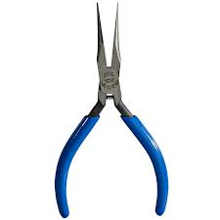
https://www.techtoolsupply.com/Klein-5in-Long-Needle-Nose-Pliers-Extra-Slim-p/kln-d335512c.htm
Needle-nose pliers is used for loosening up screws or bolts that are super-tight and used to pick up hard to reach screws which is recommend to pick up any screws that drop into the case immediately so later will not forget and left out the screws.

PART B – Sketch of a mother board layout
Figure 6: Sketch of Motherboard
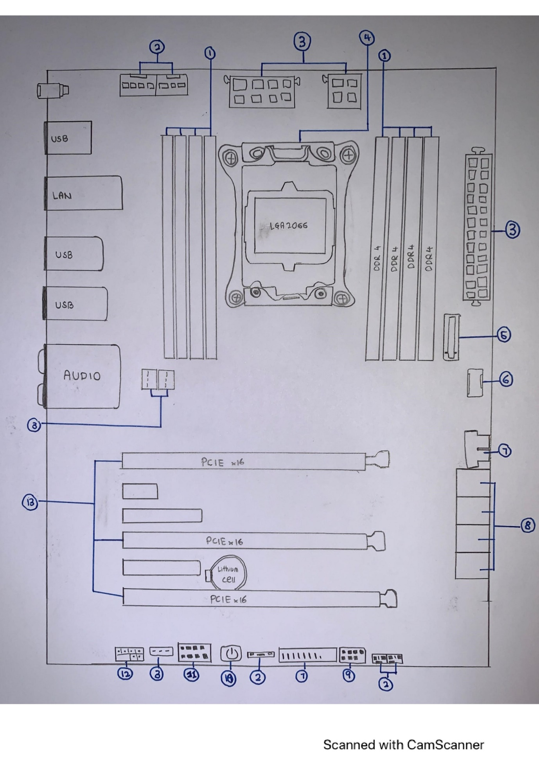

No | Items
1 | DDR4 DIMM slots
2 | CPU fan, CPU optional, AIO pump, water pump + extension and chassis fan connectors
3 | ATX power connectors (24-pin,8-pin and 4-pin)
4 | LGA 2066 CPU socket
5 | M.2 socket
6 | USB 3.1 gen 2 front panel connector
7 | USB 3.1 Gen 1 connectors (21-1 pin)
8 | Serial ATA 6Gb/s connectors (7-pin SATA6G_12, SATA 6G_34. SATA6G_65)
9 | USB 2.0 connector
10 | Power-on button
11 | Serial port connector
12 | Front panel audio connector
13 | PCIE x16, multiple GPU slots
14 | Heat sink

2.0
Component | Explanations | Example of Model
Figure 7: Graphic Card  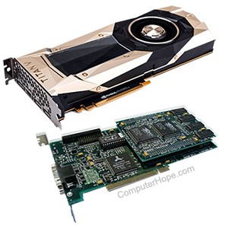  https://www.google.com/search?q=example+graphic+card&sxsrf=ALeKk01Py17XzkIH-J3JJUwj8FtItk6rLQ:1606799622258&source=lnms&tbm=isch&sa=X&ved=2ahUKEwiDwdaFg6ztAhXeyzgGHZb8B9AQ_AUoAXoECBEQAw&biw=767&bih=780#imgrc=IeUWkCTSy8jZbM | Also called video card, is a piece of computer hardware that produce the image one computer | GeForce GTX 1080 Ti Graphics Card video, SAPPHIRE NITRO+ Graphics Card, Asus graphic card and more
Figure 8: CPU/Processor  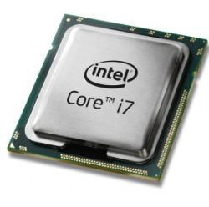 | Known as the brains of the computer, generally compose of the main memory, control unit and arithmetic logic unit | Intel Core I3, I5, I7 with n-th generations, AMD Ryzen 3,5,7 with any generation
Figure 9: Heat Sink  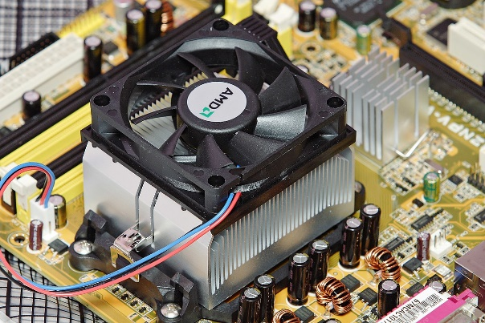 | A piece of metal that sits on top of a computer chip such as CPU and draws power away from component by letting it rise through a set of fins. A heat sink needs to make strong contact with the source of heat in order to maximize cooling | Extruded Heat Sinks, Bonded heat sinks, Skived heat sinks, stamped heat sinks and forged heat sinks
Figure 10: CD ROM  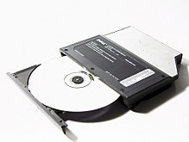 | Abbreviation of compact disc read-only memory, type of computer memory in the form of a compact disc that is read by optical. | CD ROM Mode 1, CD ROM Mode 2, CD ROM Mode XA
Figure 11: USB Cable  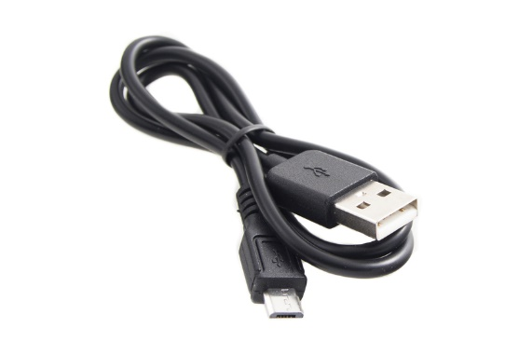 | Universal Serial Bus used mostly to connect computers to peripheral devices such as camera, phones, printers and more | USB 1.0 – 2.0, USB type A, USB type B, micro USB type A, USB 3.0 – 3.1, USB type-C
Figure 12: Slots (IDE, PCI)  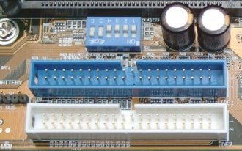  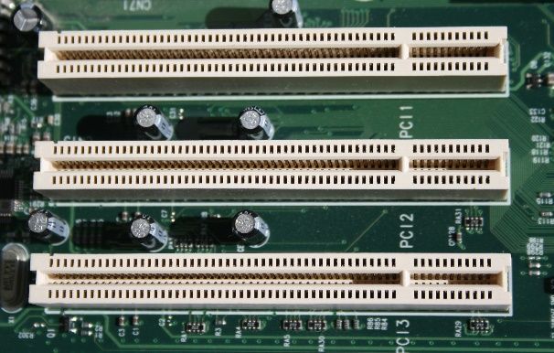 | IDE – Standard interface for connecting a motherboard to storage devices.  PCI – hardware bus used for adding internal component to desktop | IDE cable 40 pin, IDE cable 80 pin,  PCI Express RA assy 5.8mm slot 2.3mm pc, PCI EXP 2.3L 64 POS BLK G/F
Figure 13: RAM  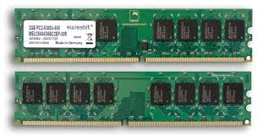 | Random Access Memory, uses to hold data it needs in the short term. | Kingston HyperX Predator 16Gb DDR3, Corsair Vengeance LED 8GB DDR4 Ram
Figure 14: Sata Cable  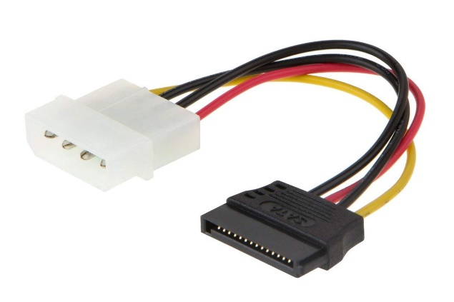 | Serial Advanced Technology Attachment used to connect devices in computer cable assemblies such as storage | Mini-SATA, SATA Express,  SFF- 8784 connector
Figure 15: IDE Cable  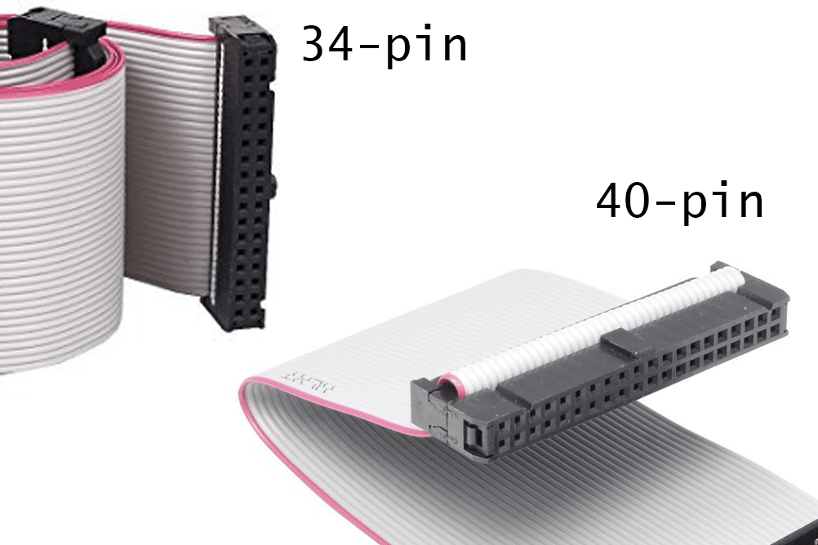 | Integrated Drive Electronics, standard type of connection for storage devices in a computer | IDE cable 34 pin, IDE cable 40 pin
Figure 16: Power Supply  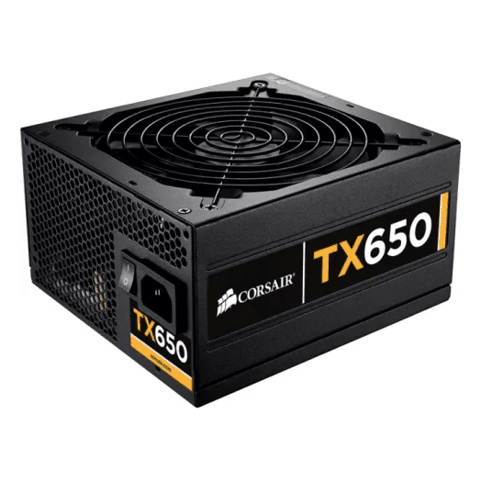 | Is an electrical device that supplies electric power to an electrical load | EVGA power supply, Cooler Master 650W 80plus Bronze, Thermaltake 1200W
Figure 17: Hard disk (jumper setting either master or slaves)  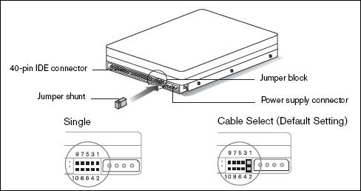 | Hard disk – Magnetic storage medium for a microcomputer  There is a pin on the back of the hard drive that nothing is connected to, these pins are called jumper. The setting these jumpers enable are hard-coded onto a drive’s programmed printed circuit board | Seagate BarraCuda, Firecuda desktop storage, Toshiba X300 and WD VelociRaptor

PART C - “Step by Step PC Assembly”
Figure 18: Install processor
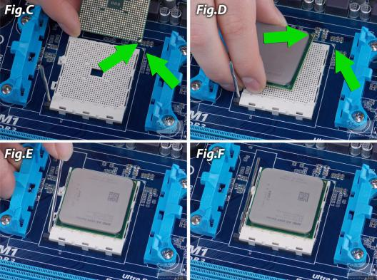
https://www.google.com/url?sa=i&url=https%3A%2F%2Fwww.cclonline.com%2Farticle%2F1105%2FGuide%2FPC-Components%2FComputer-Assembly-Guide-Part-1-How-to-Install-a-CPU-and-Cooler%2F&psig=AOvVaw0gLdPHkHRx6lylXpKyHOK2&ust=1606877342224000&source=images&cd=vfe&ved=0CAIQjRxqFwoTCICbocLlq-0CFQAAAAAdAAAAABAD

Figure 19: Thermal paste
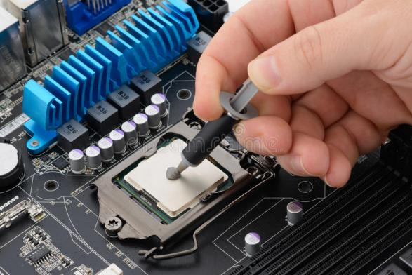
https://www.google.com/url?sa=i&url=https%3A%2F%2Fwww.dreamstime.com%2Fphotos-images%2Fthermal-paste.html&psig=AOvVaw1JQ2L-urMQ0KjVGOd9Ltvw&ust=1606877626266000&source=images&cd=vfe&ved=0CAIQjRxqFwoTCODdzebjq-0CFQAAAAAdAAAAABAL

STEP 1: Install a processor in the slot provided on the motherboard. Make sure that it is properly installed inside the socket before clip it. After that, put a little amount of thermal paste the processor.

Tips: Do not apply force to seat the processor and do not touch the side of processor with fingertips because it can damage its contacts.

Figure 20: Install heat sink
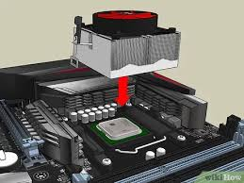
https://www.google.com/url?sa=i&url=https%3A%2F%2Fwww.wikihow.com%2FInstall-a-CPU-Cooler-in-an-AMD-Motherboard&psig=AOvVaw1Fq7x5Rd8VoMzvvIddyVSU&ust=1606876236794000&source=images&cd=vfe&ved=2ahUKEwij1M3L3qvtAhXDEysKHfTpDkQQr4kDegUIARC8AQ

STEP 2: Install the heat sink and fan on top of the processor. For precaution step, please make sure that both heat sink and fan is screwed properly using screwdriver.

Figure 21: Install RAM
https://www.google.com/imgres?imgurl=https%3A%2F%2Fi.ytimg.com%2Fvi%2FmGTT0Vcy0E4%2Fhqdefault.jpg&imgrefurl=https%3A%2F%2Fwww.youtube.com%2Fwatch%3Fv%3DmGTT0Vcy0E4&tbnid=KV_CwjzfPwrpSM&vet=12ahUKEwigx7ix36vtAhWaCHIKHelACJsQMygIegUIARC2AQ..i&docid=WIeyNq_36A-sSM&w=480&h=360&q=ram%20installation%20in%20cpu&ved=2ahUKEwigx7ix36vtAhWaCHIKHelACJsQMygIegUIARC2AQ

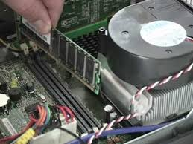

STEP 3: Install the RAM inside the RAM slot provided on the motherboard. Make sure to clip it properly.

Figure 22: Install power supply
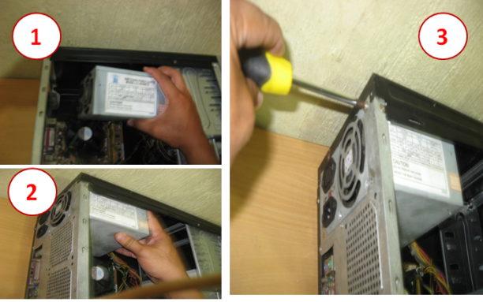
https://www.google.com/url?sa=i&url=https%3A%2F%2Fsir-sherwin.blogspot.com%2F2010%2F07%2Finstalling-power-supply-unit.html&psig=AOvVaw0QAp5vgcVmknBiUtlqGUzL&ust=1606879162148000&source=images&cd=vfe&ved=0CAIQjRxqFwoTCPiDwsXpq-0CFQAAAAAdAAAAABAD

STEP 4: Put the completed motherboard and screw it properly to CPU cabinet. Install the power supply by screwing it to the motherboard.

Figure 23: Install graphic card
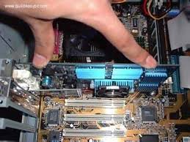
https://www.google.com/imgres?imgurl=https%3A%2F%2Fwww.buildeasypc.com%2Fpics%2Fgraphicscard_put.jpg&imgrefurl=https%3A%2F%2Fwww.buildeasypc.com%2Fhw%2Fhowto%2Finstgraphics.htm&tbnid=icOm6tiUqEde-M&vet=12ahUKEwjIzYeM4KvtAhW8jUsFHbDJBLEQMygGegUIARCxAQ..i&docid=zKRHOE9nuC591M&w=320&h=240&q=graphic%20card%20installation%20in%20cpu&ved=2ahUKEwjIzYeM4KvtAhW8jUsFHbDJBLEQMygGegUIARCxAQ

STEP 5: Slot the graphic card in PCI slot on the motherboard. Line it up and press it down firmly to seat the card. Screw it to avoid it from detached.

https://www.google.com/url?sa=i&url=https%3A%2F%2Fwww.youtube.com%2Fwatch%3Fv%3DcTXcSrLbB7E&psig=AOvVaw1RtVKOumEiSBxQS-wXtwvl&ust=1606880603047000&source=images&cd=vfe&ved=0CAIQjRxqFwoTCJjo6PXuq-0CFQAAAAAdAAAAABAE
Figure 24: Install hard disk drive and CD ROM
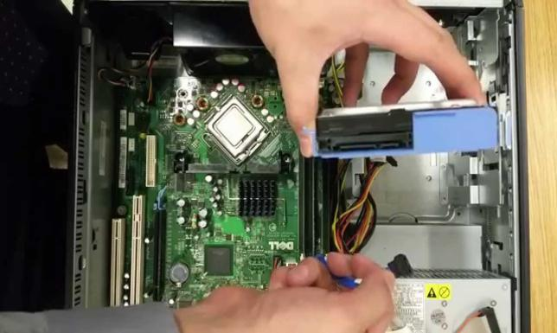

STEP 6: Install the hard disk drive and CD ROM drive in the slot provided respectively and screw it tightly to avoid any damage.

Figure 25: IDE cable and Sata cable
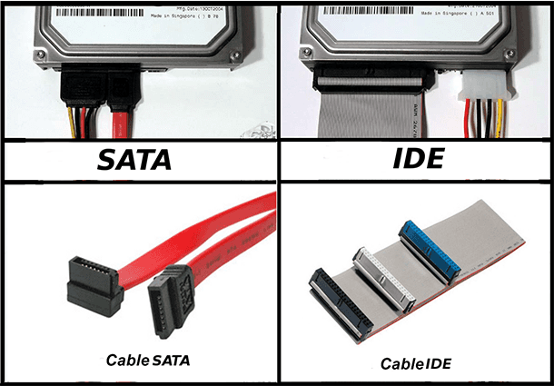
https://www.google.com/url?sa=i&url=https%3A%2F%2Fhetmanrecovery.com%2Frecovery_news%2Fhow-to-enable-ahci-mode-for-sata-in-the-bios-without-reinstalling-windows.htm&psig=AOvVaw1HfGIC_6CjXRDD_X63dgvd&ust=1606880818057000&source=images&cd=vfe&ved=0CAIQjRxqFwoTCKCx0ujvq-0CFQAAAAAdAAAAABAJ

STEP 7: Attach the IDE cable to CD ROM drive, SATA cable to hard disk drive and attach the power supply to each driver.

Tips: Neatly arrange the cables to save spaces and avoid heat trapped.

http://www.pcbuildadvisor.com/how-to-build-a-computer-step-by-step-infographic/
Figure 26: Cover cabinet
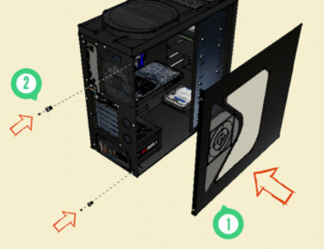

STEP 8: Close up the cabinet using the cover earlier. This is to avoid the dust trapped inside the cabinet.

STEP 9: Connect the CPU and monitor to power supply socket and test it. If the monitor shows anything, it means that the CPU assembly is done correctly.

REFERENCE

Grey, Nystedt. (2020, July 6). Want A Better PC? Try Building Your Own, from
https://www.wired.com/story/how-to-build-a-pc/

n.d. How to Build A Computer - Step By Step Infographic. PC Build Advisor, from
http://www.pcbuildadvisor.com/how-to-build-a-computer-step-by-step-infographic/

Strydom. (2020, October 10). Parts of Computer and Their Functions, from
https://computerinfobits.com/parts-of-computer-and-their-functions/

