
School of Computing Faculty of Engineering
Semester 1 2020/2021

Subject: Technology and Information Systems (SECP1513)
Section: 04
Assignment: Step by step PC Assembly

Group Name & Number:
1 |  | Name: Lai Leng Shuen  Matric Number: A20EC0060  Phone Number  E-mail:
2 |  | Name: Muhammad Shawaluddin Bin Shaari  Matric Number: A20EC0099  Phone Number  E-mail:
3 |  | Name: Muhammad Fakhrullah Bin Kamal Bahrin  Matric Number: A20EC0087  Phone Number  E-mail:
4 |  | Name: Muhammad Fadthun Amierrun Bin Md Nor'azam  Matric Number: A20EC0085  Phone Number  E-mail:

PART A
- Screwdrivers
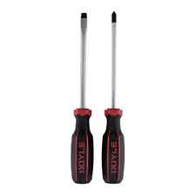
A screwdriver is a tool, manual or powered, used for screwing and unscrewing screws. Screwdrivers are used to tighten the screws on the component to hold them tightly in place. Phillips-head screwdriver with a big bit, helpful to avoid stripping the head; a long shaft also aids in keeping the handle out of the way when working in tight spaces.
- Anti-static wrist wrap
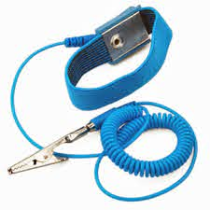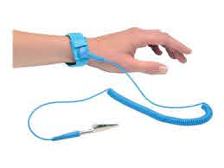
An anti-static wrist wrap is a device that reduces, dampens, or otherwise inhibits electrostatic discharge, which is the build-up or discharge of static electricity. This tool is useful when there is any electrical charge builds up between you and your hardware components, the charge is safety dissipated through to the socket. This may avoid a spark and potentially causing damage to your parts. An anti-static wrist wrap is easier to use than a pair of gloves to discharge any electrical charge.

PART A
- Cable ties
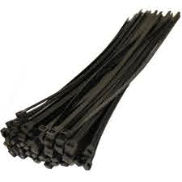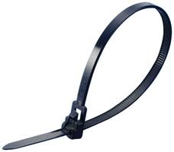
Cable management is essential to keep dust accumulation low and airflow high, and even more importantly, it makes things look nice. Cable ties are used to tie up any loose cables lying around in your case. This tool makes your finished build look clean and promotes better airflow within the case.
- Light source
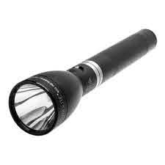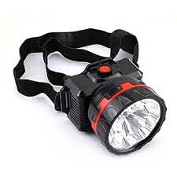
PC cases are full of shadows, and screws love to roll into the darkest corners. Therefor we need light source so that we can have a better view of assembly things especially components that are small. Having a good light source can prevent any misplacement of components.

PART A
- Needle-Nose Pliers
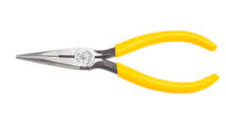
Needle-nose pliers are used when the heads of cheap screws get stripped. When this happens, sometimes the only option is to use a pair of pliers. Needle-nose pliers have a wide variety of uses, and they often include a wire cutter, which can be used to snip the excess off of cable ties.
- Gloves
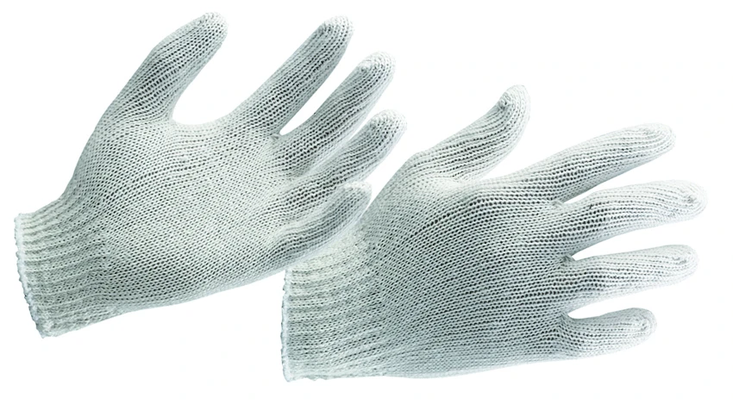
The gloves are used to hold any components with grip, especially small components. These are important to avoid injuries by sharp components.

PART B
Sketch of a mother board layout
- Sketch manually (using handwriting) a simple diagram of a motherboard layout that consists ALL keywords included in Table 1.0. Label each of the keyword. Produce your own sketch diagram. Only one sketch diagram of a motherboard layout is required for this assignment.
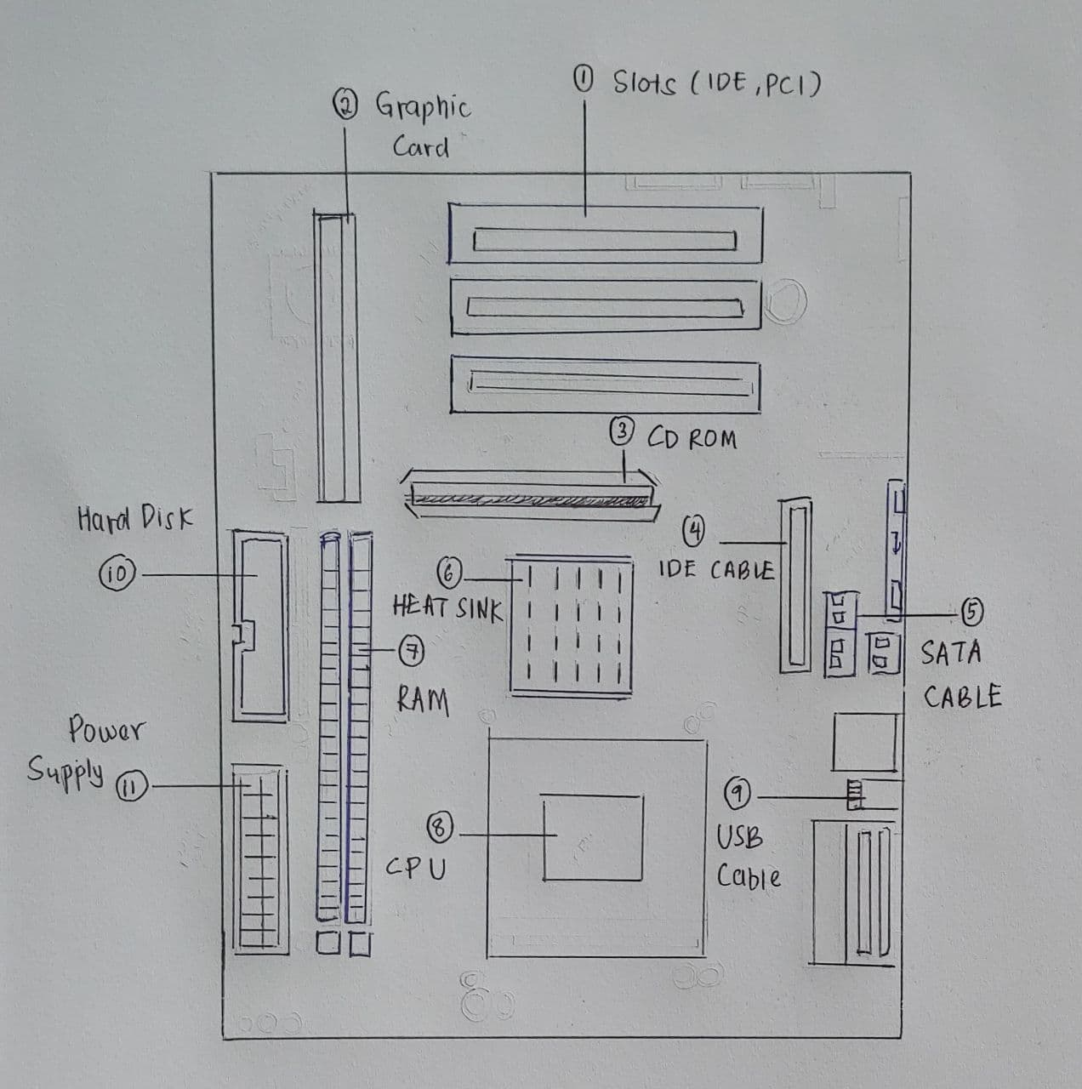
Table 1.0 - Keywords
Graphic Card | USB Cable | IDE Cable
CPU/Processor | Slots (IDE, PCI) | Power Supply
Heat Sink | RAM | Hard disk (jumper setting)
CD ROM | SATA Cable

PART B
Sketch of a mother board layout
For each keyword in Table 1.0. Provide picture(s), explanations of its functions and example of models.
No. | Name | Explanations | Picture(s)
1. | Slots (IDE, PCI) | - PCI Slot: a built-in slot on a device that allows for the attachment of various hardware components such as modems, sound cards, disk controllers and other peripheral  - IDE Slots: is a standard type of connection for storage devices in a computer | 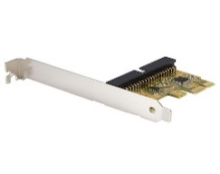
2. | Graphic Card | - The Graphics Card is responsible for rendering an image to monitor, it does this by converting data into a signal monitor can understand.  - The better graphics card the better, and smoother an image can be produced. | 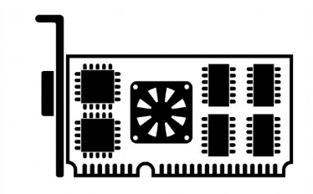
3. | CD ROM | - It functions as a compact disc that stores computer data  - Example: graphics, text, and audio. | 
4. | IDE Cable | - the types of cables and ports used to connect some hard drives and optical drives to each other and to the motherboard. | 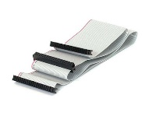
5. | SATA Cable | - Computer bus interface that connects host bus adapters to mass storage devices  - Example: hard disk drives, optical drives, and solid-state drives | 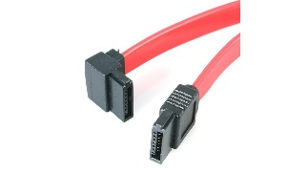
6. | Heat Sink | - component that increases the heat flow away from a hot device.  - It accomplishes this task by increasing the device's working surface area and the amount of low-temperature fluid that moves across its enlarged surface area | 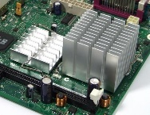
7. | RAM | - RAM gives applications a place to store and access data on a short-term basis. It stores the information computer is actively using so that it can be accessed quickly.  - Random-access-memory (RAM) | 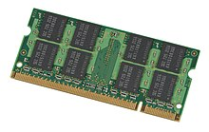
8 | CPU/Processor | - a piece of hardware that carries out the instructions of a computer program.  - The latest CPU is AMD Ryzen 5 3400 G | 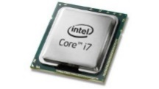
9. | USB Cable | - USB cables carry power as well as signals.  - This allows for "USB powered" gadgets as well as recharging batteries in cameras and other USB peripherals. | 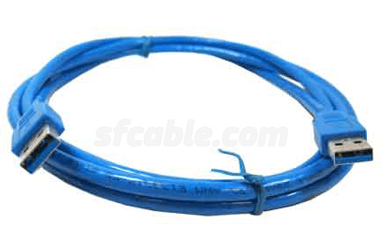
10 | Hard Disk | - Data storage device that stores and retrieves digital data using magnetic storage and one  - Types of hard disk: PATA, SATA,  - SCSI, SSD | 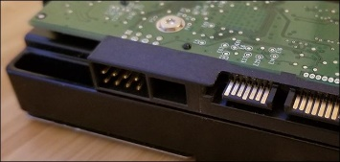
11. | Power Supply | - A power supply is an electrical device  - it supplies electric power to an electrical load. | 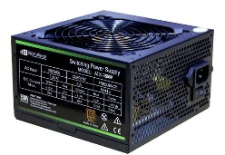

PART C
Step by Step PC Assembly
Step 1: Procuring parts
We need to prepare all the parts necessary to build the pc. The parts we will use are:
- Processor (CPU)
- Computer case
- Optical drive
- Memory (RAM)
- Power supply
- SATA cables
- Motherboard
- Processor Fan
- Case Fan
- Hard disk
- Tool kit
Step 2: Install CPU on the motherboard
Placed the CPU on the intended socket at the motherboard in the correct way. Lift the small metal rod next to the socket. Find the corresponding marking on the CPU socket and insert the CPU so that the markings are lined up. Push the rod down to lock the processor in place. Apply thermal paste on the CPU after installing the CPU.
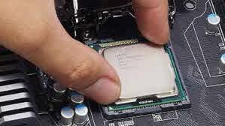
Source:
https://www.alphr.com/features/378898/how-to-install-an-intel-processor/

PART C
Step by Step PC Assembly
Step 3: Installation of the CPU heat sink
Place thermal compound to the CPU following the instructions provided with the compound. Set the heat sink on the CPU with mounting tabs aligned. Pull the locking rod down on the fan assembly to lock into place. Connect the fan assembly's power connector to the motherboard. Make sure the heat sink is installed correctly and tidily.
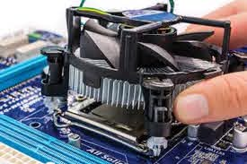
Source:
https://www.pearsonitcertification.com/articles/article.aspx?p=2731934&seqNum=19
Step 4: Open the case
Open the computer case by removing the side panels. Find the screws that hold the side panels in place and remove them. The panel is removed by first sliding it back then lifting it away from the case.
Precaution: Case may have sharp edges. Handle with care to avoid injury.
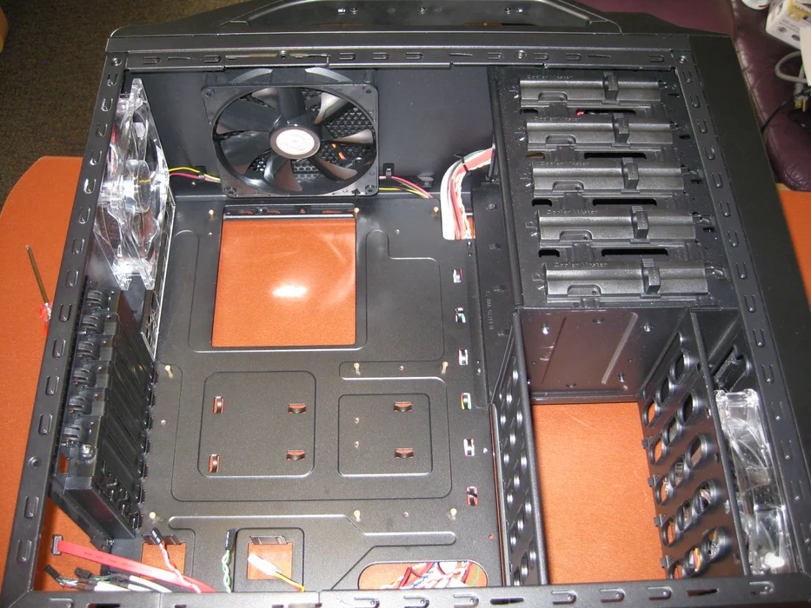
Source:
https://www.instructables.com/Computer-Assembly/
PART C
Step by Step PC Assembly
Step 5: Prepare the case for assembly
Remove any parts or packaging materials that may have been shipped inside the case. Remove the cover for the optical drive. Remove the cover on the highest drive bay to mount our DVD drive.
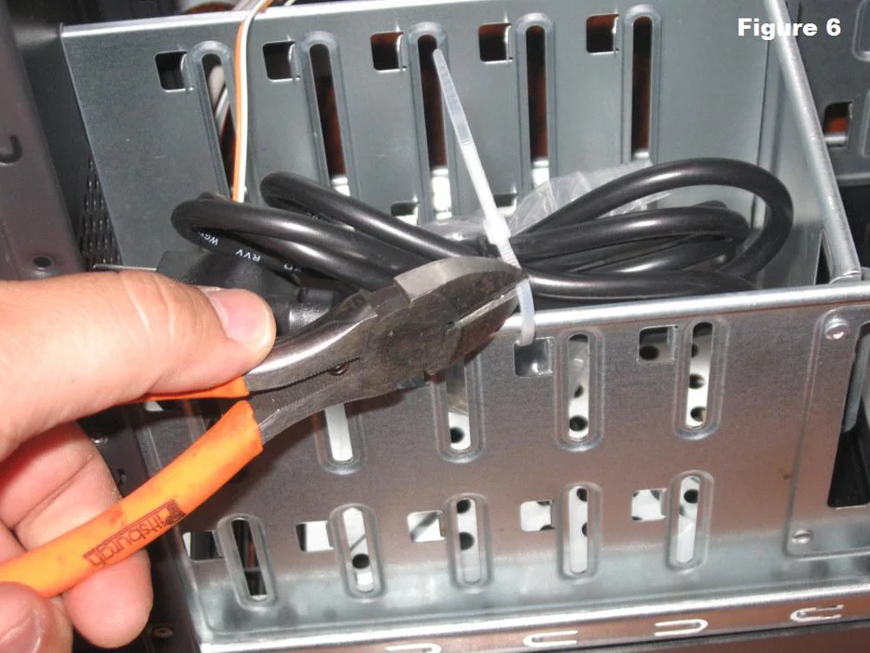
Source:
https://www.instructables.com/How-To-Assemble-A-Basic-Desktop-PC/
Step 6: Put the anti-static wrist wrap
Put the anti-static wrist wrap and connect the other end to the computer case. This step is necessary to prevent any build-up of static electricity on your body from damaging the computer components.
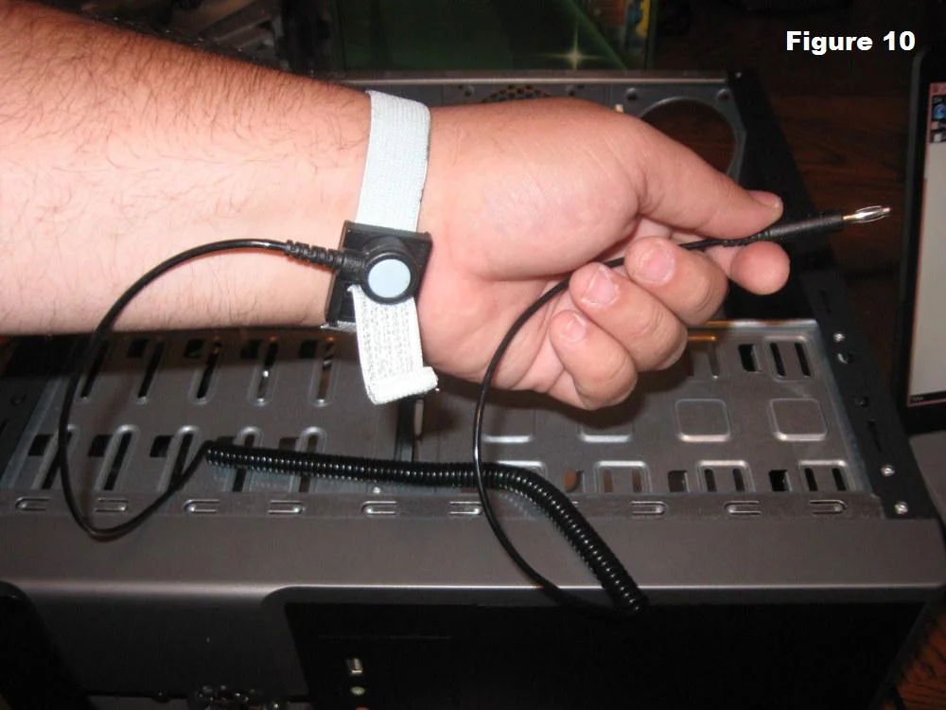
Source:
https://www.instructables.com/How-To-Assemble-A-Basic-Desktop-PC/
PART C
Step by Step PC Assembly
Step 7: Install power supply to the PC case
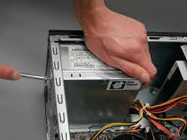
Align the mounting holes in the case and power supply. Insert screws and tighten.
Source:
https://www.discdepotdundee.co.uk/repairs-and-services/hardware-installation/replacement-psu-install-upgrade-desktop-and-laptop/
Step 8: Insert motherboard
Install the I/O panel faceplate needs to be snapped into the location in the back of the case. Be sure to orient it to the board. Install standoffs in the case. The standoffs screw into the motherboard mounting holes. Check the screw hole locations on the motherboard for exact placement. Lower the motherboard into the case and align with the I/O bezel. Install the screws. This will provide support while installing the components into the motherboard.
Precaution: To prevent damage to the motherboard it must only contact the standoffs and screws. All of the standoffs and screws must be installed.
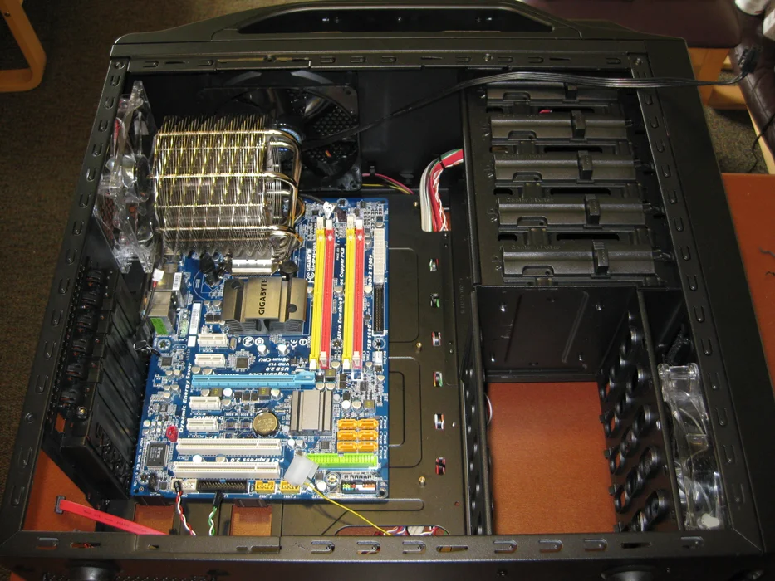
Source:
https://www.instructables.com/Computer-Assembly/
PART C
Step by Step PC Assembly
Step 9: Installation of graphic card
Locate the peripheral component interconnect express (PCIe) slot dedicated for the graphic card on the motherboard. Place the graphic card in the PCIe slot and press down the graphic card on the slot to secure it in place. Screw the graphic card in place to prevent it from moving.
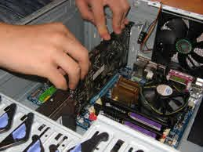
Source:
https://www.custom-build-computers.com/Installing-a-Graphics-Card.html
Step 10: Installation of RAM
Set the RAM board in the socket. Check to see that the notch in the board is in the correct location. If it is not, turn it around 180º. Press firmly on both ends of the board to set it into the socket. Make sure the tabs lock into place.
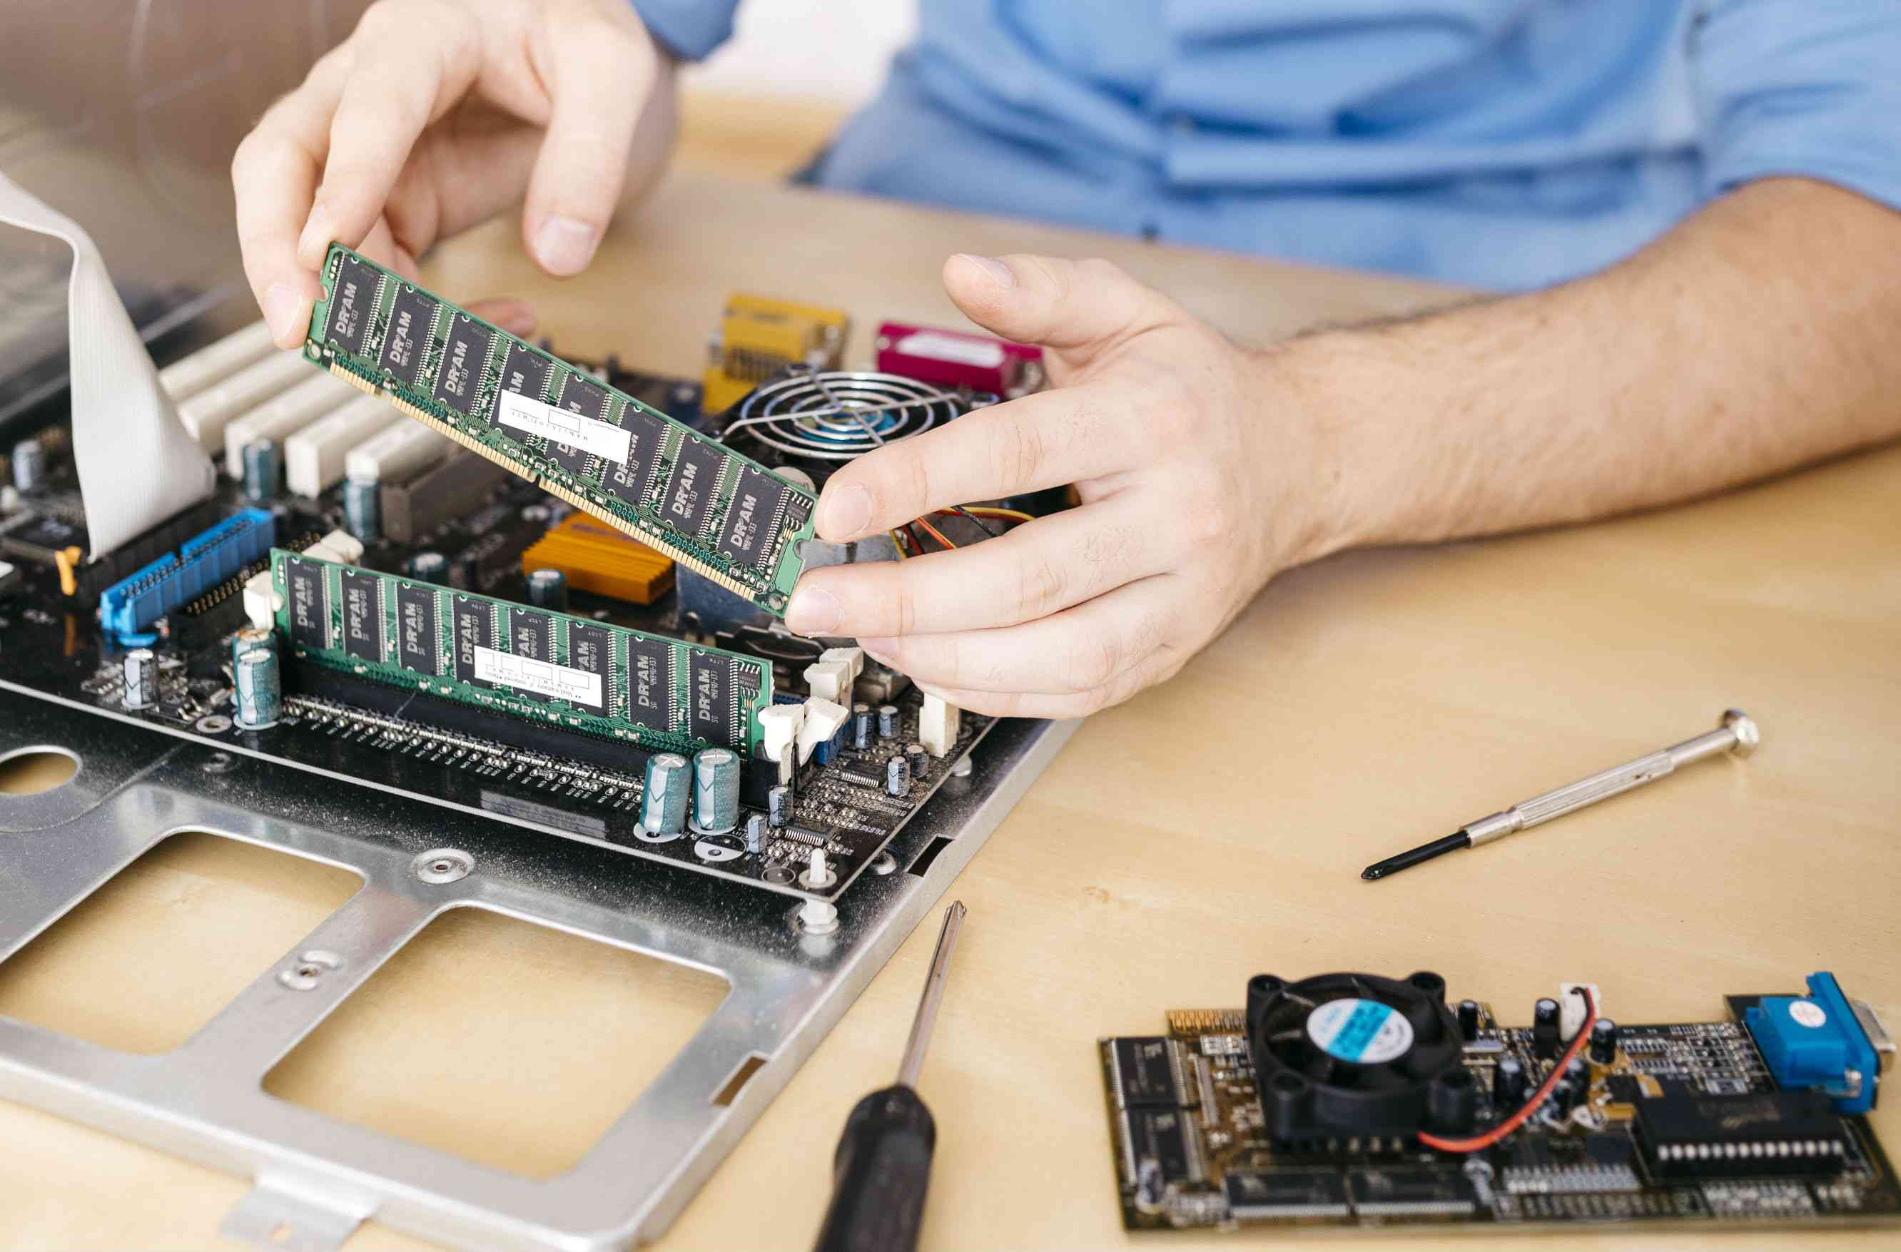
Source:
https://www.lifewire.com/install-ram-in-computer-4782047
PART C
Step by Step PC Assembly
Step 11: Installation of CD ROM
Slide the CD ROM into the slot at the front of the PC case. Make sure that it is orientated correctly. Connect the CD ROM to the power supply. Install the screws.
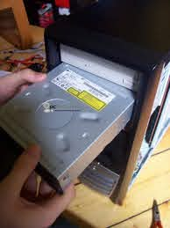
Source:
https://install-drivers-for-mac-cd-drive.peatix.com/
Step 12: Installation of the hard disk drive
Locate the slot to place the hard disk drive. Place the hard disk in the slot and screw the hard disk drive in place.
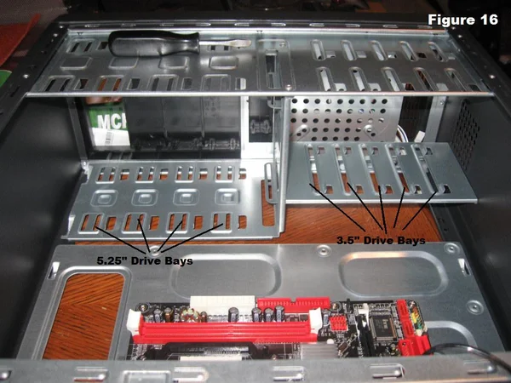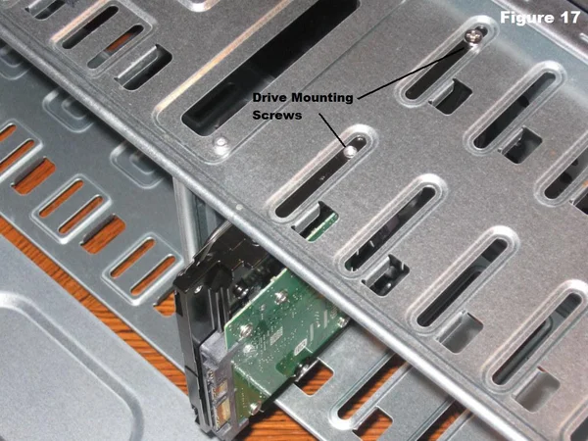
Source:
https://www.instructables.com/How-To-Assemble-A-Basic-Desktop-PC/

PART C
Step by Step PC Assembly
Step 13: Connecting IDE Cable, SATA Cable and Power Supply
Connect the IDE cable to the CD ROM. Connect SATA cable to the hard disk drive. Connect power supply to every driver (CD ROM, hard disk driver).
Precaution: Make sure that the cable is managed tidily to save room and decrease the heat accumulation inside the PC.
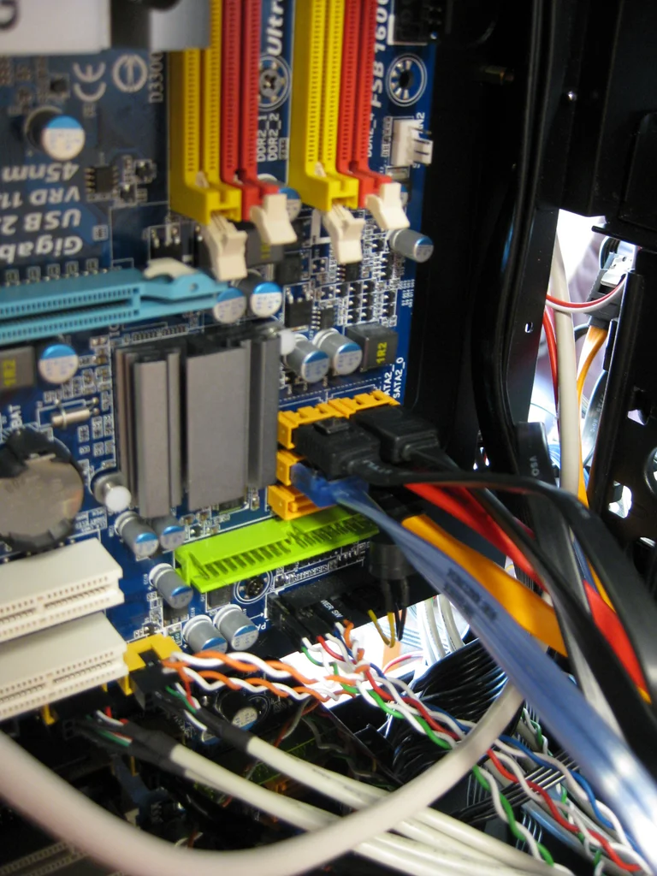
Source:
https://www.instructables.com/Computer-Assembly/
PART C
Step by Step PC Assembly
Step 14: Connect all the switch wire and USB wire
Connect the switch wire from the PC case to the motherboard. Connect the USB wire from the PC case to the motherboard.
Precaution: Refer to the motherboard manual to ensure that all the wire connection is correct
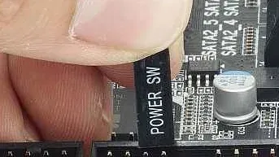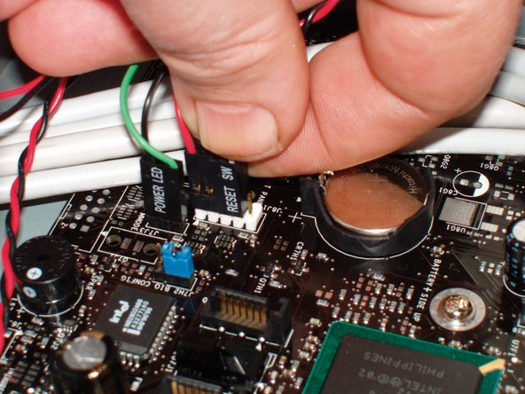
Source:
https://www.ifixit.com/Wiki/Computer_Motherboard_Replacement
Source:
https://www.alphr.com/features/378919/how-to-fit-the-internal-cables/
Step 15: Install PC case
Close the panel of PC case tightly. Screw all the screw tightlt to make sure the panel is stable and do not fall off.
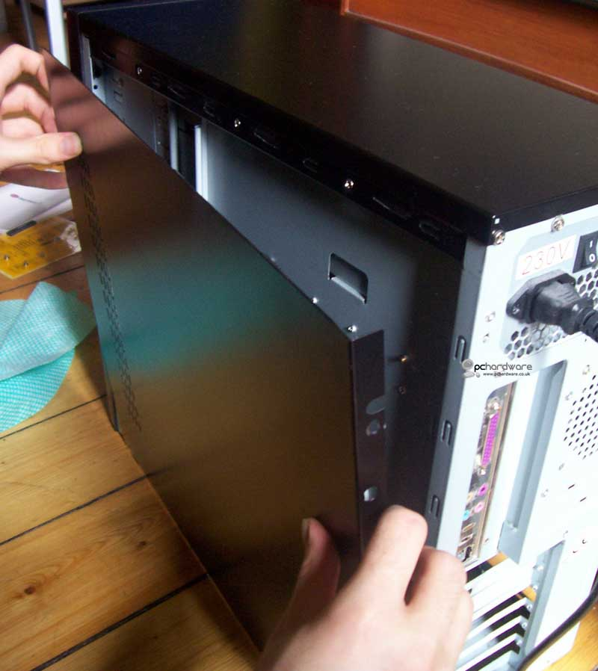
Source:
https://www.pchardware.co.uk/siteimages/install-motherboard1-large.jpg
PART C
Step by Step PC Assembly
Step 16: Testing
After finish all the assembly parts, we can already test our PC. Connect the PC to the power supply and turn on the PC. Check if the display on the monitor exist. We complete the assembly if there is a display on our monitor.


PART C
Step by Step PC Assembly
Last step - Closing the Case and Connecting the Peripherals
Place the side cover back on and secure the side panels with case screws.
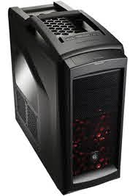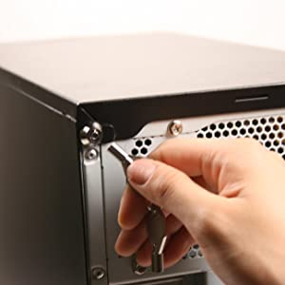
Connect peripheral devices which include keyboard, mouse, wireless network dongle, printer and webcams with your CPU by plugging into USB port.
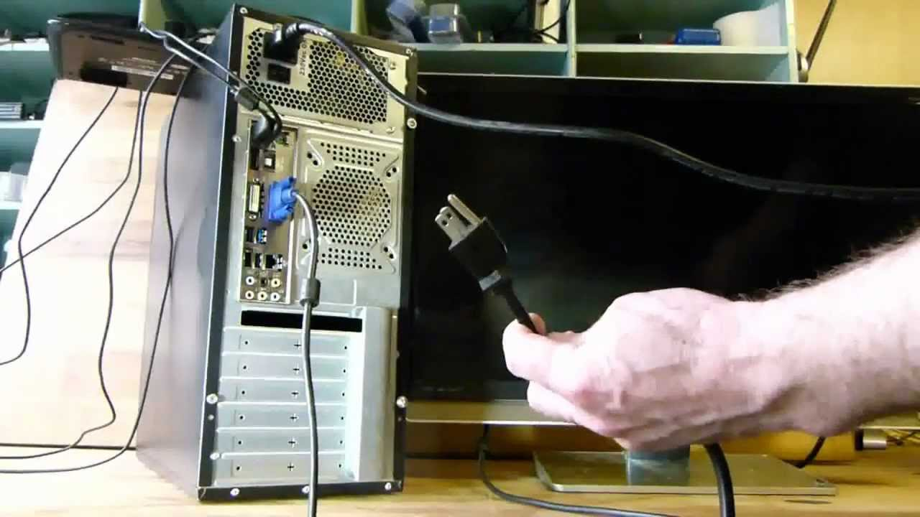

PART C
Step by Step PC Assembly
Then, connect speakers and microphone into 2.5 mm sockets.
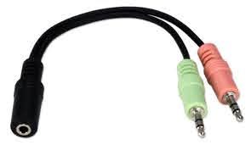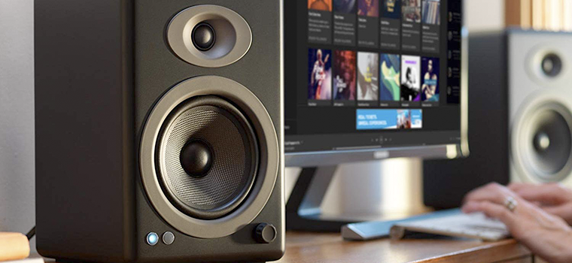
Finally connect the CPU with monitor by plugging into display ports
