Alumni Sharing Session: Inspiring Work experience & Covid19 Pandemic Challenge
By Tan Yong Sheng, Terence A/L Loorthanathan, Nur Irdina Aliah Binti Abdul Wahab, Nur Izzah Mardhiah Binti Rashidi, Nurarissa Dayana Binti Mohd Sukri

Students of University of Technology, Malaysia
(Dec. 29, 2020) - “Inspiring Work Experience and Covid-19 Pandemic Challenge” talk is about three Data Engineering fresh graduates sharing their working experience during this pandemic and how they manage to get hired by their company. They also mention beneficial things to be done in university. The purpose of this talk is to help students to understand more about their future and prepare students to face their university life. Ensuring students to develop their interest and learn more information from the Internet.

Currently working as a Data Science Engineer, Mr. Tan Yong Keong was able to secure his job by having a tailored resume and acquiring a lot of achievements and experiences during his university years. The achievements include participating in competitions, freelancing, as well as applying for an internship at ViTrox, a Malaysian-based electronics company situated at Penang. Through this, he gained professional soft skill and hard skills as companies tend to hire versatile candidates. At his current job, he deals with factory optimization and gathering data in a semiconductor manufacturing department.

Also, a data engineer, Mr. Mohammad Zamarul Akmal underwent a different experience from Mr Tan as he actually got absorbed to become a permanent staff by his internship company. He advises others to always be proactive and contribute their ideas to the company. For instance, he proposed to create a monitoring dashboard to replace his internship company’s manual tool to manage data that comes every day.

Whereas for Ms. Qistina Batrisyia, a social media data analyst, had a similar experience with Mr. Mohammad Zamarul Akmal in securing her job. She showed a lot of effort to join and participate in projects during her internship year when no one wanted to take part in the project of managing social media. By gathering data to interpret into a dashboard and improving the company’s branding, she managed to revamp the company’s marketing strategy.

Mr Tan Yong Keong gave some tips on securing a job in future by participating in a lot of competitions, he gained soft skill during university life. He also states that, company will hire people with technical skill and good soft skills.

Miss Batrisya stated that she needs to be good in excel, python and be proactive as in do not wait until somebody come teach what you need to do, instead of find the solution by yourself, since there are a lot of thing that can be learn. She also socializes with other employees by asking what she can do to help them.

Mr Zamarul tips on securing a job in future is to must learn new technical skill, not just fundamental skill by taking online classes. There are a lot of online classes can be found on the internet such as codeCamp, training class- data star, which probably suites for people majoring in Data Engineering.

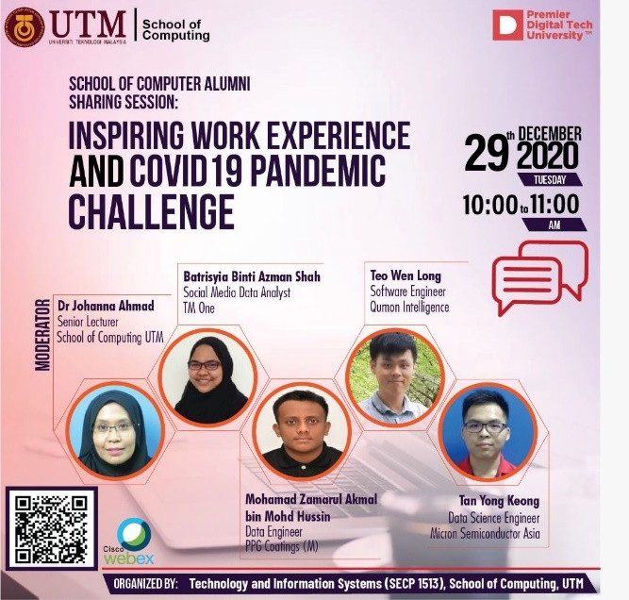
Inspiring Work Experience and Covid-19 Pandemic Challenge Poster

Mr Tan Yong Keong said, confidence can be trained, he also added in order to increase his confidence, he started to join many competitions that are related to presentations. Hence, this will boost your confidence as you familiarize yourself with the situation.

Miss Batrisya joined many activities during university life, especially, since there many projects need to be done. She encourages students to take the chance in giving ideas and speak up more in group project in order to enjoy our study life.

Mr Zamarul also claimed that he joined many programs during university life, making sure to engage more by talking to others and joining games or activity that involves presenting proposals to client instead sitting on the chair and do coding.

“As a student myself, I wonder how I will keep going in this hard path which we call a degree, everyday? Will I give up down the road? How do I motivate myself to avoid throwing in the towel?” asked Dr Johanna, the talk moderator. According to Miss Batrisya, a person that does not give up should have a passion towards what they are doing. With passion there is no need to work hard, said the young lady. According to Mr Tan Yong Keong however, a way for a person to not give up on something is the mindset. To elaborate further, Mr Tan added his mindset is to help make the world a better place. This can be proven when Mr Tan decided to plan out his final year project at UTM with a disease called dengue fever in mind. Mohammad Zamarul Akmal responded well to Mr Tan’s suggestion on mindset and added that Mr Zamarul himself is new to a company which causes him to be excited about upcoming events with the company. Currently Mr Zamarul is working on a project with big investments and hopes, with this opportunity he reminds himself daily that not everyone gets this big of an opportunity.

To summarize, the alumni are able to secure their job by involving themselves in projects, proving their worth to the company and showcase their developed soft skills. They had also shared various tips on increasing the prospect of getting hired, which are through learning new technical and practical skills, always supporting your team, and increasing your knowledge. And most importantly, candidates need to possess self-confidence, which can be developed by joining competitions and events that encourage participants to speak up and engage with others. Lastly, staying motivated on a daily basis by being passionate in what you do, being thankful for the opportunity gained and having a strong mindset will keep yourself motivated at work.

Once the talk ended, we reflected and concluded many strengths about this talk. One of them is that this talk was aimed to give motivation to students. This talk not only achieved that but we saw the extra effort put into finding people from our age group so we can relate to them. Secondly, we concluded that this talk was proposed to give out work experience stories to students. We not only gained some knowledge related to working experiences, but we learned work experiences of alumni that are computer scientists currently. This is greatly appreciated by students that attended because many of us were planning on stepping foot into that industry. Next, lecturers did a great job by inviting in Alumni’s that took courses from UTM. Because of this, students are relieved that courses from UTM promise such good futures that are proven by alumni themselves.

There are several weaknesses that we noticed throughout this talk including the answers given by the fellow speakers to some of the questions that were asked are nearly the same. Hence, it is recommended for the organizer to send the draft of questions earlier to the speakers with the intend that they will be more prepared and have more time to think about the answers deeply. Other than that, to feel more inspired and encouraged, we think that it will be better if they could share some photos or memorable moments of them being a student previously. For instance, the moment they won competitions, graduation day, the first day of becoming a permanent worker in the company and much more. Thus, we could see that they were evolving and growing to become the successful person they are now and somehow, we could relate and picture ourselves to those moments, too. All in all, it is still inspiring and a good talk.
Throughout this sharing session, we have found out that soft skills are extremely vital in our future career despite your academic profile. We must take the opportunity to develop soft skills in university life by taking part in various competitions or events. This will enhance our leadership and communication skills by presenting our ideas or working with different individuals. Besides, another lesson learned is to enrich our free time by participating in online courses to study more technical skills. We can learn other programming languages or professional software which is commonly used by other companies to increase our employability. Lastly, never be afraid of losing in any situation, most importantly is gaining experience from it and show all your efforts without having any regret.

By joining this sharing experience from the alumnus, we feel more motivated and inspired to do better and enjoy study life even more as we realized that, at the end of the day, all of the efforts that we put on will be worth it; being able to start our career wonderfully. Plus, we are aware that to become a future-proof and skilful person is a long-term journey as we have to develop ourselves gradually and learn from past mistakes. We need to be brave enough and be consistent to try and experience new things for the sake of the evolution of ourselves. Moreover, the alumnus showed us that it is not impossible to become successful even though you are not the most genius one in the class. Hence, with all of that, we are ready for the challenges in the future.

