Azure fundamental  Storage | google
Disk (standard SSD/HDD, premium SSD, ultra disks)  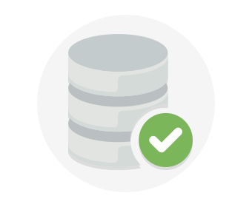  -azure fundamental has disk storage for azure virtual machines.  -can be access by application and other services as needed.  - Disk Storage allows data to be persistently stored and accessed from an attached virtual hard disk.  3 types of Disk  -standard SSD/HDD for less critical workload  -premium SSD is for mission-critical production application  -ultra disks for data-intensive workload such as SAP HANA, top tier databases and transaction-heavy workload. | Block storage ( persistent disk, local SSD)  PERSISTENT DISK  -reliable , high-performance for virtual machine instances  Benefits  - INDUSTRY-LEADING PRICE AND PERFORMANCE  - Offers low -cost storage when bulk throughput is of primary importance.  - Consistent high performance for both random-access workload and bulk throughput.  - Share data easily  - Multi-reader mounting, so many virtual machines can read data from a single Persistent Disk.  *attaching a disk to more virtual machine does not affect performance or cost  - Scale without interruption  - Unlimited flexibility by allowing to resixe storage  - No downtime even it is usued on or more virtual machine at the same time  KEY FEATURES  - Seamless backup and restore  - Automatic encryption  - Independent volumes  LOCAL SSD  What is local ssd?  - Temporary storage uses cases such as caches or scratch processing space.  HIGH-PERFORMANCE , EPHEMERAL STORAGE  - Attached to the server that hosts your VM instance, which offers superior performance  - very high input/output operations per second (IOPS),  - very low latency compared to other block storage options
Files  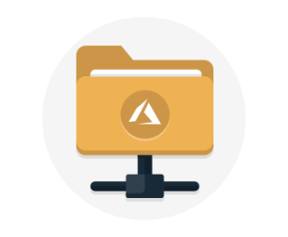  -offers fully managed files shares in the cloud are accessible through industry standard Server Massage Block and Network File System (preview protocols)  -can be mounted a file storage share to access file data by using applications running in Azure virtual machines or cloud services. But, only as a desktop application would mount a typical SMB share.  -unlimited number of Azure virtual machines or roles can mount and access the file storage share simultaneously  There are 2 typical usage to share files  - Diagnostic data  - Application data sharing  Why use azure files?  - Make it easier to migrate application since many on-premises application use file shares  - Store configuration files on a file share, can be access from multiple VMs. To ensure everybody find the tool and utilities which used by multiple developers that stored on a file share  - Write data on a file share and process or analys e the data later, for examples are diagnostic logs, metrics and crash dumps  This diagram shows that , azure files can be used in different two location  - Files shared Is incryption through SMB protocol  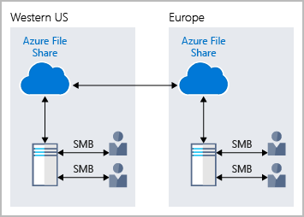  - Files can be access from any location in the world by only using URL. | File stores  -PREDICTABLE PERFORMANCE  - Can speed up to 480k IOPS and 16GB/s,  - Can handle your highest performance workloads  - ELASTICITY TO MEET BIG COMPUTE NEEDS  - High scale , meets the need of high- performance business,  - Easily grow or shrink your instances if any requirement change, via Google Cloud Console GUI ,gcloud command line, or via API- based controls  - Simple to provision , easy to mount  - Fully managed, NoOps service  - Easy mount files share on Compute Engine VMs  - Tightly integrated with Google Kubernetes Engine
Container object ( blob)  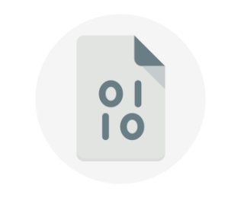  -not limited to common file formats  -contain gigabytes  -messages are encrypted for other application  -for business benefit , blob is stored in containers, which this can help to organize blobs depending in business needs  ADVANTAGES  -does not require developers to think about or manage disks  - uploaded data are called blobs  Blob is ideal for :  - serving images or documents directly to a browsers  - storing giles for distributed access  - Streaming video and audio.  - Storing data for backup and restore, disaster recovery, and archiving.  - Storing data for analysis by an on-premises or Azure-hosted service.  - Storing up to 8 TB of data for virtual machines. | Data transfer  - DATA TRANSFER SERVICES  - move or backup data to a Cloud Storage bucket either from ither cloud storage providers or from on-premises storage  - Move data from one Cloud Storage bucket to another, so that it is available to different groups of users or applications.  - Periodically move data as part of a data processing pipeline or analytical workflow.  - data transfer and synchronization easier.  - TRANSFER APPLIANCE  - Hardware appliance can be used to securely migrate large volume of data (from hundreds of terabytes up to 1 petabyte) to Google Cloud Platform without disrupting business operations.
Table  - STORE PETABYTES OF STRUCTURED DATA  - Let you scale up without having to manually shard your dataset  - Use geo- redundant storage which means data is stored will replicated here times within a region  - SUPPORTS FLEXIBLE DATA SCHEMA  - For web app user data , address books, device information , and other metadata  - Without locking down data model into particular format, this because some different rows might have different particular of rows  - MADE FOR ENTERPRISE  - It will update data stores simultaneously , especially in data stores who used by multiple of users in simultaneously.  - DESIGNED FOR DEVELOPERS  - Has multiple building apps such as .NET , Java , Android , C++, Node.js, PHP, Ruby and phyton  - Offers advanced offer especially in table storage especially OData  - Accessible via REST API which can be called by any language that make HTTP/HTTPS requests. | Mobile app services  -CLOUD STORAGE FOR FIREBASE  - Help user to store photo and vidoes quickly and easily  - Build at Google scale . google will build the prototype to production using the same technology that powers apps like spotify and google photos.  - ROBUST UPLOADS AND DOWNLOADS  - It will outomatically pause and resume the tranfered as the app loses and regains connectivity, which save time and bandwidth.  - STRONG USER-BASED SECURITY  - It integrates with Firebase Authentication ot provide simple and intuitive access control  - Allow access based on useridentity or properties of a file and other medata by using declarative security model.

Collaboration, communication, and file storage
-GOOGLE WORKSPACE
- MODERN COLLABORATION TOOLS TO SUPERCHARGE TEAMWORK
- Includes Docs, Sheets and slides. This is for teams, it can be do it at the same time simultaneously
- SECURE, ENTERPRISE-GRADE VIDEO CONFERENCING
- Google meet can be used . it is easier to use,
- Can have up to 150 participant per call
- Record of video meeting will be saved to google drive who did not attend the meeting

- EASY SECURE ACCESS TO ALL CONTENT
- Google drive can store , share and access anything from any device.
- The content in Google drive can be shared in teams

Security
Azure fundamental | google
Azure security centre  -strengthen cloud security posture  -secure your cloud resources ,SQL , networks, application and worlaod running in azure  Azure Defender  -protect hybrid cloud workloads including servers, data , storage , containers and IoT.  Microsoft defender for Endpoint (servers)  - Protect Linux servers.  - Assess application vulnerabilities in virtual machine  - - protect data that is hosted in Azure Virual Machine on premises or other clouds  - Detects unusual attempts to acces Azure Storage  Azure Arc  - Extend security coverage to workloads outside Azure  STREAMLINE SECURITY MANAGEMENT  - Use AI and automation quickly identify threats,  - Streamline threat investigation  - Help automate remediation  Why Azure for security?  - Microsoft invest more than USD 1 billion annually on cybersecurity research and development  - Employ more than 3500 security experts who are dedicated to data security and privacy  - Has more certifications than any othr cloud provider such as FIPS 140-2 for US government. | - Help create stronger passwords  - Protect your devices  - Avoid phising attempts  - Browse internet securely  SECURITY CHECKUP  - It built step by stpe tool to give personalized and actionable security  Recommendations to help you strengthen the security of you google account  CREATE STRONG PASSWORDS  -it will create strong , unique password.  KEEP TRACK OF MULTIPLE PASSWORDS  - Helps protect and keep track of the passwords you use on sites and apps.  DEFEND AGAINST HACKERS WITH 2-STEP VERIFICATION  -helps keep out anyone who should not have access to account by require to use a secondary factor on top of username and password to log in account  KEEP SOFTWARE UP TO DATE  - Protect yourself from security vulnerabilities  KEEP POTENTIALLY HARMFUL APPS OFF YOUR PHONE  -Google play protect runs a safety check on apps from google play store.  USE A SCREEN LOCK  -lock your screen to keep others from getting into your device.  LOCK DOWN YOUR PHONE IF YOU LOSE IT  -can visit google account and select ‘find your phone’ to protect data in a few quick steps.
Os environmental
Azure fundamental | google
- OS environmental is environmental in which users run application software  - Azure is cloud computing for building , deploying and managing applications and services through a network centres  - MICROSOFT AZURE PRODUCTION NETWORK ( AZURE NETWORK)  - MICROSOFT CORPORATE NETWORK (CORPNET)  Guest operating system  Azure running on guest operating system and VMs have no opportunity to run Remote Dekstop Protocol. Any changes to baseline configuration settings must go through the change and release management process  - Azure datacenter  - Microsoft cloud infrastructure and operations(MCIO), manage physical infrastructure and datacenter facilities for all microsoft online services.  - MCIO primarily responsible for managing the physical and environmental controls within the data centers, as well as managing and supporting outer perimeter network devices.  - Service management and service teams  - Each service team is responsible for an area to support Azure | Chrome OS  -Gentoo Linux which designed by google.  -proprietary software  - operating system in which both applications and user data reside in the clouds  - primarily runs web applications  -written in c, c++, JavaScript, HTML5, Phyton, Rust.  -CHROME ENTERPRISE  - Launch in 2017  - Capabilities intended for business use  GUEST ENVIRONMENT  - Each supported operating system that is available on Compute Engine requires sprecified environment packages  - LINUX guest environment  - The Window guest environment

