An Evaluation of Cloud Computing Service Providers
Navinthra Rao, Chang Min Xuan, Nur Haznirah and Saidah

School Of Computer, Engineering Faculty,
Universiti Teknologi Malaysia,Johor, Malaysia
saidah@graduate.utm.my
nurhaznirahh@gmail.com
changxuan@graduate.utm.my
navinthrarao@graduate.utm.my

1 INTRODUCTION
Cloud computing is a new way of resource utilization in Internet. In computer flowchart, a cloud is always being used to indicate cloud computing. It is also used as an abstract concept for underlying infrastructures simultaneously. The concept of cloud computing can be simply said by putting and installing personal computer storage and calculating function in supercomputers through the Internet. Hence, once entering the cloud, we can directly managing files by connecting to the supercomputers. Besides, cloud computing can be divided into different level of services, that is, Infrastructure as a Service (IaaS), Platform as a Service (PaaS) and Software as a Service (SaaS). IaaS is a flexible cloud-based service such as networking and storage whereas PaaS contents hardware and software tools over the Internet which focus on application development. On the other hand, SaaS provides complete software solution via a third party over the Internet. On October 2007, cloud computing has been started to be promoted by Google and IBM at campuses in United States including Massachusetts Institute of Technology, Carnegie Mellon University and Stanford University. The cloud computing plan provide software and hardware equipment as well as technical resources to these universities, enabling development of large-scale computing by students as the basis of research plan. On 30 January 2008, Google announce the startup of cloud computing academic plan at Taiwan while on 3 August of the same year, Dell applied for trademark of cloud computing, which may enhance the control of technology architecture in future.
2 CLOUD SERVICES
There are 3 types service model of cloud computing which is Software as a Service (SaaS), Platform as a Service (PaaS) and Infrastructure as a Service (IaaS). Amazon EC2 included all of the three types service model while Azure included both of IaaS and PaaS. Moreover, Google Cloud Platform is IaaS type of service model.
Table 1.1 below shows the differences of the types of service
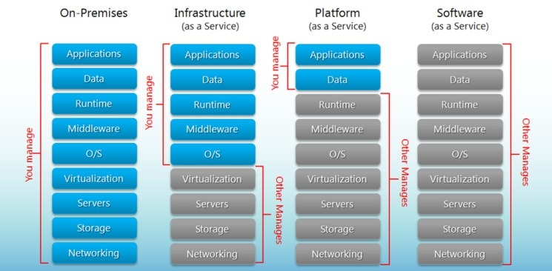
Each of the types services has their own benefits which is for SaaS, the benefits are it is affordable as it eliminates the cost involved in the purchase, installation, maintenance and upgrades of computing hardware. Other than that, it is also can be access at anywhere and ready to use. Meanwhile the benefits for PaaS are minimal development time, multiple programming language support and also can enhance collaboration. The benefits for IaaS are it can minimize the costs, can enhanced scalability and have simple deployment.
3 LEADING CLOUD COMPUTING PROVIDERS
Virtual machine instance types is a software defined by computer with its own operating systems that runs on a host server with a different underlying operating systems. Amazon EC2 provides the instances of virtual servers and virtual machine. Microsoft Azure provides the virtual hard disks and Google Cloud Platform provides the virtual machine instances. The types of instances are general purpose which is the most popular and used for web servers also for development environment. Next is compute optimized which good for compute intensive applications. Other than that is memory optimized that used for anything that needs memory intensive, accelerated computing include additional hardware (GPUs, FPGAs) and storage optimized which ideal for tasks that require huge amounts of storage.
Storage in cloud computing is model that stores data on the internet through a cloud computing providers who manage and operates data storage as a service. Amazon EC2 and Microsoft azure offered you temporary storage where amazon is S3 and Microsoft azure is block blob to stored objects. Size of storage for amazon is up to 48 TB while for google cloud platform is 3TB and for Microsoft Azure is 4TB.
Cloud operating system is a type of operating system designed to operate within cloud computing and virtualization environments. A cloud operating system manages the operation, execution and processes of virtual machine, virtual servers and virtual infrastructure as well as the back-end hardware and software resources.
In terms of security, Amazon has developed the industry's leading security platform for its customers. Amazon also claim to have the largest network of solutions and security partners. Amazon’s system is fine-tuned to avoid attacks, detect any suspicious activities, takes an action quickly and efficiently to any accidents. Amazon also provides courses to enhance strategies in defensive system. Amazon claims that its high quality security is equivalent with the protection that would be available to us with the benefit of scaling up the Amazon security to meet the growth of our business. Apart from that, for Microsoft Azure. When setting up our Azure account, we can choose for a certain security features that will improve the safety of our data. We have to encrypt all of our data that stored on the server side which, if our profile is compromised, it would prevent readable copies from being accessible. Lastly, for Google Cloud, its gives us the choice to handle our profile keys and manage it by ourselves. Google Cloud security comes with an advantage which by managing our own account, we can manage key permissions and use the audit key. So, if we have decided to allow two factor authentication (2FA), it will provide us with an extra security layer. So that, our system will not be exposed to the hackers even if a week password is broken.
In terms of performance and scalability, Amazon is a powerful business of cloud computing platform. Its facilities are split across countries. The availability zones (AZs) are kept far apart from each other. It is because to ensure that there are no failures in operation in the midst of any accident. While edge locations acts as Content Delivery Networks (CDNs) for a quick delivery and response times by routing cloud software closer to the current location. This sort of network enables quick information delivery across the region without impacting service or performance efficiency. Amazon is one of the best IaaS platforms for data access, high performance and the vast range of users, and allows all operating systems. Apart from that, Microsoft Azure is a strong and integrated platform. It is because Azure have a competitive market in terms of performance, efficiency and deployment of applications. The virtual servers and compliance with Linux database architectures are one of the main features that distinguish it from other cloud computing platforms. Azure provides with a built-in and prepared to run the cloud software that supports a variety of languages including Java, PHP, Python and so on. By using Microsoft Azure’s, we can enjoy a lot of services like scalable data warehousing, Blockchain technology, DevOps and IoT integration, big data and game app development. Next, Google Cloud is a new cloud services but has managed to form its brand. It supports numerous generations of Linux and Windows server up to 2016.
Google Cloud is an innovative company with a remarkable cabling system that begins in Guam and connects to servers in Australia, the South Pacific, Asia, Japan and the mainland of the United States. It is very easy to set up and maintain. Key services from Google Cloud are data management and storage, app development, SMB business analytics, productivity and workload management tools. The pricing among these three cloud which are Amazon, Microsoft Azure and Google Cloud can be changed based on the specific arrangement that a customer can wrangle from their service. First, pricing for Amazon is especially inscrutable. Although it offers a cost calculator, it is difficult to get precise figures because of the many variables involved. The Gartner report summed it up, saying, "AWS is the most mature, enterprise-ready provider, with the deepest capabilities for governing a large number of users and resources." Second, Microsoft Azure does not speed things up anymore. It is due to the variety software cloud services options of Microsoft and the use of situation based on the discounts, without outside assistance. Its pricing structure that very difficult to understand. Lastly, Google Cloud uses its pricing as a point of comparison. It seeks to deliver “Customer-friendly” deals that can beat other provider’s list prices. Gartner noted that "Google uses deep discounts and exceptionally flexible contracts to try to win projects from customers that are currently spending significant sums of money with cloud competitors."
Table 1.2 shows the pricing model among Amazon, Azure and Google.
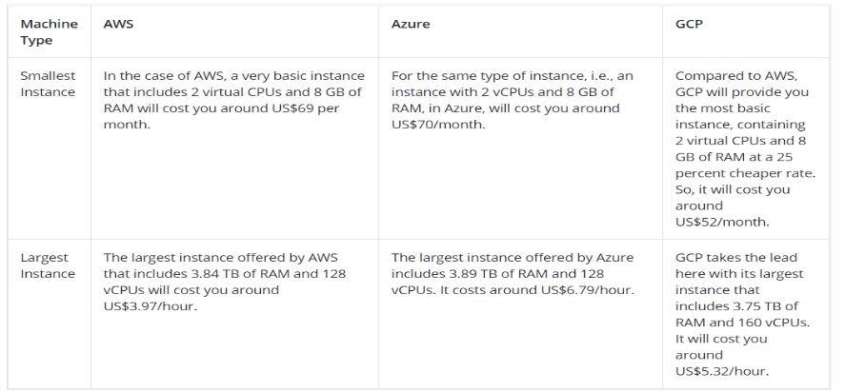
In terms of auto-scaling or elasticity, Elastic Compute Cloud or EC2, is Amazon's flagship computing service. EC2 is described by Amazon as "a web service that provides secure, resizable compute capacity in the cloud." EC2 offers a broad range of options, including a wide range of instances, Windows and Linux support, bare metal instances, GPU instances, high-performance computing, auto scaling, and more. For EC2, Amazon also provides a free tier that includes 750 hours per month for up to 12 months. Next, the key cloud-based computing service for Microsoft Azure is classified as Virtual Machines. It has Linux, Windows Server, SQL Server, Oracle, IBM and SAP support as well as enhanced security hybrid cloud capabilities and Microsoft software integrated support. Like Amazon, it has an incredibly broad catalogue of instances available, including GPU and high-performance computing options, as well as artificial intelligence and machine learning-optimized instances. It also has a free tier of 750 Windows or Linux B1S virtual machines every month for one year. Apart from that, Google's computer service list is far shorter than that of its rivals.
Compute Engine, which has both custom and predefined types of computers, per-second billing, Linux and Windows support, automatic discounts and carbon-neutral technology that uses half the power of traditional data centres, is its primary operation. For up to 12 months, it provides a free tier that includes one f1 micro instance per month. In terms of services provided from Amazon, Microsoft Azure and Google Cloud, they offers the similar basic function around scalable compute, storage and network. They all shared a common components of a public cloud like self-service, protection, identity management features and so on. In 2017, Amazon released SageMaker as a way to facilitate machine learning development by adding together a hosted Java development system with designed model management, controlled spin-up of training environments via Amazon EC2 and HTTPS endpoints for Amazon S3 hosting services. Next, Microsoft's Azure Machine Learning enhances developers to write, test and deploy algorithms as well as access an off-the-shelf API marketplace. Apart from that, Google provides an exclusive AI framework based on its popular open source TensorFlow deep learning library, which supports technologists design and deploy models.

4 CHOICES AS USERS
As cloud platform users, everyone considers using the one platform that fits them perfect or helps them in every small detail they require from the specific cloud platforms. Not just that, users choose cloud platforms that tick their requirements as if they prefer cloud platform to be their partner in crime in doing any kind of task the users need the cloud platform to do so. There are so many advantages and disadvantages of different types of cloud platforms such as Amazon EC2, Google Cloud Platform and Microsoft Azure.
Firstly, there are advantages and disadvantages when it comes to cloud platform such as Amazon EC2. One of the advantages of using Amazon EC2 is that AWS’s platform is clearly picturized and expressed in the simplest way possible so that everyone including beginners can access it easily. AWS’s platform would not give any issues for the new users and existing users due to the AWS Management Console or well-documented series. Another advantage of Amazon EC2 is that it has no capacity limits. AWS provides large capacity with minimum cost for users. This large capacity feature reduces users’ workload. Users can increase the capacity that AWS provides at low cost. Users can upgrade their capacity for free. Another advantage of Amazon EC2 is that it provides speed and agility. AWS enables the applicants to hire for services from technicians within a few 4 minutes. Applicants just have to select their requirement and can proceed to next stage without having to contact to anyone. It is easy and flexible for applicants to use the platform instantly. AWS provides applicants with tools to help cut some time they use on task such as Auto Scaling and AWS Tools. The storage provided by AWS that works at great speed is Amazon Glacier and Amazon Simple Storage Devices. Amazon EC2 has high performance database such as Amazon RDS, Amazon Redshift. Now there are several disadvantages of Amazon EC2. One of the disadvantages of Amazon EC2 is the limitations of this cloud platform. AWS sets a specific default limit on resources that vary region from region. The resources include images, volumes and snapshots. It provided limited access and information for the resources managed by Amazon EC2 and Amazon VPC console. Amazon EC2 has a disadvantage of general cloud computing issues when the user or applicant transfers file to a cloud such as a downtime, limited control and backup protection. Last disadvantage of Amazon EC2 are security limitations. AWS security is limited. For example, EC2-Classic that allows maximum of 500 per instance and each Security Group can have a maximum permission. EC2-VPC allows 100 security groups per VPC.
Moreover, the next cloud platform is Google Cloud Platform. This specific cloud platform also has advantages and disadvantages. One of the advantages of Google Cloud Platform is the usability. The cloud’s storage allows users to access data from anywhere in the world with the setting of having an established and stable internet connection. The users can keep track of their memory stick as long as they remember the username and password. Cloud storage that Google Cloud Platform provides is so convenient that it allows people from variety of devices to use it at the same time. Another advantage of this platform is that it has high durability. Google Cloud Storage offers 99.99% of durability of objects over a given year. This shows that the data survives in a most likely circumstances equivalent to the simultaneous loss of two disks. Last advantage of this platform is ease of integration such as this platform is easy to integrate with other Google Cloud Services such as Compute Engine, App Engine or Kubernetes Engine. One of the disadvantages of Google Cloud Platform is the internet reliance where it relies heavily on the Internet. If there is no stable Internet Connection, there is no way the users can access data. This platform also has a disadvantage in terms of security the cloud platform is less susceptible to damage than the hardware but it can be entrusting its security to strangers. Strangers can access the cloud just by having the username and password. Anyone can access to take one’s personal files if there are left logged in. This Google Cloud Platform comes with a disadvantage of the price expense in which the support fee subscription pack is quite expensive just for the basic service.

Furthermore, the cloud platform, Microsoft Azure has several advantages and disadvantages. One of the advantages of Microsoft Azure is the high availability of this cloud platform. By using Azure, users can have easy and high availability of server systems. The users can get uptime guarantee of 99.95% by the legal agreement. This shows that the users can get approximately 4.5 hours downtime throughout the year. Another advantage of this cloud platform is cost-effective. Since the user is using the cloud service provider, they do not have to invest in other IT infrastructure. It shows that the users can purchase anything at a global scale. The cloud environment makes it easier for users to launch internal apps and apps without investing in external hardware. As a result, it reduces the maintenance cost giving the users a complete-cost effective solution. Microsoft Azure has an advantage of strong security profile. Azure follows the DADSC approach for security as it stands to detect, assess, diagnose, stabilize and close. End users are covered with Azure reduces the risk of data loss. Microsoft Azure provides multi-factor authentication and application passwords that gives extra layer of security to halt information theft. Microsoft Azure comes with several disadvantages and one of it is the accessibility speed. In the case of Microsoft Azure, 54 regions are serving 140 different countries of the world. If the users live in a country far from the data center region, there will be a lag in speed which is troublesome. Microsoft Azure comes also has a disadvantage which is this cloud platform requires management. The users require someone specifically just to manage the data efficiently for monitoring and patching.as the Microsoft Azure does not help to manage the cloud-based center. Another disadvantage of this cloud platform is it has weak functioning platform and it requires expertise to operate it so that all the required parts are functional. The over-provision of cloud services is one common mistake made by business administrators.
We would choose Google Cloud Platform as the cloud service providers for our software development. We made this decision on choosing the Google Cloud Platform as the cloud service provider after enlisting all the criteria such as compute features, key tools and pricing aspect. From the aspect of compute features, their basic compute platform, Google Compute is the highlight of their roster of services. They support both Windows and Linux and we can configure our platform or get a pre-defined machine type. The focus in on Kubernetes deployment which is an area of expertise for Google. It also has other features such as Google App Engine, Graphic Processing Unit (GPU) and Docker Container registry. Moreover, form the aspect of key tools, Google Cloud Platform features run the gamut from natural language, translation, and speech that is ideal for transitioning into global enterprise coordination to ML app development due to their large open-source library TensorFlow. Some of the key tools are Cloud Machine Learning Engine, Cloud Speech API and Cloud Video Intelligence. As far as the pricing aspect, Google Cloud Platform is way more reasonable because it makes it easier to work advanced tech within our budget. We have the option to get basis services that vary with many features and unique at a cheaper price. We really think Google Cloud Platform as our cloud service providers for software development other than others because it is a complete container-based model. It is good fit for us because we prefer for our websites to work within a hyperscale environment and very cost-effective. Lastly, we choose Google Cloud Platform because we are looking for a green tech solution.

5 CONCLUSION
This paper highlights on the cloud platforms where each of the advantages and disadvantages have been analyzed in detail. Furthermore, the comparison between the most prominent Cloud Computing Service Providers have been discussed and listed down. The characteristics and main purposes of cloud computing are further discussed as the advantages of cloud platforms. For example, with cloud computing, users can just take benefits without the needs of deep knowledge about the technology. In addition, this paper has included the comparative evaluations as well in order to give a brief understanding about the cloud platforms

Reference

- Bootcampmedia.co.uk. 2019. "The Cloud" - Advantages And Disadvantages. Retrieved from https://www.bootcampmedia.co.uk/blog/the-cloud-advantages-and-disadvantages
- DataFlair. 2021. AWS Advantages & Disadvantages | Advantages Of Cloud Computing - Dataflair. Retrieved from https://data-flair.training/blogs/aws-advantages
- Gaille, B., 2018. 15 Microsoft Azure Advantages And Disadvantages. BrandonGaille.com. Retrieved from https://brandongaille.com/15-microsoft-azure-advantages-and-disadvantages
- Intellipaat.com. 2019. AWS Vs Azure Vs Google - Detailed Cloud Comparison. Retrieved from https://intellipaat.com/blog/aws-vs-azure-vs-google-cloud
- Managed Solution. 2019. What Are The Pros And Cons Of Microsoft Azure? Find Out. Retrieved from https://www.managedsolution.com/pros-cons-of-microsoft-azure
- Petters, J., 2020. AWS Vs Azure Vs Google: Cloud Services Comparison - Varonis. Inside Out Security. Retrieved from https://www.varonis.com/blog/aws-vs-azure-vs-google
- T, S., 2020. Insights On Windows Azure : Advantages And Disadvantages - Techiexpert.Com.Techiexpert.com. Retrieved from https://www.techiexpert.com/insights-on-windows-azure-advantages-and-disadvantages
- Vidal, J., 2018. Google Cloud Storage: Pros/Cons And How To Use It With Javascript. Retrieved from https://medium.com/dailyjs/google-cloud-storage-pros-cons-and-how-to-use-it-with-javascript-ea9ce60a94c0
- rana, aakansha. (2020, October 17). AWS vs Azure vs Google - Detailed Cloud Comparison. Retrieved January 19, 2021, from Intellipaat Blog website: https://intellipaat.com/blog/aws-vs-azure-vs-google-cloud/#pricing-model
- AWS vs. Azure vs. Google: Cloud Comparison. (2020, October). Retrieved January 19, 2021, from Datamation.com website: https://www.datamation.com/cloud-computing/aws-vs-azure-vs-google-cloud-comparison.html
- AWS vs Azure vs Google Cloud: A Cloud Service Comparison. (2020, February 14). Retrieved January 19, 2021, from MetrixData 360 website: https://metrixdata360.com/cloud-series/cloud-comparison-amazon-web-services-vs-microsoft-azure-vs-google-cloud/

