
Semester I 2020/2021

Subject : Technology and Information Systems (SECP1513)
Section : 2
Assignment : Step by step PC Assembly

GROUP NAME / NUMBER : Group 7

1 |  | Name : Goo Ye Jui  Matric Number : A20EC0191  Phone Number : 018-4040438  E-mail :yjyejui626@gmail.com
2 |  | Name : Kelvin Ee  Matric Number : A20EC0195  Phone Number : 011-21584699  E-mail :kelvinee2001@gmail.com
3 |  | Name : Yong Zhi Yan  Matric Number : A20EC0172  Phone Number : 011-61284629  E-mail : zhiyanyong01@gmail.com
4 |  | Name : Ahmad Muhaimin Bin Ahmad Hambali  Matric Number :A20EC0006  Phone Number : 019-4703276  E-mail :ahmadmuhaimin135@gmail.com
5 |  | Name : Myza Nazifa Binti Nazry  Matric Number : A20EC0219  Phone Number : 010-9802910  E-mail : myzanazifah@gmail.com

PART A – List at least FOUR tools needed to assemble a PC. For each tool, Provide picture(s), explanations of its functions and its importance.

First tool- Screwdriver

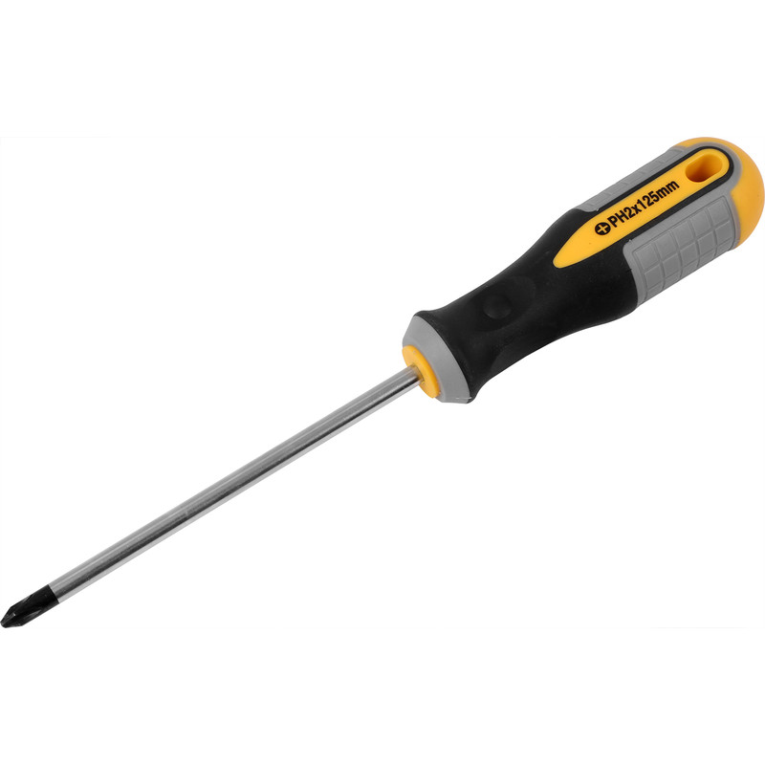

There are a lot of types of screwdrivers like Phillips head, slotted, Pozi-drive, Torx, Hex drive etc. Most of the computer components like motherboard, SSD, hard drive and others are held together with screws and most common types of screws used in computers are Philips-head. Therefore, the most important tool for PC building is a Phillips-head screwdriver with a big bit, supportive to try not to strip the head, and a long shaft also comes handy in keeping handles out of the way when dealing with tight spaces. In building PCs, we should have at a minimum, small and medium sized Phillips. There are screwdrivers with magnetic features to help users retrieve screws, especially small screws.

Second tool- Anti-static equipment

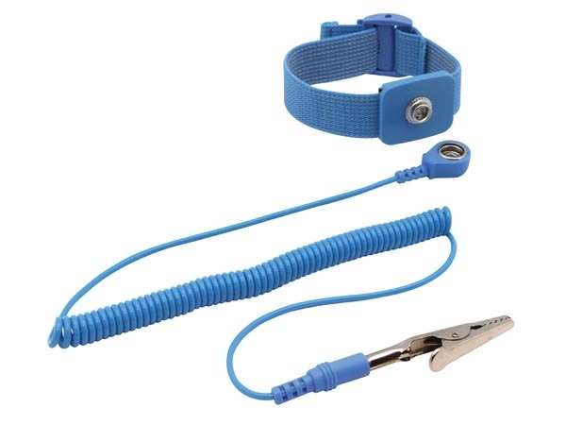

An antistatic device is any device that reduces dampens, or otherwise prevents electrostatic discharge which is the discharge of static electricity. Electrostatic discharge can damage electrical components such as computer hard drives and other components. When building a PC the first thing we want is to keep all the components safe and work fine, so an antistatic device will reduce the risk of damaging the components in the building period. Lastly, using antistatic devices you can avoid hurting yourself in the meantime, maybe building a PC doesn't involve high voltage that may cause a fatal injury but it is better prevented than cured.

Third tool - Zip or Twist ties

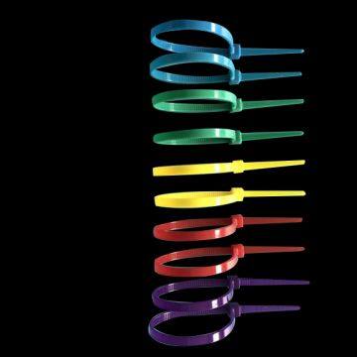

Zip or twist ties are important in cable management. Cable management is important to those users who seek a clean aesthetic looking desk. Cable management is also essential to keep airflow high as they keep dust accumulation low. The most common colour that people choose their twist ties is black because it blends with the surrounding components such as the power supplier. We can tidied up cables that might move in the future because it is easier to remove it and it will make the entire desk look like wireless.

Fourth tool- Pliers

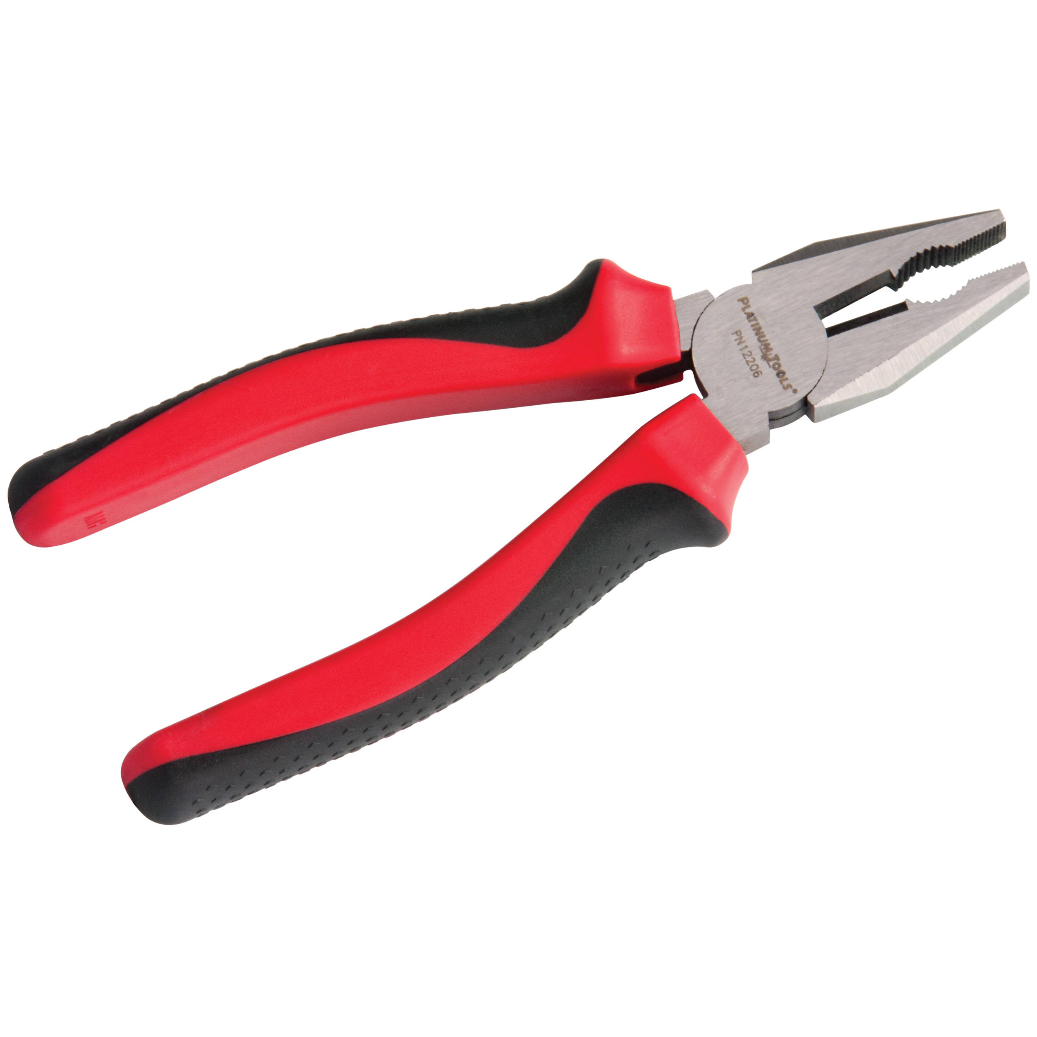

There are several types of pliler like slip-joint, water-pump, linesman, locking and needle-nose with different functions. Pliers are hands too that are meant for holding an object firmly. Most functions used for pliers in building a PC are cutting the excess cable ties by using needle-nose pliers.

PART B – Sketch of a mother board layout
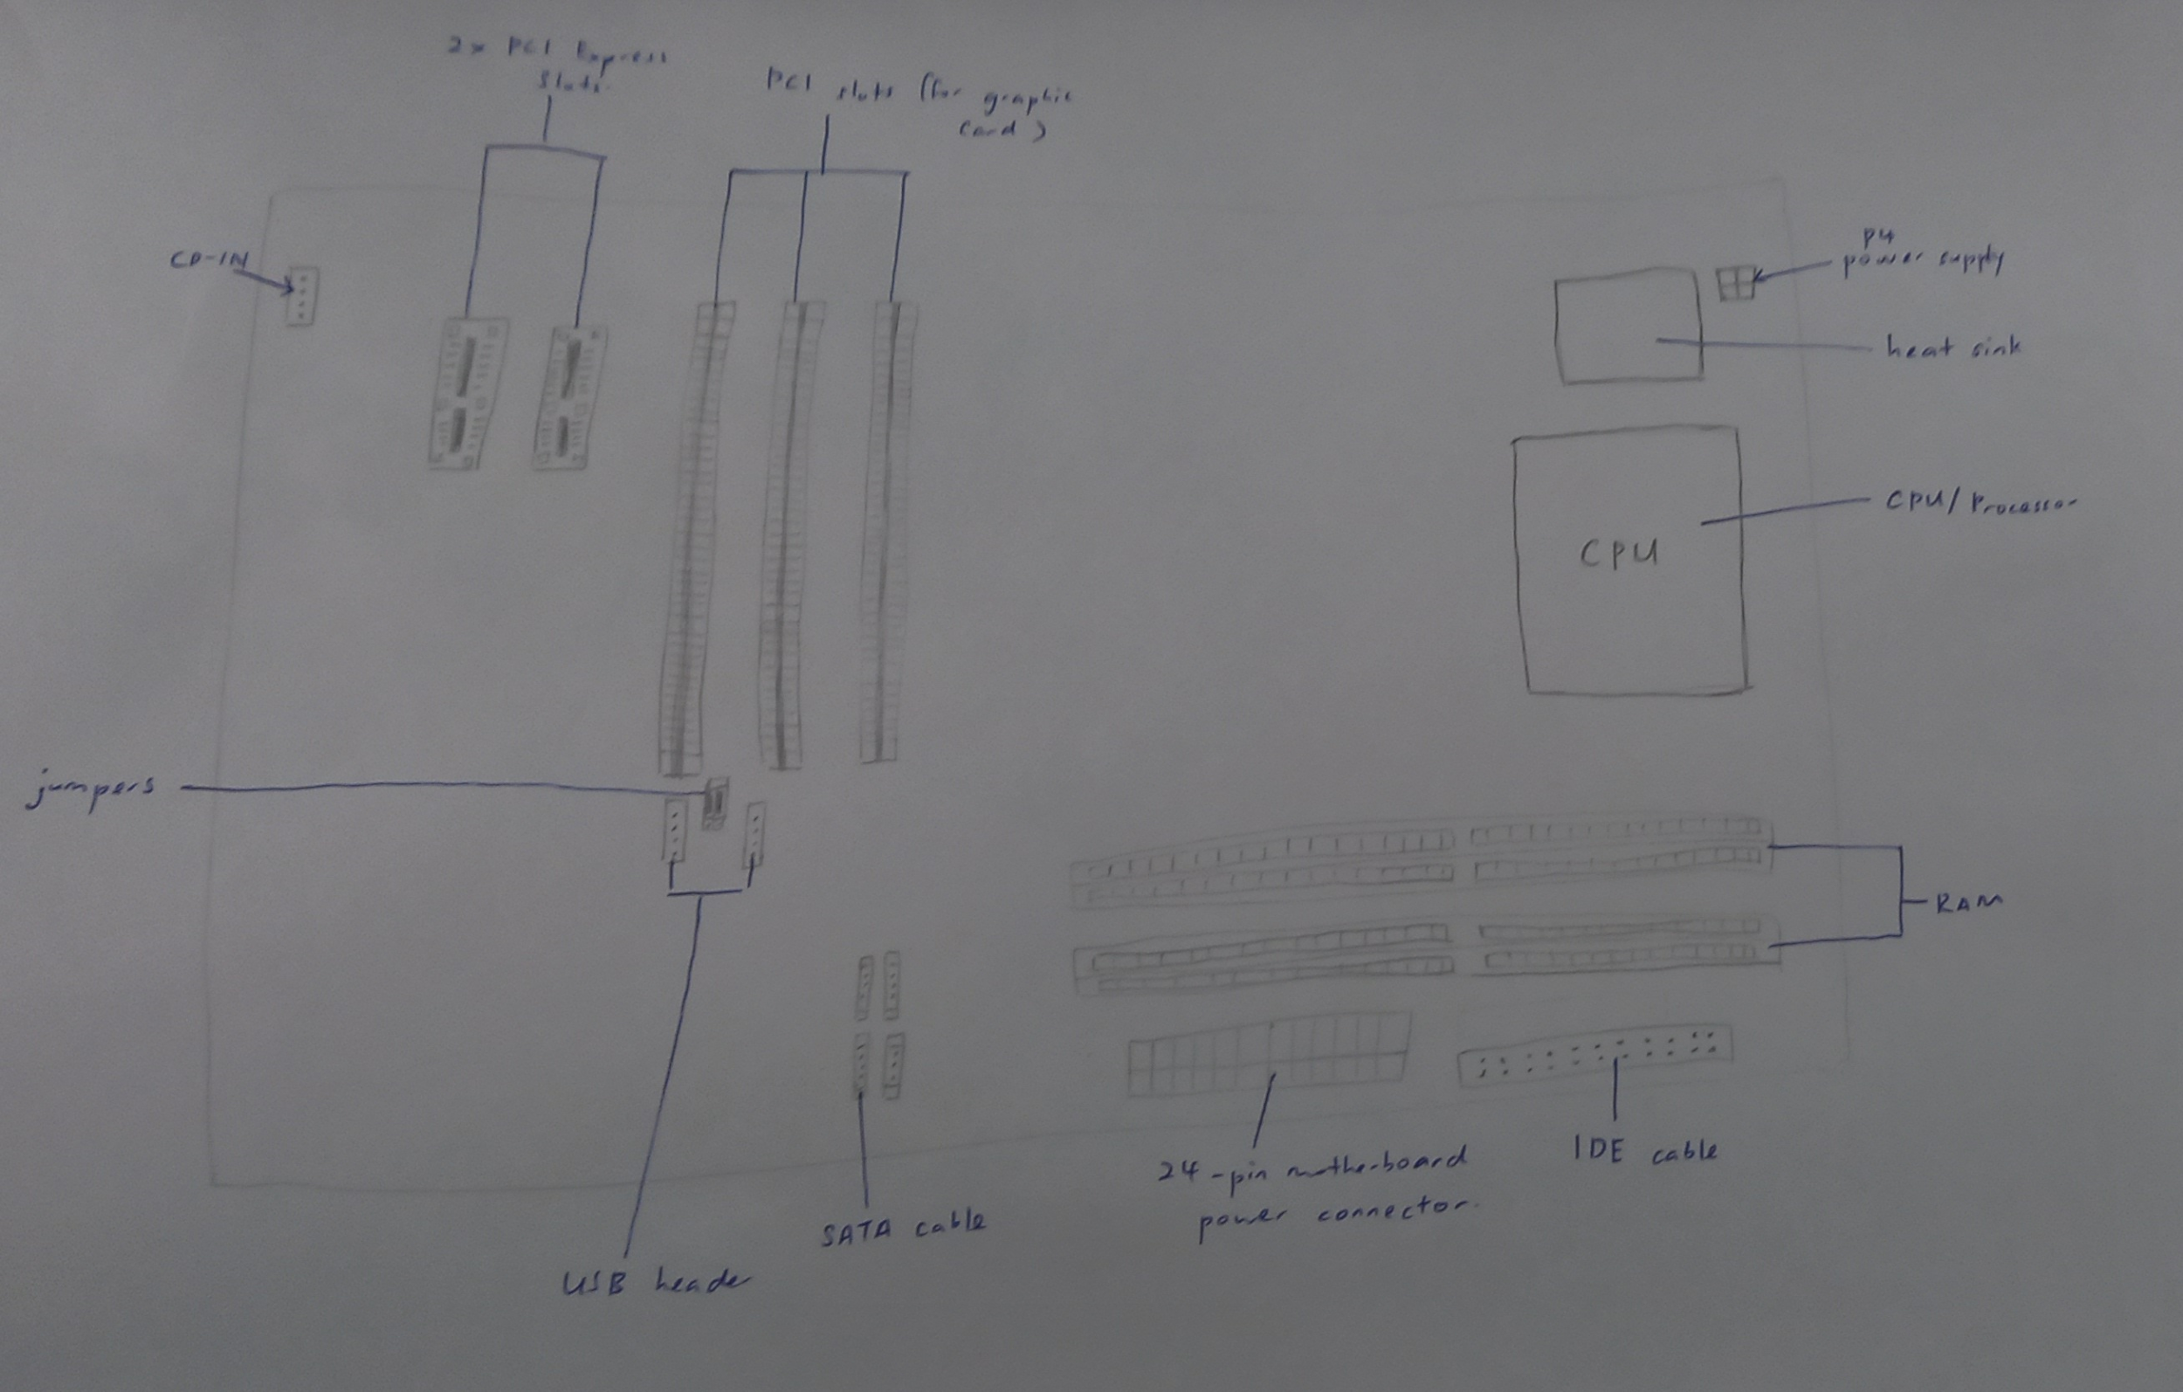
Figure 1 : Sketch of the motherboard

COMPONENT | FUNCTIONS
GRAPHIC CARD  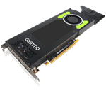 | · A piece of computer hardware that produces image that can be seen on a monitor. It also allows the computer to produce the image and graphics more quickly.  · It will convert data into a signal that can be understood by the monitor.  · The motherboard and the monitor are connected by the video card.  · This will allow the card to accept information from the CPU (Central Processing Unit) and send the output to the monitor.  · Two types of graphic cards:  - Integrated: Graphics built into the motherboard where no add-in card is used  - Discrete: An add-in graphics card that is installed on to the motherboard as an extra component.  (Ebuyer, 2015), (Eri Luxton)  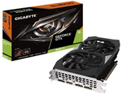  Nvidia GeForce GTX 1660 Ti  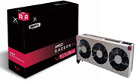  AMD Radeon VII  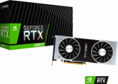  Nvidia GeForce RTX 2080 Ti
CPU / PROCESSOR  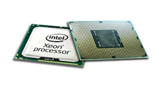 | · A piece of hardware that will carry out the instructions of a computer program.  · The CPU will perform the basic arithmetical, logical, and input/output operations of a computer system.  · It also stores data, intermediate results, and instructions (program).  (Central Processing Unit (CPU): Parts, Definition & Function, 2020), (Tutorials Point)  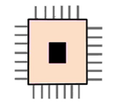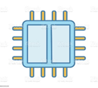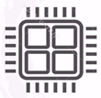  Single-Core CPU Dual-core CPU Quad-core CPU  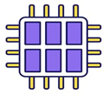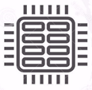  Hexa-core processors Octa-core processors
HEAT SINK  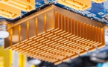 | · Heat sink is a thermal conductive metal device designed to absorb and disperse heat away from a high temperature object such as a computer processor.  · Heat sink transfers the heat from the source to avoid overheating.  · The heat is distributed throughout the heat sink.  (Arrow, 2019), (Techopedia, 2011)  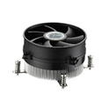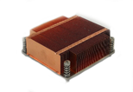  Active heat sink Passive heat sink  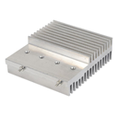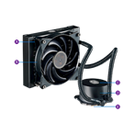  Solid metal heat sink Pumped liquid heat sink  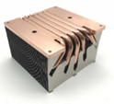  Two phase heat sink
CD ROM  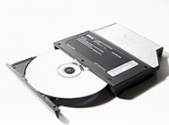 | · CD ROM is a compact disc that stores computer data of graphics, text, and audio.  · CD-ROM drives cannot write information to a CD (burn) because they are read-only drive.  (CDROM2GO), (Ryan Casima, 2016)  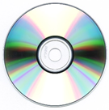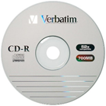  CD-ROM CD-R  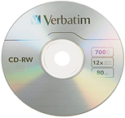  CD-RW
USB CABLE  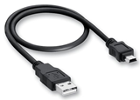 | · USB cables is used for connecting devices such as printers and digital cameras to the computer.  · The USB interface provides various benefits, including plug-and-play, increased data transfer rate (DTR), reduced number of connectors, and addressing usability issues with existing interfaces.  (Christina Hansen), (Techopedia)  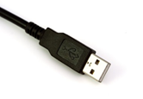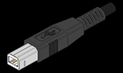  USB-A USB-B  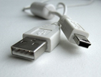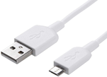  Mini-USB Micro-USB  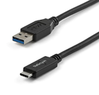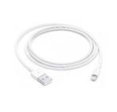  USB-C Lightning Cable
SLOTS  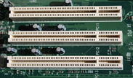 | · Slots is a socket on the motherboard that is used to insert an expansion card (or circuit board).  · Slots are often called expansion slots because they allow you to expand the capabilities of a computer.  (Techopedia, 2016), (Webopedia)  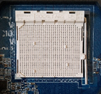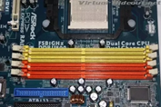  CPU Slot RAM Slot  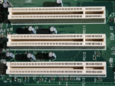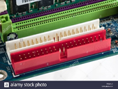  PCI Slot IDE Slot
RAM  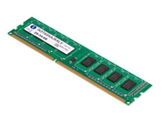 | · A RAM device can access data in random order, which makes it very fast to find a specific piece of information.  · RAM devices are used in computer systems as the main memory.  · RAM is used to read files and act as temporary storage.  (What Is Random-Access Memory (RAM)? - Definition & History, 2015), (Aaron Parson, 2017)  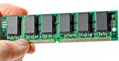  SRAM  (Static random-access memory)  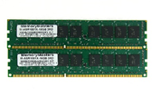  DRAM  (Dynamic random-access memory)
SATA CABLE  (Serial Advanced Technology Attachment)  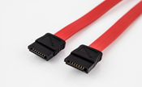 | · An interface used to connect ATA hard drives to a computer's motherboard.  · Transfer rates start at 150MBps.  · SATA is easier to manage because they don't take up as much space and can be tied up more easily. The thinner design also results in better airflow inside the computer case.  (Techterms), (Tim Fisher, 2020)  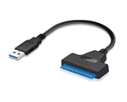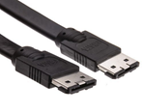  SATA eSATA
IDE CABLE  (Integrated Drive Electronics)  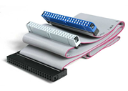 | · The types of cables and ports used to connect some hard drives and optical drives to each other and to the motherboard.  · Has 3 connection points where one end of the IDE cable is to connect to the motherboard while the other two are open for the devices.  (Tim Fisher, 2019)  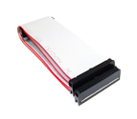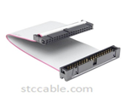  34-pin floppy drive cable 40-pin ribbon cable
POWER SUPPLY  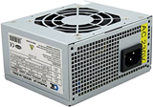 | · To provide electrical current power to various components or hardware contained in the computer case.  · Power supply will divide the power according to the capacity required by each computer component.  · Power supply also maintains the stability of electric current in various components.  (powersupplypc, 2020)  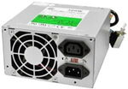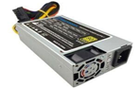  AT Power Supply ATX Power Supply
HARD DISK  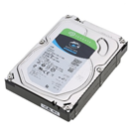 | · To permanently store and retrieve computer data. It uses magnetic storage to store and receive information.  · Keeps the data saved even after the computer is turned off.  · It exists inside a computer case (CPU) and is connected to the computer motherboard using data cables (PATA, SCSI, SATA).  (Komal Mishra, 2020)  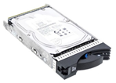  PATA (Parallel Advanced Technology Attachment)  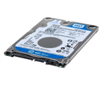  SATA (Serial Advanced Technology Attachment)  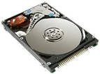  SCSI (Small Computer System Interface)  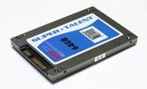  SSD (Solid State Drives)

PART C - “Step by Step PC Assembly”

Step 1 : Install the CPU/Processor on the motherboard

- Open the latch gently.
- Sit the processor into the socket gently
(Follow the notches or you might destroy the pins.) (Do not touch the back of the chip!)
- Depress the lever to close the latch.
- Put a little thermal paste on top of the processor.
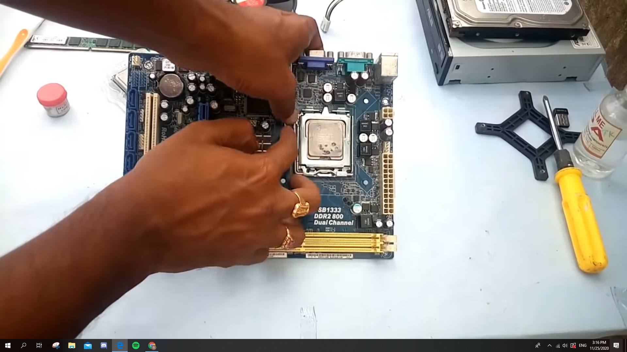

Step 2 : Install the heat sink on the motherboard

- Place the heat sink gently.(Follow the four holes around the cpu socket)
- Screw the heat sink and the holes with screws and screwdrivers.

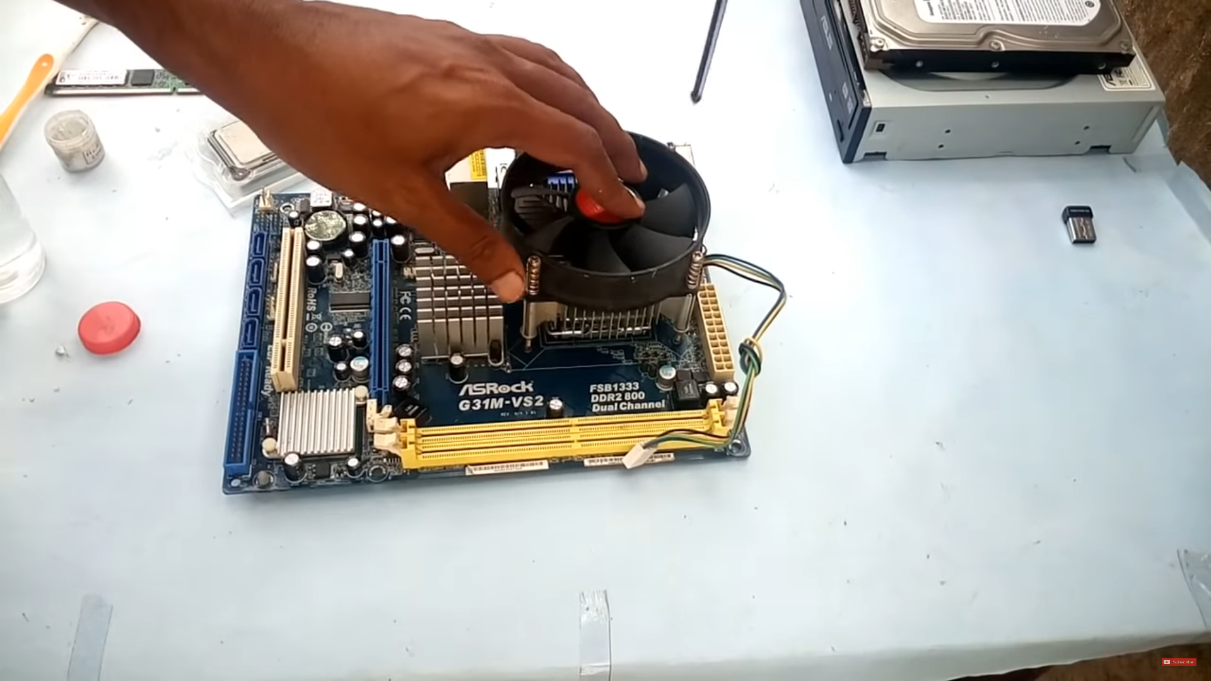

Step 3 : Install the power supply
- Place the power supply at the power supply slot (normally at the rear side) into the computer case.
- Align it with the screw holes.
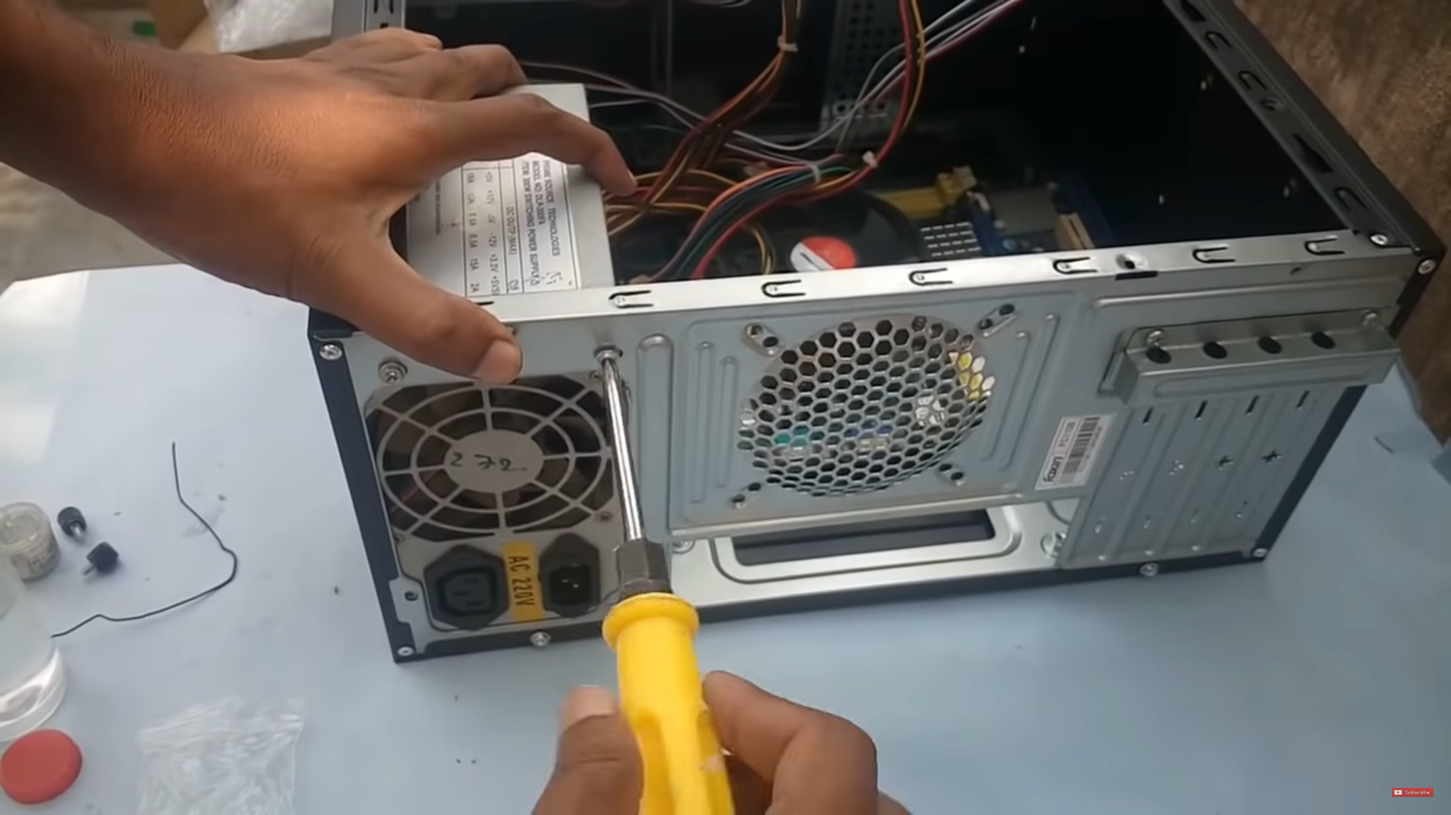
- Screw the power supply and the case holes with screws and screwdrivers.

Step 4 : Install the motherboard into the case.

- Align the motherboard to the I/O Slots (IDE, PC).
- Align the screwholes of the case to the motherboard.
- Screw the motherboard and the case holes with screws and screwdrivers.(turn clockwise!)
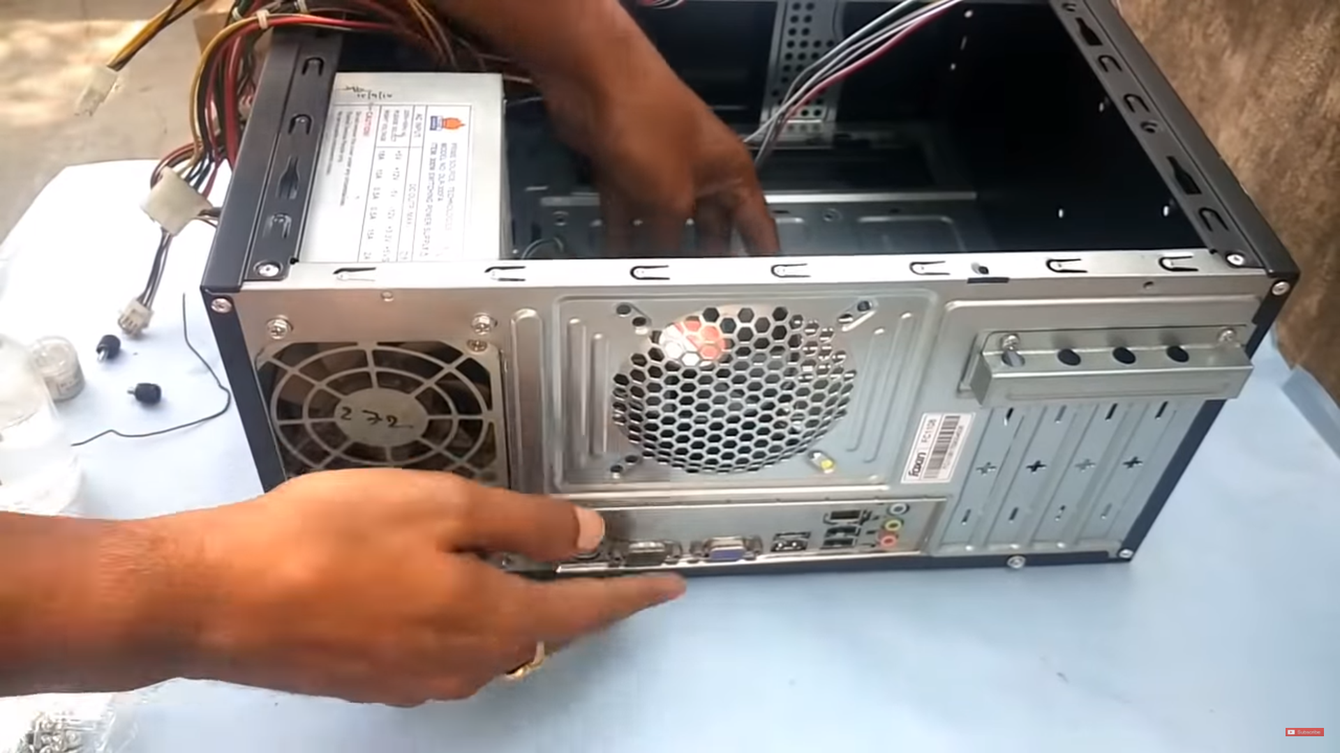

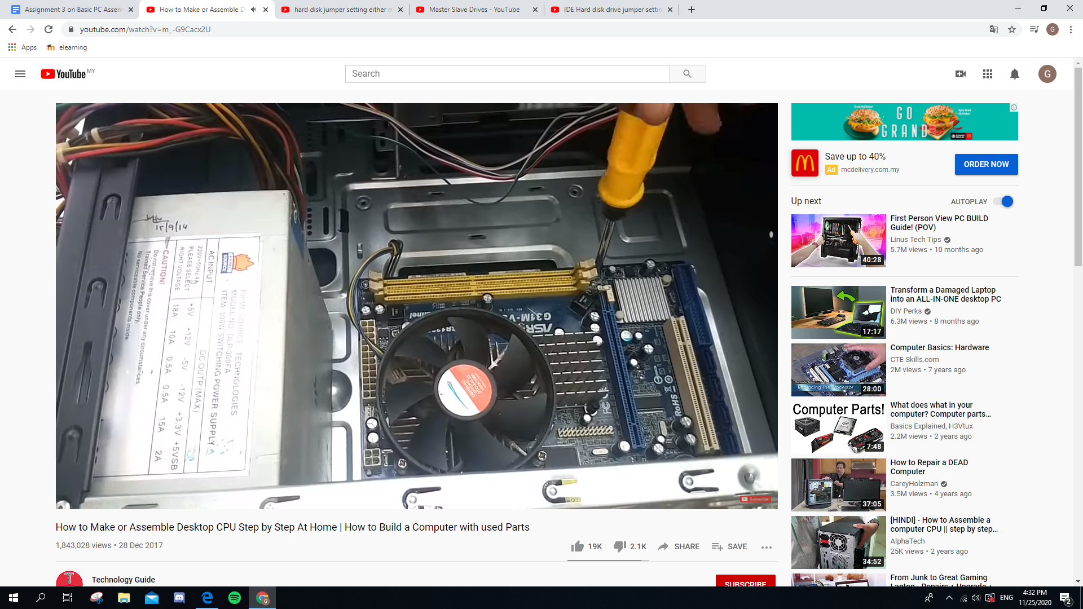

Step 5 : Install the graphic card.
- Attach the graphic card into the PCI-E slot
- Screw the graphic card with the graphic card holder. (Make sure it does not fall off easily)
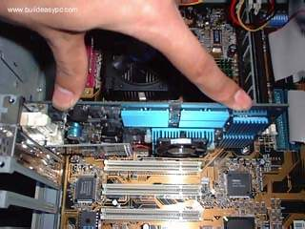
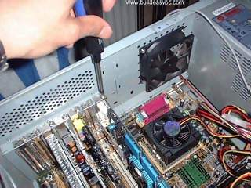
Step 6 : Install the hard disk (jumper setting either master/ slave)

- Locate the hard disk slot (which is usually at the top front of the case).
- Screw the hard disk and the case holes with screws and screwdrivers.(turn clockwise!)

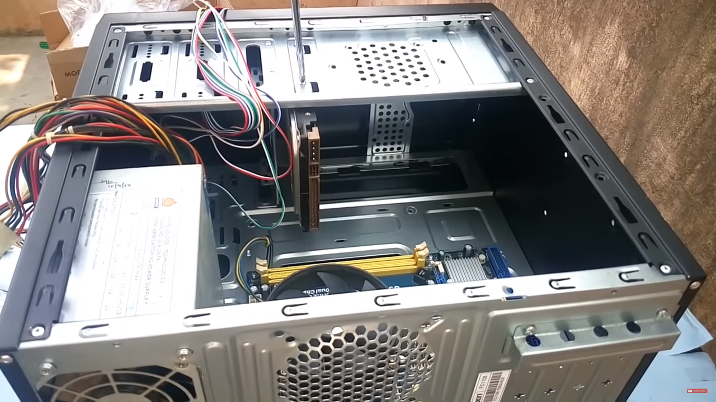

Step 7 : Install the RAM

- Locate the RAM slot (which is usually around the motherboard)
- Attach the RAM into the RAM slot. (Do not touch the golden electrical components on a stick of RAM).

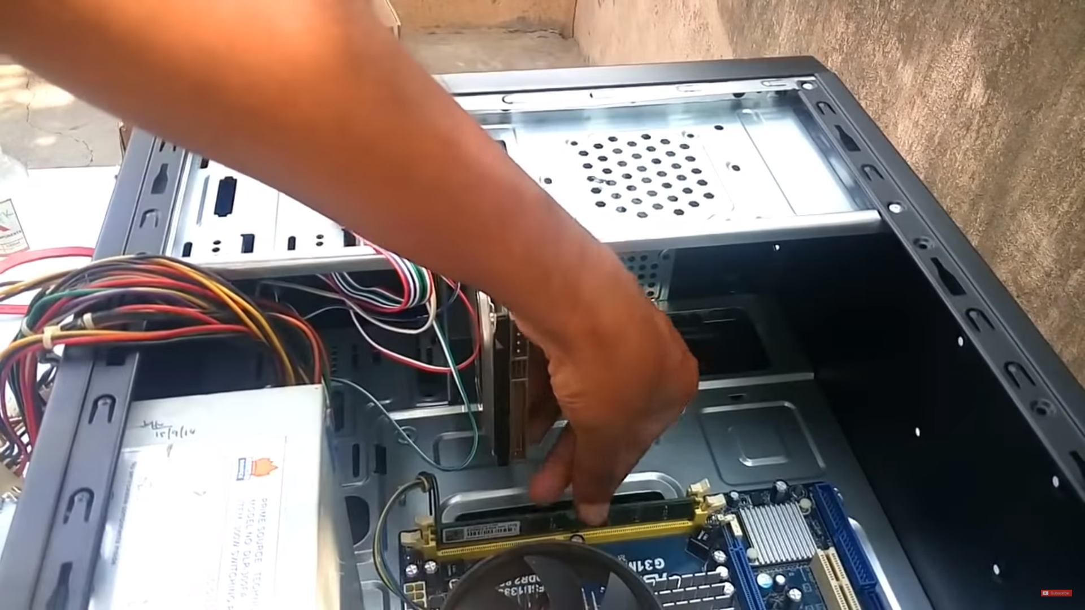

Steps 8 : Install the CD-ROM

- Remove the drive bay cover of the CD ROM from the computer case.
- Insert the CD-ROM drive inside the drive bay. (Make sure to insert it gently or it will get stucked)
- Screw the hard disk and the case holes with screws and screwdrivers.(turn clockwise!)
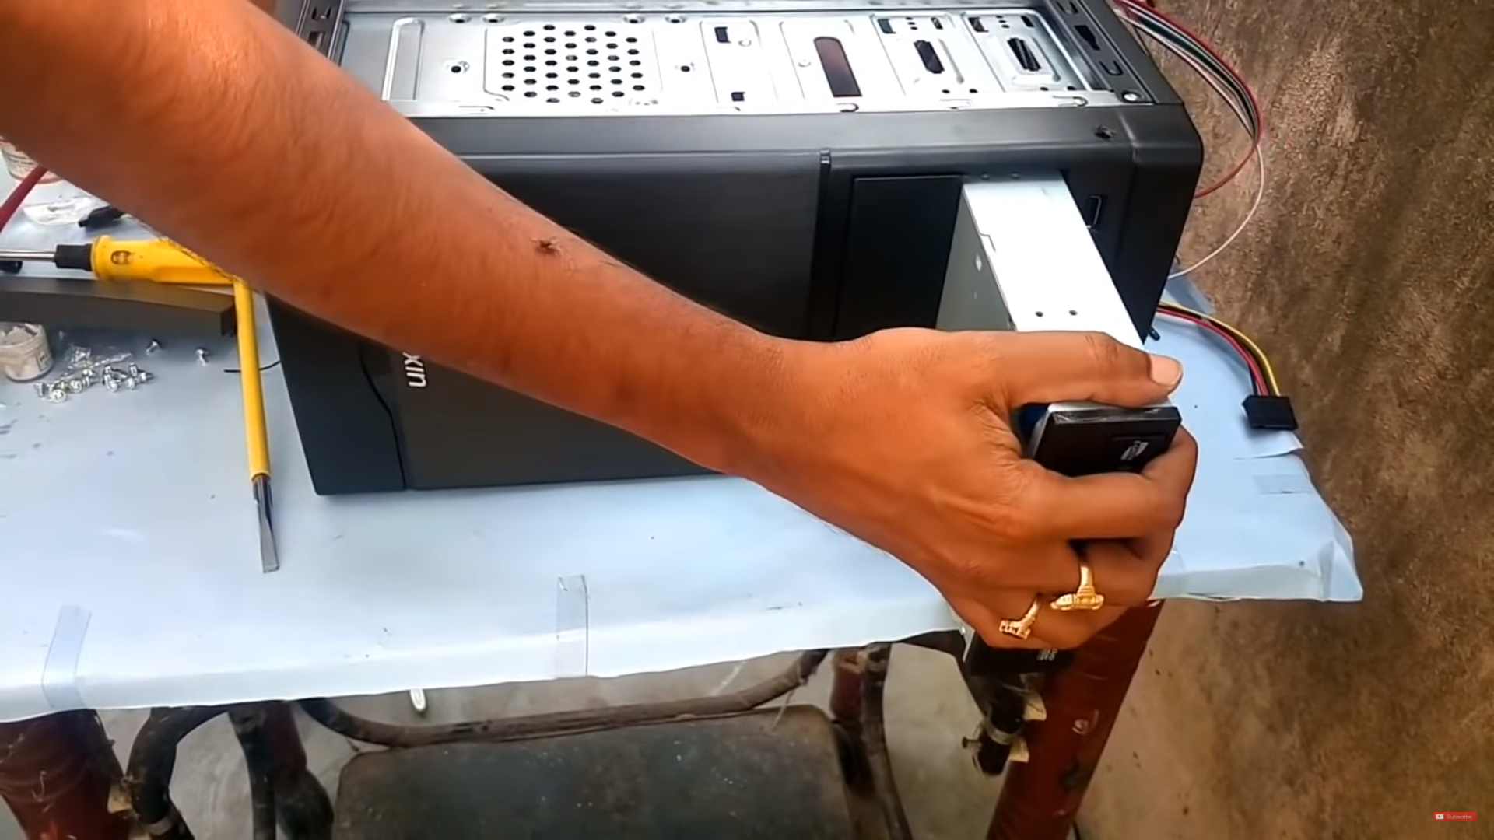

Step 9 : Install Case fan
1)Align the mounting holes by holding the fan to the mounting pad on the inside of the case. The fan needs to be mounted so that it blows air out of the case.
2)Insert the screws from the outside of the case and tighten to mount the fan.
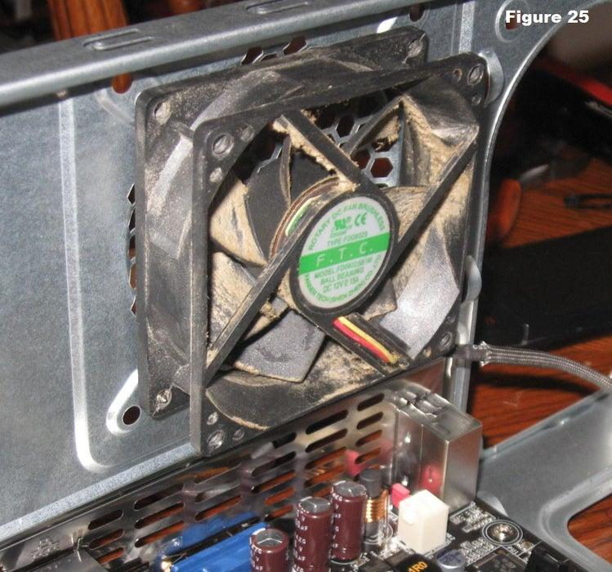
Step 10 : Connect the cable.

- Connect the SATA cable from motherboard to CD ROM.
- Connect the IDE cable from motherboard to hard disk.
- Connect the power cable (24-pin) from power supply to motherboard.
- Connect the SATA cable from power supply to CD ROM.
- Connect the front panel USB cable and Audio cable to motherboard.
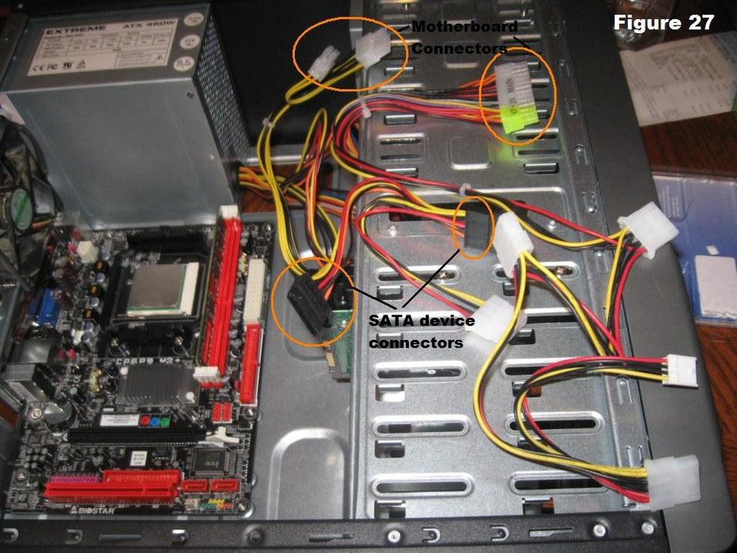

Step 11 : Wrap Up
- Reinstall the side panels on the case.
- The computer is now ready to be turned on and to have software loaded on it.
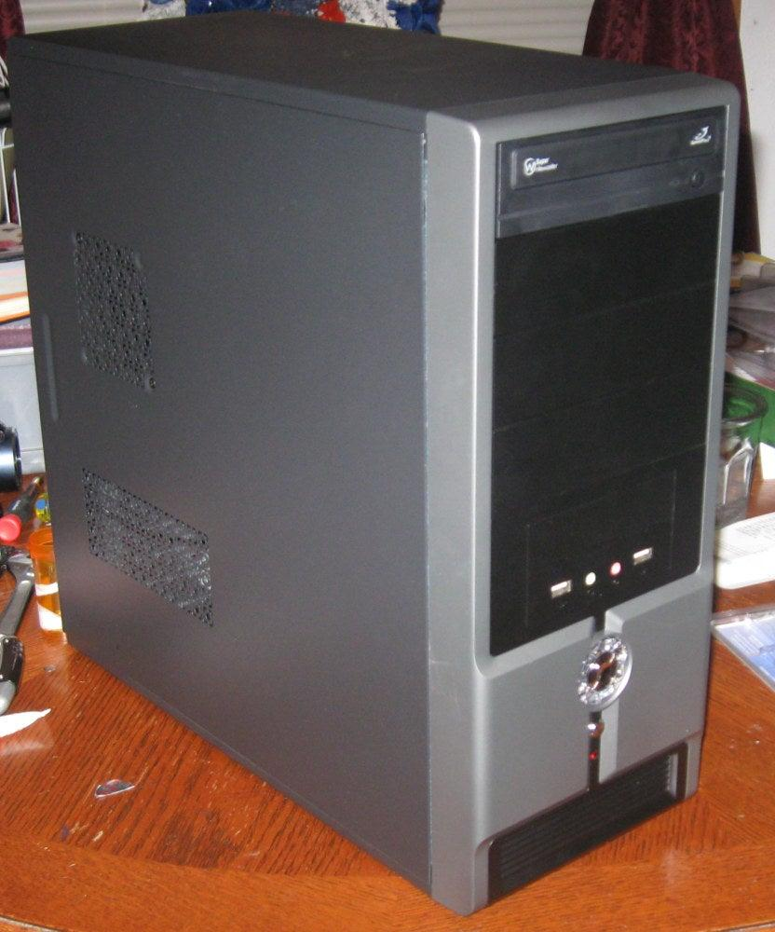

REFERENCES
1. Ebuyer. (2015, April 7). What is a graphics card? Retrieved from:
https://www.ebuyer.com/blog/2015/04/what-is-a-graphics-card/#:~:text=A%20Graphics%20Card%20is%20a,signal%20your%20monitor%20can%20understand.
2. Eri Luxton (n.d.). What is the function of the graphics card? Retrieved from:
https://www.techwalla.com/articles/what-is-the-function-of-a-graphics-card
3. Paul Zandbergen. (2020, July 30). Central Processing Unit (CPU): Parts, Definition & Function. Retrieved from:
https://study.com/academy/lesson/central-processing-unit-cpu-parts-definition-function.html#:~:text=The%20central%20processing%20unit%20(CPU)%20of%20a%20computer%20is%20a,operations%20of%20a%20computer%20system.&text=The%20CPU%20is%20sometimes%20also,unit%2C%20or%20processor%20for%20short.
4. Tutorials Point. (n.d.). Computer – CPU (Central Processing Unit). Retrieved from:
https://www.tutorialspoint.com/computer_fundamentals/computer_cpu.htm
5. Computer Hope. (2020, February 8). Core. Retrieved from:
https://www.computerhope.com/jargon/c/core.htm#:~:text=A%20CPU%20can%20have%20multiple,between%20two%20and%20twelve%20cores.
6. Arrow. (2019, 31 October). Understanding Heat Sinks: Functions, Types & More. Retrieved from:
https://www.arrow.com/en/research-and-events/articles/understanding-heat-sinks-functions-types-and-more

7. Techopedia. (2011, August 18). Heat Sink. Retrieved from:
https://www.techopedia.com/definition/2211/heat-sink
8. Celsia. (n.d.). Heat Sink Types. Retrieved from:
https://celsiainc.com/technology/heat-sink/
9. CDROM2GO. (n.d.). CD-ROM Information. Retrieved from:
https://www.cdrom2go.com/cd-rom-information
10. Ryan Casima. (2016, December 20). What are the functions of CD-ROM drive?
Retrieved from: https://www.techwalla.com/articles/functions-cd_rom-drive_
11. Bemuso. (n.d.). CD Media Basics.
Retrieved from: https://www.bemuso.com/musicbiz/cdmediabasics.html
12. Christina Hansen. (n.d.). USB Cable FAQs.
Retrieved from: https://www.cableorganizer.com/learning-center/articles/usb-cable-faq.htm
13. Techopedia. (n.d.). USB Connector.
Retrieved from: https://www.techopedia.com/definition/25899/usb-connector
14. Houkconsulting. (2018, November 2). Understanding the Different Types of USB Cables and Ports.
Retrieved from: https://www.houkconsulting.com/2018/11/understanding-usb-cables-ports/
15. Techopedia. (2016, December 8). Expansion slot.
Retrieved from:
https://www.techopedia.com/definition/2195/expansion-slot#:~:text=An%20expansion%20slot%20is%20a,advanced%20graphics%2C%20Ethernet%20or%20memory.&text=With%20a%20backplane%20system%2C%20up,expansion%20cards%20can%20be%20installed.
16. Webopedia. (n.d.). Slot.
Retrieved from: https://www.webopedia.com/TERM/S/slot.html
17. Kyle W. Bell. (n.d.). Types of Slots on a Motherboard.
Retrieved from: https://smallbusiness.chron.com/types-slots-motherboard-56027.html
18. What Is Random-Access Memory (RAM)? - Definition & History. (2015, June 16).
Retrieved from: https://study.com/academy/lesson/what-is-random-access-memory-ram-definition-history-quiz.html#:~:text=RAM%20stands%20for%20random%2Daccess,is%20dynamic%20RAM%20(DRAM).
19. Aaron Parson. (2017, February 10). What is the Function of RAM in a Computer?
Retrieved from: https://www.techwalla.com/articles/what-is-the-function-of-ram-in-a-computer
20. Guru99. (n.d.). Different Types of RAM (Random Access Memory) Explained.
Retrieved from: https://www.guru99.com/different-types-ram-random-access-memory.html#3
21. Techterms. (n.d.). SATA.
Retrieved from: https://techterms.com/definition/sata#:~:text=Stands%20for%20%22Serial%20Advanced%20Technology,drives%20to%20a%20computer's%20motherboard.&text=They%20also%20use%20smaller%2C%20thinner,better%20airflow%20inside%20the%20computer.
22. Tim Fisher. (2020, October 13). What is a Serial ATA (SATA) Cable?
Retrieved from: https://www.lifewire.com/serial-ata-sata-2626009
23. Tim Fisher. (2019, November 30). What is an IDE cable?
Retrieved from: https://www.lifewire.com/what-is-an-ide-cable-2625908#:~:text=IDE%2C%20an%20acronym%20for%20Integrated,other%20and%20to%20the%20motherboard.
24. Powersupplypc. (2020, March 7). Understanding PC Power Supply Definition and Function.
Retrieved from: https://powersupplypc.com/understanding-pc-power-supply-definition-and-function/
25. Komal Mishra. (2020, August 25). Hard Disk Definition, Functions and Types.
Retrieved from: https://digitalmarketingdeal.com/blog/what-is-hard-disk-definition-functions-and-types/#:~:text=Hard%20Disk%2C%20also%20called%20Hard,computer%20for%20a%20long%20time.

