Alumni Sharing Session
Navinthra Rao, Chang Min Xuan, Nur Haznirah, Saidah

UTM, 29 December: Every person has their own dream that they wanted to achieve. In order to achieve their dreams, there are a few things for them to improve and conquer. Alumni sharing session has opened our mind and make us realize on how to have a good career and be a successful person. One of the ways is a person needs to have good soft skills. Being a proactive person is important to boost our confidence. Additionally, your study result can affect your employability too, which means having results with flying colours are important to make your dream comes true.

The purpose of the talk is to let students know more deeply about this topic entitled, “Inspiring work experience and Covid-19 pandemic challenge”. In this talk, we can gather a lot of information, especially about working experience after graduation. Through this talk, we can learn some useful tips or advices and try to apply it in our daily life such as be more confident, enhancing our soft skills and always keep learning new things. Then, the other purpose of this talk is to let us learn how to survive in job during this Covid-19 pandemic. For example, we learned how to motivate ourselves while working at home. This question is very essential as we are now trapped in this pandemic. Besides, as a student, how we comply the rules of attending all the online classes without overwhelmed by laziness. This talk gave us inspiration to keep working and never give up even when we are at home.

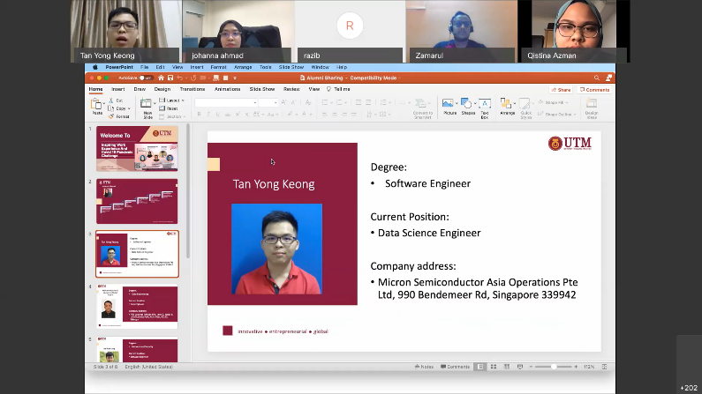
This sharing session was on the Inspiring Work Experience and Covid-19 Pandemic Challenge. This session was handled by Dr. Johanna Ahmad, Senior Lecturer in School of Computing, UTM. This sharing session also includes former UTM graduates who are currently employers in their working field even during this pandemic. One of the three former UTM graduates was Mr. Tan Yong Keong who currently works as Data Science Engineer in semi-conductor manufacturing company known as Micron Semiconductor Asia Operations after graduating in 2019. Another member that has joined this sharing session was Mr. Mohammad Zamarul Akmal bin Mohd Hussin who is holding a position as a Data Engineer in PGA Coatings after graduating after graduating in June 2020. The final member to join this sharing session to share their experience was Miss Qistina Batrisyia binti Azman Shah who is a Social Media Data Analyst at TM One. This session was conducted to encourage first year students to stay motivated throughout all the obstacles during this pandemic by listening to the former UTM senior experiences.

By this session, the former graduates have shared their personal interests, work experience and their university life during their studies. Their experiences have helped first year students to stay motivated and look forward to return to university once the lockdown rules are uplifted. Besides, they also shared that working experience will be fun because you always have to learn new things to improve as an employee. Moreover, the former seniors have shared their view on career life and study life.

Their experiences have taught first year students to enjoy their study life. Their experiences for being university students has taught first year students to enjoy their study life by managing time well between studies and leisure time. The former UTM graduates also mentioned that it is best to make new friends not only from the same faculty but from some other faculties to create a stronger bond among your friendship circle. The former UTM graduates stated that it taught them to be more responsible and disciplined when they have stepped into their career life.

There were also a great deal of questions given and all of them are answered by the speakers respectively. The first proposed question is about how to secure the job. According to the speakers, they encourage all of the students to actively participate in competitions. Hence, we can thoroughly gain achievements, professional skills and presentation skills. Moreover, the other way to secure the job is try to give ideas and propose suggestions for any problems we faced during internship. By doing so, we may stand out at the internship. The next question is about how to learn new language in programming. The students are recommended to not limit themselves in learning new language, but conquer the concept of that certain language and apply it to others. Furthermore, the useful tips in working life from speakers are be proactive and do not limit yourself. For instance, we should not be passive all the time. In contrast, we have to try to learn new things to enrich ourselves. The next essential two tips shared by Zamarul are learning new technical skills and improving soft skills respectively. The students are advised to take any online courses like freeCodeCamp, linkedIn and edX to learn technical skills while enhancing good communication skills and teamwork skills are important to improve soft skills. In addition, the speakers share about confidence can be gained by training, volunteering in presenting ideas, trying to speak out more. While entering a competition, winning and losing is not a big deal. However, learning in terms of experience, exposure to new skills and learning from the winners are the significant elements that we should have. Furthermore, to get motivated, we ought to love what we choose to do, have a clear mind set and be passion and excited to learn new things all the time.

In conclusion, this sharing session has given an insight to all the first year students on how the university life and career life looks like briefly. Not only that, through this session, the students have to be proactive by always engaging in group discussions to develop their communication skills. If you are not sure what to do, do not wait until someone comes to tell you. Bear in mind, we should take initiatives in finding out solutions or asking colleagues on how to do it. This sharing session has educated first year students to never limit themselves after listening to the experiences of former UTM graduates by always trying new things to improve themselves and help them prepare for the future. Last but not least, this sharing session has taught the first-year students to be more responsible in managing their time well and take part in more competitions to build their self-esteem and self-confidence.

The reflection of this talk is, it has inspired us in many ways as it helps us to be more determined and focused with our goals that we set. The talk gave us a lot of information on how to succeed in our life. We also learnt that mastering technical skills and soft skills play a fundamental role in separating us from others during job employment. In advance, we realize that we have to be very proactive and show passion in whatever activities that we are involving in. Other than that, we also need to keep on exploring on new things to help us train to be ahead of other people in every aspect. We knew that starting from when we are in college, we have to master the soft skills so that we can survive in the interview and get employed by any company.

