

Semester I 2020/2021
Subject : Technology and Information Systems (SECP1513)
Section : 04
Assignment : Step by step PC Assembly

GROUP NAME / NUMBER : 03
1 |  | Name : Lim Zeng Kai  Matric Number : A20EC0068  Phone Number : 0165165066  E-mail : lim.kai@graduate.utm.my
2 |  | Name : Azlinah Binti Herman  Matric Number : A20EC0018  Phone Number : 0163772495  E-mail : azlinah@graduate.utm.my
3 |  | Name : Joey Chai Wan Yi  Matric Number : A20EC0054  Phone Number : 0136839880  E-mail : joeywan@graduate.utm.my
4 |  | Name : Sharteswary A/ P Bojarajoo  Matric Number : A20EC0225  Phone Number : 0167699123  E-mail : sharteswarybojarajoo@graduate.utm.my

Part 1
- Screwdriver
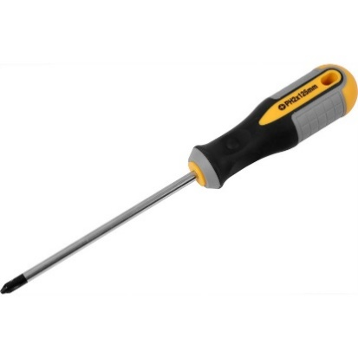

https://cdn.aws.toolstation.com/images/141020-UK/800/73136.jpg

The screwdriver is a required tool to assemble a desktop. The function of the screwdriver is to tighten the screws on the components. A Phillips-head size number #2 would be ideal, as all screws inside the desktop are going to be crosshead ones. A magnetic screwdriver is very handy to avoid dropping the screws in hard to reach places during the installation of the desktop. The importance of the screwdriver is to hold the screws securely in place.

- Thermal Paste

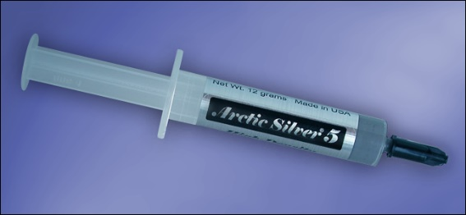

https://www.howtogeek.com/wp-content/uploads/2017/03/compound.png

A thermal paste will help the PC to run smoothly. The function of the thermal paste is to dissipate the heat from the processor and into the heat sink. The heat sink will then expel the heat away from the hardware. Most CPU coolers come with a patch of thermal paste already applied, you can swab off the provided thermal paste and apply a new layer to ensure the paste is soft and the correct amount is used. The importance of the thermal paste is to keep the CPU cool, especially when it is hard at work processing tasks.

- Anti-static Wrist Strap
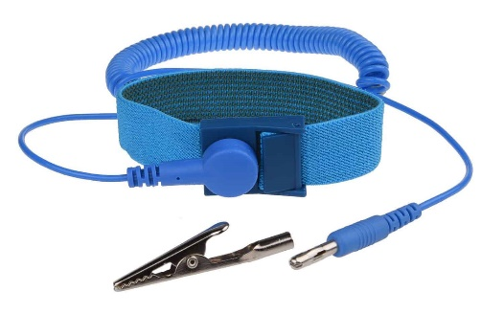

https://www.gamingscan.com/wp-content/uploads/2019/01/anti-static-wrist-strap.jpg

An anti-static wrist strap is also known as ESD wrist strap, which stands for electrostatic discharge an electrostatic discharge. An anti-static wrist strap should be used to assemble a desktop. The function of the anti-static wrist strap is to reduce the risk of electrostatic discharge while working with electrostatic sensitive equipment. The strap is significant as it is used to avoid any buildup of static electricity near sensitive electronics, where the static charge might damage electronics or cause further safety issues. Put one end around the wrist and clip the other to a piece of grounded metal.

- Rubbing alcohol


https://bitzngiggles.com/wp-content/uploads/2020/03/Rubbing-alcohol-bottle-post.jpg

The function of the rubbing alcohol is to make a quickly evaporating cleaner for the desktop. Gently apply the alcohol in a thin sheet and clean off the components of the desktop. The importance of rubbing alcohol is to dissolve grime and evaporates quickly without leaving residue or causing corrosion. It is sterile and will clean off any gunk, then evaporate and leave the components ready for action. It allows sufficient time to dry before applying any kind of thermal paste. High alcohol content in the solutions can dry in a few seconds to a minute.

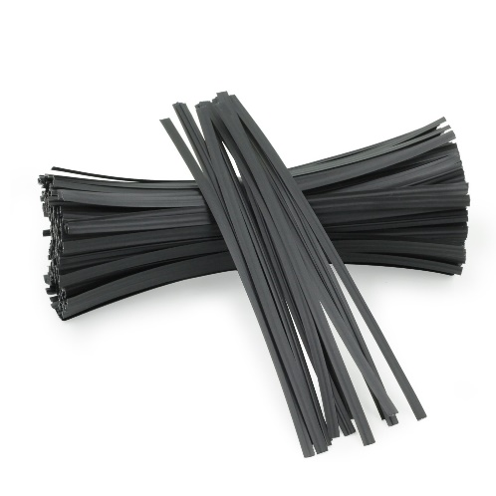
- Twist Ties

https://m.media-amazon.com/images/I/71YuzLMAV6L.jpg
Twist ties are used to tie up any loose cables lying around on the desktop. Cable management also essential to keep dust accumulation low and airflow high. The function of the twist ties is to keep the cables and wires organized and prevent them from getting tangled. Its importance is to make the finished build look neater and promote better airflow within the desktop. Don't fit the twist ties too tight around the cables as it could damage them. Cut the ends of the ties once you have fitted one.

Part 2
16
15

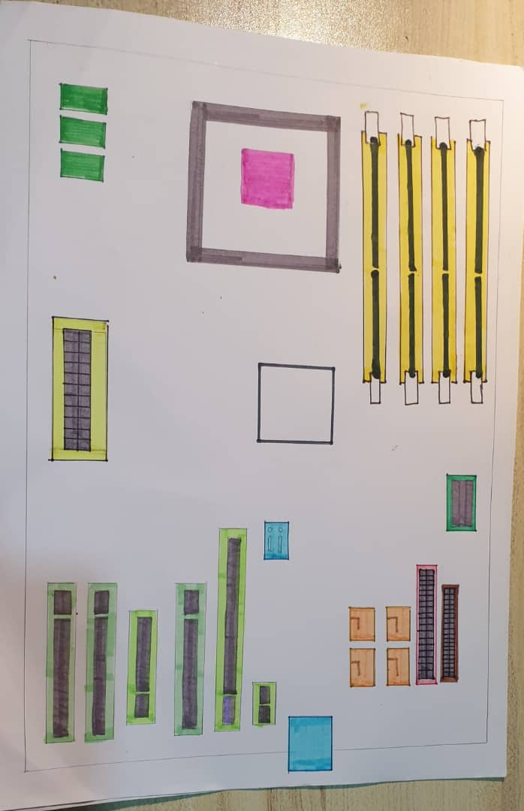
14
13
12
11
10
9
8
7
6
2
3
1
4
5

9.Graphics card
10. PCI Express x1 card connector
11.USB cable
12.USB panel
13.SATA cable
14. IDE drive connector
15. Main power connector
16.Hard disk drive slots
1. RAM Module connector
2. Processor
3. Heat sinks & CPU fans mount
4. Hard disk data cable
5.Floppy drive connector( CD ROM)
6.PCI card connector
7.PCI Express x4 card connector
8. PCI Express x16 card connector

Name: Graphics Card
Link:https://www.gigabyte.com/Press/News/1635
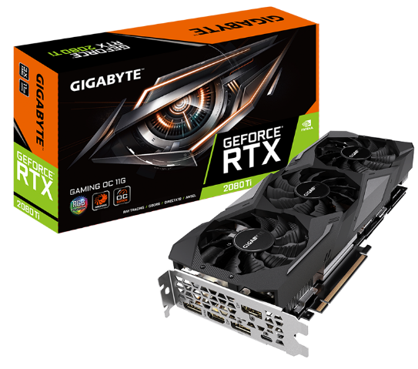
Function: Graphic Card allow computer to produce images and graphics. The card is connected to the motherboard and the monitor, which allows the card to accept information from the CPU and send the output to the monitor.
Model: GeForce RTX 3080

Name: USB Cable
Link:https://rocstor.com/product/rocstor-premium-6in-usb-2-0-cable-usb-a-female-to-usb-motherboard-4-pin-header-f-f-type-a-female-usb/
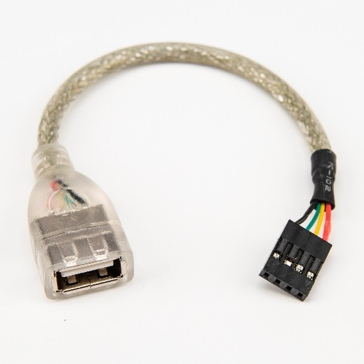
Function: USB cable, also known as Universal Serial Bus, is a device that carries power and signal. Its function is to help connect the computer peripherals devices like scanner, printer, and digital camera to the computer.
Model: USB A, USB B, and USB C

Name: IDE Cable
Link: https://www.computerhope.com/jargon/i/ide.htm
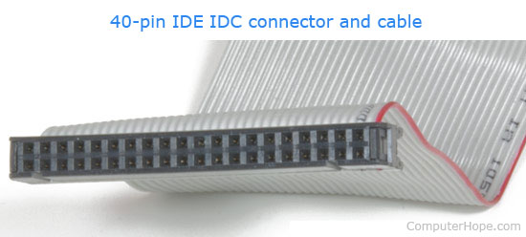
Function:IDE, which stands for Integrated Drive Electronics, is usually used as a sort of connection for storage devices in a computer. IDE is often used to regulate the motherboard so it can be connceted to the disk drive. Another function of the IDE cable is to connect two computer devices or components at the same time. It also helps to provide a more complex cabling.
Model: StarTech.com Model IDE66 18" Ultra ATA/66/100/133 80-wire IDE Cable

Name: CPU Processor
Link: https://www.anandtech.com/show/8312/state-of-the-part-cpus
Function: CPU, also known as central processing unit, is a device that perfoms all types of data processing operations.The foour main funcgtions of a CPU is to fetch, decode , exucute and store data. It also performs the basic arithmetical, logical, and input/output operations of a computer system. The CPU is very crucial as it controls the operation of all parts of the computer.
Model: 10th Gen Intel Core i9, 10th Gen Intel Core i7,and 10th Gen Intel Core i5
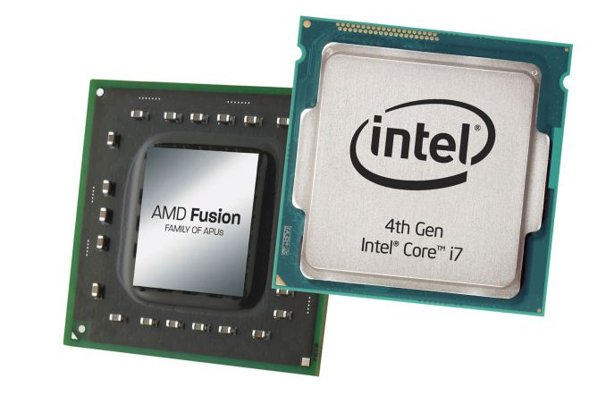

Name: Slot (PCI)
Link: https://winstartechnologies.com/what-is-the-function-of-pci-slot/
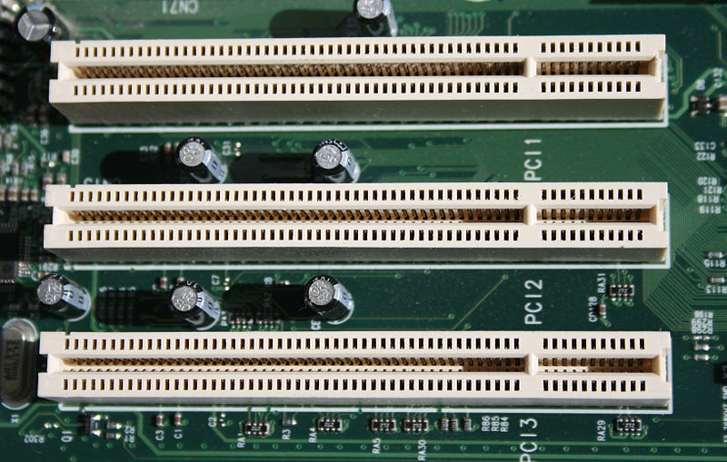
Function: A PCI slot is a built-in slot on a device that allows for the attachment of various hardware components ,such as network cards, graphics card and other peripherals, which can be used to expand a computer’s capabilities.
Model: PCIe 3.0 x16 slot

Name: Power Supply
Link:http://www.playtool.com/pages/psuconnectors/connectors.html
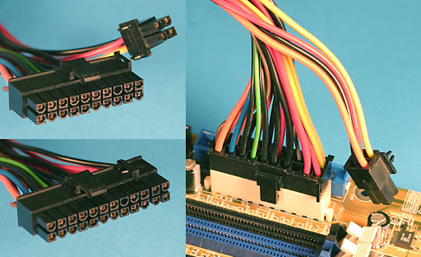
Function: A device that converts mains alternating current(AC) to low-voltage regulated direct current(DC) power for the internal components of a computer.
Model: Corsair SF750

Name: Heat Sink
The heat sink’s function is to increase the heat flow away from a hot device. The heat sink has a thermal conductor which helps it to accomplish the task. The thermal conductor allows heat to flow away from the CPU into the fins, which will provide a larger surface area for the heat to vanish throughout the rest of the computer, hence cooling both the heat sink and processor.
Model: NZXT Kraken X72

Link: https://en.wikipedia.org/wiki/Heat_sink
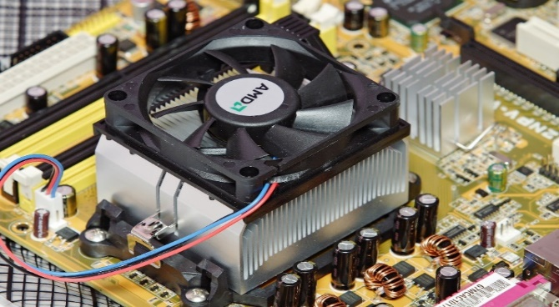

Name: Random access memory
Link: https://en.wikipedia.org/wiki/Random-access_memory
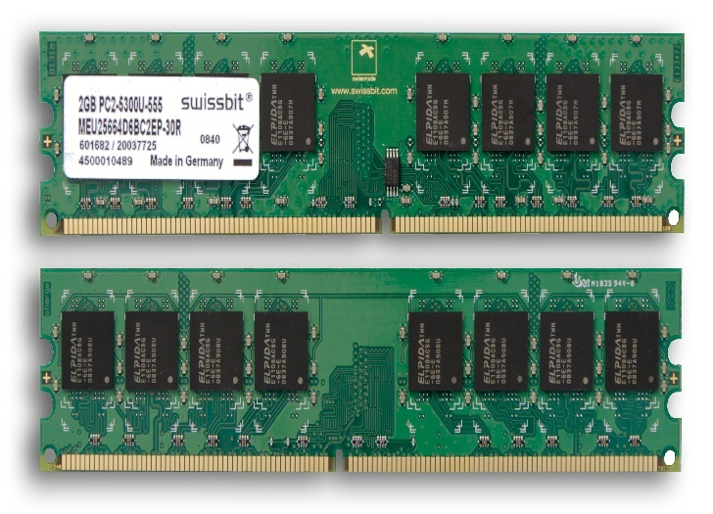
Function: RAM ,also known as Random Access Memory, is a type of super-fast storage that computer uses to hold data it needs in the short term. It stores the information that a computer is actively using so that it can be accessed quickly.
Model: 16GB DDR4 Memory Ram PC4 2133P 2133MHz 1.2V ECC REG DIMM

Name: Hard Disk Drive
Link:https://en.wikipedia.org/wiki/Hard_disk_drive
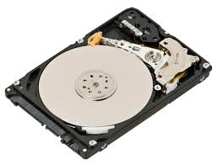
Function: The function of a hard disk drive or (HDD) is to store and retrieve digital data . It is also called as a “Permanent Storage” as it can store computer data forever
Model: Samsung T5 SSD external hard drive

Name: CD ROM
Link :https://en.wikipedia.org/wiki/CD-ROM
Function: CD ROM , stands for "Compact Disc Read-Only Memory”, is used to store programs and data files.
Model: CD 52X 700MB 80MIN Blank CDR CD-R
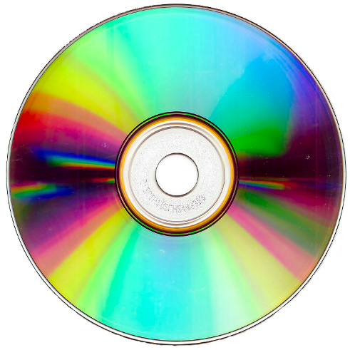

Name: SATA Cable
Link: https://forums.tomshardware.com/threads/large-sata-cable-has-nowhere-to-plug-into-my-motherboard-help.3171976/
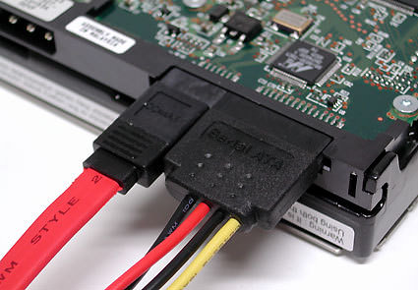
Function: Serial Advanced Technology Attachment (SATA) or Serial ATA cables are mainly used for computer bus connections in storage applications. The cables are mainly utilized to connect a mass storage device, like hard disk drives, and solid-state memory drives, to a host bus adapter, like a motherboard.
Model: Sabrent USB 3.0 to SSD and StarTech USB 3.0 to 2.5

Part 3
STEP 1 - Preparation
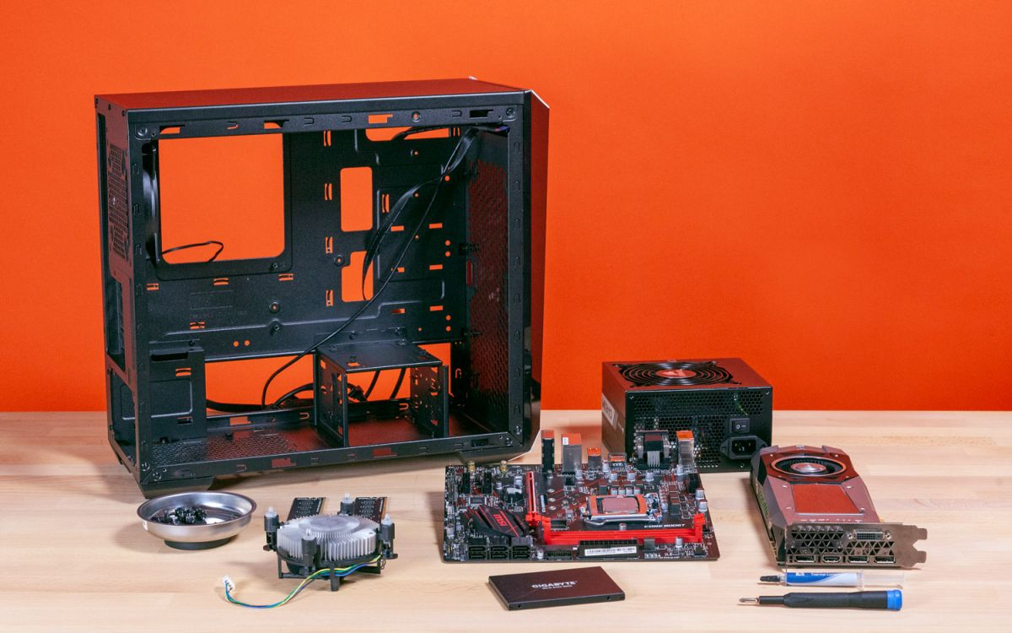
https://www.google.com/url?sa=i&url=https%3A%2F%2Fwww.tomshardware.com%2Freviews%2Fhow-to-build-a-pc%2C5867.html&psig=AOvVaw3zplEg0acx1hcvLr-dyA1m&ust=1607150035216000&source=images&cd=vfe&ved=0CAIQjRxqFwoTCJjsk_fas-0CFQAAAAAdAAAAABAf
Prepare everything that is required to assemble a PC such as a motherboard, processor, graphic card, heat sink, CD ROM, USB cable IDE and PCI slots, RAM, SATA cable, IDE cable Power supply, hard disk, etc. Besides, we also need to prepare some tools like screwdrivers and screws to use during the installation parts. Use an anti-static wrist strap to assemble the desktop and apply it to rub alcohol to clean off the components. Twist ties are recommended to use to keep the components neatly.

Precaution and tips:
- Please check all the components and tools in your list before you start the installation.
- Please check all the components in good condition before you start the installation. This is because maybe they are some broken when you receive the item, so you can return the broken item before you use them.
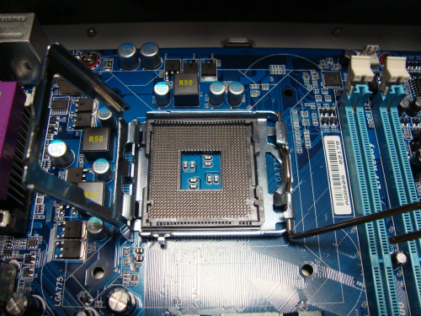
STEP 2 – Installing the processor motherboard

Lift the retention arm on the CPU socket by using your hand to put the retention arm and let the CPU socket is opening.
https://www.google.com/url?sa=i&url=https%3A%2F%2Fwww.anotherwindowsblog.com%2F2011%2F02%2Fhow-to-build-your-own-computer-part-2.html%2F180-open&psig=AOvVaw0leae0pQxFM3PyX7Rl-3nM&ust=1607143781511000&source=images&cd=vfe&ved=0CAIQjRxqFwoTCMCI86TDs-0CFQAAAAAdAAAAABAX

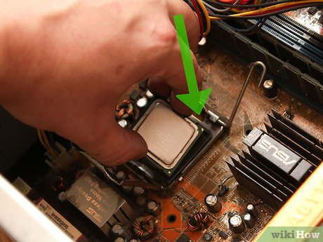
Line up your CPU in the right direction. You can refer to the indicator on the corner of the CPU or CPU socket like a small triangle, so it can help you get the alignment correctly. When you find the correct direction and your CPU should put into the correct position.
https://www.google.com/url?sa=i&url=https%3A%2F%2Fwww.wikihow.com%2FInstall-a-New-Processor&psig=AOvVaw2jlQZ_h9WbZcTEPmzW0hEj&ust=1606980084968000&source=images&cd=vfe&ved=0CAIQjRxqFwoTCMCG1s_sru0CFQAAAAAdAAAAABAK
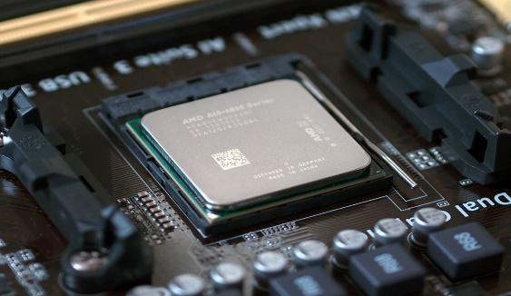
When your CPU is properly on the socket and you should able push down the retention arm easily then the installation of the CPU is completed.

https://www.google.com/url?sa=i&url=https%3A%2F%2Fwww.pcworld.com%2Farticle%2F2957260%2Fhow-to-install-an-intel-or-amd-cpu-in-your-computer.html&psig=AOvVaw0QHPWIUCzY2lzTRFGlO_op&ust=1607144514065000&source=images&cd=vfe&ved=0CAIQjRxqFwoTCODM9ojGs-0CFQAAAAAdAAAAABAD

Precaution and tips:
- There are two types of processors in the market which is Intel processor and AMD processor. You should make sure which type of processor you are more prefer to install and buy their component. This is because the Intel processor uses Land Grid Array(LGA) to hold the CPU however AMD processor uses Zero Insertion Force(ZIF) to trap the CPU’s pin.
- If there are some plastic covers over your motherboard or some other component and remove them before you start your installation. Because you maybe forget to remove and you run your desktop for a long time, there may be a high temperature on your component and cause the plastics to cover burn up.
- Be careful when you holding your CPU or CPU socket during the installation. This is because the pin on the CPU or CPU socket is very weak and may easy to cause some damage to those parts.

STEP 3 - Apply thermal paste to the top of the processor
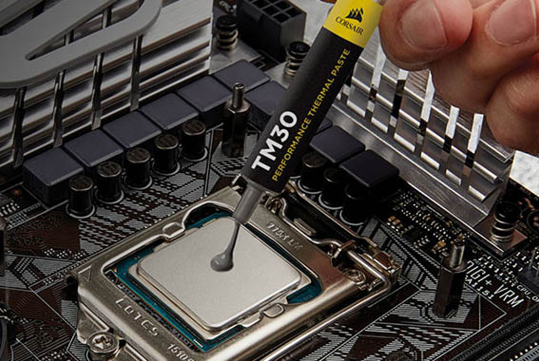
Before installing the heat sink, apply a thin layer of thermal paste on the top of the processor. Thermal paste can helps conduct heat from the processor to the heat sink.

Precaution and tips :
- Don’t put so much thermal paste on the top of the processor.
- You can have some patterns so to ensure cover the surface of the processor as below picture.
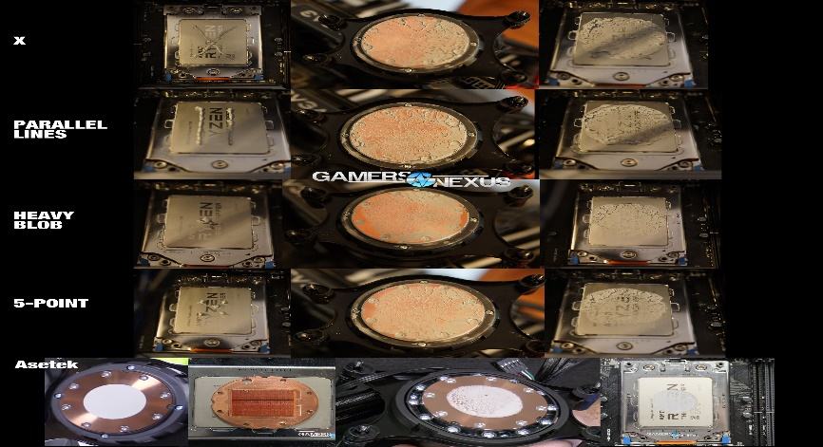
https://www.google.com/url?sa=i&url=https%3A%2F%2Fwww.gamersnexus.net%2Fguides%2F3013-amd-threadripper-thermalpaste-application-methods-benchmarked&psig=AOvVaw1fVh6lxX84R03B86jh-VXN&ust=1607154470018000&source=images&cd=vfe&ved=0CAIQjRxqFwoTCPCP6Y7rs-0CFQAAAAAdAAAAABAU
STEP 4 – Install heat sink on motherboard
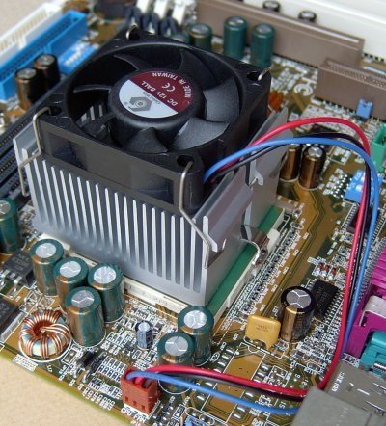

After applying the thermal paste, install the heat sink above the processor and align it with the hole provided in the motherboard. If there are screws, screw it diagonally by using a screwdriver. Connect the power connector of the heat sink on the motherboard.

https://www.google.com/url?sa=i&url=https%3A%2F%2Fwww.pctechguide.com%2Fhow-to-upgrade-your-motherboard%2Fmotherboard-heatsinks&psig=AOvVaw3rdXPPnVfR9eUhCeyURzv3&ust=1607155706298000&source=images&cd=vfe&ved=0CAIQjRxqFwoTCPDzoKjws-0CFQAAAAAdAAAAABAr

Precaution and tips :
- Be careful when using the screwdriver to screw the heat sink on the motherboard. This is because there are some force can cause damage on the motherboard when
- There are recommended to screw all the screw until having a resistance then screw the next diagonally. After four screws have little resistance then screw all of them tightly.
- Make sure the heat sink is tight and will not fall out.

STEP 5 – install RAM on the motherboard
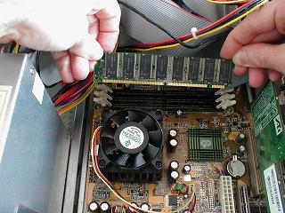
Install the RAM with a line up the notch in the sick of RAM into the RAM slots. Set the RAM stick in the slot and apply equal force at the end of the RAM stick to set it into the RAM slots. You should hear a click sound when the RAM stick is inserted successfully. Repeat the process for each RAM stick you want to install.
https://www.google.com/url?sa=i&url=https%3A%2F%2Fwww.fonerbooks.com%2Fr_ram.htm&psig=AOvVaw3H0Dqv0O1BMvvPMGOdr7dx&ust=1607159557837000&source=images&cd=vfe&ved=0CAIQjRxqFwoTCPj7uYf-s-0CFQAAAAAdAAAAABBE
Precaution and tips:
- Avoid touching the pins of the RAM stick to avoid damage.
- Make sure the matching RAM stick into their matching slots. Most are labeled on the board or by color.

STEP 6 – Install power supply and motherboard into the computer case
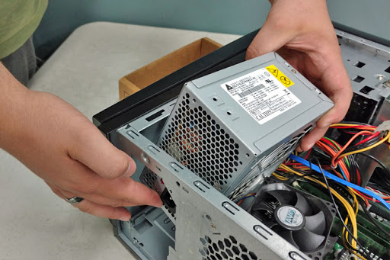
Find the power supply’s location in the computer case then insert the power supply into the location. Make sure to insert with the correct direction.

https://www.google.com/url?sa=i&url=http%3A%2F%2Fkaplancomputers.com%2F%3Fportfolio%3Dpower-supply-install&psig=AOvVaw0UR8bEk39A-AIYWr9Qrl8t&ust=1607162136346000&source=images&cd=vfe&ved=0CAIQjRxqFwoTCMiDydeHtO0CFQAAAAAdAAAAABAL
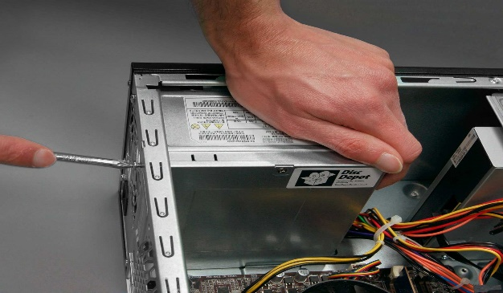

After you insert the power supply into the location you must screw the power supply by using a screwdriver. You can use one hand to hold the power supply and the other hand to screw it tightly.
https://www.google.com/url?sa=i&url=https%3A%2F%2Fwww.discdepotdundee.co.uk%2Frepairs-and-services%2Fhardware-installation%2Freplacement-psu-install-upgrade-desktop-and-laptop%2F&psig=AOvVaw0UR8bEk39A-AIYWr9Qrl8t&ust=1607162136346000&source=images&cd=vfe&ved=0CAIQjRxqFwoTCMiDydeHtO0CFQAAAAAdAAAAABAR

Precaution and tips:
- Normally, the power supply should have a plug toward the outside and some cable is inserted into the computer case. This will help you determine the direction of the power supply.
- Make sure the power supply screw tightly, test it until will not fall before you move to the next step.

Put the motherboard into the computer case and see where the holes in the motherboard. Matching the mouthing holes in a computer case with the motherboard carefully.

https://www.google.com/url?sa=i&url=https%3A%2F%2Fwww.wikihow.com%2FMount-a-Motherboard-in-a-Case&psig=AOvVaw0T6Sorzk59uJ5DiakHLtuE&ust=1607163407788000&source=images&cd=vfe&ved=0CAIQjRxqFwoTCMCOlbiMtO0CFQAAAAAdAAAAABAJ

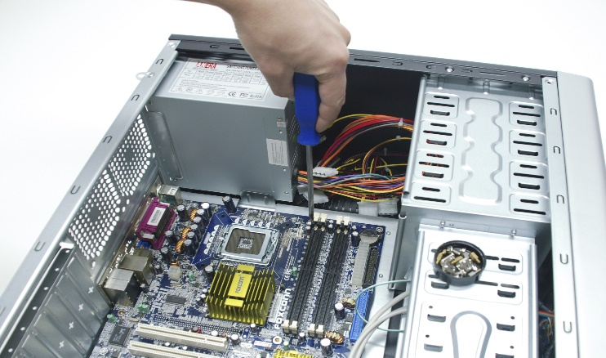
https://www.google.com/url?sa=i&url=https%3A%2F%2Fcodepen.io%2FDrj2699%2Ffull%2FXbNoyJ&psig=AOvVaw0T6Sorzk59uJ5DiakHLtuE&ust=1607163407788000&source=images&cd=vfe&ved=0CAIQjRxqFwoTCMCOlbiMtO0CFQAAAAAdAAAAABAW
After you put the motherboard correctly, install the screws by using a screwdriver.

Precaution and tips:
- Be careful when you install the motherboard into the computer case. Hold it carefully to avoid falling or any over force on it.
- Make sure the motherboard screw tightly, test it until will not fall before you move to next step.

