Alumni Sharing Session
RM1.50

Wednesday, January 6, 2021

INSPIRING WORK EXPERIENCE & COVID19 PANDEMIC CHALLENGE
Purpose of the talk  Joey Chai Wan Yi  JOHOR – Technology and Information Systems, School of Computing recently organized an alumni session on 29 December 2020 from 10.00 am to 11.00 am. The purpose of the talk is to give some briefing to first-year UTM students about the speakers’ work experiences and how to face the covid 19 pandemic challenges. The talk invited three ex-students of UTM, Tan Yong Keong, Mohamad Zamarul Akmal bin Mohd Hussin and Batrisyia Binti Azman Shah. Dr. Johanna Ahmad was the moderator of the talk.  Tan Yong Keong  Lim Zeng Kai  JOHOR – Mr. Tan Yong Keong graduated in 2019 with a degree in software engineer. He currently works for the company's data science engineer, which is called Micron Semiconductor Asia Operation Pte. At the beginning of the speech, he gave us some tips to secure the job, which are gaining some skill during university life. You can participate in many competitions no matter win or lost you can gain a lot of professional skills that can help you in your life and also can train you confident. Besides, you must try to do gains  some achievements because  achievement is useful for your  future. All of these can make your  a dashboard, which will be used by the management of clients for marketing purposes. Qistina ‘s tip on getting hired is to show a lot of effort to join real-life projects during the internship. In her case, her manager was impressed with her effort and decided to ask her to join as full-time staff. She also mentioned that we should improve our technical skills, be active during the internship and most importantly, we should not limit ourselves and must be opened to learn new things. Next, Qistina advised us to join more competitions, expose ourselves to the real world and speak more. Some lessons include being more confident, gaining new and meaningful experiences and the ability to work in a team, a highly valued skill by employers.  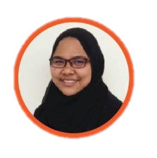  Qistina Batrisyia binti Azman Shah  Summary  Joey Chai Wan Yi  JOHOR - In conclusion, the speakers were willing to share their work experiences and how to adapt  Covid19 pandemic challenge. They also gave some useful advice and tips to the first-year students about their study life in UTM. To get a good job opportunity, a university student needs to equip with practical skills and soft skills by joining some programming competitions actively and confidently speak out the opinion in public. | resume better and helps you in your interview. Furthermore, he also gives some advice to the junior. Some junior worried about learning the new programming language but Tan advises that we just need to learn the concept because the concept is the same as another language. Next, he advises junior to keep practicing coding like practice in the online website such as leetcode.    Tan Yong Keong  Mohammad Zamarul Akmal Bin Mohd Hussin  Azlinah Binti Herman  JOHOR - He was graduated in June 2020 with a degree in Data Engineering and currently works as a permanent employee as Data Engineer in his internship company which is PPG Coatings (M) Company located at Shah Alam, Selangor. During the internship, Zamarul proposed to create a monitoring dashboard that can monitor all jobs. Finally, this project became his Final Year Project (FYP). He also gave two tips to improve during this pandemic  Reflection  Lim Zeng Kai  JOHOR - This talk is good for newcomers at the university. It can confirm what must be done in college life to be successful, but the speaker still lacks work experience and cannot provide more details of work experience. I realized that I need to participate in many competitions because I can acquire a lot of skills in the competition. Therefore, this speech inspired me to pay more attention to the club and academia, which allowed me to gain a lot of knowledge.  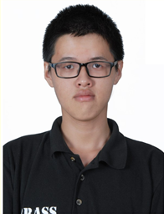  Lim Zeng Kai  Azlinah Binti Herman  JOHOR - In my opinion, this talk was very enjoyable and relaxing because all the speakers were UTM alumni compare to the other industrial talk before this. All the questions from the moderator were being answered clearly by all speakers. The weakness of this talk is only the time was very limited. It was only conducted in an hour so there were not many questions can be asked. This talk motivated me to do well in my study life because I need to be active in university to get many experiences and boost my confidence level. The speakers gave useful advice from their experience to us, the junior and new students in UTM.  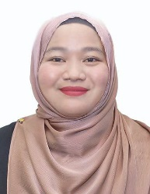  Azlinah Binti Herman | which are learning new technical skills and improve soft skills. He advises to take any online courses such as Code Camp and EDX and also join a training program to have new technical skills that we can attach to our resume. For soft skills, he said that has good communication skills to give ideas and also be an easy-going person, blend with people to have better teamwork skills. Lastly, Zamarul advises, “Try to discipline yourself by minimizing your mistakes”.    Mohammad Zamarul Akmal Bin Mohd Hussin  Qistina Batrisyia binti Azman Shah  Sharteswary A/ P Bojarajoo  JOHOR - She was graduated in June 2020 with a degree in Computer Science (Data Engineering). She is currently a social media data analyst at TM One. She has been working there for almost a year, including an internship. Her role as a social media data analyst is to gather social media data and interpret it to  Sharteswary A/ P Bojarajoo  JOHOR - From this talk, I learned much insightful information on ways to get hired and other useful information. Besides that, I got first-hand tips from my seniors on various topics, such as college life. Being a first-year student, I was scared and nervous, but after listening to my seniors, I feel motivated to be a better student.  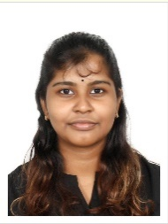  Sharteswary A/ P Bojarajoo  Joey Chai Wan Yi  JOHOR - Alumni sharing session gave me the field of view of work-life after I am graduating from the university. The strength of the talk is the speakers can share their work experience and respond to the questions given by the students. I felt that the speakers still have a lot of content to share but due to the limited time, they are unable to reply to the questions given by the students. I need to equip with practical skills and soft skills before I am entering my career life. Besides, I will involve in the programming competition actively so I can gain some experience and prepared myself for career life.  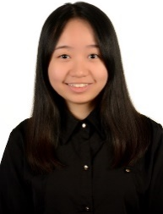  Joey Chai Wan Yi

