The Journey
of Industry Revolution

The world
has experienced three Industrial Revolution which is Industrial Revolution 1.0 (18th century), Industrial Revolution 2.0 (19th century) and Industrial Revolution 3.0 (20th century).
Experts believes that the Industrial Revolution 3.0 is
coming to an end and we must prepare for
Industrial Revolution 4.0.

“From this industrial talk, I had learned about 4IR, the history and the future of Industry Revolution 4.0. I really hope that I can give some contribution to my country after I finish my course in university so that Malaysia can be more advanced in 4IR.”
-Joey-

Your text here

First
- Mechanical Production
- Example: steam, water
- 1784: First power loom
Second
- Mass Production
- Example: Electricity
- 1870: First assembly line
Third
- Digital
- Example: IT, electronics
- 1969: First programable logic controller
Fourth
- Cyber Physical Systems
- Example: physical, digital, biological
- Today: Robots learning from humans

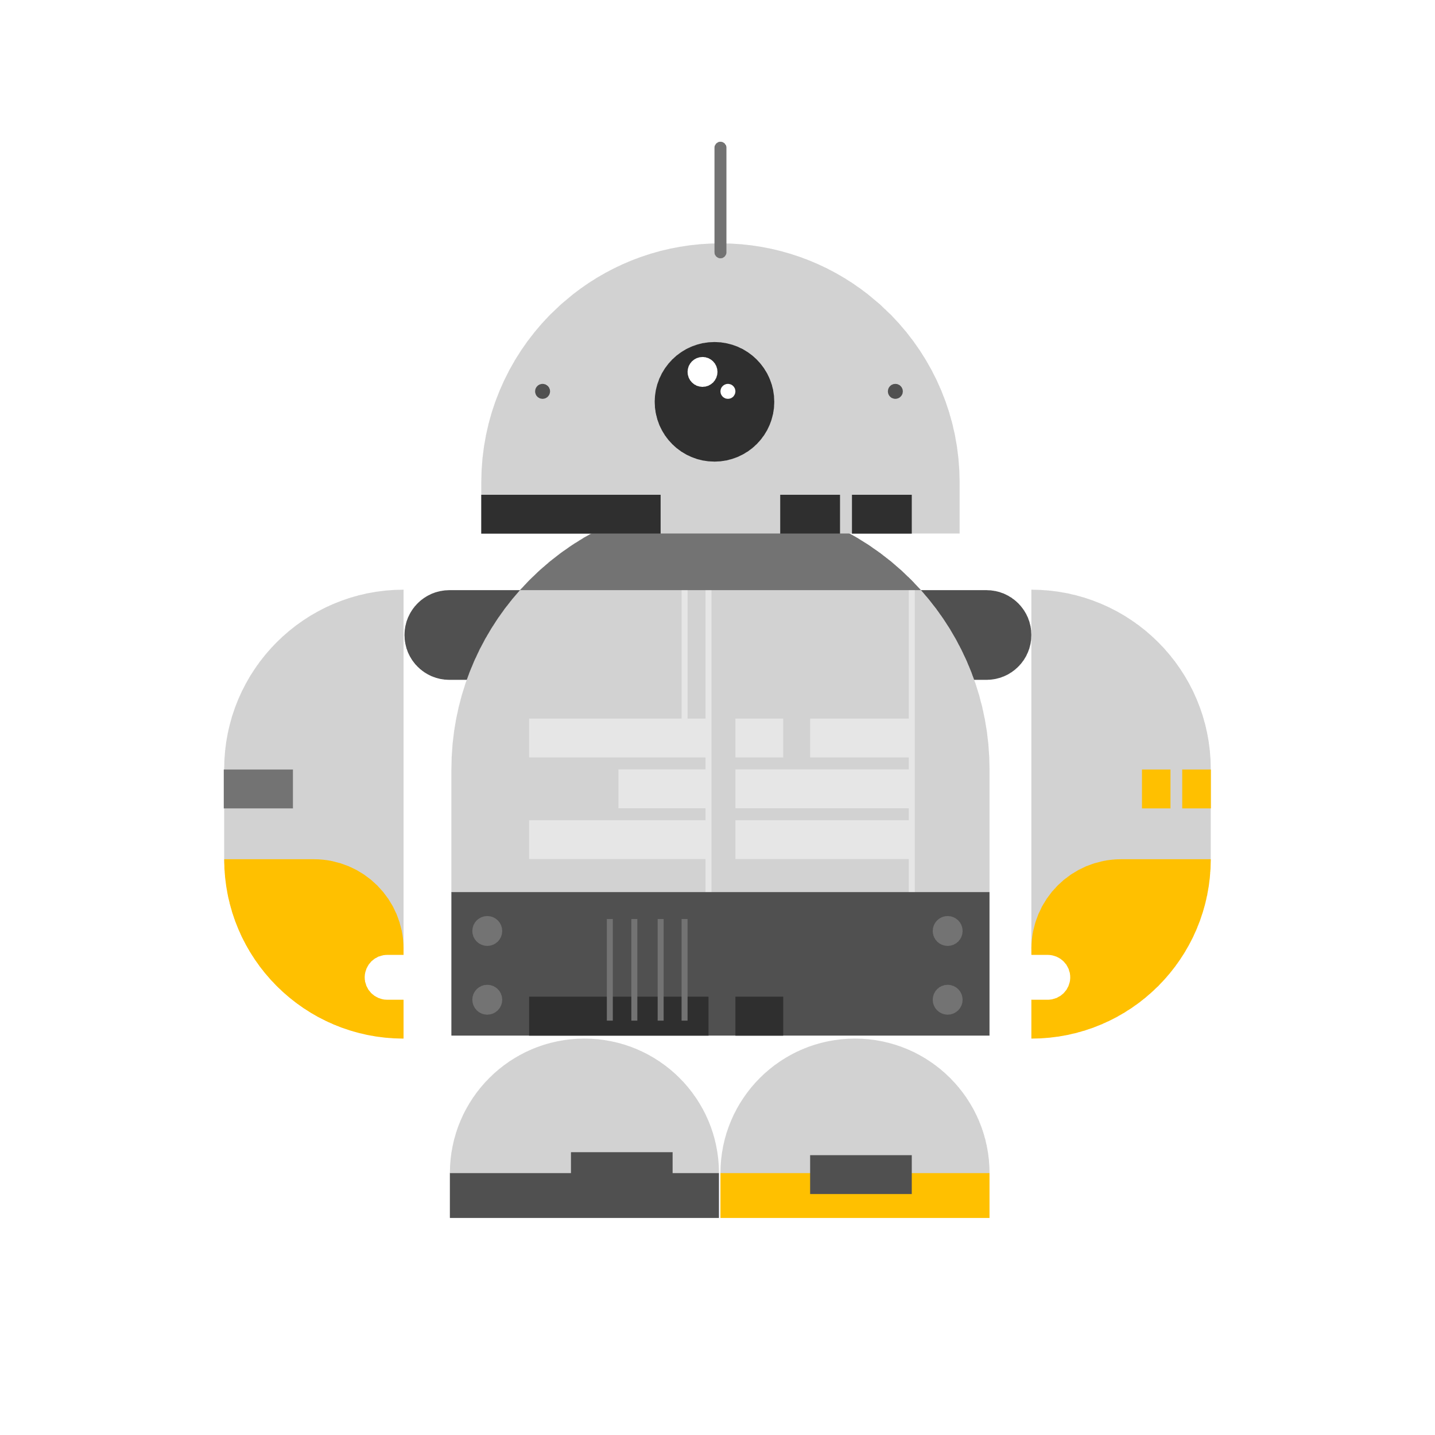
“From this industrial talk, my knowledge of Industry Revolution 4.0 has greatly improved. This can help me have greater preparation for the future. I study hard on the cybersecurity part so I can catch up in this revolution and I can also help in our country’s development in this aspect.”
-Lim-

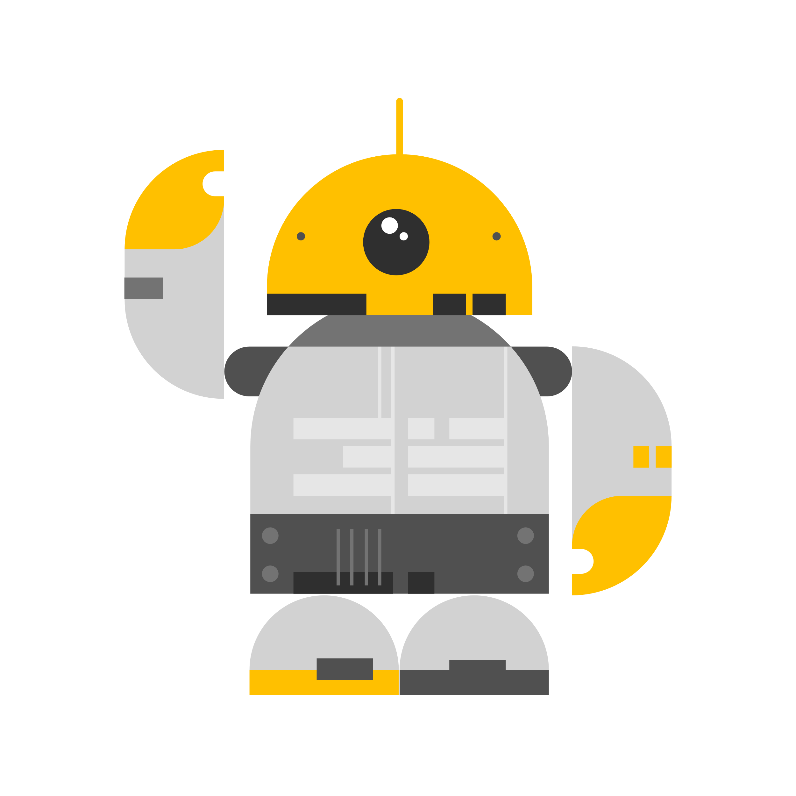
4th Industrial Revolution
- Autonomous Robots
- Stimulation
- System Integration
- Industrial Internet of Things
- Cybersecurity
- Cloud
- Additive Manufacturing
- Augmented Reality
- Big Data and Analytics

Introduction
Date: November 24, 2020
Title: “Industry 4.0: Past, Present,
and Future".
Time: 10:00 am to 12:00 pm
How: Cisco Webex and Facebook
Attendee: TIS students
Host: Digital Services Department, UTM (UTMDigital)
Moderator: Mr Nik Kamal Izuddin bin Bin Nik Ibrahim
Speaker: Mr Reazean Shah bin Yussoff (Director of Telekom Malaysia Southern Strategic Economic Region)
“This industrial talk made me realize that there are a lot of things that I need to learn especially in this Industry Revolution 4.0 to improve myself so that I can contribute with the modernisation of our country as my aim is to be someone useful to my race, religion, and country. “
-Lina-

The Future
- Invisible Analytics
- Artificial Intelligence
- Virtual Reality
- Video Consumption
- Wearable
- Mobile Payments
- Smart Home
- Connected Car
- Drones
- 3D Printing

“Throughout the talk, I learnt many valuable knowledgeable and insightful infomartion. Besides that, the talk has expanded my understanding about the IR 4.0 and has taught me how to better equip myself in order to serve my country in the near future.”
-Shartes-

Acknowledgement
Many thanks to UTMDigtal and Mr Nik Kamal Izuddin bin Nik Ibrahim for hosting and moderating the industrial talk. Thank you, Mr Reazean Shah, bin Yussoff for being the speaker of this industrial. We would like to thank everyone who gave their support and cooperation.

