

Semester I 2020/2021

Subject : Technology and Information Systems (SECP1513)
Section : 03
Assignment : Step by step PC Assembly

Group 7

1 |  | Name : Husam Hasan Mohammed Rageh  Matric Number : A20EC4026  Phone Number 01161105154  E-mail : husamhasan2222@gmail.com
2 |  | Name : Adham Alaa Abdellatif Abdelraouf  Matric Number : A20EC0254  Phone Number : +18569615132  E-mail : abdellatif20@graduate.utm.my
3 |  | Name : Mohammed Adham Mohammed Nooraldeen Tawfik  Matric Number : A20EC4040  Phone Number : +601151711714  E-mail : mohammed-2000@graduate.utm.my
4 |  | Name : Emran Almbruk Mohamed Lakhbuly  Matric Number : A20EC4014  Phone Number: +60183981646  E-mail : emranalmbruk2000@gmail.com
5 |  | Name : Abdulaziz Abdulrahman Awad Ba Haj  Matric Number : A18CS4057  Phone Number : +60163895435  E-mail : awad1999@graduate.utm.my

Part A 3
1.0 Screwdrivers 3
2.0 Anti-Static Wrist Strap 3
3.0 Cable or Twist Ties 3
4.0 Flashlight 4
5.0 Needle-Nose Pliers 4
Part B 4
1.0 4
2.0 4
Part C 4

Part A

1.0 Screwdrivers
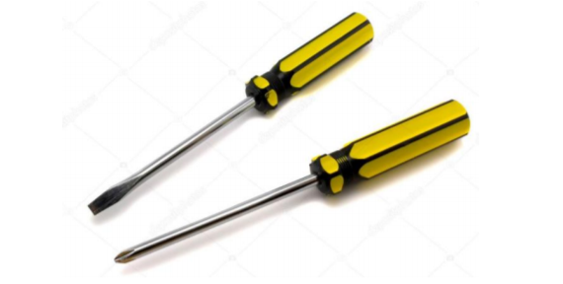
Use it to tighten the screws on your parts to keep them in place safely. A screwdriver is probably all you need for a typical PC build.

2.0 Anti-Static Wrist Strap
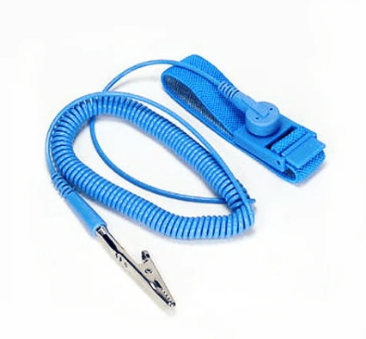
An anti-static wrist strap (or band) is a bracelet-type device that attaches to an electrical socket that you wear on your wrist, and if any electrical charge builds up between you and your hardware components, the charge is dissipated to the socket by security.

3.0 Cable or Twist Ties
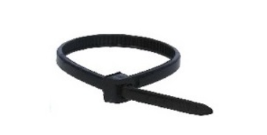
In your case, cable ties and twist ties are used to tie up any loose cables lying about, which not only makes the finished build appear neater, but also improves overall airflow.

4.0 Flashlight
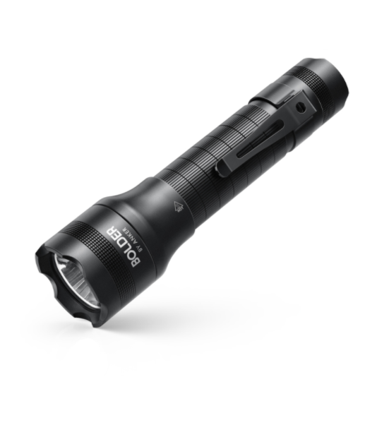
Flashlight is needed for an extra light source to see exactly what you're doing when working within your case.

5.0 Needle-Nose Pliers
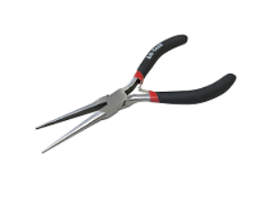
Needle-Nose Pliers is for loosening up screws or bolts that are super-tight, picking up hard to reach screws that you may drop within your case, removing chipped/broken screws, removing motherboard standoffs, and cutting zip ties.

Part B

1.0
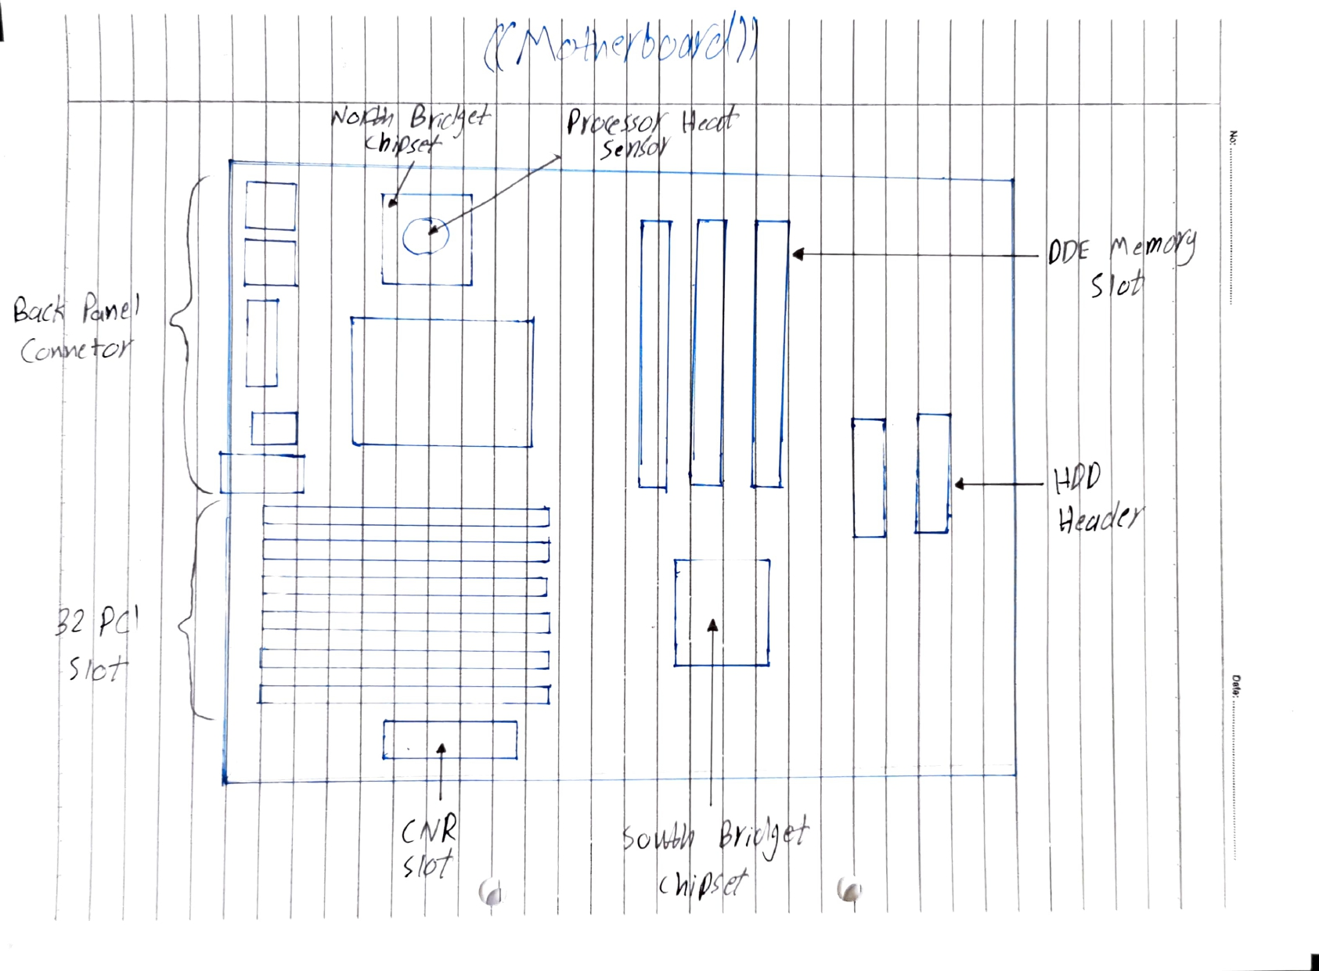

2.0
PC Part | Explanation
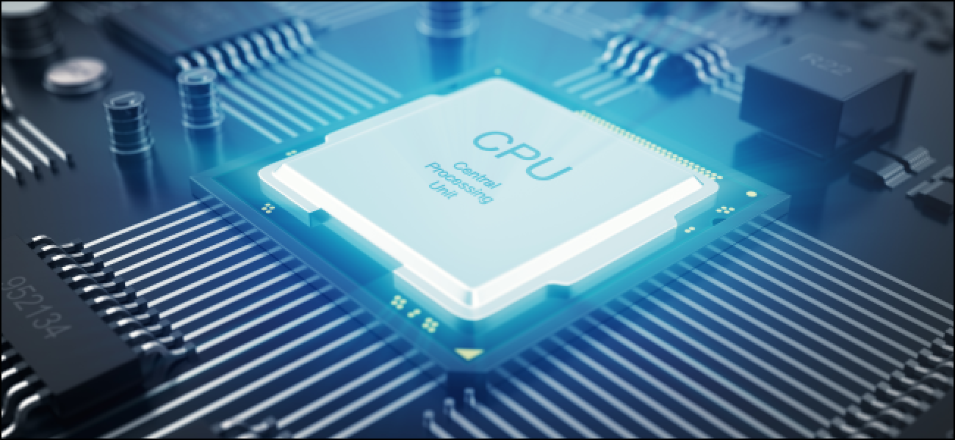 | The Processor or the Computer Processing Unit or CPU in short is the brain of the PC. It controls the tasks run on the PC and renders Photos/Videos.  Examples of CPUs are:  Intel i9-999K  AMD Ryzen 5 5600X
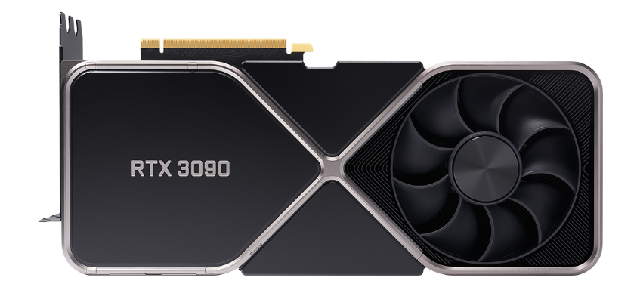 | The Graphics Processing Unit or GPU in short is a video card that helps you run games at a photo realistic High Quality. The newer the Graphics card, The higher frames ypu’ll get. Graphics cards get better every year.  Examples of GPUs:  The GeForce RTX™ 3090  AMD Radeon RX 6800
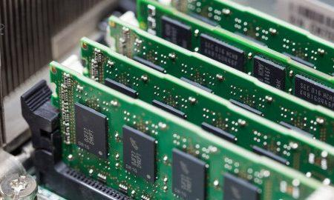 | Random Access Memory or RAM in short allows computer to store short term memories.  Examples of RAM:  Corsair Vengeance LED  G.Skill Trident Z RGB  Corsair Dominator Platinum RGB  HyperX Fury RGB 3733MHz
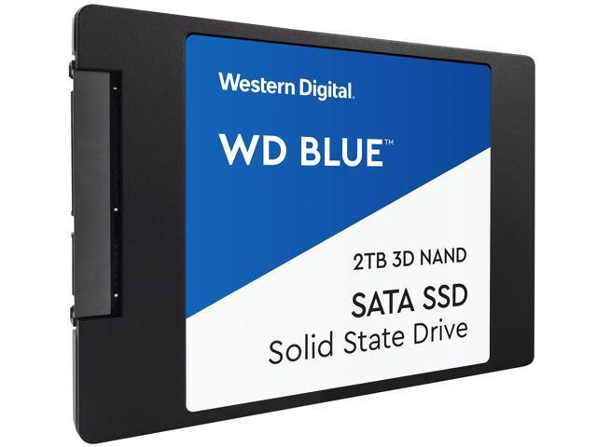 | The Solid-State Drive or SSD in short. SSDs are more responsive and consume less power than Hard disk drives (HDDs)  Examples of SSDs:  Samsung 980 Pro  WD Black SN850  Adata XPG Gammix S50 Lite
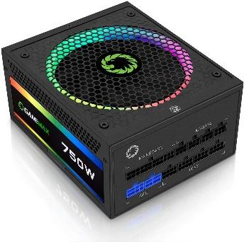 | The Power Supply Unit or PSU in short is what powers up the PC. Always try to buy a high-quality PSU to avoid ruining other parts of your PC.  Examples of PSUs are:  Seasonic Focus Plus Platinum 650W  Seasonic SSR-750PX  Corsair AX850
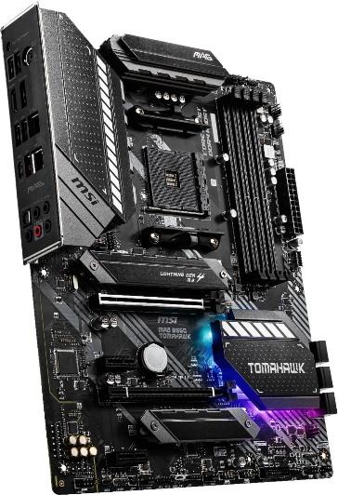 | The Motherboard is the link between all components of the PC.  Motherboards come in different types and sizes.  Examples of Motherboards:  ASUS ROG Strix X570-E Gaming  ASUS TUF Gaming B550-PLUS  MSI MPG Z490 Gaming Plus  GIGABYTE TRX40 AORUS Master  ASUS ROG Maximus XII Hero Z490
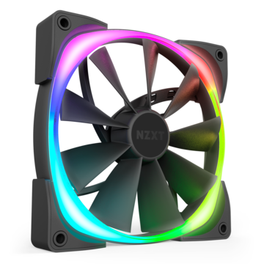 | The Fan is one of the most important parts of the PC. Keeping your PC cool at all times is essential to prevent your CPU and GPU from heating up and crashing.  Examples of Fans:  Noctua NF-S12B redux-1200  Arctic F12-120  Cooler Master MF200R  Corsair LL Series LL120
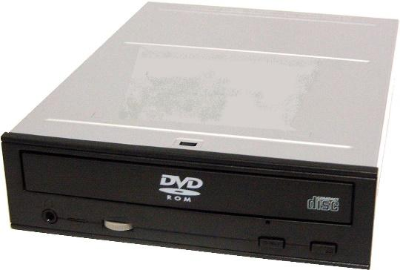 | THE DVD Drive is only important if you use Blu-rays and CDs. Most gaming PCs nowadays don’t have a DVD Drive, but having one is a benefit, nevertheless.  Examples of DVD Drives:  Asus ZenDrive  Pioneer XD07B  LG Ultra Slim
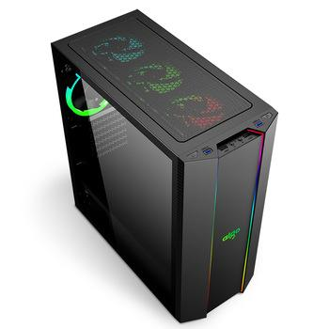 | The case is where you put everything together. It is important to keep everything cooled inside. That is why most gamers recommend a case with a mesh front panel.  Example of cases:  Corsair iCue 4000X.  Fractal Design Meshify-C  Nanoxia Deep Silence 4  NZXT H200i

Part C
1- Assembling the CPU:
The first thing is pushing the retention lever down and outward to release the CPU retention plate and then move the handle backward until the retention plate is fully open. You have to make sure not touch the CPU socket. Remove the processor from packaging, taking care to hold it by the edges and never touch the bottom metal portion of the processor. Remember that a CPU fits only one way into the socket. Look at the processor and the socket before inserting the chip to ensure proper alignment. A socket and CPU normally have a triangle marking or circular dot that indicates pin 1. The processor also has notches on each side that align with the socket. Do not force! Insert the CPU into the socket by aligning it with the socket and lowering it until it is flush with the socket.
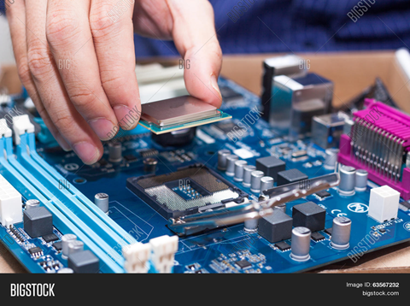

2- Installing the CPU fan:
The CPU fan is really a combination of a heat sink and fan together. The unit draws heat away from the CPU. You can simply install the CPU fan by following these instructions:
a- Place thermal compound to the CPU. You can do that by following the instructions provided with the compound.
b- Set the fan assembly on the CPU with mounting tabs aligned.
c- Pull the locking rod down on the fan assembly to lock into place.
d- Connect the fan assembly's power connector to the motherboard. Consult the manual to determine proper placement.
You have to be careful if you fail to apply thermal compound will result in insufficient cooling and will cause damage to the CPU and/or motherboard.

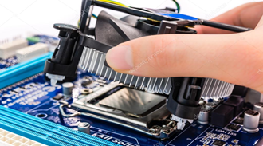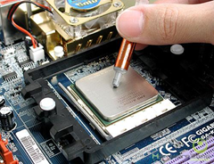

3- Open the case:
You can open the computer case by removing the side panels. Search for the screws that hold the side panels in place and remove them. The panel is removed by first sliding it back then lifting it away from the case.
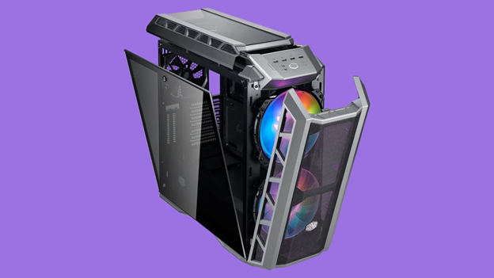

4- Preparing the case for assembly:
There are a few things that need to be done before assembling:
A- Remove any parts or packaging materials that may have been shipped inside the case.
B- Remove the cover for the optical drive. In our case, we will be removing the cover on the highest drive bay to mount our DVD drive. Do this by pressing in the retaining tabs.
C- Make note of the cables pre-installed in the case. These should be front panel connections for features such as the power switch, audio jacks and usb ports. If they are not labeled, consult the manufacturer’s documentation and label them yourself now before other parts are installed in the case.

5- Install Case Fan:
The case fan is usually installed on the back panel of the case. If the fan mount is not obvious consult the case documentation. To mount the fan:
a- Align the mounting holes by holding the fan to the mounting pad on the inside of the case. The fan needs to be mounted so that it blows air out of the case.
b- Insert the screws from the outside of the case and tighten.
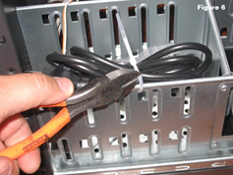

6- Installing the motherboard:
To install the motherboard, there are some parts that need to be included with your purchased components:
1-I/O Bezel is a trim panel installed in the back of the case that surrounds the interface ports on the motherboard. It should be included with the motherboard.
2-Standoffs are installed in the case screw holes to create a riser that separates the case and motherboard. Screws and standoffs should be included with the case, but it is a good idea to order these items just in case they aren't included.
Follow these steps to install the motherboard in the case:
a- Install the I/O bezel plate into the opening in the back of the case. It pushes in from the inside.
b- Install standoffs in the case. The standoffs screw into the motherboard mounting holes. Check the screw hole locations on the motherboard for exact placement.
c- Lower the motherboard into the case and align with the I/O bezel.
d- Install the screws.
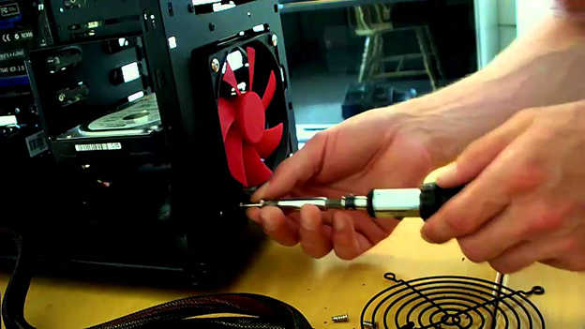

Step 7: install the switch mode power supply (SMPS)
Consult your case documentation for details and then follow these directions to install the power supply:
1. Align the mounting holes in the case and power supply
2. Insert screws and tighten.
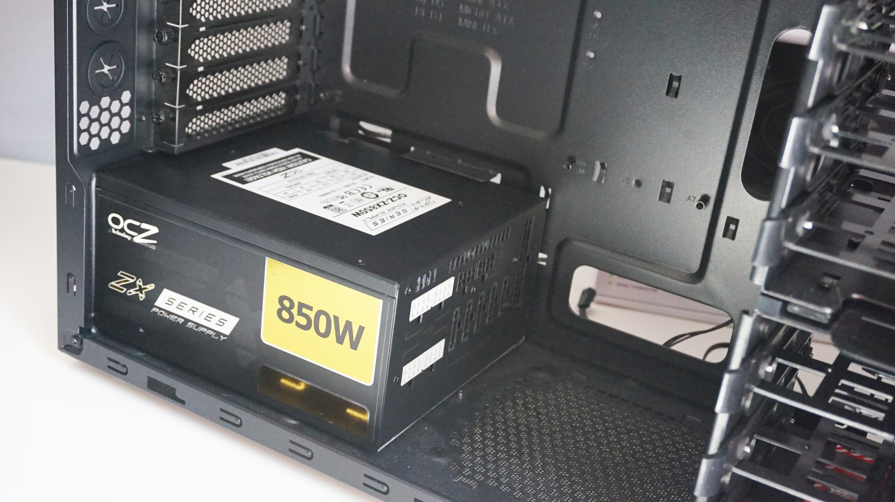

Step 8: install the hard drive
1.Find a 3.5" drive bay to install the drive in. If you have trouble finding a place to mount the drive consult your case documentation for suggestions.
2.Slide the drive into place until the screw holes on the sides are lined up with the holes in the case. 3.Install the screws
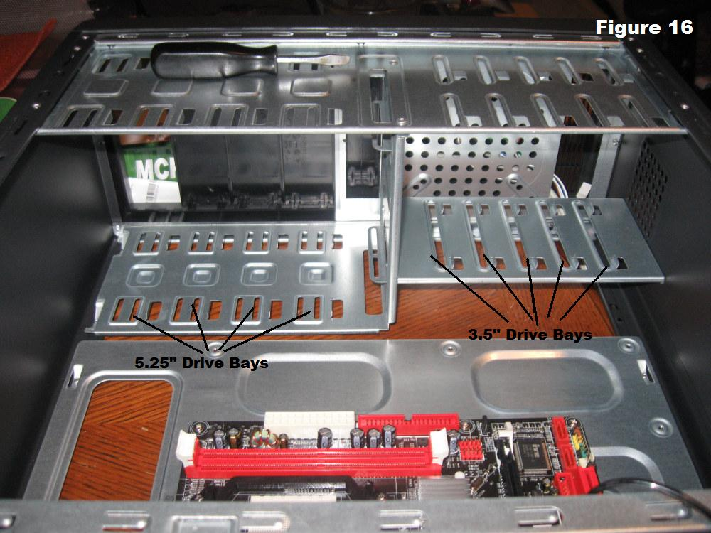

Step 9: install the RAM
1.Set the RAM board in the socket then check that the notch in the board is in the correct location
2.Press firmly on both ends of the board to set it into the socket. Make sure the tabs lock into place
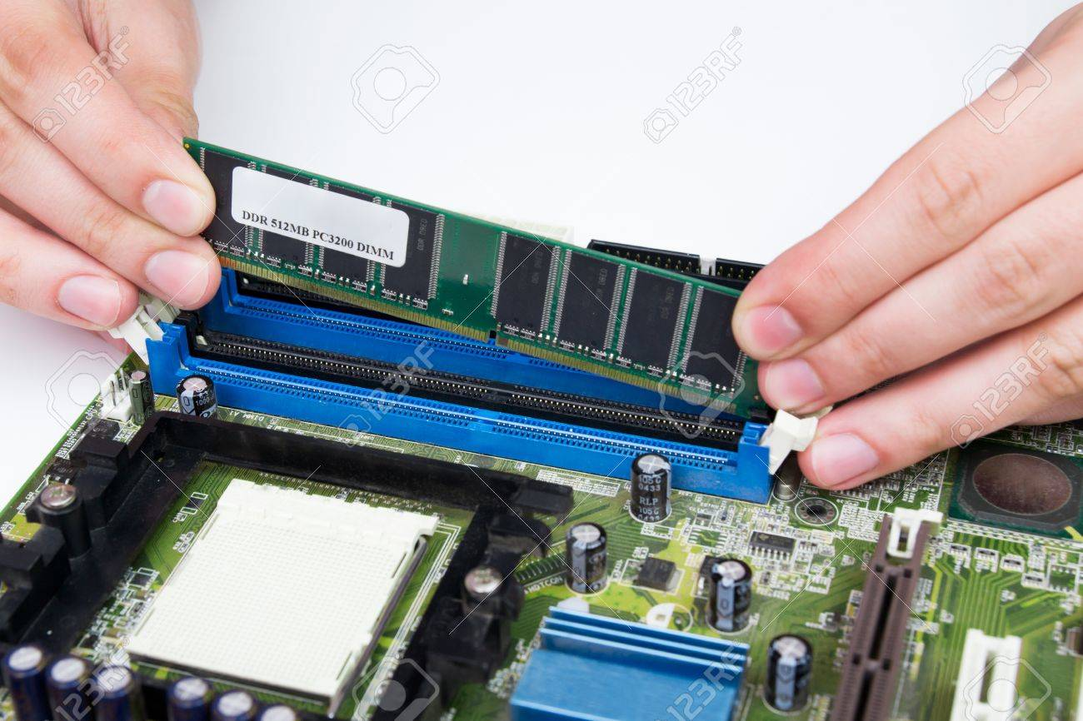

Step 10: install optical drive (DVD drive)
1. Slide the drive into the drive bay until the screw holes are lined up and the front of the drive is flush with the front of the case
2. Install the screws.
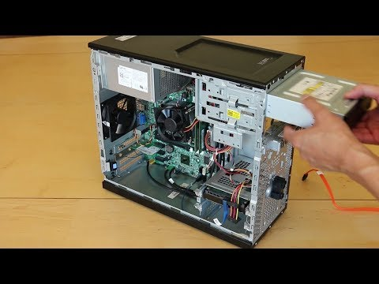

Step 11: connect the cables
With all of the components installed in the case, the jungle of wires can be daunting. It is important to consult the motherboard manual in order to make sure proper connections are made. There are two kinds of connections, power and data.

1.Every device that has been installed needs power. In the photo, the power supply connectors are shown. The motherboard has two power connections, and there are two connectors specifically for SATA devices (drives). The other connectors will run fans and other non-SATA devices.

2.Data cables connect drives and front panel devices to the motherboard. Please consult the motherboard documentation for the exact placement of connectors.

Caution: Incorrect connections can damage components and cause bodily injury

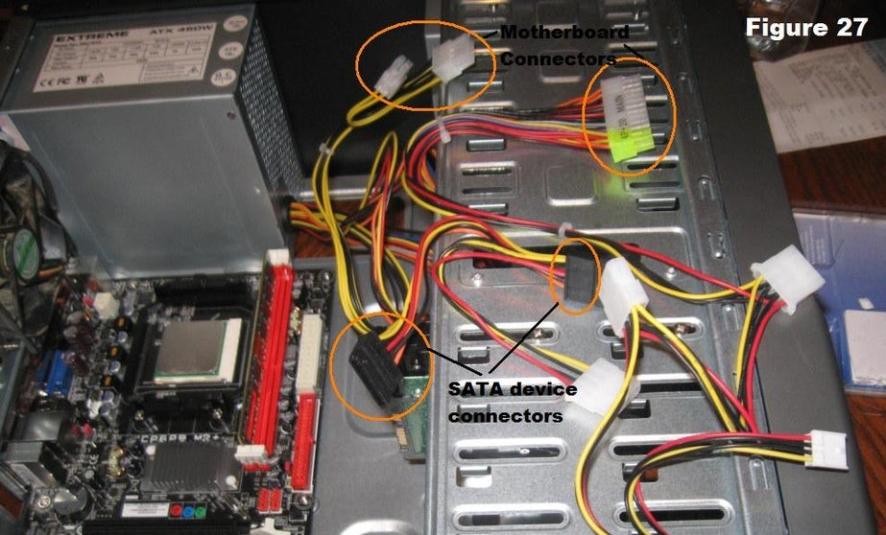

Last STEP - CLOSING THE CASE AND CONNECTING THE PERIPHERALS.
1.Place the side cover back on and secure the side panels with case screws.
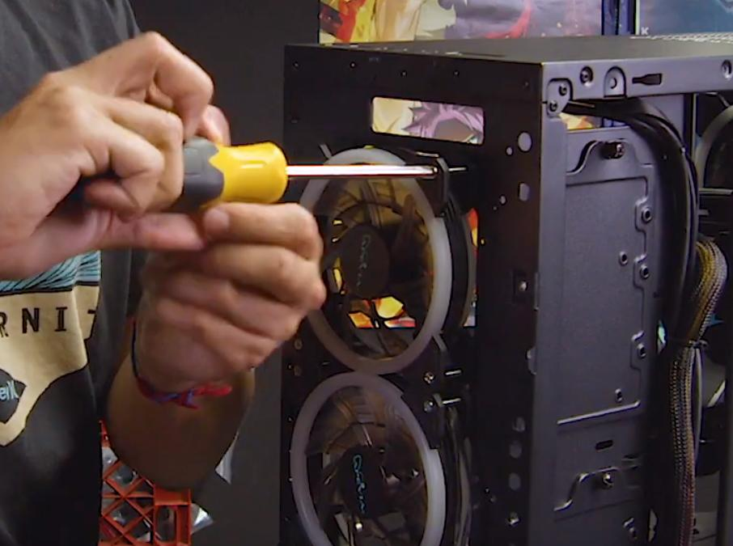

2.Connect peripheral devices which include keyboard, mouse, wireless network dongle, printer and webcams with your CPU by plugging into a USB port.
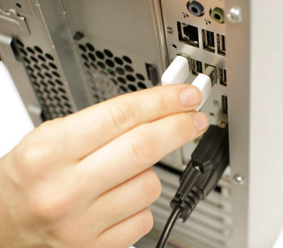

3.Then, connect speakers and microphone into 2.5 mm sockets.
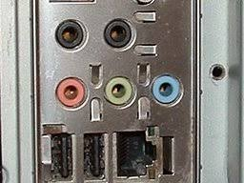

4.Finally connect the CPU with monitor by plugging into display ports
