Inspiring Work Experience and Covid-19 Pandemic Challenge
A Talk of Inspiring Work Experience and Covid-19 Pandemic Challenge was held on 29th December 2020 via Cisco Webex Event platform. The talk was organized by Technology and Information Systems (SECP 1513), School of Computing, UTM. The talk was delivered by the moderator, Dr Johanna Ahmad, Senior Lecturer of School of Computing and 3 speakers which were Batrisya Binti Azman Shah, Mohammad Zamarul Akmal and Tan Yong Keong which came from 3 different background. The talk last for about an hour. In the talk, the speakers advise the audience to be more proactive, participate in more competition in our university life. This is because from the competition, we can learn a lot of experiences and soft skills. Besides, group competition allowed us to learn about team-working. We can learn how to communicate with our teammates and become more confident to speak out our opinions. According to the speakers’ experiences, CGPA may not be the most important thing for a company to hire them, but the attitude, experiences and their skills are the one which let them have advantages over others.
The main purpose for this talk is to give more spirit and energy towards the new students. This talk shares a lot information on how to secure a job right after you graduate. They gave us tips and advices like we have to try to explore new things. There is a lot of things more that we can do other than the tasks that was given to us. In this talk, they also share about how to love programming and how to gain confidence. Start to discipline yourself and just asks questions whenever you do not understand.
The talk talked about the experience of working after leaving a university life. The speakers shared about their experience in working industries. The speakers also shared some ideas and tips on how to face working industries. There is also a section were the questions where the speakers had to answer the questions from the participants. This is good because it gives the participants a good exposure on the working experience. Three of the speakers shared their background on how they can get their first job. They also give some advises on how the company recruits the fresh graduate. Different speakers gave their thoughts in different ways and this makes the talk more interesting. Overall, the talk gave the participants the ideas.
The talk has many strengths. All the speakers are from information technology (IT) field. This helped us to have a clear picture about our working environment in the future as we are also pursuing degree in computer science. The next strength is the speakers were very friendly and informative. It makes the talk very interesting and the speakers were ready to share their knowledge and learning in the talk. It was easy for the listeners to approach the speakers and ask questions as the speakers give very good and precise answers. Not only that, the speakers gave us many useful tips and guidance for us to follow to be a better employee in the future and to get a good job in a well-known organization. The weakness of the talk is all the speakers were from private sectors. Having speakers from government sector might have given us opportunity to get to know about the criteria for government jobs and the working environment of a government employee.
From this talk, we learned the importance of having soft skills such as communication skills and social skills in obtaining a job in this pandemic. We also learned how to make use of this lockdown period which is to learn many new technical skills which will ensure us to have an extra advantage when we are applying for a job. This also was a great exposure for us about the working environment and job interviews. We learned that we have to make use of this university time by participating in competition, talk sessions and seminars organized by the university to sharpen our skills and develop our knowledge. We should also have to learn to minimize our mistakes from now so that we can be a good employee who deliver work with better quality work in the future. We have understood that having good academic results will not be good enough to get a good and respectable job. Additional skills in preferable field. We will definitely put effort on improving our soft skills and employability skills and attempt to learn new skills such as learning new programming language or learning how to create a software.

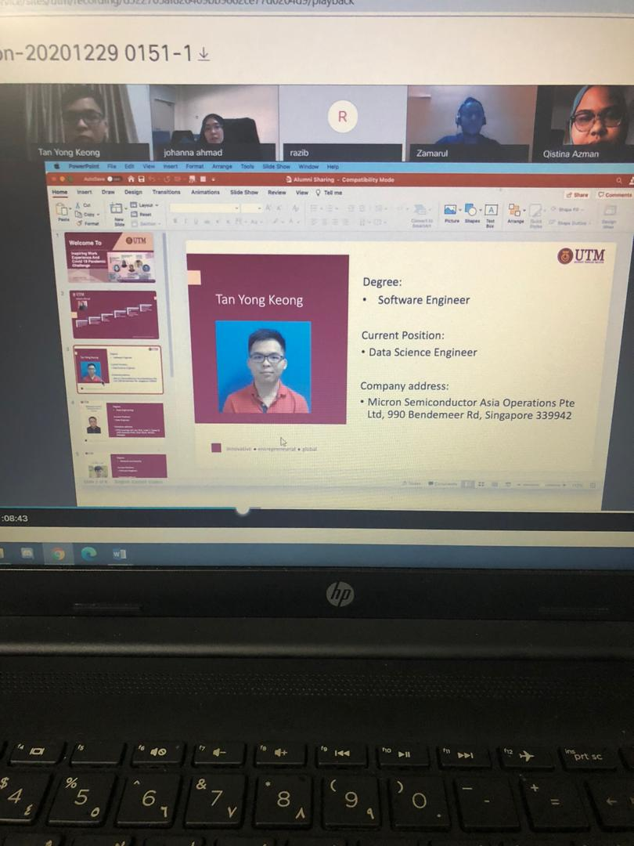




Hanis Rafiqah bt. Hisham Razuli
Indira A/P Thangaraj
Iman Ehsan Bin Hassan
Goh Yitian

