
School of Computing
Faculty of Engineering

Design Thinking (Group)
SECP1513 Technology and Information System Semester 1, Session 2020/2021

Tittle : Application Software

Lecturer : Dr. Haswadi bin Hassan

Name : Teh Jing Ling A20EC0228
S M Tashdid Hassan A20EC4048
M D Shafiur Rahman A20EC4034
Section : 07

Programme : Bachelor of Computer Science (Software Engineering)

Table of Content
No | Tittle | Page
1 | Introduction | 3
2 | Detail Step and Descriptions | 4
3 | Detailed Description | 5-7
4 | Design Thinking Assessment | 8
5 | Design Thinking Evidence | 9-15
6 | Reflection | 16
7 | Task for Each Member | 17
8 | Video Link | 17

1. INTRODUCTION

Design thinking
Design thinking is an iterative process that knows our needs, challenges imagination and detects problems to come up with a creative solution for prototype and test. It also provides a solution that approaches solving problems. It is an important skill to designers from different fields including engineering and computing to fulfil the user’s needs. Design thinking can be separate into five phases which are empathy, define, ideate, prototype and test.
Application Software
Application software or end-user software are made for consumers to help them in their daily activities such as online research, typing, calculation, playing games etc. Unlike system software, they are used by the end-user and are specific in their functionality or tasks and do the job that they are designed to do. For example, MS Word is a software that allows its user to write document. All apps we see on our mobile are Application Software.
Our project is an Application Software which is called “Typer Man”. A speech-to-text software which will help its user with typing any word and sentences. It is hard for some people to type on their mobile or computer when communicating with friends on social media or writing long essays. The Application will type everything for you by saying the sentence to your mobile or computer.

2. Detail Step and Descriptions

Phase 1: Empathy
Empathy is a stage where the inventors know the user's needs and wants. Our target was on people that facing typing problems during daily work and life. During the interview, we asked user about that problem and experience that regularly faced by them.
Phase 2: Define
Define is a stage that dedicates the identified problem of the user. After taking the interviews, we have brought to light that most of them are facing difficulties in typing, it is time consuming, typing wrong key by mistake, new to typing, big finger or sweaty hands etc.

Phase 3: Ideate

Ideate is a stage which comes up with many ideation solutions from brainstorming to explore new creative and alternative ways. We have listing down our idea and grouping our idea step by step through phases.

Phase 4: Prototype

Prototype is an experimental phase to identify the most suitable solutions and put it in the product. After our discussion, we come up with solutions and start to do out prototype. The prototype is an audio to text converter app. We used application apps like Canva to do the prototype.

Phase 5: Test

Test is a stage in which the user tests a prototype and gets feedback from the users so that the inventors can revisit the previous step to iterate the process and enhance the product. We demonstrate our prototype after the processing of prototype. We also explain the features of ‘Typer Man’ to user and get some feedbacks from user so that we can improve our prototype.

3. Detail description
Problem faced by users
Typing is not a fun thing for many people. Sometimes we have to type for hours in order to write what is in our minds. But it is not easy for everyone. Many people who communicate on social media or in emails have to type long words that may not express their full thoughts. It is not easy to type something that you want to say. Some people find typing to be very difficult as they cannot type as fast as possible and communicate the way they want.
Solution
The app we are creating “Typer Man” will remove typing for users who find typing on their phone difficult. The app will type anything by itself. All you have to do is say the sentence to the app and the app will type the entire sentence.
For Example:
If you want to type your friend,”How are you?”
You just say the sentence and the app will type it down for you.
You can then send it to your friend.
This way you no longer need to type anything and can send every word you want to say efficiently and will help them communicate on online quickly
Teamwork
Teh Jing Ling focuses on production of video and compiles the report. SM Tashdid Hassan will more concentrate at the process of producing a prototype for application software and interview and test sesion.M D Shafiur Rahman will focus on the content of the report.
Due to pandemic Covid-19, MD Shafiur Rahman currently in Bangladesh and Teh Jing Ling in Red Zone in Selangor from the start of the project. Thus, we face the time difference between two countries. We mostly use WhatsApp for discussing our problems. Besides that, we hardly have ideas and creative solutions at the beginning. Luckily, we all have found out one better solution for the task and manage to discuss our problem with types of social apps.

Group Minutes Meeting Record 1
- Attendance (3/3)
- Teh Jing Ling
- SM Tashdid Hassan
- MD Shafiur Rahman
- Date
3/11/2020
- Meeting Location
WhatsApp: Tis group 1
- Meeting Start/Finish
Meeting Start: 1.00PM (Malaysia time)
Meeting End: 2.30PM (Malaysia time)
- Agenda
- Separate Task
- Discuss the topic of design thinking
- Meeting Record
- None
- Evidence
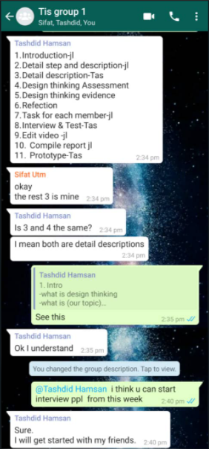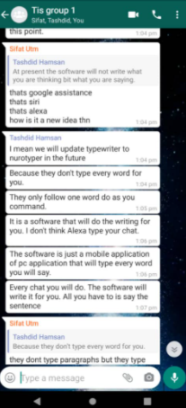

Group Minutes Meeting Record 2
- Attendance (3/3)
- Teh Jing Ling
- SM Tashdid Hassan
- MD Shafiur Rahman
- Date
12/11/2020
- Meeting Location
Host: MD SHAFUIR RAHMAN
Google Meet: https://meet.google.com/vwq-dvcx-scg
Pin: 428 113 910#
- Meeting Start/Finish
Meeting Start: 10.00PM (Malaysia time)
Meeting End: 11.00PM (Malaysia time)
- Agenda
- Discuss the problem that faced by user
- Come up with idea and solution.
- How to do a prototype
- Meeting Record
- SM Tashdid Hassan
- Evidence
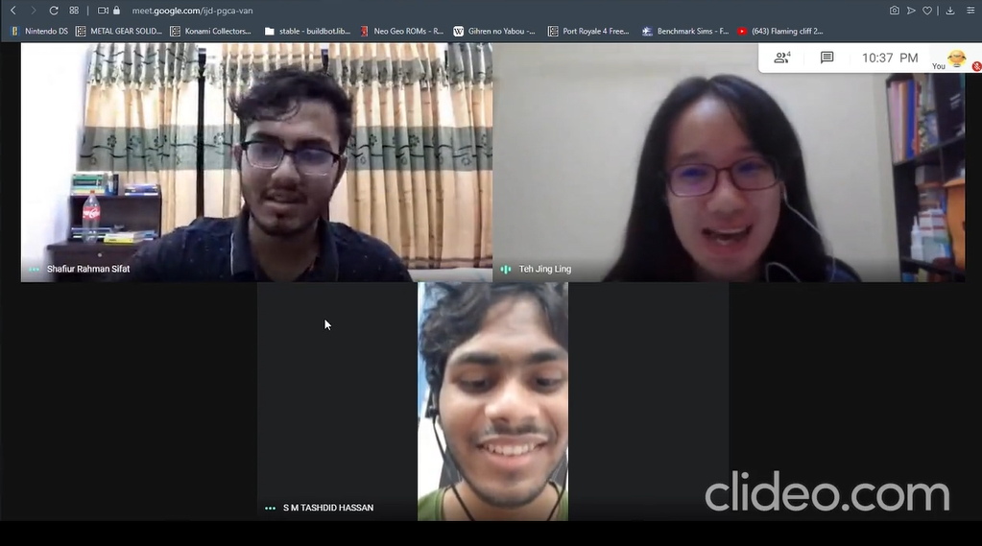

4.Design thinking assessment
During the end of the project demonstration
At the conclusion of our project, our team holds up great. We helped each other though we divided our parts and everyone worked very hard to complete the project. We learn that design thinking is a process of problem solving in all aspects of our life. Besides that, we know that develop an app was no easier because we need to satisfied each design thinking phase. For our next phase, we are going to develop our app and for the future we will include some technology to our app so that user’s with speaking disabilities can type by their brain waves on just thinking.
During the transition between design thinking phases
At the transition phase, we face many types of problems which we do not have any idea and solution to solve the problem that users face. We also have some disagreement during the discussion due to different ideas but we discuss together and choose the most suitable solution. During every phase of design thinking, we cooperate together to discuss and solve the issues we faced.

5. Design Thinking Evidence
I) Sample work
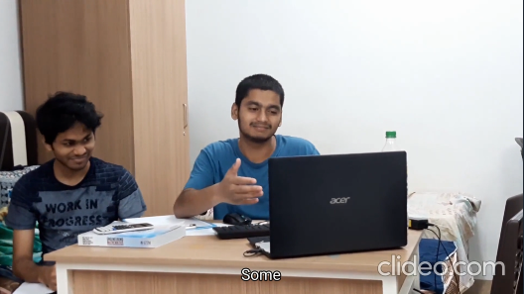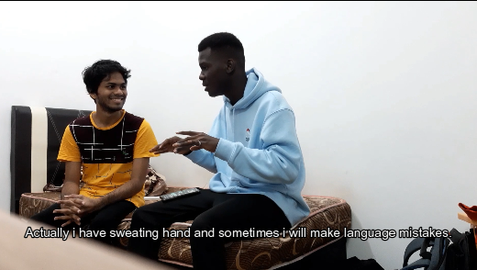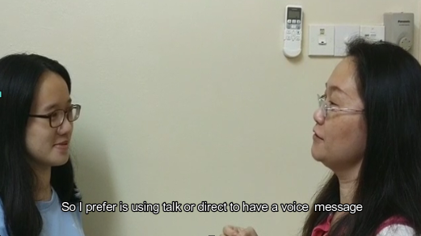
i.Interview session during empathy phase

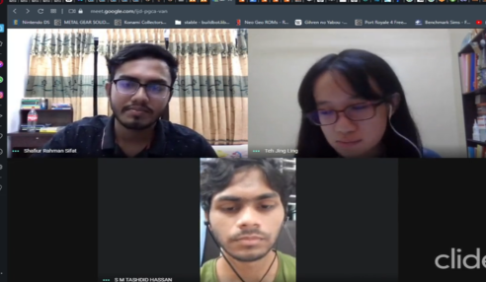

ii.Discussion during define and ideate phase

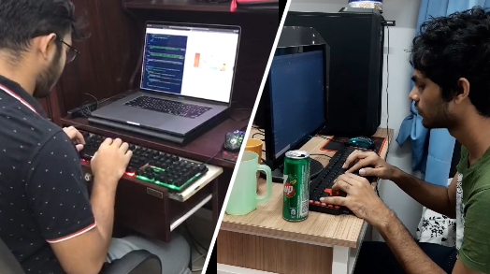
iii. Prototype phase

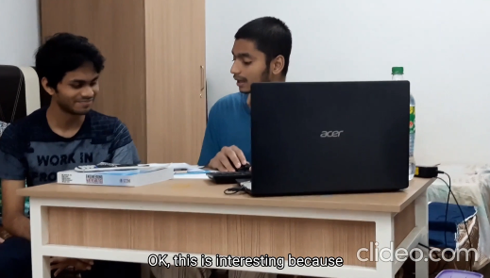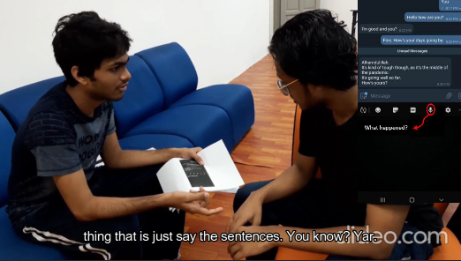
iv. Test phase

Prototype

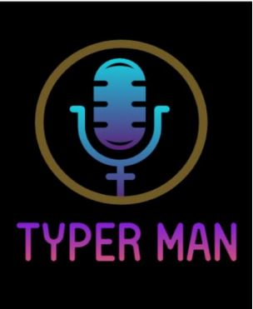
LOGO of Prototype

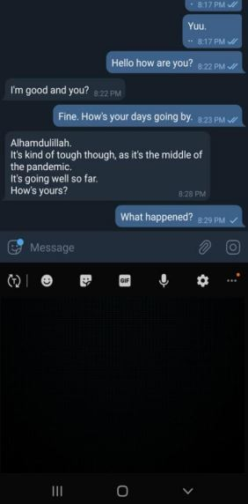
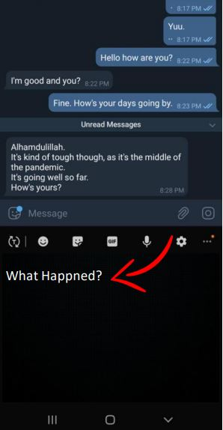
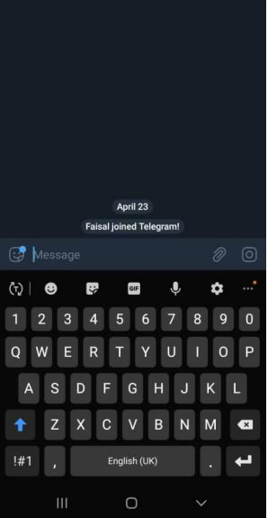

What happened?

User interface
for message
User interface
for audio track
User interface
for audio to text and message

II) Record for each phase

Empathy
The table below are the question and answer during the interview session.

A First User
Name | Samiul
Occupation | Student
Field | Electric & Electronic Engineering
Do you feel typing is difficult? | Yes
If Yes, what are the problem faced? | - Typing is very time consuming  - No often to typing cause difficult to typing and finish a task in a short period.

B Second User
Name | Abdul
Occupation | Student
Field | Software Engineering
Do you feel typing is difficult? | Yes
If Yes, what are the problem faced? | - Sweating hand.  - Always make mistake when typing because normally don’t face the screen when typing and only face keyboard.

C Third User
Name | Joyce
Occupation | Executive
Field | IT
Do you feel typing is difficult? | Yes
If Yes, what are the problem faced? | - Finger is too big to type on E-pad mobile and easily to make mistake.  - Talking using voice message is faster than typing message.  - Sometimes keypad hang cause miss pressing button and lost the page  - Time consuming.

Define
Below table showed the problem faced by user.
Problem | Reason/Description
No often typing | - Normally use writing  - Typing need use take times compare to writing
Sweaty hand | - Slippery when typing  - Easily make mistake
Do not face laptop/computer screen when typing | - Easily make mistake when typing  - Can not concentrate with both screen and keypad
Time consuming | - Take too many times to typing
Big finger | - E-pad in mobile phone is too small to type  - Easily make mistake
Talking using voice message is faster than typing message | - Talking can express feeling faster and good rather than typing
Keypad/Keyboard hang | - Cannot type smoothly  - Sometimes cannot type  - Miss pressing button and lost the page

Ideate
This table provides possible ideas that our team members have come out with to solve our user’s problem.

Idea Phases | Ideas | Improvement/Reason
First Phase | Create an app “Typer Man” | - Automatically type every word and sentence the user wishes to type by speaking it to the microphone.
Second Phase | Create an audio icon | - User can press the icon when speaking.
Third Phase | Create an option button for grammatical correction purpose. | - Fix any grammatical problem the user made when saying the word or sentences.  - Allow “Typer Man” to correct grammatical errors automatically.
Fourth Phase | Integrate “Typer Man” to the mobile. | - To further help users in their typing.

Prototype
Through our discussion, we decide to use the solution from First Phase, Second Phase and Fourth Phase instead of the Third Phase. The reasons will be listed at below:
Idea Phase | Idea | Reason
First Phase | Create an app “Typer Man” | - Audio will be converter to text  - Automatically type every word and sentence that the user says by using microphone  - “Typer Man” will automatically correct the grammatical error.
Second Phase | Create an audio icon | - User can press the icon when start speaking and leave the icon when finish speaking.
Third Phase | Create an option button for grammatical correction purpose. | - This phase already implemented in First Phase by using automatically correct grammar mistake
Fourth Phase | Integrate “Typer Man” to the mobile. | - To further help users in their typing.

Test
We had done some tests with the users. We explained the detail about our prototype how to convert an audio to text to users. Due to COVID-19, it was not possible to perform tests as we expected. All the tests we have done so far gave us positive feedback and we are looking forward to getting more support and positive responses.

6. Reflection

Teh Jing Ling

a) My goal is explored more knowledge about Technology and Information System. This is because it related to programming knowledge. I need to know what are the needs and wants that market need. As a future programming engineering, I need have enough knowledge about Technology and Information System so that I can build a software in correct way.

b) From design thinking, I learned that we need step by step to know, define, ideate of a problem. So that, design thinking can help me understand the problem that I faced and solve the problem on the correct and efficient way.

c) In the future, I will participate in club like Robocon Club to learn more and explore more knowledge related. It can help me to improve and exercise my creative thinking that can implemented in my daily life.
SM Tashdid Hassan
a) My goal is to create softwares that will help human beings and make their life easier. I want to learn new and exciting things about Technology and Information systems. I want to create a business where I can make exotic software for mankind and help the human race propel even further.

b) From this project I got to learn what I lack and where I need to improve to accomplish my goals. I can say with confidence that design thinking has helped me understand my abilities. It helped me and allowed me to come out of my comfort zone and use my mind in a way I might not think of using.

c) In the near future I will download many Software like Unreal engine or Unity workshop to help me develop apps and games that I will use to get a better understanding of application software. I will also participate in various clubs like Robocon and earn a lot of experience for my future goals.

MD Shafiur Rahman
a) My goal with regards to this course is to learn more about the information systems based on the management of computers. As I am going to persue my career in the field of software engineering, I would be happy to learn more about the system’s hardware, software, database and networks.

b) Design thinking impacted very well on my goals with regards to this program. I got to be more productive in my field of study by developing prototype software, worked in a great team of individuals, and got to be more creative in problem solving. It also helped me to understand the user's needs and be better in serving people with my products.

c) In the process of doing the project, I found some lacking which will help me do better and make up for those in the long run. Improvement of my potential in the industry will be done by working hard in my studies and learning new things every day to develop my skills to be a software engineer.

7. Task for each member
NAME | Teh Jing Ling | S M Tashdid Hassan | M D Shafiur Rahman
Task | Edit video & compile report & Interview | Interview and Test | Design thinking assessment
Task | Introduction |  | Design thinking assessment
Task | Detail description
Task | Design thinking evidence
Task | Detail step and description | Prototype
Task | Reflection

8.Video Link
https://youtu.be/pkWZRH_bx5c

