The Importance and Trending of IT Project Management
Adam Haqiem¹, Brendan Dylan Gampa², Dzakirin Asyraff³, Eunice Lim Xian Ni⁴

^{1,2,3,4}School of Computing, University of Technology Malaysia, 81300 Skudai, Malaysia

Abstract—This report reviews the details from an industrial talk entitled “The Importance and Trending of IT Project Management”. Such details including the importance of IT Project Management, the trending of IT Project Management, and relevant IT careers. This report also includes the reflections after the talk from each group member and their acknowledgment.
Keywords—IT, Project Management, importance, trending, careers

Introduction
The speaker for the industrial talk is Mohd Khairul Reeza Ruslan, Head of Project Management Office Commerce Dot Com Sdn Bhd. The talk title is The Importance and Trending of IT Project Management. The talk was on the 1st of December 2020, from 10.00 a.m. to 11.00 a.m. It was moderated by Dr. Goh Eg Su, Senior Lecturer from School of Computing UTM.

IT PROJECT MANAGEMENT

The Importance of IT Project Management
Project management is the the application of skill sets, techniques and knowledge when carrying out a project so that can meet the project objectives. IT project management is undeniably important as they provide the teams and clients a clearer focus when executing a project. IT project managers will be able to foresee and analyse all the financial risks for each projects and later come up ways to minimise production costs with the best quality. Each project has its own distinct strategic framework so that the project is ensured to be delivered within proper timeline and not over budget. Without a proper IT project management, the projects may be exposed to unclear goals, high risk plans, unhappy clients, company facing negative profit and project be delivered late.

Trending of IT Project Management
Based on the points mentioned by our honourable speaker, he stressed out on the needs for young generation to always align their mission and vision towards the community’s preferences nowadays. Therefore, he has listed several crucial points regarding the trending in IT Management based on his experience. One of the points is shifting and globalized gig economy where most company focused on hiring fresh graduates for freelances job. Next, he mentioned on focusing on big data. It is important to be very cautious all the time since one mistake in data lacking will bring huge loss to a project.
Other than that, the implementation artificial intelligence also become a trend nowadays since it helps the company to match workers with the suitable job. Moreover, the crucial change management allows the developers to be prepared in case there is any bug appears on their product. In order to reduce cost management of a project, most companies prefer to combine more than one programming languages completing the tasks given on time.
Furthermore, young generations should also get used with different video conferencing apps in order to avoid themselves from causing troubles with other people. Last but not least, the speaker also stressed on handling one’s emotion during group project and how they would work under pressure. Figure 1 represents the difference between IQ and EQ as well as how the combination would give positive result [1].
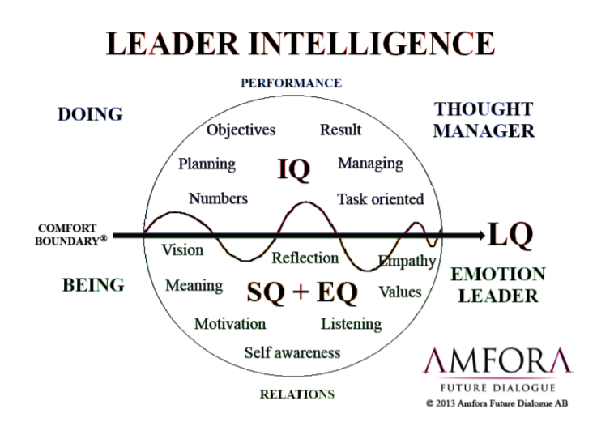
Figure 1: The difference between IQ and EQ [1]

RELEVANT IT CAREERS
Referring to the speaker, the first point made by the speaker is, getting a successful future starts from now and your own self. The speaker points out that you need to change from now to be successful in the future. Then he proceeds to explain that although people say luck is a factor, you still need to be prepared by the time the luck comes.
After that, he states that to become a project manager is not easy. The point he is trying to make is to become successful is not an easy process. He then states that if you became a project manager just after you graduate, you will have a difficult time. This is because you don’t have the experience to do the work efficiently. You have to build your experience from the start.

REFLECTIONS
- Adam’s reflection
This talk has thought me that if I wanted to be successful, I need to work for it from now on. The action for me to improve my potential in the industry is I will gain experience and knowledge through everything I will go through
- Brendan’s reflection
I learn a lot of things from the talk as it helps me to prepare on facing real life challenges of starting a career. I realised that I should expect the job vacancies will be more competitive and it is important for one to become a role as well as exposing myself to more leadership values.
- Dzakirin’s reflection
After the talk, I am inspired to improve myself to be a better team player and a responsible person. It is now evident to me the value needed to excel in IT project management and I will make sure to master all of the values for me to compete in this industry.

- Eunice’s reflection
It was a very informative talk that enabled me to understand the purpose of IT project management. I also realised a successfully conducted project involves a team of members working hard cooperatively to develop the project.

Acknowledgment
We are grateful to be given the privilege to attend this resourceful industrial talk. The talk has provided us with a lot of insight towards the nature of our industry. We would also express our appreciation to Dr. Zuraini, our SECP 1513 lecturer for the help and attention that she gave for her students in completing our tasks.

References

- [1] T. Gage and C. Smith, "Leadership Intelligence: Unlocking the potential for school leadership effectiveness," South African Journal of Education, vol. 36, no. 1328, 2016.

