

SEMESTER I 2020/2021

SUBJECT: TECHNOLOGY AND INFORMATION SYSTEM
SECTION: 8
ASSIGNMENT: STEP BY STEP PC ASSEMBLY

GROUP NAME/NUMBER: GROUP 1

1. |  | Name: ADAM HAQIEM BIN ABD.RAHIM  Matric Number: A20EC0002  Phone Number:0149125892  E-mail: adamhaqiem@graduate.utm.my
2. |  | Name: DZAKIRIN ASYRAFF BIN ZAMSARI  Matric Number: A20EC0030  Phone Number: 01121590726  E-mail: dzakirinasyraff@graduate.utm.my
3. |  | Name: EUNICE LIM XIAN NI  Matric Number: A20EC0034  Phone Number: 0109359205  E-mail: eunice@graduate.utm.my
4. |  | Name: BRENDAN DYLAN GAMPA ANAK  JOSEPH DUSIT  Matric Number: A20EC0021  Phone Number: 0137908486  E-mail: brendandylangampa@graduate.utm.my

PART A
List at least FOUR tools needed to assemble a PC. For each tool, provide picture(s), explanations of its function and its importance.
1. Screwdrivers
Most of the time, screwdrivers are used to ease the assembly and the disassembly of the pc. Specifically, flat and Phillips-head screwdrivers are applied (Picture 1) since most parts of the PC contain small or medium-sized Phillips-head screws. The reason why we need to use both of the screwdrivers so that we will not damage or scratch the pc body as well the screws.

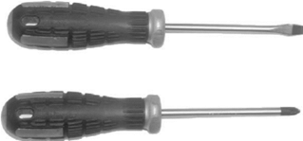

Picture 1: Flat head screwdriver (top) and Phillips screwdriver (bottom)

2. Anti-Static Kit
Anti-static kit is used to prevent Electro-static discharge (ESD) from occurring on the PC. This is because ESD can damage or destroy the PC parts even before you finish building it. Anti-static kit consists of an anti-static rubberized mat, wrist strap or grounding bench (Picture 2). The mat is used to create a safe grounding channel, preventing the components from being damaged. It is also used to prevent scratches on the PC.
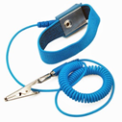
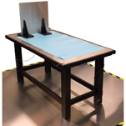
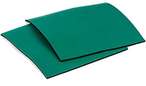

Picture 2: The tools needed for anti-static kits. Starting from the left is anti-static rubberized mat, wrist strap and grounding bench

3. Twist Ties
This tool is used to keep the cabling from the PC neatly (Picture 3). This is because neat cables will allow smooth airflow and dirt out from the PC. Moreover, twist ties can be reused and removed easily when we want to build a new PC later on.
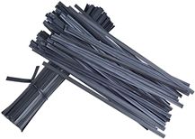
Picture 3: Twist ties

4. Needle-Nosed Pliers
This tool is specially used to cut any excess cable from the PC (Picture 4). It is beneficial when inserting or removing jumpers off from the hard drive or motherboard. Without pliers, it would be harder for one to fix and neat the wiring in the PC.
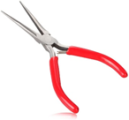
Picture 4: Needle-Nosed Pliers

5. Thermal Paste
It functions to improve the PC’s thermal efficiency by applying the mixture to the area where the processor comes into contact with the heat sink (Picture 5 and 6). Unless the PC itself has a built-in heat sink compound, the thermal paste will be optional.
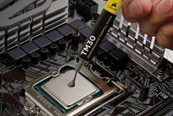
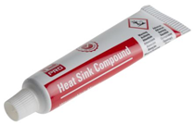

Picture 5: Thermal paste Picture 6: Applying thermal paste to the processor
PART B

1.0 Sketch of a motherboard layout

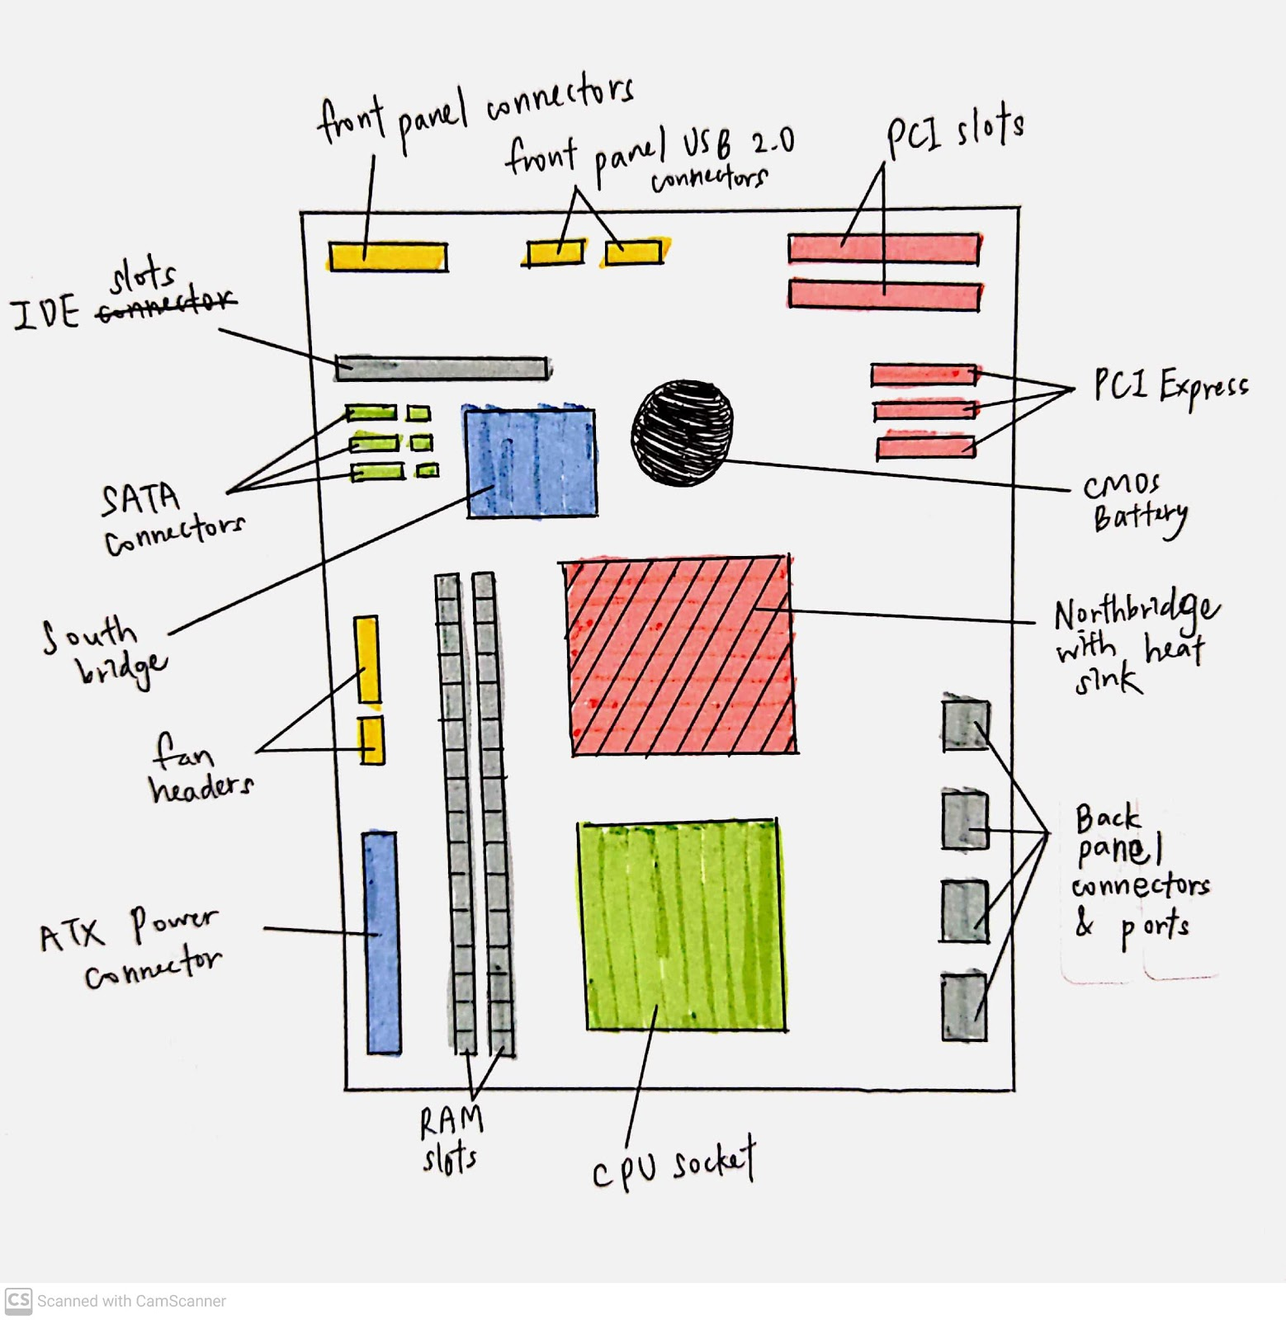

Picture 7: Motherboard layout

2.0 Provide picture(s), explanations of its functions and example of models.

Keywords | Descriptions
1. Graphic card | Functions:  Graphic cards collect binary data and translate the data into graphic and images we see. The processor for graphic cards is GPU or graphical processing unit. The motherboard and monitor are both connected to graphic card. Then the card will receive data from CPU and output to monitor.  Example of models:  - Nvidia GeForce GTX 1660 Ti  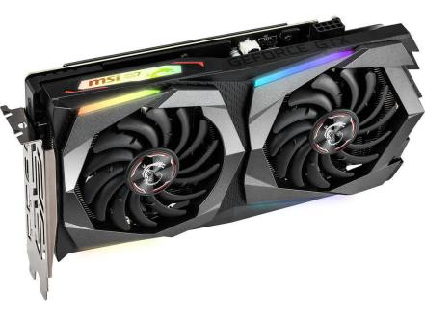  - AMD Radeon VII  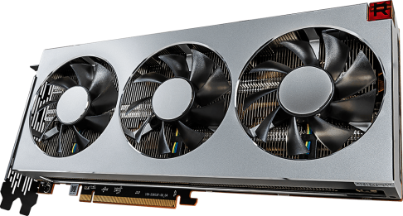
2. CPU / Processor | Functions:  CPU (Central processing unit) or processor runs and executes instructions after receiving signals from different part of components. The CPU inside contains a quartz clock in which its main task is to output tiny pulses of electricity at regular intervals. Every time it ticks the CPU will process a piece of data or carries out an instruction. For example, the CPU with clock speed of 5GHz can process five thousand million data per second.  Example of models:  - AMD Ryzen 5 5600x  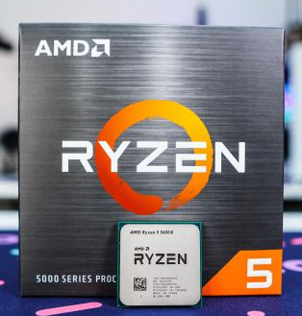  - Intel Core i5-10600K  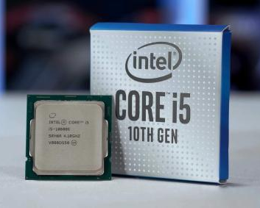
3. Heat sink  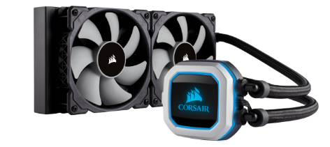 | Functions:  Heat sink provides cooling function by increases the heat flow around the CPU so that can prevent CPU from overheating. There is a thermal conductor in heat sink that carries the heat away from CPU into fins that has a large surface area. Thus, heat is successfully dispersed to surrounding air.  Example of models:  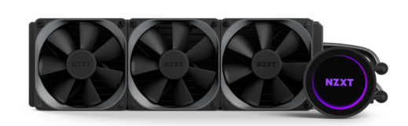  - NZXT Kraken X72  - Corsair H100i Pro
4. CD ROM | Functions:  CD ROM functions when a laser is emitted and reflected to the bottom of the CD. The photo detector will then read the reflected light pulses. The microprocessor will decode these incoming pulses and send the processed data to the rest of computer parts to be used. CD ROM is commonly used for data reading, software installation and music playback.  Example of models:  - LG Electronics Ultra Slim DVD Drive (GP65NB60)  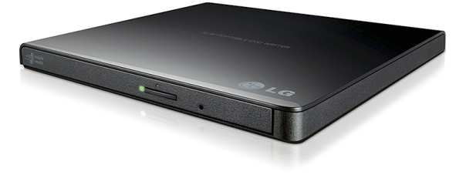  - Pioneer BDR-XD05B  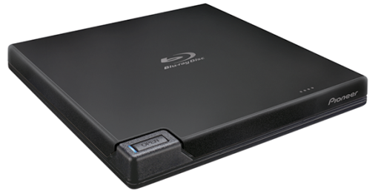
5. USB cable | Functions:  USB cables (Universal Serial Bus) functions by connecting electronic devices to a computer. They can be connected into a free socket and run smoothly. USB cables also carry signals and power, thus they can recharge batteries of small electronic devices and other USB peripherals.  Example of models:  - Anker Powerline USB-C to USB 3.0 Cable  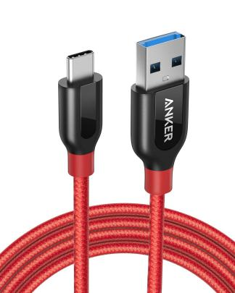  - Aukey USB-C to USB-C Right Angle Cable 2-Pack  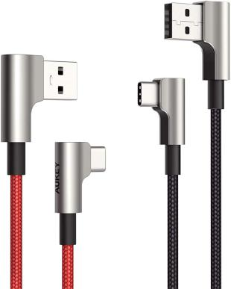  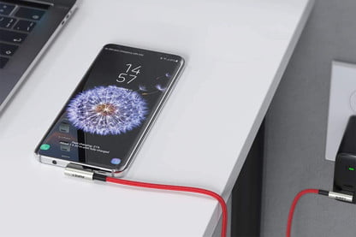
6. Slots (IDE / PC) | Functions:  Slots can also be known as bus slot or expansion port. Their main usage is to acts as computer hardware expansion by providing expansion slot so that can add an adapter. It has rules to control number of bits being transferred at one time to the adapter. They usually are installed at the motherboard.  Example of models:  -The IDE slots that are usually attached to the motherboard.  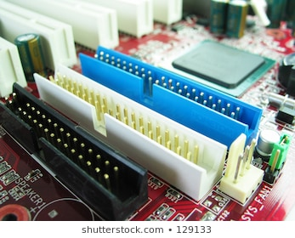
7. RAM | Functions:  RAM (Random Access Memory) provides temporary storage for programs that are running. It stores the information so that they can be used immediately.  Example of models:  - Corsair Vengeance LED  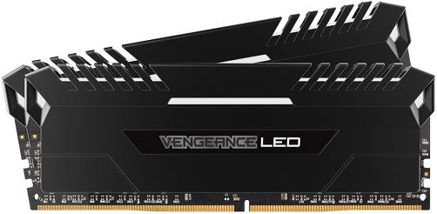  - Kingston HyperX Predator  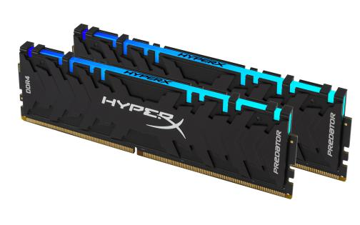
8. SATA cable | Functions:  SATA cables are used to transfer data between two hard drives or ATA and ATAPI devices at high rates. SATA cables primary purpose is to connect motherboard and internal hard drive. Besides, eSATA cable which has the same function of USB cable can connect the computer externally.  Example of models:  - Monoprice SATA III 6.0 Gbps Cable with Locking Latch and 90-Degree Plug  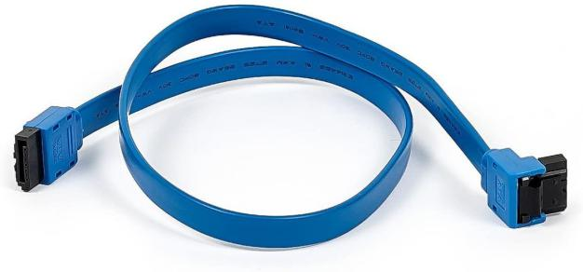  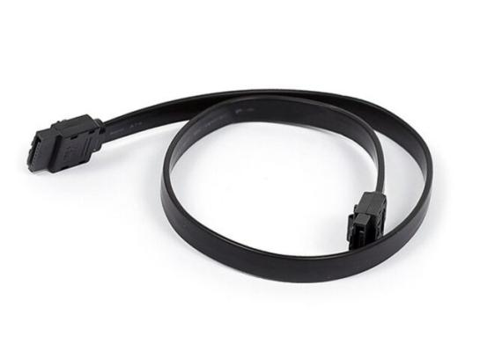  - SATA 6Gbps Cable with Locking Latch
9. IDE cable | Functions:  IDE cable (Integrated Drive Electronics) is a standard type of connection that connects the motherboard to storage device. Generally, it is used to connect between hard drives and optical drives and to the motherboard.  Example of models:  - StarTech.com IDE66 Dual Drive Ultra ATA IDE Hard Drive Cable  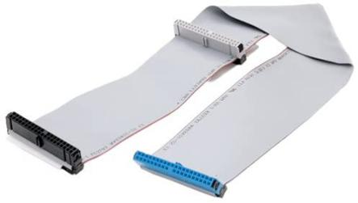  - Goobay 50670 HDD IDE Cable for Ultra ATA Hard Drives with max  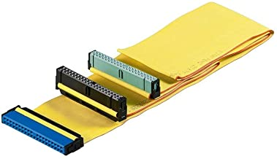
10. Power supply | Functions:  Power supply converts main AC to DC power which is to supply low voltage regulated electricity in order to run the internal components of computer.  Example of models:  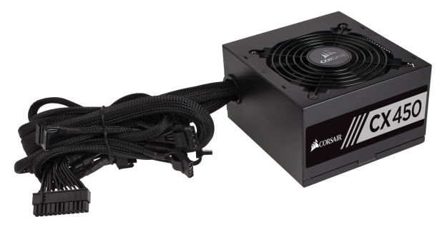  - Corsair CX450  - Corsair RM550x  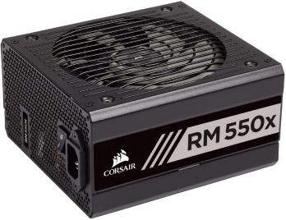
11. Hard disk (jumper setting either master/slave) | Functions:  Hard disk is a non-volatile device that is used to store and retrieve data by using magnetic storage. It is connected directly to the disk controller of motherboard. It comes along with one or more platters that are coated with magnetic material. The platters will then spin rapidly over the data so that data can be collected on the platters.  Example of models:  - Seagate BarraCuda  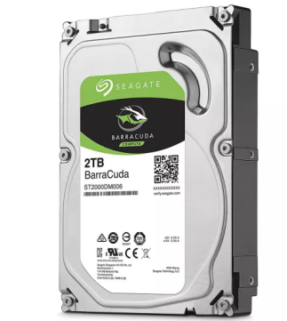  -Toshiba X300  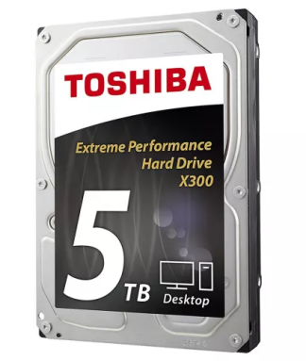

PART C

For part C, all of the pictures are taken from https://www.build-gaming-computers.com/how-to-assemble-a-pc.html

- Inserting Processor onto motherboard

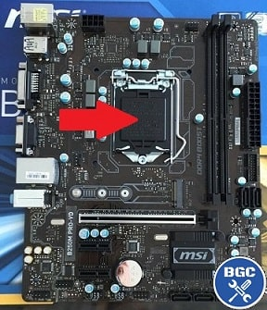 | Locate the CPU socket. It is a large square socket somewhere on the middle of the motherboard
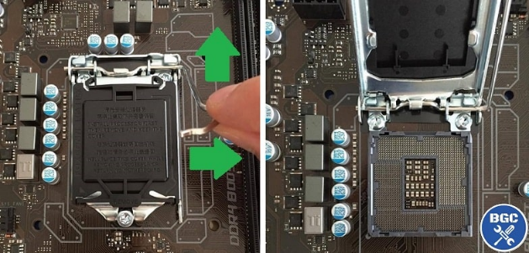 | Open the CPU socket. Lift up the retention arm which is a metal lever on the side of the socket.
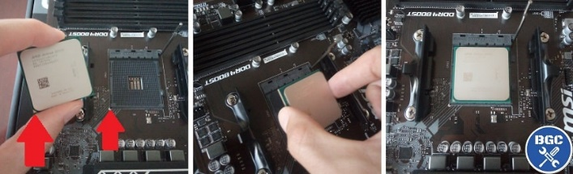  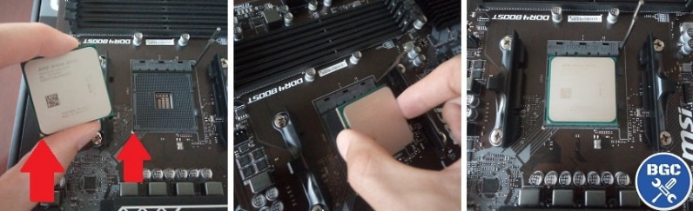 | There is a mark on the bottom left of both the CPU and the socket to make sure it is the right alignment. Make sure both marks are on the bottom left. Grab your CPU but do not touch the bottom part of it and avoid touching the top as well because it is where your thermal paste will be. Lower the CPU into the socket it will effortlessly sit into place unless it is not aligned the correct way and NEVER drop your CPU.
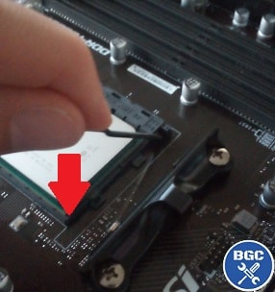 | Then, lock the CPU socket by lowering the lever/retention arm back into its original place.
- Mounting heatsink and fan on motherboard

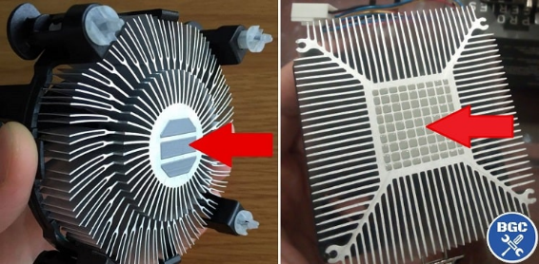  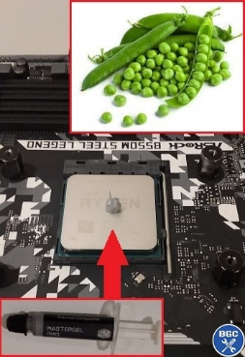 | Most stock cooler already come with thermal paste pre-applied to the underside of the cooler as you can see on the picture. But if you are using a fan that does not come with pre-applied thermal paste, you need to apply it yourself.  Squeeze out the paste onto the middle of the CPU until the paste is the size of a green pea. Do NOT spread the paste out.
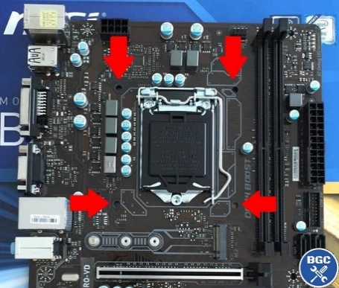 | Pick up your fan and lower your fan onto the top of your CPU lining up the four corners with the four holes on the motherboard.
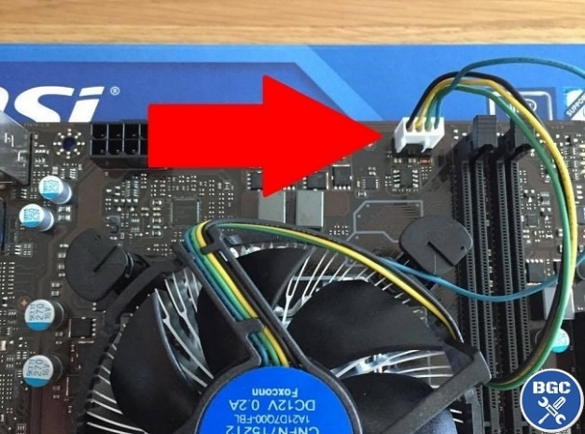 | To lock the fan in place, push down on each of four corners until a clicking sound is heard. Try to gently lift the fan out of its place to see if it’s nice and firmly locked in.
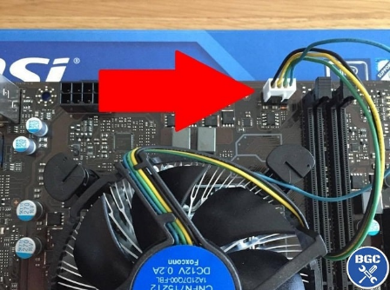 | Connect the fan cable to the four pin connector on the motherboard which is labelled “CPU_FAN” or something similar. Avoid having the fan cable lay across the fan as it could jam the fan.

- Inserting RAM into motherboard

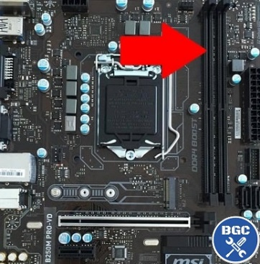 | Locate the slot for RAM modules which is called the DIMM(Dual Inline Memory Module) slots. The first slot should be the first one to be filled which is labelled “DIMMA1” on the motherboard.
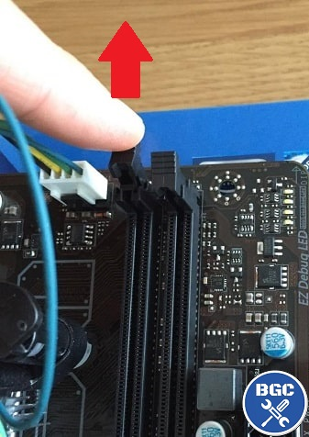 | Unlock a small clip(or two) on the motherboard’s memory socket.
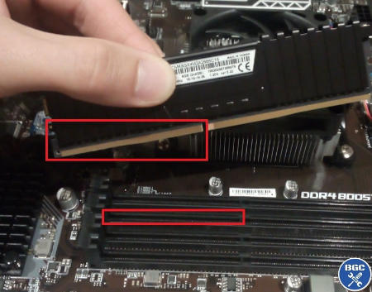 | Match up the bottom connectors on the RAM modules to the cut-outs on the slot.
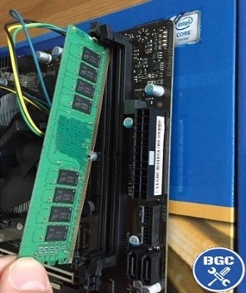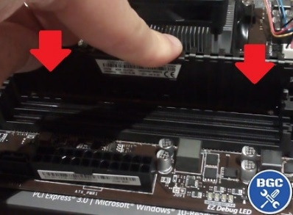 | Gently insert the module into the slot at a slight angle. Then lower the other end in and push the stick firmly into place by pressing down on top of the module and it will automatically snap the clip back into place.

- Mounting motherboard into case

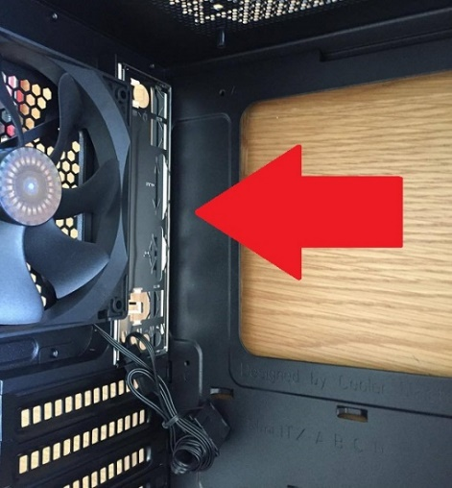 | Install the motherboard IO shield in the case. It will only fit one way around, most motherboards it’s with the mouse and keyboard connections on top and audio ports on the bottom of the plate.  Push on all 4 corners until you hear it snap into place.  Make sure it is properly fitter, give it a slight push from outside of your case to get a feel.
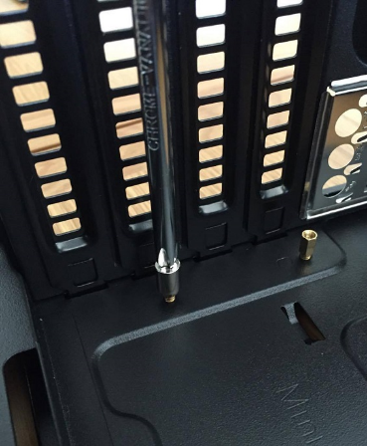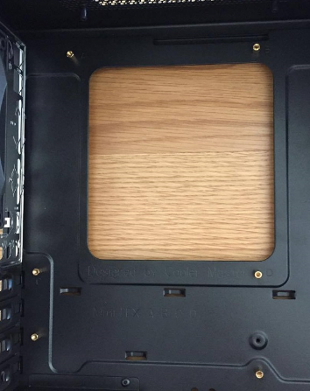 | Install your standoffs in your case. Screw all of them into your case. Make sure each standoff has been installed for your motherboard.
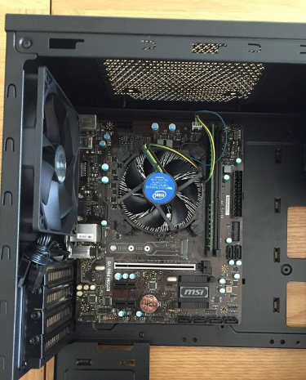 | Lower the motherboard onto the standoff while aligning it with the IO shield. Make sure your motherboard is in the correct way in the case.
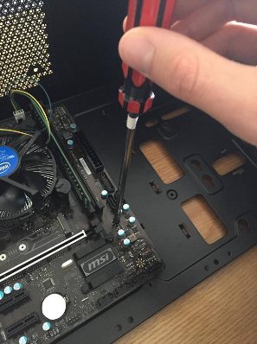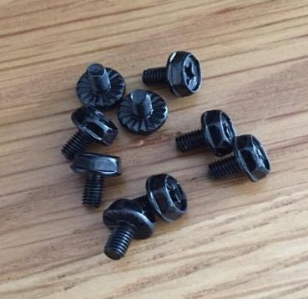 | Put your screws through the standoff and tighten them securely but not too tight as it could damage your motherboard.

- Mounting graphic card

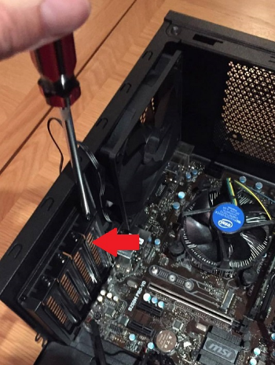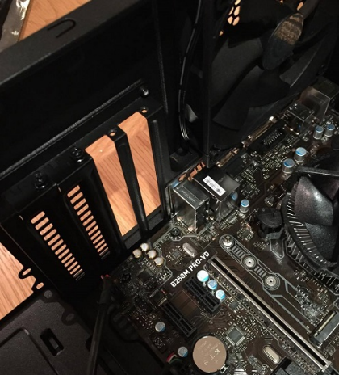 | Remove case expansion bracket. Depending on how big or wide your graphics card is, you will need to remove either one or two rear metal brackets.  You do this by unscrewing them.
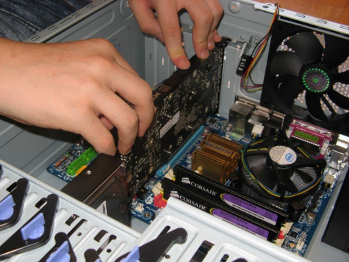 | Align your graphics card with the back of the case in the proper position, then carefully inserting the bottom of the card into the PCIe/PCI socket on the motherboard. Gently press down from the top of the card until you feel it’s firmly in place.
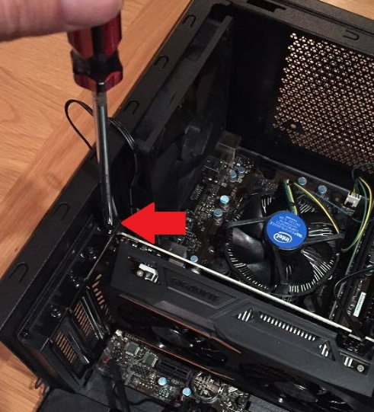 | Re-screw the same screw you removed from the case expansion bracket into the top of the metal brackets to fully secure your graphics card into the case

- Mounting power supply

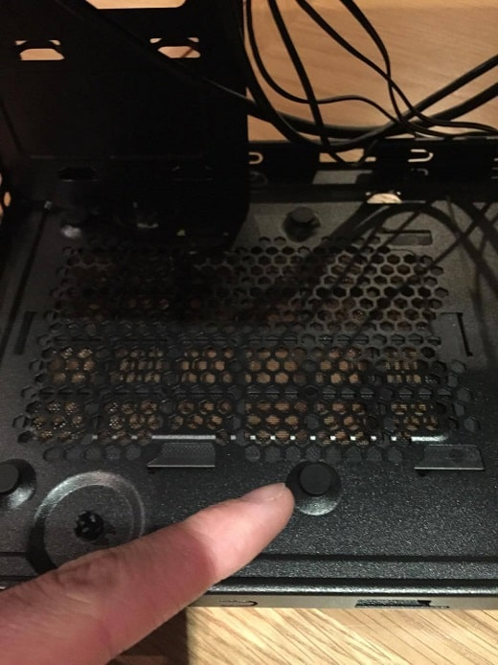 | Check for rubber feet at the bottom of the case.  The rubber feet are there to help reduce the effect from PSU vibration. If there’s no rubber feet to be found at the bottom of the case, it is optional to buy some self-adhesive rubber pads if vibration would be a problem later on.
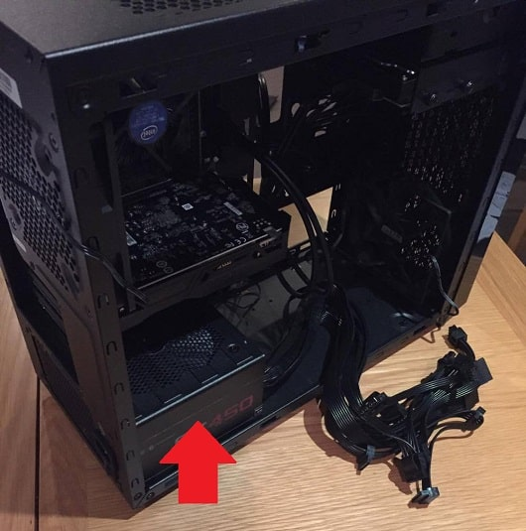 | Fit in the power supply at the bottom of the case.  Make sure the power socket and power switch are facing out the rear of the case while the cable connections are facing inside the case.
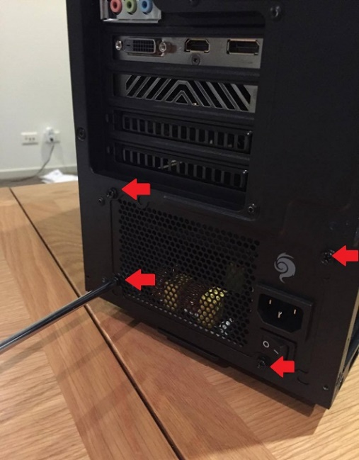 | Screw in the power supply to secure it.  The power supply has to line up with the screw holes on the back of the case. Screw in while holding the power supply firmly in place. Make sure no to screw overly tight as it could damage computer hardware.

- Mounting hard disk drive inside case

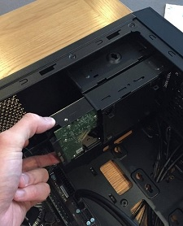 | Slide in the hard disk into the drive/case bay or cage.  Make sure that the connections of the drive are facing the inside of the case.
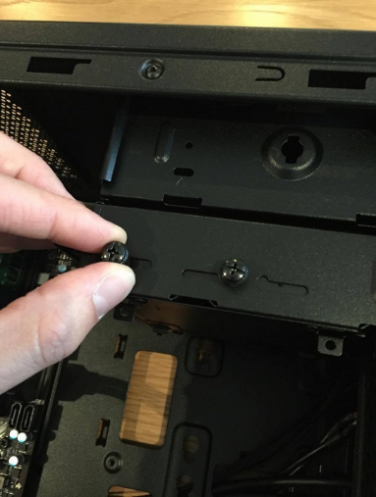 | Screw in the hard drive to secure it.  The hard drive has to line up with the holes in the drive bay or cage. Do not screw overly tight as it could damage the hardware
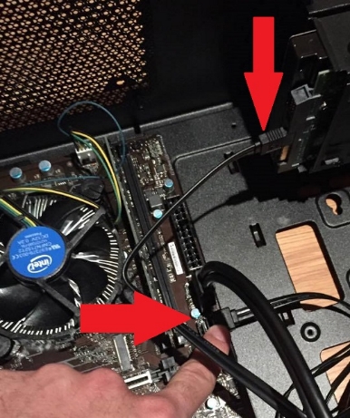 | Connect the hard disk to the motherboard with SATA cable.  The SATA cable must be plugged into the first SATA3 port. Try to thread the cable through a cable management hole in the case (if available).
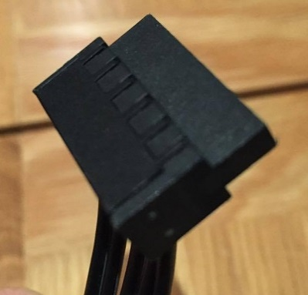 | Connect hard disk to power supply with SATA power connectors.

- Mount optical drive (CD ROM) inside case

 | Remove case front panel (if necessary)
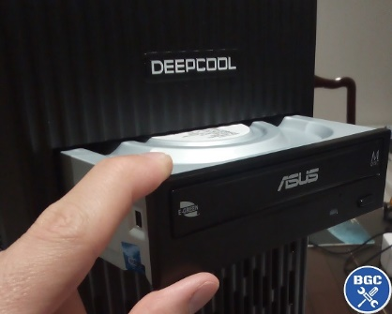 | Slide the optical drive through a 5.25" drive bay from outside.  This could be with the PC upright or lying on its side, depending on whichever is the easiest. The optical drive has to be slid all the way in.
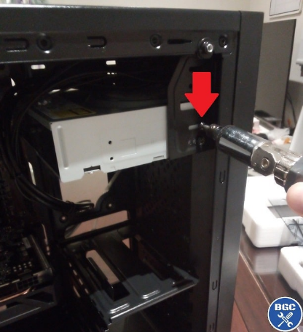 | Screw the optical drive to the case to secure it.  The optical drive has to line up with holes on the case’s drive bay. Make sure not to screw overly tight as that could damage the computer hardware.
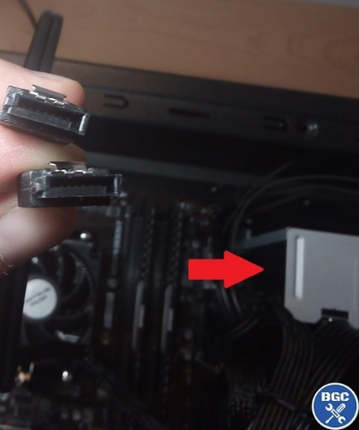 | Connect optical drive to the motherboard with SATA data cable.  The SATA cable should be plugged into the next numbered port after the storage drive (HDD). Try to thread the cable through a cable management hole on the back of the case (if available).
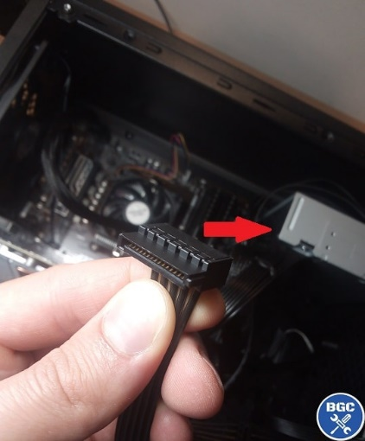 | Connect optical drive to the power supply with SATA power cable

- Connecting the front panel cables to the motherboard

Identify the front panel headers on motherboard.

Make sure to consult the motherboard manual to locate where all the cables need to plug in on the motherboard before connecting the front panel connectors to the motherboard.
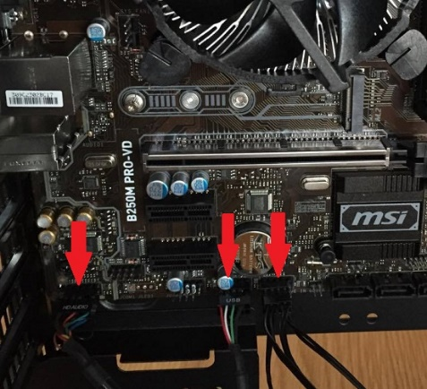 | Connect the front panel cables to motherboard headers.  After identifying the front panel headers and knowing where and what to connect, simply plug in the cables carefully as to not cause any damage through excessive force.

- Closing the case and connecting the peripherals

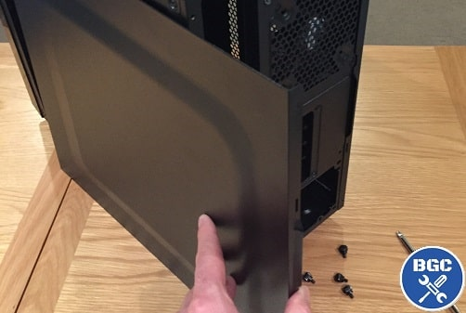 | Place the side cover back on and secure the side panels with case screws.
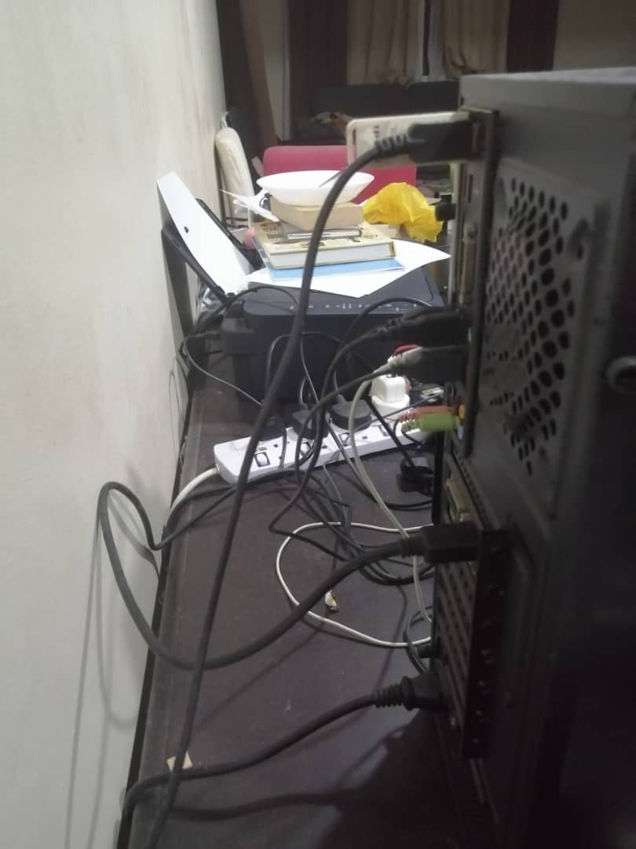 | Connect peripheral devices which include keyboard, mouse, wireless network dongle, printer and webcams with your CPU by plugging into USB port.
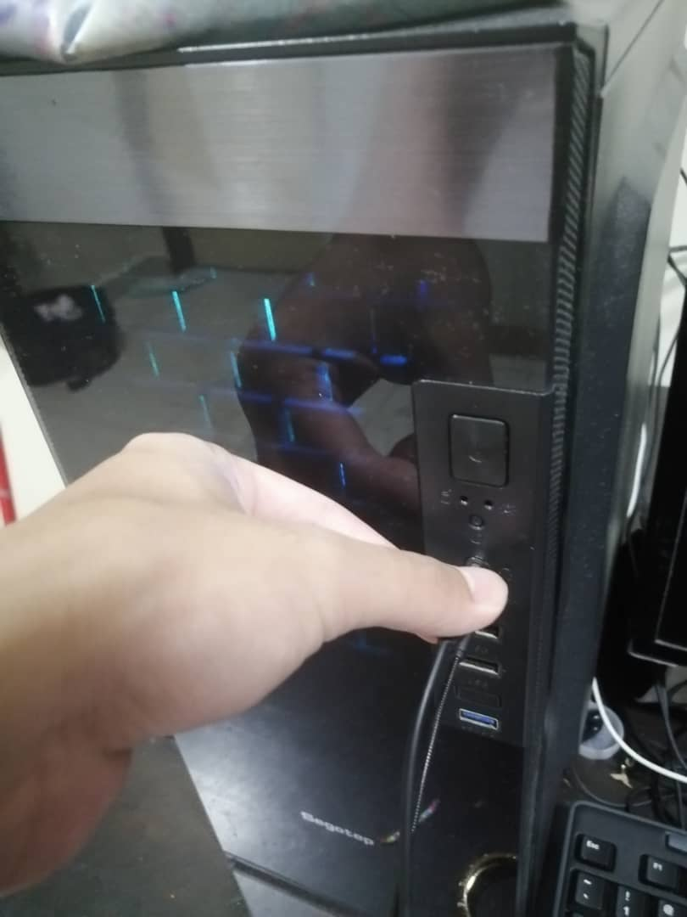 | Then, connect speakers and microphone into 2.5 mm sockets.
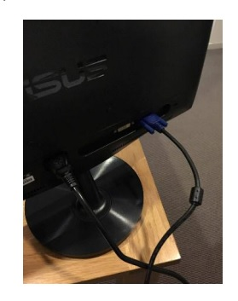 | Finally connect the CPU with monitor by plugging into display ports.

