

SEM 1 20202021 : SECTION 08

Technology and Information System

Course Chapter Assignment
(Presentation)

Chapter 2:

INTERNET, THE WEB AND ELECTRONIC COMMERCE

Group Num# : GROUP 1

Name : 1. Adam Haqiem Bin Abd.Rahim (L)
2. Brendan Dylan Gampa anak Joseph Dusit@Dusit 3. Dzakirin Asyraff Bin Zamsari
4. Eunice Lim Xian Ni

Lecturer : Dr. Zuraini binti Ali Shah

Mind Map
This is the mind map summary of Chapter 2: Internet, The Web and Electronic Commerce

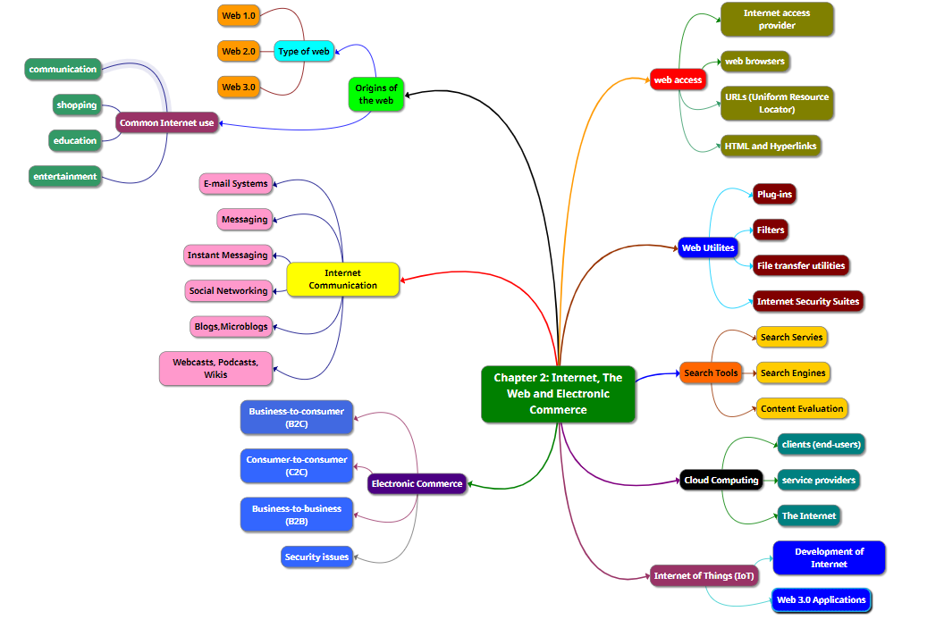

URL YouTube Link for Video Presentation

Here is the URL link for our video presentation:
https://youtu.be/chME0Na1X20

This is the URL link for our chapter slide:
https://docs.google.com/presentation/d/1WIpcF_k9IKhW82fVrtF2pBk01s9pPDbNcUgWm0bbANg/edit?usp=sharing

