

COURSE: TECHNOLOGY AND INFORMATION SYSTEM (SECP)

DESIGN THINKING ASSIGNMENT

MODULE / SECTION | SECP 1513 / 08
ASSIGNMENT TYPE | GROUP
TITLE OF ASSIGNMENT | The Dimenzio
CHAPTER | Chapter 2 : The Internet, the Web and the Electronic Commerce
PREPARED FOR | Dr. Zuraini Binti Ali Shah
PREPARED BY (GROUP 1) | - Adam Haqiem Bin Abd.Rahim (L)
PREPARED BY (GROUP 1) | - Brendan Dylan Gampa Anak Joseph Dusit @ Dusit
PREPARED BY (GROUP 1) | - Dzakirin Asyraff Bin Zamsari
PREPARED BY (GROUP 1) | - Eunice Lim Xian Ni
DUE DATE | 15/11/2020

YouTube Link: https://www.youtube.com/watch?v=IAIZ7EihKMQ&feature=youtu.be

TABLE OF CONTENTS

1. ABSTRACT 1
2. INTRODUCTION 2
3. PROBLEM BACKGROUND 3
4. METHODOLOGY
4.1 THE DESIGN THINKING PROCESS
4.1.1 EMPATIZE 4
4.1.2 IDEATE 5
4.1.3 PROTOTYPE 7
4.1.4 TEST 8
4.2 TASK ASSIGNMENT 9
5. THE PROPOSED SOLUTION
5.1 ACKNOWLEDGEMENT OF SIMILAR PRODUCT 11
5.2 FEATURES OF PROPOSED SOLUTION 12
5.3 USERS FEEDBACK 13
5.4 FUTURE WORKS AND IMPROVEMENTS 14
6. REFLECTIONS AND CONCLUSIONS 15

ABSTRACT

Apparel sizing error has caused an amount of lost in online businesses. Therefore, we decided to conduct a project that can aid the manufacturers and sellers in solving this problem by applying what we had learnt from this course. Hence, we created a prototype by surveying the interviewee’ issues in online shopping and analyzed their comments. The finished prototype was tested with our interviewees to see their response. By using their feedback, we strategized a plan to marketize the product by analyzing its advantages, disadvantages, opportunities, and threats to different group ages. Thus, we believe that our prototype will make such an impact especially in e-commerce.

INTRODUCTION

E-commerce is the abbreviation of “electronic commerce” which describes the buying and selling of goods on the internet. Sellers will display their products on a site which acts as a platform for promoting goods and services to buyers. The most popular ones are Shopee, Lazada and Taobao. Over the last decades, e-commerce sales have been increasing rapidly as compare to physical retail store. Forward-thinking online merchants begin to foresee the opportunities available in online shopping and are making their way into the world of e-commerce. To survive in this competitive virtual market, they have to unleash the most innovative way to attract customers via online. One of the ways is to focus on understanding different generations, especially Millennials and Generation Z as they consist the largest population among online shoppers. Hence, online retailers have to fully optimise and cater these customers. Dynamic contents have to be delivered in order to attract young customers and provide them a wholesome enjoyable shopping experience.

PROBLEM BACKGROUND

The online fashion market is experiencing an unprecedented growth these days. Most of the people now opt for purchasing fashion items online due to its various benefits. In online shopping, a plethora of choices of clothes can easily be found by customers with just one simple click of button on the search bar. It is so convenient that people also can compare the prices of specific clothing from different online stores anytime.

However, it appears that this stigma has been keeping this niche market from growing to its peak.

Below Table 1 are the problem statements as follow:

Problems | Descriptions
- The inaccuracy of sizes and measurements in apparels | It is a common problem and should be solvable, yet they persist. Many customers unable to wear their newly bought clothes comfortably and appropriately due to sizing error.
- The quality of clothes is not the same as in description | Customer reviews can only provide the people assurance but are not always reliable because there are no guarantees that the quality of apparels they bought online would be at its finest. Customers are still afraid that the clothes would turn out not as accurately portrayed as in description. It might be due to some selfish sellers who are trying to cut material costs and used a low quality and cheaper fabric instead.
Table 1: Problem statements

DESIGN THINKING PROCESS

EMPATHISE

Our group has conducted an interview session through Google Meet with three consumers who are believed to be actively involved in online shopping. We have provided two questions that needed to be answered by them based on their experience.

Below Table 2 are the questions that answered by interviewees:

No | Questions
1 | As a consumer or seller, what are the problems you faced when purchasing or selling products online?
2 | Are you mostly satisfied with the items you bought online?
Table 2: Questions that were answered by interviewees
The first interviewee is 19-year-old Shalom Seng Jing Er from Tawau, Sabah. She mentioned that her usual problems when buying online is mainly towards the authenticity of products bought. She can hardly recognise the materials viewed on the shopping website as well as determine the right size of her desired apparels. Other than that, she stated some measurements are different from the one she saw in the seller’s description. Thus, she believed that the sellers only put the original picture of their products as it ended up giving her a fake one.
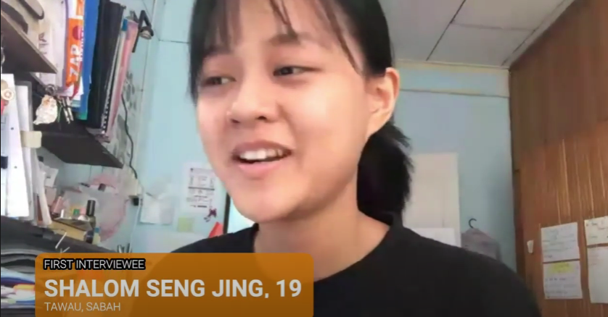
Picture 1: First Interviewee
Next, our second interviewee is 19-year-old Muhammad Nafis from Kajang, Selangor. He also agreed with Shalom’s point about the material shown by seller. Moreover, he added his dissatisfaction towards the seller’s clumsiness for not updating their stocks in the shopping website. As a result, when he paid the seller, they informed him that the product he ordered is out of stock. For most of the items arriving at him, he mentioned that the items do not meet his expectation since it is different from the one displayed on the website.

Picture 2: Second Interviewee
Our third interviewee is 19-year-old Phoebe Dolores Dora from Kuching, Sarawak. During the interview, she is mostly satisfied with the products she bought online. This is because the items’ price in shopping website is slightly lower than the one, she usually saw in the store. Her only worries are the parcels might be damaged upon arriving at her as well as the expensive shipping cost. In overall, she is mostly satisfied and have no issues with the sellers.

Picture 3: Third Interviewee
Throughout this interview session, we noticed that none of our interviewees mentioned their problems as a seller. However, that does not affect our research since we have detected one critical issue which is the inaccuracy of size and measurement of the apparels.

IDEATE

On 1st November 2020, we conducted an in-depth meeting through Discord to brainstorm and discuss ideas that may become our project prototype. All of us took turns to propose our ideas to the members based on the problem stated. Each of us had given our own creative ideas on how to tackle the problem:

Below Table 3 shows the problem and the members’ respective solutions:

Problem | Suggestions
The inaccuracy of sizes and measurements in apparels | - A handheld mini scanner that acts as an electronic measuring tape
The inaccuracy of sizes and measurements in apparels | - A mobile application that is used to detect authenticity of items
The inaccuracy of sizes and measurements in apparels | - A pair of spectacles that can measure a specific part of clothes through the lenses
The inaccuracy of sizes and measurements in apparels | - The Dimenzio, a device that can automatically measure the lengths and sizes of clothes
Table 3: The problem faced and members’ respective solutions

The problem we have decided to tackle on is the inaccuracy of sizes and measurements in apparels as it seemed to be the critical stigma that caused many customers expressing dissatisfications on this online fashion market.

Below Table 4 shows the suggestions and descriptions of prototype:

Suggestions | Descriptions
Handheld mini scanner | Functions  - Acts like an electronic measuring tape.  - When we place the scanner on a piece of cloth and mark the first point, it will automatically set the first marking as “0cm”.  - As we mark the second point, the scanner will help us to measure the length between first marking and second marking.  Drawbacks  The scanner must be held 90º from the surface in order to scan accurately. It means that parallax error might happen when scanning.
Mobile app that can detect authenticity of items | Functions  - Acts like a mini scanner  - When users place the scanner close to the logo of a certain fashion brand, it will detect immediately whether it is a counterfeit product or an authentic brand. - Can take pictures of a specific fashion product and the app will help to calculate the raw materials that made up of this product.  Drawbacks  Does not solve the problem of inaccuracy of sizes and measurements of apparels which encountered by online shoppers.
A pair of eyeglasses that can measure a specific part of clothes | Functions  - Applies scanning technology  - Turn on automatically the moment a user wears it and scans the image that goes through the lenses.  - Help to calculate the measurement of clothing and later displays the measurements on the lenses.  Drawbacks  Since it’s a complicated device, it may be bulky which could be uncomfortable for the user to wear. Besides, everyone has their own suitable frame size and shape for spectacles, thus it makes it harder to create a general frame size and shape for everyone.
The Dimenzio - a device that can automatically measure the lengths and sizes of clothes | Functions  - It functions when users hang the apparel on top of a bar. There will be two sliders attached on the bar that will read the lengths and height of the apparel.  - Each slider have scanner where each of them will measure the length of a specific part.  - Has a LED monitor fixed at the bar facing the users. Customers who are buying clothes online then can read the sizes of apparel very accurately and precisely.  - Useful and practical to online fashion retailers as it may help to improve their online businesses.
Table 4: The suggestions and descriptions of prototype:

At the end of our brainstorming process, we decided to go with the fourth idea. This is because the fourth idea seemed to be the most effective prototype that can solve the inaccuracy of sizes and measurements in apparels.

PROTOTYPE

Before we started building our prototype, we had to decide what kind of approach and which materials will be the best. We further discussed and came up a few ideas.

Below Table 5 is the ideas to build the prototype:

No | Ideas
1 | Using desktop application to design and create the 3D model
2 | Using cardboards and other recycled materials
Table 5: Ideas to build the prototype:

Our final decision was to use the cardboard and other recycled materials as we were not familiar with the designing software that are used to design and create 3D models in desktop. Since the pandemic was still ongoing and spreading rampantly, unfortunately we were unable to meet each other to build the protoype together. Hence, Dzakirin Asyraff was assigned to create the prototype and it was named The Dimenzio.

The concept of The Dimenzio was based on the design of vernier calliper as well as barcode scanner. Firstly, Dzakirin Asyraff sketched the prototype layout using Adobe Photoshop. Below Picture 1 is the sketch for prototype layout.
He then proceeded in preparing the materials which were few pieces of cardboards and piece of white plain paper. The rectangles that were cut out from cardboards were glued together as seen in Picture 1. They will represent the Dimenzio’s bar. The square-sized white paper pasted at the right corner of bar will represent the LED screen that can display the accurate measurement of apparels. Since this is a prototype, we also decided to create it in 2D form but not 3D.
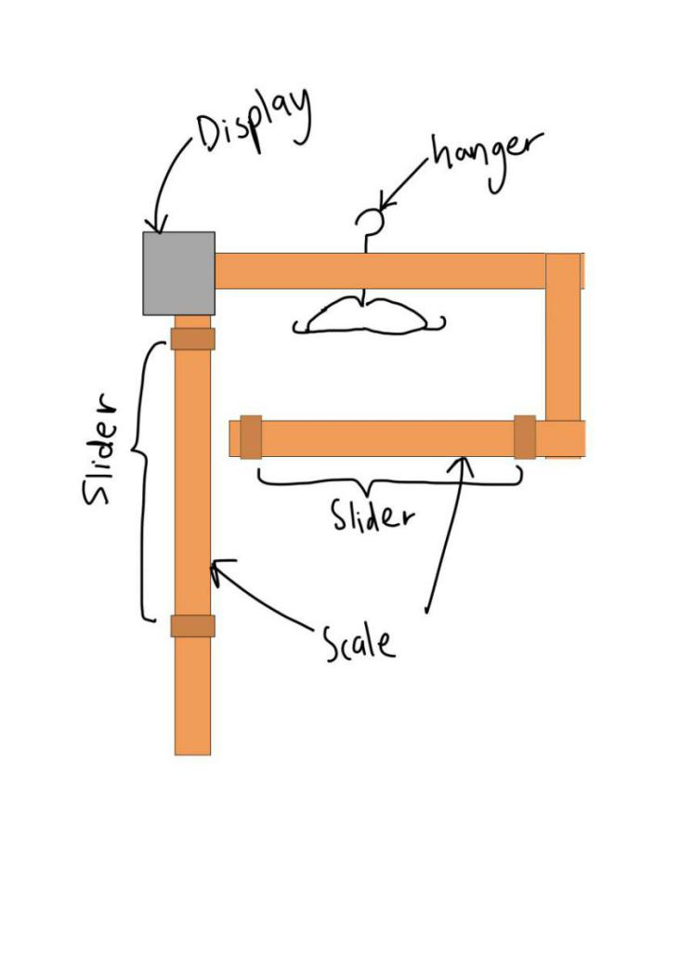

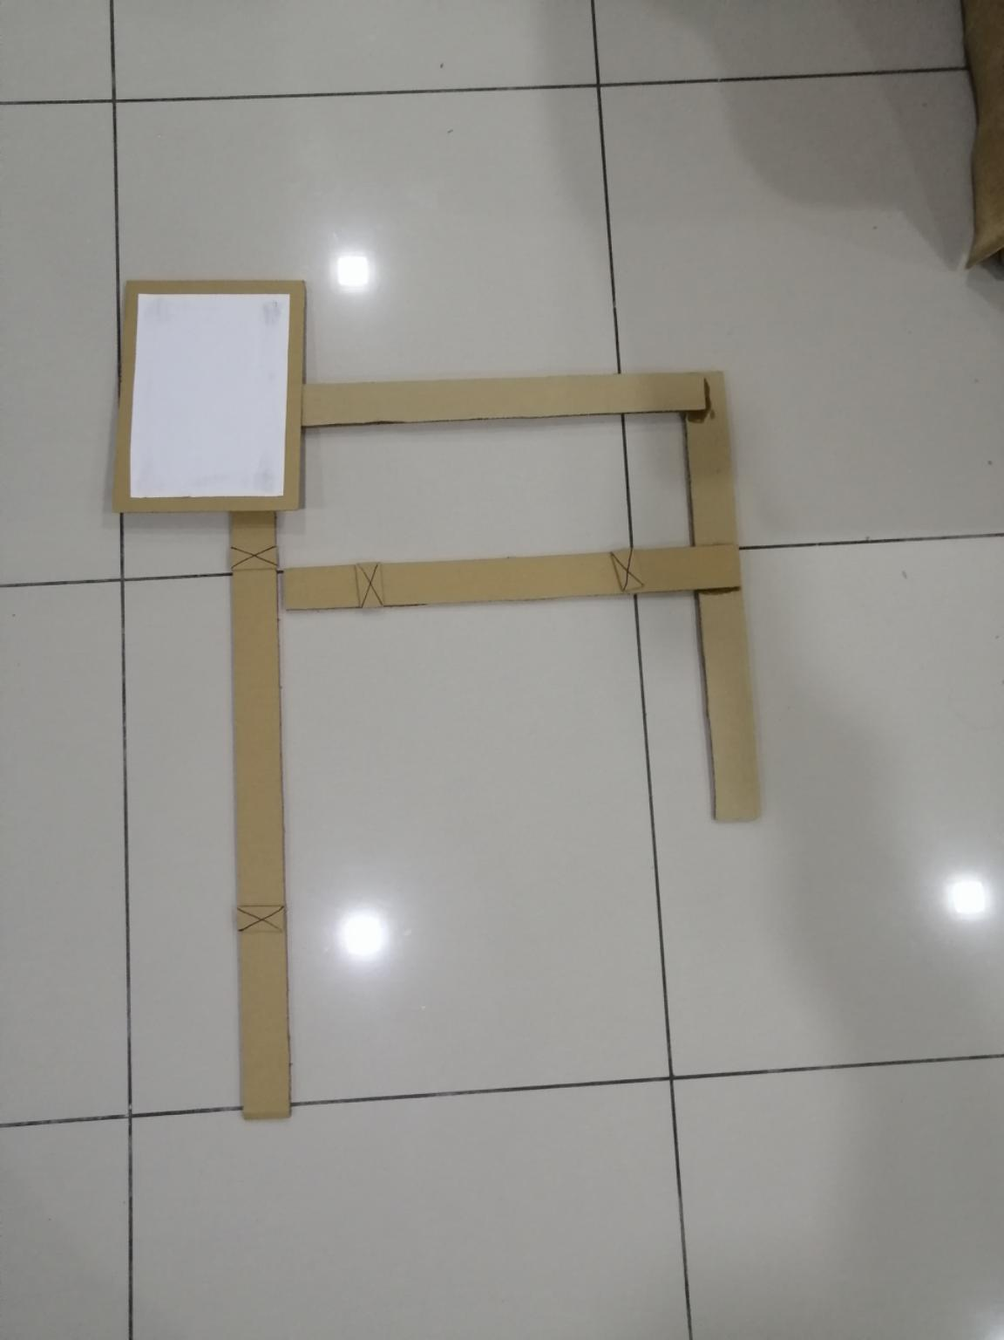

Picture 4: Sketching Prototype layout Picture 5: Actual Prototype

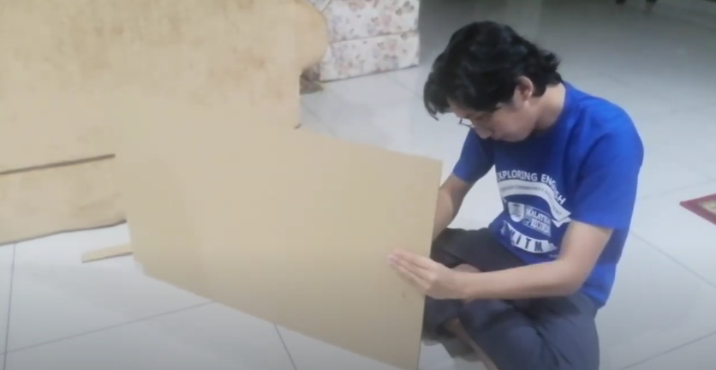

Picture 6: Building Prototype

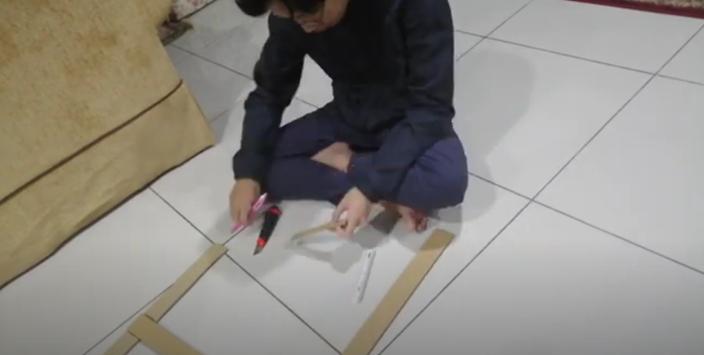

Picture 7: Building Prototype

TEST

There are 2 ways to use this product, horizontally and vertically. The testing used horizontal method by laying down the clothing item first before the product on top of it. The difference with vertical method would be to hang the product and the clothing item from a hanger. The following step would be the same for both method, which is the measuring part. This is done by sliding all of the slider to its correct place corresponding to the clothing item. The up and down slider should be slidable to measure the length meanwhile the left and right slider are used to measure the width. After everything is set, the display screen will show the final measurement in cm as an output for the user.

Below Picture 8 - 15 are prototype demonstrations:

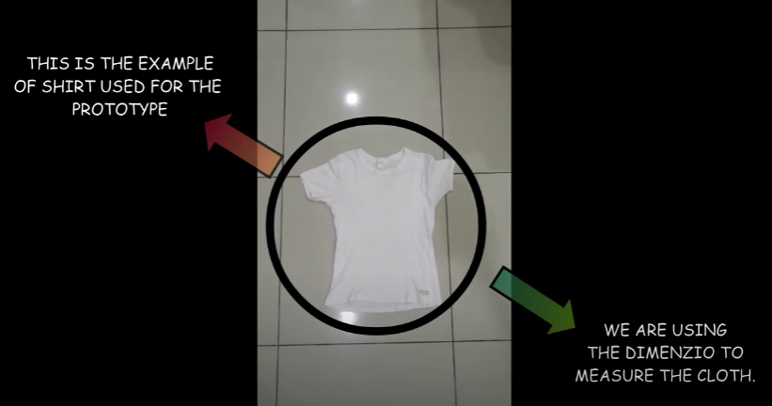
Picture 8: First step

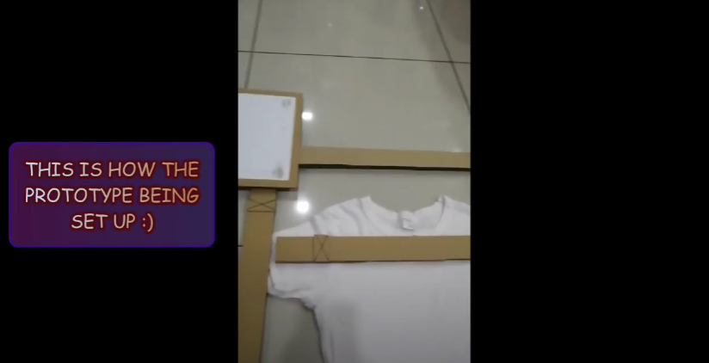
Picture 9: Second step

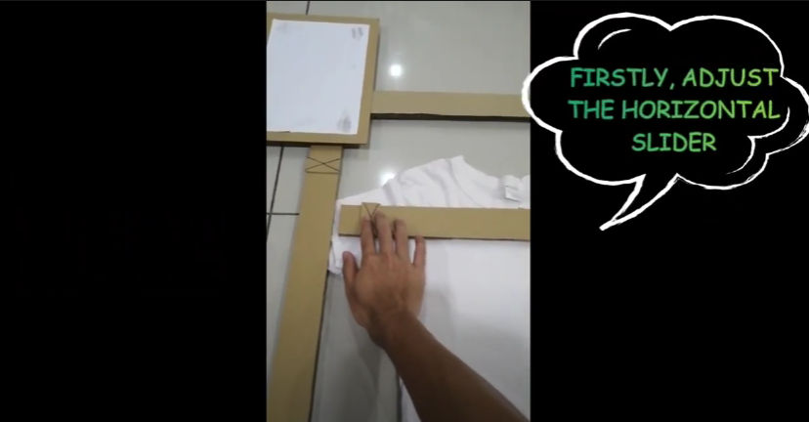
Picture 10: Third step

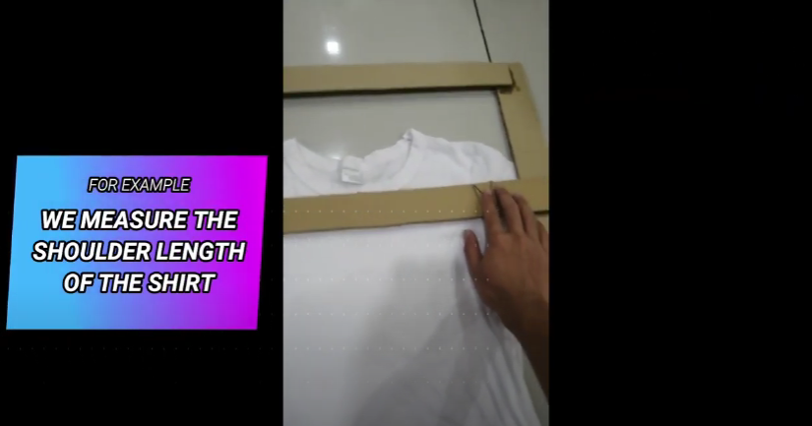
Picture 11: Fourth step

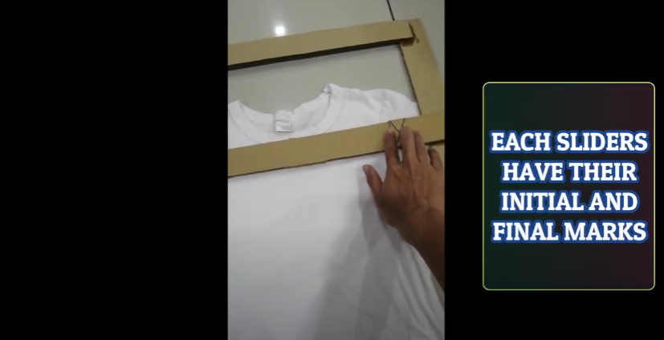
Picture 12: Fifth step

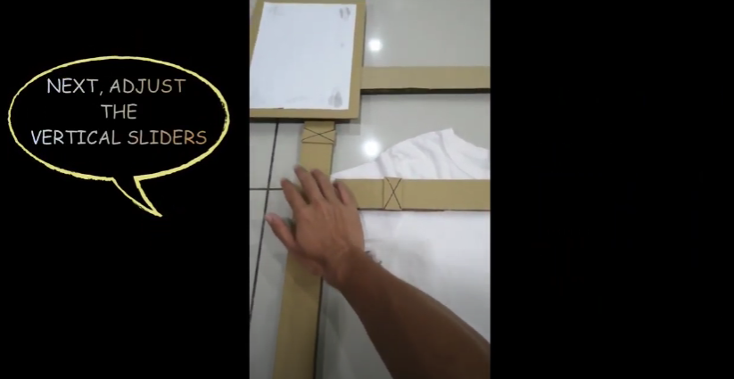
Picture 13: Sixth step

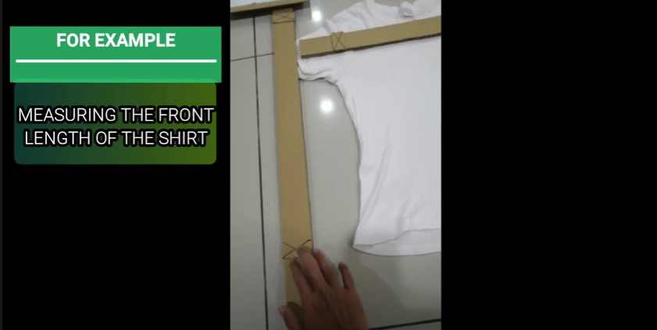
Picture 14: Seventh step

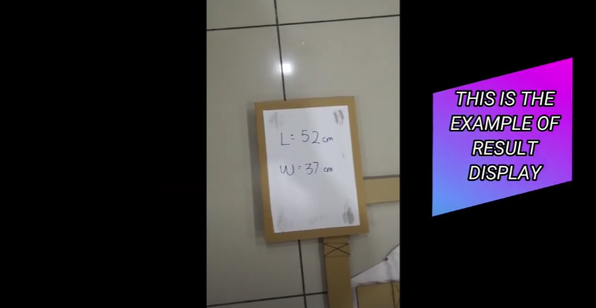
Picture 15: Eighth step

TASK ASSIGNMENTS

With the ongoing Covid-19 pandemic in Malaysia, our movements are strictly inhibited thus we are forced to stay home while completing this project. With that being said, our meetings and interviews were all conducted online.

Below Table 6 showing the tasks assigned to each member:

Names | Task Assigned
- Adam Haqiem Bin Abd.Rahim (L) | - Make sure members are working accordingly  - Mark attendance during each meeting  - Help out in writing report
- Brendan Dylan Gampa Anak Joseph  Dusit @ Dusit | - Record the meeting sessions  - Compile the videos and edit them using FilmoraWondershare  - Help out in write report
- Dzakirin Asyraff Bin Zamsari | - Create the prototype  - Sketch prototype  - Test the prototype
- Eunice Lim Xian Ni | - Write the report  - Assign tasks to members
Table 6: Task assignments for each member of the group

Our first meeting began on the 27th October 2020 where we met informally through Discord. We introduced ourselves and discussed the topic that we were assigned to present. After that, we decided to have e-commerce as our main theme for the design thinking project. We kept throwing ideas from time to time as we constructed a plan that allows us to detect the problems arose in e-commerce by conducting an interview session with random users.

On 31st October 2020, we held an interview session with our selected users through Google Meet. The assigned member who are in-charged of this meeting had given them the questions a night before to allow them to prepare for their own respective answers. Another reason we did this is to ensure that the session went smoothly. During the session, we met and greeted among one another as we mentioned our purpose organizing the interview with them. All three of our interviewees managed to answer our targeted questions successfully as we also added side question asking on their preferred shopping website.

Moving on to our next activity, we held an in-depth discussion by analysing the problems faced by our users the next day which was on 1st November 2020 via Discord. During that session, we proposed a few ideas that might potentially become our prototype for the project based on Table 2. At the end of our discussion, we finally made up our mind by creating a prototype proposed by Dzakirin Asyraff which is The Dimenzio, a tall and sturdy device that will auto-measure the sizes and lengths of attires by hanging them.

Once the prototype layout had decided, Dzakirin began to focus on building it. He prepared the materials, measured them and cut out all the wanted sizes from the cardboard and glued them together. He also drew on the cardboard using black marker so that some important parts can stand out. While building the prototype, Dzakirin had recorded the whole process and later sent to Brendan to be edited. On 9th November 2020, he sent us the link of videos and photos. Later, all the members proceeded to write the report, compile, and edit the videos.



Picture 16: Discussing Task Assignments and Questions for Interviewees


Picture 17: Discussing Prototype


Picture 18: Reviewing Prototype

THE PROPOSED SOLUTION

ACKNOWLEDGEMENT OF SIMILAR PRODUCT

The Dimenzio is invented by combining several basic products that we used to see in our daily life which are vernier calliper and barcode. These two devices have given a massive impact to the humanity as well as overcoming our limitation.

Firstly, vernier calliper is considered one of the tools with high sensitivity when measuring an item. It has an upper scale that can measure minimum of 1 mm while the lower scales with minimum of 0.1 mm. The sensitivity itself is good enough to proof that it can measure small objects accurately with low syntax errors. In order to apply the same concept with our prototype, we will ensure that the slider has a minimum value of 0.1 for any units depends on the length of the apparels. This is to ensure a more accurate result as well as to satisfy our customer’s need when they want to pick their sizes.

Next, barcode scanner is usually been used mainly in supermarkets, shops or any outlets that require one to scan the barcode. The scanner consists of photo conductor that translates optical impulses into electrical energy. Furthermore, the decoder circuit inside a scanner is used to analyse the image data provided as it sends the barcode content into output. Therefore, we apply the same concept to The Dimenzio especially the sliders as they contain the same mechanical function as the barcode scanner. The different is that the prototype are able to scan various cloth materials instead of barcode.

Hence, we believe that The Dimenzio will be well-marketized as we apply the basic feature of vernier calliper and barcode scanner into it.

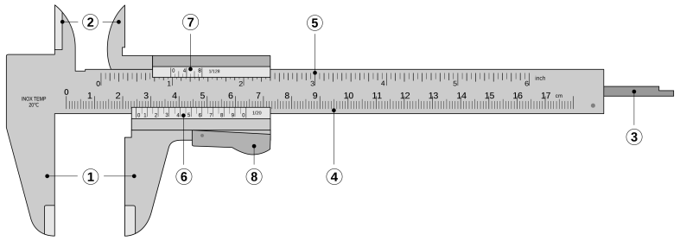

Picture 19: Concept of Prototype - Vernier Calliper

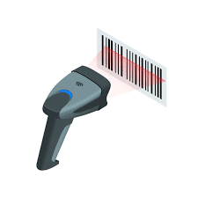

Picture 20: Concept of Prototype - Barcode scanner
FEATURES OF THE PROTOTYPE SOLUTION

It is a device created where users who mostly are online fashion sellers, they can hang their apparels on the bar. One of the Dimenzio’s feature is that there is a LED monitor fixed at the left corner of bar which is used to activate the device, store data, compute the apparels’ measurements and display the measurements on the screen so that buyers can read them and be made clear with the clothes sizing. The LED monitor acts like the “head” as it plays the most important role in running this device.

Another feature of the Dimenzio is it has a scanner on the slider. When the slider is slided across the apparel, the scanner will read the measurements accurately. Then, it will save the data so that can be displayed on the LED screen.

Picture 21: Actual prototype

USERS FEEDBACK

After undergoing several tests with the users, the responses are quite positive. Shalom Seng Jing commented that it really helps to provide a clearer understanding about the apparel’s size. As a buyer, she can now confidently purchase the clothes online without worrying whether the clothes will have measuring errors.

FUTURE WORKS AND IMPROVEMENTS

The future work that can be done to improve the Dimenzio is we can use lightweight, high durability, strong and cheaper cost of materials to build the machinery parts for the Dimenzio. For example, we can use aluminium, carbon alloys or plastics. The Dimenzio is planned to make sure it is lightweight so that users who mostly are online fashion retailers, they can easily move or carry it around. With that being said, we can add wheels on the Dimenzio’s legs to make it be portable. We can also install a pedal to lock all the wheels. It acts as a brake to fix the Dimenzio’s movement. Whenever the user wants to move or adjust the position of the Dimenzio, the user can unlock the pedal and the wheel will function properly again.

Besides, in order to create the Dimenzio to be more user-friendly, its height should be adjustable so that can cater different people with different height. This makes the Dimenzio to be more flexible and allow users to adjust freely the height of Dimenzio to the height they preferred and are comfortable with.

Besides, we can install sound system to the Dimenzio where a mini speaker will be connected to the LED monitor. Thus, users can choose to set the sound system whether they want it to work or they prefer to mute it. This will definitely cater the blind online retailers who are trying to sell clothes online.

Another creative improvement that can be made is we can create different versions of Dimenzio. For example, we can come up with the standard version of Dimenzio which is the cheapest. Thus, it can only carry out basic scanning and measuring. The upgraded version of Dimenzio is where the device looks luxury with addition of sliders and more advanced measurement features that users can experience. The upgraded version of Dimenzio can detect and measure the tiny details of clothes.
REFLECTIONS AND CONCLUSIONS
In a nutshell, I believed that our group has made a massive achievement on producing a prototype through design thinking method. This method is very helpful indeed as it allows every members of the group to brainstorm ideas in the right way. My goal for this program is hoping that there will be more prototypes invented either it is physically or digitally from the young generation. This is very important because new problem always available every day and solutions are required for it.
On the other hand, we also faced a few problems during the process of producing the prototype. Firstly, we are not able to build the prototype together physically due to CMCO (Conditional Movement Control Order) throughout all states in Malaysia. We only met through video conferencing apps when it comes to discussion and brainstorming ideas. This recent pandemic might limit our activity face to face, but this does not affect our motivation as we keep pushing ourselves on progressing for the project. Fortunately, my teammates are able to work together without any issues.
The design thinking method has impacted many aspects of my life. It allows me to construct idea effectively and clearly guiding me to solve the problems. As it is also related to my future career, becoming a software engineer requires a strategic planning on respective project. Without the implementation of design thinking, it would seem to be impossible for one to do their projects with outstanding result.
During the current COVID-19 pandemic, the struggle to find a desired job is getting tougher thus reminding the young generation that they also need to fight for their place in order to survive. Hence, I need to improve myself in terms of soft skill, time management and leadership. These three criteria are the one I need to sharpen and luckily, the design thinking method provides all of them at once. My necessary action to enhance my potential is keep exploring knowledge related to my dream career not just through academic syllabus but informal learning as well.

