

SECP 1513
TECHNOLOGY AND INFORMATION SYSTEM

DESIGN THINKING:
CABLE CARE

LECTURER:
DR AZURAH ABD SAMAH

SUBMITTED BY:
MEK ZHI QING (A20EC0077)
NOR SYAMIRA BINTI ABDULLAH (A20EC0110)
ROHAIZAAZIRA BINTI MOHD ZAWAWI (A20EC0138)
ZEREEN TEO HUEY HUEY (A20EC0173)

SEMESTER 1 2020/2021

CABLE CARE
Team member’s name: Mek Zhi Qing, Nor Syamira binti Abdullah, Rohaizaazira binti Mohd Zawawi, Zereen Teo Huey Huey
School of Computing, Faculty of Engineering
University Teknologi Malaysia, 81310 Skudai,
Johor Bahru, Malaysia.

ABSTRACT
In this era of globalization, the problems that are related to phone cable are often becoming the hot topic among society. Cable Care application represents a solution for addressing access to cable problems. This application will enable the user to detect the lives of their cable. Also, the interview that was conducted shows that there were same problems faced by different users. Indeed, this is the common problems, and they need the solving method to defeat it. These findings support the feasibility of this application in order to ease the users from difficulties that they are facing in daily life.
1.0 INTRODUCTION
Mostly, cables are connected from computer units directly to devices like mobile phones and printers. The main objective of these cables is to transfer data from one device to another. The method of using this cable is connecting one end of it to the mobile phone and another end to the computer. Data transfer usually takes just a few seconds to a few minutes, depending on the size of the data to be transferred or the speed of the computer.
Cables can also be used to connect printer to computer if you want or to print documents directly from the PC. These cables are also useful in connecting mobile phones to the printer. Another function of cables is that they can be used to charge mobile phones. Just connect one of the sides of cable into the right port on the phone and the other end is to be plugged into the PC's USB port.
Since we widely use cable in our daily lives, we must face some problem when using it. For example, the cable broke suddenly, and the charging speed is slow due to the cable. These issues will be the main discussion for our group to provide a solution to the users.
2.0 PROBLEM BACKGROUND
We generally use mobile phones for different path of our life and we likewise required power bank and charging cable if our mobile phone running out battery. Numerous individuals these days purchasing the charging cable through online shopping platform such as Shopee and Lazada and some of them purchasing charging cable at physical shop. But they do not know how long the period of cable can be in good condition.
Most of the interviewees claim that they will buy at least two new cables in half year. They claim when they insert the charger into the phone's charging port their mobile phones cannot be charge. They will start panicking or go into hysteria because the lives of cable charger are short.
3.0 METHODOLOGY
3.1 Empathize
a) Observation
Based on our observations, many people around us always face the same problem which is their cable that used to charge electronic devices such as mobile phones and power bank broke suddenly. Even though they do not use the cable for a long period of time, the cable also broke unexpectedly. This causes them unable to charge the devices and affect their daily routine as mobile phones is an essential thing in daily life. This can be observed by the frequency they buy a new cable.
b) Engage
We also carry out a few interviews to user with different background to understand more about this problem. Most of the interviewees claim that they will buy at least two new cables in half year. They buy the new cable through many different platforms such as online (Shopee) and the physical shop. Most of the user interested in Cable Care as they hope that this can help them to save money and can compare the cable they buy in different platform.
List of Possible Question that we can ask user
1. What is your name and how old are you?
2. How frequently do you buy a new cable?
3. Where do you buy the new cable?
4. Do you facing problem that the cable always broke suddenly?
5. Are you interested if we design a new application regarding to your problem?

c) Immerse
To find out more information, we buy new cables from different platform and test their function in two weeks. Through these 14 days, we found that the new cable we buy through physical shop was still function, but the charging speed becomes slower for the cable we buy from online.
3.2 Define
Based on our observations, engage with the users, and immerse ourselves in the problem. Our group members undergo a series of discussion and list the problem faced by the users. We found out that the main problem is the cable always broke suddenly and this make the users do not have any method to solve the problem at that moment. The high frequency of buying a new cable also caused them to feel burden. The users also cannot decide whether the quality of the new cable they buy online is better than physical store or not.
3.3 Ideate
Our group started to brainstorm idea after knowing the problem and requirement from users. We undergo our discussion about the main function that we would like to have in our Cable Care through Google Meet. Each of us share our idea and list all the function that we think is useful for the users. Then, we choose the idea which we think it is possible to realize in our app through voting from every member. For the designing of app, every group member tries to sketch a few patterns based on the function. We choose the best design by using the same method which is vote. Through these processes, our group able to develop and choose idea smoothly.
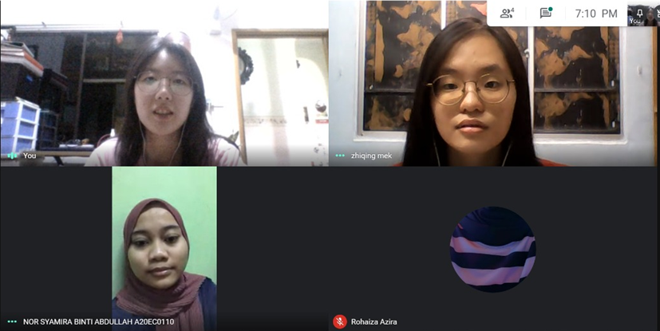
Figure 1: group members undergo discussion through Google Meet.
3.4 Prototype
After deciding the design of the Cable Care, we need to build up a prototype which is to make our ideas into reality. At first, we draw the prototype simply on an A4 paper act as the screen of smartphone. Then, we try to make it better by using the app on tablet to draw so that the users can get a better experience when they try it. We have changed a few prototypes to make it better.
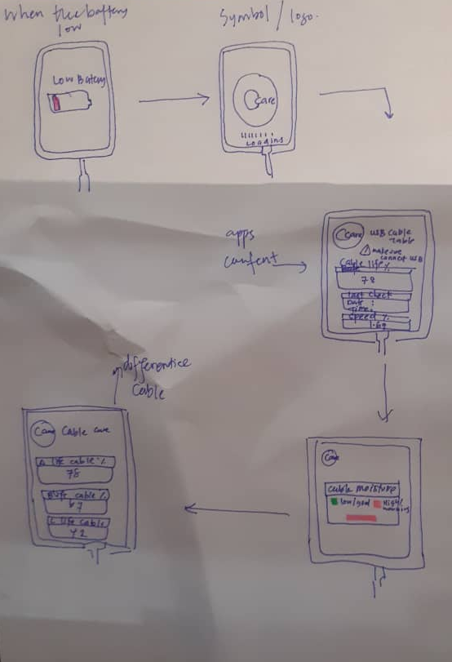
Figure 2: Draft of our prototype

3.5 Test
As the prototype is done, we introduce it to our user and explain each of the functions to them. We let them know how those functions can help them to solve their problems. We also gather their feedback regarding to Cable Care so that we can make this application better and more helpful. From their feedback, we able to find out more idea that we did not realise before.
3.6 Task Assigned for Each Member
In order to accomplish our assignment on time, we have assigned different task for each member. Syamira works for the abstract, introduction and conclusion. Rohaizaazira works for the problem background and prototype. Mek Zhi Qing works for the methodology and Zereen Teo Huey Huey works for the proposed solution. However, we always help each other when the other member face problem.
4.0 THE PROPOSED SOLUTION
4.1Acknowledgement of Similar Product
Throughout our study, we did not find out that any similar application compares to Cable Care. However, we are aware that there is a tool called cable tester which use to detect the function of cable. Based on https://www.fluke.com/en-us/product/network-cable-testers/copper/ms2-100, one of the product called “Fluke Networks MicroScanner™ Cable Verifier” is used to determine the problem of twisted wire and coaxial cable and used to detect network services which is normally use in electronic appliances but not for smartphone. Although this cable tester can detect the cable whether can function well, the cable lifespan also cannot determine through this cable tester.
4.2 Features of Proposed Solution
By using this Cable Care, the user can know the lifespan of cable when the cable is linked to smartphone. Then, the history of checking cable also shown in the app. If user used different cable, the application also could detect and separate the data so that the user can compare among the cables. For the notification function in this app, a pop-up message will be shown to remind the user to check cable. The moisture and the charging speed of cable is also displayed in Cable Care.

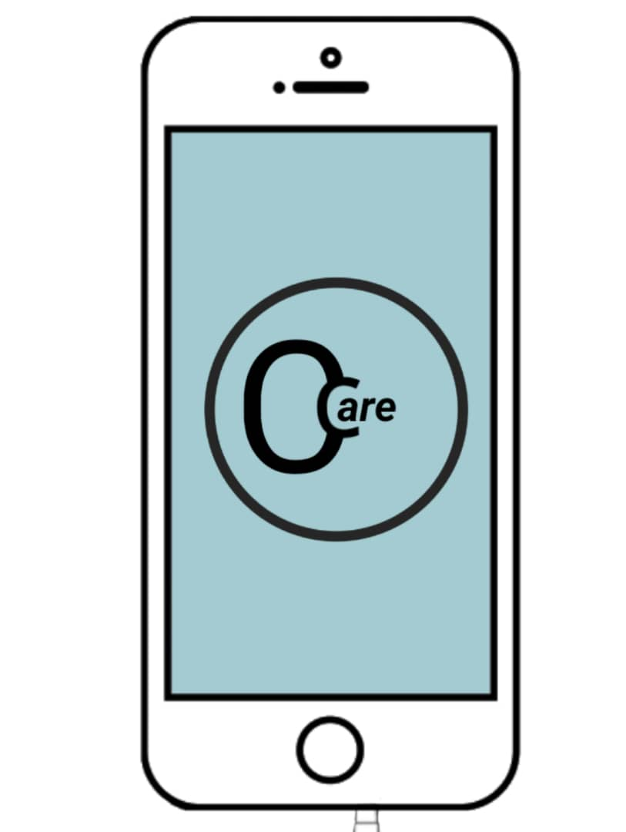
Figure 3: Cable Care application logo

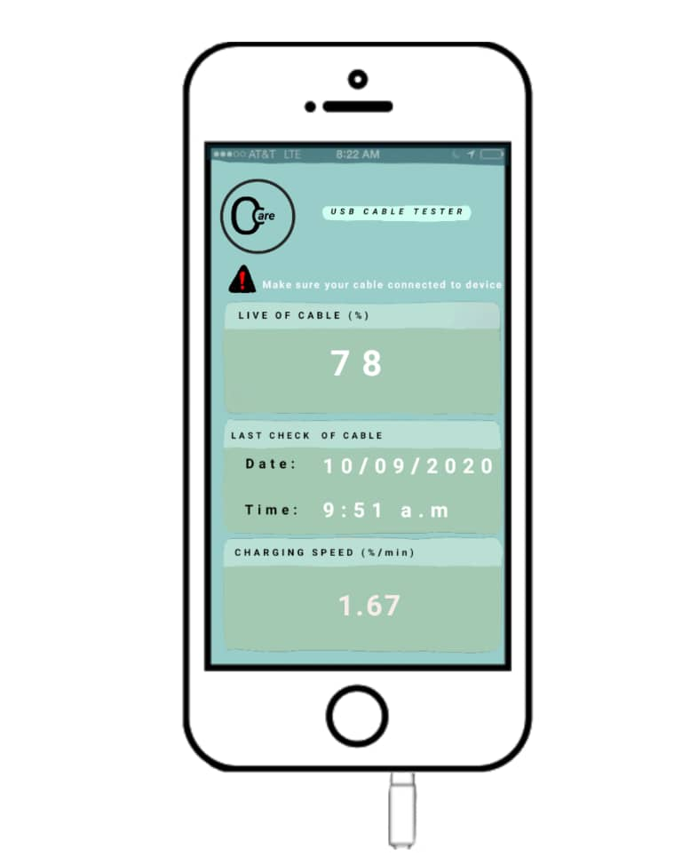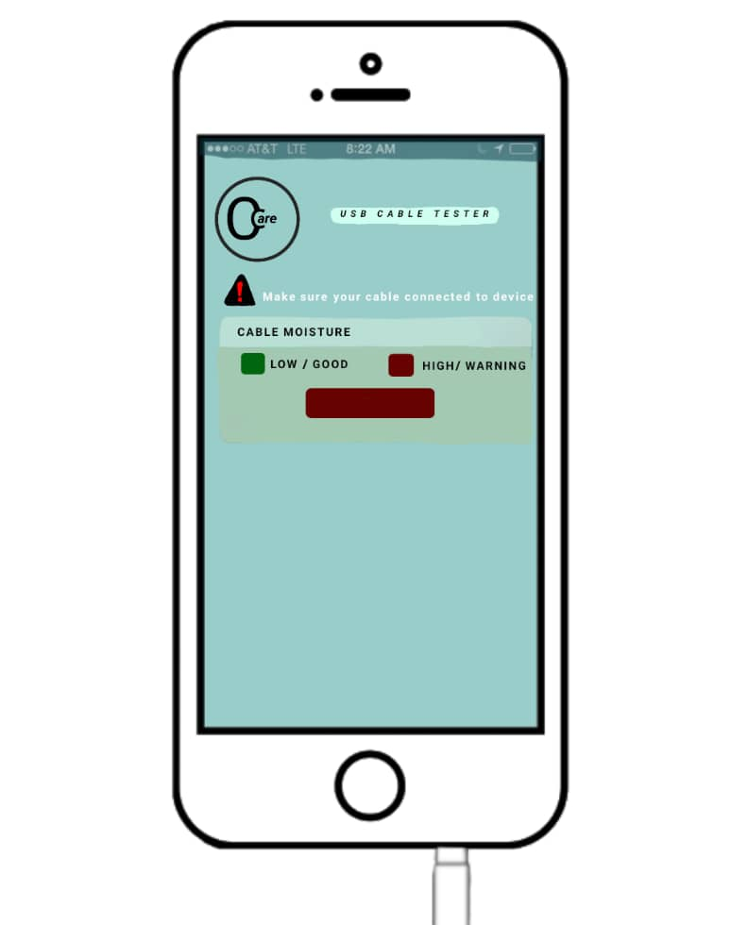
Figure 4: Feature in Cable Care Application

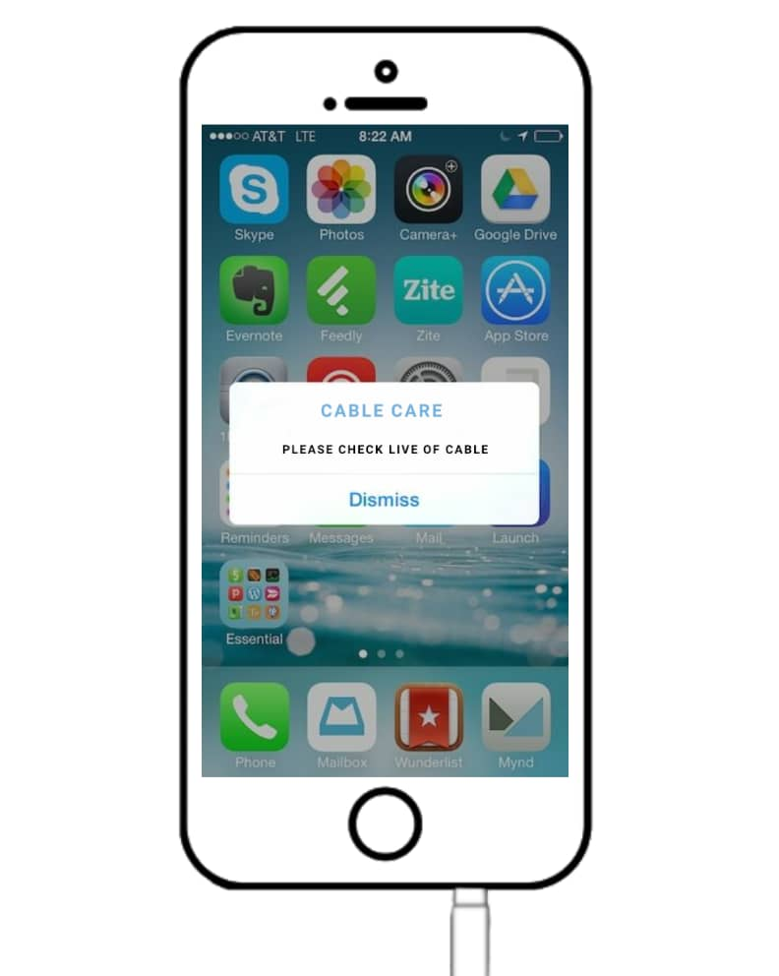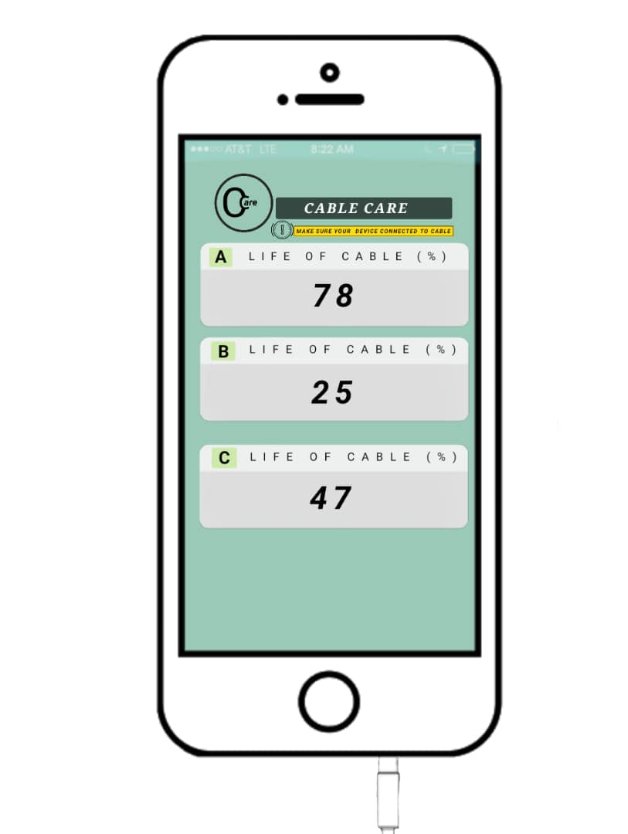
Figure 5: Feature in Cable Care Application
4.3 Users Feedback
We ask user to try our product. After their use, they feel this product is useful in daily life. Although Cable Care gives them convenient, some of the users worry about this application is only provided for handphone cable. The users suggest that Cable Care can use for other wire product such as earphone but not only cable. Some of them hope that can get more information about cable in our product.
4.4 Business analysis using SWOT
Review of Cable Care based on business analysis using SWOT (strengths, weakness, opportunities, threats)
Strengths | Weakness
- Detect cable lifespan | - Only can detect handphone cable
Opportunities | Threats
- Can be further improved for detect other wire product | - Cannot repair the cable

4.5 Improvement
Based on reflection from user, we found that Cable Care still has a lot of function to be improve. For example, Cable Care can use to detect earphone problem not only detects cable problem. Otherwise, the information about cable can display in the application for more understanding. The Cable Care will be used in computer for detecting wire problem in the future.
Throughout this program, we have learned a lot of knowledge to become better. We learn how to work in close cooperation with each other. We also realize that discussion is the best way to solve our problem during teamwork. Last but not least, we have gained communication skill when communicate to our group members and the users throughout this program.

5.0 REFLECTION & CONCLUSION
This project took us through the various phases of project development. The joy of working while tackling the various problems and challenging gave us more excitement. Also, we had learnt that teamwork is very important to make our project run smoothly. Moreover, teamwork can improve productivity and brings better results. We all satisfied that we could know all the difficulties facing by many people and our idea was accepted by them. It was a wonderful learning experience while working on this project.
The Cable Care application is definitely the live saver for people. With the advantages of application, it can ease people to know the life expectancy of their cable. This is due to the fact that many people have to change their cables once a month. The cost of the cable is quite pricy and some of the people cannot afford for it. However, we also realised that some problem still cannot be solved using Cable Care. Hence, we will work hard and try to improve our application in the future.

