

TECHNOLOGY AND INFORMATION SYSTEM
SEMESTER I 2020/2021
SECP1513-06
DESIGN THINKING REPORT GROUP iX
NAME OF STUDENTS | MATRIC NO.
LAI CHEE YEE | A20EC0199
CHEAH YAU KHIN | A20EC0185
MOHAMAD HAZIQ ZIKRY BIN MOHAMMAD RAZAK | A20EC0079
WONG HUI SHI | A20EC0169
OMAR MOHAMED ABDELFATTAH IBRAHIM | A20EC4047

LECTURER: DR. MUHAMAD RAZIB BIN OTHMAN
SUBMISSION DATE: 15th NOVEMBER 2020

Table of Contents

Introduction 3
Detailed Steps and Descriptions 4
Detailed Descriptions 5
Design Thinking Evidence 6
- Empathy 6
- Define 9
- Ideate 9
- Prototype 11
- Test 11
Reflections 12
Task for Each Member 16
Reference 16

List of Figures
Figure 1: 5
Figure 2: 7
Figure 3 : 7
Figure 4 : 8
Figure 5 : 10
Figure 6 : 10
Figure 7 : 11

List of Tables
Table 1: 3
Table 2: 8
Table 3 : 9
Table 4 : 12
Table 5 : 16
INTRODUCTION
Design thinking is a process that we seek to understand the user, challenge assumptions, and find the right find solutions or strategies that are tailored-made for the complex problem. It focuses on human-centered problems and the people solving them need to come up with innovative ideas or human-centered designs to meet those needs. Other than that, design thinking is very helpful for people nowadays because it can be used in any fields such as business, education, technology, and many others. Design thinking not only gives us a way for us to solve problems efficiently, but also a unifying language for us people to give out a better, more creative solution.
There are five phases of the design thinking which are empathize, define, ideate, prototype and test. In our opinion, we feel that one of the most important parts of this project is the prototyping stage and it is the stage where we get to validate our ideas and to see if it is the right fit for the given problem. Design thinking is more than just a process, it sheds a new light for people to think outside the box and make innovative solutions with the right things in mind.

DETAILED STEPS AND DESCRIPTIONS
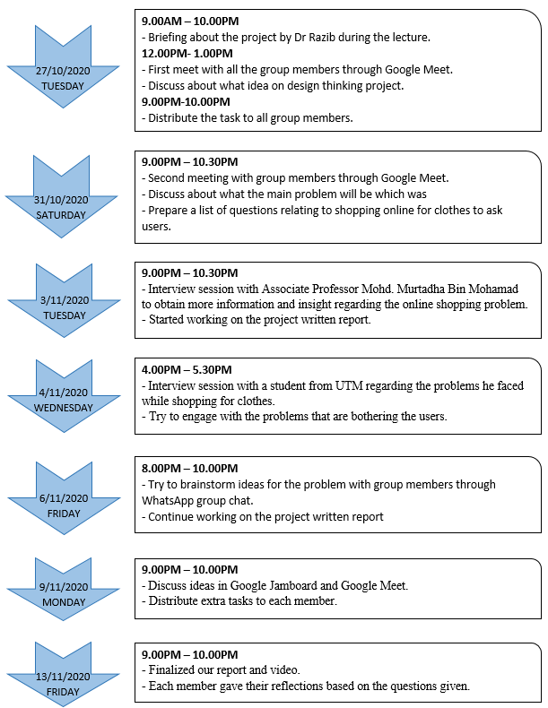
Table 1

DETAILED DESCRIPTIONS
Problem
The problem that we faced throughout every interview is that the students are difficult to know their size accurately when shopping online. Due to the Covid-19, everyone needs to stay at home, so many people started using online shopping apps to buy their daily supplies especially clothing. But the problem is sometimes the size stated in the apps is not precise and cause the buyer bought things that cannot fit on them. A few buyers also do not exactly know whether that cloth suitable for them or not. Most of the people afraid that they will regret buying those things.
Solution
After all the problems are identified, our group has a brainstorming session. We gave out our ideas and solutions to solve the problems. Finally, we came out with a conclusion. We decide to create an augmented reality (AR) online shopping app. This app can help the buyer to have a look on themselves wearing or dressing the specific products before they purchase it. With this AR online shopping app, the buyer can have a look on the products in 3D and try on it by using their mobile phones. When the clothes are not exactly fit on them, the apps will notify and recommend the best choices for the buyer. Through all this, the buyer can buy their favourite clothes with more accurate size and with no regret.

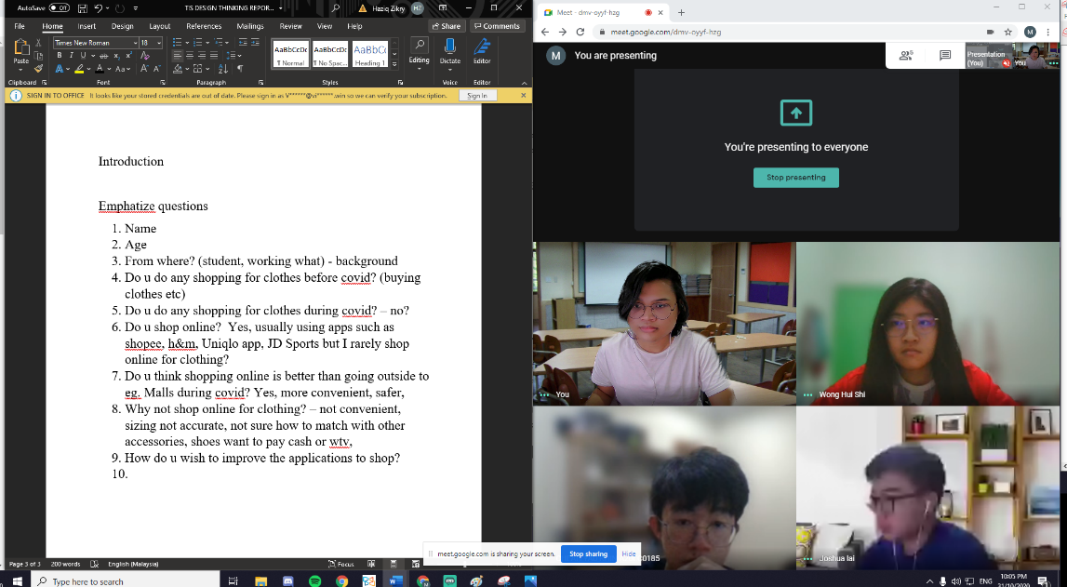

Figure 1: Four out of five of us brainstorming questions for the interviews

Team Working
Teamwork is very important for us to succeed in doing this assignment. We had some arguments of ideas and opinions during the meetings, but in the end, we accepted each other’s opinion and finally come out with a conclusion that agreed by all the members. We also have a brainstorming session on how to solve the problems. During the discussion, each of us contributes our ideas and we discuss among each other. Besides, all members also have great discipline to attend the meeting to have the discussion. Furthermore, the tasks given are also distributed to each of us and everyone were also responded in the group whenever any of us need help regarding the task. We also discuss about how the prototype can be designed. As a conclusion, every member took responsibility in participating every meeting and help each other in doing their tasks. Responsibility, punctuality and cooperation can be shown while conducting every meetings and tasks.

DESIGN THINKING EVIDENCE
Based on our findings, we found out that people are having a hard time to shop especially for clothes during this pandemic. Instead, they spend a lot of time on their smartphones and tablets to shop online but have difficulty to know specific sizes and suggestions for clothes. Therefore, we decided to make a mobile application to allow people to shop for clothing and accessories with features such as a virtual fitting room, similar clothing suggestions and more.
Empathy
Empathy is vital to an arrangement of human-focused improvement, for example, plan thinking, as it encourages you to put aside your own reality discernment's and increase genuine understanding into clients and their needs. Empathy helps us gain a deeper appreciation and understanding of people's emotional needs, and the way they see, understand, and interact with the world around them. To empathize, we should observe, engage, and immerse.
In the observing step, we interact with other users to find out the problems that they face. The information gathered during this step is interpreted to find out the core problems. Therefore, our main target audience are consumers who have difficulty to do clothes shopping during this pandemic. Moreover, consumers are opted to shop online which can cause difficulty to most people.
Next is to engage. To find out more on our problem, we have carried out the research by interviewing two people to have a better view and perception regarding to this problem. The first person we interviewed was Associate Professor Mohd. Murtadha Bin Mohamad through the Webex Meeting Client. He is an Associate Professor in Faculty of Engineering, School of Computing in Universiti Teknologi Malaysia (UTM). There were more than 150 computer science students who attended this interview to ask him questions regarding their assignment.
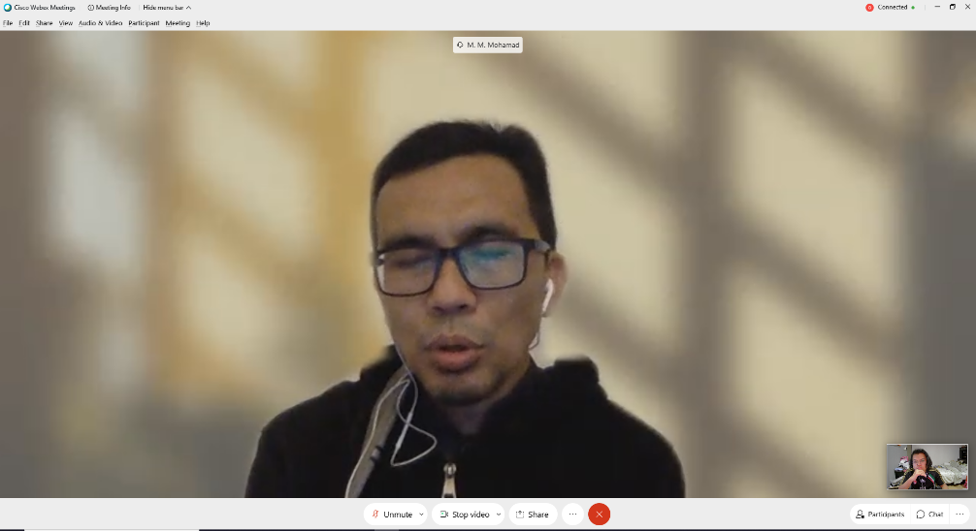

Figure 2: Interview session with Associate Professor Mohd. Murtadha Bin Mohamad
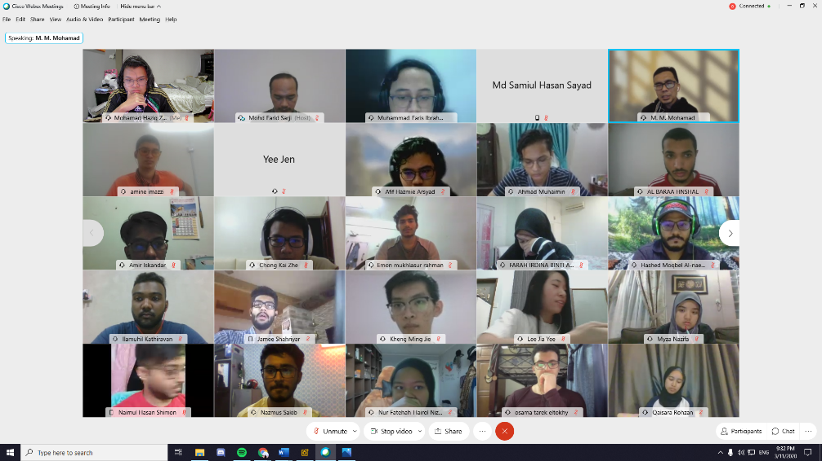

Figure 3: More than 150 students attended this interview.
Unfortunately, there were too many students who were trying to ask the professor questions. Thus, we were only able to ask him only one question which is, what are some of the problems from shopping online through applications.
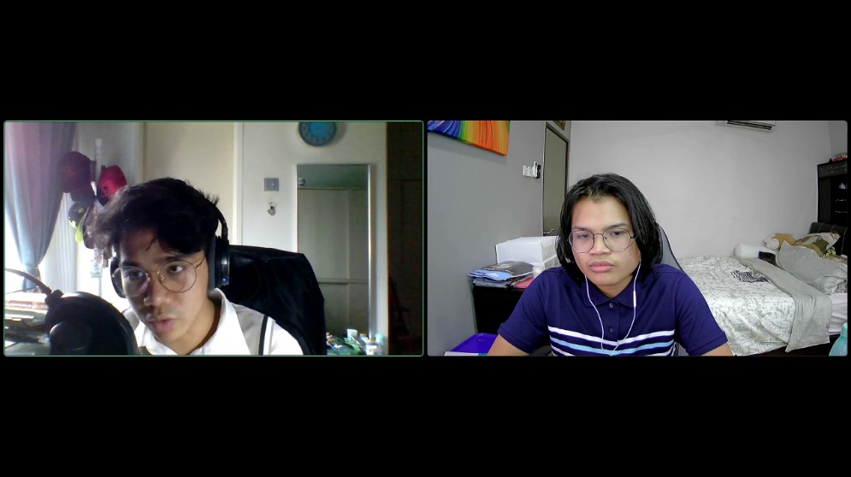
The next person we interviewed as our respondent was a student from UTM. We interviewed him online through the online Discord application.
Figure 4: Interviewing a student from UTM
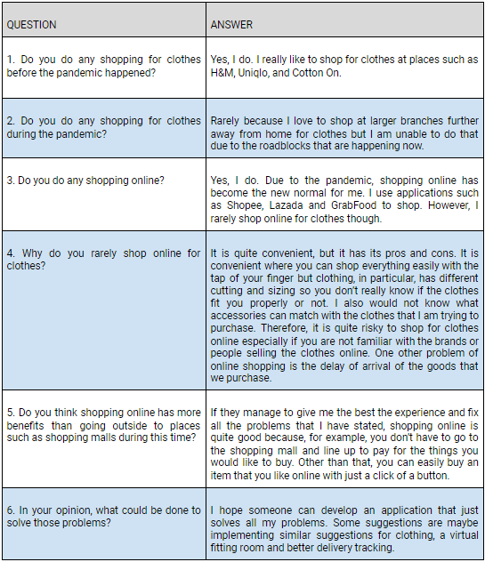
Here are the questions that we asked him and the answers that he gave:

Table 2
The last step in empathy is to immerse. From the interviews that had been carried out, we were able to see the pattern of the respondents’ thought and their problems in dealing with shopping online for clothes. From there, we started to brainstorm for creative ideas and solution to overcome these problems.
Define
The define stage is where we gather information from the previous stage to define what is the main problem that faced by others. This is where we analyse all the information that we gathered from the empathy stage. After that we were able to identify the core problems to be able to define the problem in a human-centered manner. Therefore, based on our analysis, here are the main problems that we can derive from the empathy stage.
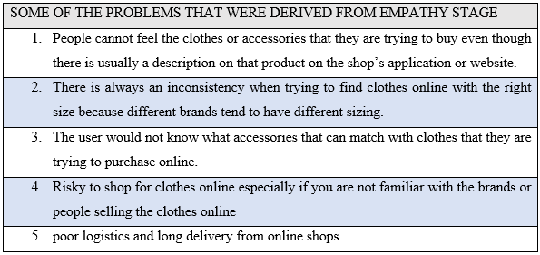Table 3
Thus, we can see that the current pandemic gives out a hard impact to users on how they would like to shop. We have decided to help to overcome these problems by understanding them so that we can have the best solution that will be result the as our prototype.
Ideate
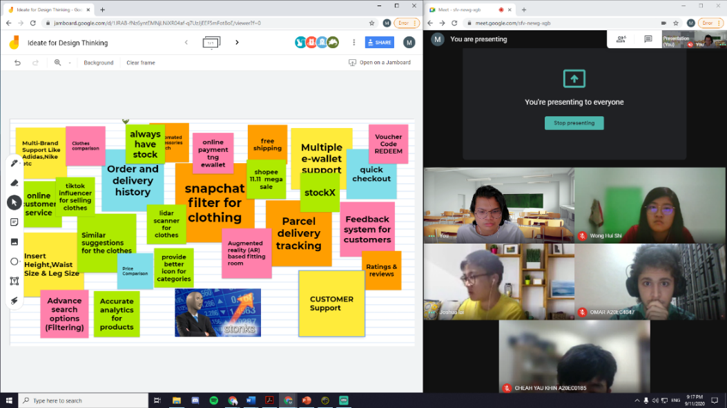
Ideate is the phase where the goal is to brainstorm and generate ideas which can be possible solutions to a problem. This is where we apply our critical and thinking skills to discover answers for the problem as there is no single right method of tackling the problems. We gathered in a video meeting and started throwing ideas around from multiple views and perspectives and noted them down on Google Jamboard. During this phase, we listed all the ideas followed by the filtration process. Then, we chose the idea which is most likely to be our solution and prototype. After some discussion and deliberation, we decided on which prototypes to make.
Figure 5: Brainstorming ideas and solutions with group members using Google Jamboard
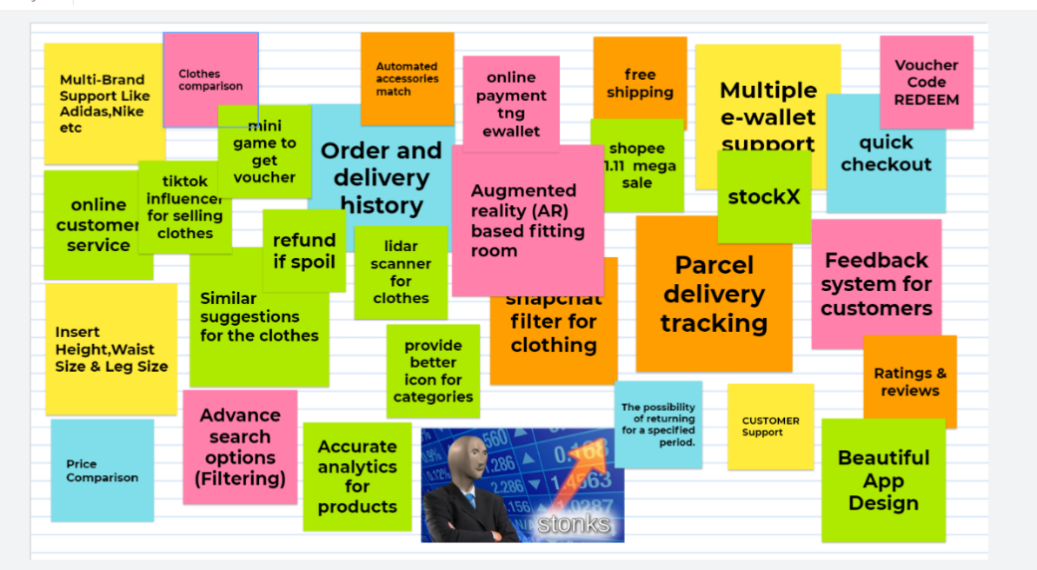

Figure 6: All the ideas and solutions given by each group member
Prototype
The prototype stage is where the ideas generated from the ideate stage is brought to life into the physical world. We had many rough prototypes with different versions and features implemented into it. In the end, we decided to make a prototype mobile application which primarily focuses on shopping for clothes and accessories. The features include an Augmented Reality (AR) based virtual fitting room, a price comparison feature between products, provides similar suggestions to the clothes you may want to buy, parcel delivery tracking and links to the brands online stores for easy purchase.

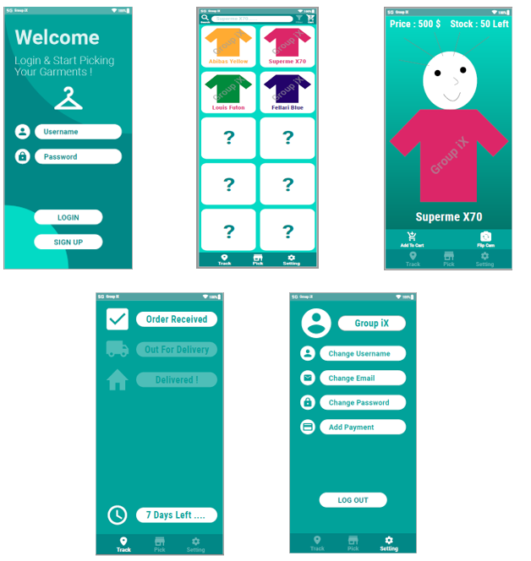
Figure 7: Our final prototype.
Test
Testing phase is where we let users test out our prototype and see if it solves their problems and get their feedback while at it. Due to COVID-19, we were not able to show the users our prototype physically but instead we demonstrated it by video to the target users.

REFLECTIONS

Mohamad Haziq Zikry Bin Mohammad Razak | - What is your goal/dream with regards to your course/program?  My personal goal from this course/program is to be a successful Data Scientist in the tech industry who is well versed in solving real world problems and help companies solve major and ambiguous problems. I believe that this subject, Technology & Information System will be able to equip me with the right skills and knowledge before graduating in the future. I am keen to explore more in the tech industry and would love to expand my network and make new connections along the way.  - How does this design thinking impact on your goal/dream with regards to your program?  This design thinking project had taught me to be more proactive and more vocal in a group conversation by effectively offering input and recommendations on how the project should be done and finished. Furthermore, this process has taught me on how to be more strategic and systematic in planning a very thorough solution for a high-risk problem. By following the design thinking process, I am able to know what the users want and come up with solutions that can be implemented into a prototype. Thus, I think that this design thinking project can definitely have a positive impact on my goal in becoming a successful Data Scientist and it can help develop myself in becoming a more knowledgeable person in the tech industry after I graduate.  - What is the action/improvement/plan necessary for you to improve your potential in the industry?  Some of the necessary actions or improvements that I should do to improve my potential in the industry is to improve my soft skills overall. There is no point in being a smart person but is unable to present the idea to an audience of many. Hence, grooming my personality as well as my soft skills are important to build a successful portfolio. Other than that, I can become more useful and competent to the industry by improving my technical skills. This includes things such as mastering a certain programming language and not learning many programming languages. It is always better to be a master at something than being mediocre at everything. Therefore, technical skills such as that is another skill that I should polish in order to be more successful in the industry. As a conclusion, there are many things for me to improve and learn and I believe this course will help me in realizing my dreams and aspirations.
Lai Chee Yee | - What is your goal/dream with regards to your course/program?  My dream regard for this course is to be able to become a successful software engineer. My parents give me a big hope to pursue my dream. I was feeling lucky to have an opportunity to get my first choice which is software engineer in a prestigious university which is called UTM. Journey to degree may not easy, but with passion and faith, I believe one day I will be in the convocation celebrate my graduation .Tech company such as Facebook, google, amazon are now demand for hire software engineer. software engineer is a job that could help our country moving forward. With the AI technology online business, application, it shows that software engineer become an important role to our economy, education and entertainment.  - How does this design thinking impact on your goal/dream with regards to your program?  After complete design thinking, I realise that teamwork is very important for our prototype. each of us trying their best to create an idea for our prototype.it is a good start to let us know how to solve real life problems. My communicate skills become better by discussing the prototype together. This design thinking project give me a lot of understanding about new technology, how application works. I am looking forward for the industry after I graduate.  - What is the action/improvement/plan necessary for you to improve your potential in the industry?  To improve my potential in the industry, I must able to improve my communication skills and coding skill which will use the most of the time in the industry so that I will not getting a hard time during having a real-life problem. I have to be more responsible for every job and not blame others for their mistake. I should be humble when doing our job because we human is not perfect, we cannot always show off how well we are, but we need to know our limit. Moreover, I need to gain some soft skill during my internship, so that I will adapt the environment of the industry.
Wong Hui Shi | - What is your goal/dream with regards to your course/program?  My dream regarding to my course is to become a software engineer with creativity and can design a new app. Nowadays, technology has become a part of the day-to-day life for each and every one of us. Therefore, study in software engineering have more opportunity to have a job in the future since it is high demand. Luckily, I have this opportunity to pursue my study in software engineering at UTM in Malaysia. I hope that I able to write the programs that satisfy specification to help those people who need help. I also hope that I can design an app which can has a great help in the future. Besides, I hope that I can get a job in any of the company regarding technology with my skill and have a good environment for me to improve myself.  - How does this design thinking impact on your goal/dream with regards to your program?  Design thinking had a big impact on me. During the whole session of this design thinking, I realise that teamwork is very important. As the saying goes “many hands make light work”, a successful project needs cooperation of all the group members. In every session of design thinking, everyone contributes their ideas and we discuss among each other. Each of us also willing to accept other’s opinions. Besides, we also help each other in doing the task. In this design thinking, I gained more knowledge about the technology nowadays. I also know that responsibility is very important. Everyone has their responsibility doing their task and we need to communicate with each other during the whole session. With this I can improve my communication skill to prepare myself to have a job in the future. Design thinking also inspiring creative and innovative mind. It helped me to think out of the box to design the online shopping app that benefit the people. In design thinking, I also learn how to solve problem by brainstorming a solution.  - What is the action/improvement/plan necessary for you to improve your potential in the industry?  The improvement for me to improve my potential in the industry is to build up my soft skills. Communication is very important for me to work with each other in the future. Therefore, it is necessary for me in the upcoming time. To improve my communication skill, I plan to involve myself in many activities to build up my courage and confidence when communication with others. Besides, hard skill is important too. Specific technical knowledge and training can help me perform well in my field which is software engineering. I plan to participate in some competition related to programming so that I can improve my programming skill and learning more programming languages. UTM has a good environment for me to improve myself since it has more activities and clubs that I can involve in. I can also learn all those things during my internship in any company. Creativity and innovativeness are also important in designing and enhancing an apps. With a creative and innovative mind, an apps can be created more easily. Improving soft skill, hard skill and our mind set are necessary for me to improve my portfolio. Self-improvement will not bring any harm, but in opposite it will bring us many benefits and help us to have a better life in the future.
Cheah Yau Khin | - What is your goal/dream with regard to your course/program?  I wish to become an innovative software engineer that can create various helpful apps to make our life easier than ever. I am also interested in making interesting games for fun. Following the trend of this era, I also wish to know more about the creation of AI that helps us to solve the puzzles of life. Before I become a full-fledged software engineer, I wish to enjoy the fullest as a student in UTM.  - How does this design thinking impact on your goal/dream with regard to your program?  Design thinking force me to brainstorm new ideas for the creations of new things. Thus, I will be able to get a grasp about our current situations as well as problems we are facing. Along the process of design thinking, a lot of things were taken into consideration before prototype is made. Therefore, I am able to see the world from a different angle through design thinking. Design thinking also help the to understand the importance of teamwork as well as time management in every aspect.  - What is the action/improvement/plan necessary for you to improve your potential in the industry?  I wish to learn more programming languages to prepare myself in the industry. I also wanted to learn more about the usage of other programs which helps to speed up my workflow as a software engineer. Furthermore, I will also brush up my communication skills with other people by joining club activities since I am not very good at social. I will also learn a bit about art and design since aesthetics is also important when it comes to software developing and game developing.
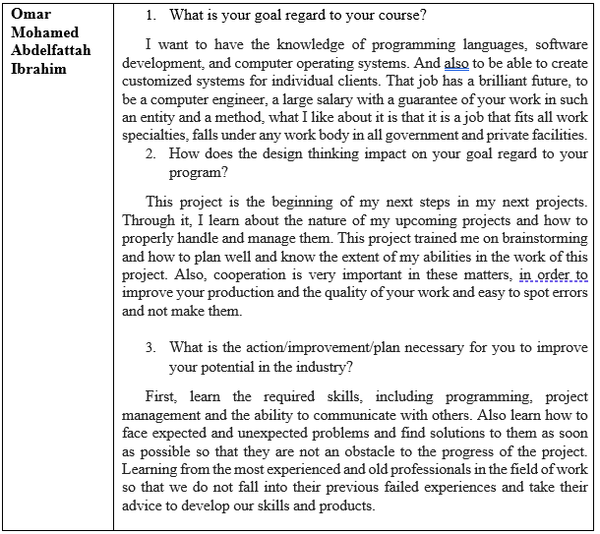
Table 4
TASK FOR EACH MEMBER

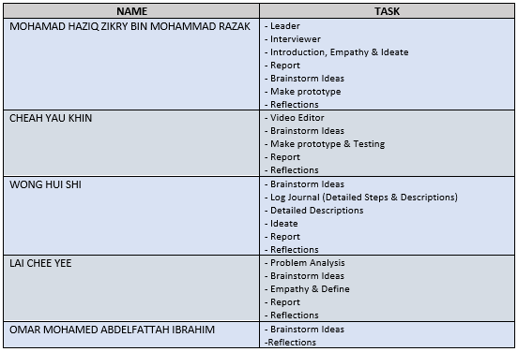
Table 5

REFERENCE
Siang, R. F. (August, 2020). 5 Stages in the Design Thinking Process. Retrieved from INTERACTION DESIGN FOUNDATION: https://www.interaction-design.org/literature/article/5-stages-in-the-design-thinking-process

