

Semester I 2020/2021

Subject : Technology and Information Systems (SECP1513) Section : Section 8
Assignment : Step by step PC Assembly

GROUP NAME: Group iX

1 | Photo | Name: MOHAMAD HAZIQ ZIKRY BIN MOHAMMAD RAZAK  Matric Number: A20EC0079  Phone Number 0182385036  E-mail: mohamadhaziqzikry@graduate.utm.my
2 | Photo | Name: LAI CHEE YEE  Matric Number: A20EC0199  Phone Number:  E-mail:
3 | Photo | Name: WONG HUI SHI  Matric Number: A20EC0169  Phone Number:  E-mail:
4 | Photo | Name: CHEAH YAU KHIN  Matric Number: A20EC0185  Phone Number:  E-mail:
5 | Photo | Name: OMAR MOHAMED ABDELFATTAH IBRAHIM  Matric Number: A20EC4047  Phone Number:  E-mail:

Part A
Tool 1: Screwdrivers
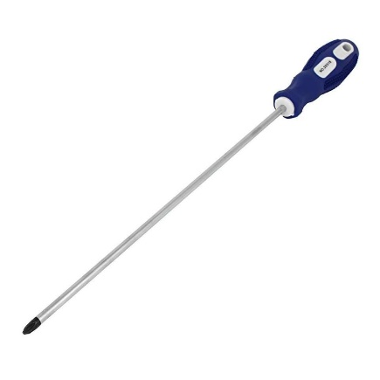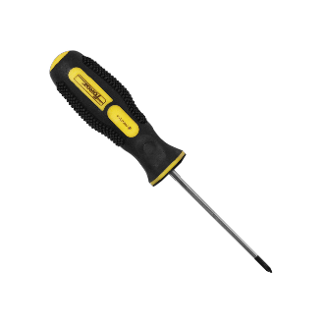
Function: To tighten and untighten the screws on your components to hold them securely in place. For a modern PC build, a Phillips-head screwdriver is usually the ideal size to use.
Importance: Able to install and remove the components easily. A long shaft screwdriver is also important in keeping the handle out of the way when working in tight spaces around the components and a short shaft as well. A screwdriver that has a magnetic tip is also very helpful to avoid dropping small screws during installation in PC assembly.
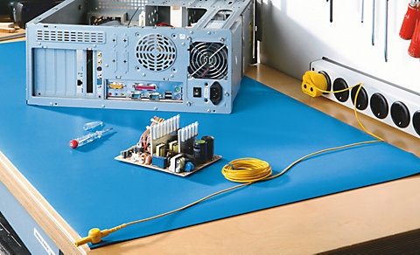
Tool 2: Anti-Static Equipment
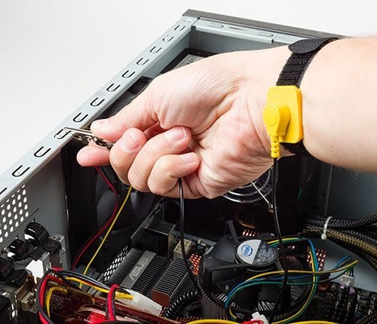
Function: Device that reduces or discharge of static electricity. In other words, it is to avoid static sparks to your body when building your PC. This anti-static equipment can be in the form of a wrist strap that clips to a grounded object or plugs into the ground socket of any plug outlet. Another form of equipment is an anti-static mat can be placed on the floor of the workspace, allowing unrestricted movement.
Importance: To prevent the damage and risk of electrical components such as computer hard drives and flammable liquid gases.

Tool 3: Cable Ties
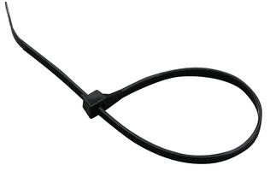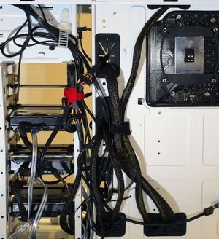

Function: To tie up any loose cables and categories the wire to make it neat and tidy.
Importance: Makes the finished PC build look neater, better cable management, and promotes better airflow within the PC case.

Tool 4: Pliers
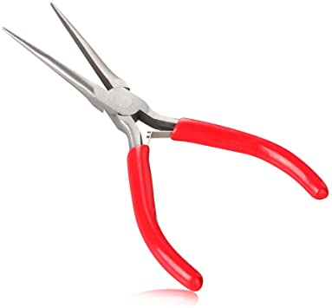
Functions: Typically used as a wire cutter, which can be used to snip the excess off the cable ties.
Importance: for loosening up screws or bolts that are super-tight, picking up hard to reach screws that you may drop within your case, removing chipped/broken screws, removing motherboard standoffs, and cutting zip ties.

Tool 5: thermal paste
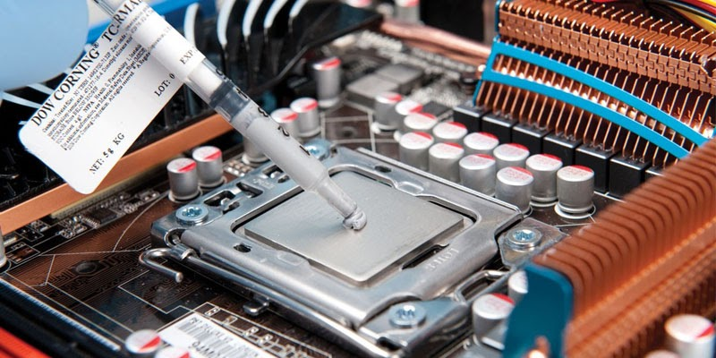
Function: A silvery-grey substance that you apply to a processor before installing a heatsink cooling solution. It allows for an efficient transfer of heat from the IHS of the processor to the base plate or water block of the CPU cooler that is designed to dissipate that heat.
Importance: to make sure the processor is in cooling conditions. To avoid the processor from being damaged easily when heat dissipates.
Tool 6: Trays

PART B – Sketch of a mother board layout
1.0Sketch manually (using handwriting) a simple diagram of a motherboard layout that consists ALL keywords included in Table 1.0. Label each of the keyword. Diagram
1.0 and 2.0 below are examples of the sketches. Do not copy any of these diagram. Produce your own sketch diagram. Only one sketch diagram of a motherboard layout is required for this assignment.

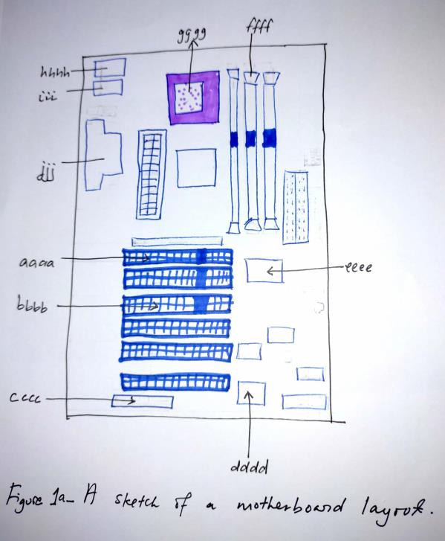 | 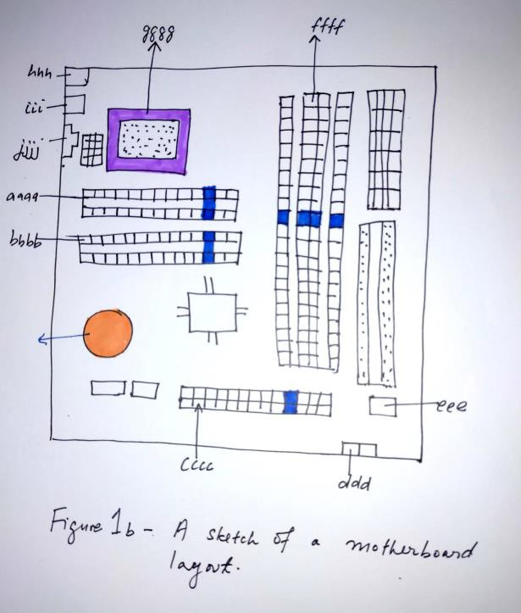
Diagram 1.0 | Diagram 2.0

2.0For each keyword in Table 1.0. Provide picture(s), explanations of its functions and example of models.

Graphic card
USB cable
IDE cable
CPU /Processor
Slots (IDE, PC)
Power supply
heat sink
RAM
hard disk (jumper setting either master/slave)
CD ROM
SATA cable
PART C - “Step by Step PC Assembly”
Based on the given video and keywords in Table 1.0, prepare a report on “Step by Step PC Assembly” that provide guided instructions on how to Assemble a PC. Assumed that in front of you is an opened computer case (without the side panels). Number of steps should not exceed the number of keywords.
STEP 1 – Write the Activity Name
- Provide close up photo, guided detail instructions, precautions, tips (e.g how to install RAM).
STEP 2 -

STEP 3 -

STEP n -

Last STEP - CLOSING THE CASE AND CONNECTING THE PERIPHERALS.
(Complete the step by inserting relevant photo(s) which illustrate the given descriptions)

Insert relevant photo(s) which illustrate the descriptions |  | Place the side cover back on and secure the side panels with case screws.
Insert relevant photo(s) which illustrate the descriptions |  | Connect peripheral devices which include keyboard, mouse, wireless  network dongle, printer and webcams with your CPU by plugging into USB
 |  | port.
Insert relevant photo(s) which illustrate the descriptions |  | Then, connect speakers and microphone into 2.5 mm sockets.
Insert relevant photo(s) which illustrate the descriptions |  | Finally connect the CPU with monitor by plugging into display ports

PART C - “Step by Step PC Assembly”

Step 1: Open Case
- Remove the back screws
- Take side cover off

Step 2: Mount Motherboard
- Screw motherboard standoffs into the case
- Punch out rear I/O plate from the case (if existing) and replace it with the motherboard I/O plate
- Fasten the motherboard in place on top of the mounting standoffs

Step 3: Mount Processor (CPU)
- Locate the CPU socket holder on the motherboard
- Lift up the latch lever to release and hinge open the CPU socket cover.
- Holding the CPU by its sides, line up any alignment notches or the triangle marked on the corner of the CPU to the triangle marked on the motherboard. Gently place it straight down into the motherboard socket to seat the CPU
- Lower the CPU socket cover over the CPU and lower the latch lever closed again to secure the CPU socket holder closed

Step 4: Install CPU Cooler
- If required, apply thermal paste to the back of the CPU
- Seat CPU heatsink/cooler and fix in position.
- Plug the power cable attached to the cooler fan into the motherboard connector.
Some CPU coolers do come with a thermal pad already applied, in which case you can skip step 1. If yours doesn’t, you will need to apply thermal paste to the CPU surface before seating the CPU cooler in position.
Cable headers on motherboards vary in their location depending on what motherboard you have. To identify the correct header, look for the labeling on the motherboard; they are always labeled next to the header with the intended connection, for example:
- CPUFAN = CPU fan
- SYS_FAN1 = System fan (any general fan can be plugged in here)
- SYS_FAN2 = System fan (any general fan can be plugged in here)

Step 5: Install Power Supply (PSU)
- Mount the power supply and fasten with screws to the case mounting points
- Plug the largest cabling connector from the power supply cabling into the motherboard power connector.
- Plug the 8-pin cabling connector from the power supply cabling into the CPU power connector

Step 6: Mount Memory (RAM)
- Press to open the clips at both ends of the RAM mounting slots
- Line up the notch on the RAM stick with the mounting slot
- Seat the RAM and press it firmly down into the slot. The tabs should automatically latch closed as you press the RAM down, securing the RAM in place
- Install any other RAM sticks using the same process

Step 7: Install Graphics Card
Not all computers have a dedicated graphics card. If you have decided to use the on-board graphics of your motherboard instead of installing a dedicated graphics card, you can skip this section.
- Remove the expansion slot covers from the rear of your case where the graphics card will sit
- The graphics card slots into a PCI expansion slot on the lower half of the motherboard. Line it up and press down firmly to seat the card.
- Put in the screws to hold the graphics card in place
- Plug in the power connector cables from your power supply into the graphics card power connector (if existing – not all graphics cards required external power)
When you plug in your display monitor, always use the output ports of the graphics card frist (if you have one installed) and not the output ports of the motherboard itself. This ensures you are actually using your graphics card!

Step 8: Mount Storage Drives
- Mount storage drives in the case drive bays. Fix the drive in place with screws through the case frame into the case mounting holes located on the storage drive
- Connect the drive to the motherboard using a SATA cable
- Plug in power cabling to the storage drive
- Mount any other storage drives in the same way

Step 9: Mount Optical Drive
Optical drives are optional and only required if you wish to read or write CDs, DVDs, or Bluray discs. Some people choose not to include an optical drive in their PC build if they don’t plan on using optical discs.
- Remove any front panels from the computer case where the optical drive will sit.
- Mount optical drive in the case by fixing with screws through the case frame into the case mounting holes located on the optical drive
- Connect the optical drive to the motherboard using a SATA cable
- Plug in power cabling from your power supply to the optical drive
Just like external storage drives that we connected in Step 8, optical drives also require two connections: power and data. Again, the data connection cable is a SATA cable which connects the optical drive to the motherboard. The power connection cable supplies power to the drive, and plugs into the drive from the power supply

Step 10: Connect case fans and front panel connectors
Some computer cases come with case fans already installed/mounted within the case. However, you will still need to plug the power cables of these fans into a header port located on your motherboard. This supplies the fan with power which is required for it to operate.
Front panel connections may vary according to your case, but typically comprise of the same components: audio, USB, and power/reset/lights etc. These will be present in the form of cables that come from the front panel; the ends of which will be hanging loose in your case. You’ll need to hook these up to the appropriate locations on your motherboard.
- Mount any case fans within your case as required using the supplied screws or clips
- Connect any case fan power connectors to the multiple fan headers located at various places on the motherboard.
- Identify the cabling from the front panel ports of your PC. These front panel connectors will need to be plugged into the motherboard so that buttons and inputs/outputs (I/O) on your case front panel will work
- Connect any front panel audio connectors to the the motherboard front audio header
- Connect any front panel USB connectors to the motherboard USB headers
- Connect the front panel case connectors to the motherboard front panel I/O headers
Different computer cases may have slightly different I/O connections, but generally both the connectors and motherboard headers are labelled, so use these to your advantage when working out where to plug each cabling connector! If in doubt, refer to the documentation which came with your motherboard, which should tell you exactly where to connect these items.

Step 11: Close Case and Connect Peripherals
Before closing up your case completely, you may wish to do some ‘cable management’, which means tucking away, rerouting, or removing and securing any loose slack from cables which would otherwise be hanging around loose in your case.
We recommend using cable ties to neatly secure cables in bundles and away from any moving parts (such as fans).
- Place the side cover back on
- Secure the side panel with case screws
- Connect peripheral devices including mouse, monitor, keyboard, speakers etc.

Connecting Peripherals

Plug into USB ports:
- Keyboard
- Mouse
- Wireless network dongle
- Printers
- Webcams

Plug into 2.5mm sockets:
- Speakers
- Microphone
- Line-in/line-out devices

Plug into ethernet ports:
- Internet connection
- Local area network (LAN) cables

Plug into display ports:
- Monitor / screens
- Be sure to plug into the correct display ports: always plug into the graphics card display output (if you have one installed) instead of the motherboard display ports.
- If you don’t have a dedicated graphics card, then plug into the motherboard’s display output ports.

Step 1: Open Case
- Remove the back screws
- Take side cover off
Its easiest to work on your PC with it laying sideways on a flat surface, so the open side is facing up. Don’t forget to ground yourself (by touching the case) before working on assembling parts.
Keep any screws which were supplied with the case separate and take note of the different types. Most cases will come with a few different packets of screws and they may have different sizes or threads, so make sure to match them up with the correct mounting locations as best as possible. If in doubt, refer to the documentation which came with your computer case.

Step 2: Mount Motherboard
- Screw motherboard standoffs into the case
- Punch out rear I/O plate from the case (if existing) and replace it with the motherboard I/O plate
- Fasten the motherboard in place on top of the mounting standoffs
There a few different sizes (also known as ‘form factors’) of motherboard commonly available, so most cases have screw positions that will accommodate the various sizes of motherboard. You don’t need to install mounting standoffs in all of them; just the ones that match your motherboard will be fine.
The I/O plate is an input-output plate which is simply a metal cover that is customized to your particular motherboard. You’ll need to remove the default I/O plate that may have been supplied with your case and swap it out for the one that came with your motherboard.
Screws and standoffs are often supplied with your computer case, however sometimes screws may be supplied with a motherboard.

Step 3: Mount Processor (CPU)
- Locate the CPU socket holder on the motherboard
- Lift up the latch lever to release and hinge open the CPU socket cover.
- Holding the CPU by its sides, line up any alignment notches or the triangle marked on the corner of the CPU to the triangle marked on the motherboard. Gently place it straight down into the motherboard socket to seat the CPU
- Lower the CPU socket cover over the CPU and lower the latch lever closed again to secure the CPU socket holder closed
Don’t apply force to seat the CPU. Avoid touching of pressing down on the back of the CPU with your fingers, as any residue from your hands can destroy the heat transfer surface for the cooler which will be mounted next.
Another important thing to note is to remove any plastic packaging around the CPU socket cover before installing your CPU and cooler. Usually there is a piece of removable hard plastic somewhere around the CPU socket cover which serves to protect the CPU terminal pins on the motherboard. Be sure to remove and discard this as you install your CPU.

Step 4: Install CPU Cooler
Make sure the CPU cooler is installed directly to the back of the CPU metal housing. We’ve heard stories of installations where the plastic packaging on the CPU socket cover (which is meant to be discarded after CPU installation) was not removed, and the CPU cooler was mistakenly mounted to the plastic. Don’t make this expensive mistake, as this will cause overheating and damage to your CPU.
- If required, apply thermal paste to the back of the CPU
- Seat CPU heatsink/cooler and fix in position.
- Plug the power cable attached to the cooler fan into the motherboard connector.
Some CPU coolers do come with a thermal pad already applied, in which case you can skip step 1. If yours doesn’t, you will need to apply thermal paste to the CPU surface before seating the CPU cooler in position.
Cable headers on motherboards vary in their location depending on what motherboard you have. To identify the correct header, look for the labeling on the motherboard; they are always labeled next to the header with the intended connection, for example:
- CPUFAN = CPU fan
- SYS_FAN1 = System fan (any general fan can be plugged in here)
- SYS_FAN2 = System fan (any general fan can be plugged in here)

Step 5: Install Power Supply (PSU)
- Mount the power supply and fasten with screws to the case mounting points
- Plug the largest cabling connector from the power supply cabling into the motherboard power connector.
- Plug the 8-pin cabling connector from the power supply cabling into the CPU power connector
Most power supplies will have a whole bunch of cabling and connectors coming out of the rear. Others may have sockets for cables to be plugged in. We find it easiest to connect the power cabling for each hardware component to the power supply as you assemble the PC (rather than waiting until the all parts are assembled and plugging in all power cables at once); we do it this way so that you won’t accidentally forget to connect power to any device.

Step 6: Mount Memory (RAM)
- Press to open the clips at both ends of the RAM mounting slots
- Line up the notch on the RAM stick with the mounting slot
- Seat the RAM and press it firmly down into the slot. The tabs should automatically latch closed as you press the RAM down, securing the RAM in place
- Install any other RAM sticks using the same process
Most motherboards will have multiple RAM mounting slots. If you are installing pairs of RAM sticks, mount them in the same color slots on the motherboard.
When pressing the RAM into the motherboard mounting slots, you’ll often have to use a fair amount of force to ensure it is seated properly. Be careful not to flex the motherboard too much when doing this – it can help to support the edge of the board if necessary with your spare hand to avoid bending the motherboard too much as you press down on the back of the RAM stick.

Step 7: Install Graphics Card
Not all computers have a dedicated graphics card. If you have decided to use the on-board graphics of your motherboar instead of installing a dedicated graphics card, you can skip this section.
- Remove the expansion slot covers from the rear of your case where the graphics card will sit
- The graphics card slots into a PCI expansion slot on the lower half of the motherboard. Line it up and press down firmly to seat the card.
- Put in the screws to hold the graphics card in place
- Plug in the power connector cables from your power supply into the graphics card power connector (if existing – not all graphics cards required external power)
When you plug in your display monitor, always use the output ports of the graphics card frist (if you have one installed) and not the output ports of the motherboard itself. This ensures you are actually using your graphics card!

Step 8: Mount Storage Drives
Storage drives come in two main sizes: a 3.5″ form factor or 2.5″ form factor. Due to their smaller size, 2.5″ drives may need an adapter plate to mount them within your PC case. The exact mounting strategy for storage drives will vary from computer case to computer case.
Sometimes, you may need to refer to the manual for your case in order to fit drives into the drive bays.
- Mount storage drives in the case drive bays. Fix the drive in place with screws through the case frame into the case mounting holes located on the storage drive
- Connect the drive to the motherboard using a SATA cable
- Plug in power cabling to the storage drive
- Mount any other storage drives in the same way
External storage drives will typically come with two connections that you need to make: power and data; which is why we plug in two separate cables to each drive. The data connection cable is a SATA cable which connects between the motherboard and the storage drive. The power connection cable supplies power to the drive, and plugs into the drive from the power supply.

Step 9: Mount Optical Drive
Optical drives are optional and only required if you wish to read or write CDs, DVDs, or Bluray discs. Some people choose not to include an optical drive in their PC build if they don’t plan on using optical discs.
- Remove any front panels from the computer case where the optical drive will sit.
- Mount optical drive in the case by fixing with screws through the case frame into the case mounting holes located on the optical drive
- Connect the optical drive to the motherboard using a SATA cable
- Plug in power cabling from your power supply to the optical drive
Just like external storage drives that we connected in Step 8, optical drives also require two connections: power and data. Again, the data connection cable is a SATA cable which connects the optical drive to the motherboard. The power connection cable supplies power to the drive, and plugs into the drive from the power supply

Step 10: Connect case fans and front panel connectors
Some computer cases come with case fans already installed/mounted within the case. However, you will still need to plug the power cables of these fans into a header port located on your motherboard. This supplies the fan with power which is required for it to operate.
In other cases you might need to mount your own case fans, or you may even choose to run your computer without any case fans at all.
Front panel connections may vary according to your case, but typically comprise of the same components: audio, USB, and power/reset/lights etc. These will be present in the form of cables that come from the front panel; the ends of which will be hanging loose in your case. You’ll need to hook these up to the appropriate locations on your motherboard.
- Mount any case fans within your case as required using the supplied screws or clips
- Connect any case fan power connectors to the multiple fan headers located at various places on the motherboard.
- Identify the cabling from the front panel ports of your PC. These front panel connectors will need to be plugged into the motherboard so that buttons and inputs/outputs (I/O) on your case front panel will work
- Connect any front panel audio connectors to the the motherboard front audio header
- Connect any front panel USB connectors to the motherboard USB headers
- Connect the front panel case connectors to the motherboard front panel I/O headers
Different computer cases may have slightly different I/O connections, but generally both the connectors and motherboard headers are labelled, so use these to your advantage when working out where to plug each cabling connector! If in doubt, refer to the documentation which came with your motherboard, which should tell you exactly where to connect these items.

Step 11: Close Case and Connect Peripherals
Before closing up your case completely, you may wish to do some ‘cable management’, which means tucking away, rerouting, or removing and securing any loose slack from cables which would otherwise be hanging around loose in your case.
We recommend using cable ties to neatly secure cables in bundles and away from any moving parts (such as fans).
- Place the side cover back on
- Secure the side panel with case screws
- Connect peripheral devices including mouse, monitor, keyboard, speakers etc.

Connecting Peripherals
Connecting peripherals to your computer once it is all assembled is a matter of simply making sure everything you want to use with your computer (like keyboard, mouse, speakers etc) is plugged in to the right spot. Use the following list as a guide for what goes where:

Plug into USB ports:
- Keyboard
- Mouse
- Wireless network dongle
- Printers
- Webcams

Plug into 2.5mm sockets:
- Speakers
- Microphone
- Line-in/line-out devices

Plug into ethernet ports:
- Internet connection
- Local area network (LAN) cables

Plug into display ports:
- Monitor / screens
- Be sure to plug into the correct display ports: always plug into the graphics card display output (if you have one installed) instead of the motherboard display ports.
- If you don’t have a dedicated graphics card, then plug into the motherboard’s display output ports.

Build Complete!
Congratulations, if you’ve made it this far you should have a fully assembled computer! After a final check to ensure there are no loose screws floating around in your case, and that all cables are clear of any moving parts, it’s time to power on your new computer.

