

UHMT1012-25
GRADUATE SUCCESS ATTRIBUTE
INDIVIDUAL CASE STUDY
THE RISING POPULARITY OF ONLINE SHOPPING

SUBMITTED TO: DR LEONG HONG YENG, NICOLE
FROM:
NAME | MATRIC NUMBER
NUR SYAMALIA FAIQAH BINTI MOHD KAMAL | A20EC0118

THE RISING POPULARITY OF ONLINE SHOPPING
Have you ever heard of the saying, “Everything at your fingertips?” With the development of technologies and internet, conventional methods of search, such as word-of-mouth and hands-on experience can be replaced with a better solution (Davenport et al., 2005) which is known as online shopping. According to Cai and Cude (1970), online shopping is known as a practise involving the search for online retailers and goods, the search for information on products, the collection of payment options and the contact with other customers and retailers, as well as the purchase of products or services. Many companies or retailers prefer online shopping or e-shop as a platform to interact with customers and clients as globalization makes it possible. In their company, e-commerce such as Lazada, Alibaba and Amazon have succeeded as they create great influences for consumers around the world by opening up new opportunities to make deals whether they are customers or retailers. Besides, this method changes how the market works as everything have become digitalised and much more challenging with the arising competition from local and overseas. Therefore, most customers prefer online shopping as they can compare rates and save a great deal of time, even though there may still be some inconveniences such that fraud and security problems and lack of experiences are the remaining main concern.
Many customers who choose to shop online accept that price comparisons can be made easily. As it is generally known, citizens will definitely have to settle for whatever price the vendor has put on a specific item when they visit a shop. The presence of e-shops allows everyone to purchase within their budgets after assessing the lowest price. That is why consumers have the ability to compare prices from hundreds of different suppliers for online shopping, since they have the right to select which online store provides the most affordable goods they want to purchase using shopping bot. Customers must pre-articulate their desires, wishes and shopping priorities in order to assess how to incorporate the use of the shopping bot into their search and decide how to use the data it produces in their decision-making process (Cai & Cude,1970). In this way, after taking costs, sizes and styles into account, people will make a better decision to buy what they want. In addition, with the countless offers available on the Internet, online shoppers are searching for the latest deals and enticing product and service promotions provided by brands and sellers (The Star Online, 2020). For instance, the incoming grand sale on Lazada 11.11, has great services and offers that allow the customers to enjoy purchasing things and comparing products that brings customers and retailers satisfaction. Thus, online shopping brings great deals of comparing prices.
Next, buying stuff on the Internet allows people to save a lot of time. This is because we are no longer expected to visit malls for online shopping to make a purchase. We can purchase the necessary items and also pay online by just sitting at the convenience of our homes. Our time is saved with a few taps of fingertips. In the world of online shopping, we can buy when we like, or when we have a spare moment. (Shamee, 2020) as the e-shop available for 24/7 hours. Online shopping is easy, convenient at your doorstep, with your goods reaching you. There's no need to drive down to the mall right now, thereby saving you money, time and effort. For example, online grocery shopping has become particularly popular over the past few years, with a variety of high street and online retailers providing delivery services. This is a great way to save time, as you can not only get delivery choices, but also websites have online baskets that recall previously purchased foods. According to a study conducted in southern Poland (Ingaldi, M.,2020), more than 66 percent of respondents said they make such transactions more regularly due to the COVID-19 pandemic (Fig. 1b). This is possibly influenced by trade controls during a pandemic and the fact that since their introduction, many stores have adapted to the new conditions. Improving the market distribution system leads to the acquisition of interactions for society and helps sustain and protect the economics of many countries. In addition, with a minimum investment of RM11 or with certain conditions, shoppers enjoy free delivery (The Star Online, 2020). Such offers definitely draw consumers as they inspire them to invest money in positive ways. Hence, it is undeniable that purchasing products online helps individuals to save a lot of time.
More frequently, technology is followed by drawbacks, and online shopping is no exception. Fraud and security concerns are the main issues that always haunt citizens when buying online. The internet is vulnerable to cybercrime and only via this internet is online shopping facilitated. Many individuals are drawn to great deals that sound too good to be true. Fake online shopping portals show on the website some great products and draw customers to purchase the product. In search of unsuspected targets, cyber criminals, including identity hackers, prowl the internet to steal their credit card details as all the personal information of the customers is exposed via the websites. Besides, products that are not fit as descriptions provided by the retailers also happened as they are cheating in business dealings. This will leave bad images to other retailers and destroying the business they had built. However, e-commerce is taking fast action to create security system that helps to prevent these problems. For example, the introduction of efficient information technologies such as cookies, a personalization system used by websites to monitor visitors and their purchases, has enabled the detection of the browsing and buying habits of customers by online vendors. A voluntary compliance method, the use of privacy seals (Cai & Cude,1970), has also been developed by the e-commerce industry. Hence, the use of reputable online retailers increases the ability to shop online for personal and payment details safely. (Shamee, 2020). Consequently, swindling and security issues are not to be taken lightly because they can mentally impact society.
Undeniably, not everyone used to shop online. Initially, it is often difficult for us to examine the quality of these goods since people are unable to touch or see the products they want to purchase in practise. As a consequence, they can buy products of poor quality. For example, sometimes, sizes are imprecise. Just by looking at a picture, we cannot decide texture, fabric, fit, cut, quality, heft, or durability. When you hold them in your hands, items that looked amazing might feel chintzy, uncomfortable, or inexpensive. In addition, when customers do not feel satisfied with the goods they have purchased online, they prefer to abandon or not use these products at all. Besides, Cai and Cude (1970) claimed that the digital divide was redefined as an access challenge to broadband, with more limited access to rural and low-income areas. No access internet connection or lack of experience in using it, make the rural people less confidence in doing online shopping. That is the reason they are prone in doing business physically. Most of internet shoppers are found to be younger, better educated and richer and to have a more digital use (Davenport et al., 2005). While online shopping is used by the younger and well-being generations, there is a lot of potential for individuals who do not used to buy online to practise as there are many direct resources for beginners and advice to support them in their own business. Therefore, lack of experience in online shopping is the disadvantage in buying things online.
To conclude, online shopping has its pros and cons. As it marks the beginning of revolution in the usage of technology and the internet in business, one has to be a knowledgeable, seasoned internet user as well as a street-wise online e-commerce shopper to really profit from online shopping. To remain competitive in the current market, retailers have to stay agile and develop capabilities. With the slogan "The customer is always right" which urges service staff to give high priority to customer satisfaction, the needs of customers and the business will become the top priorities for them. Typically, I am pleased with the facilities and friendly approach of the distributors as well as the application itself when I use online shopping sites such as Lazada and Shopee. It is crucial for everyone to know at least a bit knowledge in conducting shopping online for critical times as for most individuals and companies, the COVID-19 pandemic situation is complicated. People are afraid of infection, but they would like the limitations associated with it to stop after some period of closing in the house so that they can go out wherever they want and usually spend their time (Ingaldi, M.,2020).
(1463 words)

REFERENCES
Cai, Y., & Cude, B. J. (2008). Online shopping. Handbook of Consumer Finance Research, 137–159. https://doi.org/10.1007/978-0-387-75734-6_9
Davenport, T. H., Mule, L. D., & Lucker, J. (2005). A multi-attribute analysis of preferences for online and offline shopping. Journal of Electronic Commerce Research, 6(4), 281–290.
Ingaldi, M. (2020). POPULARITY OF E-SHOPS DURING THE COVID-19 PANDEMIC. 2, 1–10. https://doi.org/10.2478/cqpi-2020-0001
The Star Online. (2020, November 03). Lazada dares shoppers to beat its price this 11.11. Retrieved November 07, 2020, from https://www.thestar.com.my/news/nation/2020/11/03/lazada-dares-shoppers-to-beat-its-price-this-1111
Shamee, M. (2020, November 16). Online purchasing has drastically changed our products and purchasing capabilities -. Retrieved November 21, 2020, from https://www.avenuemail.in/online-purchasing-has-drastically-changed-our-products-and-purchasing-capabilities/

APPENDICES
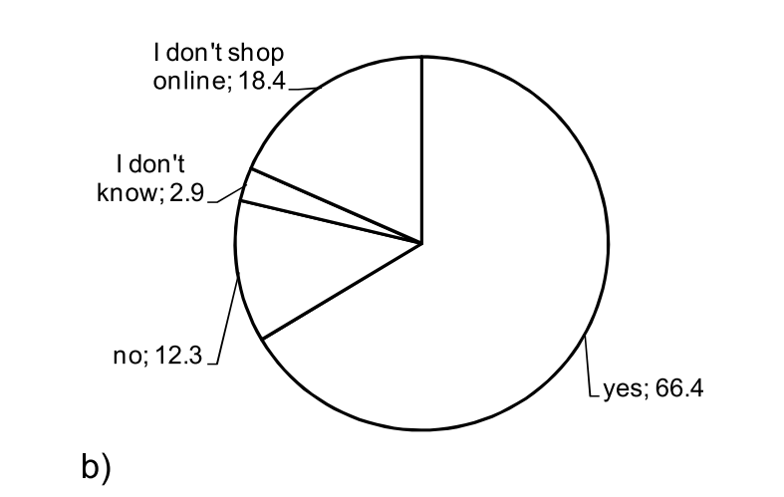
Figure 1b from https://doi.org/10.2478/cqpi-2020-0001

