THE IMPORTANCE AND TRENDING OF IT PROJECT MANAGEMENT
Shahril Bin Saiful Bahri ¹, Gui Yu Xuan ², Phang Cheng Yi ³, Nurzarifah Binti Azizan⁴
¹ Shahril Bin Saiful Bahri, School of Computing, Faculty of Engineering, Universiti Teknologi Malaysia.
² Gui Yu Xuan, School of Computing, Faculty of Engineering, Universiti Teknologi Malaysia.
³ Phang Cheng Yi, School of Computing, Faculty of Engineering, Universiti Teknologi Malaysia.
⁴Nurzarifah Binti Azizan, School of Computing, Faculty of Engineering, Universiti Teknologi Malaysia.
Abstract
This article is for people to understand and to use project management while doing project. This article will outline the importance and trending of project management. Project have own characteristics to help us to complete the project. There exists a method called PRINCE 2 for project management. A few stages in project management will help us avoid confusion to a project too. Besides that, there are seven elements in the trending of IT Project Management.
- INTRODUCTION
IT Project Management is the process of managing the plan, organization, and accountability to achieve information technology goals. The title of industry talk is The Importance and Trending of IT Project Management. This talk was given by Mohd Khairul Reeza Ruslan, PRINCE 2, MoP, Head of Project Management Office Commerce Dot Com Sdn Bhd on 1st December 2020, from 10am until 11am.
- IT PROJECT MANAGEMENT
- The Importance of IT Project Management
Mr Khairul said that a project is a one-time job defined by time, cost and quality. A project done with a few characters such as time, cost, quality, scope, risk and benefits. By these characters we can outline the problem and important parts of the project. Thus, the project can be completed effectively and efficiently.
Mr Khairul explained and showed us the example of the portfolio, programme, and project. Project is a unit of its own to achieve specific goals of the target. A few projects contribute to a big target is a programme. A portfolio is the contribution of programmes to a big target.
According to Mr Khairul, project management is the application of knowledge, skills, tools and techniques to project activities to meet the project requirement. Mr Khairul also explained that PRINCE 2 is a method for project management to maintain the effectiveness of the process. There are seven principles in PRINCE 2 such as continued business justification, learn from experience, defined rules and responsibilities, manage by

stages, manage by exception, focus on product and tailoring to suit the project environment.
There are a few stages in IT Project Manager such as initiation, planning, execution, monitoring and closing to tailor the process by scaling down the process to the minimum requirement.
In conclusion, the project management is important to create a clear plan to manage the quality and control cost and time to produce a satisfied product.

B. Trending of IT Project Management

Project Management is flexible as it can be applied anywhere at any time. As stated by Mr Khairul, there are seven elements in the trending of IT Project Management. First is the Gig Economy, which is a type of job like short-term contracts and freelance work. The job has risk but the pay is still high. It also consists of time, people and task management to ensure the work flows smoothly. Second element is focus on data (BiG Data). It is important to analyze data as data is very crucial and the key to the development of the projects. Next, automation and Artificial Intelligence such as drones and it is better learn and familiarise with AI as it can give efficient results to the project that suits the best. Fourth, the change management where at the end of every project there must be something to implement so we need to plan it well as well as adapt and adjust to the process. Fifth, the method melding that defines the project industry complex to combine into a single method. Then, the tools and solutions that direct project planning such as the use of online tools to communicate as it is not something new and people need to get used to it. Last, the importance of EQ that will determine whether we succeed or not in every aspect and to increase the soft skills.
Fig.1. Figure 1 shows that you can achieve a big project by planning your steps carefully such as product, risk, time, result, etc. For example, we can use the 7 principles of PRINCE2 to guide us to produce better products.
ACKNOWLEDGEMENT
We would like to thank the lecturers of Technology and Information System by organizing the Industry Talk to give us knowledge regarding to IT Project Management. We would like to thank our lecturer, Dr Azurah A Samah by giving suggestions to this article.
REFERENCES
[1] [Untitled illustration of big project]. Big Project. Retrieved on December 13,2020, from https://ugc.futurelearn.com/uploads/images/6e/79/header_6e792c78-6647-454f-876f-fa1b475fcda6.jpg
[2] IT Project Management. (2020). Retrieved on 13 December 2020, from https://www.smartsheet.com/content-center/best-practices/project-management/project-management-guide/project-management-IT#:~:text=Software%20Development-,What%20Is%20IT%20Project%20Management%3F,can%20be%20large%20and%20complex.
[3] Kate Eby. (2018, May 29). Demystifying the 5 Phases of Project Management. Retrieved on 13 December 2020, from https://www.smartsheet.com/blog/demystifying-5-phases-project-management#:~:text=Developed%20by%20the%20Project%20Management,%2Fmonitoring%2C%20and%20project%20close.
[4] Technology and Information System. (2020, December 1). The Importance and Trending of IT Project Management. [Video]. Webex. https://utm.webex.com/recordingservice/sites/utm/recording/playback/1f7c1229a78448648c63a11cd72bd8ba

- FIGURE

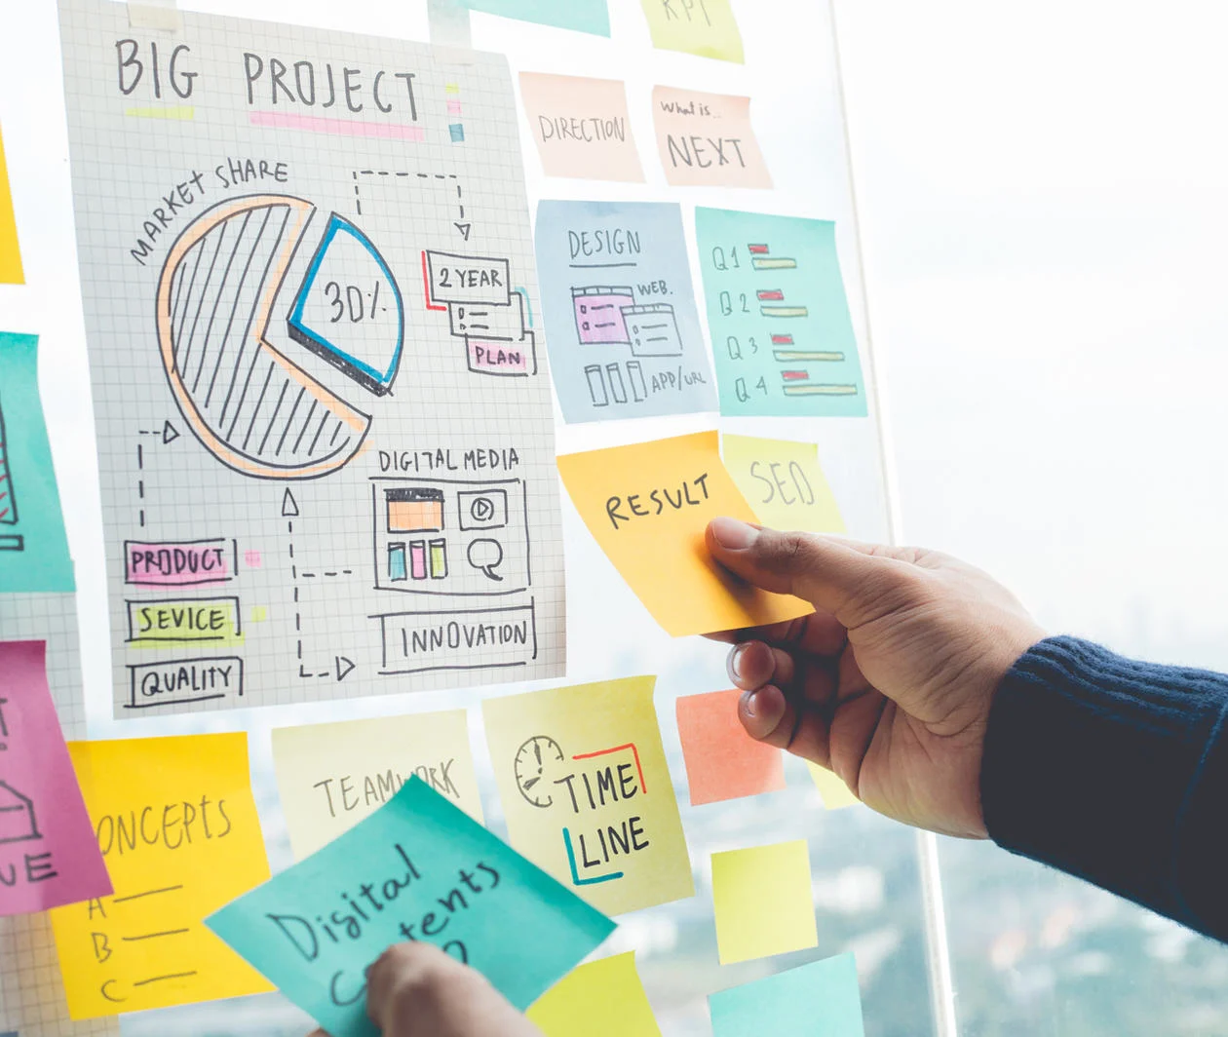
III. RELEVANT IT CAREERS

According to Mr. Khairul, the most important thing in the career prospect is oneself no matter what occupation we engage in. For instance, we could be a project manager, developer or programmer, but the point to be successful is the knowledge, skills, attitudes and determination that we equipped ourselves to face the challenge in future. For a project manager, leadership is important to lead, guide and solve any problems that will arise in the progress of a project.

IV. REFLECTIONS
- Shahril’s
Through this talk, I aspire to become more focused on doing my degrees so I can achieve my goal becoming programmer. Mr Khairul had opened my eyes and with that I shall commit my fullest towards any project that is given to me in the future, and we should cooperate to further improve our project.

- Yu Xuan’s
IT Project Management simplify the process of project. Through this talk, I learn more about project management and how to use it effectively. It will help me to improve my organizing skill since project management is a process of managing a plan. By this skill, I can complete a project easily.

- Cheng Yi’s
I hope that I could become a successful programmer and project manager no matter in any field. Mr. Khairul has inspired me on how to manage a project well by applying 7 principles. I need to enhance my soft skills and hard skills that can improve the project management in future.

- Zarifah’s
My goal is that I can increase my professional knowledge and attain new experiences. Throughout this talk, I gained a lot of things on project management and the importance of improving my skills in many aspects such as on emotional intelligence that can set a good quality degree. So, I need to analyse and manage well on my plan in succeeding any project in the future regardless of the consequences.

