
Semester I 2020/2021

Subject : Technology and Information Systems (SECP1513)
Section : 01
Assignment : Step by step PC assembly

GROUP NAME/ NUMBER:
1 |  | Name: Shahril Bin Saiful Bahri  Matric Number: A20EC0144  Phone Number: 0192332195  E-mail: shahril5822@gmail.com/ shahril01@graduate.utm.my
2 |  | Name: Gui Yu Xuan  Matric Number: A20EC0039  Phone Number: 0166291961  E-mail: guixuan@graduate.utm.my
3 |  | Name: Phang Cheng Yi  Matric Number: A20EC0131  Phone Number: 0178268313  E-mail: phangyi@graduate.utm.my
4 |  | Name: Nurzarifah Binti Azizan  Matric Number: A20EC0127  Phone Number: 0197766620  E-mail:  nurzarifah01@graduate.utm.my

PART A

- Screwdrivers
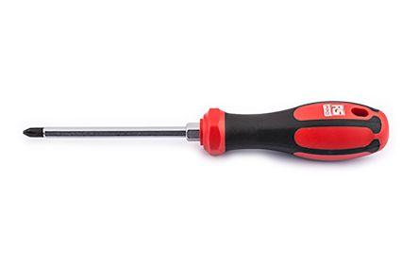

The screwdrivers are used to install and remove the screw and the importance of screwdrivers are to build up the PC. Without screwdrivers, we cannot close the case of PC and install the components of PC.

- Needle Nose Pliers
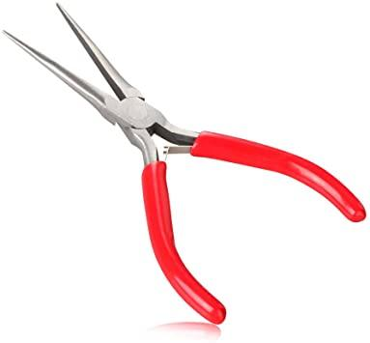

The needle nose pliers are used to handle the cables and wires easily and the importance of needle nose pliers are to bend and reposition the cables and the wires.

- Cable Ties
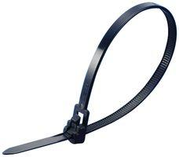

The cable ties are used to bundle the cables and wires neatly and the importance of cable ties are to keep the cables and wires organize so that they will not damage to the components.

- Table Lamp
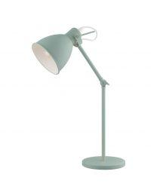

The table lamp is used to provide light source when we are building the PC. The importance of the table lamp is to prevent us to work in the dark situation.

- Thermal Paste


The thermal paste is used to eliminate the space on the CPU and the importance of thermal paste is to maximize the heat transfer so that CPU can run the process in optimal temperature.

- Screw Board
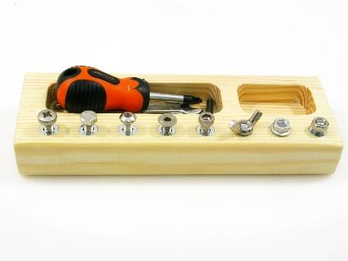

The screw board is used to store the screws and the importance of screw board is to prevent the loss of the screws.

PART B

1.0 SKETCH DIAGRAM MOTHERBOARD

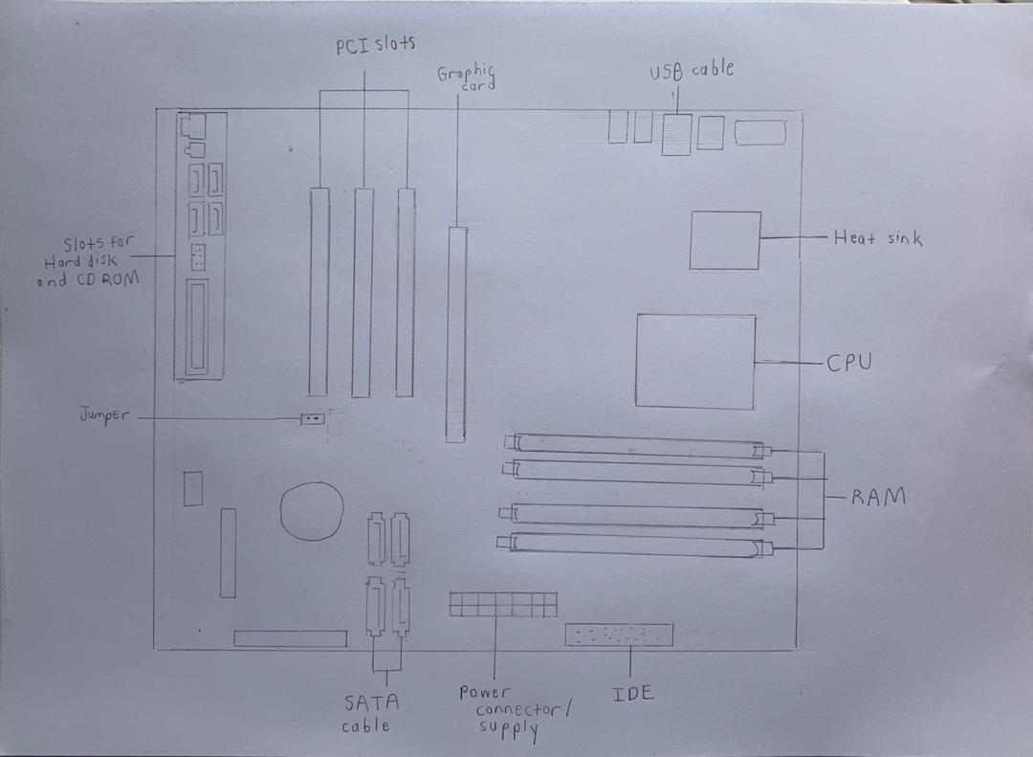

Diagram 1.0

2.0 For each keyword in Table 1.0. Provide picture(s), explanations of its functions and example of models.

PICTURES AND EXAMPLE OF MODELS | FUNCTIONS
CPU /Processor  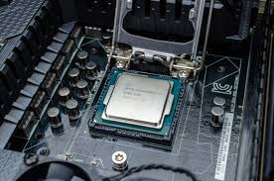  Model : AMD A6 9500 CPU Processor (1MB Cache, 3.5GHz, Socket AM4, 6 Cores)  Intel® Core™ i5-1035G1 Processor  Types: Single-Core CPU, Dual-Core CPU, Quad-Core CPU, | To fetch, decoding, and executing program instructions as well as performing mathematical and logical calculations
Heat sink  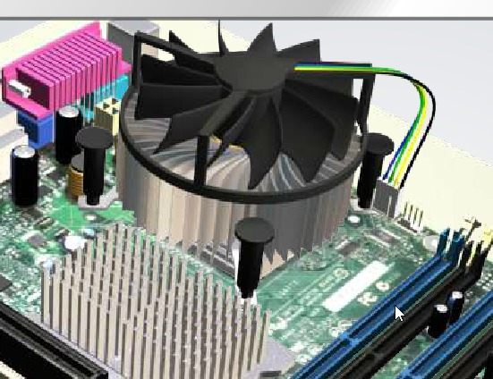  Model :Intel Socket 775 CPU Heatsink Fan  Types: Active Heat Sink, Passive Heat Sink | To cool down integrated circuits in computer systems and processor
RAM  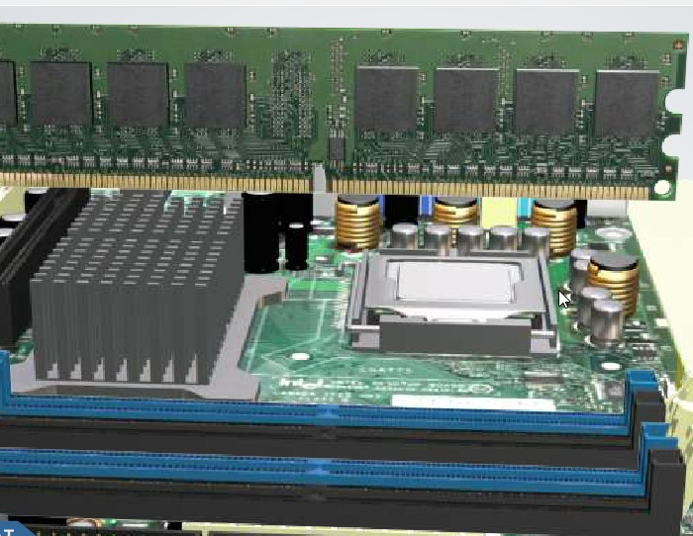  Model: 2 x 240-pin DIMM sockets /  2x DDR3 1600, 1333, 1066 MHz  Types: SRAM (Static RAM), DRAM (Dynamic RAM) | To provide temporary storage space for data and program code but data loss will occur once it loses power. RAM allows computers to perform many of its everyday tasks such as loading applications, browsing the internet, editing spreadsheets and experiencing the latest game. Memory also allows faster tasks switching among these tasks.
Power supply  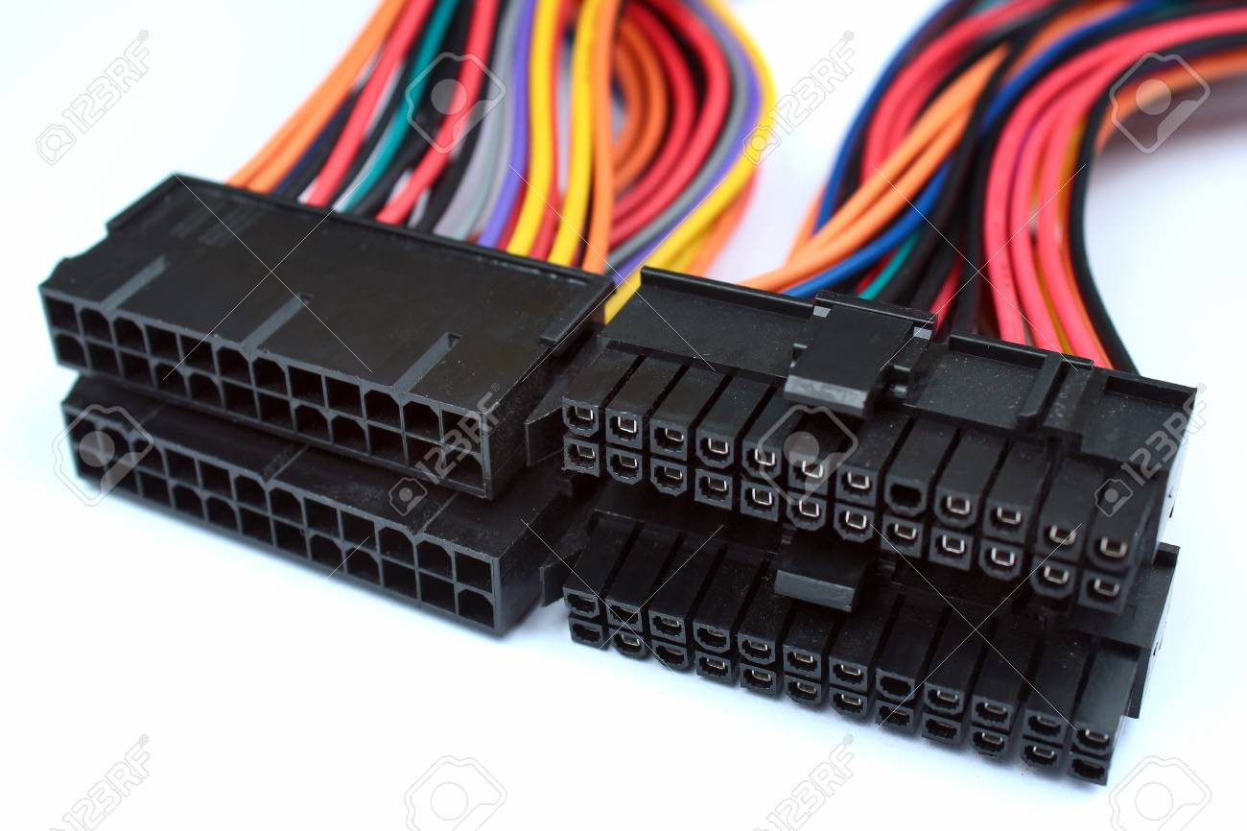  Model :1x 8pin power connector, 1x 24pin power connector  Types: ATX, ATX12V, EPS12V, SFX12V | To provide electrical current power to various components in the computer case
Slots (IDE, PC)  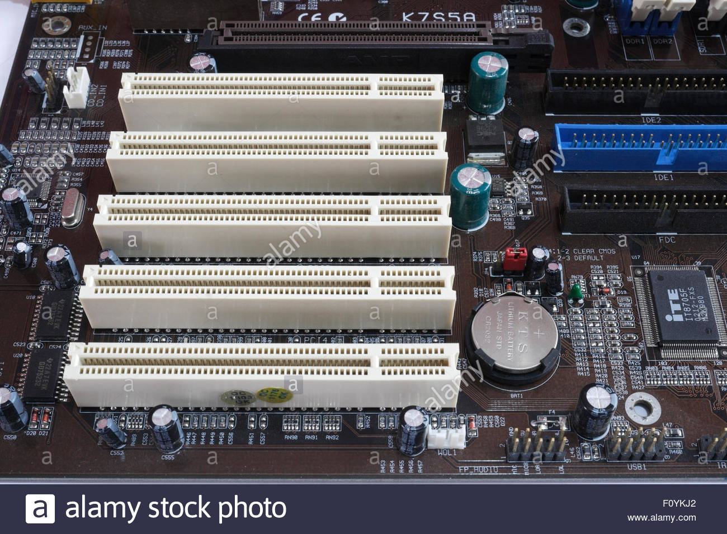  Model : PCI Express x16  Types of IDE: PATA (Parallel ATA), SATA (Serial ATA)  Types of PCI: PCIe x1 slot, PCIe x4 slot, PCIe x8 slot, PCIe x16 slot, PCIe x32 slot | IDE:  As an interface for connecting a motherboard to storage devices such as hard drives and CD-ROM  PCI:  Provide additional I/O ports on the back of a computer and allows to insert expansion cards to the motherboard
CD ROM  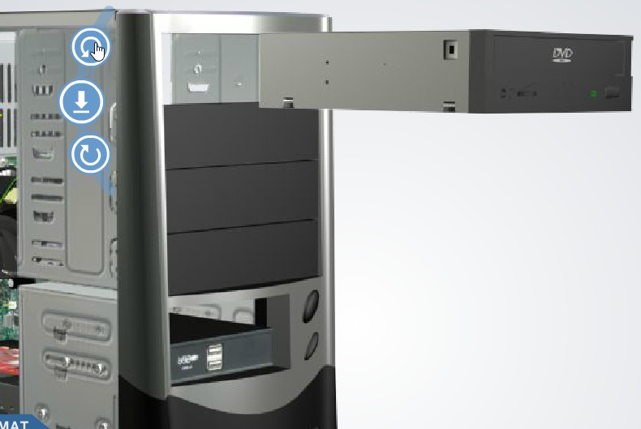  Model : Dell HL Data Storage 48X CD-Rom 16X DVD-Rom SATA Optical Drive DH50N YTDV4 5.25  Type: CD-R, CD-RW | Function as compact disc that stores computer data of graphics, text and audio
IDE cable  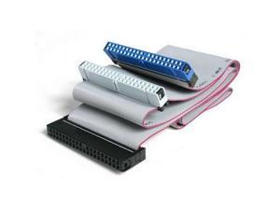  Model : Original Asus IDE Ribbon Cable 40 Pin 3 Plugs For 3.5 inch Hard Drives or CD/DVD Players  Type: IDE 34 pin Cable, IDE 40 pin Cable | To connect from the motherboard of a computer to the hard drive, cd drive and/or floppy drive
USB cable  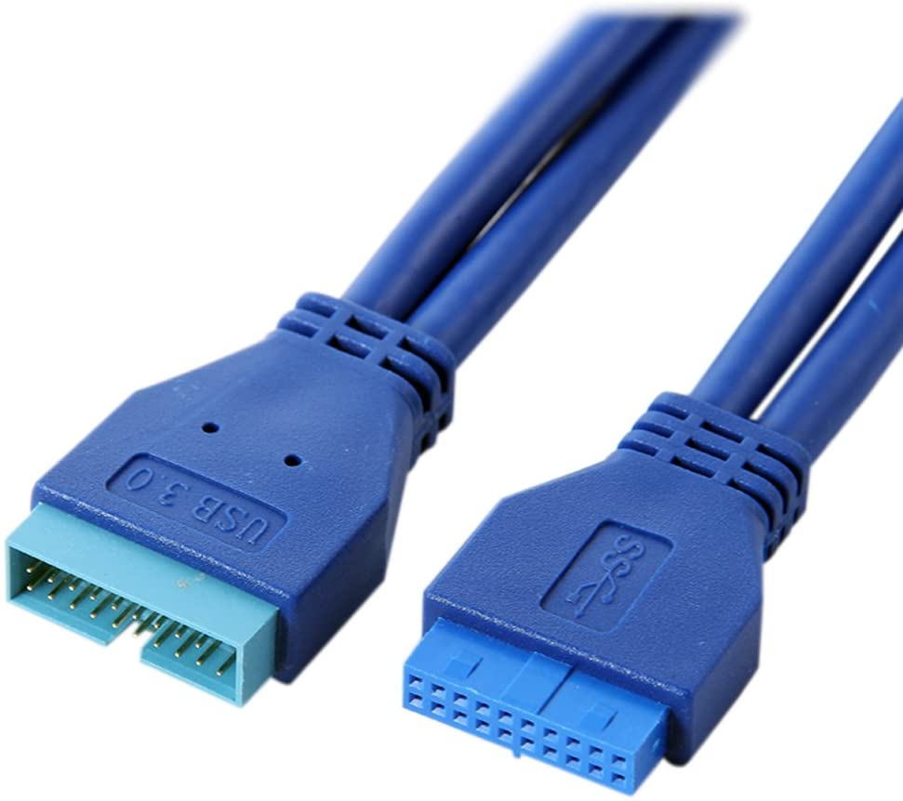  Model :19-pin to 2x USB-A (3.0/5Gbps)  USB 2.0  Type: USB-A, USB-B, USB-C, Mini-USB,  Micro-USB, USB 3 | USB cable:  -to connect computers to peripheral devices  USB port:  -Allow USB devices to be connected to each other with and transfer digital data through USB cables.  -To supply electric power across the cable to devices.
Hard disk (jumper settings either master or slave)  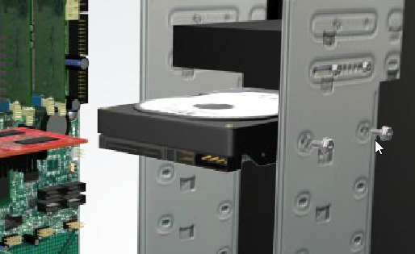  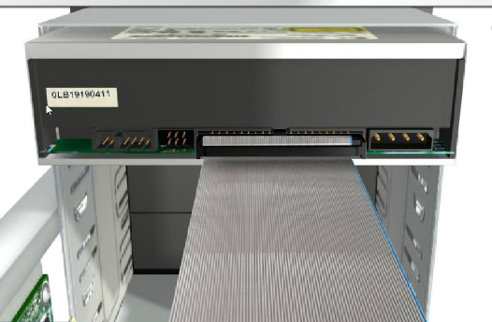  Model : 1x M.2 slot with NVME/SATA mode conversion jumper  Type: Internal Hard Disk, External Hard Disk | To store data such as computer's operating systems, application, documents and personal files for long term
SATA cable  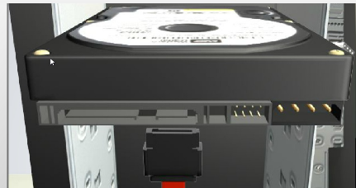  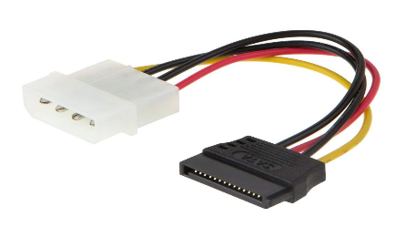  Model : Asus 3.0 SATA III Data Cable 6Gbps SSD Hard Disk Cable  Type: E-SATA, Low Profile SATA, Micro SATA, SATA Bracket, SATA Bridge, SATA Power, SATA-SATA | As a computer bus interface that connects host bus adapter to mass storage devices such as hard disk drives, optical drives and solid-state drives
Graphic card  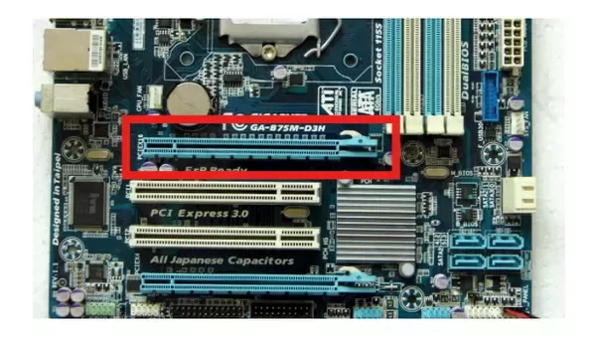  Model: RTX 2080 Ti, RTX 2080 Super  Type: Integrated Graphic Card, PCI Graphic Card, AGP Graphic Card, PCI-Express Graphic Card | To rendering an image to computer monitor by converting data into a signal that monitor can understand

PART C

Step 1 - CPU installation
- match the golden triangle on the corner of the CPU with the triangle on the socket. Do not touch or push the CPU. Drop down the CPU to the socket on motherboard.

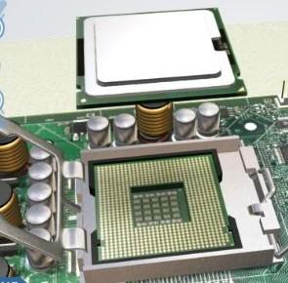

Step 2 - Heat sink installation
- Apply the thermal paste on CPU, then lower the heat sink on the top of CPU by lining the hole on the motherboard. Hold the heat sink on the top of the CPU and screw in screws in a X pattern to avoid uneven thermal paste.

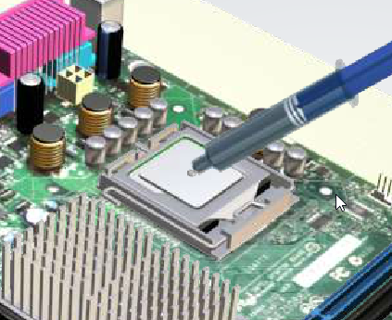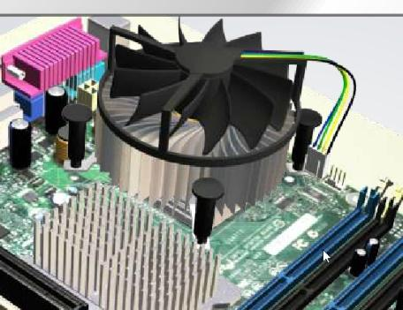

Step 3 - Memory installation
- Check up for the correct slots to install the RAM. Unlock the slot on motherboard by pushing the RAM socket then insert the RAM into the slot by pressing and lastly lock the slot. If you have two RAM, make sure you follow the manual and do not place both RAM side by side to avoid low memory.
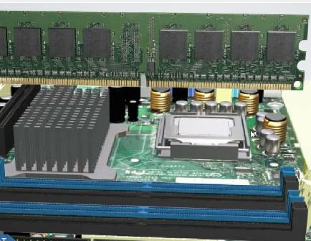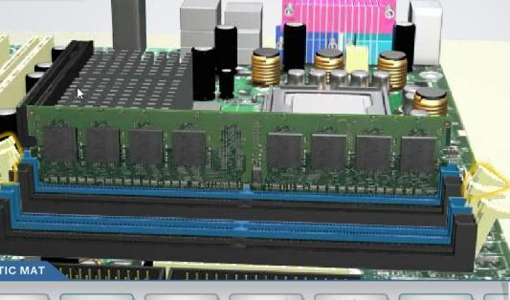

Step 4 - Motherboard installation
- Install Motherboard IO shield first before install motherboard. Install the standoffs into different hole by attach standoff socket in the case. Then, carefully lower the motherboard and fit into the port. Double check to ensure the ports are line properly.
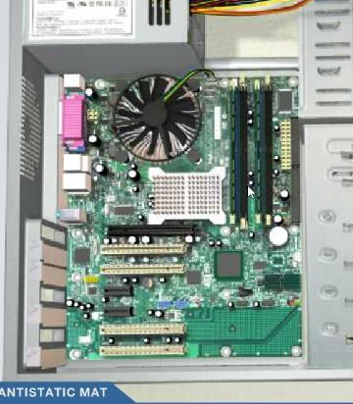

Step 5 - Power supply installation
- Facing power supply down if the case has ventilation slot. Connect the cables to power supply. Grouping the cables together and push them through the backside of the power supply mounting area. Slot in the power supply and screw it.

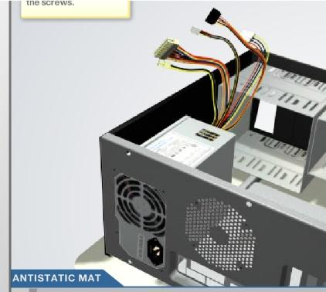

Step 6 - Hard disk and SSD installation
- Fit the hard disk and SSD into the cases and screw the cases to secure the hard disk. Then, connect the hard disk and SSD with the SATA power cable and data cable to the power supply and the motherboard.

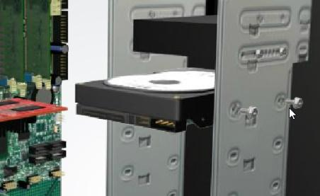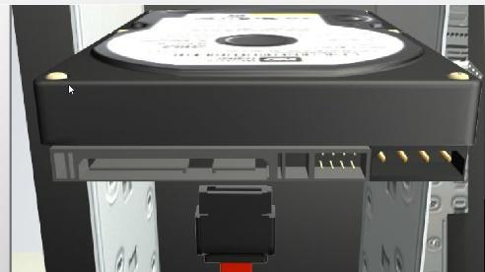

Step 7 - CD-ROM installation
- Remove the CD-ROM drive bay cover and insert the CD-ROM inside the drive bay. Connect the CD-ROM drive with the SATA power cable and data cable to the power supply and the motherboard. Apart of that, connect CD-ROM drive with the IDE cable to the power supply and the IDE slot on the motherboard.
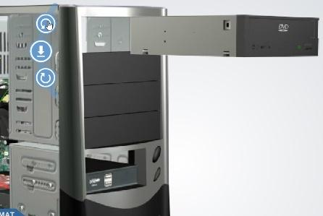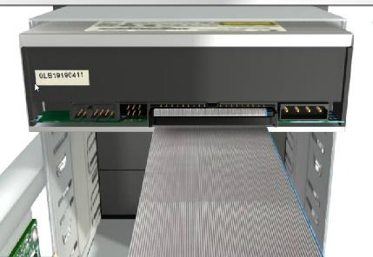

Step 8 - BUTTONS
- Make sure your I/O power buttons are working properly, double the check the wires that been plug in, identify the pins and cables need connecting. Plug in USB 3.0 header and USB 2.0 Header. Install USB 3.0 cable into the available slots on the motherboard.
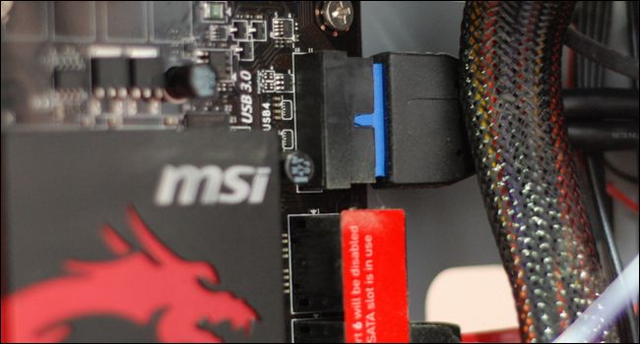

Step 9 - Power cable
- Identify the 8-pins EPS cable and 24-pin cable and connect to the 8-pin power slot and 24-pin ATX power port of the motherboard respectively. Get SATA power to be connected to your storage. Thread the PCIe power cable so that we can be ready to install the graphic card.
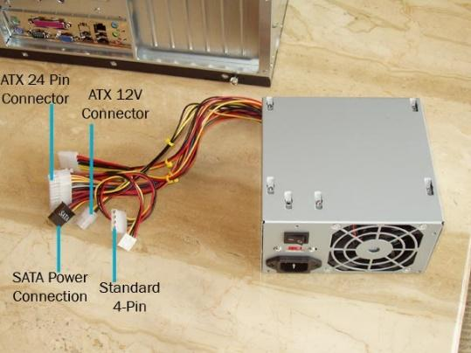

Step 10 - GRAPHIC CARD
- Locate the 2 PCIe slots and remove the screws. I/O of the graphic card should be facing out the back of the chassis. The gold contacts on the graphic card must touch the PCIe slot and gently push until you hear a click. Then plug in the PCIe power.
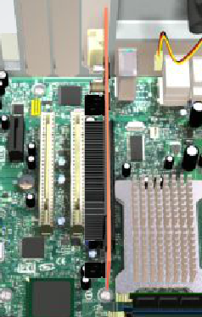

Step 11 - Closing the case and connecting to peripheral devices.
- After that you are all set to install the operating system that you may like.
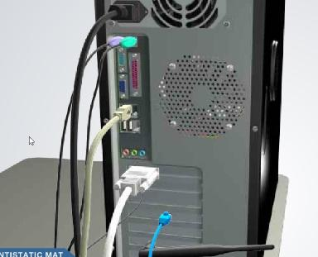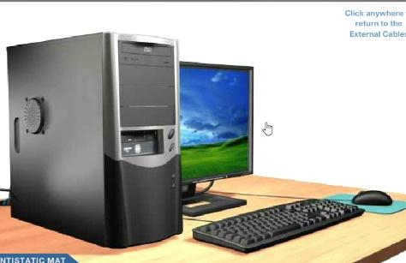

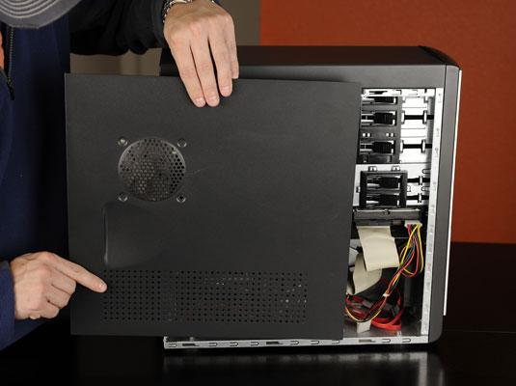  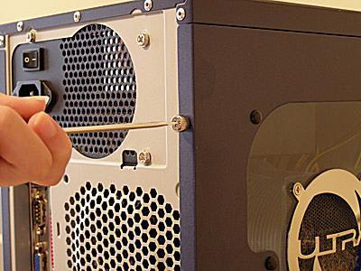 | Place the side cover back on and secure the side panels with case screws.
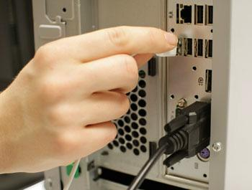 | Connect keyboard with CPU by plugging into USB port.
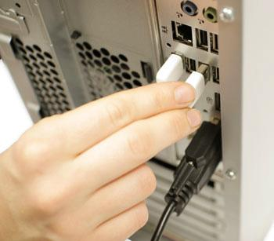 | Connect mouse with CPU by plugging into USB port.
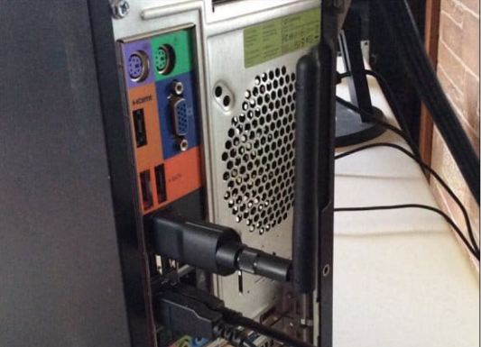 | Connect wireless network dongle with CPU by plugging into USB port.
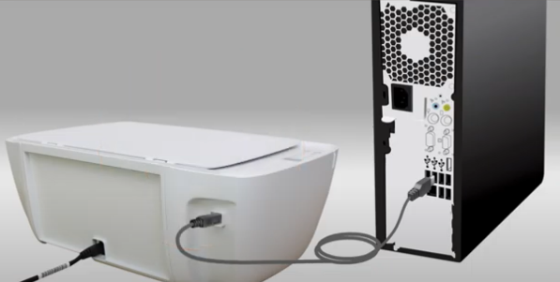 | Connect printer with CPU by plugging into USB port.
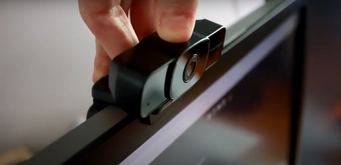  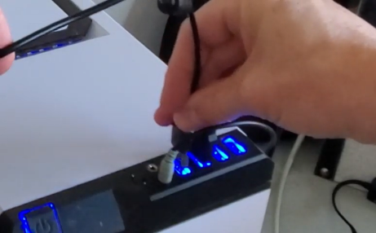 | Connect webcam with CPU by plugging into USB port.
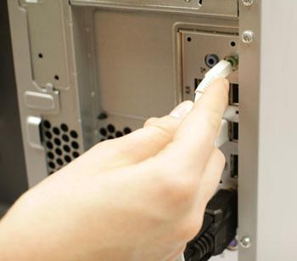 | Connect speaker and microphone into 2.5mm socket.
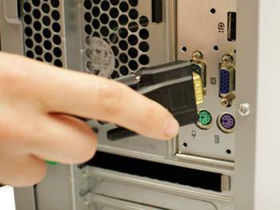 | Connect the CPU with monitor by plugging into monitor port.

Reference

[Untitled illustration of a cable ties]. Cable Ties. Retrieved on 17 November 2020, from https://www.google.com/search?q=cable+ties&tbm=isch&ved=2ahUKEwjqgNa8uqftAhUBiEsFHbwcBqIQ2-cCegQIABAA&oq=cable&gs_lcp=CgNpbWcQARgAMgQIIxAnMgQIABBDMgQIABBDMgQIABBDMgQIABBDMgQIABBDMgQIABBDMgQIABBDMgQIABBDMgcIABCxAxBDOgUIABCxA1DA2wFYzOIBYNXtAWgAcAB4AIABgAGIAZIEkgEDMi4zmAEAoAEBqgELZ3dzLXdpei1pbWfAAQE&sclient=img&ei=DmzDX-rBM4GQrtoPvLmYkAo&bih=601&biw=642
[Untitled illustration of a computer case]. Computer Case. Retrieved on 22 November 2020, from https://www.google.com/search?q=Place+the+side+cover+back+on+and+secure+the+side+panels+with+case+screws.&sxsrf=ALeKk03nlgGw3QdcwzdZNx-HLirwxLZ6UA:1606009444207&source=lnms&tbm=isch&sa=X&ved=2ahUKEwjD4LWzg5XtAhX8yDgGHQFHBwsQ_AUoA3oECAUQBQ&biw=1280&bih=610
[Untitled illustration of a CPU/Processor]. CPU. Retrieved on 26 November 2020, from https://www.google.com/url?sa=i&url=https%3A%2F%2Fwww.pcworld.com%2Farticle%2F2960805%2Fhow-to-replace-your-pcs-motherboard.html&psig=AOvVaw3AsYVutF5GZfysSJSpq6xJ&ust=1606741064261000&source=images&cd=vfe&ved=0CAIQjRxqFwoTCJjN74jnp-0CFQAAAAAdAAAAABAD
[Untitled illustration of a IDE cable]. IDE cable. Retrieved on 26 November 2020, from https://www.google.com/url?sa=i&url=https%3A%2F%2Fhelmetdon.in%2Fproducts%2Fa-adee-ide-cable-flat-for-data-transfer-motherboard-to-harddisk-or-hdd&psig=AOvVaw3g24lsKuY1ErHKV9mxj2sO&ust=1606741228272000&source=images&cd=vfe&ved=0CAIQjRxqFwoTCIjB7NXnp-0CFQAAAAAdAAAAABAE
[Untitled illustration of a needle nose pliers]. Needle Nose Pliers. Retrieved on 17 November 2020, from https://www.google.com/search?q=needle+nose+plier&tbm=isch&ved=2ahUKEwjw3LutuaftAhX37TgGHXSeDIcQ2-cCegQIABAA&oq=needle&gs_lcp=CgNpbWcQARgAMgQIIxAnMgQIIxAnMgcIABCxAxBDMgQIABBDMgIIADICCAAyAggAMgIIADICCAAyAggAOgUIABCxA1DNkBJY65cSYKOjEmgAcAB4AIABhgGIAZQFkgEDMi40mAEAoAEBqgELZ3dzLXdpei1pbWfAAQE&sclient=img&ei=4mrDX_DjH_fb4-EP9LyyuAg&bih=601&biw=642
[Untitled illustration of a Power Supply]. Power Supply. Retrieved on 26 November 2020, from https://www.google.com/url?sa=i&url=https%3A%2F%2Fwww.123rf.com%2Fphoto_100401701_pc-motherboard-power-cables-and-connectors.html&psig=AOvVaw1o2QzqZrB2TjUT8dYpPW1W&ust=1606741132639000&source=images&cd=vfe&ved=0CAIQjRxqFwoTCKCN3qfnp-0CFQAAAAAdAAAAABAD
[Untitled illustration of a SATA cable]. SATA cable. Retrieved on 26 November 2020, from https://www.google.com/url?sa=i&url=https%3A%2F%2Fwww.lifewire.com%2Fserial-ata-sata-2626009&psig=AOvVaw0HzQuQAOIFB5Tlx_H2Csln&ust=1606741326248000&source=images&cd=vfe&ved=0CAIQjRxqFwoTCMiZ_oTop-0CFQAAAAAdAAAAABAD
[Untitled illustration of a screw board]. Screw Board. Retrieved on 17 November 2020, from https://www.google.com/search?q=screw+board&tbm=isch&ved=2ahUKEwjSl8_8uqftAhXJA3IKHcsIBk4Q2-cCegQIABAA&oq=screw&gs_lcp=CgNpbWcQARgBMgQIIxAnMgQIIxAnMgcIABCxAxBDMgIIADICCAAyAggAMgIIADICCAAyAggAMgIIADoECAAQQzoFCAAQsQNQoO0BWLzzAWCt_AFoAHAAeACAAY0BiAHdBJIBAzIuM5gBAKABAaoBC2d3cy13aXotaW1nwAEB&sclient=img&ei=lGzDX9L9OcmHyAPLkZjwBA&bih=601&biw=642
[Untitled illustration of a screwdriver]. Screwdriver. Retrieved on 17 November 2020, from https://www.google.com/search?q=screwdriver&sxsrf=ALeKk006XQiIGjMRyZ-VabVT1Q_n8cCv-A:1606642244783&source=lnms&tbm=isch&sa=X&ved=2ahUKEwjD3p_iuKftAhXTpOkKHRk6AzoQ_AUoAXoECAwQAw&cshid=1606642400302310&biw=642&bih=601#imgrc=AjaGHe7Giwrg5M
[Untitled illustration of a Slots (PCI)]. Slots PCI. Retrieved on 26 November 2020, from https://www.google.com/url?sa=i&url=https%3A%2F%2Fwww.alamy.com%2Fstock-photo%2Fpci-slots.html&psig=AOvVaw06j-aqJrrwSWEeN9boqxR4&ust=1606741186501000&source=images&cd=vfe&ved=0CAIQjRxqFwoTCOD808Hnp-0CFQAAAAAdAAAAABAD
[Untitled illustration of a table lamp]. Table Lamp. Retrieved on 17 November 2020, from https://www.google.com/search?q=table+lamp&tbm=isch&ved=2ahUKEwietuLLuqftAhVXOisKHStEBpwQ2-cCegQIABAA&oq=table+lamp&gs_lcp=CgNpbWcQAzIECCMQJzICCAAyAggAMgIIADICCAAyAggAMgIIADICCAAyAggAMgIIADoHCCMQ6gIQJzoECAAQQzoICAAQsQMQgwE6BQgAELEDUJXlAVjg8wFg4PYBaAFwAHgAgAFxiAHMB5IBAzYuNJgBAKABAaoBC2d3cy13aXotaW1nsAEKwAEB&sclient=img&ei=LmzDX57nHtf0rAGriJngCQ&bih=601&biw=642
[Untitled illustration of a thermal paste]. Thermal Paste. Retrieved on 17 November 2020, from https://www.google.com/search?q=thermal+paste&tbm=isch&ved=2ahUKEwjq6tLbuqftAhUJCXIKHW3ADDMQ2-cCegQIABAA&oq=ther&gs_lcp=CgNpbWcQARgAMgQIIxAnMgQIABBDMgcIABCxAxBDMgQIABBDMgQIABBDMgcIABCxAxBDMgUIABCxAzIFCAAQsQMyAggAMgIIAFDG_gNYzIoEYI6UBGgBcAB4AIABa4gB6gOSAQMzLjKYAQCgAQGqAQtnd3Mtd2l6LWltZ8ABAQ&sclient=img&ei=T2zDX6qHMYmSyAPtgLOYAw&bih=601&biw=642
[Untitled illustration of a USB cable]. USB cable. Retrieved on 26 November 2020, from https://www.google.com/url?sa=i&url=https%3A%2F%2Fwww.amazon.com%2FUCEC-MotherBoard-Female-Extension-Cable%2Fdp%2FB00UBFXBTG&psig=AOvVaw11fJvERHcplrcB-aLRXj0Q&ust=1606741285667000&source=images&cd=vfe&ved=0CAIQjRxqFwoTCKDorPPnp-0CFQAAAAAdAAAAABAD
Administrator. (2018, 22 November). What is a Heat Sink? Heat Sink Types. Retrieved on 29 November 2020, from https://www.electronicshub.org/heat-sink/
Angelo Maceri. (2009, 22 November). 4 Types of Graphics Cards. Retrieved on 29 November 2020, from https://www.doityourself.com/stry/4-types-of-graphics-cards
Basics 10: Setting Up a Computer. Retrieved on 22 November 2020, from https://canvas.instructure.com/courses/955530/assignments/3758440
Cisco It Essentials Virtual Desktop. [Computer Software]. (2018). Retrieved on 23 November 2020, from https://victoryfasr829.weebly.com/cisco-it-essentials-virtual-desktop-pc-laptop-41-free-download.html
ComputerGeek. (2019, 26 June). What Are The Different Types of CPU or Processor? Retrieved on 29 November 2020, from https://www.computerhunger.com/what-are-the-different-types-of-cpu-or-processor/
Customcablebrett. (2015, 12 August). What is SATA Cable? What are different types of SATA Cables and which one do you need? Retrieved on 29 November 2020, from https://customcablesbrett.wordpress.com/2015/08/12/what-is-sata-cable-types-of-sata-cables-and-input/
HP Support. (2018, 23 October). Connect a USB HP Printer Using a Full Feature Driver in Windows| HP [Video file]. Retrieved on 22 November 2020, from https://www.youtube.com/watch?v=RHtYKefdZ7c
J.T. (2018, 13 August). Types of USB Cables and Their Uses. Retrieved on 29 November 2020, from https://www.cablewholesale.com/blog/index.php/2018/08/13/types-of-usb-cables-and-their-uses/
Kamau, P.(2020, 25 November). 10 Parts of a Motherboard and Their Function. Retrieved from 27 November, 2020, https://turbofuture.com/computers/the-motherboard-components
Kevin Lee, Zak Storey. (2020, 4 May). How to build a PC: a step-by-step guide to building the best PC. Retrieved on 24 November 2020, from https://www.techradar.com/sg/how-to/how-to-build-a-pc
Mark Coppock. (2019, 3 May). How to choose a PC power supply. Retrieved on 29 November 2020, from https://www.electronicshub.org/heat-sink/
Marsha James. (2017, 10 February). Types of CD ROM Drives. Retrieved on 29 November 2020, from https://itstillworks.com/types-of-cd-rom-drives-10408.html
Patrick Lathan, GamersNexus. (2016, 23 December). 5 TOOLS YOU NEED TO BUILD A PC. Retrieved on 17 November 2020, from https://blog.nzxt.com/tools-need-build-pc/
PC Power Supply. Retrieved from 27 November, 2020, https://powersupplypc.com/understanding-pc-power-supply-definition-and-function/
Rubens, P. (2019, 24 May) Random Access Memory: Fast, Short Term Memory. Retrieved from 27 November, 2020, https://www.enterprisestorageforum.com/storage-hardware/random-access-memory-ram.html#:~:text=A%20vital%20part%20of%20every,for%20data%20and%20program%20code.&text=Random%20access%20memory%2C%20RAM%2C%20provides,it%20expects%20to%20use%20imminently.
Sayan Kumar Pal. (2020, 13 February). Different Types of RAM (Random Access Memory). Retrieved on 29 November 2020, from https://www.geeksforgeeks.org/different-types-ram-random-access-memory/
Scharon Harding. (2020, 21 February). What is PCIe? A Basic Definition. Retrieved on 29 November 2020, from https://www.tomshardware.com/reviews/pcie-definition,5754.html#:~:text=PCIe%20slots%20come%20in%20different,at%20one%20bit%20per%20cycle.
Tim Fisher. (2019, 30 November). What is an IDE Cable? Retrieved on 29 November 2020, from https://www.lifewire.com/what-is-an-ide-cable-2625908#:~:text=IDE%2C%20an%20acronym%20for%20Integrated,other%20and%20to%20the%20motherboard.
Tyson, J. & Wilson, T.V. (2020). How Graphics Cards Work. Retrieved from 27 November, 2020, https://computer.howstuffworks.com/graphics-card.htm
Ultimate Tech Hub. (2020, 2 September). HOW TO INSTALL ANY WEBCAM – QUICK & EASY! [Video file]. Retrieved on 22 November 2020, from https://www.youtube.com/watch?v=oAGQaPxlPGs
Understanding Heat Sinks: Functions, Types & More. (2019, 31 October). Retrieved from 27 November, 2020, https://www.arrow.com/en/research-and-events/articles/understanding-heat-sinks-functions-types-and-more#:~:text=A%20heat%20sink%20is%20a,across%20its%20enlarged%20surface%20area.
What is a graphics card? Retrieved from 27 November, 2020, https://www.ebuyer.com/blog/2015/04/what-is-a-graphics-card/#:~:text=A%20Graphics%20Card%20is%20a,signal%20your%20monitor%20can%20understand.
What is a Hard Drive? -Types, Function & Definition. Retrieved from 27 November, 2020, https://www.assignmenthelp.net/assignment_help/what-is-hard-drive
What is a USB cable? Retrieved from 27 November, 2020, https://www.l-com.com/frequently-asked-questions/what-is-a-usb-cable

