
Semester I 2020/2021

Subject : Technology and Information Systems (SECP1513)
Section : _07_____________________
Assignment : Step by step PC Assembly

GROUP NAME / NUMBER : ___02_______
1 | Photo | Name :MD SIRAJUM MUNEER  Matric Number :A20EC4035  Phone Number:01162172660  E-mail :meemmeem477@gmail.com
2 | Photo | Name :Muhammad Najib bin Jamaludin  Matric Number :A20EC0215  Phone Number:+60125052174  E-mail :mailto:gazbiy16@gmail.com
3 | Photo | Name :MD.TAWFIQUZZAMAN  Matric Number :A20EC4036  Phone Number:+60186632805  E-mail :mailto:tawfiquzzaman1909@gmail.com

Part A
- 1. Wire cutters and strippers

The wire cutter and stripper is used to remove the insulation from electric wires for making contact .it is very important for assembling a pc. without this we can’t make contact with one wire to another wire .While assembling a pc ,we must need wire cutters and strippers so that we can make the wire to wire connections so easily.

- 2. Adjustable wrench
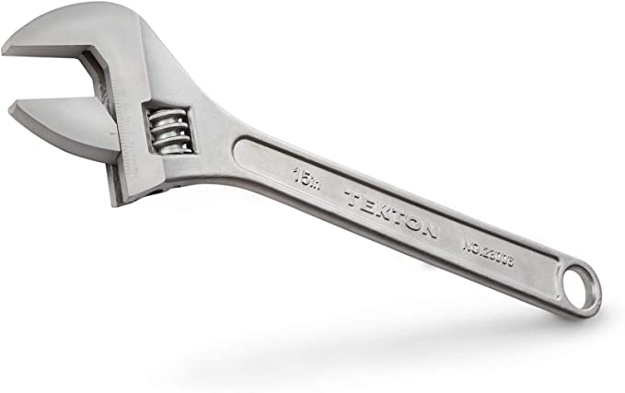
An adjustable spanner or adjustable wrench is an open-end wrench with a movable jaw which is commonly used with different size of nuts or bolts or fasteners . we often use this product while assembling a pc .we use this because when we assemble a pc we meet different sizes of fasteners .As it is a adjustable wrench, we can easily use it to fasten any kind of nuts or bolts .
- 3. Heat sink compound
- 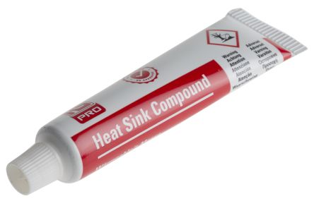
Heat sink compound is used to fill that gap and is made to efficiently transfer the heat from the heat generating component to the heat dissipating device. Without this the gap won’t be filled and the component will not work properly.
- 4. Small container to hold screws
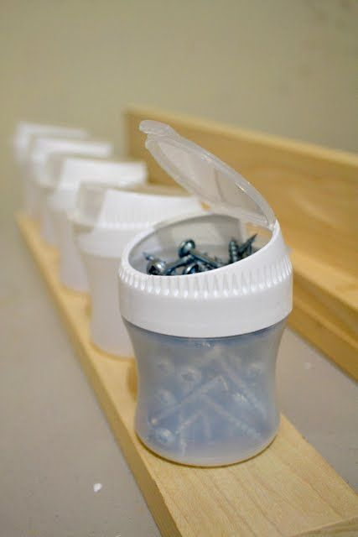
This is widely used to store screws .While assembling a pc ,we ,met different kind of screws, each have its own destination .If we use a small container and level them according to their size ,it would be easy for us to situate the screws according to its place . if we do so, it will make our work easier .

Part B

Sketch of a motherboard layout

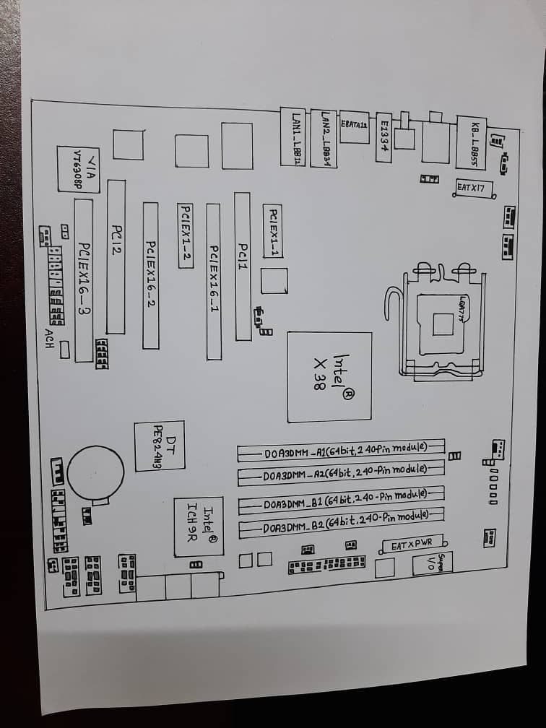

PART C
PC ASSEMBLY STEPS
STEP 1 CPU INSTALLATION
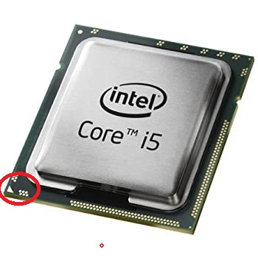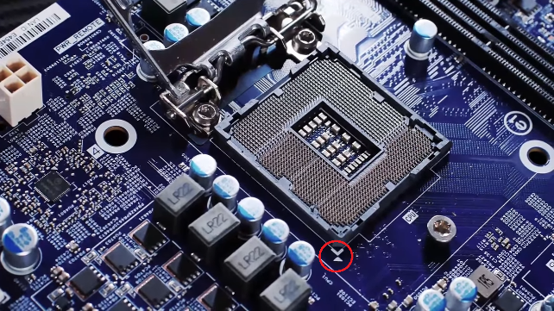
Prepare the motherboard for CPU installation. Match the triangle at corner of the CPU and the motherboard before inserting the CPU into the CPU socket on the motherboard. Insert the CPU gently into the socket.
STEP 2 RAM INSTALLATION
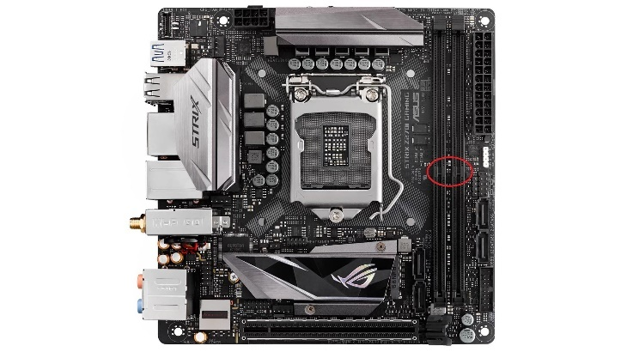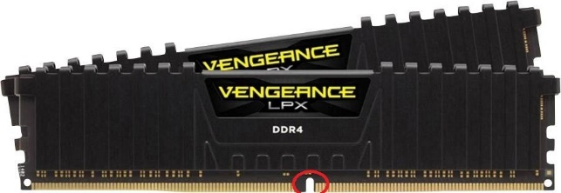
Open the tabs at the end of the RAM slot and line up the notches on the RAM with the RAM slot on the motherboard. Press both ends of the RAM until the tabs at the RAM slots closes. Repeat the same step for the 2nd RAM. If you’re only installing one RAM, use the 2nd RAM slot on the motherboard which is the furthest from the CPU socket.
STEP 3 CPU COOLER INSTALLATION
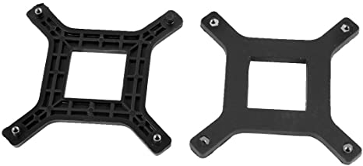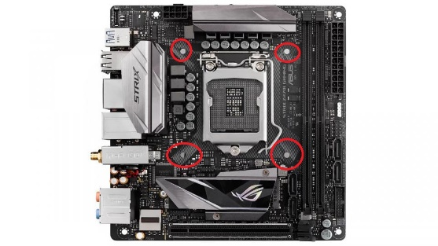
Install the backplate of the cooler on the backside of the motherboard through the holes on the motherboard before putting the cooler on the processor apply a small amount of thermal paste (size of a grain of rice) on the CPU. Install the cooler onto the CPU and use the screws given.

STEP 4 INSERTING MOTHERBOARD INTO THE CASE
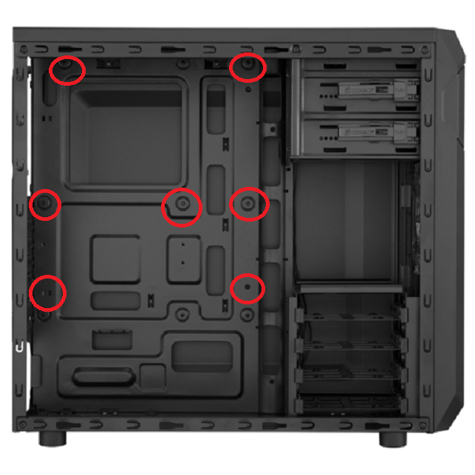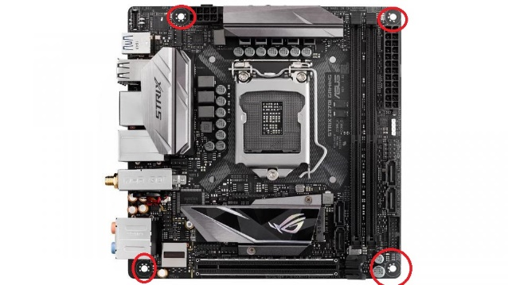
Insert the motherboard into the case by lining up the standoffs in the case with the holes on the motherboard
STEP 5 POWER SUPPLY INSTALLATION
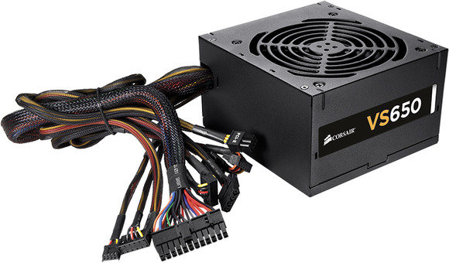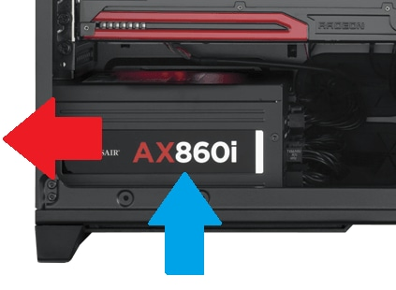
Install the power supply at the bottom part of the case and make sure the power supply fan is pulling the air into the power supply itself. Do not suffocate the fan as it can cause serious damage to the PC
STEP 6 STORAGE
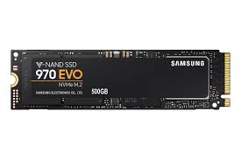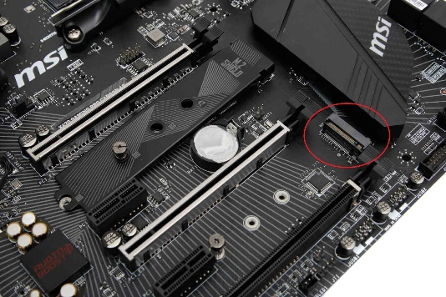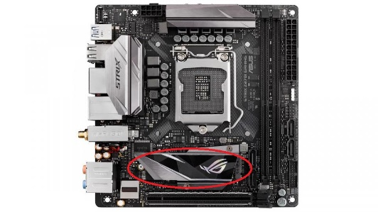
Some motherboards now can use m.2 SSD as storage with the operating system with higher boot speeds when opening your computer, you can install these on the m.2 slot on the motherboard.
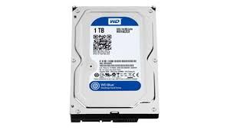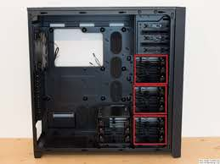
You can also use Hard Drives as an additional storage. Insert the Hard Drive in the Hard Drive tray in the computer case.
STEP 7 FAN INSTALLATION
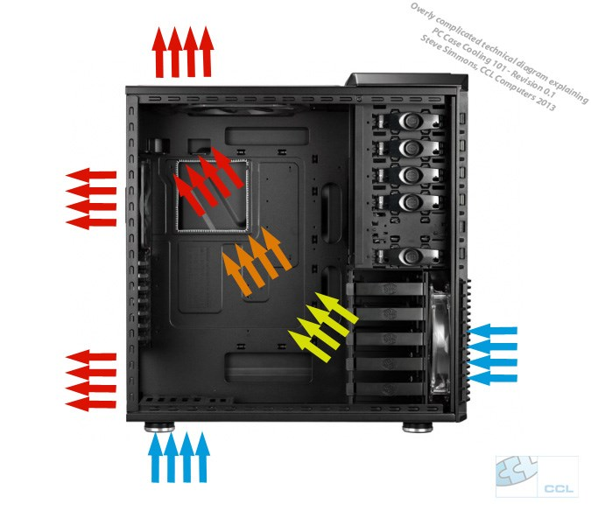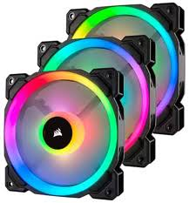
When installing the fans in the case, it is important to have a good airflow in the case. Install the fans with the arrows pointing into the case as air intakes and with arrows pointing out of the case as exhaust fans. The air intakes are labelled blue and the exhaust fans are labelled red.
STEP 8 GPU INSTALLATION
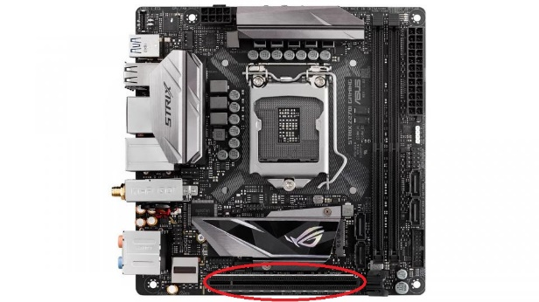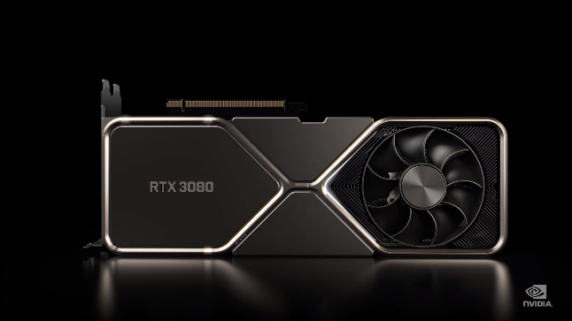
Some motherboards have integrated graphics so you don’t need to have a graphics card to display your output. But if you have a graphics card you can insert the card into the PCIE slot on the motherboard.

STEP 9 CABLE ROUTING
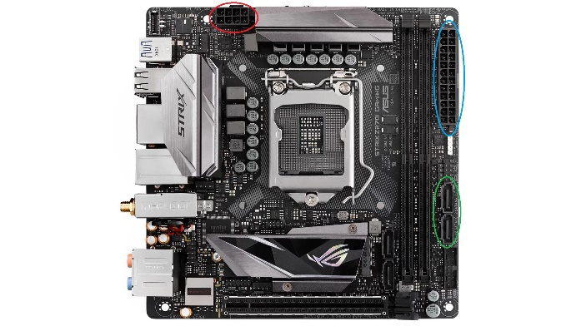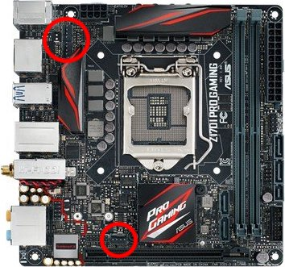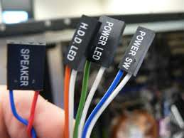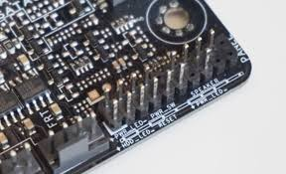
Fan Connectors
Front Panel Headers
Front Panel Connectors

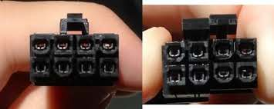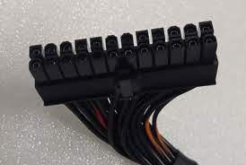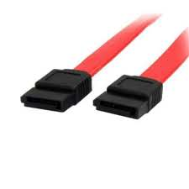
24 – Pin Connector
SATA connectors
CPU connector

Connect the 24-Pin power connector on the motherboard labelled blue, connect the CPU connecter on the motherboard labelled red, connect the SATA connectors on the motherboard labelled green and the hard drives you are using. Connect the front panel headers that are in the case to the connecters on the motherboard they are labelled which pins is for each function. Connect the fan headers on the motherboard.
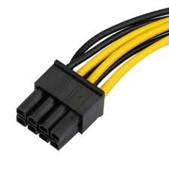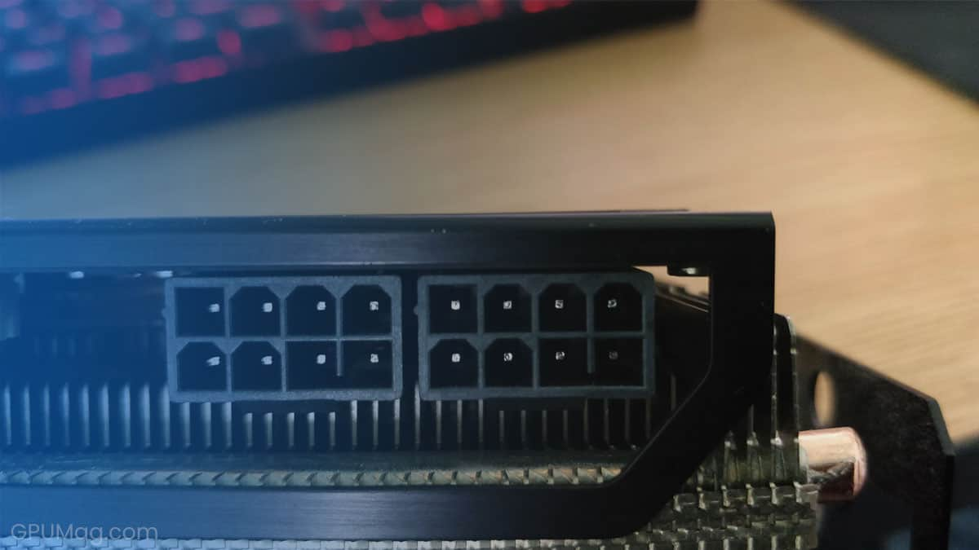
If you have a GPU installed, use the two 8-pin connectors and connect them to the GPU power port.
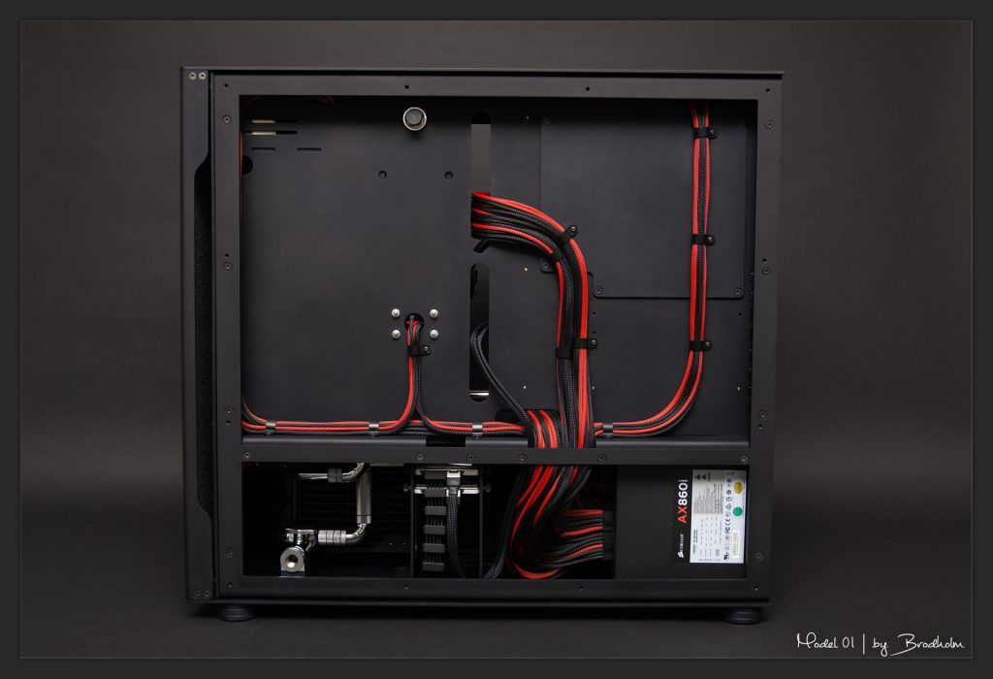
You can use the holes in the case to route your cables and you can also use zip ties to tie your power cables onto the case. A good cable management will make your computer look nice.
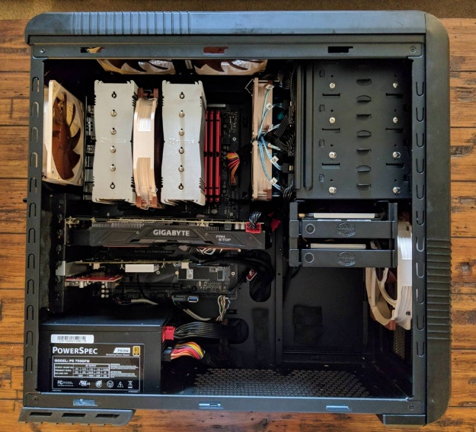
Example of a well cable management PC
STEP 10 CONNECTING PERIPHERALS
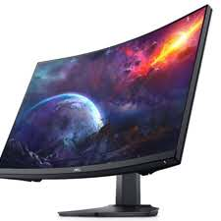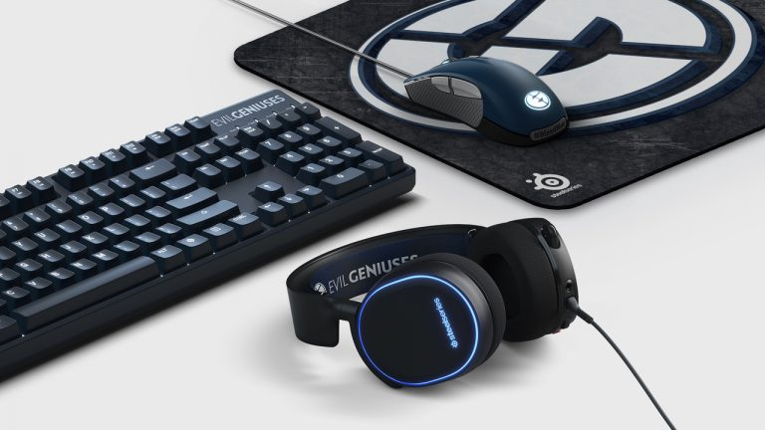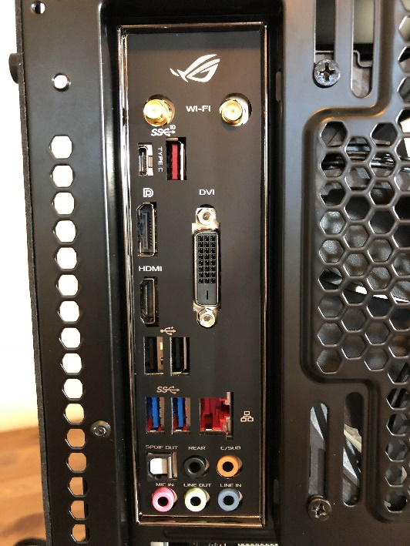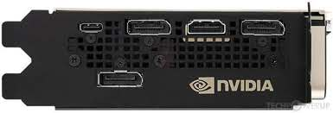
Connect your keyboard and mouse to the USB port on the motherboard rear I/O. Connect your display connector from your monitor to the motherboard rear I/O, if you have a GPU installed you should use the GPU display port as a display output.

STEP 11 TURNING IT ON
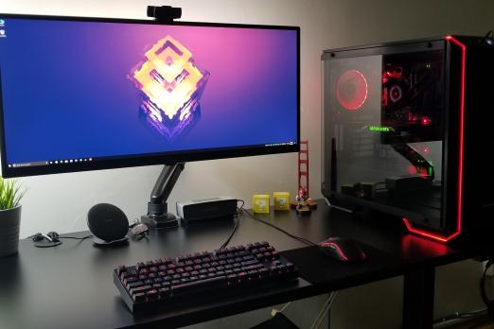
Press the power button on the case and hope it turns on.

