

Semester I 2020/2021

Subject : Technology and Information Systems (SECP1513) Section : 11
Assignment : Step by step PC Assembly

GROUP NAME / NUMBER : GROUP 6
1 |  | Name : CHEN YI QIU  Matric Number : A19EC3017  Phone Number : +8618279886531  E-mail : 574166266@qq.com
2 | 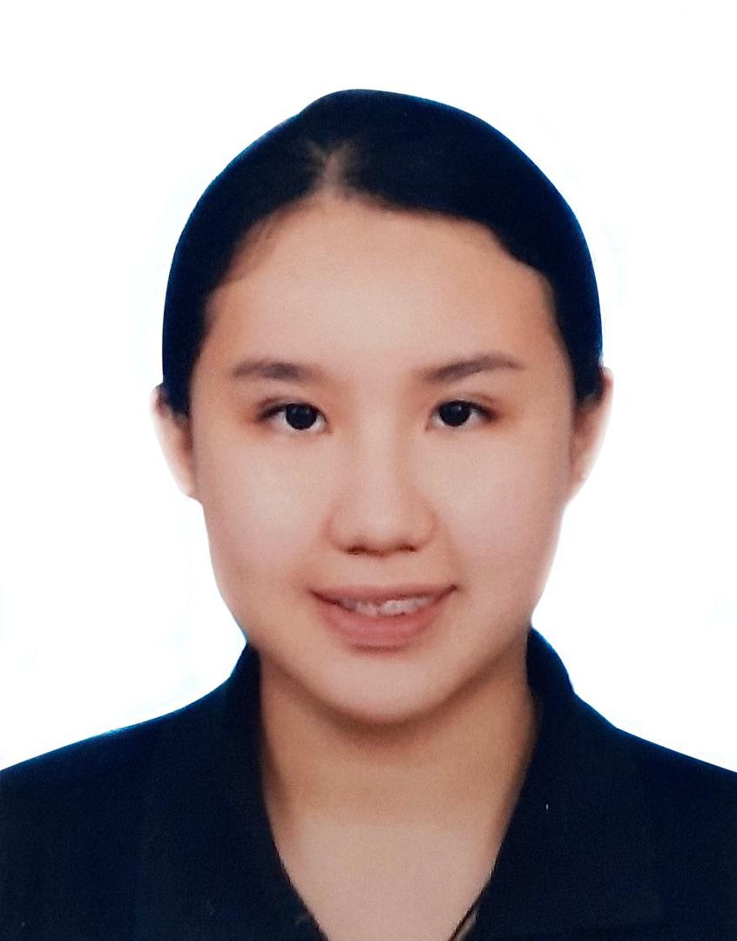 | Name : LAI TING YING  Matric Number : A19EC3033  Phone Number : 019-7576171  E-mail : tingying@graduate.utm.my
3 | 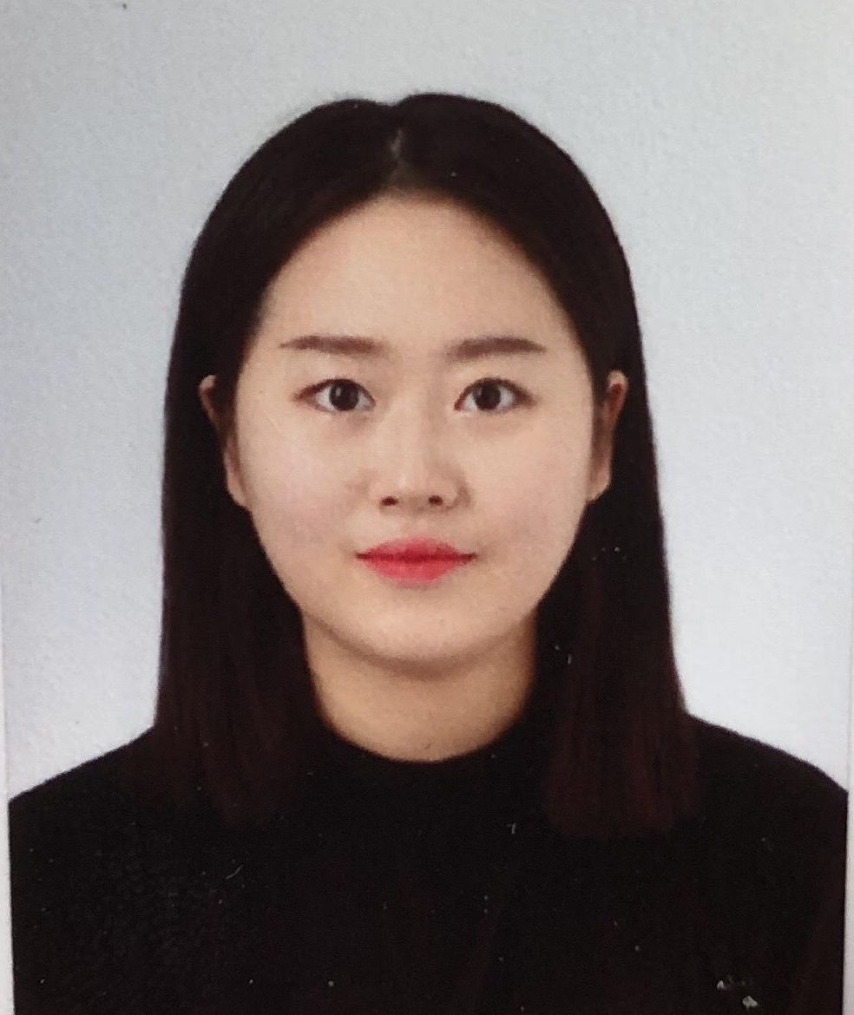 | Name : SONG JI YOON  Matric Number : A19EC9046  Phone Number : 016-706-2198  E-mail : jiyoon@graduate.utm.my
CONTENTS

PART A - Tools needed ......................................................................................................................................................... 2

PART B - Sketch of a mother board layout ............................................................................................................... 6

PART C - Step by Step PC Assembly ............................................................................................................................... 9
PART A - Tools needed

1.0 Screwdrivers
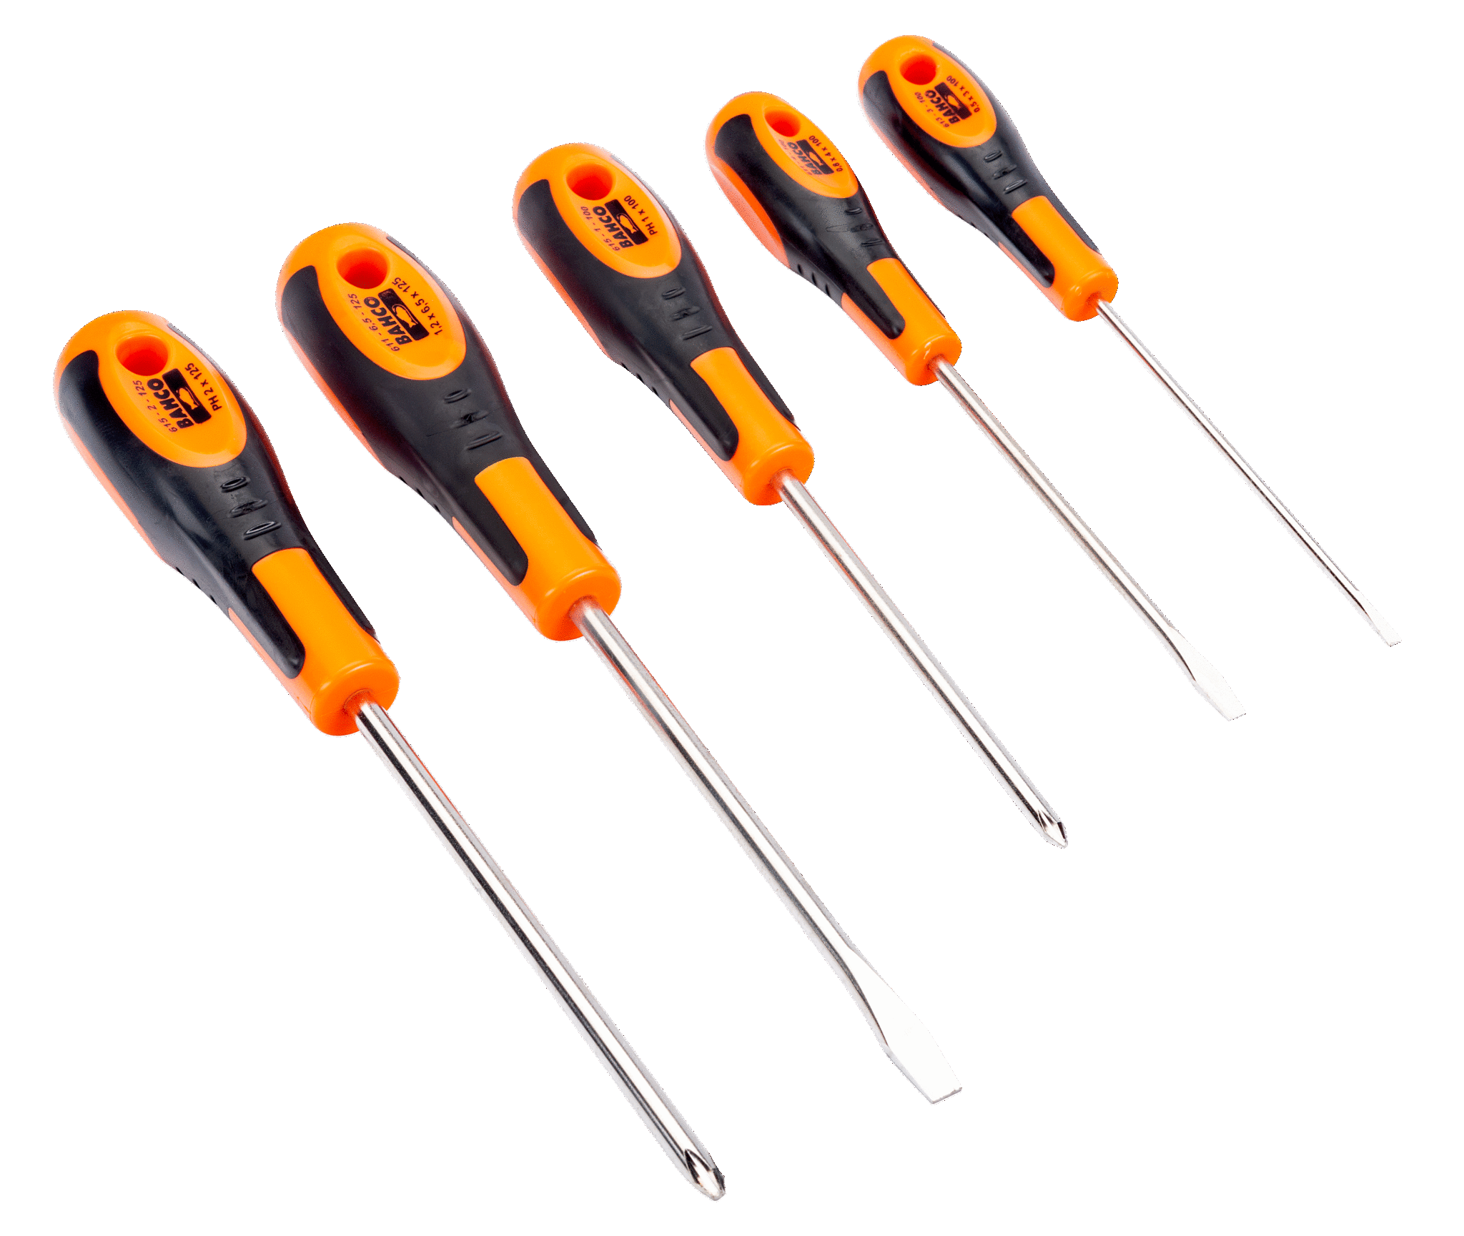
A screwdriver is a tool that could tighten or loosen the screws using the blade part of the screwdriver to the screws head. There are many types of screwdrivers such as slotted screwdriver (-), Phillips screwdriver (+), Robertson screwdriver and etc. In PC assembly, we might use the Phillips screwdriver and slotted screwdriver.
This tool is important because it could combine or separate any parts which are necessary for pc assembly. It is important to check the screw head size before using these tools to tighten or loosen the screws. Otherwise, the screw head will get damaged if it does not match the same size.

2.0 Anti-static gloves
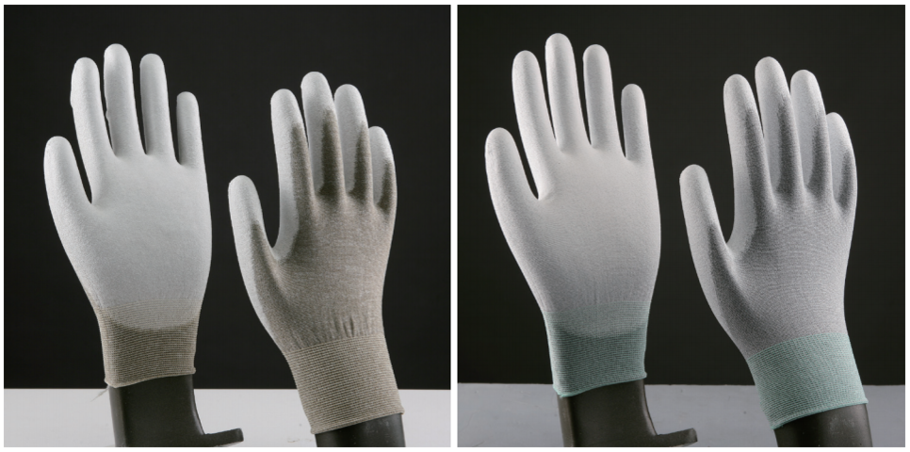
Anti-static gloves prevent damaging electrostatic discharge(ESD). ESD cause not only the danger for those who assemble a PC, but also the failure of the electronic components. Especially for the components that will be installed on the PC, it will affect the long-lasting and running of the PC.. Therefore, this equipment is important to wear when assembling a PC.

3.0 Flashlight or Flexible Lamp
Flashlight or flexible lamp will give a light source to the place where are dark. Flashlight is necessary to check the right place for components in PC assembly. In the build, there might be a dark place which the light can't reach or there might have some components or instruction in devices which are too small to read and see. Thus, in these situations we need a flashlight or flexible lamp to check over.

4.0 Cable ties (Zip ties)
Cable ties are used for tying things such as wire in PC. We could reduce the space in PC by using cable ties to tie up the loosen and unorganized wires. Therefore, the space inside the PC will be well-organized and will have better airflow.

5.0 Needle-nosed pliers
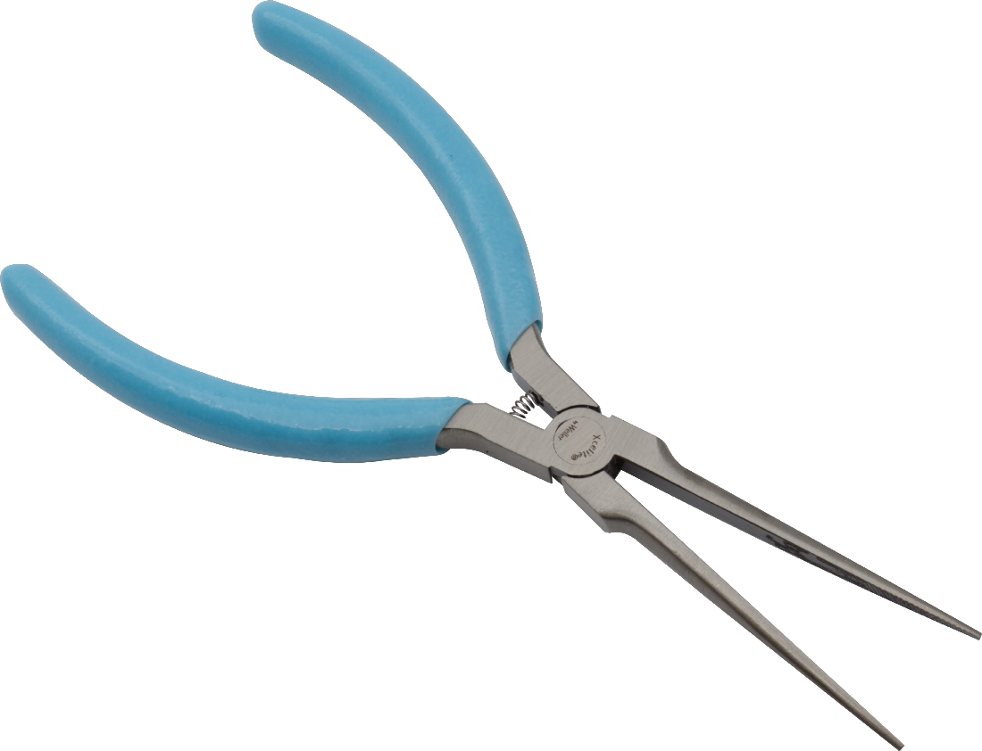
Needle-nosed plier is a tool used for delicate work. It can pull out the small drivers or any small components which have been felled down somewhere or which has to be removed from the PC. Also, it can be used to cut the cable ties. It is important to remove or pull out the small components to prevent any problems like an electrical shortage.

6.0 Small container (Small zipper bag)
A small container is used to store a screw or any small components. It will decrease the loss of
screws or any small components while assembling the PC.

7.0 Adjustable Wrench
An adjustable wrench is a tool that can loosen or tighten a nut or bolt. This tool is important because it could combine or separate any parts which are necessary for pc assembly which the function is similar to the screwdriver. It is adjustable, therefore we don't have to check the nut or bolt size before applying this tool.
PART B - Sketch of a mother board layout
Motherboard Model: Micro ATX
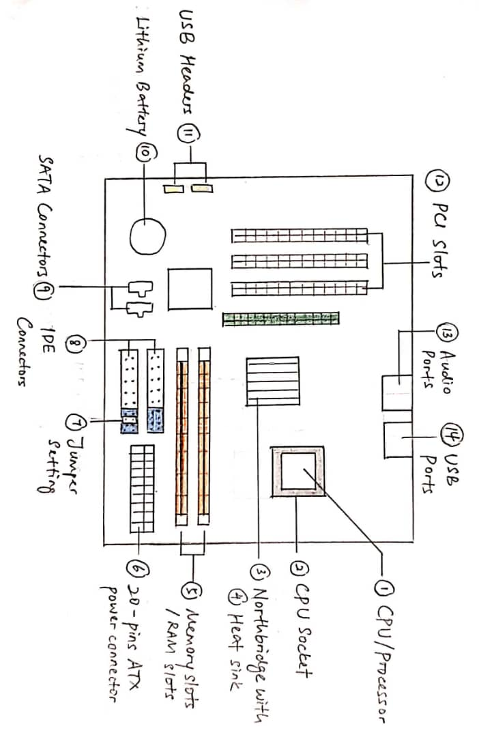
Diagram 1: Motherboard Layout of Micro ATX
No | Pictures | Names and Functions
1 | 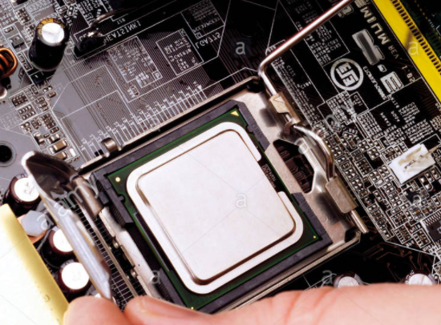 | CPU / Processor :  It is known as the brain of the computer. It performs all the tasks received from the hardware and software including doing all the calculations.
2 | 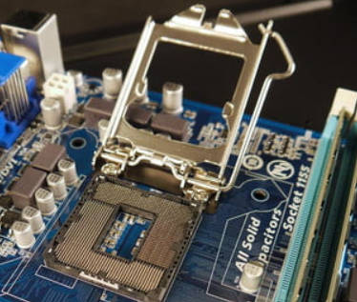 | CPU Socket :  Where the CPU is placed on the motherboard and the CPU is removable. So, we can remove the CPU from the socket anytime.
3 | 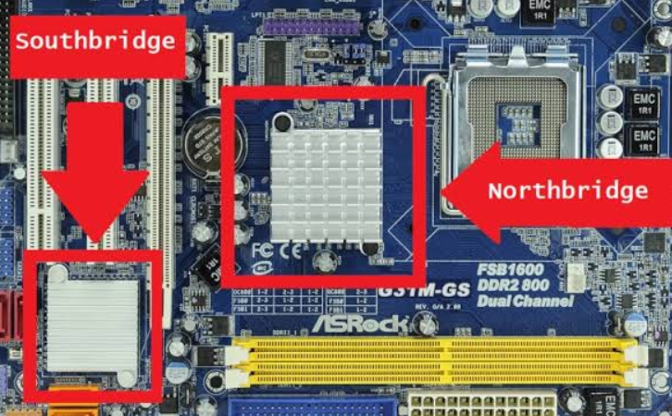 | Northbridge :  It connects and allows the communication between the components at the upper part of the motherboard, like CPU and memory slots.  Southbridge :  It connects and allows the communications among the lower part of the motherboard, like PCI slots, SATA, USB and so on.
4 | 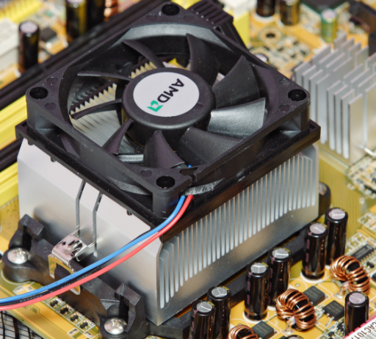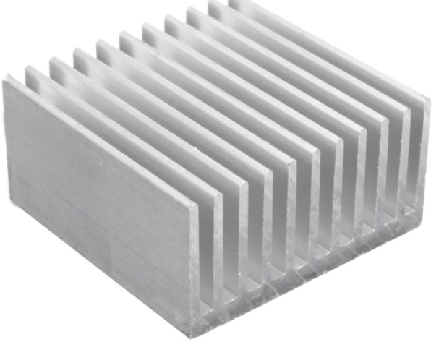 | Heat sink :  It helps to cool down the components like CPU and Northbridge in order to ensure the performance.
5 | 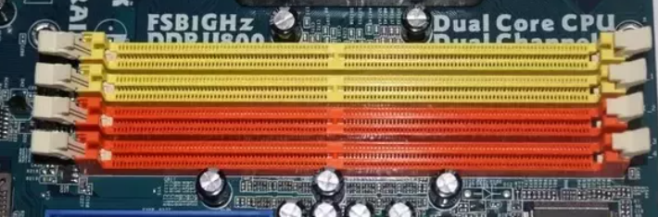 | Memory Slots / RAM slots:  They allow RAM or memory chips to be inserted into the computer and RAM stores the data from CPU.
6 | 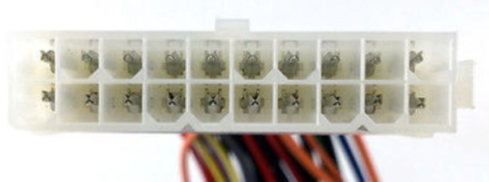 | ATX Power Connector :  It provides power to most of the components on the ATX motherboard.
7 | 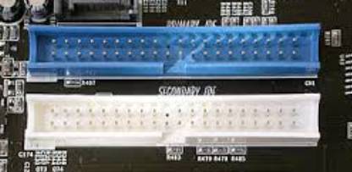 | IDE Connector :  It connects the motherboard to the hard drives and optical drives such as hard disk and CD ROM. Each IDE connection can connect to 2 devices.
8 | 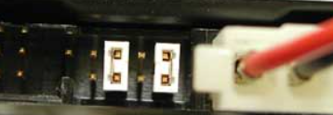 | Jumper Setting :  When an IDE connector support 2 devices, the jumper setting, master and slave, is used. To communicate with the computer, the slave (currently unconnected) will have to wait for the master (currently connected) before it transfers the data.
9 | 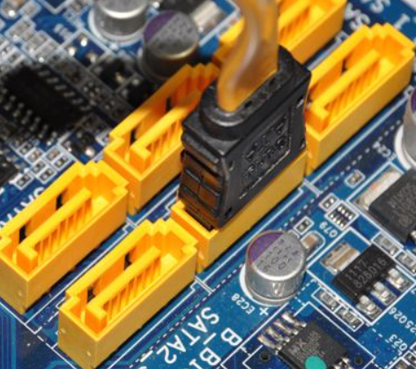 | SATA Connector :  It also connects to both the hard drives and optical drives. It is smaller and faster compared to IDE, but each SATA can support one device only.
10 | 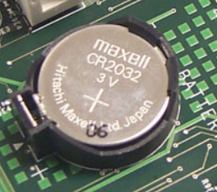 | Lithium Battery :  It is also known as CMOS battery as it provides power to the CMOS - Complementary Metal-Oxide-Semiconductor, which stores the information about the system devices.
11 | 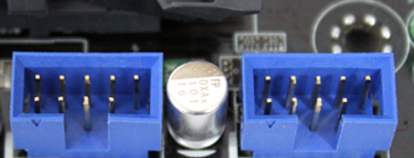 | USB Header :  The cable is connected to the header, which runs to the USB port in the front panel of the case without having us to reach the back of the system case just to plug in the USB devices.
12 | 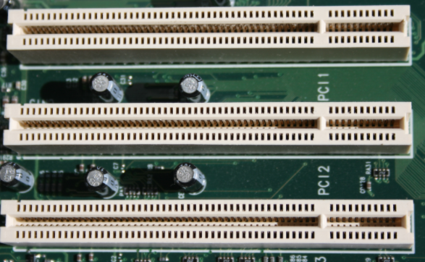 | PCI Slots :  They can be used to expand the capabilities of a computer by inserting additional internal components like sound card, graphics card and network card.
13 | 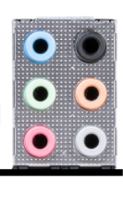 | Audio Ports :  They connect to the audio output devices such as speakers.
14 | 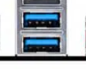 | USB Ports :  They are used to connect pen drives and USB cables.

PART C - Step by Step PC Assembly

Step 1 Place dual core processor
1.Lift up the latch Lever to release and hinge open the CPU socket over.
2.Then Place the dual core processor on it.
3 And then lower the CPU socket cover over the processor and secure processor by lowering the latch.

STEP 2 Install heatsink
1.Apply some thermal paste to the back of the processor.
2.Place heatsink and fix position.
3.Plug the cable attached to the heatsink to the motherboard.

Step 3 Place power supply
1.Place power supply and fasten it with screws to the case mounting points.

Step 4 Place motherboard
1.Screw motherboard standoff into the case
2.Take out rearI/O plate from the case and replace it back with holding motherboard on it.
3.Fasten with screws.

Step 5 Place the hard drive
1.Place the hard drive in the case drive bays. And fix it in place with screws.

Step 6 Place RAM
1.Line up the notch on the RAM stick with the mounting slot
2.Secure it by pressing it firmly down.

Step 7 Place DVD drive
1.Remove any panels from the case where the drive sits.
2.Place the drive in the case and fix it with screw.

Step 8 Place graphic card
1.Remove the expansion covers from the case
2.Then slots it into a PCI expansion slot on the lower half of motherboard.
4.Tighten with screws
5.Plug power cable to the graphic card.

Step 9 Connecting cables
1.Connect the DVD drive to motherboard using a SATA cable
2.Connect hard drive to motherboard using a IDE cable
3,Plug in power cabling to the hard drive.
4.Plug in power cabling to the DVD drive.
5.Plug the largest cabling connector from power supply to motherboard.
6.Plug 8-pin cabling connector from the power supply cabling into the cpu power connector.
7. Connect any front panel USB connectors to the motherboard USB headers.
8.Connect any front panel USB connectors to the motherboard front audio header.
9.Connect any front panel USB connectors to the motherboard front panel I/O header.
Last STEP - CLOSING THE CASE AND CONNECTING THE PERIPHERALS.

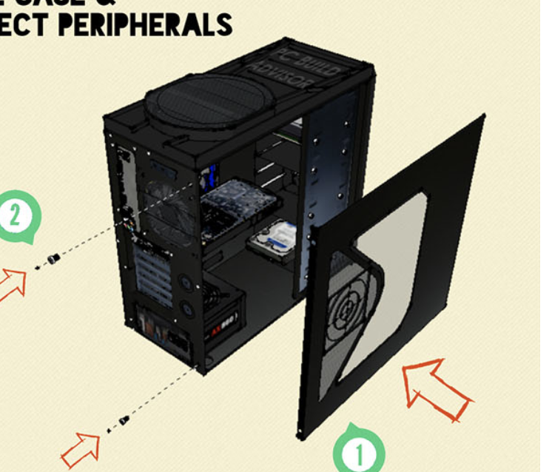 |  | Place the side cover back on and secure the side panels with case screws.
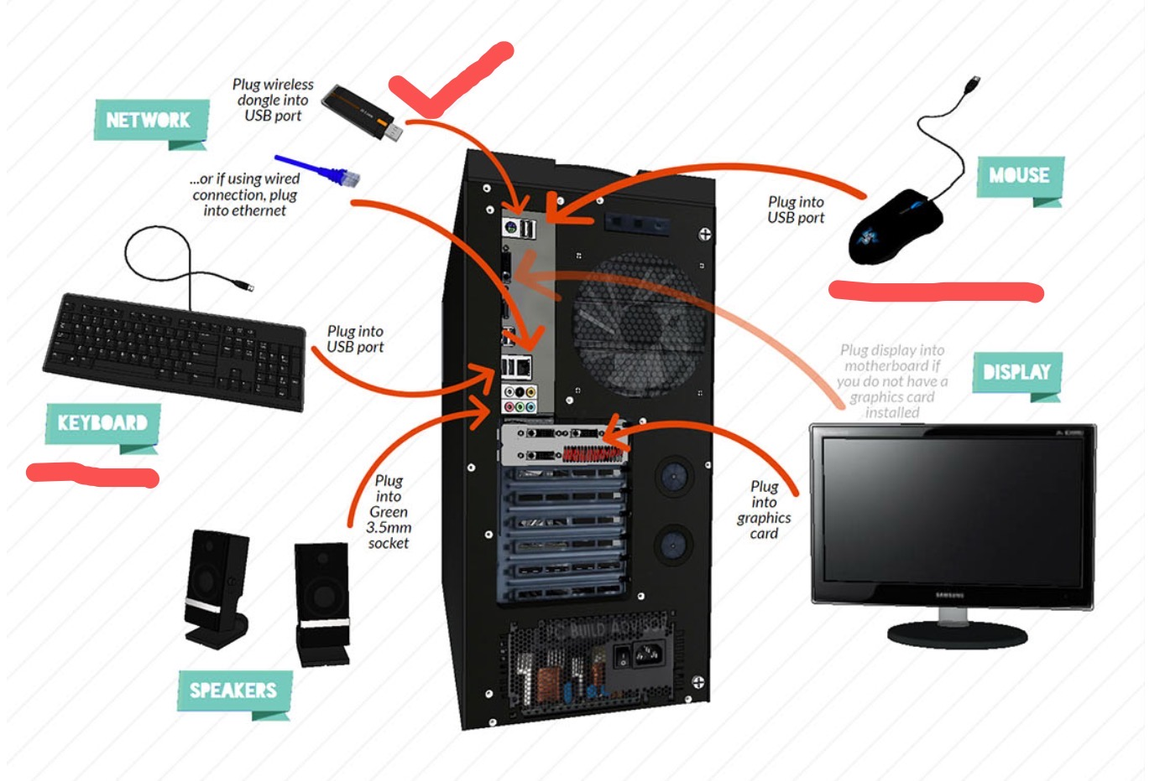 |  | Connect peripheral devices which include keyboard, mouse, wireless  network dongle, printer and webcams with your CPU by plugging into USB port.
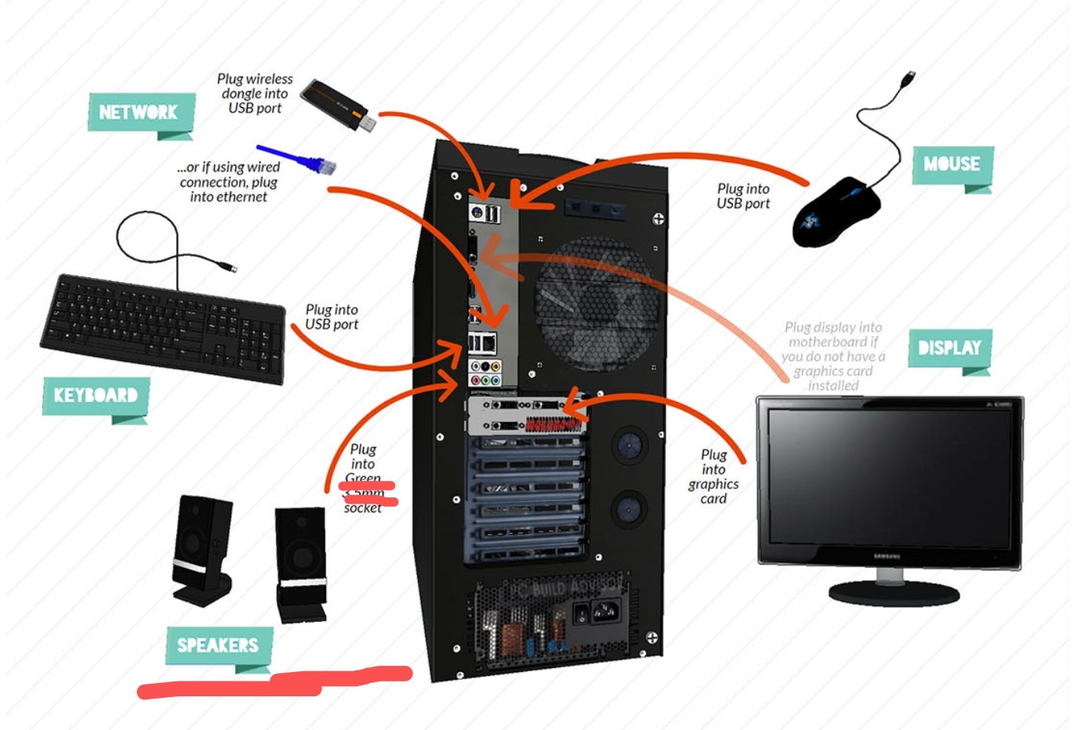 |  | Then, connect speakers and microphone into 2.5 mm sockets.
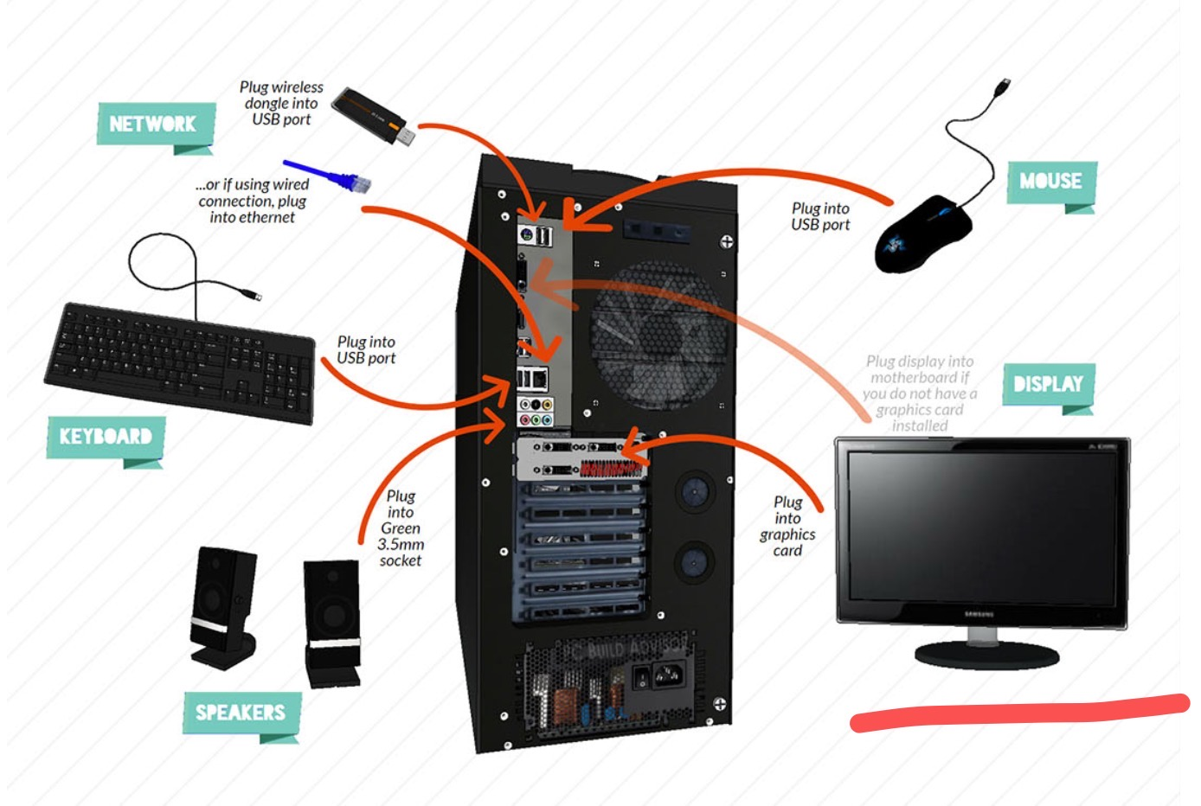 |  | Finally connect the CPU with monitor by plugging into display ports

