

Semester I 2020/2021

Subject : Technology and Information Systems (SECP1513)
Section : 01
Assignment : Step by step PC Assembly

GROUP NAME / NUMBER : 2

1 |  | Name : Goh Yitian  Matric Number : A20EC0038  Phone Number : 011-11703015  E-mail : gohyitian@graduate.utm.my
2 |  | Name : Hanis Rafiqah bt. Hisham Razuli  Matric Number : A20EC0041  Phone Number : 0126971024  E-mail : hanisrafiqah@graduate.utm.my
3 |  | Name : Iman Ehsan Bin Hassan  Matric Number : A20EC0048  Phone Number : 0172283349  E-mail : imanehsan@graduate.utm.my
4 |  | Name : Indira A/P Thangaraj  Matric Number : A20EC0049  Phone Number : 0149714709  E-mail : indira@graduate.utm.my

PART A-TOOLS NEEDED
- Screwdrivers
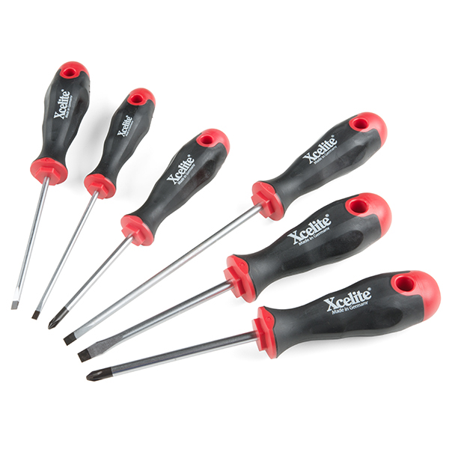
The screwdrivers are using for turning screws with slotted heads. There are different types of screwdriver but in assembly the pc, a Phillips-head screwdriver with magnetic tip is the most important as most of the screws in computer are Phillips-head. Magnetic tip of the screwdriver is important to keep the screw in place when we need to lower the screw into the system. Screwdriver is important to tighten the screws and prevent the stripping of screws.
- Antistatic wrist strap, ESD wrist strap
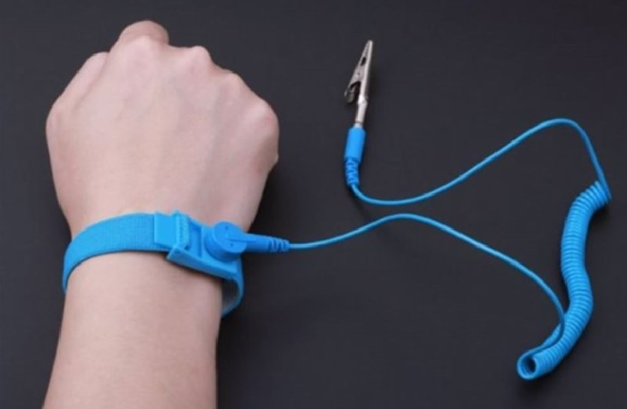
The ESD wrist strap is used to discharge static electricity on the body to ground. It is important to prevent static build up which could harm the electronic circuit when assembly the pc.
- Light sources
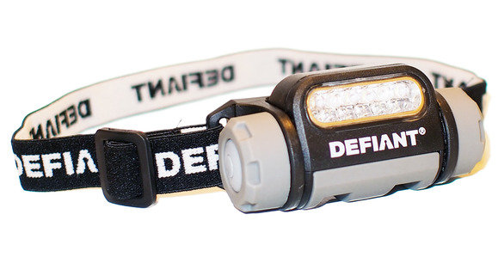
A headlamp is easy to use and hands-free. It use to give extra light when assembly the pc as most of the cases have black or dark-colour interior and are full of shadows. The screw may roll into the dark hole and hard to see. Headlamp is important to make our job easier when can see the things clearly.
- Thermal paste
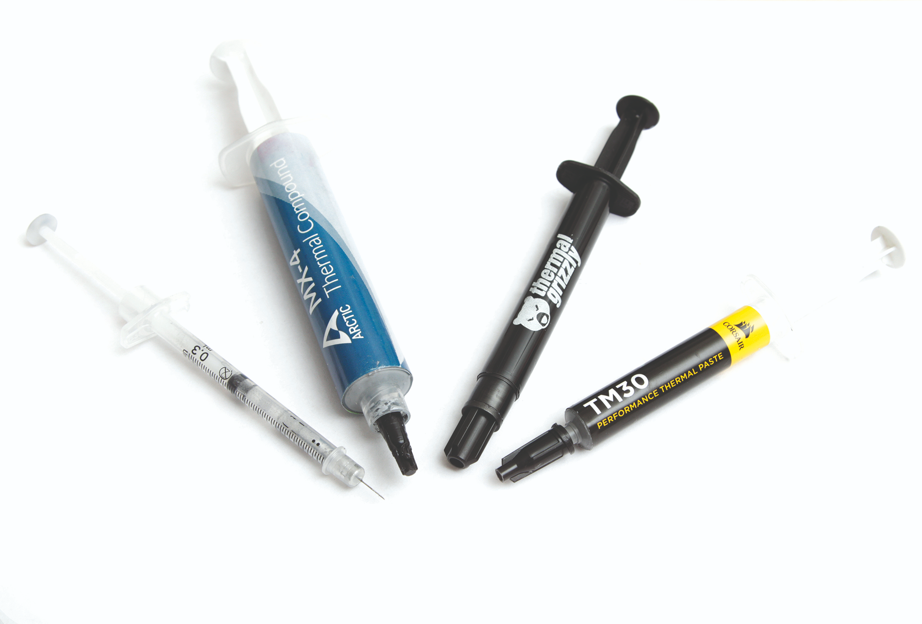
Thermal paste is used to promote better heat conduction between two surfaces. Thermal paste is important to ensure that heat transfer from the processor to the heat sink.
- Needle-nose Pliers
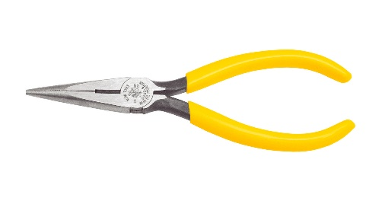
Pliers have a lot of function, it can used for gripping, bending and cutting. It is important to pick up small crews when the crews fall into the space in pc where our hands are too big to pick.
- Zip ties
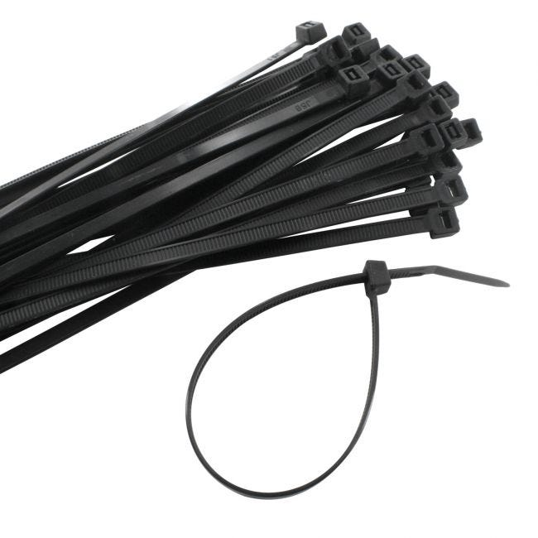
The function of zip ties is to keep the cables in place, to make the system looks tidy and clean. It is importance for maintain a lower temperature through better unobstructed air flow.

PART B – Sketch of a mother board layout
1.0
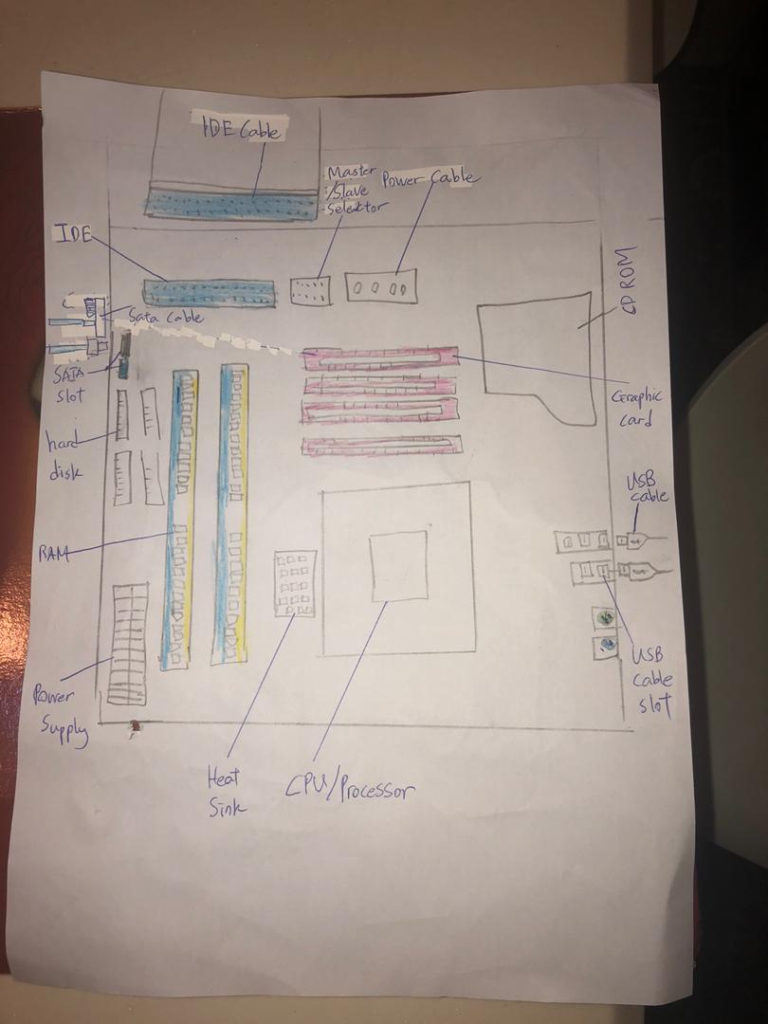
2.0
NO. | KEYWORDS | FUNCTIONS | EXAMPLE OF MODELS
1. | GRAPHIC CARD  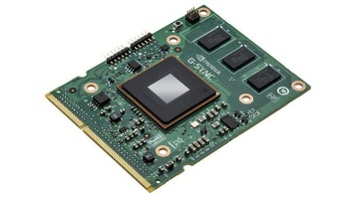 | Convert data into signal to produce image on the screen AND provide high-quality 3D graphics and  animation for games and simulations | - AMD Radeon RX Vega  - Nvidia GeForce GTX 1070 Ti  - Nvidia GeForce GTX 1660 Ti  - Nvidia GeForce GTX 1660 Super
2. | CPU/PROCESSOR  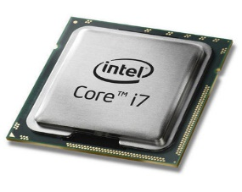 | Performs logic, arithmetic, controlling and input or output operation according to instructions. | - INTEL Core i3  - INTEL Core i5  - Xeon  - AMD  - INTEL Core i7
3. | HEAT SINK  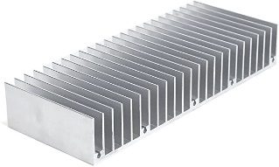 | - Provides an efficient path for heat to escape to the environment from the heat sink.  - Aluminum Heat Sink, Copper Heat Sink, Solid Metal Heat Sink, Pumped Liquid Heat Sink, Two-Phase Heat Sink, CNC Machined Heat Sink are some types of heat sinks. | - Noctua NH-U14  - CORSAIR Hydro Series H60  - CRYORIG H7 Tower  - Cooler Master MasterAir Maker 8
4. | CD ROM  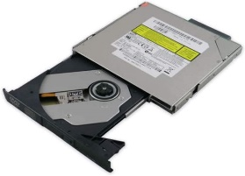 | - stores computer data of graphics, text, and audio | - Apple CR-503-C  - Apple CR-504-L  - Apple CR-506-C  - ASUS SDRW-08D2S-U
5. | SLOT (IDE/PC)  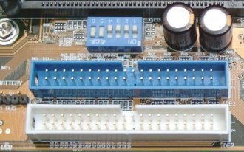 | - Provide connection points for specialized cards or circuit boards.  - designed for a specific component, such as memory or storage, or designed for general expansion | - ASUS  - Gigabyte  - MSI  - ASRock
6. | RAM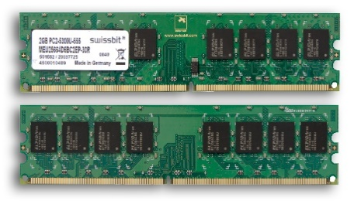 | - RAM is a volatile running program that store and access data on a short-term basis. It stores the information your computer is actively using so that it can be accessed quickly.  - Static RAM (SRAM), Dynamic RAM (DRAM), Synchronous Dynamic RAM (SDRAM), Single Data Rate Synchronous Dynamic RAM (SDR SDRAM) are some types of RAM. | - Corsair Vengeance LED  - G.Skill Trident Z RGB  - Kingston HyperX Predator  - Kingston HyperX Fury  - Corsair Dominator Platinum RGB
7. | SATA CABLE  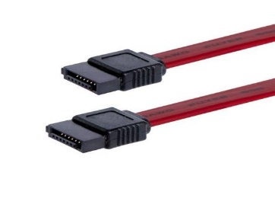 | - Connect devices in computer cable assemblies, such as storage devices.  - Micro SATA, SATA bracket, SATA Bridge, SATA Power are some types of SATA cable. | - Corsair Carbide 500R  - BENFEI 3-pack SATA III  straight data cable  - Neeyer 6 pack SATA III  straight data cable
8. | IDE CABLE  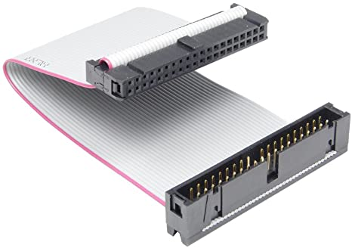 | - Connect some hard drives and optical drives to each other and to the motherboard.  - connecting a motherboard to storage devices such as hard drives and CD-ROM/DVD drives | - MULTICOM IDE/SATA,1.5FT  - Roline cable.
9. | POWER SUPPLY  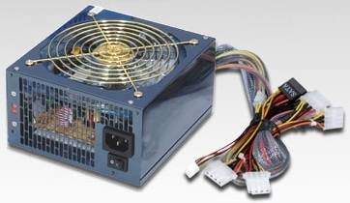 | - Convert AC to DC and power desktops. AC adapters power laptops and tablets and recharge  batteries. | - Antec Trus 330 W power supply  - ATX Power Supply.
10. | HARD DISK  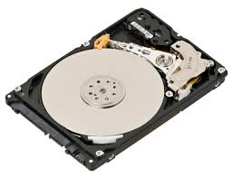 | - Stores and retrieves digital data using magnetic storage and one or more rigid rapidly rotating platters coated with magnetic material.  - Parallel Advanced Technology Attachment (PATA),Serial ATA (SATA),Small Computer System Interface (SCSI),Solid State Drives (SSD) | - Seagate  - Western Digital,  - Toshiba  - Hitachi  - SanDisk  - G-Tech
11. | USB CABLE  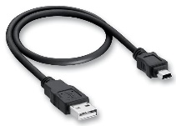 | - Used to connect keyboards, mice, printers, and storage devices; one port can connect several devices to system unit.  - Some types of USB cable Micro USB cable,USB TYPE-C,USB TYPE-A | - AnkerPowerline Micro USB cable  - AmazonBASICS Micro USB cable  - Fuse Chicken Titan Micro USB cable

Part C- Step by Step PC Assembly
Step 1- The installation of unit processor center on the motherboard.
- Make sure that the CPU is placed on the socket properly and neatly before it is tightened using a cream.
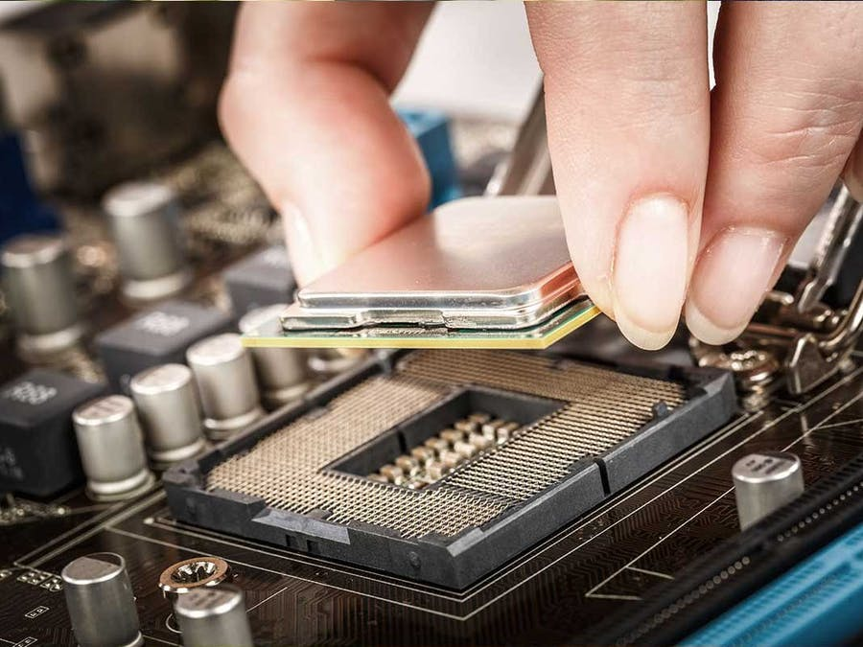
Step 2- The use of thermal paste.
- Place a little thermal paste on the processor.
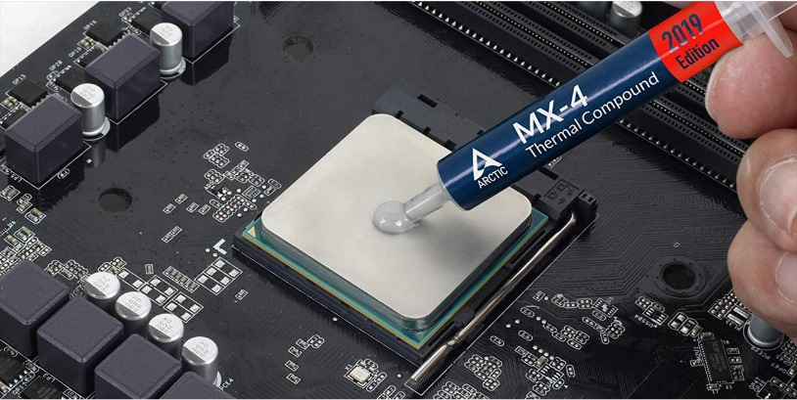
Step 3- The installation of processor fan.
- Install the heat sink and fan neatly on the processor.
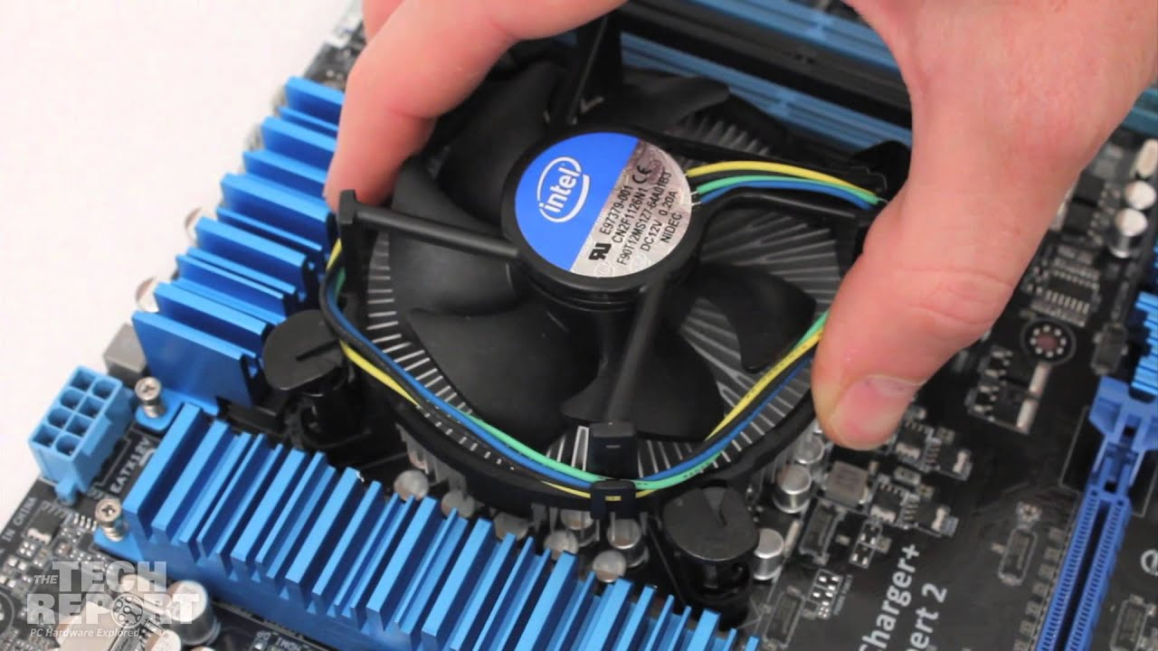
- Please make sure that the heat sink and fan have been clipped tightly.
Step 4- The installation of random access memory (RAM).
- Insert the RAM pieces into the RAM slot.
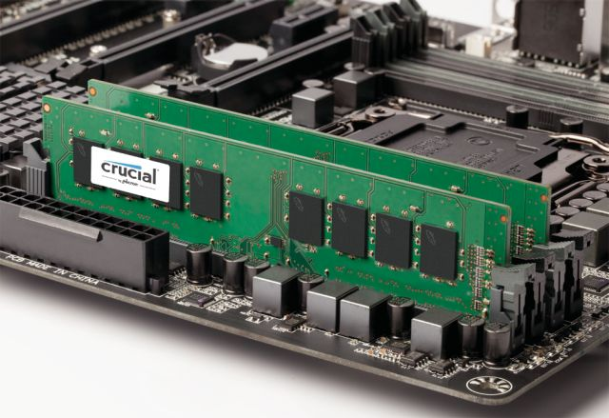
- Make sure the RAM is installed properly.
Step 5- The installation of power supply.
- Please attach the power supply to the casing.
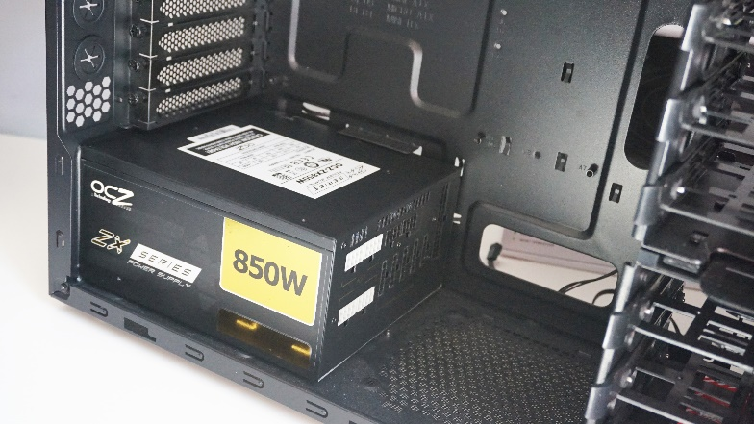
- Install and tighten the screw on each section.
Step 6- The installation of motherboard.
- Insert the motherboard into the casing.
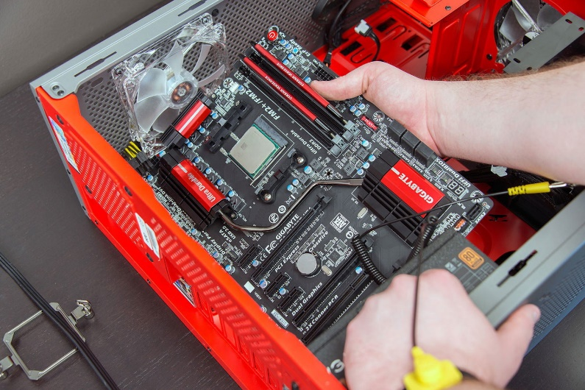
- Then, install and tighten the screws on each part.

Step 7- The installation of graphic card.
- Install the graphic card into the PCIe slots on the graphic card holder so that it is neat and not easily detached.
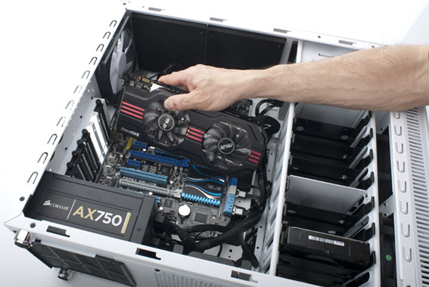
- Screw on the graphic card holder so that it is neat and not easily fall off.
Step 8- The installation of CD / DVD ROM drive.
- Install CD ROM drive into PC.
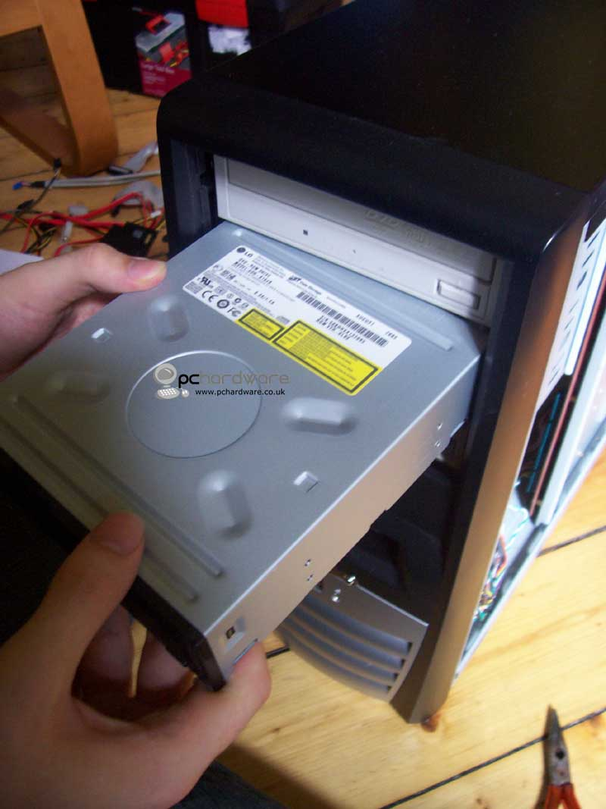
- Then, insert the hard drive into the casing.
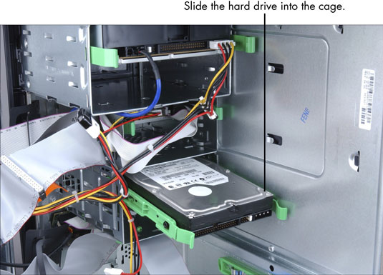
- Make sure hard drive and CD ROM are not easily swayed or loose.
- This is to ensure that the hard disk and CD ROM are not easily damaged.
Step 9- Connecting IDE cable, SATA cable and power supply.
- Connect the IDE cable to the CD ROM drive.
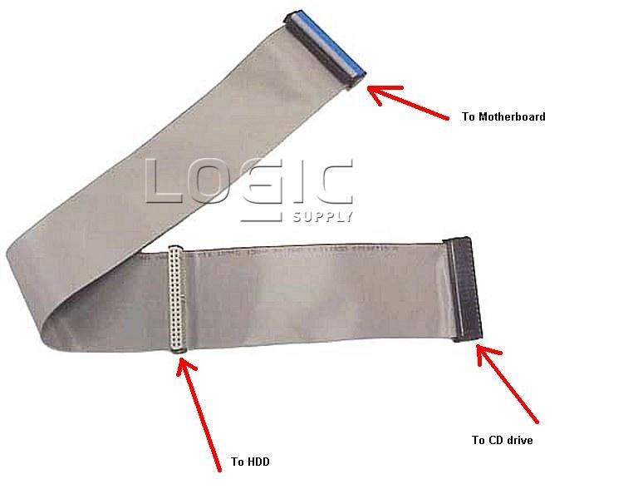
- SATA cables are connected to the hard disk and connect the power supply to each drive.
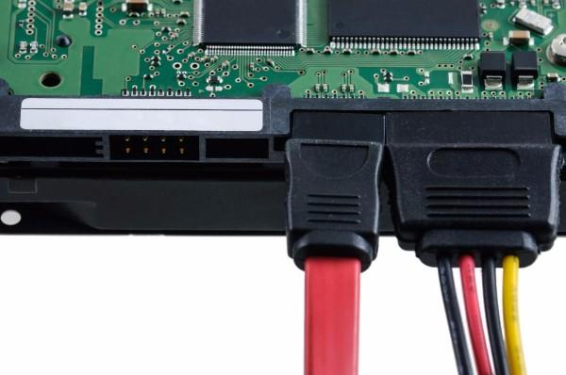
- Tidy up the IDE cable and power supply well to save space and reduce heat in the casing.
Step 10- Connecting switch wires and USB cable on the motherboard.
- Plug the switch wire and USB cable found on the casing onto the motherboard.
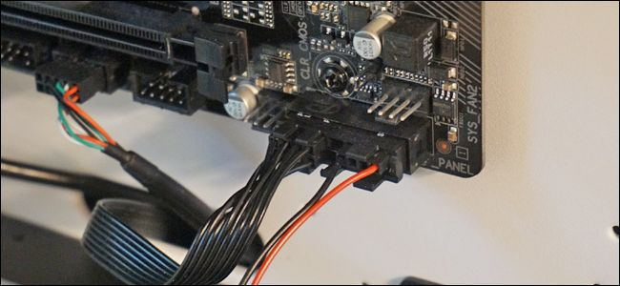

Last Step- Closing the case and connecting the peripherals.
- Place the side cover back on and secure the side panels with case screws.
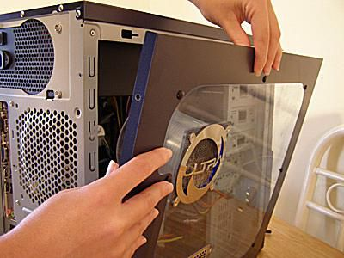
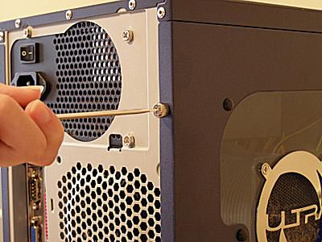
- Connect peripheral devices which include keyboard, mouse, wireless network dongle, printer and webcams with your CPU by plugging into USB port.
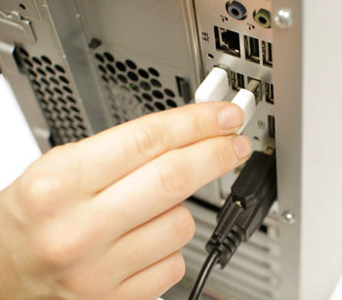

- Then, connect speakers and microphone into 2.5 mm sockets.
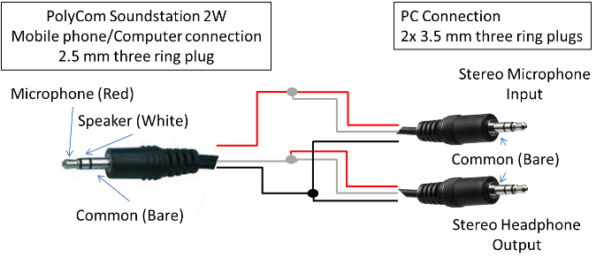
- Finally, connect the CPU with monitor by plugging into display ports.
