

Semester I 2020/2021

Subject : Technology and Information Systems (SECP1513) Section: 01
Assignment : Step by step PC Assembly

GROUP NAME / NUMBER : 06

1 |  | Name : Nur Haznirah Binti Hazman  Matric Number : A20EC0114  Phone Number : 017-9864550  E-mail : nurhaznirah@graduate.utm.my
2 |  | Name :Navinthra Rao A/L Ventakumar  Matric Number : A20EC0104  Phone Number : 018-9524371  E-mail : navinthrarao@graduate.utm.my
3 |  | Name : Saidah Binti Saiful Bahari  Matric Number : A20EC0141  Phone Number : 016-5005405  E-mail : saidah@graduate.utm.my
4 |  | Name : Chang Min Xuan  Matric Number : A20EC0024  Phone Number: 011-57510703  E-mail : mxchang01@gmail.com

REPORT
PART A – List at least FOUR tools needed to assemble a PC. For each tool, Provide picture(s), explanations of its functions and its importance.

1.0 Screwdrivers
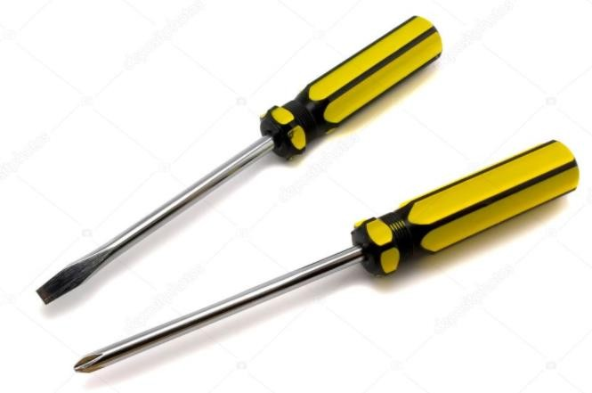

The screwdriver is a tool that used for installing and removing screws. The importance of screwdriver is they are made in various designs and shapes. Screwdrivers also available in the diverse ranges. So, with this we can use the right width blade when installing or removing screws.
2.0 Pliers


Pliers are a multi-purpose hand tool with opposing jaws for gripping, bending and cutting. The importance of the pliers is to make the process of insertion or removal of relatively small part and accessories on the hard disk of the computer.

3.0 Anti-Static Equipment
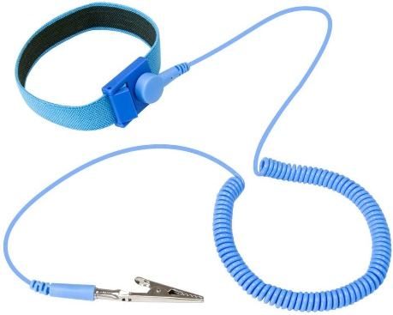

This is anti-static equipment. The function for this tool is to prevent the static electricity from building up. The importance of this tool is it can protect the components from static damage and protects your tabletop from scratches.

4.0 Light Source
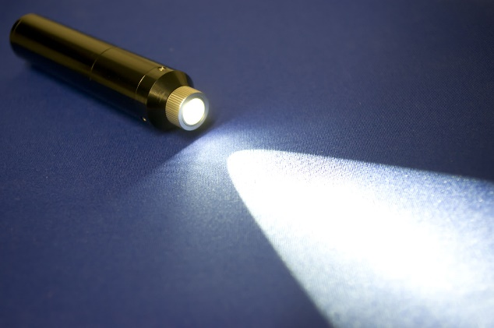

Light source is used to see clearly in the PC cases. Because in PC cases are full of shadows. The importance of light source is to make our work easier to do by looking clearly behind the shadows.

5.0 Cable Ties
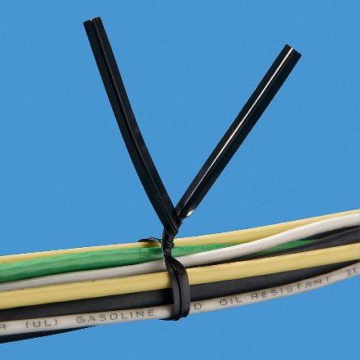

Cable ties is a type of fastener used for holding cables or wires together. The importance of cable ties is to keep the wires properly managed.
PART B – Sketch of a mother board layout
1.0Sketch manually (using handwriting) a simple diagram of a motherboard layout that consists ALL keywords included in Table 1.0. Label each of the keyword. Diagram
1.0 and 2.0 below are examples of the sketches. Do not copy any of these diagram. Produce your own sketch diagram. Only one sketch diagram of a motherboard layout is required for this assignment.

Table 1.0
NO | COMPONENTS | FUNCTIONS | EXAMPLE OF MODELS
1 | Graphic Card  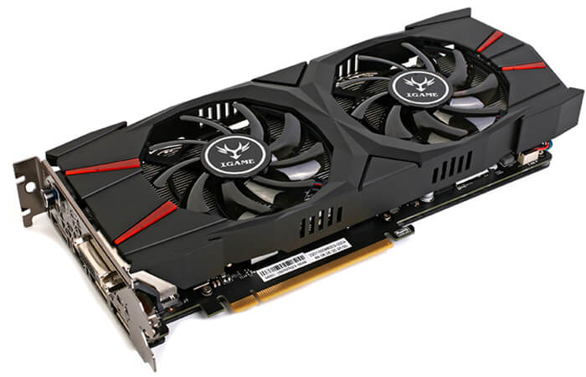 | Graphic cards allows computer to produces graphics and images more quickly | - AMD Ryzen Threadripper Graphics Card Video
2 | USB Cable  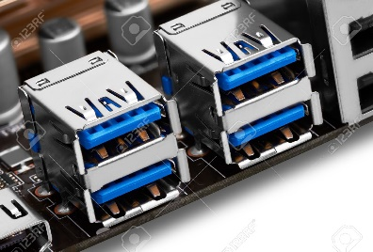 | USB cable used for connecting pen drives and external hard drives like Ipods or MP3 players | - Micro USB B-Type  - Mini USB (5 pin) B-Type  - A-Type
3 | IDE Cable  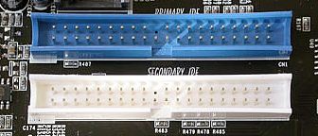 | Integrated Drive Electronics (IDE) is a standard interface for connecting a motherboard to storage devices such as hard drives and CD-ROM/DVD drives. The original IDE had a 16-bit interface that connected two devices to a single-ribbon cable | - IDE 34-pin ribbon cable  - IDE 40-pin ribbon cable
4 | CPU  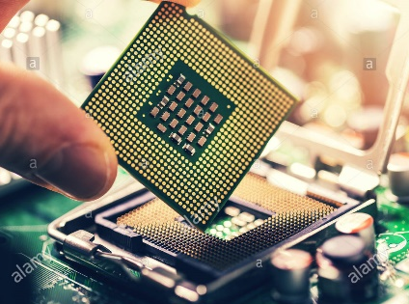 | The CPU performs most of the computations and functions that allow a computer to run its operating system and any installed programs. | - Intel Core  - AMD Ryzen Threadripper
5 | Slots  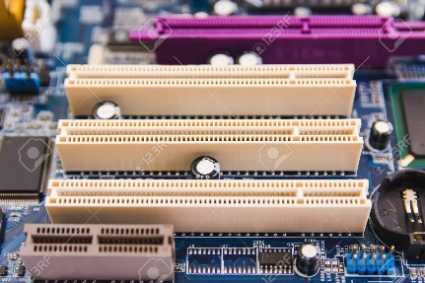 | Slots is to upgrading internal computer parts is always an option if programs on your computer are running sluggishly or if software is incompatible due to a lack of resources. | - CPU slots  - RAM slots  - PCI slots  - PCI express slots  - ISA  - AGP
6 | Power Supply  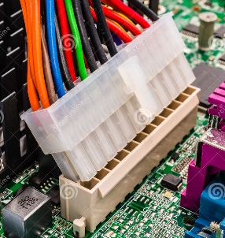 | Giving power to the system processor, memory, and all slotted add-on boards (ISA, PCI, AGP) | - ATX main power connecter  - ATX Auxiliary power connector  - ATX12V connector
7 | Heat Sink  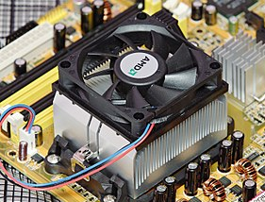 | Heat sink is a component that increases the heat flow away from a hot device. It accomplishes this task by increasing the device's working surface area and the amount of low-temperature fluid that moves across its enlarged surface area. | - Fin layout
8 | RAM  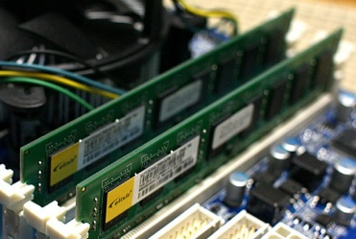 | Random access memory (RAM) is to provide fast temporary storage and workspace for data and program code, which includes both applications and the system's operating system along with hardware drivers for each hardware device, such as hard disk controllers, keyboards and printers. | - Dynamic RAM (DRAM) chip  - Static random-access memory (SRAM)  - Synchronous DRAM (SDRAM)
9 | Hard Disk  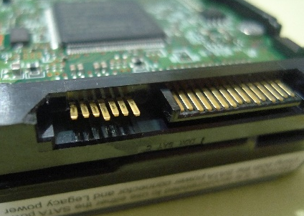 | Enable particular settings by placing a jumper shunt onto specific pins—creating an electrical circuit between them. The settings these jumpers enable are hard-coded onto a drive’s programmed printed circuit board. | - Small Computer System Interface (SCSI)  - Solid State Drives (SSD)  - Parallel Advanced Technology Attachment (PATA)
10 | CD ROM  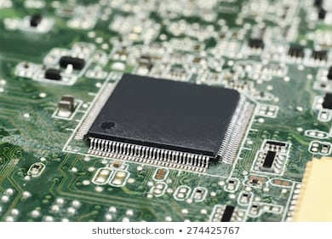 | CD-ROM which stands for Compact Disc read-only memory are popularly used to distribute computer software although any type of data can be stored on them. CD-R is another variation which can only be written to once but can be read many times. | - Compact disk-recordable (CD-R)  - Compact disc-rewritable (CD-RW)
11 | SATA Cable  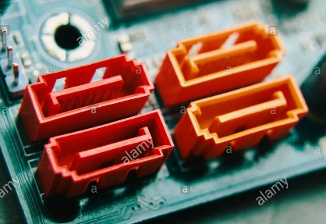 | Serial Advanced Technology Attachment (SATA) is for connecting devices like optical drives and hard drives to the motherboard | - SATA bridge  - SATA bracket  - Micro SATA  - SATA power

DIAGRAM 2.0
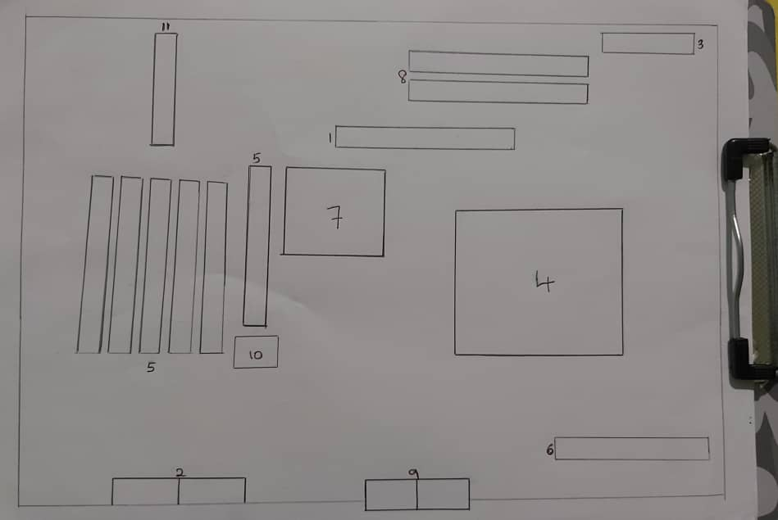

PART C - “Step by Step PC Assembly”
Based on the given video and keywords in Table 1.0, prepare a report on “Step by Step PC Assembly” that provide guided instructions on how to Assemble a PC. Assumed that in front of you is an opened computer case (without the side panels). Number of steps should not exceed the number of keywords.

STEP 1 – Installation of Dual Core Processor
- Provide close up photo, guided detail instructions, precautions, tips (e.g how to install RAM).
Install Dual Core Processor on Motherboard. Lift up the CPU socket cover and place the CPU in the socket correctly by referring to the triangle alignment marking. Then, make sure it is hold tightly and place nicely with CPU socket cover.

STEP 2 – Installation of CPU Cooler
If thermal pad is not available, apply some thermal paste on the processor. Place Heatsink and Cooler neatly on the processor. Do make sure that Heatsink and Cooler are screwed tight and fix in position.

STEP 3 – Installation of Power Supply
Mount the power supply and screwed it tightly on the mounting area.

STEP 4 – Installation of Motherboard and Random Access Memory (RAM)
Mount the Motherboard in the case and screwed it one by one to the computer case mounting points. Next, press the piece of RAM into the RAM mounting slot. Make sure the piece of RAM is in correct position and secured firmly.

STEP 5 – Installation of Graphic Card
Fix the graphic card on PCI Express slot and hold it in position with screws to prevent it loose easily.

STEP 6 – Installation of CD ROM
Remove the front case so that the CD Rom is able to sit in the computer case.

STEP 7 – Installation of Hard Disk
Push and locate the hard disk drive carefully through the area where the front case has been removed and fix it again with screws on the mounting holes. Make sure that the hard disk and CD Rom is place firmly.

STEP 8 –Installation of IDE slots
Integrated Drive Electronics (IDE) connects motherboard to storage devices such as CD Rom, hard disk and power supply. Do connect them with each other.

STEP 9 – Connection of IDE cable
Connect the IDE cable with CD Rom, hard disk and power supply. Arrange the IDE cable neatly to save space and to avoid heat collecting in the computer case.

STEP 10 – Connection of SATA cable
Serial Advanced Technology Attachment (SATA) connect hard devices in computer. It connect hard drives and optical drives to computer which will exchange data through motherboard.

STEP 11 – Connection of Front Panel USB cable to Motherboard
Connect the Front Panel USB cable to Motherboard. While connecting it, make sure your hands are dry and clean and do not exert much pressure from the back of the USB cable or else it might break. Read the letter of USB cable carefully and make sure it is connected in right position.

Last STEP - CLOSING THE CASE AND CONNECTING THE PERIPHERALS.
(Complete these step by inserting relevant photo(s) which illustrate the given descriptions)
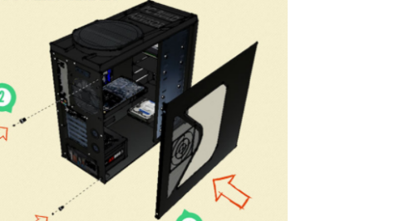 |  |  | Place the side cover back on and secure the side panels with case screws.
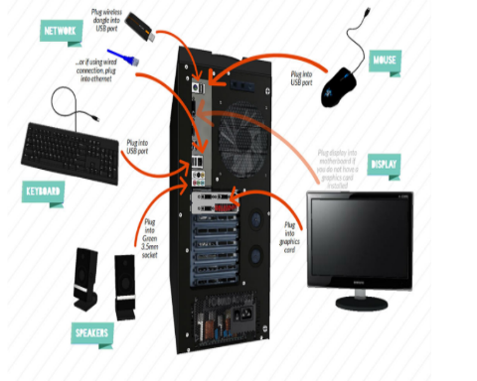 |  |  | Connect peripheral devices which include keyboard, mouse, wireless network dongle, printer and webcams with your CPU by plugging into USB port.
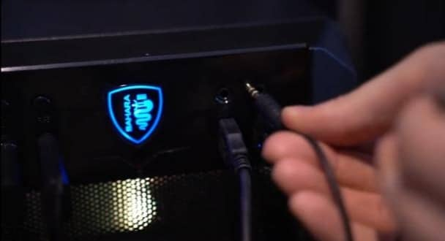 |  |  | Then, connect speakers and microphone into 2.5 mm sockets.
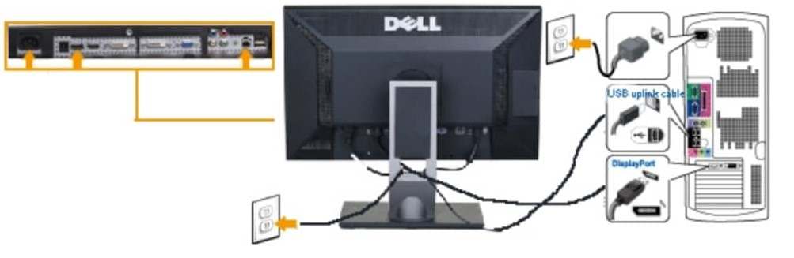 |  |  | Finally connect the CPU with monitor by plugging into display ports

