

SEMESTER 1 2020/2021
Subject: Technology and Information System (SECP1513)
Section: 09
Assignment: Step by Step PC Assembly
Group Number: 5
1. |  | Name : Muhammad Luqman Bin Nazam  Matric Number: A20EC0095  Phone Number: 0197345460  Email: luqman-01@graduate.utm.my
2. |  | Name : Fatin Aimi Ayuni Binti Affindy  Matric Number: A20EC0190  Phone Number: 01118825956  Email: fatinaimiayuni@graduate.utm.my
3. |  | Name : Aliya Malika Sugimin  Matric Number: A20EC0288  Phone Number: +6287772079240  Email: sugimin@graduate.utm.my

PART A – Tools needed to assemble PC
- Screwdrivers
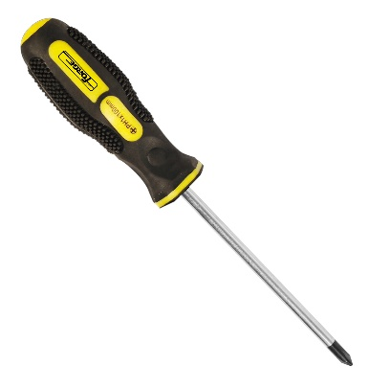
The screwdrivers are essential tools when it comes to assemble a PC. Computers are tied together with screws and, thankfully, Phillips-head is almost any form of screw found in computers. To keep them firmly in place, you'll use Phillip-head screwdriver to tighten the screws on their parts. In the year 2020, many types of screwdrivers have been made, it would be preferable if you could buy a screwdriver with a magnetic tip which makes it easier to extract the screws and very handy to avoid dropping small screws in small, dark, and hard to reach places during installation. A screwdriver with a long shaft makes it easier to reach certain tight parts in the PC. However, you can still keep a short screwdriver on hand in a perfect environment and there are certain conditions that make it simpler to use a shorter one.
- Cable / Zip-ties
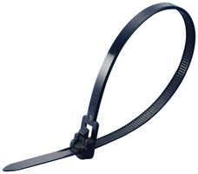
Cable management can be frustrating for the majority of PC user if the PC doesn’t come with any cable management options. One of the best tools for cable management is investing some cable and zip-ties. These are amazing at keeping cables firmly at their place and create clearance for your hardware. Cable ties are used to tie up any loose cables that not only make your finished installation look neater, but also encourage better airflow inside your case. However most new device cases come shipped with a lot of cable/zip ties, so the odds are you won't have to buy one. It's necessary that you don't fit your cables too tightly around them as you might damage them. You may simply use sharp scissors or needle-nose pliers to cut the ends of your ties once you've mounted one.
3.0 Needle-Nose Pliers
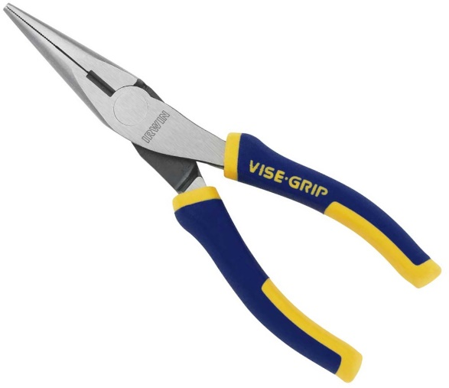
Rarely needed to have for different circumstances, but convenient to have when you’re installing and building PC. You may use this needle-nose plier to loosen super-tight screws or bolts, pick up hard-to-reach screws that you dropped within the case, remove chipped or broken screws, snip the excess cable ties and remove motherboard standoffs.

- Flashlight / Light source
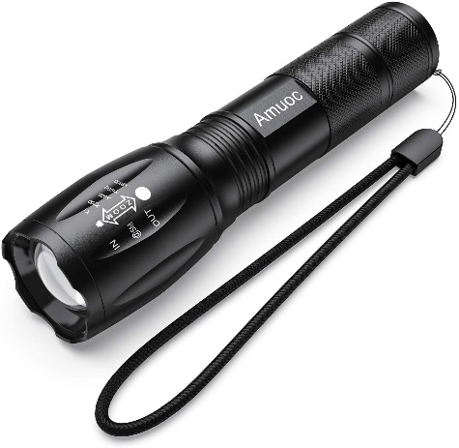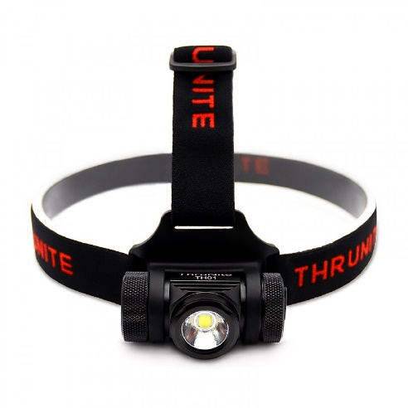
You will need an additional light source to see exactly what you are doing while working in your situation, depending on where you are installing your computer. Some PC cases really do their best to block out light, even if you are in a well-lit space, so you might need to use a flashlight if you need to brighten things up. A bright desk lamp with a long, pose-able neck is convenient, but for direct illumination, nothing beats an inexpensive headlamp. It may feel a little over the top, but a headlamp is always going to point in the right direction and carrying it does not need an extra hand. In a pinch, a flashlight will work, but it will make multitasking much harder as well.

- Anti-Static Equipment
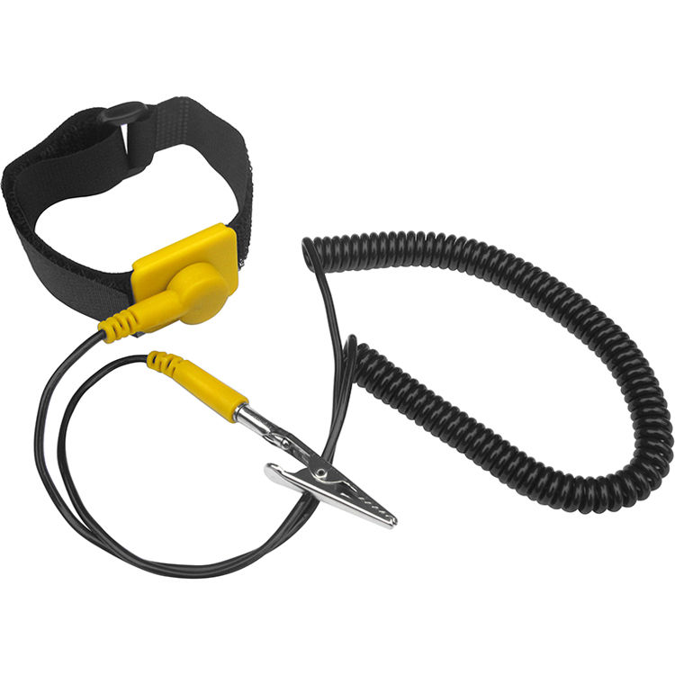
An anti-static wrist strap is a bracelet-type device that you wear on your wrist that attaches to an electrical socket, and if you and your hardware components build up any electrical charge, the charge will dissipate through the socket (avoiding a spark and potentially causing harm to your parts). For any serious PC assembly, anti-static equipment should be used. Occasionally, contacting a grounded case or another grounded, metal object will reduce the greatest chance of electrostatic discharge. Other than that, we can also use an anti-static mat that can be mounted on the workspace during the assembling, allowing unrestricted movement, but it can also be terribly costly for a novice builder. The most cost-effective approach is purchasing the wrist strap and then clipping it to a grounded item or plugging it into any wall outlet's ground socket. All of these are mainly to reduce the risk of damaging the components.

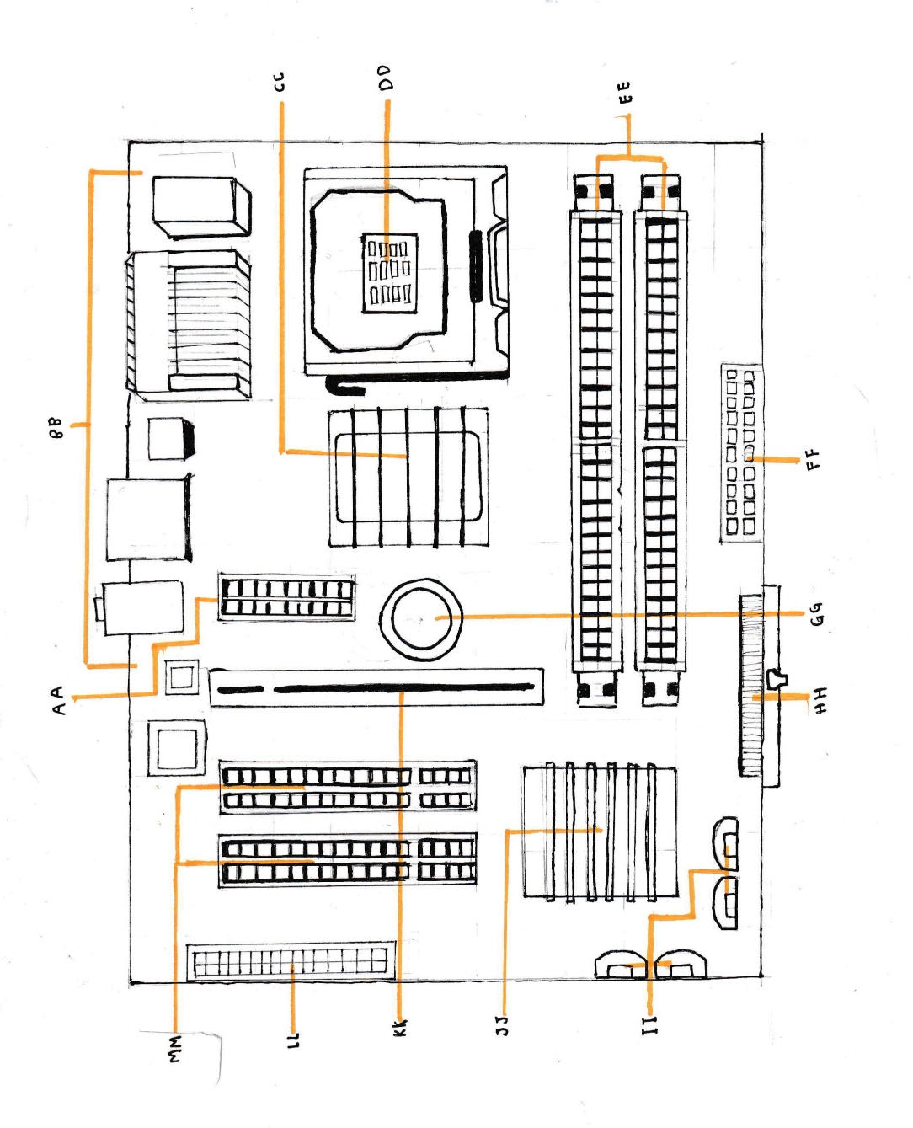
PART B – Sketch of Motherboard Layout

Sketch of motherboard layout
 | KEYWORD | MODEL | NAME | FUNCTION
1. | AA, MM | 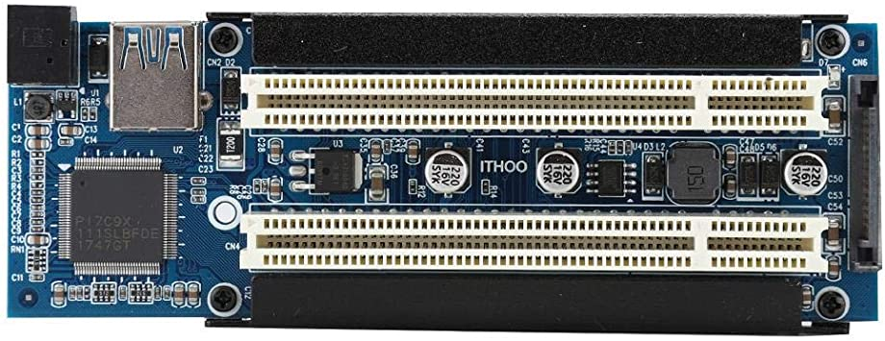 | PCI Slots (Peripheral Component Interconnect) | Intel has adapted the bus protocol. PCI slot is embedded computer slot that enables different hardware modules. The PCI bus links the I/O devices (such as NIC or RAID controllers) to the computer's primary logic. The ISA bus has been replaced by the PCI bus.
2. | BB | 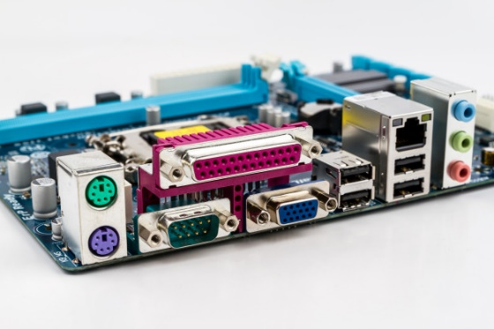 | Back Panel Connectors | 1.Mouse & keyboard: A mouse is a small portable devices which is a size of a hand that controls the curso or pointer of a computer screen in accordance with how it is moved on a flat surface .However, keyboard refers to peripheral mechanism that allows a computer to input user text into the computer screen. A keyboard is an input mechanism that is the main medium of communication while using a computer.  2. USB (Universal serial bus): USB is a general interface that allows for connectivity between computers, such as a personal computer (PC) or smartphone, and a host controller. Peripheral devices such as digital cameras, mice, keyboards, printers, scanners, media devices, portable hard drives and flash drives are related. The USB has displaced a wide range of interfaces such as the parallel and serial port, owing to its wide variety of applications, including support for electrical control. USB also allows the removal and any replacement without the need to reboot the devices.  3. Parallel port: A parallel port is an interface that enables a PC to send or receive data to a peripheral unit, such as a printer, through many packaged cables. A printer port known as the Centronics Port is the most common parallel port. A parallel port has several connections which, technically, allows data to be sent down several cables simultaneously. Bi-directional communication is allowed by later versions. For low-data-rate communications, such as dot-matrix printing, this technology is still used until today.

3. | CC, JJ | 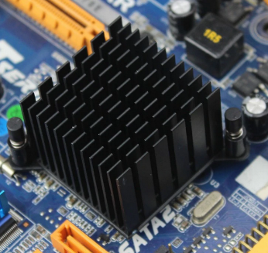  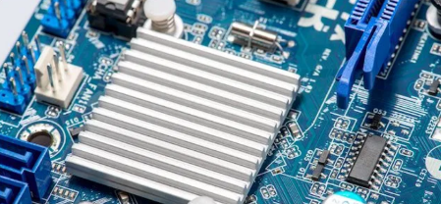 | Northbridge, Southbridge | In the chipset on the motherboard, the northbridge is one of two chips, called integrated circuits (ICs),  1.Northbridge known as the hub for the memory controller. It manages the motherboard's faster parts, including RAM, ROM, Standard Input/output Framework (BIOS), Accelerated Graphics Port (AGP), PCI Express, and the Processor and Southbridge chip. It also manages, whether it is placed on the motherboard, the CPU cache.  2.Southbridge It is a group of microchips engineered and manufactured as a single unit for a single purpose. Input and output (I/O) are controlled or handled by this chipset. USB, serial, IDE and ISA are examples of I/O interface links that are managed by Southbridge. These are the lesser motherboard features
4. | DD | 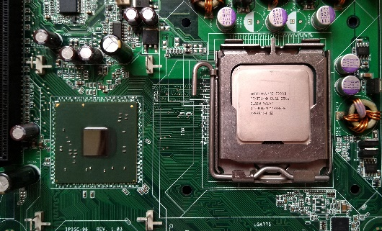 | CPU Chip (Central Processing Unit) | The unit that does much of the computation within a computer is called central processing unit (CPU). It processes and functions as an efficient interpreter of all instructions obtained by applications operating on the PC and by other hardware components. The CPU depends heavily on a chipset, which is a collection of microchips placed on the motherboard, to manage instructions and data flow to and from other areas of the machine which is microprocessor.
5. | EE | 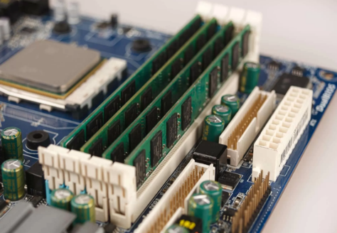 | RAM Slots (Random-access Memory) | Random access memory (RAM) is a type of data storage that is usually stored on the motherboard. This sort of memory is volatile, and when the device is switched off all information contained in the RAM is erased. Volatile memory is transient memory, while ROM (read-only memory) is non-volatile and until the power is switched off, stores data indefinitely.
6. | FF | 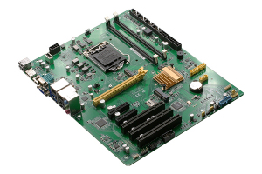 | ATX (Advanced Technology extended) | A specification used to outline mother board configuration and dimensions to improve standardization. It was an evolutionary concept based on the previous Advanced Technology (AT) platform. With a greater use of space and power for most new PC systems, ATX gradually became the preferred form factor.

7. | GG | 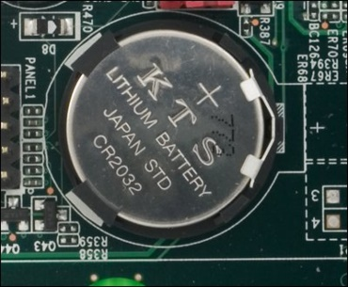 | CMOS Battery  (complementary metal oxide semiconductor) | To supply the electricity to CMOS while the device is switched off. A battery is provided on all motherboards. There are three options to mount these batteries on the motherboard: the outdated external battery, the most common onboard battery, and the built-in battery. CMOS is powered by lithium batteries that can last two to 10 years.
8. | HH | 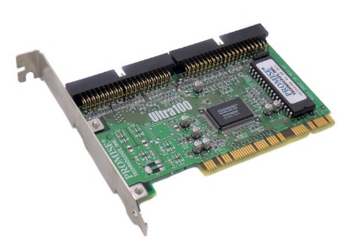 | IDE Controller | The IDE controller is integrated into the motherboard of today's machines. Controllers were separate external devices prior to the IDE drive, so IDE minimized some concerns related to storage devices and integrated controllers.
9. | II | 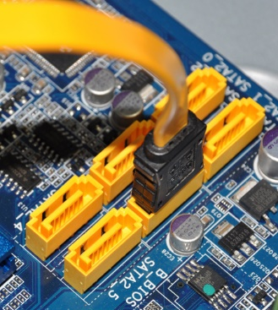 | Serial ATA/ SATA | A serial advanced technology attachment (serial ATA, SATA or S-ATA) is A computer bus interface used by mass storage devices such as optical drives and hard drives to connect host bus adapters. This interface is generally used to link hard disc drives, such as a machine motherboard, to a host device. SATA is an upgrade to the 1980s parallel signaling standard (parallel ATA or PATA) used for improved integrated drive electronics (EIDE) and earlier integrated drive electronics (IDE).
10. | KK | 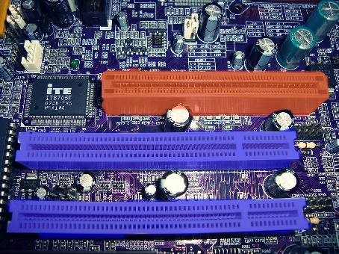 | AGP Slot (Advanced Graphics Port) | AGP slot is a slot on the motherboard to make a direct connection between the card and memory. It is an alternative to PCI as for the ability of it being in higher speed and it freed up the PCI slot for other peripheral devices.
11. | LL | 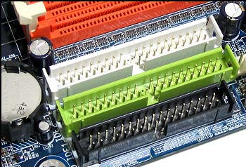 | FDD (Floppy Disk Drive) | It is a device used to read data storage information. It is not widely been used in these days because it is an old way of reading data. The usage of FDD is now being replaced by other devices like USB and network file transfer.
12. |  | 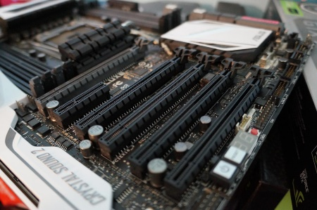 | Graphic Card | Graphic card is used to display data that is received from the CPU. It is designed specifically to perform complex mathematical and geometric calculations which are important for rendering graphics.  Model examples: AMD Ryzan Threadripper Graphic Card Video, GeForce GTX 1080 Ti Graphic Card Video
13. |  | 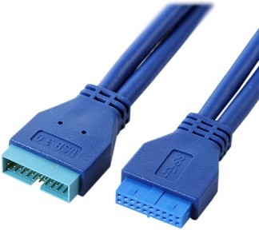 | USB Cable | USB Cable provides a quick connection between computer to peripheral devices such as cameras, camcorder, printers and more.  Model examples: USB Type-A, USB Type-B
14. |  | 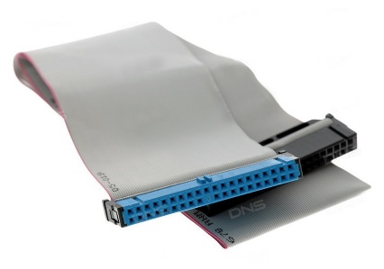 | IDE Cable | IDE cable is a connector used to connect storage devices in the computer. However, IDE cable transfers data a bit slower because this is an old innovation.  Model examples: ATA-2, ATA-3
15. |  | 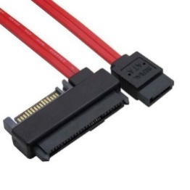 | SATA Cable | It has the same purpose like IDE Cable except, it transfer data faster than IDE Cable because it is a newer cable invented. Compared to IDE cable, SATA cable can transfer at the rate of up to 6GB/s.  Model examples: SATAIII, ESATA
16. |  | 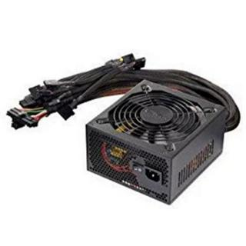 | Power Supply | It is a hardware component of the computer that supplies power to all other component.  Model examples: Switch Mode Power Supply(SMPS), Uninterruptible Power Supply(UPS)
17. |  | 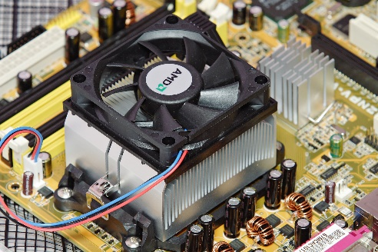 | Heat sink | Heat sink is used to move away the heat from a component to make sure the component does not overheat.  Model examples: Aluminium Heat Sink, Thermally-Conductive Heat Sink
18. |  | 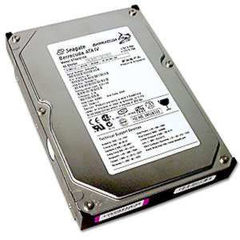 | Hard Disk | Hard disk is a storage device that stores and retrieves data by using magnetic storage and rotating platters coated with magnetic material.  Model examples: Seagate TB, Dell TB 2.5” SATA
19 |  | 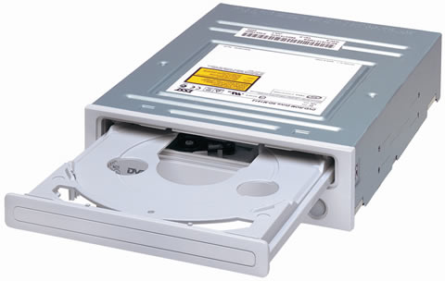 | CD ROM  (Compact Disc Read Only Memory) | It is a storage that stores computer data that uses reflected light to read the data.  Model examples: Dell Samsung SATA 48X CDRW 16X DVD-Rom, Asus Drw-24d5mt

PART C – Step by step PC Assembly
Step 1: Install CPU into motherboard
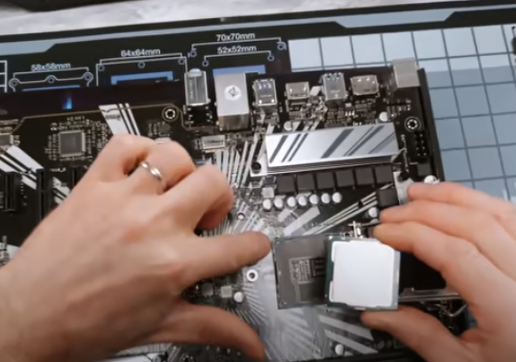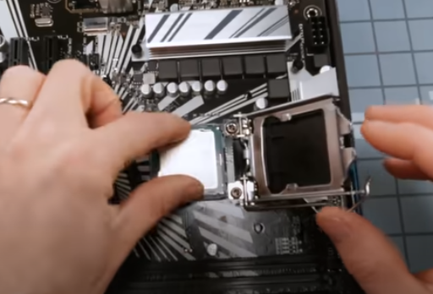
Push down the lever so the retention phase should move out of your way. Then, line up the little golden triangle on one of the corner with the dot on the corner of the socket. Without applying any force at all, lightly put it in the case and give a little movement to make sure it’s firmly in the place. Lower the lever and put it under the retention mechanism.
Step 2: Insert RAM into motherboard
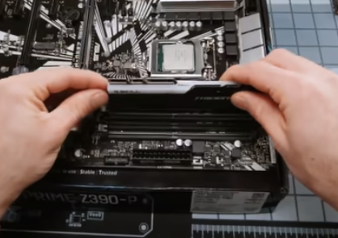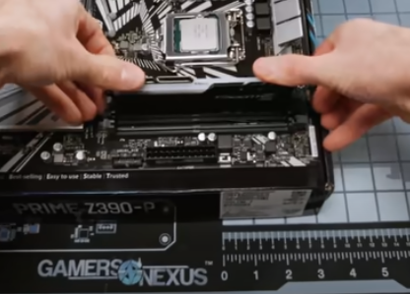
Before putting it in the slot, make sure the position of notch is correct so it can fit correctly in the slot. Push firmly on both sides of RAM until a click sound is heard on both ends.

Step 3: Mount heat sink on motherboard
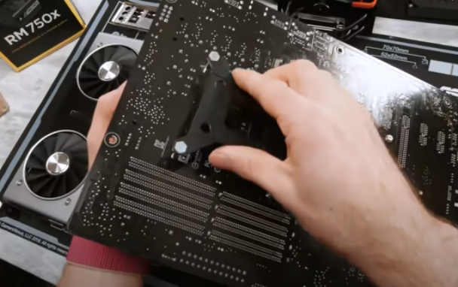
Firstly, take the back plate and align it on the back of the motherboard. Make sure to be careful while handling the motherboard by the edge or metal components or plastic connector so the PCB won’t be touched with our greasy hand. Use spacers to ensure there is not too much or too little pressure once our heat sink is installed. The orientation of the mounting bars is going to determine which way the heat sink will be facing.
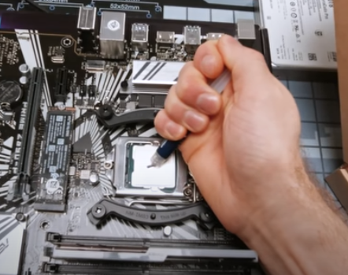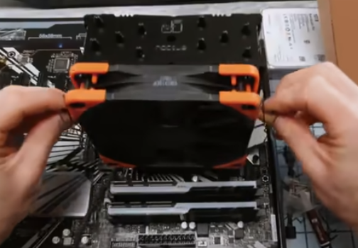
Do not put too much thermal compound because putting too much will cause messy on the HIS. Just make it enough covered. Install the heat sink evenly.

Step 4: Mount mother board into case
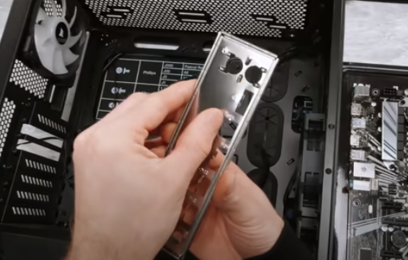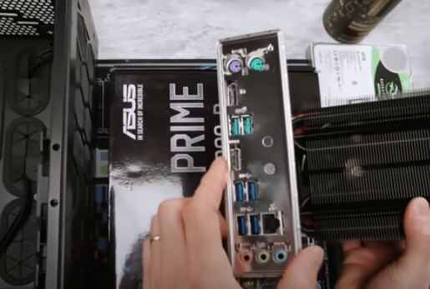
Before the motherboard is installed, IO shield needs to go first. Check all the tabs on the back are bent up enough to allow the port through and check it with the motherboard to make sure the orientation is correct.
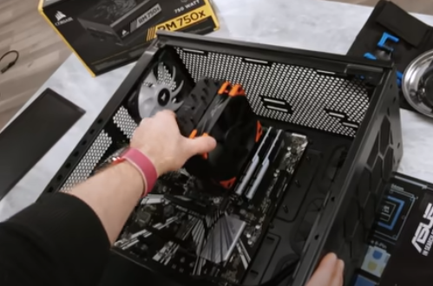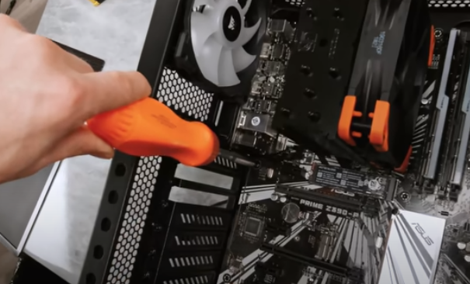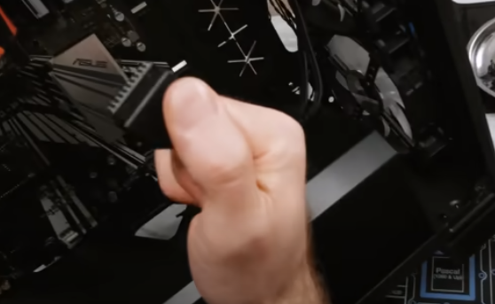
To install the motherboard, check whether the correct standoffs are installed in the case. Please be aware that extra standoffs can be dangerous because it can scratch the back of the motherboard and cut the traces on the motherboard. When the motherboard is already placed correctly, screw it onto the case. Plug the USB 3-pin cable into the board and be careful because the pins are fragile. Before applying pressure, make sure to hear a small click and continue with other wires.
Step 5: Mount hard disk in case
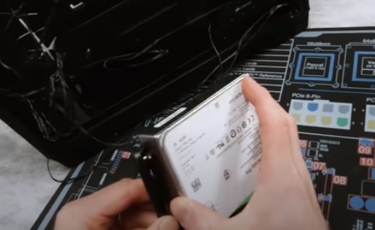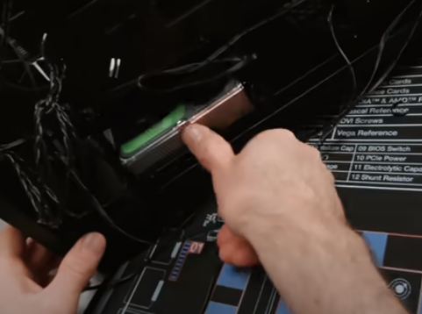
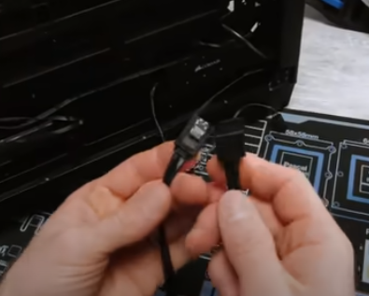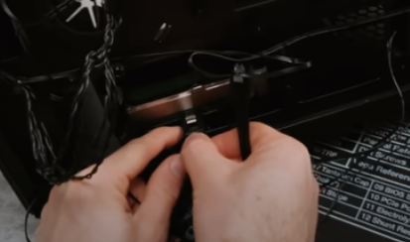
Install the hard disk in its case. If it is a tool-less cradle, it does not require screw which is much easier and quicker. Slide it into the case until it clicks. Take the SATA cable and connect it from the back of the drive to an available SATA port on the motherboard. On one side of the SATA cable there is like a locking mechanism and a little of L shape, that side goes to the drive, put it until it clicks. Connect other end over to correspondent connector on motherboard. Other than SATA cable, there is also a connector use to connect hard disk with the motherboard which is called IDE cable. It is connected to the IDE slot on the motherboard. However, IDE cable transfers data slower than SATA cable. Thus, SATA cable is widely used todays compared to IDE cable.

Step 6: Mount graphic card in case
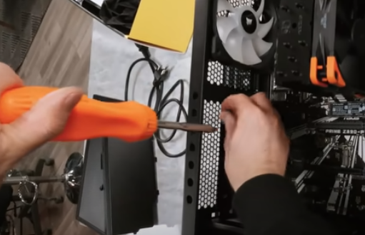
Take out two PCI slot covers (depending on the size of the graphic card).
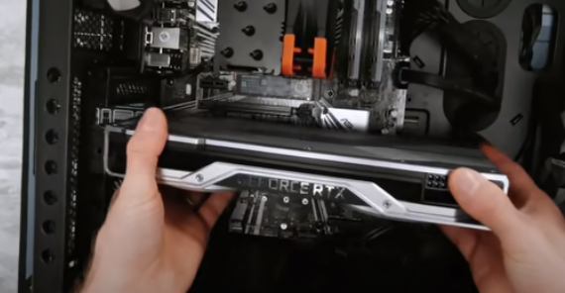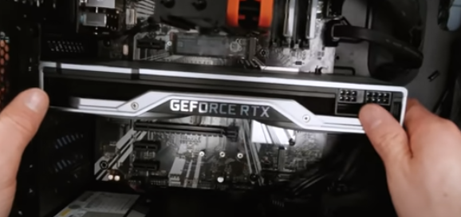
Hold the graphic card on both ends so even pressure will be applied as the graphic card is pushed down. To make things easier, line up the graphic card to IO shield first, and when it is aligned correctly, install the graphic card. Once it is done, screw it in its place to secure. Continue with the PCI Express Connector and connect it to the graphic card.

Step 7: Install optical drive for CD Rom
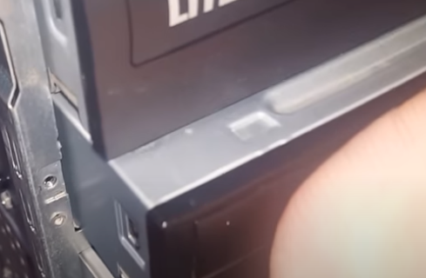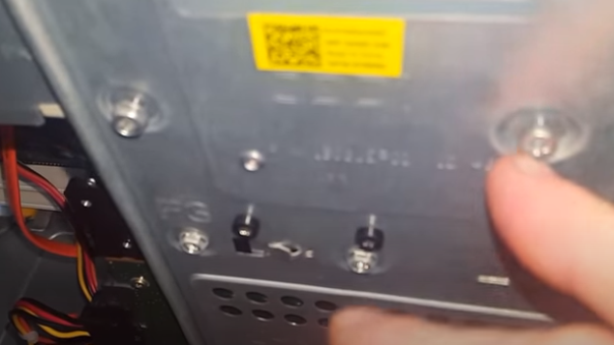
To install optical drive, remove the front case and slide it through the drive bay. When it is in its place, secure it with screw. Then, connect it with the SATA cable to the motherboard.
Step 8: Mount power supply
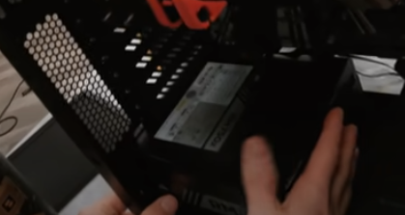
The first thing to do is to check for rubber feet in bottom case which will reduce the effect of the vibration to lower noise. Before installing, decide the best orientation for the installation. When the decision is made, mount the power supply in the bottom of case. Secure the power supply with screws to keep it in its place firmly.

Step 8: Close the case and connect the peripherals
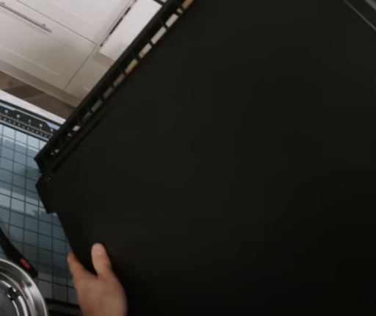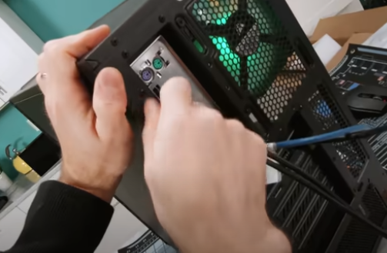
Place the sides cover back on and secure the side panels with case screws.
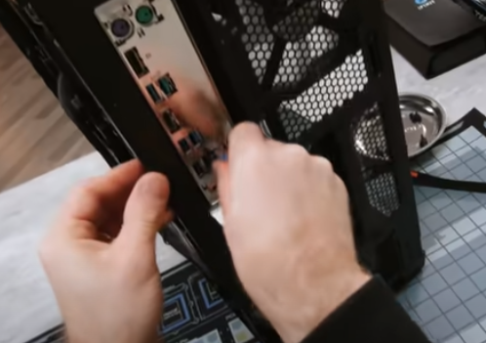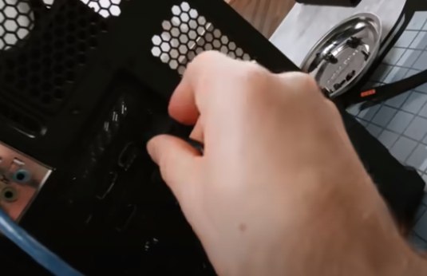
Connect peripheral devices which include keyboard, mouse, wireless network dongle, printer and webcams with you CPU by plugging into USB port.
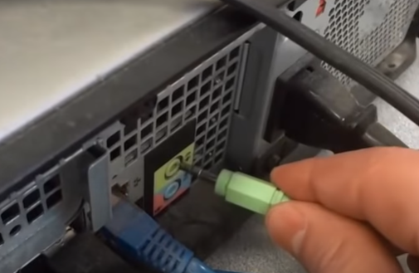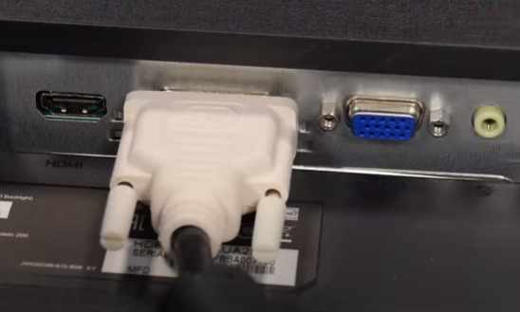
Then, connect speakers and microphone into 2.5 mm sockets. Finally, connect the CPU with monitor by plugging into display ports.

