

SECP1513
TECHNOLOGY AND INFORMATION SYSTEM

DESIGN THINKING:
ONE TOUCH STORAGE SYSTEM

LECTURER:
Dr Azurah Abd Samah

SUBMITTED BY:
Shahril Bin Saiful Bahri (A20EC0144)
Gui Yu Xuan (A20EC0039)
Phang Cheng Yi (A20EC0131)
Nurzarifah Binti Azizan (A20EC0127)

Semester 1 2020/2021
ONE TOUCH STORAGE SYSTEM
Team members’ name: Shahril Bin Saiful Bahri, Gui Yu Xuan, Phang Cheng Yi,
Nurzarifah Binti Azizan

School of Computing, Faculty of Engineering
Universiti Teknologi Malaysia, 81300 Skudai,
Johor Bahru, Malaysia

ABSTRACT
This report describes an application embedded secondary storage named One Touch Storage System which is a combination of VPN and cloud storage that provided solutions to solve the problems faced by users to save their documents. The backgrounds of users are also studied to find out the real problems faced and get the better comprehend through discussion. The necessity of One Touch Storage System is analysed from the user and presented in this report. The result show that One Touch Storage System give benefits that correspond to the problems faced by the users in their daily routine.

- INTRODUCTION

In this modern age, the uses of printed documents or learning materials become fewer and fewer. The preferences for people nowadays to access reading resources and materials change rapidly in a digital world. Besides, electronic documents are also widely used in different fields such as enterprise, education, medical and the list go on.

Meanwhile, the accommodation of data storage systems is required to keep abreast with the times. Hence, the development of data storage system spring up to satisfy the demands of the people to store their crucial and large capacity documents.

There are two types of data storage system in computer which are primary storage and secondary storage. Primary storage gives temporary storage and use Random Access Memory (RAM). It will cause content loses if the computer loses power. Secondary storage gives permanent storage to save data for future use and regardless of power supply. The examples of secondary storage are hard disk, disc, drives and cloud storage.

- PROBLEM BACKGROUND

In today's technological era, the storage system had become important things to us. This is because the human brain cannot remember too many things, so we store information in the storage system. Sometimes, we also use the storage system to stored data and to do the transmission. However, there are many problems emerged with storage system, such as exposing our data to third parties. There must be a safety hazard and increase the security threats.
Storing data in the storage system has become a habit. Therefore, there are a lot of data and important information on the equipment. This incident also gives a third party the opportunity to invade our equipment. In addition, because of the huge amount of data that needs to be stored, the operating speed of the system will be reduced, and the device space is not enough to support more data. Therefore, we need to spend more money to buy new equipment or buy larger capacity equipment that enable us to store the data.
Besides, if we cannot back up data in time, uncontrollable factors such as accidental deletion of data or sudden system crash will cause data loss. This matter will cause us a lot of trouble. More importantly, today's electronic devices no longer support certain secondary storage devices, such as CDs. So, we will face more challenges in storing data.

- METHODOLOGY

Empathize Mode

Observation
Based on our observations, many people faced the problems with inefficient data storage systems such as the slow booting for HDD, insufficient memory of local disk for large capacity document, data loses if power off suddenly or forgot to save, no automatically backup, new devices do not provided CD driver and security problems.

Engage
For better understanding about the problems faced by the users, background of the users and the ways used to solve their problems, an interview was conducted through online meeting and a survey was done by constructing a google form. In general, most of the responses especially students indicate that they have insufficient storage spaces on their devices like computer and laptop. Also, they prefer to use USB drive or cloud storage to save their data.

Immerse
Each of us use our own personal computer or laptop to run the large capacity program and files to experience what the problems that the users faced. We also found that most of the new laptops do not have the CD driver. As a result, some files which are save in the CD or DVD are unable to use in certain condition. Moreover, we were required to install certain applications to satisfy our requirements for multifunction such as VPN, virus detector and cloud storage. Such operations may make the storage space on devices become exhausted.

Define Mode

Followed by the empathize mode that we used to identify the problems faced by the users, we decided to design an application that can satisfy the requirement of the users for the better storage system. We considered all the design contents according to the ways that provided one-stop service which could include many functions such as storage, autosave and backup, drop zone, virus scanner and cleanup timer.

Ideate Mode

After a brainstorming process, we had some initial concept to have a more complex application which called One Touch Storage System. We discussed the designs and contents that required to be in the One Touch Storage System. Everyone had listed down the ideas and these ideas were filtered and rearranged to proceed to the next step.

Prototype Mode

In this phase, we made our ideas into physical form. We separated the task into two parts. The first part is the design of sample application and the second part is the production laptop prototype by using cardboard. In early process, we identified the deficiency of our sample application and made some improvements.

Test Mode

To enhance the design and make it better, we demonstrated the operation of the application by ourselves as users and shared our experiences in group to find out a more comprehensive way to solve the problem. Test mode helps us to detect previously unconsidered problems.

- FEATURES OF PRODUCT

Problems faced by users have motivated us in the making of One Touch Storage System which is basically a combination of VPN and OneDrive. By using the application, users are able to save data online and also offline. It gives a much secure system to the backup data and it is easier to use. Users also can input their data safely in the storage files. Moreover, it gives users one place to store, share, and sync their work or school files.

Other than that, the program also provides a virus scanner to the data that enter the storage. This is made so that it can avoid viruses and users can feel safer when they backup their data. Users also can customize and update their data without feeling worry as the scanner can provide advanced security, privacy as well as a good performance.
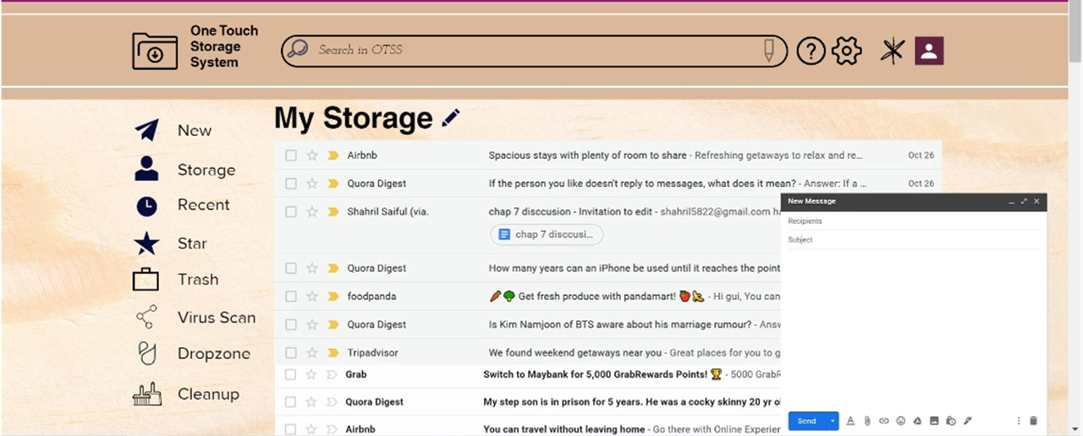

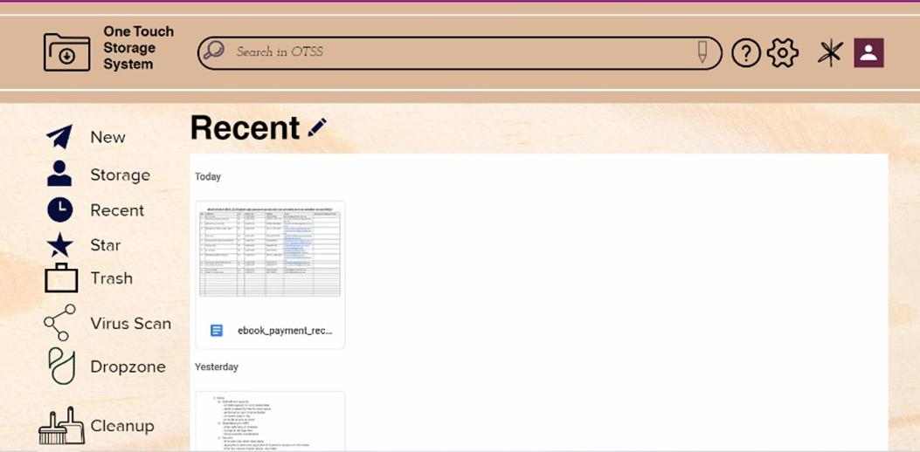

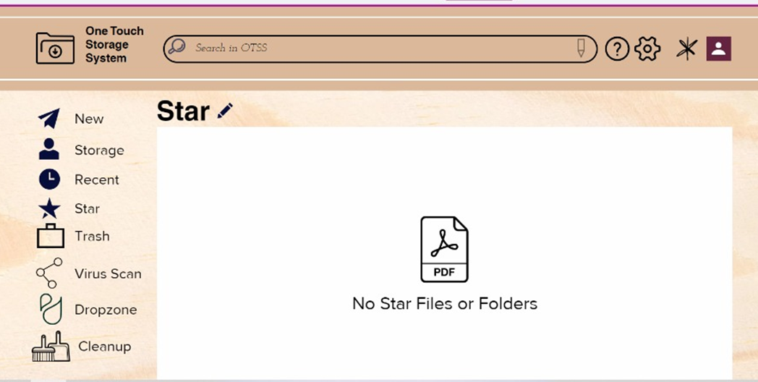

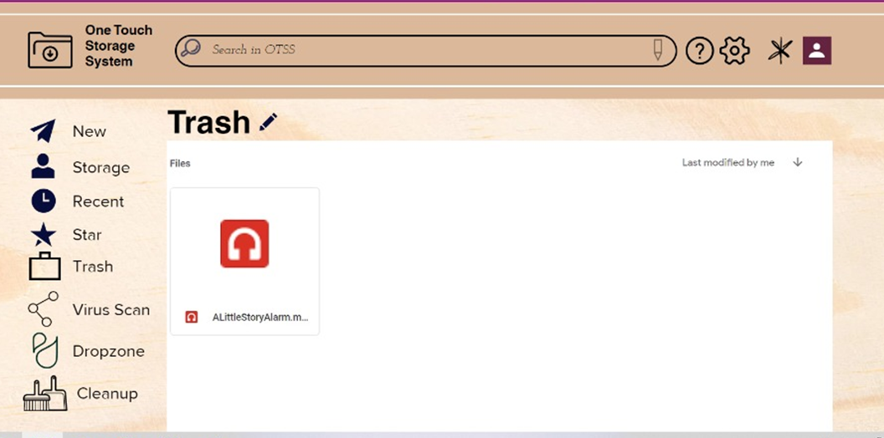

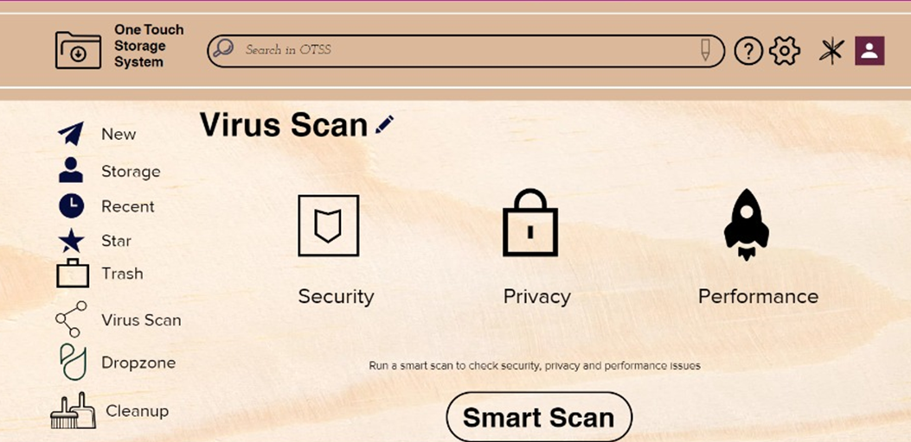

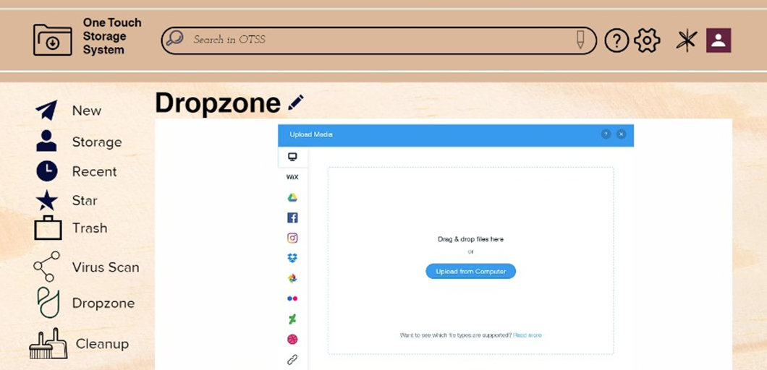

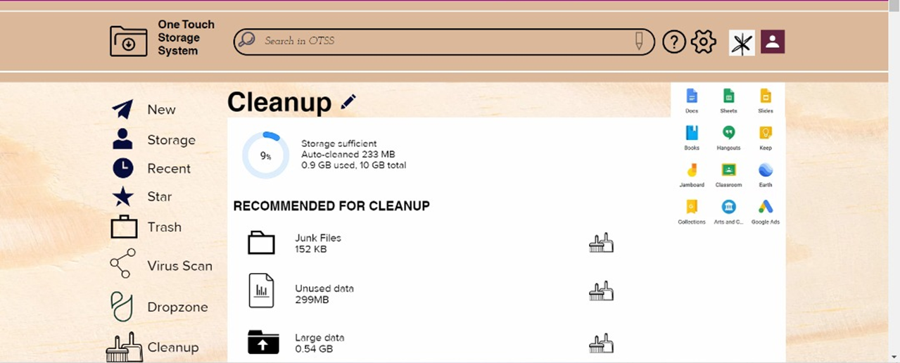

Figure 1: Design of Featured on One Touch Storage System (OTSS)
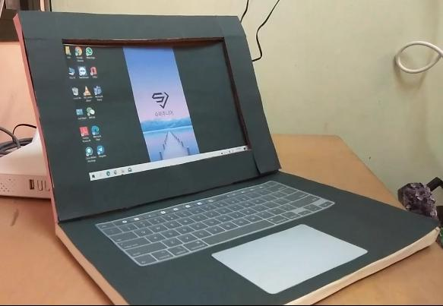

Figure 2: Laptop prototype for demonstrating One Touch Storage System (OTSS)

- USER STUDY

Surveys are carried out to further analyse the issue and demands of the users through both planned and brief. The surveys are given out to two classes of people: interviewees who are public and targeted which are carried out to get information of the users ' needs. In addition to the need for users, we also interviewed some Bioinformatics students to obtain their views on issues relevant to the industry, their acknowledgement on similar products, the designing of products.

Findings and Discussion Obtained from Surveys

Background of Interviewees
Interviewees are divided into two major groups: public and students from Bioinformatics course (scheduled and targeted). A total sample of 61 responses, age ranging below 18, 18-45 and above 45 years old involved in this user study. As shown in the figure below, the interviewees are from different occupation backgrounds which indicates the One Touch Storage System as it is designed to a person's background regardless of their age group or occupation.
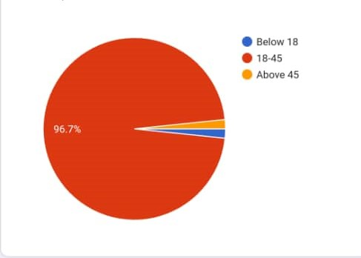
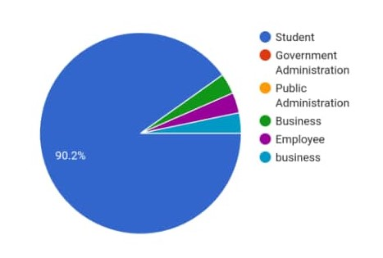

Figure 4 and 5: Age and Occupation

Identifying Problems Faced by Public Related to Secondary Storage
Based on the survey that we collected, many people prefer to use USB and Solid-state Drive (SSD) to store their data in the storage system. Some people also chose Cloud Storage and Hard Disk Drive (HDD) where it comes later. The most common issue that most of the interviewees faced is related to the capacity of the storage devices as mostly is not enough to store data. Problem that matters the most is also on what to choose on the storage system as there are almost many choices that also need to be considered on their needs. This can be observed by seeing what is more suitable for students or individual use. Other than that, data loss also is one of the problems that concern most of the users as stated on the survey.

Industry-Related Issues
The idea was analyzed by the answer on the survey as people gave their feedback and some ideas. Based on the interviews from Bioinformatics students, the interviewees have provided us some opinion on how to overcome the problems they faced. The interviewees have suggested us provide the users with more capacity as it is significantly essential to the users. They also recommended a system where the data is backed up automatically without any connections. Some of them show concern about reducing the cost of purchasing more storage to be implemented in this product to ensure it is not costly to the users.

Acknowledgement of Similar Products
From the user study, majority interviewees from both groups were very familiar and aware of how the program works as the products are slightly the same as the VPN and OneDrive as it is the combination of both. They said that they usually use different applications to fulfill both requirements which are VPN and storage space. They never heard that before about the applications that provided one-stop service which includes multifunction in one application.

User Feedback
Most interviewees express their interest and concern in the survey. They also give feedback and ideas about how the issues can be overcome. They are willing to use the products as long as they do not interrupt and make their daily lives troublesome, especially for those who are students that mostly use the program to store, sync and transfer their data. Some of them are concerned about the security that plays important parts in the program.

- BUSINESS ANALYSIS

One Touch Storage System evaluation proceeds with market review on users by including the strengths, weaknesses, prospects and risks towards our strategy to give a better performance on our users.

Strengths | Weaknesses
- User-friendly interface where users can use easily and much comfortable to their needs  - Updated every time cleaning system runs so that can avoid slow booting | - Cannot transfer data when there is no internet connection  - Not much storage as it is limited
Prospects | Risks
- Can be improve on the storage and cleaning system  - It can be further enhanced in order to gain more users | - Strong viruses may infect the system when users not properly take actions on it

- CAPACITY BUILDING AND SOFTSKILLS DEVELOPMENT

Through this project, we learned how to collaborate to accomplish our goal. We have also learned to resolve conflicts and inconsistent opinions between us through communication. When organizing and assigning activities, we also learned how to lead a group. When we complete a product together, we know how hard it is to achieve our goal, so we have become more grateful to what we have.

We know that communication skills are essential to prevent disharmony between teams. When doing something, we must also show positive behaviour, because only when the team is united, we complete the work and make the perfect job. Besides, the team leader is also an important role. He wants to organize the meeting and confirm the progress of our work. Sometimes, the leader will also encourage and support us.

- REFLECTION AND CONCLUSION

In this project, we have a new understanding of technology. In the beginning, we tried to learn how to use electronic devices to complete our work. For example, video recording during the meeting and using electronic devices to design our prototype. But fortunately, with our cooperation, we successfully overcome the obstacles.

In addition, we have strengthened soft skills. During the discussion, we quarreled due to disagreement and were not satisfied with each other. However, in the process of getting along, we learned to communicate with team members to solve problems and we also learned to give our own opinions in a better way.

To conclude the project "One Touch Storage System", it provides users with a better platform to store data and share data with others. The system improves security by preventing the user's privacy from being exposed to third parties. It also provides students with free large-capacity storage space, and the cost of purchasing large-capacity storage space is lower. The automatic backup system can prevent data loss. To avoid a situation where there is no Internet connection, the system provides offline service.

