

SECP-1513

TECHNOLOGY AND INFORMATION SYSTEM

DESIGN THINKING :
HYGIENE MANAGER
LECTURER :
Dr Azurah Abd Samah

SUBMITTED BY :
Huda Najihah binti Ahmad Asri A20EC0045
Marnisha binti Mustafa Kamal A20EC0075
Keshiniy A/P Mogan A20EC0057
Woon Zi Jian A20EC0171

SEMESTER 1 2020/2021

HYGIENE MANAGER

Team members’ name: Marnisha binti Mustafa Kamal, Huda Najihah binti Ahmad Asri, Keshiniy A/P Mogan, Woon Zi Jian

School of Computing, Faculty of Engineering

Universiti Teknologi Malaysia, 81310 Skudai,
Johor Bahru, Malaysia

ABSTRACT
This paper describes a smart alarm mobile application named Hygiene Manager which provides solutions to common problems faced by the public to keep their hands clean and always wearing a mask when they are going out. The problems faced by the users are also discussed to give a better understanding of the real problems faced by different individuals. Analysis of user study is presented in this paper to justify the problems surrounding the needs of the Hygiene Manager application. The results of the analysis show that the features of the Hygiene Manager application address and accommodate most of the common problems faced by the users in their daily lives.

- INTRODUCTION
In the year 2019, the world received an unfortunate fate where a virus was spread rapidly, resulting in a global pandemic. Based on WHO, COVID-19 is a respiratory illness that spreads when mucus or droplets containing the virus gets into the body and can also spread via touch. It has almost been a year, yet a proper vaccine yet to be found. COVID-19 has taken down a million lives and put thousands of lives in critical condition.

Due to this, we must take care of our hygiene in a proper manner. It is advised by the WHO to take some precautions. Physical distancing, wearing masks, avoid crowds, and wash your hands frequently are a few precautions for us to follow. The Malaysian government has strictly stressed following the Standard Operation Procedure (SOP) to ensure we can fight against the disease. Therefore, we have to take care of our personal hygiene to stay safe.
- PROBLEM BACKGROUND
During a global pandemic, one of the cheapest, easiest, and most important ways to prevent the spread of a virus is to wash your hands frequently with soap and water and wear masks to prevent virus transmission. In fact, many people do not realize the importance of washing their hands frequently and wearing masks, as it can prevent the virus from transmitting from one another. Washing hands frequently and wearing masks should be practice in our daily lives. Most people do not wash their hands after blowing their nose and touch random surfaces after visiting a public space. Most people tend to forget their masks whenever they go out, even though the government has stressed the importance of hygiene multiple times.

3.0 METHODOLOGY
Empathize Mode
Observation
Based on our observations, some people tend to forget wearing a mask when going out, and many people forgetting to wash their hands with soap after they going out. For example, some people will just walk out of the house and forget to wear their masks. Some people also forget to wash their hands with soap after going to public areas and touching public places. This can be easily observed by seeing people going out with no mask and many people coming back from outside and straight doing the things they should do.
Engage
For a better understanding of users’ problems and requirements, interviews are conducted online and using google form. Generally, most interviewees show that they did not wash their hands frequently with soap. They will only wash their hands whenever they felt their hands are dirty. Some of them also being forgetful to wear their mask when they going out and they only realize that when they see others wearing a mask. They are comfortable with the Hygiene Manager application as long as it will not troublesome to their daily lives and easy to be used. Some of them concern about the phone battery will be draining faster than usual if using the application to remind them to wash hands and wear a mask.
Immerse
To experience the problem that users are having, we challenged ourselves to wear a mask and sanitize our hands whenever go out or enter any shop lots. We also challenged to wash our hands with soap after every single thing we do such as before and after a meal, after using the toilet, after coughing and sneezing, and more. However, we found out that it is very difficult to fulfill as we being forgetful when we concentrating on certain tasks. We are only able to remind ourselves for washing hands and wearing a mask when people around are doing the same thing or when our hands are dirty.
Define Mode
To develop a deep understanding of our users and the design space, all group members of four did undergo analysis, investigation, research, and discussion. We have come up with an actionable problem statement with our points of view that focuses on the users. After we have understood the needs of users in empathize mode, we found out that a reminder is needed for the user to solve this problem. We have all agreed that we needed to create a mobile application as a solution to the problems faced.
Ideate Mode
With continuous hours of discussion with our group members via Google Meet, we managed to brainstorm ideas on the Hygiene Manager. For example, how many icons will be there and their functions? In the designing part, each of us came up with our own sketch of app designs. To select the best idea, each of us voted for the best, attractive, and easy handling app design. The design with the most vote was chosen as a final choice.
Prototype Mode
In this phase, we have made our application into graphic form. For a user to more understand our concept of the design, we have made a mock application to show some features. In the early stage, the application was rough and this allows us to make amendments and improvements in other possibilities.
Test Mode
To modify the design to make it better, we have explained our application to the user for responses. We asked for users’ reviews and experiences to establish a more comprehensive way to solve the problems. Their responses and reviews made us identify the problems that we left unidentified. Test mode helps us to identify previously unconsidered features and let this application to be improved.

Task Assignment
On the 25th of October, Dr. Azurah had assigned an assignment about design thinking to us. We formed a group of four included Marnisha, Huda Najihah, Keshiniy, and Zi Jian. Then, we had our first discussion through Google Meet. We discussed our topic and the ideas for the assignment. Each of us proposed an idea and we chose the idea with the highest vote. After that, we distributed the task among us. Firstly, we were searching for a person who is with a Technology and Information System background. Then, we created a questionnaire using Google Form and distributed it to the public. Besides that, we came up with some questions to interview the interviewee. We had also created a prototype mock application to show the interviewee more about the application. After that, we had interviewed Mr. Azmi who was specialized in the mobile application for UTM Digital. During the interview, we collected the answer and reviews from him about our application. After we gathered the information, we analyze and summarize the information and started to do the video presentation and report. Then, Marnisha and Huda Najihah did the video presentation while Keshiniy and Zi Jian generated the report of this assignment. Lastly, all of us checked the video and report and submitted it to Dr. Azurah.
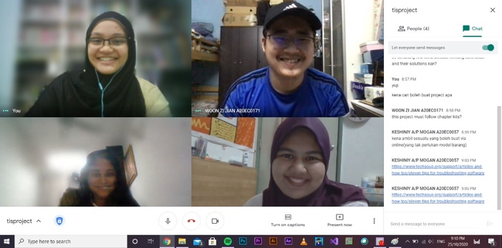
Figure 1: Screenshots of ways of group discussion

5.0 THE PROPOSED SOLUTION
User Study
To further investigate the users’ problem and requirements, interviews are conducted through online and google form. The interviews are conducted with two groups of individuals who are public and targeted interviewees. Interviews are conducted to get information about users’ needs. Apart from that, we also interview the staff specialized in the mobile application to get their opinions on their acknowledgments of similar products, feedbacks about our application and future improvements.
Findings and Discussion Obtained from Interview
Background of interviewees
Interviewees are divided into two major groups, public, staff, and students from Computer Science (targeted). A total of 40 interviewees, ages ranging from 13 and above were involved in this user study. As shown in figure 2, the interviewees are categorized by gender.
Figure 2: Background Study of Interviewees
Identifying Problems Faced by Public Related to Hygiene Management
The most common problem faced by most of the interviewees is that they tend to forget to wash their hands when they are focusing on a certain task. Some people also being forgetful to wear a mask when they were going out. The problem that matters to them the most is they do not know the acknowledgment of washing their hands with soap. They only will wash their hands with soap when they feel their hands are dirty. This can be observed easily when people straight doing their tasks when they came back from outside.
Acknowledgement of Similar Product
From the user study, the majority of interviewees from both groups were not aware of any similar products to the Hygiene Manager. Some of them have awareness of mobile applications that act as an alarm to remind users to wash their hands. However, they had never heard of a mobile application that can both remind users of washing hands and wearing a mask.
Features of Product
Problems faced by the users had motivated the development of the Hygiene Manager application, a mobile application that was used to remind users to wash their hands frequently and wear masks when they are going out. By using this application, users can set the reminder to remind themselves to wash their hands after a certain time. Next, users can update their home location to let the application automatically track their location and remind them to wear a mask when they are going out. Users also can customize their own routine and the theme of the application.
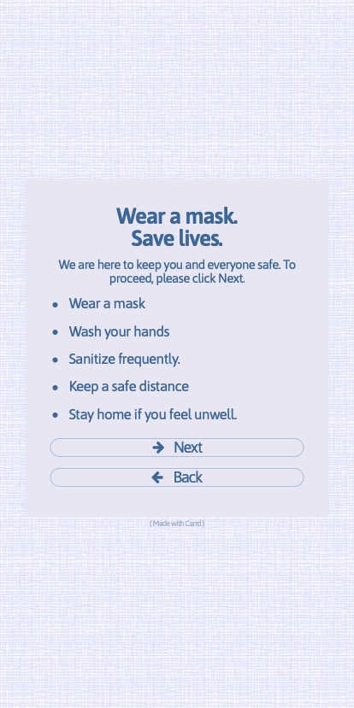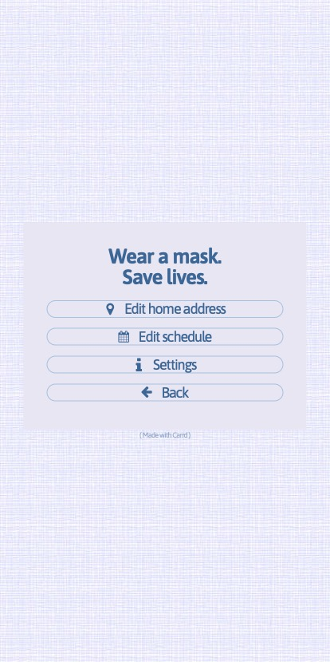
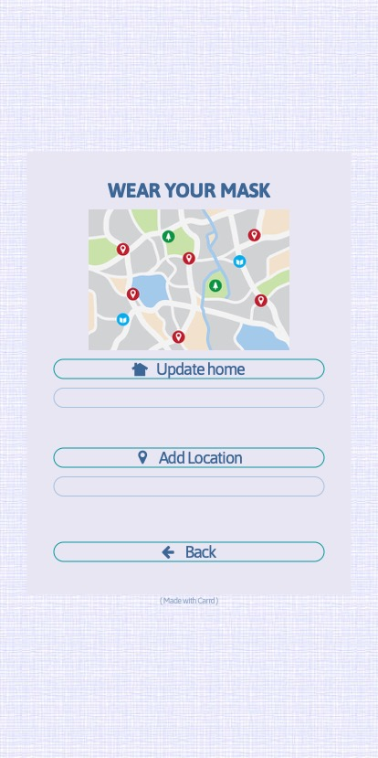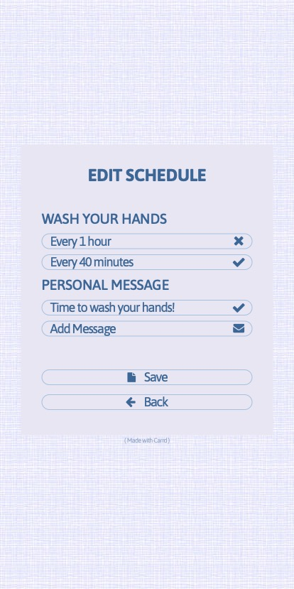
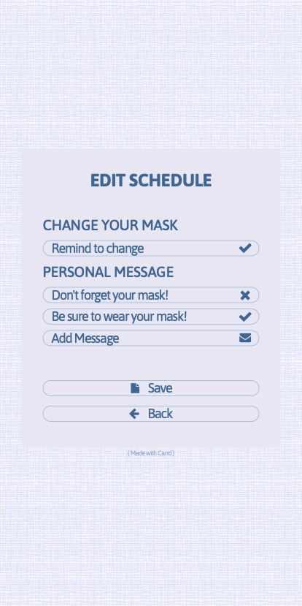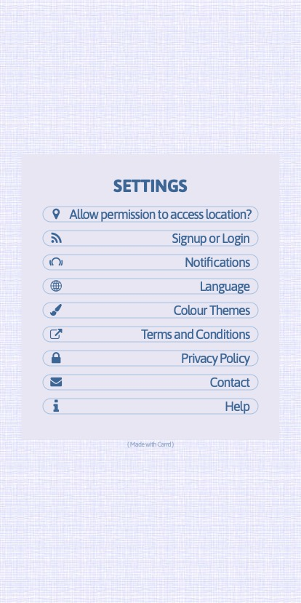
Figure 3: Screenshots of Features in Hygiene Manager Mobile Application

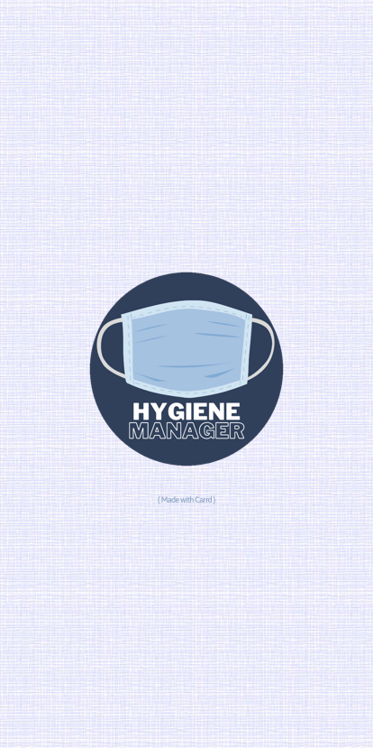
Figure 4: Logo of the Hygiene Manager Mobile Application

User feedback
Most of the interviewees show their interests in the given idea. They are comfortable and think that the idea should be executed in the future as soon as possible as we are having global pandemic issues. They are willing to use the applications as long as it is not interrupting their daily lives but also helping them to manage their hygiene. Some of them show concern about battery life is draining more faster if using the application.
Business Analysis
Business analysis using SWOT (Strength, Weakness, Opportunities and Threats) is conducted on Hygiene Manager.
Strengths | Opportunities
- User-friendly where it doesn’t pollute the environment  - Remind us to always be hygiene | - Will be profitable  - Will be worldwide recognizable
Weakness | Threats
- If the user didn’t allow permission to access their live location and send a notification, Hygiene Manager could not remind the user to keep themselves hygiene. | - Hackers can hack the application to know the user’s location.

Future Works and Improvement
Throughout this project, we had some ups and downs which is needed to be improved. First and foremost, we have to understand and embrace the concept of MVP (minimum viable product). Instead of waiting and getting the project to be perfect, we can follow the principles of MVP by releasing the Hygiene Manager in the market as soon as possible even though it’s just a prototype. This allows the users to give feedback on how to improve the app so that we can improve the prototype till we release the final product.

Apart from that, we also like to keep a clear and accessible schedule. This is because each member has their own task to do to succeed in this project. However, some tasks depend on other tasks to complete. For example, a part of the final report needs the details of the interview section. Therefore, each member should know when they have to complete their tasks and knew what other members’ tasks as well. This can be done by having a good platform to assign all their tasks and their due dates where other members are also able to see their work.

6.0 REFLECTION AND CONCLUSION
In this project, we faced so many problems and challenges which made us more strong, flexible, and adaptable. First and foremost, due to the Covid-19 pandemic, everything was conducted online where all the meetings were conducted online through Google Meet. Even though we managed to conduct our meetings, it’s still wasn’t like a face-to-face meeting. This is because some of the information will display or receive late due to connection problems. Apart from that, the decision was hard to make due to everyone having a different perspective and everyone was not online at the same time. Therefore, the discussion time was not even.

Throughout this project, we learn how to work as a team. Even though we were far away from each other, we still managed to work as a team with the help of social media and the internet. Not only that, but we also tolerate and used diplomacy when it comes to the decision making section. On the other hand, we also managed to strengthen our soft skills such as communication skills where we learned how to speak and deliver the message clearly with positive body language and facial expressions.

To conclude, the Hygiene Manager reveals the contribution of this successful product to the user’s problem. First and foremost, it will always remind the user to wear a mask whenever the user leaves their house. Hygiene Manager also reminds the user to always sanitize their hands to keep themselves hygiene. This can prevent the user from getting infected by the COVID-19 or any other viruses. Apart from that, this also will make them from getting summon by the police officers for not wearing a mask.

