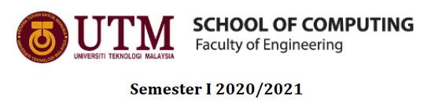

Subject : Technology and Information Systems (SECP1513)
Section : 1
Assignment : Step by Step PC Assembly

GROUP NAME / NUMBER : 3
1. |  | Name: Huda Najihah binti Ahmad Asri  Matric Number: A20EC0045  Phone Number: 010-218 2840  E-mail: hudanajihah@graduate.utm.my
2. |  | Name: Keshiniy A/P Mogan  Matric Number: A20EC0057  Phone Number: 013-470 9452  E-mail: keshiniy@graduate.utm.my
3. |  | Name: Marnisha binti Mustafa Kamal  Matric Number: A20EC0075  Phone Number: 018-220 8667  E-mail: marnisha@graduate.utm.my
4. |  | Name: Woon Zi Jian  Matric Number: A20EC0171  Phone Number: 018-2226331  E-mail: woonjian@graduate.utm.my

PART A : Tools needed

- SCREWDRIVERS

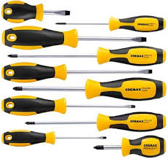

The screwdrivers are used to screwing (installing) and unscrewing (removing) screws. Screwdrivers are important to screwing the screws into the screw holes, so that the screw can hold the object on place or to unscrew out the screws out of the hole to remove the object such as removing the side panels out of the case.

- WIRE CUTTERS
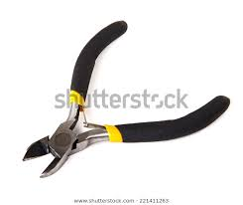
The function of wire cutter is to cut copper, brass, iron, aluminium and steel wire. It is important to cut out any unwanted or extra lengthy wires. It also helps to cut the cable tie which is used to hold the wires together.

- LIGHT SOURCE

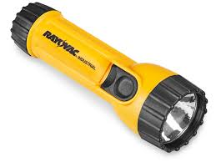
Flashlight act as a light source to direct into a place where there is insufficient light. Flash light is important because PC cases will be full of shadows and screws can fall or roll into the dark corners. Therefore, flashlight will be helpful to find out the screws.

- GROUNDING STRAP
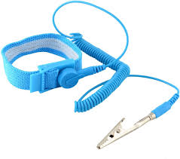
Grounding strap is used to protect individuals and equipment by serving as a safe path to grounding live current. It is really important so that it prevents any build up of static electricity on our body from damaging the computer components.

- CABLE TIES

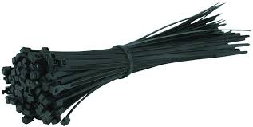

Cable ties are used to hold items together, most commonly electrical cables or wires. Cable ties are important so that it can keep cables in place and neat.

- PLIERS

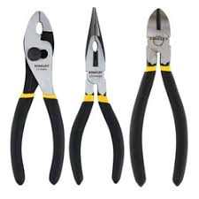
Pliers are a hand tool used to hold objects firmly. They are also used for bending, cutting and compressing wide range of materials. Pliers are important for cutting wires or bending wire into accurate angle. It also used to make the process of inserting and removing tiny parts and accessories on the hard disk of the PC.

PART B : Sketch of a motherboard layout
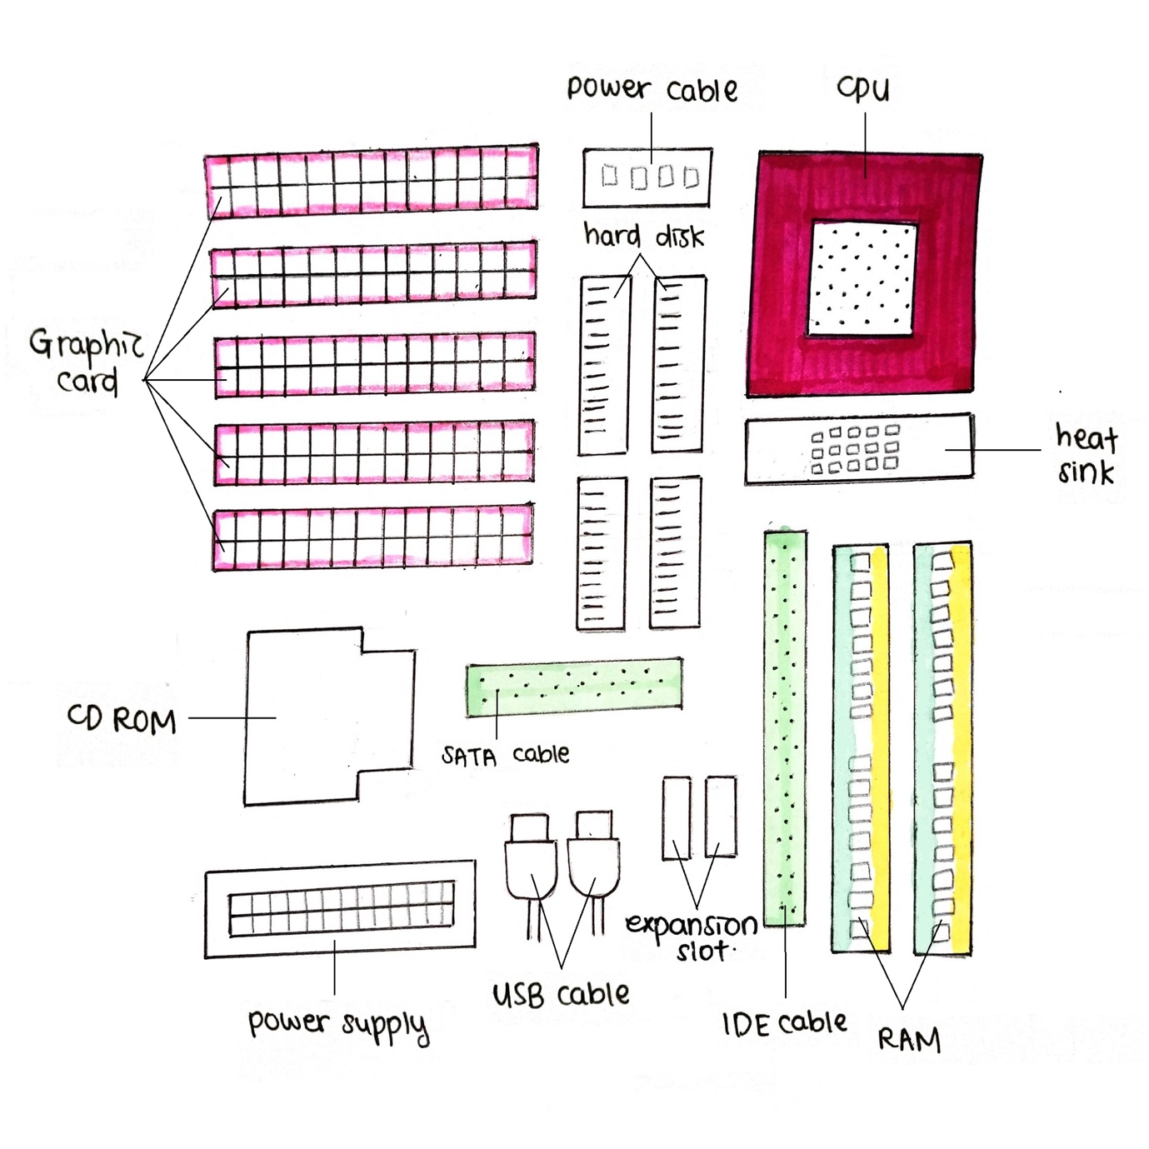
Diagram 1.0

Graphic card
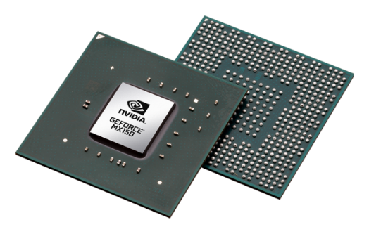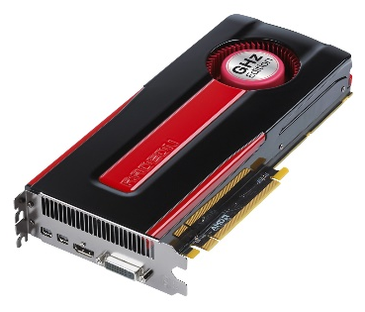
A graphic card is used to produce images on monitor. There are two types of graphic card which are integrated and discrete. Integrated usually is built-in the motherboard and can be found in general laptop, meanwhile discrete is an add-in card which has its own video memory.
Example of models:
- Intel® UHD Graphics 620
- AMD Radeon HD 7870

CPU / Processors
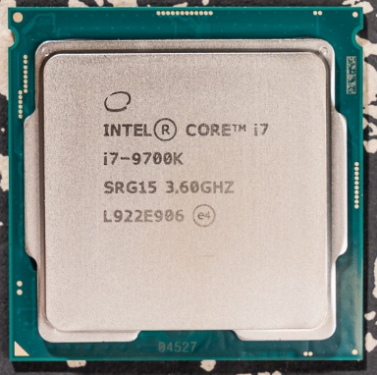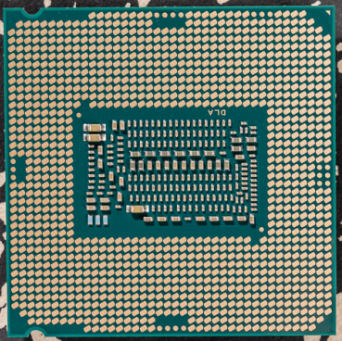
Central Processing Unit, CPU is the brain of computer. Just like its’ nickname, CPU processes and executes instructions so that the computer works. It receives input, processes the input, stores the data and produces output.
Example of models:
- Intel® Core i7-9700K
- AMD Ryzen 7 3800XT

Heat Sink
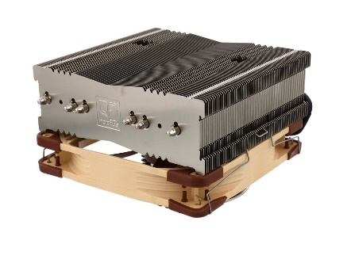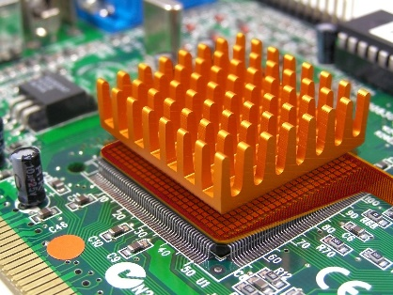
Heat sink is a component used to cool down devices. It has a set of fins that helps to transfer heat away from the device. It’s usually paired with a fan or a liquid cooling solution.
Example of model:
- Noctua NH-C14S

CD ROM
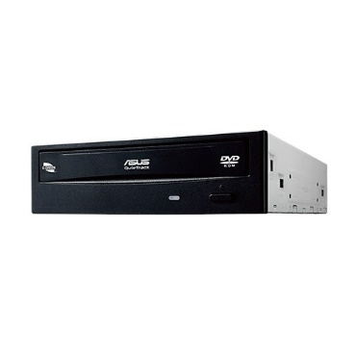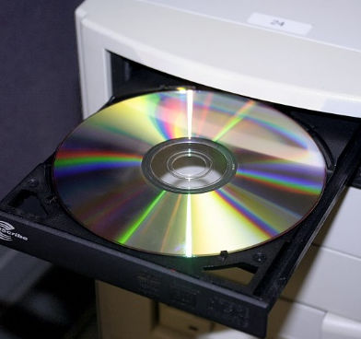
CD ROM is a short form for ‘Compact Disc Read-Only Memory’. It contains data, which only can be played and can’t be rewrite nor edited. CD ROM can be read by using a CD ROM drive which read the CD ROM by using laser light or electromagnetic waves.
Example of models:
- Intel® SATA Slim-line Optical DVD Drive AXXSATADVDROM
- Asus DVD-E818AAT

USB Cable
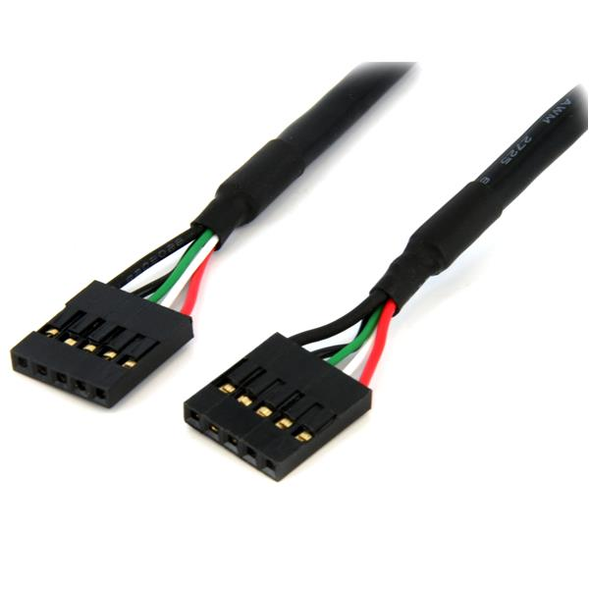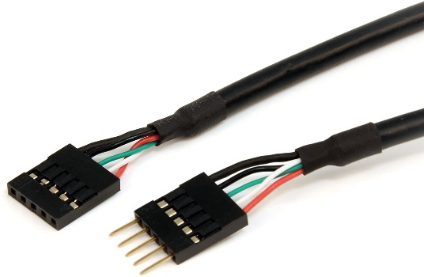
USB stands for Universal Serial Bus. USB cable connects specific USB ports and the matching port on motherboard.
Example of models:
- Startech USBINT5PIN
- Startech USBMBADAPT

Slots
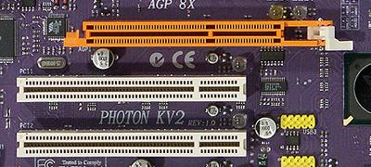
Expansion slot provides a port on motherboard for hardware expansion card to be installed. There are many types of slot, but the most common ones are PCI, PCI Express and AGP. Each with different usage and speciality.
Example of models:
- PCIe® 4.0
- AGP 3.0

RAM
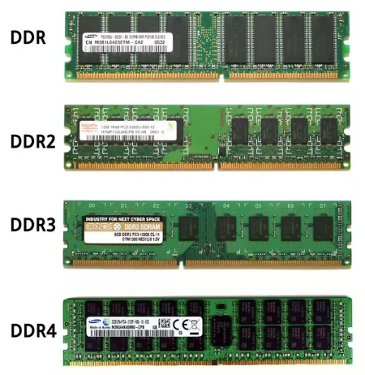
While hard-disks stores data permanently, the ‘Random Access Memory’ is like a short-term memory for computer. It’s a temporary data storage that helps computer process information immediately. When the computer is turned off, the data in RAM will be gone unless it’s saved in hard disk. The higher the memory of RAM, the faster the computer will run.
Example of models:
- DDR SDRAM PC3200
- Micron DDR3 MT41J128M16JT-093:K

SATA Cable
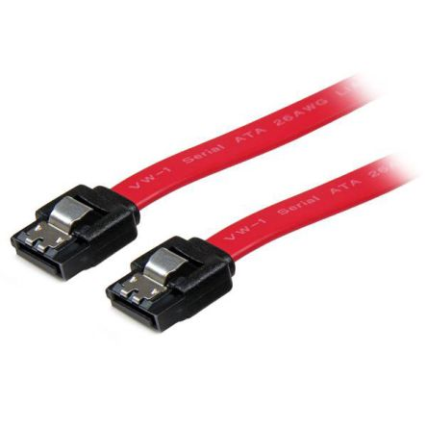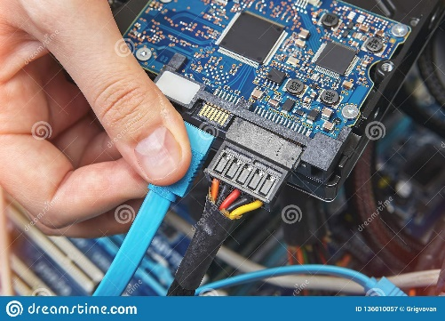
SATA Cable or Serial Advanced Technology Attachment is used to connect devices to the motherboard.
Example of models:
- SATA24RA1
- LSATA18RA1

IDE Cable
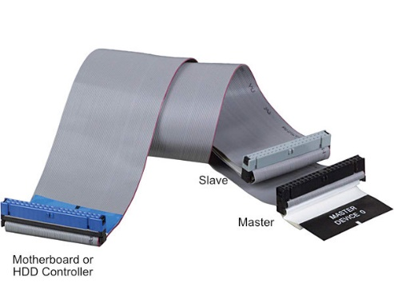
IDE cable or Integrated Drive Electronics is also used to connect devices to the motherboard, but unlike SATA cable which has only two connection points, an IDE cable on the other hand has three connection points.
Example of models:
- IDE66

Power Supply
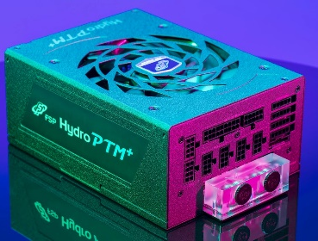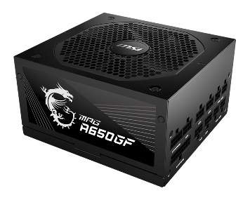
A power supply converts current from alternating current (AC) to direct current (DC) then supplies it thorough the computer. It also helps computer from overheating by regulating the voltage.
Example of models:
- MSI MPG A650GF
- FSP Hydro PTM 650W

Hard Disk
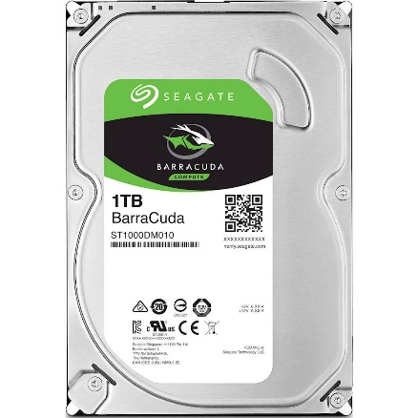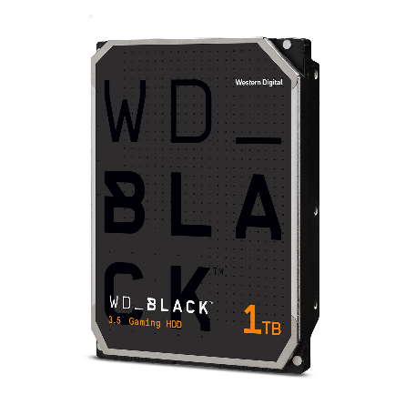
Hard disk is a hardware that stores large amount of data permanently. It accesses and stores data using magnetic storage and platters that rotates at high speed. Jumper settings in hard disk has a configuration called master-slave which after configured, the control’s direction is always from master to slave.
Example of models:
- Seagate Barracuda ST1000DM010
- WD_Black WD2500LPLX (CMR)

Part C – Step by Step PC Assembly

Step 1 : Install a CPU

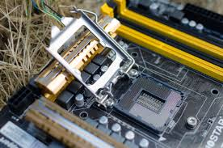
1.1 Firstly, release the tension lever on the CPU.

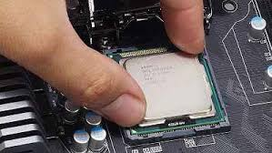
1.2 Then, attach the CPU into the CPU socket.

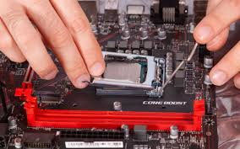
Precautions:
The arrow on the top of the CPU needs to line up with one on the socket or the socket cover.

Don’t attempt to install a CPU with the arrow facing the wrong direction, it will cause your chip to be damaged.

1.3 Once the CPU settled correctly in the socket, press the tension lever back down.

Step 2 : Install CPU heatsink

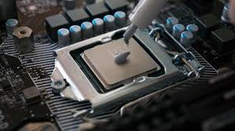
2.1 Apply the thermal paste on the CPU.

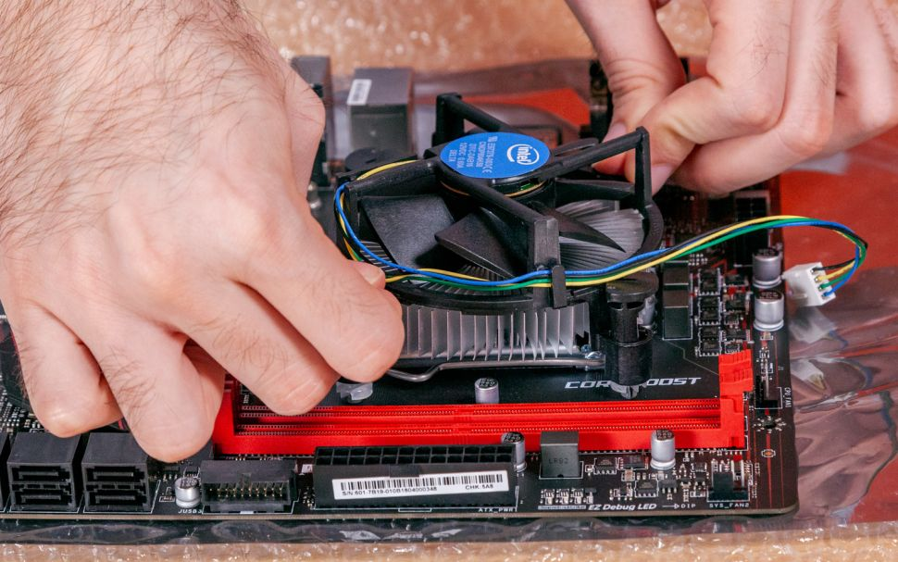
2.2 Install the CPU heatsink/cooler with fix in position.

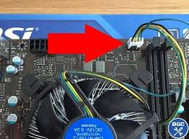
2.3 Plug the power cable attached to the cooler fan into the motherboard connector.

Precautions:
Don’t spread too much of thermal paste on the CPU.
Tips:
Pushing opposite corners of the CPU heatsink to evenly spread the thermal paste and to keep from putting uneven pressure on one side of the CPU.

Step 3 : Install RAM

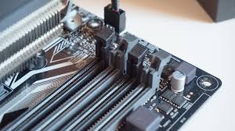
3.1 Press to open the clips at both ends of the RAM mounting slots.

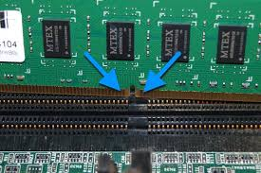
3.2 Line up the notch on the RAM stick with the mounting slot.

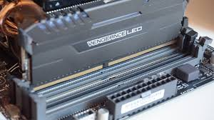
3.3 Seat the RAM and press it firmly down into the slot. The tabs should automatically latch closed as you press the RAM down, securing the RAM in place.

Precautions:
If you’re installing two RAM sticks in a board that has four slots, check the motherboard manual to make sure you’re installing your RAM in the right slots.

Step 4 : Install power supply

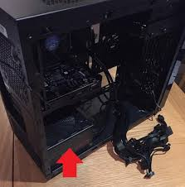
4.1 Mount the power supply at the bottom of the case.

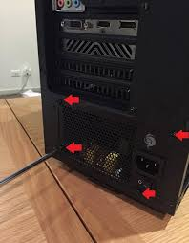
4.2 Fasten the screws to the case mounting point.

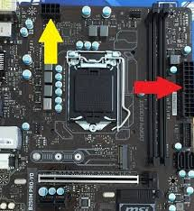
4.3 Plug the largest cabling connector and 8-pin cabling connector from the power supply cabling into motherboard power connector and CPU power connector respectively.

Step 5 : Install the motherboard into the computer case

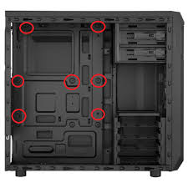
5.1 Screw the motherboard standoff into the computer case.

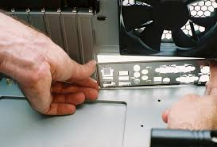
5.2 Install the motherboard I/O plate.

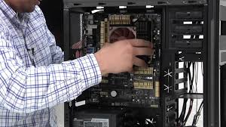
5.3 Fasten the motherboard in place on top of the mounting standoffs.

Tips:
Install the mounting standoffs in the case positions that match the screw mounting holes on your motherboard.

Step 6 : Install graphic card

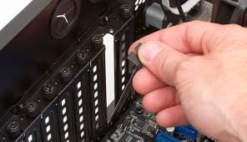
6.1 Remove the expansion slot cover from the rear of the computer case.

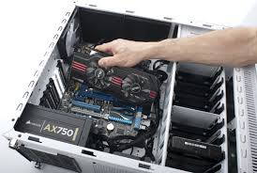
6.2 Slot the graphic card into PCI expansion slot on the lower half of the motherboard. Line it up and press down firmly to seat the card.

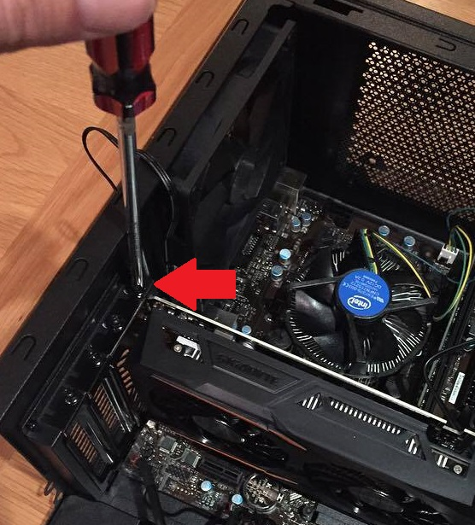
6.3 Put in the screw to hold the graphic card.

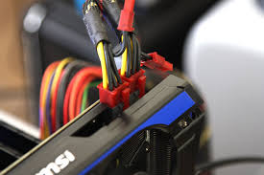
6.4 Plug in the power connector from power supply into graphic cards connector. (if existing – not all graphic cards require external power)

Step 7 : Install hard disk drive

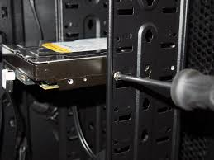
7.1 Mount the hard disk drive in the case drive bays. Fix the drive in place with screws.

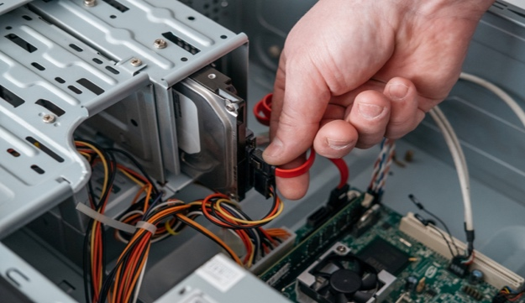
7.2 (a) If you are installing SATA hard disk drive, connect the hard disk drive using SATA cable to SATA slot on the motherboard.
7.2 (b) If you are installing IDE hard disk drive, connect the hard disk drive using IDE cable to IDE slot on the motherboard.

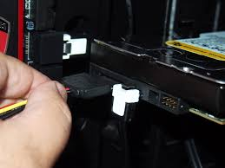
7.3 Plug in the power cabling from power supply to the storage drive.
Tips:
You need to set jumper if you are installing more than one IDE hard disk drive. The main drive will be set as master and second drive will be set as drive.

Step 8 : Install CD ROM drive

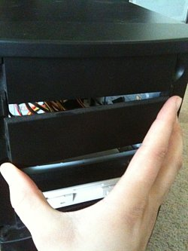
8.1 Remove the front panel from the computer case where the CD ROM drive will sit.

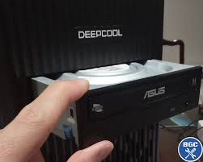
8.2 Mount in the CD ROM drive in the case by fixing it with screws.

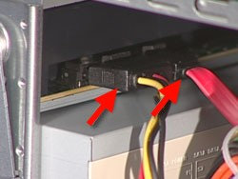
8.3 Connect the CD ROM drive to the IDE slot or SATA slot on motherboard by using IDE cable or SATA cable. Connect power cables from the power supply to the CD ROM drive.

Step 9 : Connect case fans & front panel connectors
9.1: Identify the cabling from front panel ports of your PC included:
a) Power switch cable
b) Reset switch cable
c) Audio cable
d) USB cable
e) Hard drive light cable
f) Power light cable

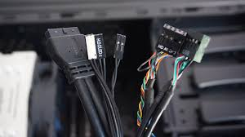

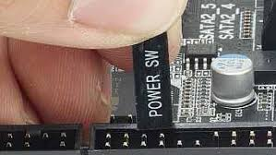
9.2 Connect all the cables to the motherboard respectively.

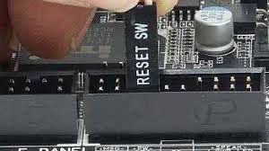
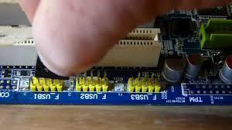

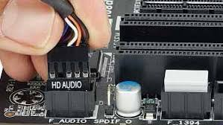

Step 10 : Closing the case and connecting the peripherals

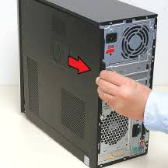
10.1 Place the side cover back on and secure the side panels with case screws.

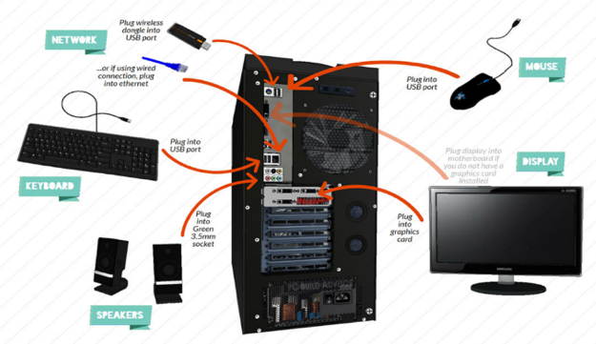
10.2 Connect peripheral devices which include keyboard, mouse, wireless network dongle, printer and webcams with your CPU by plugging into USB port.

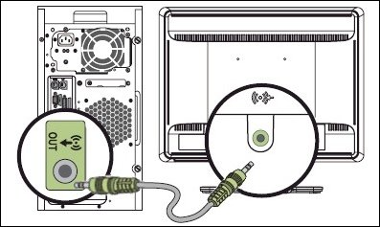
10.3 Then, connect speakers and microphone into 2.5mm sockets.

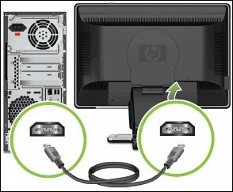
10.4 Finally, connect the CPU to monitor by plugging into display ports.

REFERENCE
PART A
- Lathan, P. (2016). 5 TOOLS YOU NEED TO BUILD A PC. Retrieved 23 November 2020, from https://blog.nzxt.com/tools-need-build-pc/
- Blues, J. (2020). How to Assemble a Basic Desktop PC. Retrieved 23 November 2020, from https://www.instructables.com/How-To-Assemble-A-Basic-Desktop-PC/

PART B
- Bernstein, J. (2012) Master, Slave and Cable Select Hard Drive Jumper Settings. Retrieved 25 November, from https://www.onlinecomputertips.com/support-categories/hardware/471-hard-drive-jumpers
- Fisher, T. (2019) What is an IDE Cable? Retrieved 25 November, from https://www.lifewire.com/what-is-an-ide-cable-2625908#:~:text=IDE%2C%20an%20acronym%20for%20Integrated,other%20and%20to%20the%20motherboard.
- Techopedia (2016) Hard Disk Drive (HDD). Retrieved 26 November, from https://www.techopedia.com/definition/5288/hard-disk-drive
- Villinger, S. (2020). What is RAM and Why is it Important? Retrieved 27 November, from https://www.avast.com/c-what-is-ram-memory

PART C
- Andrew E. Freedman.(2020) How to Build a PC. Retrieved 24 November, from https://www.tomshardware.com/reviews/how-to-build-a-pc,5867.html
- Kevin Lee, Zak Storey (2020) How to build a PC: a step-by-step guide to building the best PC. Retrieved 24 November, from https://www.techradar.com/sg/how-to/how-to-build-a-pc
- Technology Guide (2017) How to Make or Assemble Desktop CPU Step by Step At Home | How to Build a Computer with used Parts. Retrieved 24 November, from https://www.youtube.com/watch?v=m_-G9Cacx2U

