Name : Prema Karira Anas Sulaiman
Matric : A18CS0320
Assignment 1
- Reporting
Last year, to be precise in 2019 I participated in the TEDx event on my campus, Universiti Technology Malaysia. TEDx is an event that serves as a platform for sharing great ideas and thoughts. The resonance of the thoughts caused by the speakers' conversations explicitly triggers new conceptualizations among the participants. That was a day that fills the mind with an intellectual flow, where thoughtful snacks can be enjoyed and inspirational people met for good reason. The theme discussed at TEDx UTM was Thoughts in Resonance. This event was held at the FABU convention hall, UTM, Johor Bahru on 9th of March 2019. This event was opened to anyone who registers themselves to the TEDx UTM committee. UTM students and those from outside UTM can take part in this event, as long as TEDx quota is still available.
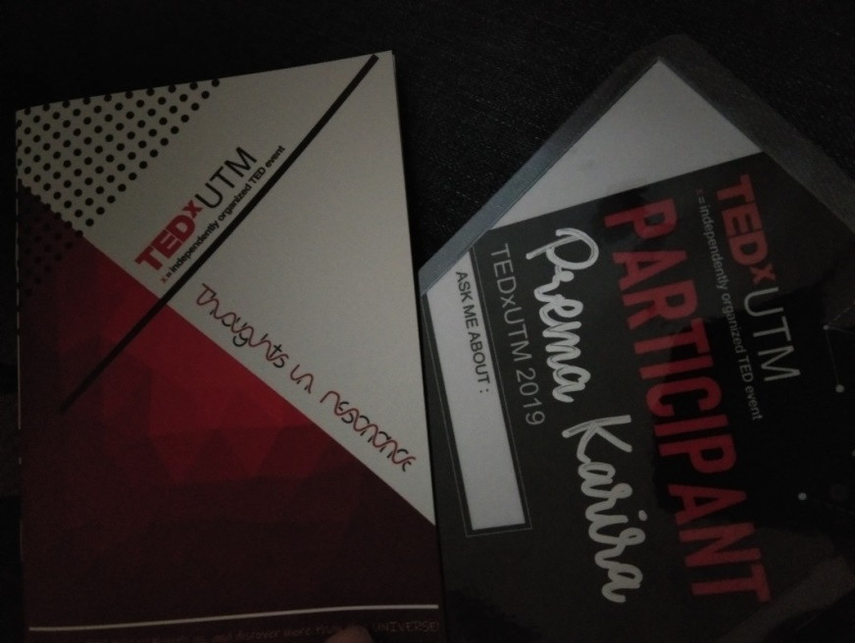

Picture 1: Here is the evidence that I had joined TEDx event at FABU Convention Hall, UTM, JB.

At this event we met directly with great speakers of course. There were 10 great speakers invited to this event, including the first being Assoc. Prof. Ramesh Zaidi Rozan is an associate professor. Secondly is Dr Vanlal Thanzimi a Senior Lecturer in Psychology, at Monash Malaysia. Third, Ir. Ammar Mohd Rashid a Managing Directory of AMR Environmental Sdn Bhd. The fourth is Mr. Drew Binsky a Travel Video Content Creator who has traveled the world. The fifth is Mr.Matthias Gelber an Environmentalist. Sixth, there is Mr. Ng Zhu Hann a Chief Strategist. Seventh, Mr. Warren Mak is a Founder and Managing Director of TED WEALTH PLT. Eighth, Ms. Karen Foo is a Motivational speaker and author, one of the women I admire and truly inspire. Ninth, Ms. Lenna Lim is a great actrees and most recently is Ms. Mutang Tagal's advice is a Humanitarian and Crafter.
In the TEDx event the attendees and speakers immediately joined forces to spark deep discussion and connections in small groups. The speaker will share experiences with the participants by presenting the prepared slides or videos. We are also welcome to ask questions about anything after the speakers tell and explain the material they convey.

- Responding
2 years ago my friend invited me to join this TEDx event. Actually, I am not interested in this event. I joined this event because I just wanted to accompany my friend to participate in this event. In the end, on 30 December I registered with the committee to participated in this activity. In my mind this event is just an ordinary boring seminar like some of the other seminars I have attended. I am a person who gets bored very quickly if I attend a seminar that just sits quietly then watches the speaker explain without any reaction to the audience.
But all of that is beyond my expectations. On 3 March 2019 when the event was held I was very surprised. What is in my mind and my expectations is very inversely proportional to the reality. It turned out that I really enjoyed the flow of the event. I really pay attention to what the speakers present, what the speakers convey, coupled with interesting videos of their experiences. At the beginning of the event, I was also very happy because I was welcomed by the TEDx committee. Get snacks and merchandise too. The speakers were also very professional in delivering their material until all the participants were amazed by all the speakers invited to the event. I am also motivated by their achievements, their storylines to the point where they become successful, and also their careers. I am very motivated and inspired by the inspirations here. They provide many pictures of how to achieve success at this time.

- Relating
I have never met an event like this before. Some of the seminars that I have participated in are also interesting, not all seminars that I have attended are not interesting to me even though I am present at the event. But an event like this, which moved me to be like them does not exist yet and this TEDx event is the best event in my opinion as long as I attend some of the other seminars too. Unlike other events, this event is very good and worth it in my opinion. It is highly recommended to join this event because there we will meet great people who move us to be like them.
When I joined this TEDx event, I thought that so far I did not have a single skill that I could focus on and do. I watched these speakers from their long journey from zero to this second to become respected and arguably successful people. They have one ability that they focus on for themselves. Skill is what led them to be like this. The skills they carry and develop are something they hone so that their skills become potential skills. From there I started to think and look for what abilities I could have, which I could develop, which I could focus on, and what abilities I could hone. Hard work and prayer are important aspects for us to hold on to at any time. But the ability to find out who we are is the most difficult for us to find. We must know more deeply who we really are. We must be able to understand what we really are like. That is why until now I have not been able to find the ability in myself because I myself have not been able to know what I really am like. Those speakers are my inspiration to remain unaware of what giving up is. They are the best motivators I have met.

- Reasoning
Some important aspects are hard work, prayer, and also skills in us. By working hard, we can understand what the life process is from the point where we don't have anything and also the ability to the point where we become the best. Hard work helps us to achieve our goals in the future and what we need to achieve the next day. But it is also incomplete, if hard work is not accompanied by prayer. Because, we still have a god who always rules all our lives in this world. Hard work without prayer results in zero. No matter how hard we work, if we don't pray it is still all meaningless. Likewise, if we just pray without hard work, everything will also not produce anything. So balance between hard work and prayer. Like one of these TEDx speakers, he is a very powerful person in my eyes.
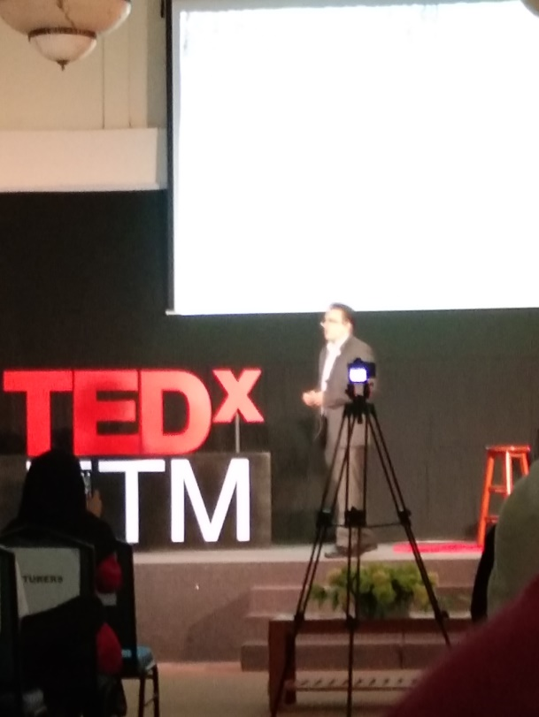
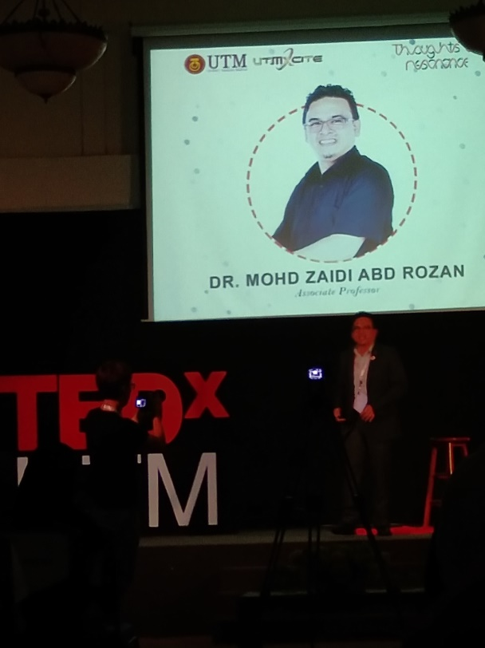

Picture 2: Dr. MOHD ZAIDI ABD ROZAN

I am amazed to see his ambition. Yes, he is Dr. Mohd Zaidi Abd Rozan. Dr. Mohd Zaidi Abd Rozan has worked in more than five organizations prior to UTM, where he held various positions from academic and non-academic in both Private and Government based organizations. He is also involved in the business world as an entrepreneur since 1993 until now. He has a B.Sc. (Physics). Computer. Ed and M.Sc. (IT) from Universiti Teknologi Malaysia (UTM), MALAYSIA and received D. Eng. in Information Science & Control Engineering from Nagaoka University of Technology, JAPAN in 2007. Dr. Zaidi is an Associate Professor in Information Systems, at Azman Hashim International Business School (AHIBS), where he is officially a senior academic of the Faculty of Computing for more than 15 years. Currently, he is the Director of the UTM Center for Student Innovation & Technology Entrepreneurship (UTM XCITE). Since 2015, it has achieved entrepreneurship & innovation funding of over RM1.2 Million. As a student, I was very motivated to continue to seek knowledge, work hard and have high enthusiasm like him. He is very good at being able to seek knowledge everywhere and has high enthusiasm.

- Reconstructing
What can we take from this event and what benefits we can get a lot. The speakers at this event are great motivators in the world. TEDx invites so many great people to every conference, where they share “magic” and inspirational ideas. Now, TED Talks believes that the power of ideas can change attitudes, lives, and even the world. The conclusion that I got from all the speakers is that we must have skills and passion. Because with these two factors, money will come naturally. wanting to have a good career, and working really hard is sometimes not enough. So, we have to be good at seeing what skills we have and our passions, not just being interested in things that are interesting to us. My job as a student is to study material diligently. Besides, I also have to start looking for what skills are in me and pursue my passion. Besides that, I also have to give positive things to the people around me, be a good person and be useful for others as well. Because great people do not think about themselves but also help others to always do positive things. Don't give up easily under any circumstances. Because, something that seems almost to fail, or is almost successful, can actually become a work of art in itself. It is precisely that "almost" that encourages us to keep going.

