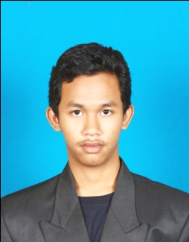

Mohammad Faris Bin Suhaimi
Lot 1803 Kg Bakat Hilir Jabi,
22020 Jerteh,
Terengganu
014-8301819
faris_ja131@yahoo.com
Objective : To begin my lecturer career at a highly-reputed and eminent educational institute and to gain exceptional career move ahead through long efforts and performance regularity.

Summary of Qualifications:
- Highly gifted teaching aptitude
- Crystal clear understanding of the underlying principles of the subject and its relevancy to other domains
- In-depth knowledge of various techniques and approaches applied at a research project
- Perfect knowledge about the common job duties of a lecturer and ability to perform them efficiently
- A little familiarity with the general administrative environment at educational institutes and idea about their practices
- Highly innovative in depicting the subject matter to the students/audience, using traditional methods as well as modern aids
- Mastery in English communication and comprehension.
- Superb proficiency at computer aided teaching and research tools and the web search engines
Academic education:
- Graduated in Science(Industrial Mathematics) from University Technology Malaysia, Johor Bahru, Johor (2015)
- Completed post graduation in Science from University Technology Malaysia, Johor Bahru, Johor (2018)
Extra Curricular:
- Participated in Reserve Officer Training Unit (Malaysia) at University Technology Malaysia.
- Represented residential college for rugby competition.
Work Experience :
- Teaching PMR and SPM student in modern mathematics and additional mathematics at secondary school.

Interests and Hobbies:
- Trekking
- Reading science fiction books
- Playing rugby
- Canoeing
Personal Details:
- Date of Birth: 16 / 09 / 1993
- Marital status: Single
- Expected employment status: Full time
References:
- Dr. Sharidan Shafie
C10-421
07-5534465
- En Ismail Kamis
C13-323
019-7596535

