Name: Lau Mun Hing
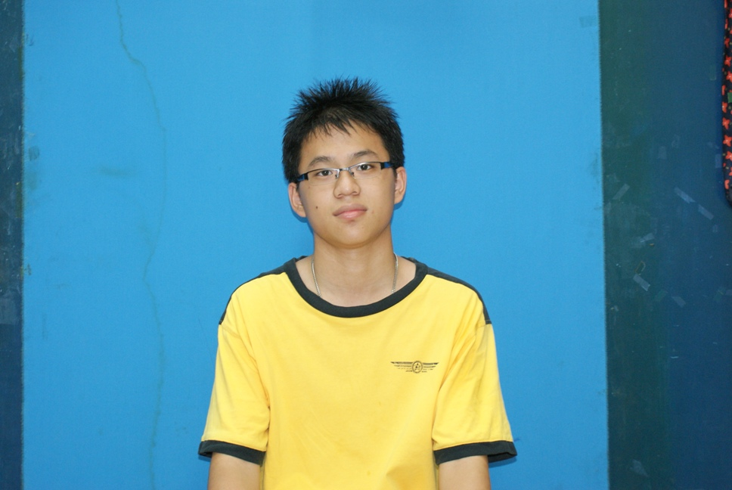
Phone: 016-5126905
Email address: munhing218@hotmail.com
Home address: 17 Persiaran Kelebang Selatan 31,
Taman Bertuah, 31200 Chemor, Perak.

- Nationally awarded scholar during University by the government of Malaysia (PTPTN). With an excellent academic profile consistent throughout my academic years.
- High-spirited and full of energy to begin a new phase of life after education. Willingness to learn and humbleness will allow me to gain the necessary experiences to progress towards my goals in the future.

Skills

- Self motivated and Independent
- Excellent Team Player
- Strong Analytical Skills
- Strong Communication and Interpersonal Skills
- Computer/Technical Literacy
- Problem-Solving/Reasoning/Creativity
- Teamwork
- Loyalty
- Positive Attitude/Motivation/Energy/Passion

Recent Awards

- Certificate of Participation, National Service (National Service Department, Malaysian Ministry of defence),2009
- Certificate of Participation, National Chinese Chess Competition (National Chinese Chess Club), 2006 & 2007

Professional Experience

- Space Out F&B Management & Marketing
Assistant Supervisor
- Able to communicate with the customers
- Able to provide information that customer required
- Able to organize an event and set up all the things

Technology

- Software: MS Office(Word, Access, Excel, Power Point)
- Languages: English, Mandarin, Malay as well as Cantonese

Education

UNIVERSITI TEKNOLOGI MALAYSIA, SKUDAI, JOHOR, MALAYSIA
Bachelor Science, 2011-2015
- Major: Mathematics Industry (Graduated with 3.50)
-Good academic performance; consistent throughout pre-tertiary education. Transcript available upon request.

SMK METHODIST ACS
- Graduated with 3.08 for STPM
- MUET ( Band 3)

S.M.K POI LAM
- Graduated with 5A and 6B( Bahasa Melayu-3B, Bahasa Inggeris-3B, Bahasa Cina-3B)

Reference
Dr.Norhaiza Ahmad
Email address: norhaiza@utm.my
Contact No: 019-7747457
Position: Lecturer UTM

Prof.Madya Dr.Ismail Mohamad
Contact No: 07-5534296
Position: Lecturer UTM
